PAAREES Perfumes

CHANEL MEN

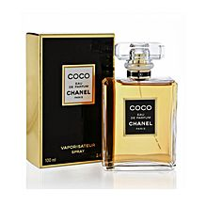

**Chanel for Men - 100ml**

By Chanel

Key Features

* Imported
* Eau de Toilette
* For Men
* 100ml