PAAREES Perfumes

Calvin Klein MEN

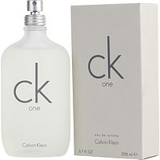

**CK for Men - 100ml**

By CK

Key Features

* Discounts available on App
* Eau de Toilette
* For Men
* 100ml