PAAREES Perfumes

Calvin Klein MEN

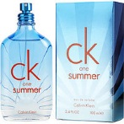

**CK for Men - 100ml**

By CK

Key Features

Eau de Toilette

* For Men
* 100ml