PAAREES Perfumes

CK Women

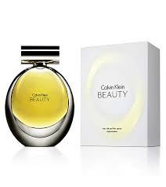

**CK - For Women - 100ml**

Key Features

* Antibacterial formula with golden ions
* Without alcohol and colorants
* Skin tolerance
* Dermatologically proven.