PAAREES Perfumes

GUCCI MEN

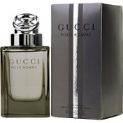

**Gucci for Men - 100ml**

By Chanel

Key Features

* Imported
* Eau de Toilette
* For Men