PAAREES Perfumes

GUCCI Women

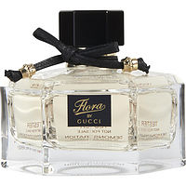

**Gucci for Women - 100ml**

By Gucci

Key Features

* Imported
* Eau de Toilette
* For Women