PAAREES Perfumes

GIORGIO ARMANI Women

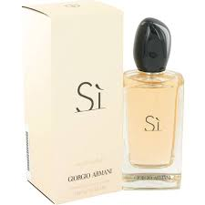

# GIORGIO ARMANI

Key Features

* Long lasting fragrance
* Perfume for women
* Best Gift For Him
* Eau De Toilette
* Perfume: **100ml**

# 