Person Vein Identification using CNN

In this project we are employing Convolution Neural Network (CNN) to identify person based on finger vein. CNN will extract features from images automatically and then used this features for person identification and does not require any hand crafted features like finger minutiae or palm area HAAR cascaded files which contains finger and palm information and this files designed by humans and may contains error which result into inaccurate identification.

All existing biometric algorithms are dependent on humans hand crafted features whose prediction accuracy is not up to the mark. In propose work we are employing machine learning SVM algorithm and deep learning CNN algorithm and then evaluating both performance in terms of accuracy and confusion matrix.

To train both algorithms we are using 30 different finger veins images dataset downloaded from KAGGLE website and below is the dataset URL. All this images are captured using Thermal cameras.

<https://www.kaggle.com/datasets/ryeltsin/bdfvusm>

In below screen we are showing dataset details used in this project

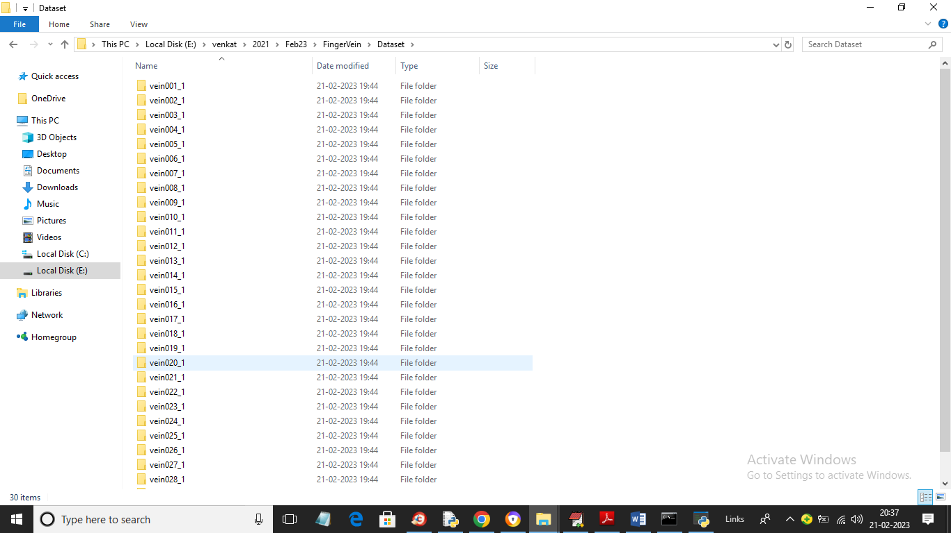

In above dataset screen we have 30 folders from 1 to 30 for persons finger vein from 1 to 30 and just go inside any folder to view finger vein images

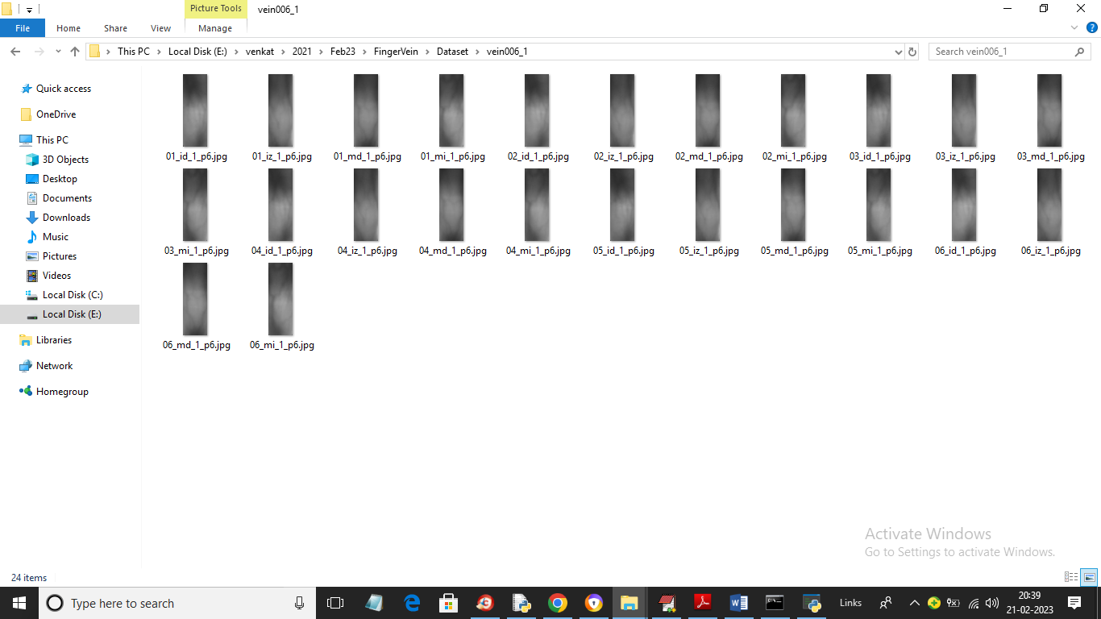

In above screen we can see images of finger vein and by using above images we will trained both SVM and CNN algorithms

To implement this project we have designed following modules

1. Upload Finger Vein Dataset: using this module we will upload dataset to application and then find and plot different person fingers found in dataset
2. Preprocess Dataset: using this module we will read image and then resize all images to equal size and then shuffle and normalize images and then split dataset into train and test where application using 80% images for training and 20% for testing
3. Run SVM Algorithm: 80% processed trained images will be input to SVM algorithm to train a model and then 20% test images will be applied on trained model to calculate prediction accuracy
4. Run CNN Algorithm: 80% processed trained images will be input to CNN algorithm to train a model and then 20% test images will be applied on trained model to calculate prediction accuracy
5. Comparison Graph: using this module we plot comparison graph between both algorithms
6. Identify Finger Vein from Test Image: using this module we will upload test finger vein image and then CNN will analyse vein image and then identify person from that image

SCREEN SHOTS

To run project double click on ‘run.bat’ file to get below page

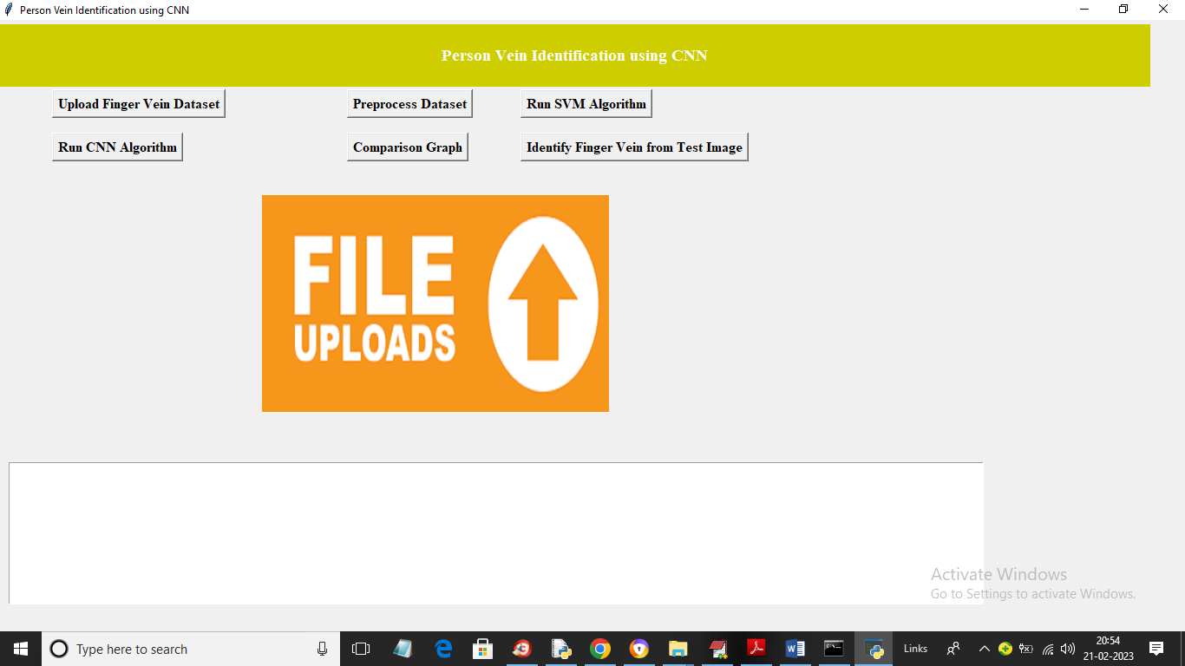

In above screen click on ‘Upload Finger Vein Dataset’ button to upload dataset and get below output

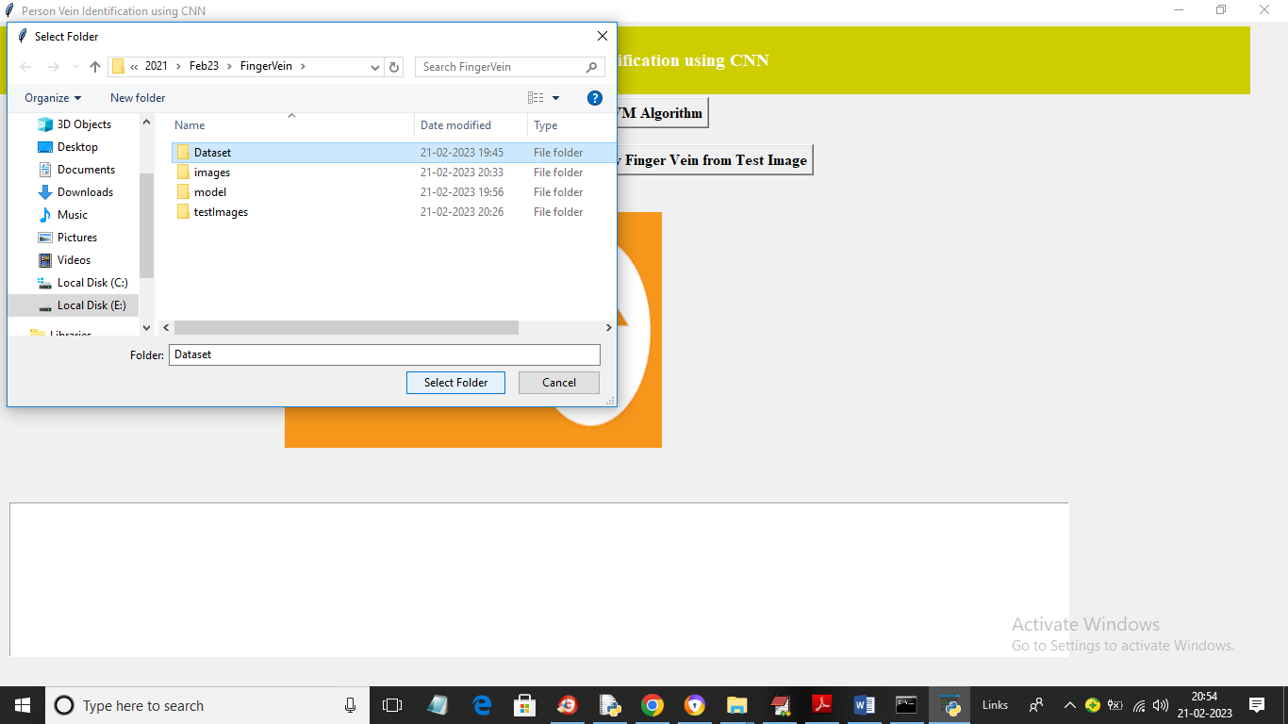

In above screen selecting and uploading ‘Dataset’ folder and then click on ‘Select Folder’ button to load dataset and get below output

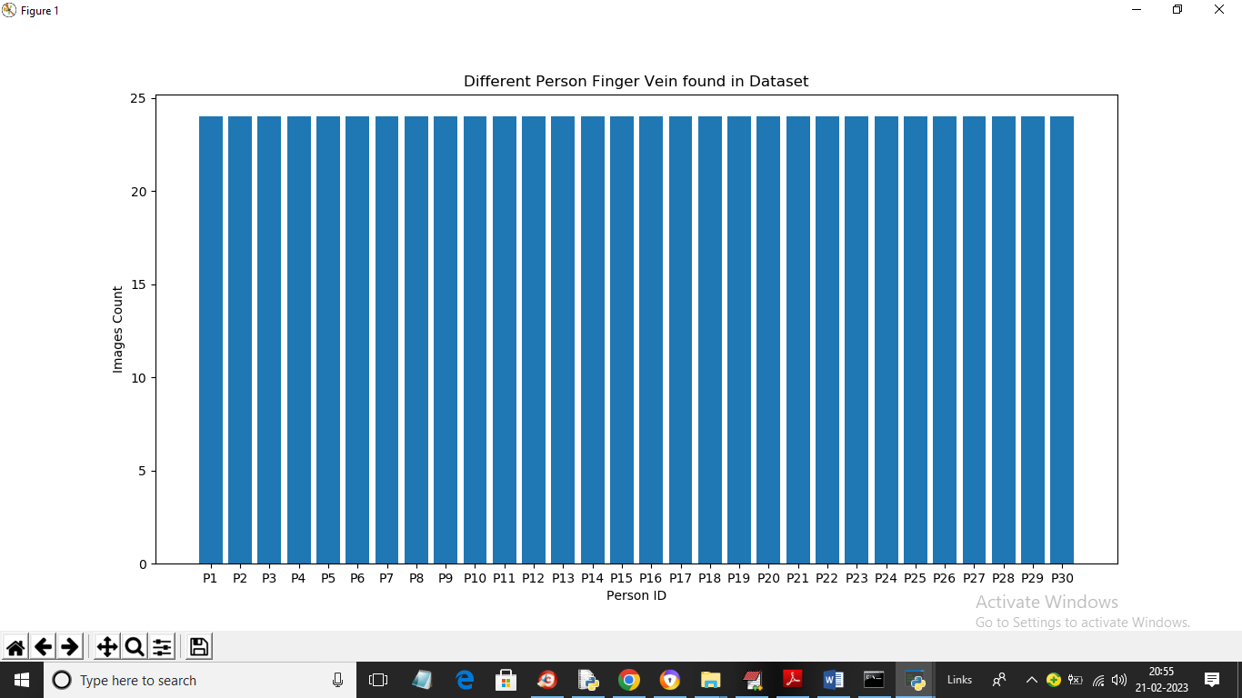

In above screen dataset loaded and in above graph x-axis represents person ID and y-axis represents number of finger images found for that person and now close above graph and then click on ‘Preprocess Dataset’ button to process image and get below output

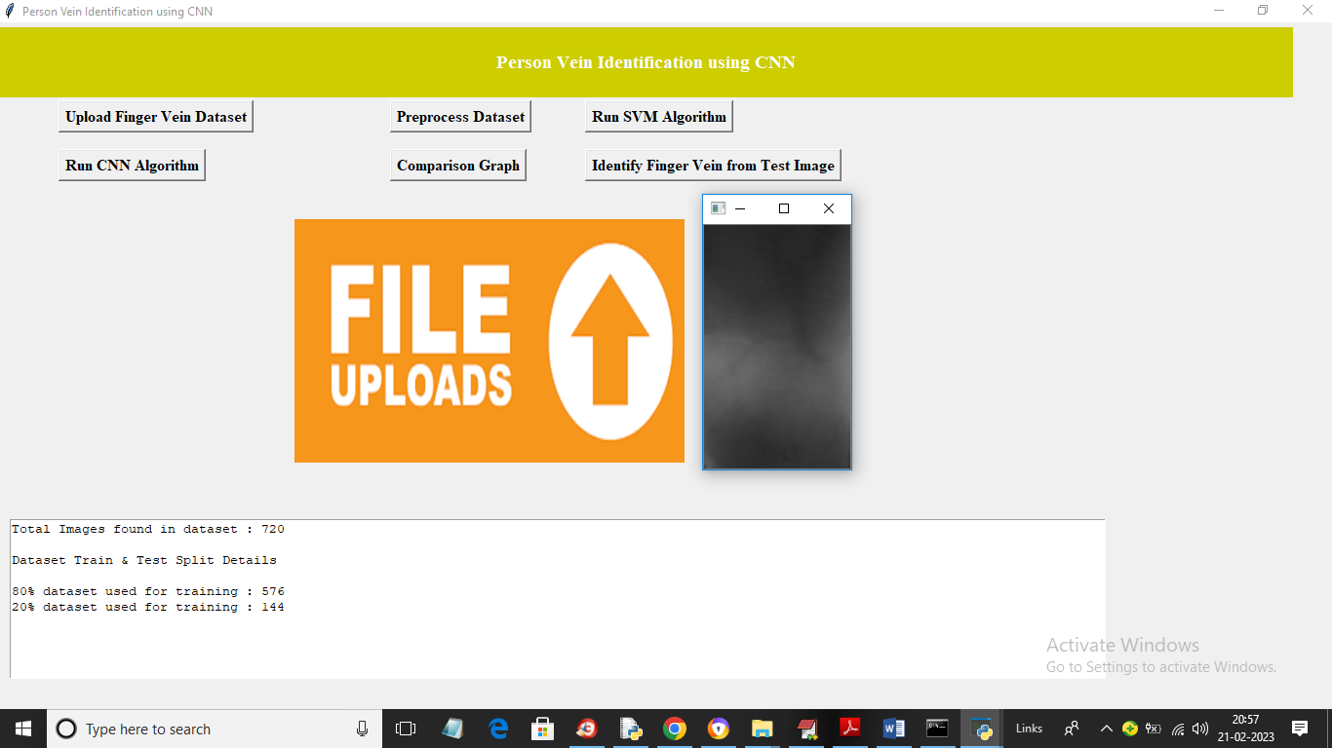

In above screen in text area we can see total processed images and can see 80% images size using for training and 20% for testing and then showing one processed image and now close above image and then click on ‘Run SVM Algorithm’ button to train SVM and get below output

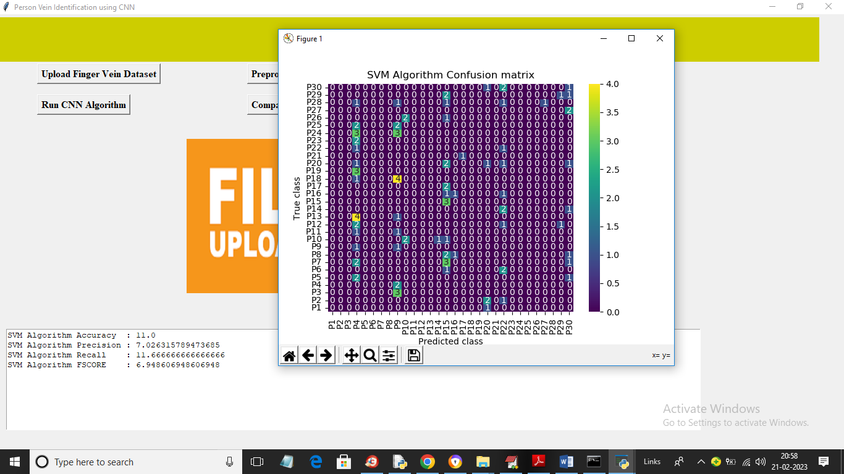

In above screen with SVM we got 11% accuracy and in confusion matrix graph x-axis represents Predicted Labels and y-axis represents True Labels and only the count in diagnol are the correct prediction count but in above graph diagnol we are seeing very few count and remaining are 0 so SVM is not accurate and now close above graph and then click on “Run CNN Algorithm’ button to train CNN and get below output

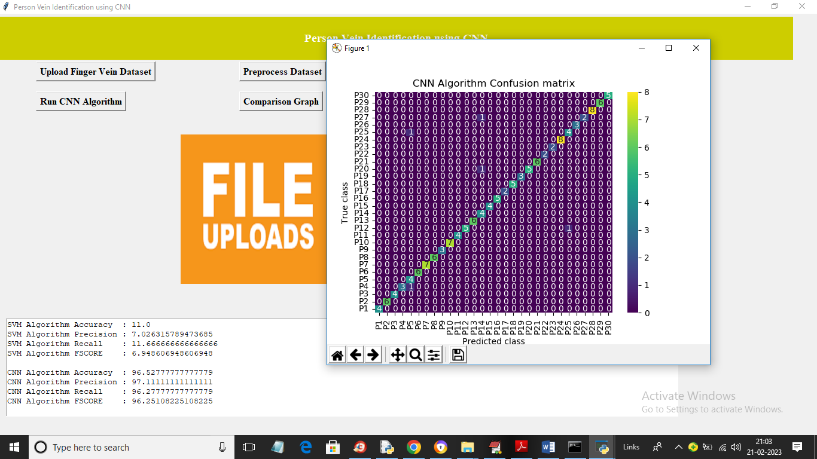

In above screen with CNN we got 98% accuracy and in confusion matrix graph in diagnol we can see all person images are correctly predicted and remaining blue colour boxes as in-corrected prediction contains 0 only. All blue colour boxes represents incorrect prediction count. Now close above graph and then click on ‘Comparison Graph’ button to get below graph

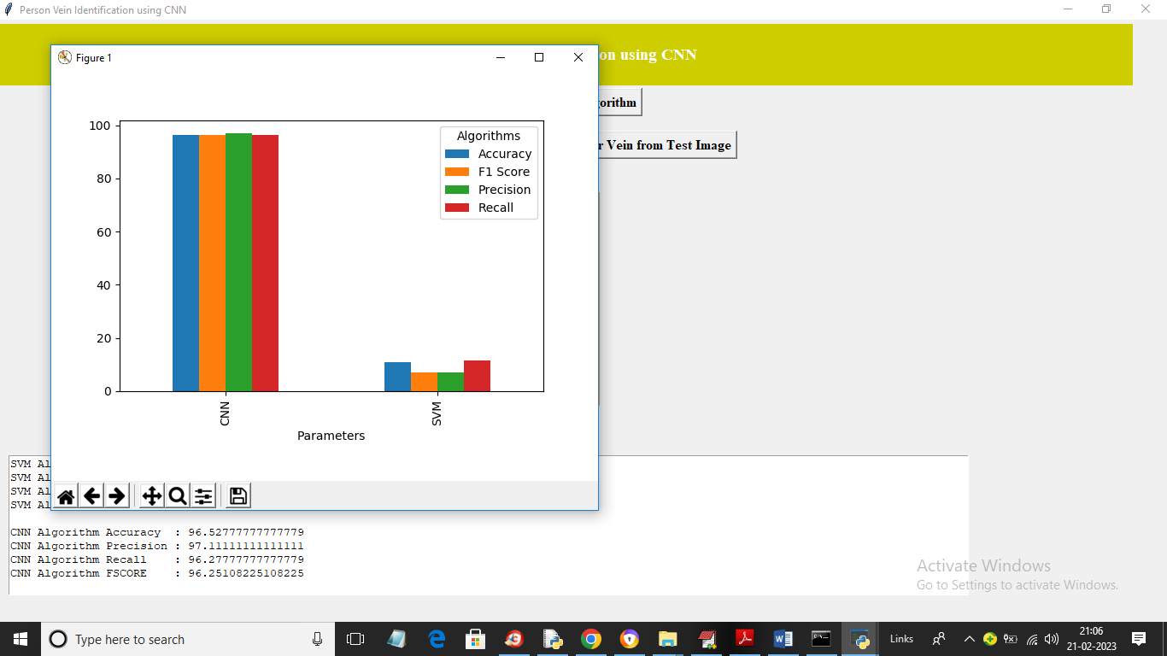

In above graph x-axis represents algorithm names and y-axis represents accuracy and other metrics in different colour bars and in both algorithms we can see CNN got high performance. Now close above graph and then click on ‘Identify Finger Vein from Test Image’ button to upload test finger vein image and then identify person

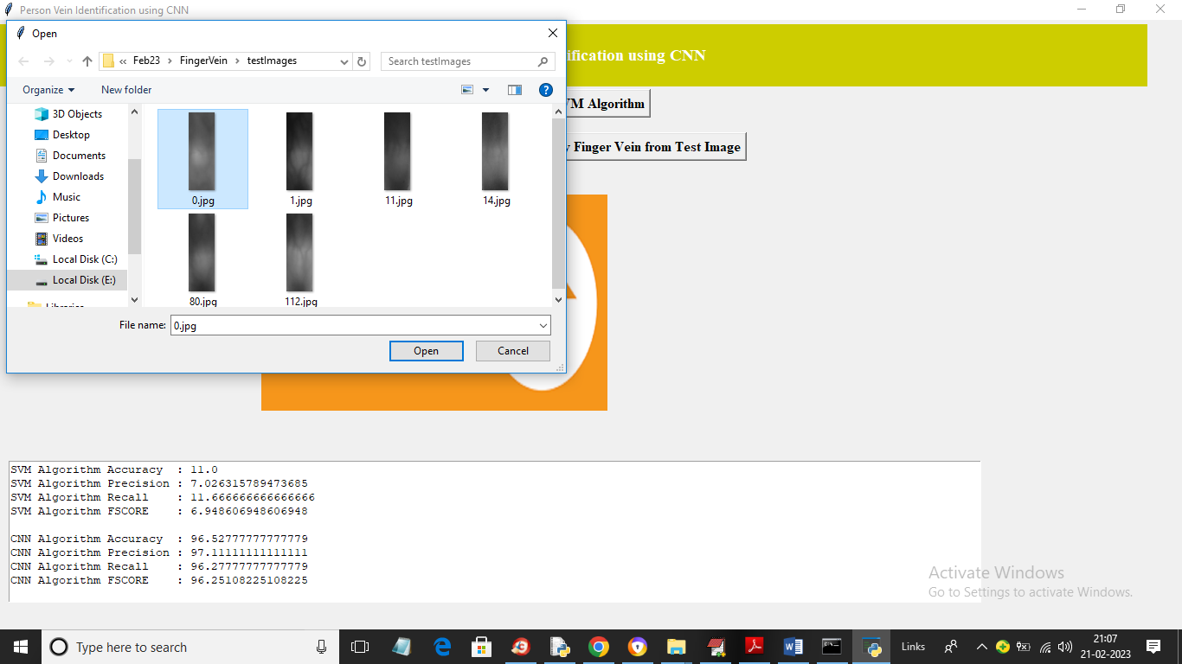

In above screen selecting and uploading ‘0.jpg’ and then click on ‘Open’ button to get below output

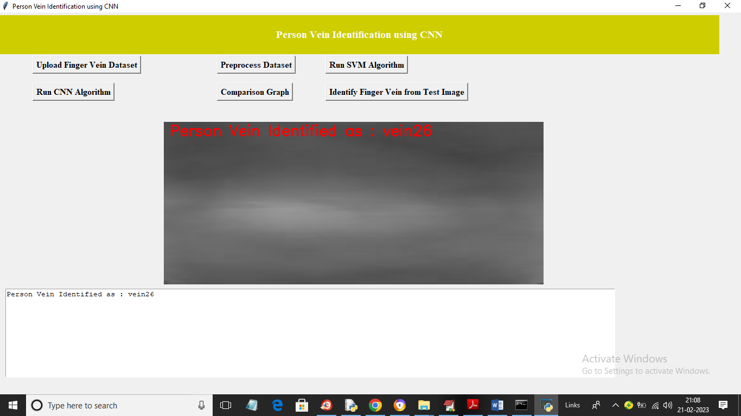

In above screen finger vein identified for person ID 26 and similarly you can upload and test other images

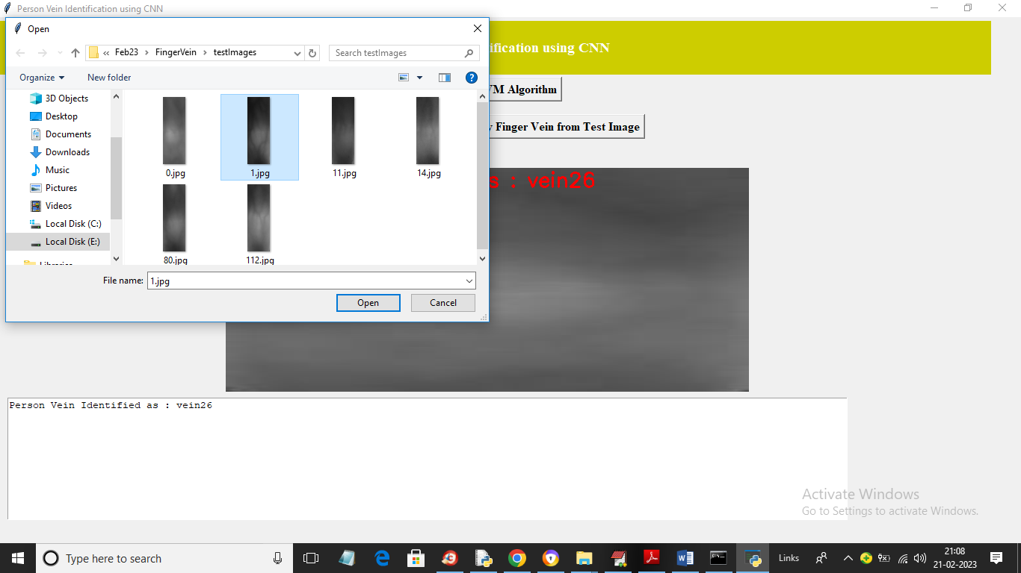

In above screen uploading another image and below is the output

