Executive Business Report
End-to-End Sales Forecasting & Demand Intelligence System
- XYlofy AI & Data Science Internship

1. Executive Summary
This project was carried out to analyze historical sales data from the Superstore Sales Dataset and develop an intelligent sales forecasting system. The main objective was to predict future product demand, detect unusual sales patterns, segment products based on demand behavior, and present the results through an interactive dashboard. Three different forecasting models were developed and compared to identify the most accurate approach. The project also included anomaly detection techniques and product demand segmentation using machine learning. The final dashboard helps business managers understand sales performance and supports better inventory planning and decision-making.

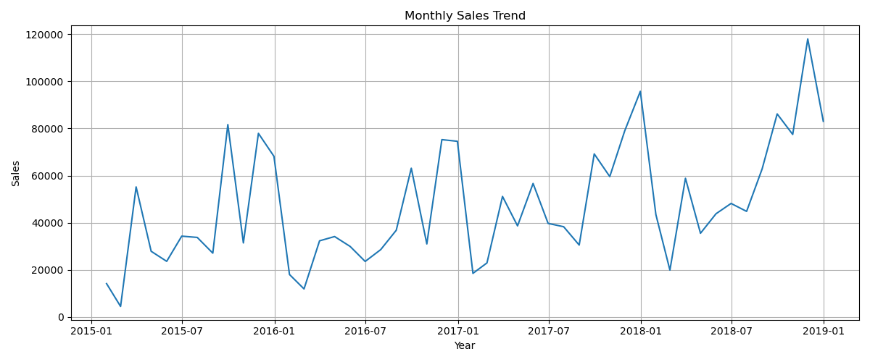

2. Key Findings from Exploratory Data Analysis (EDA)
The exploratory data analysis provided several useful business insights. Technology generated the highest overall revenue among all product categories. Sales showed a clear increasing trend over the four-year period with noticeable seasonal patterns during certain months. Regional analysis indicated differences in sales performance across different locations, while shipping time remained relatively consistent. Time series decomposition confirmed the presence of both long-term trends and seasonal variations, making the dataset suitable for forecasting models.

3. Sales Forecasting Results
Three forecasting models were developed and evaluated using MAE, RMSE, and MAPE metrics.
Model | MAE | RMSE | MAPE
SARIMA | 18031.40 | 19009.18 | 18.97%
Prophet | 40970.33 | 53868.95 | 40.04%
XGBoost | 14148.40 | 16213.61 | 14.34%
Among all three models, XGBoost produced the best forecasting performance, achieving the lowest prediction errors. Therefore, XGBoost was selected as the final model for predicting future sales demand.
The three-month forecast suggests stable future demand with stronger growth expected in the Furniture category and moderate growth across the East and West regions. These predictions can help managers plan inventory levels more effectively and reduce both stock shortages and overstock situations.
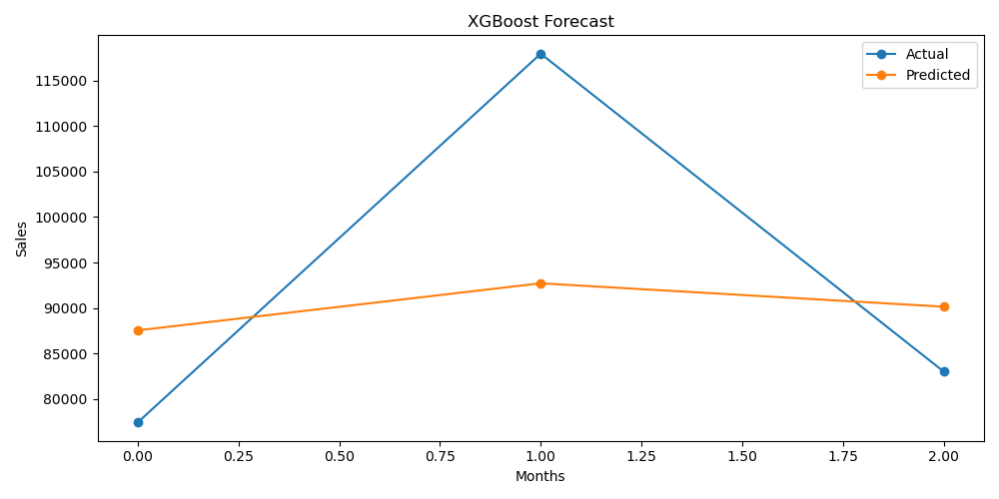

4. Anomaly Detection Findings
Two anomaly detection techniques were applied during this project:
- Isolation Forest
- Z-Score Method
Both methods detected 11 unusual sales weeks, indicating consistent identification of abnormal sales behavior.
Possible reasons behind these anomalies include:
- Festival season sales
- Heavy discount campaigns
- Large bulk customer orders
- Temporary stock shortages
- Unexpected changes in customer demand
Identifying these anomalies allows businesses to investigate unusual events and improve future planning.
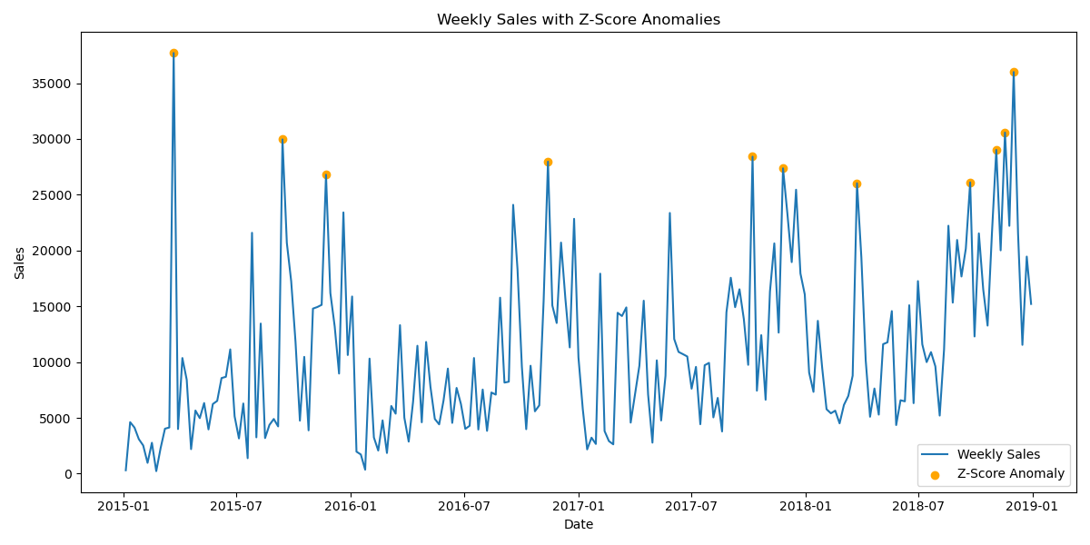

5. Product Demand Segmentation
Product sub-categories were grouped using K-Means Clustering based on sales volume, sales growth, volatility, and average order value.
The products were divided into four demand groups:
- High Volume, Stable Demand
- Growing Demand
- Low Volume, High Volatility
- Declining Demand
Each cluster requires a different inventory strategy. Stable products should always be sufficiently stocked, growing products require gradual inventory expansion, highly volatile products should be monitored carefully, while declining products require controlled inventory to reduce unnecessary storage costs.

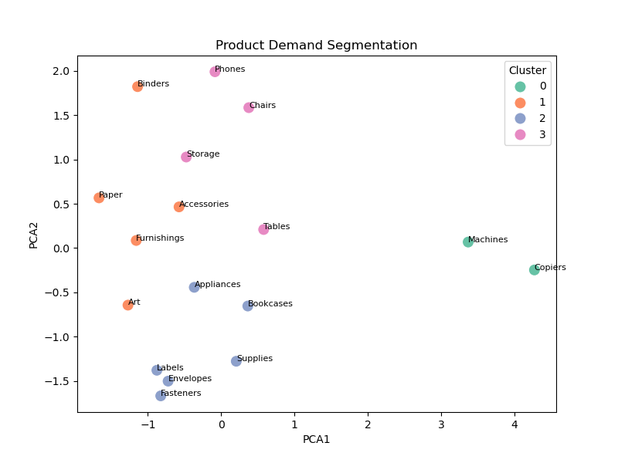

6. Business Recommendations
Based on the analysis and forecasting results, the following recommendations are suggested:
- Adopt XGBoost as the primary forecasting model because it achieved the highest prediction accuracy among all tested models.
- Increase inventory levels before seasonal demand peaks, especially for products showing stable and growing demand.
- Monitor sales anomalies regularly to identify unusual business events early and improve inventory planning decisions.

7. Project Limitation
The forecasting models were trained only on historical sales data. External factors such as economic conditions, competitor activities, weather conditions, customer behavior changes, and future promotional campaigns were not included in the models. Including these external variables could further improve forecasting accuracy in future versions of the system.

8. Conclusion
This project successfully demonstrated the use of data science, time series forecasting, machine learning, anomaly detection, and clustering techniques to solve a real-world retail business problem. Among the forecasting models, XGBoost achieved the best performance and was selected as the final forecasting model. The interactive Streamlit dashboard provides an easy-to-use interface for visualizing sales trends, exploring forecasts, monitoring anomalies, and understanding product demand patterns. Overall, this system can support businesses in making better inventory planning decisions, reducing operational costs, and improving customer satisfaction.

Prepared By
Syed Sana Sulthana
XYlofy AI & Data Science Internship – 2026

