Terraform-06

1). Watch the Terraform-06 video.
2). Execute the script shown in the video.
3). Provision EC2, S3, and VPC using Terraform modules.
4). Provision EC2 for 3 different environments (Dev, Staging, and Prod) using Terraform workspaces.

2). Execute the script shown in the video.

- Open VS Code
Open VS Code.
Create/open your main folder:
Terraform
For example, if you are using Windows:
C:\Terraform
Then in VS Code:
File → Open Folder → C:\Terraform
Your VS Code Explorer should look similar to the screenshot in your document.

- Create aws_instance folder
Inside Terraform, create:
aws_instance
Then create these two files:
aws_instance/
├── main.tf
└── variables.tf
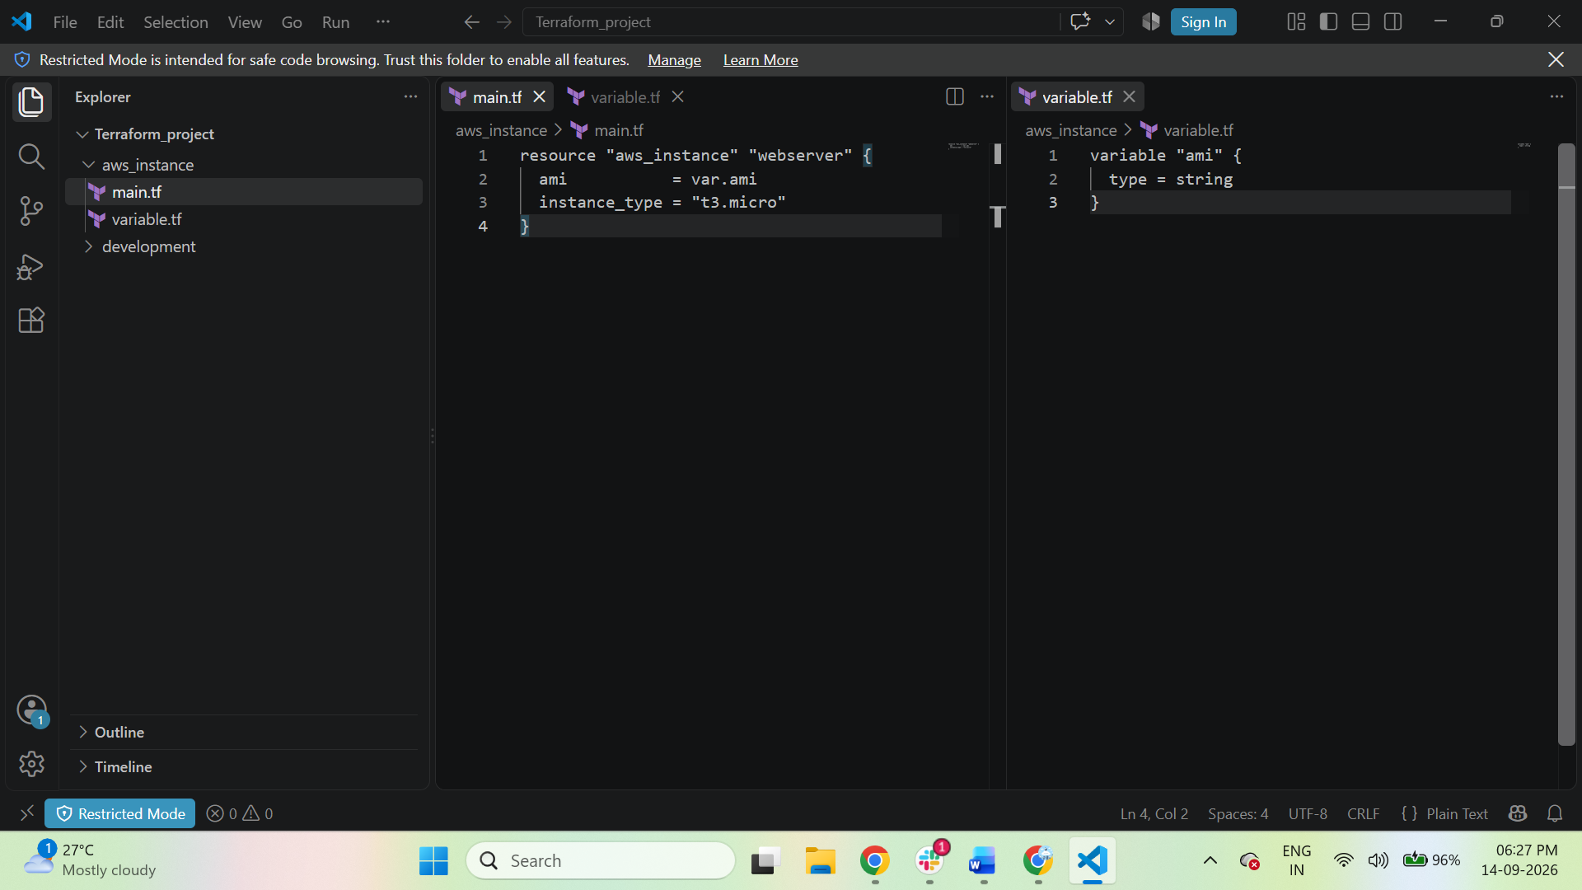

- aws_instance/main.tf
Open:
aws_instance/main.tf
This is the module's EC2 resource.

resource "aws_instance" "webserver" {
ami = var.ami
instance_type = "t3.micro"
}

- aws_instance/variables.tf
Create:
aws_instance/variables.tf
Use:
variable "ami" {
type = string
}
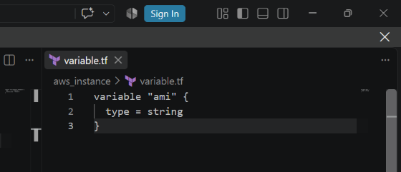
So your module is now:
aws_instance/
├── main.tf
└── variables.tf

- Create development folder
Back under the main Terraform folder, create:
development
So:
Terraform/
│
├── aws_instance/
│ ├── main.tf
│ └── variables.tf
│
└── development/
└── main.tf

- development/main.tf
Open:
development/main.tf

module "dev-webserver" {
source = "../aws_instance"
ami = "YOUR_AMI_ID"
}
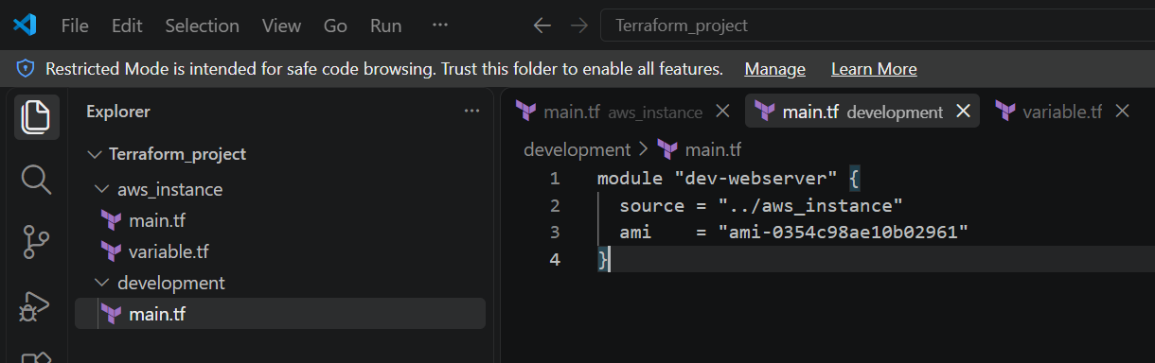
The important part is:
source = "../aws_instance"
That tells Terraform:
"Use the Terraform module located in the aws_instance folder."

- We also need AWS Provider
So in the Terraform root folder, create:
provider.tf
Put:

terraform {
required_providers {
aws = {
source = "hashicorp/aws"
version = "~> 6.0"
}
}

required_version = ">= 1.5.0"
}

provider "aws" {
region = "us-east-1"
}
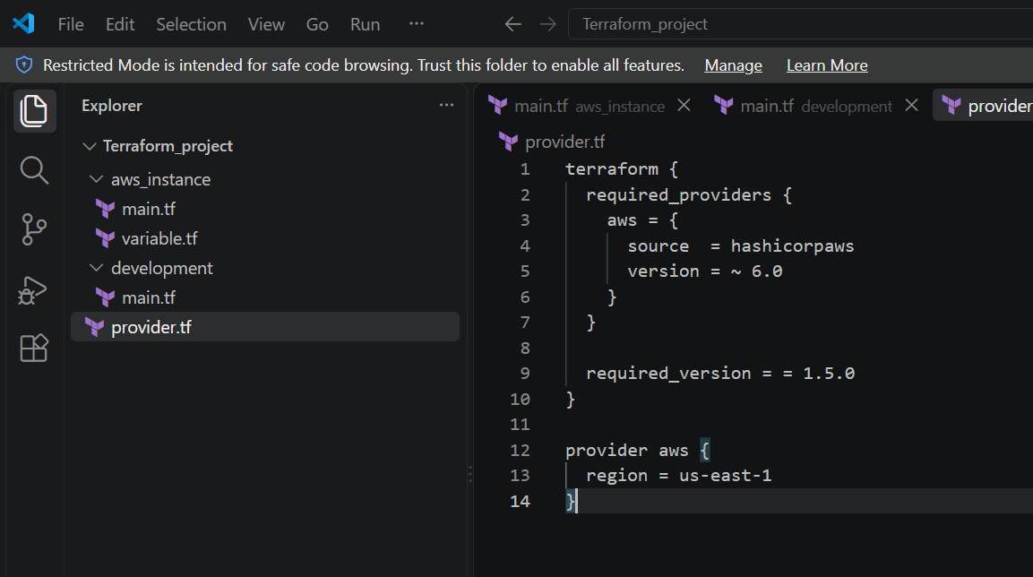

- Final VS Code Structure for Task 2
At this point your VS Code Explorer should look like:
Terraform_project/
│
├── aws_instance/
│ ├── main.tf
│ └── variables.tf
│
└── development/
├── main.tf
└── provider.tf

- Check AWS Authentication
Before Terraform creates anything, make sure your AWS CLI is configured.
Run:
$ aws sts get-caller-identity
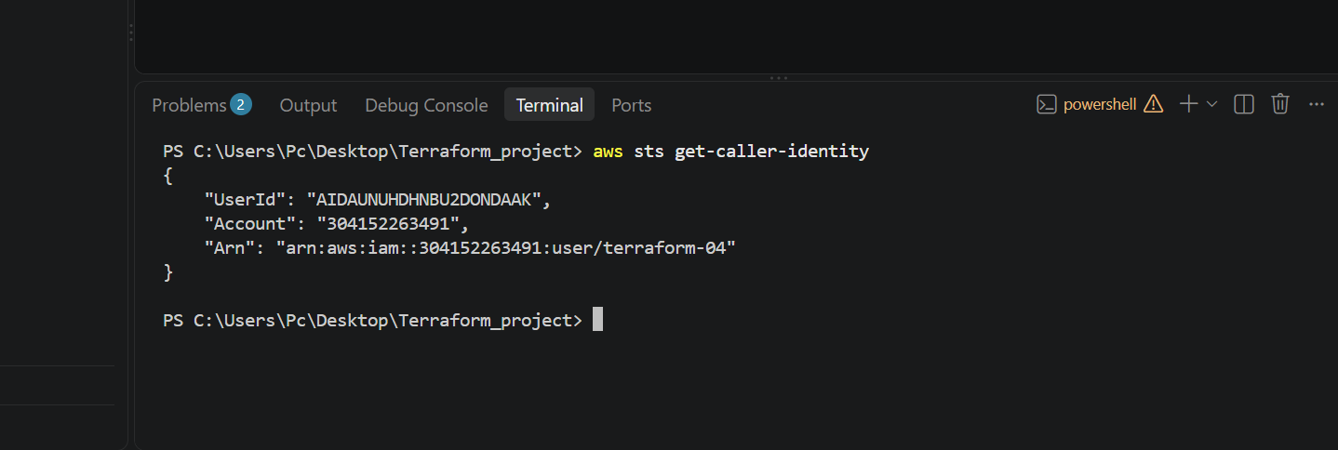

- Open the VS Code terminal
Run:
$ cd C:\Users\Pc\Desktop\Terraform_project\development
Then verify:
$ dir
You should see:
main.tf
provider.tf
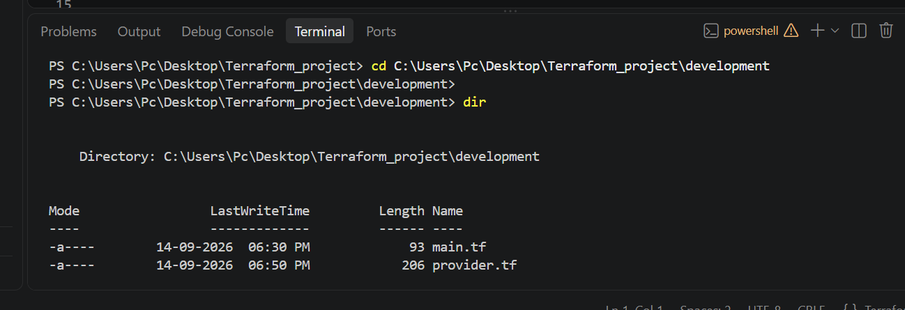

- Terraform Init
Now we're ready to execute the script.
From:
Terraform/development
run:
$ terraform init
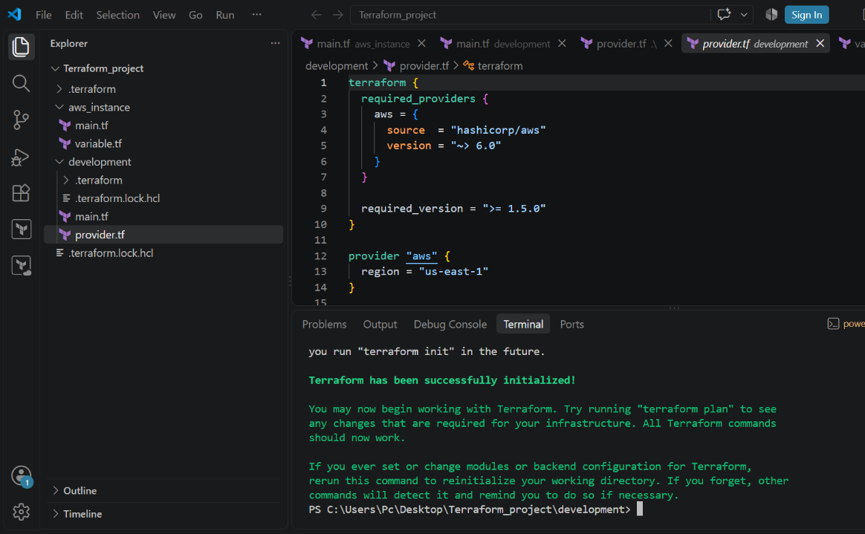

- Validate
Run:
$ terraform validate
Expected:
Success! The configuration is valid.
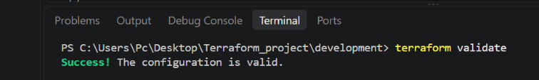

- Format
Run:
$ terraform fmt -recursive
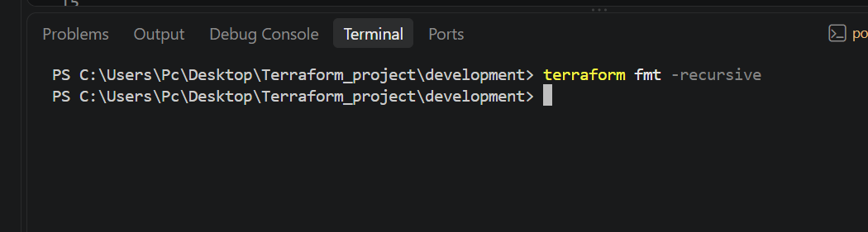

- Plan
Run:
$ terraform plan
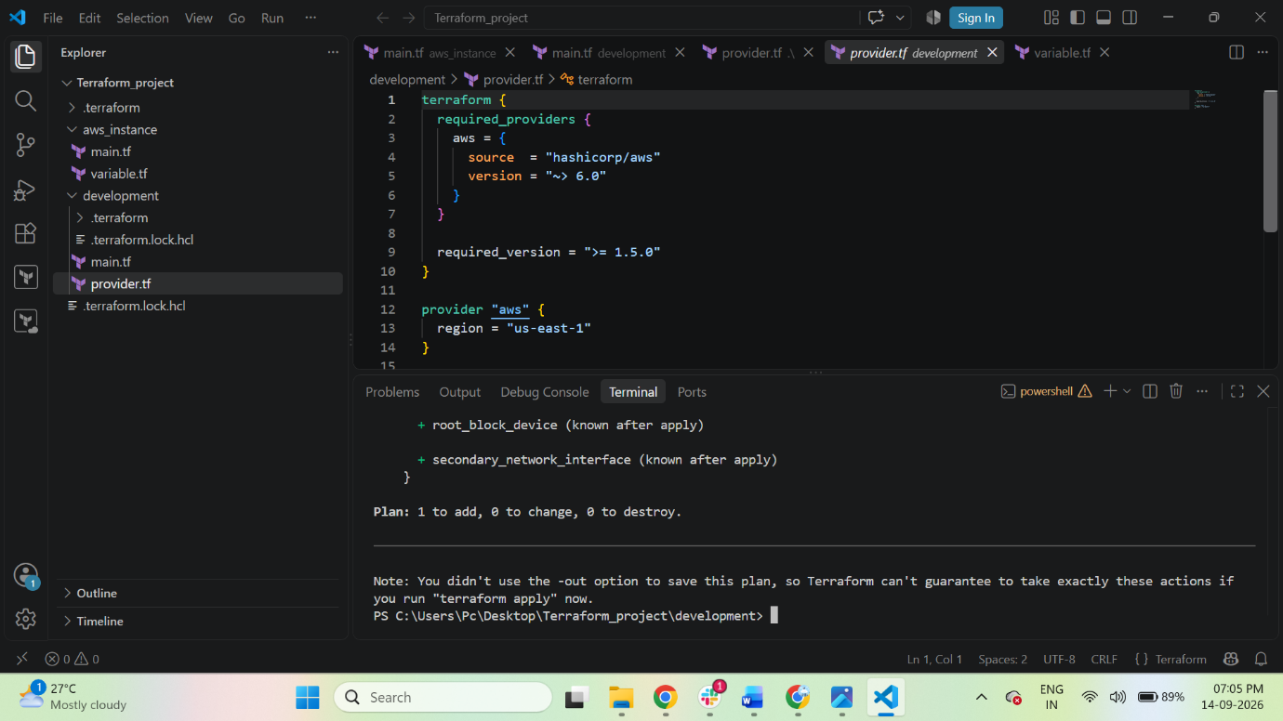

- Apply
Now execute:
$ terraform apply
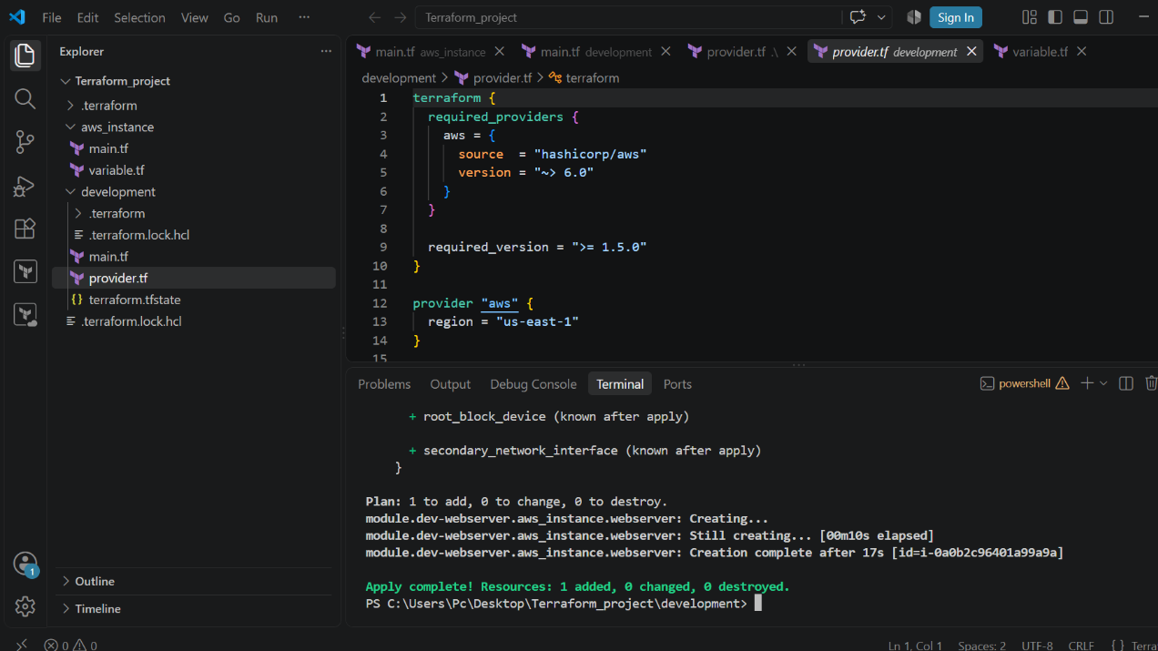

- Verify the Terraform State
Run:
$ terraform state list
You should see:
module.dev-webserver.aws_instance.webserver

- Verify in AWS
Go to:
AWS Console → EC2 → Instances
You should see your EC2 instance.
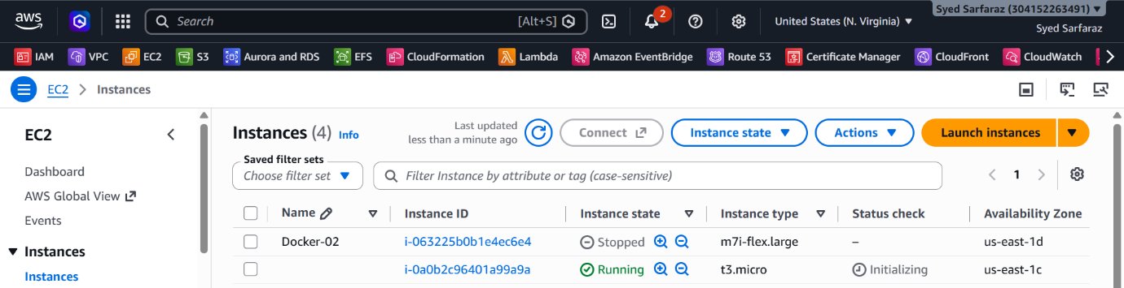

3). Provision EC2, S3, and VPC using Terraform modules.

Task 3 — Terraform Modules
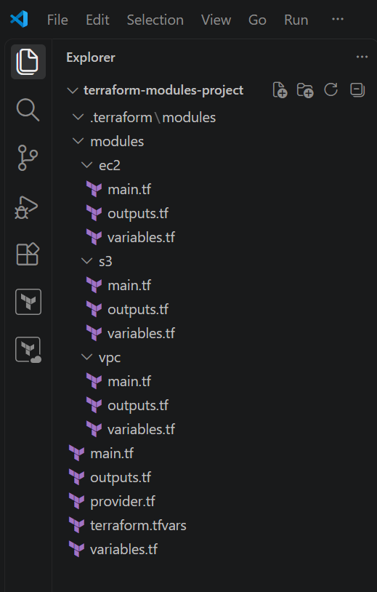
Step 1 — Create a NEW project
In VS Code, create/open:
C:\Terraform\terraform-modules-project
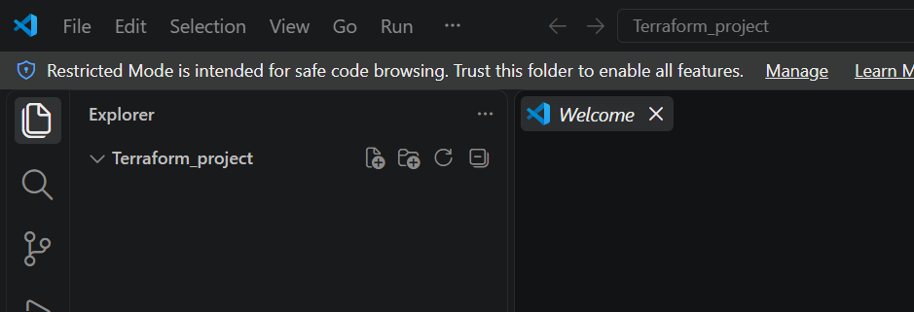

Step 2 — provider.tf
Create in the project root:
terraform-modules-project/provider.tf

terraform {
required_providers {
aws = {
source = "hashicorp/aws"
version = "~> 6.0"
}
}

required_version = ">= 1.5.0"
}

provider "aws" {
region = "us-east-1"
}
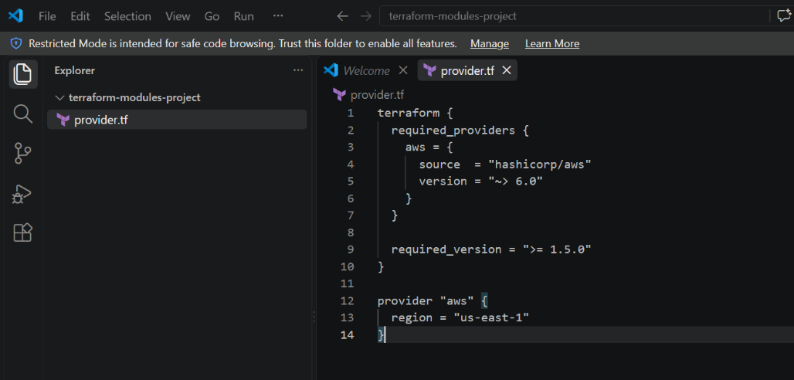

modules/vpc/main.tf

resource "aws_vpc" "this" {
cidr_block = var.vpc_cidr

tags = {
Name = "Terraform-VPC"
}
}

resource "aws_subnet" "this" {
vpc_id = aws_vpc.this.id
cidr_block = var.subnet_cidr
availability_zone = var.availability_zone

tags = {
Name = "Terraform-Subnet"
}
}
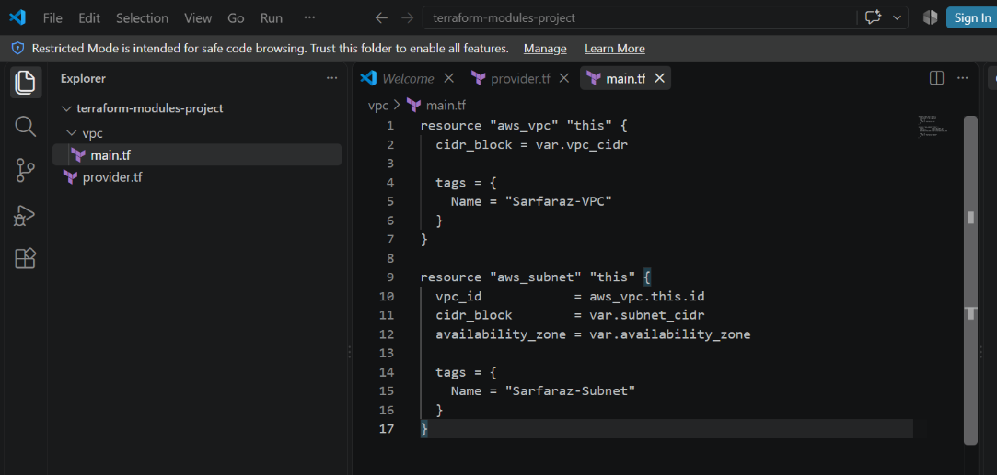

modules/vpc/variables.tf

variable "vpc_cidr" {
description = "CIDR block for VPC"
type = string
}

variable "subnet_cidr" {
description = "CIDR block for subnet"
type = string
}

variable "availability_zone" {
description = "Availability Zone"
type = string
}
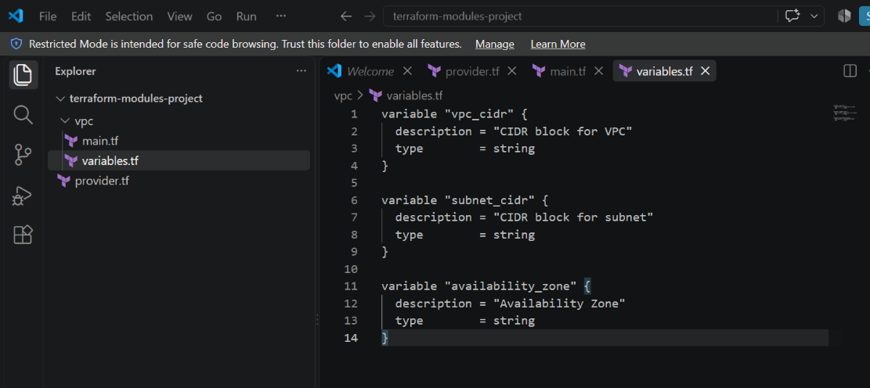

modules/vpc/outputs.tf

output "vpc_id" {
description = "VPC ID"
value = aws_vpc.this.id
}

output "subnet_id" {
description = "Subnet ID"
value = aws_subnet.this.id
}
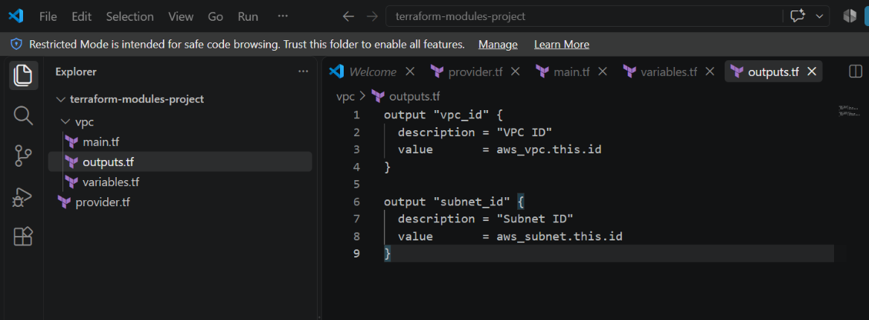

Step 4 — S3 Module
Create:
modules/s3/variables.tf
variable "bucket_name" {
description = "Name of the S3 bucket"
type = string
}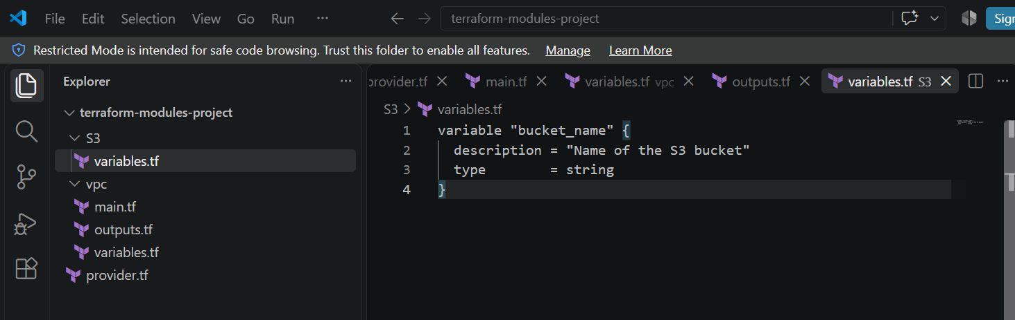

Create:
modules/s3/main.tf
resource "aws_s3_bucket" "this" {
bucket = var.bucket_name

tags = {
Name = var.bucket_name
Environment = "Dev"
}
}
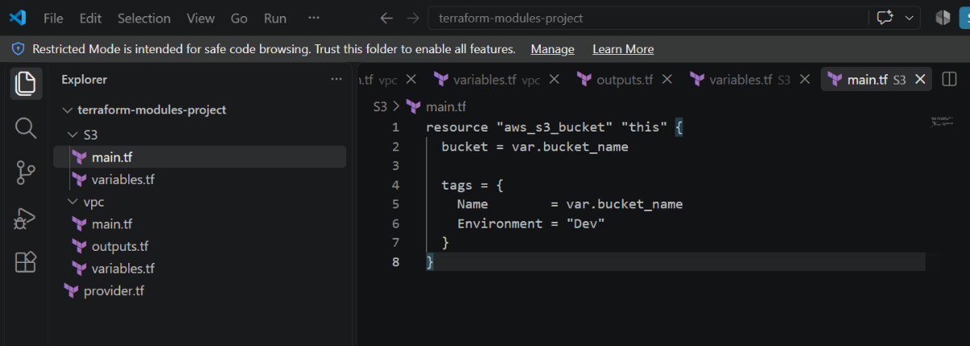

Create:
modules/s3/outputs.tf
output "bucket_name" {
description = "S3 bucket name"
value = aws_s3_bucket.this.bucket
}

output "bucket_arn" {
description = "S3 bucket ARN"
value = aws_s3_bucket.this.arn
}
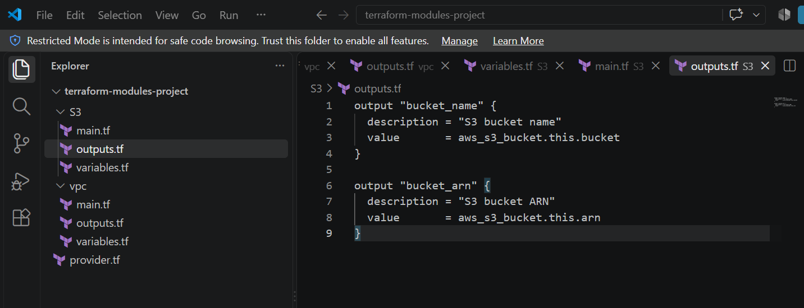

Step 5 — EC2 Module
modules/ec2/variables.tf

variable "ami_id" {
description = "AMI ID"
type = string
}

variable "instance_type" {
description = "EC2 instance type"
type = string
}

variable "subnet_id" {
description = "Subnet ID where EC2 will be created"
type = string
}

variable "instance_name" {
description = "EC2 instance name"
type = string
}
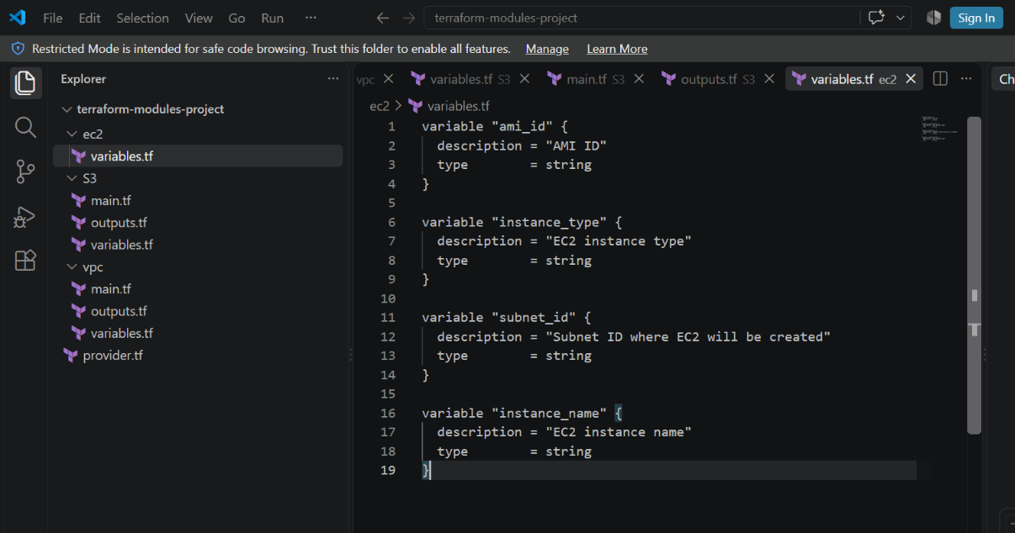

modules/ec2/main.tf

resource "aws_security_group" "this" {
name = "${var.instance_name}-sg"
description = "Security group for EC2"
vpc_id = data.aws_vpc.selected.id

ingress {
description = "SSH"
from_port = 22
to_port = 22
protocol = "tcp"
cidr_blocks = ["0.0.0.0/0"]
}

egress {
from_port = 0
to_port = 0
protocol = "-1"
cidr_blocks = ["0.0.0.0/0"]
}

tags = {
Name = "${var.instance_name}-SG"
}
}

data "aws_vpc" "selected" {
id = data.aws_subnet.selected.vpc_id
}

data "aws_subnet" "selected" {
id = var.subnet_id
}

resource "aws_instance" "this" {
ami = var.ami_id
instance_type = var.instance_type
subnet_id = var.subnet_id
vpc_security_group_ids = [aws_security_group.this.id]

tags = {
Name = var.instance_name
}
}
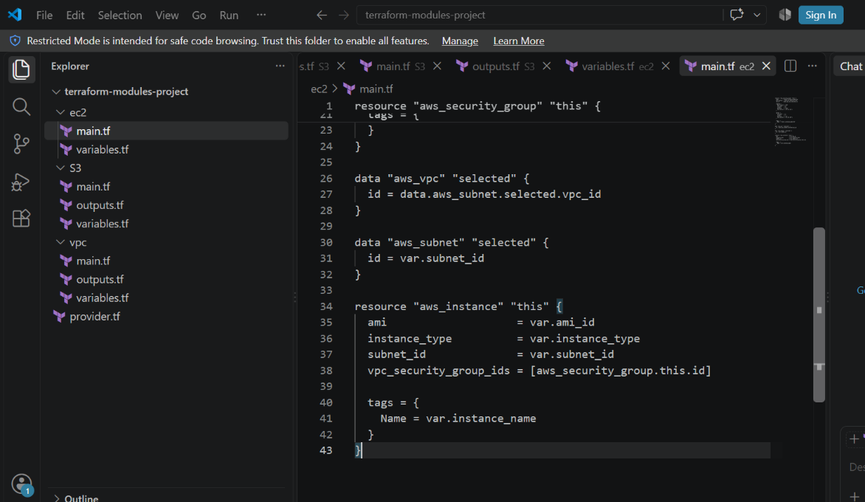

modules/ec2/outputs.tf
output "instance_id" {
description = "EC2 instance ID"
value = aws_instance.this.id
}

output "public_ip" {
description = "EC2 public IP"
value = aws_instance.this.public_ip
}

output "security_group_id" {
description = "Security group ID"
value = aws_security_group.this.id
}
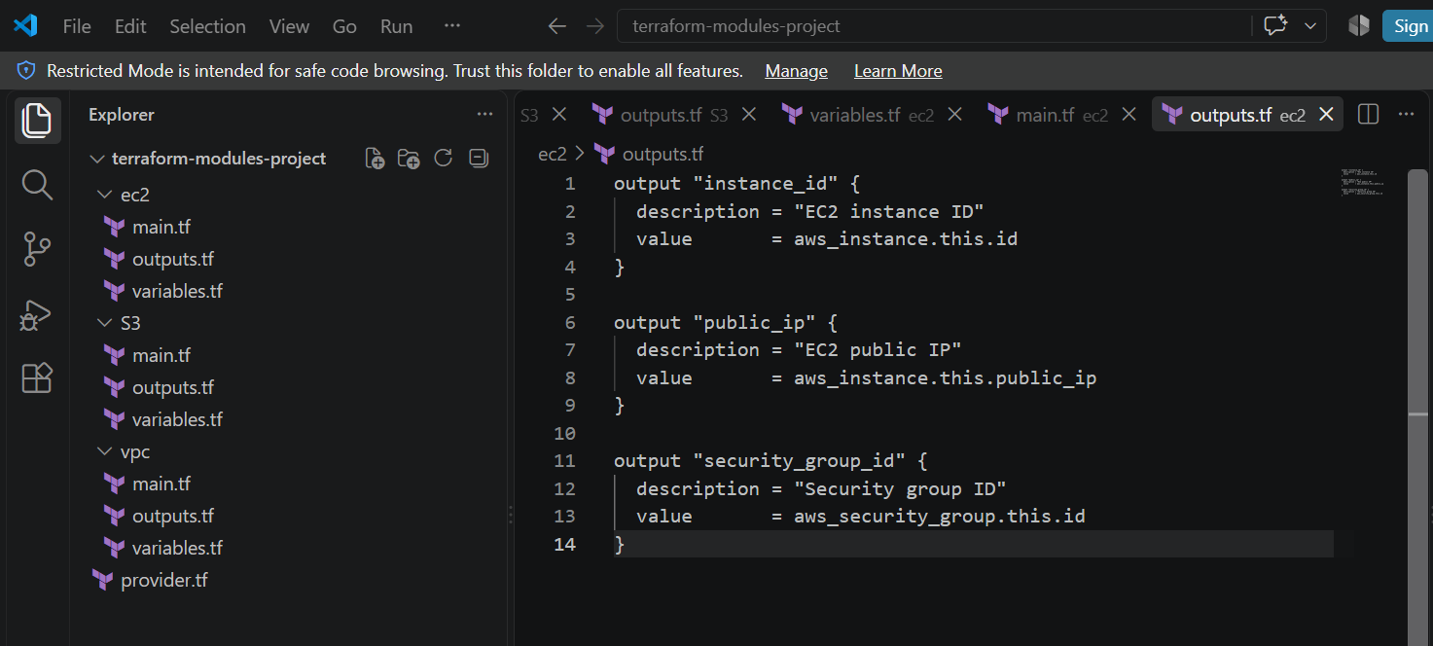

Step 6 — Root variables.tf
Create:
terraform-modules-project/variables.tf
variable "vpc_cidr" {
description = "VPC CIDR"
type = string
}

variable "subnet_cidr" {
description = "Subnet CIDR"
type = string
}

variable "availability_zone" {
description = "Availability Zone"
type = string
}

variable "bucket_name" {
description = "S3 bucket name"
type = string
}

variable "ami_id" {
description = "AMI ID"
type = string
}

variable "instance_type" {
description = "EC2 instance type"
type = string
}

variable "instance_name" {
description = "EC2 instance name"
type = string
}
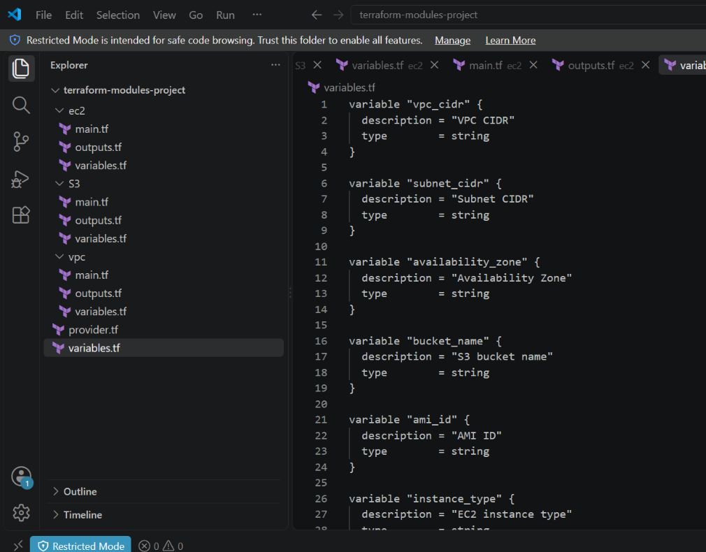

Step 7 — terraform.tfvars
Create:
terraform-modules-project/terraform.tfvars
Use:
vpc_cidr = "10.0.0.0/16"
subnet_cidr = "10.0.1.0/24"
availability_zone = "us-east-1a"

bucket_name = "CHANGE-THIS-TO-A-UNIQUE-NAME"

ami_id = "YOUR_AMI_ID"
instance_type = "t3.micro"
instance_name = "Terraform-Module-EC2"

Change these two values:
CHANGE-THIS-TO-A-UNIQUE-NAME
and:
YOUR_AMI_ID
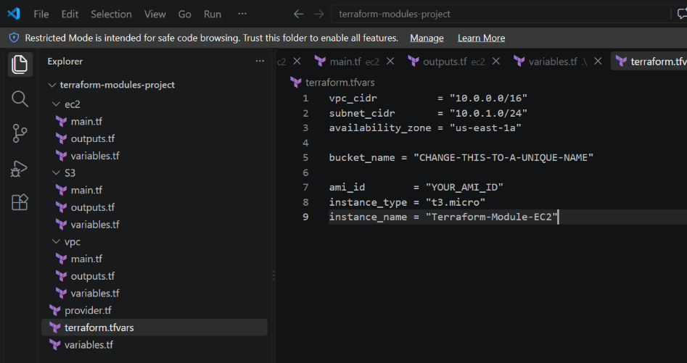

Step 8 — Root main.tf
This is the important file because it calls all three modules.
Create:
terraform-modules-project/main.tf
module "vpc" {
source = "./modules/vpc"

vpc_cidr = var.vpc_cidr
subnet_cidr = var.subnet_cidr
availability_zone = var.availability_zone
}

module "s3" {
source = "./modules/s3"

bucket_name = var.bucket_name
}

module "ec2" {
source = "./modules/ec2"

ami_id = var.ami_id
instance_type = var.instance_type
subnet_id = module.vpc.subnet_id
instance_name = var.instance_name
}
⭐ Important line
subnet_id = module.vpc.subnet_id
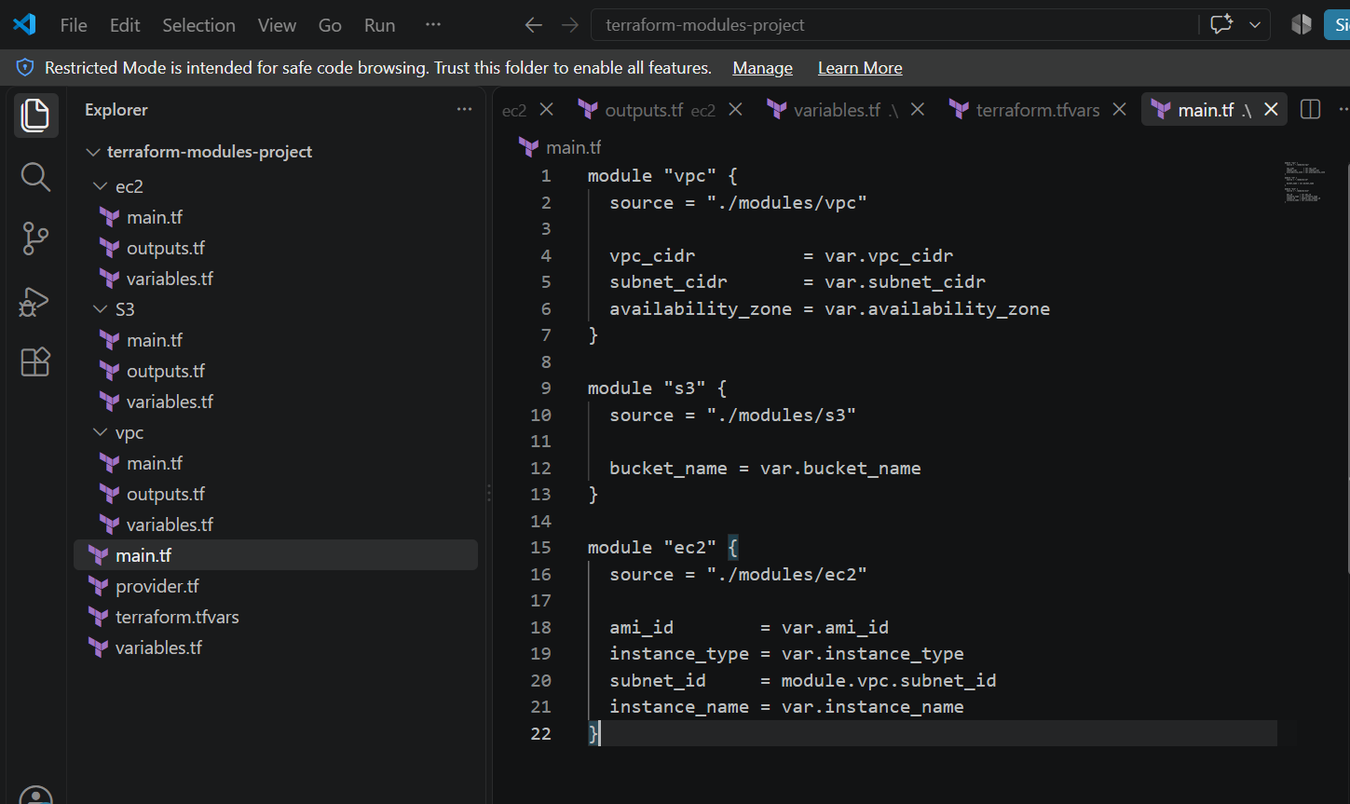

Step 9 — Root outputs.tf
Create:
outputs.tf
output "vpc_id" {
description = "VPC ID"
value = module.vpc.vpc_id
}

output "subnet_id" {
description = "Subnet ID"
value = module.vpc.subnet_id
}

output "bucket_name" {
description = "S3 bucket name"
value = module.s3.bucket_name
}

output "bucket_arn" {
description = "S3 bucket ARN"
value = module.s3.bucket_arn
}

output "instance_id" {
description = "EC2 instance ID"
value = module.ec2.instance_id
}

output "public_ip" {
description = "EC2 public IP"
value = module.ec2.public_ip
}
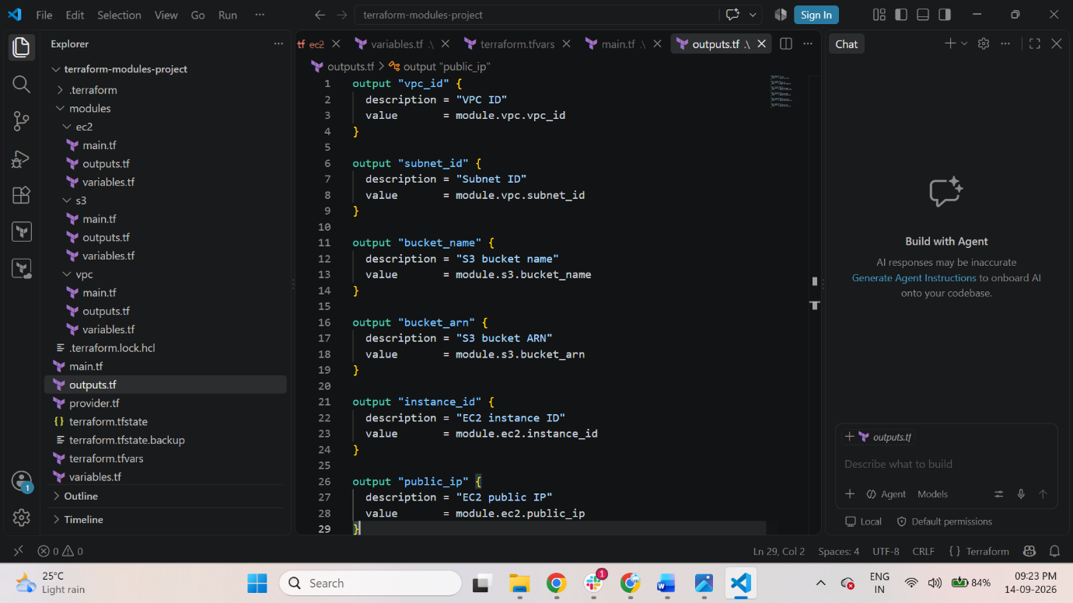

Step 11 — Run Terraform
From the project root:
cd C:\Terraform\terraform-modules-project
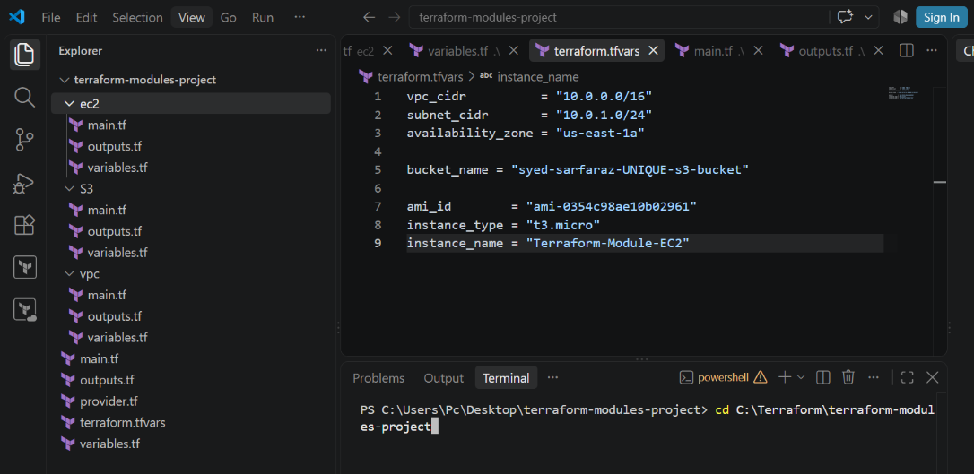
Check:
$ Dir
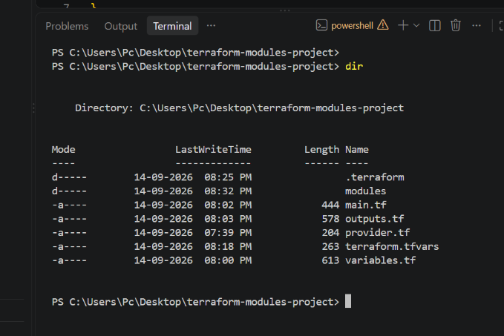
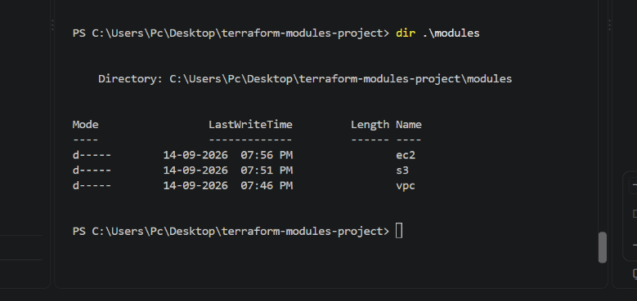

Then:
$ terraform init
The assignment expects Terraform to initialize the modules.
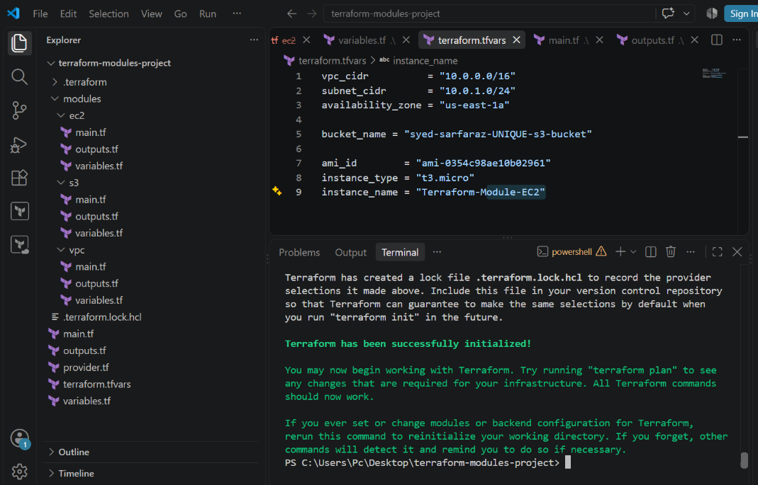

Then:
$ terraform validate
Expected:
Success! The configuration is valid.
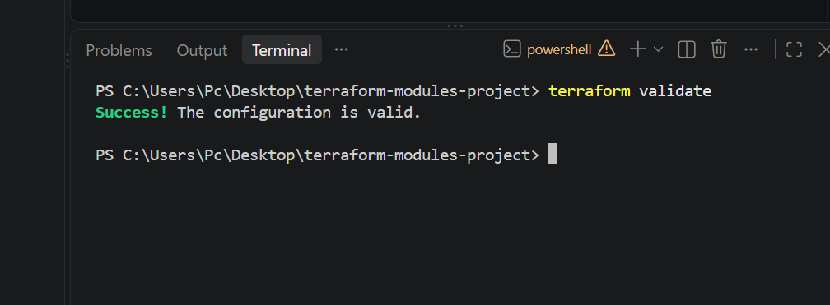

Then:
$ terraform fmt -recursive
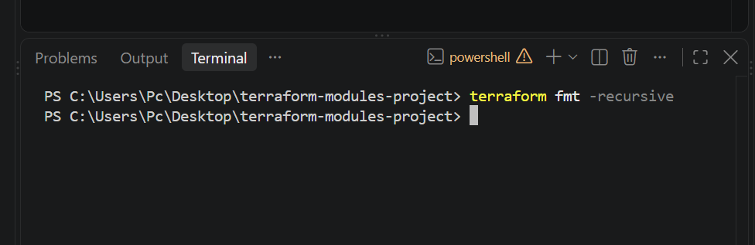

Then:
$ terraform plan
The assignment expects the plan to contain:

VPC
Subnet
Security Group
EC2
S3 Bucket
and approximately 5 resources to add.
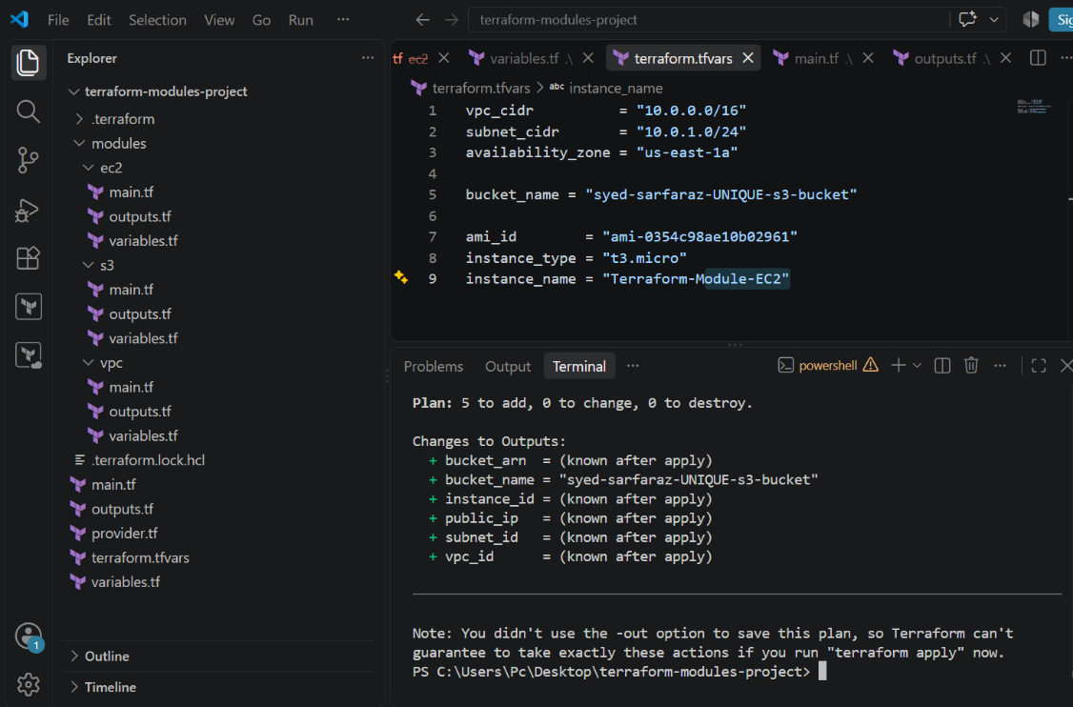

Step 12 — Apply
Only when terraform plan is successful:
$ terraform apply
Enter:
Yes
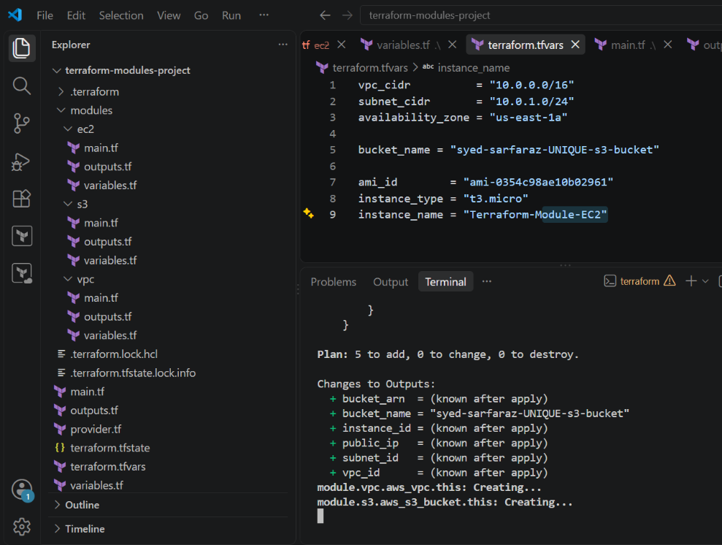
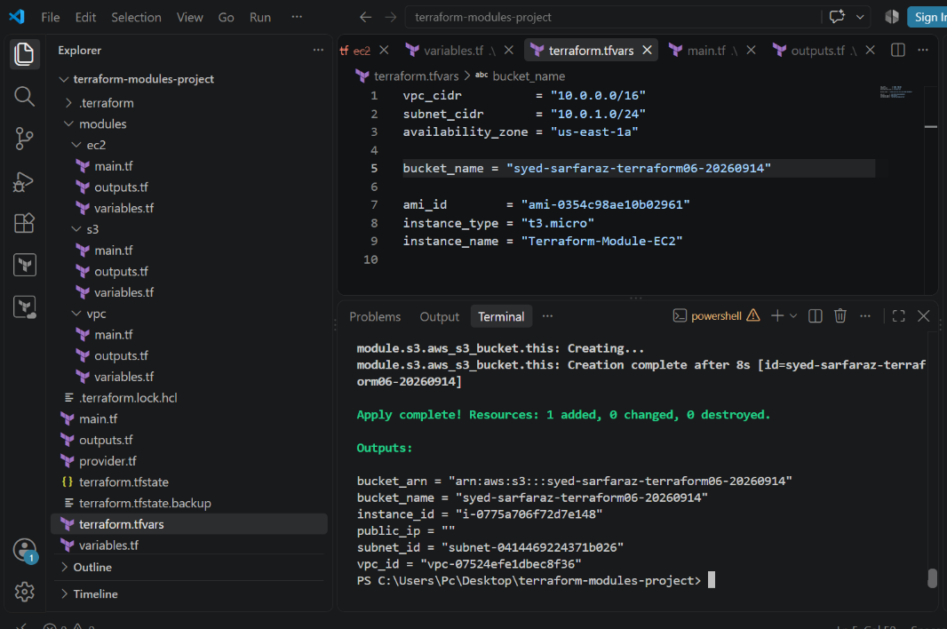
The expected architecture is:
AWS
│
├── VPC
│ └── Subnet
│ └── Security Group
│ └── EC2
│
└── S3 Bucket
This is the architecture specified in the assignment.

Step 13 — Verify
Run:
$ terraform output
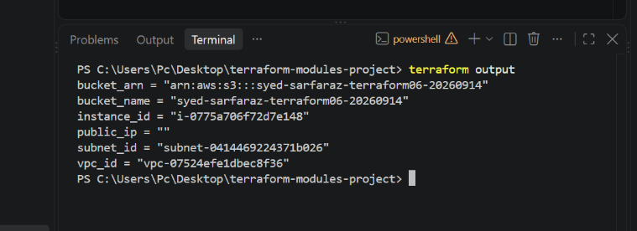

Then:
$ terraform state list

You should see resources similar to:
module.vpc.aws_vpc.this
module.vpc.aws_subnet.this
module.s3.aws_s3_bucket.this
module.ec2.aws_security_group.this
module.ec2.aws_instance.this
Then verify in AWS:
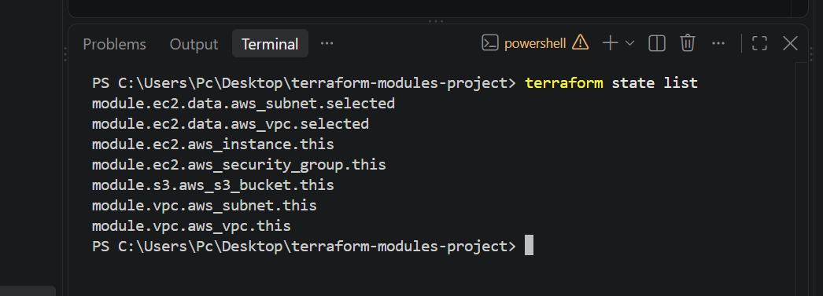

VPC → Your VPCs
Look for:
Terraform-VPC
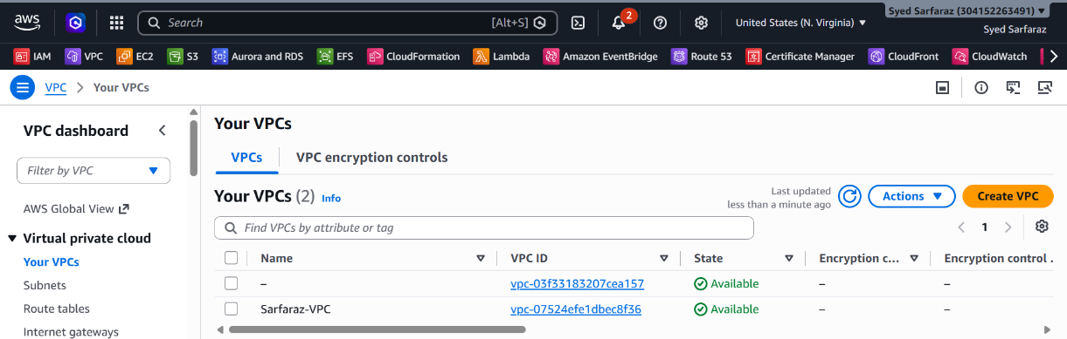

VPC → Subnets
Look for:
Terraform-Subnet
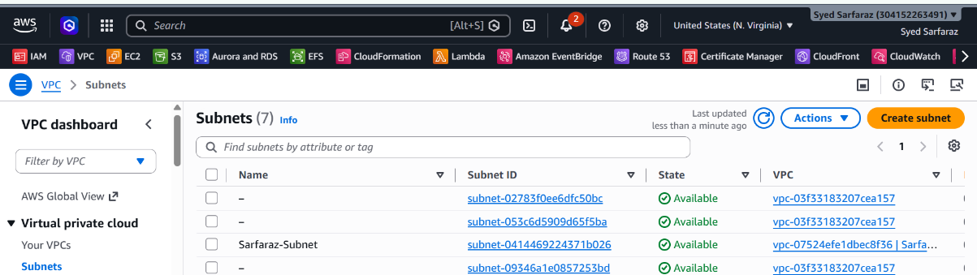

EC2 → Instances
Look for:
Terraform-Module-EC2
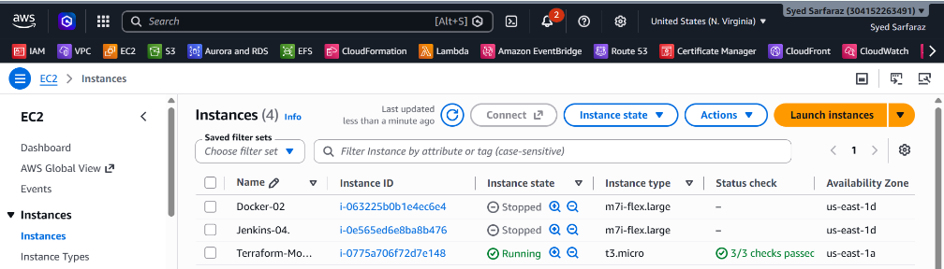
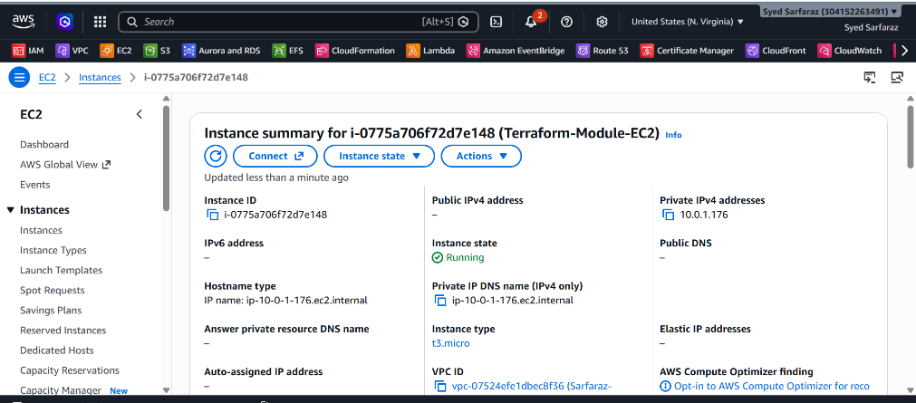

S3 → Buckets
Look for your bucket.
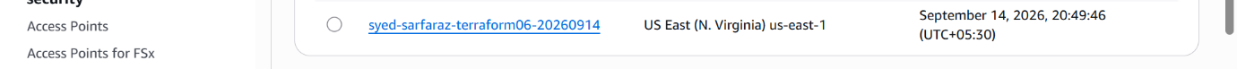

That's all for Task 3
Your workflow is simply:
1. Create project
↓
2. Create VPC module
↓
3. Create S3 module
↓
4. Create EC2 module
↓
5. Call all modules from root main.tf
↓
6. terraform init
↓
7. terraform validate
↓
8. terraform fmt -recursive
↓
9. terraform plan
↓
10. terraform apply
↓
11. Verify AWS

4). Provision EC2 for 3 different environments (Dev, Staging, and Prod) using Terraform workspaces.

Task 4 — EC2 for Dev, Staging & Prod Using Terraform Workspaces

Step 1 — Create a NEW project
In VS Code create:
terraform-workspace-ec2/
├── provider.tf
├── variables.tf
├── main.tf
├── outputs.tf
└── terraform.tfvars
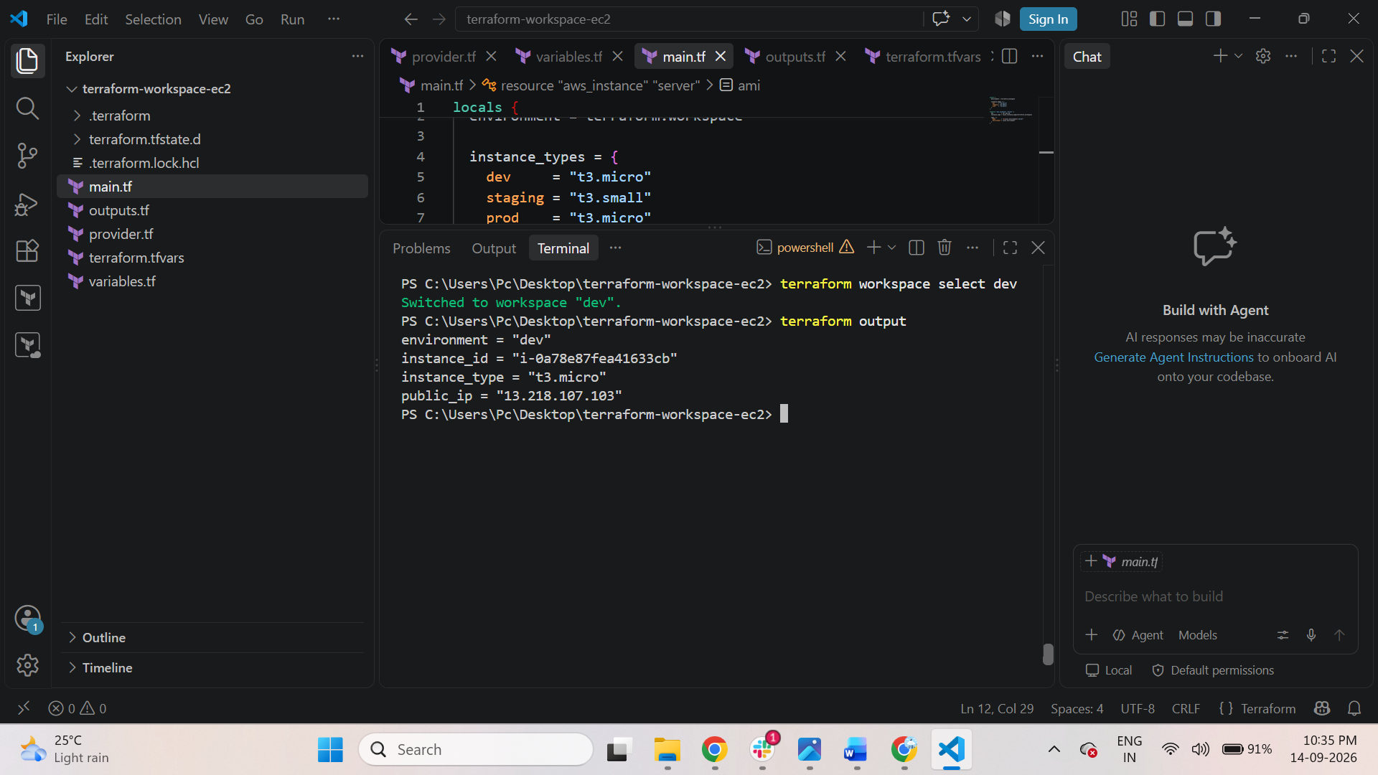

Step 2 — provider.tf
terraform {
required_providers {
aws = {
source = "hashicorp/aws"
version = "~> 6.0"
}
}
}

provider "aws" {
region = "us-east-1"
}
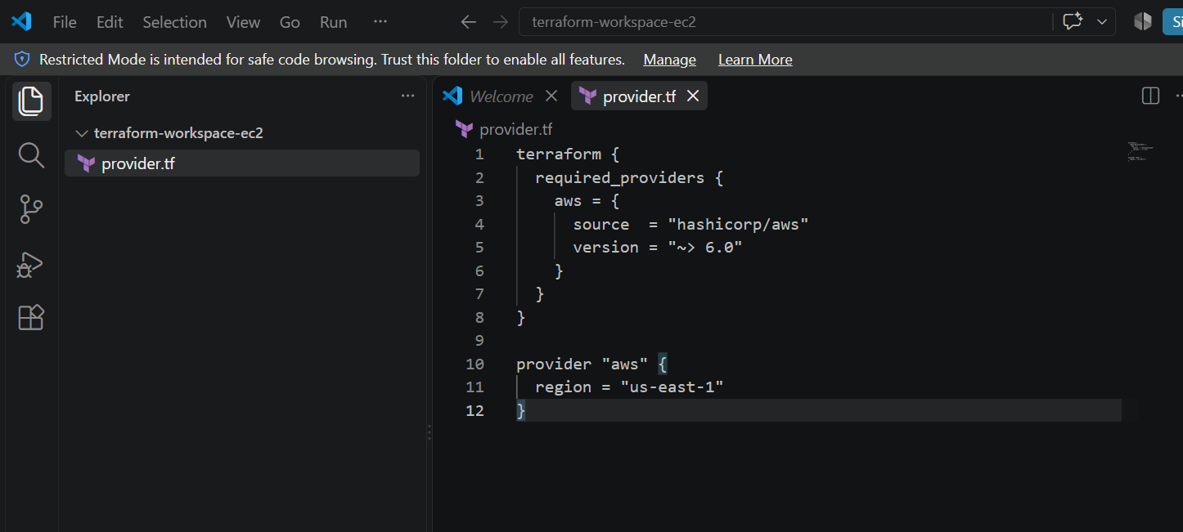

Step 3 — variables.tf
variable "ami_id" {
description = "AMI ID for EC2"
type = string
}
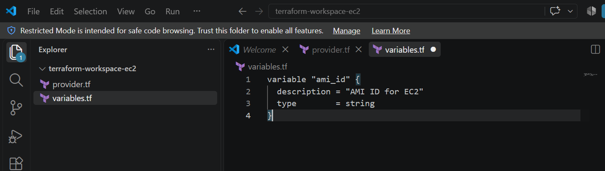

Step 4 — main.tf
Use the better workspace approach from the PDF:
locals {
environment = terraform.workspace

instance_types = {
dev = "t3.micro"
staging = "t3.small"
prod = "t3.medium"
}
}

resource "aws_instance" "server" {
ami = var.ami_id
instance_type = local.instance_types[terraform.workspace]

tags = {
Name = "${local.environment}-server"
Environment = local.environment
}
}
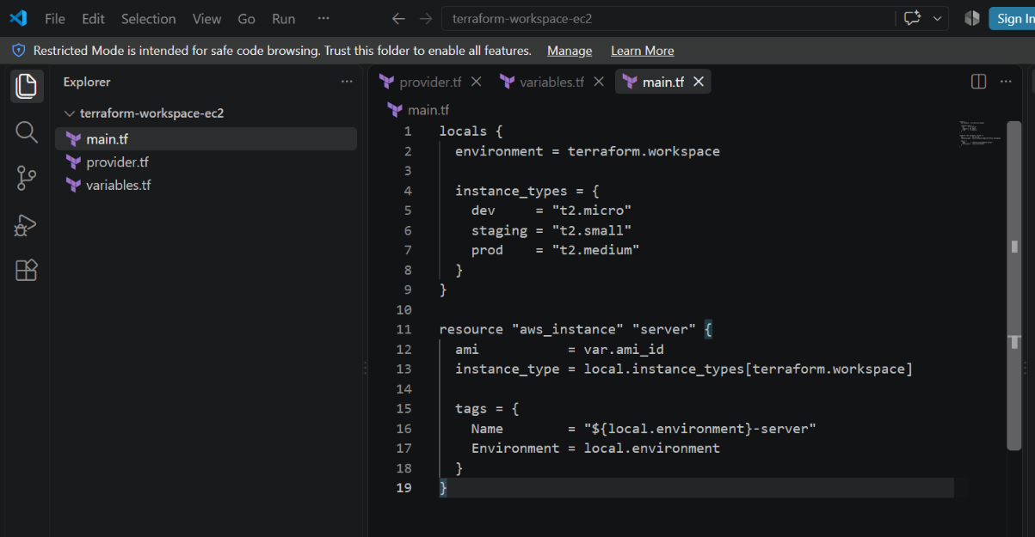

Step 5 — outputs.tf
output "instance_id" {
value = aws_instance.server.id
}

output "public_ip" {
value = aws_instance.server.public_ip
}

output "environment" {
value = terraform.workspace
}

output "instance_type" {
value = aws_instance.server.instance_type
}
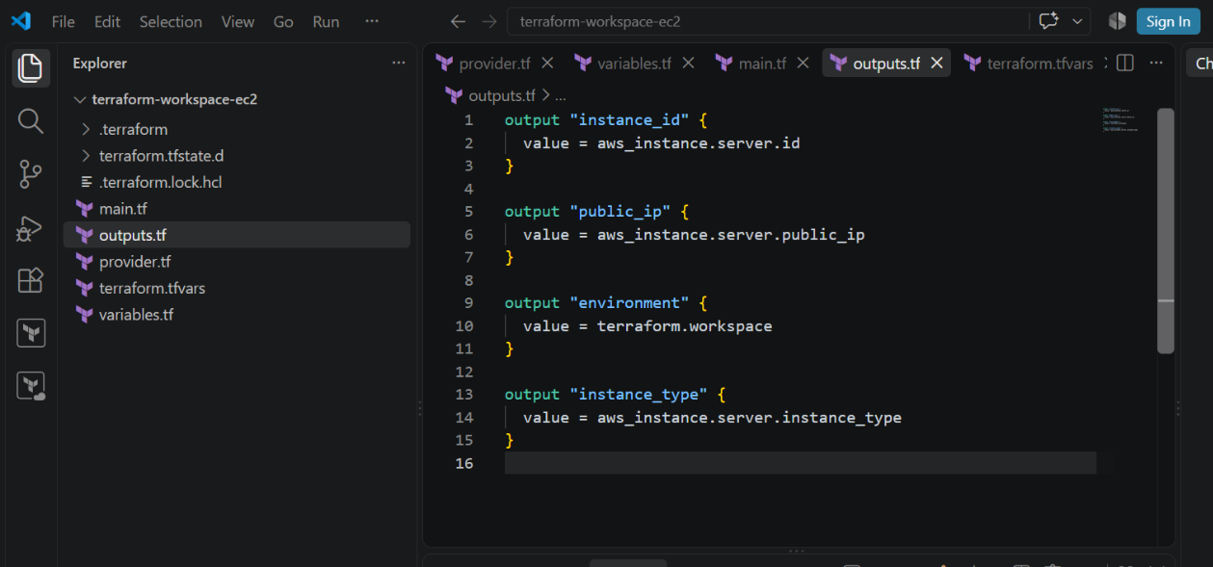

Step 6 — terraform.tfvars
Create:
terraform.tfvars
Put:
ami_id = "YOUR_AMI_ID"
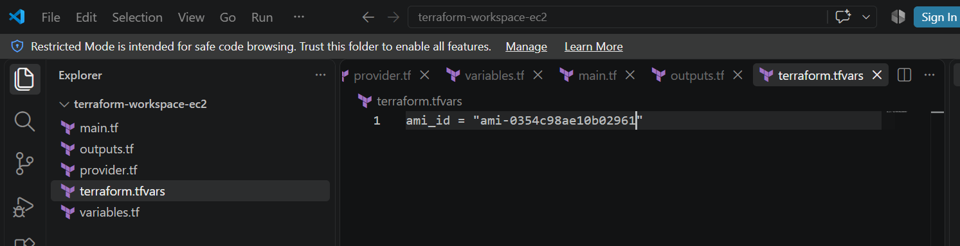

Step 7 — Initialize
Open the VS Code terminal in the project folder:
$ cd C:\Users\Pc\Desktop\terraform-workspace-ec2
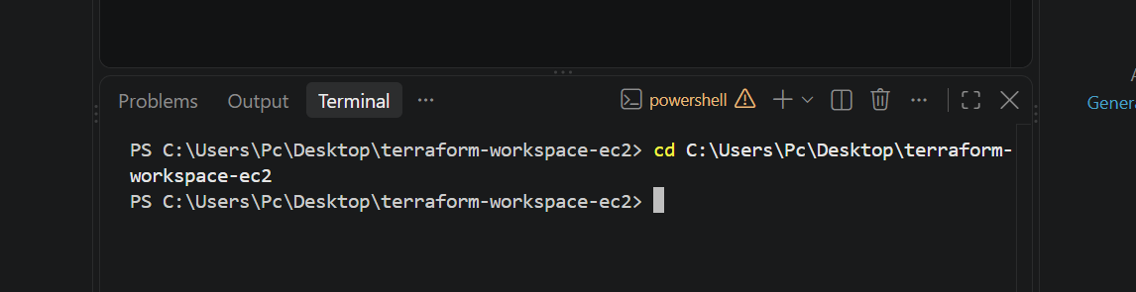
Run:
$ terraform init
Expected:
Terraform has been successfully initialized!
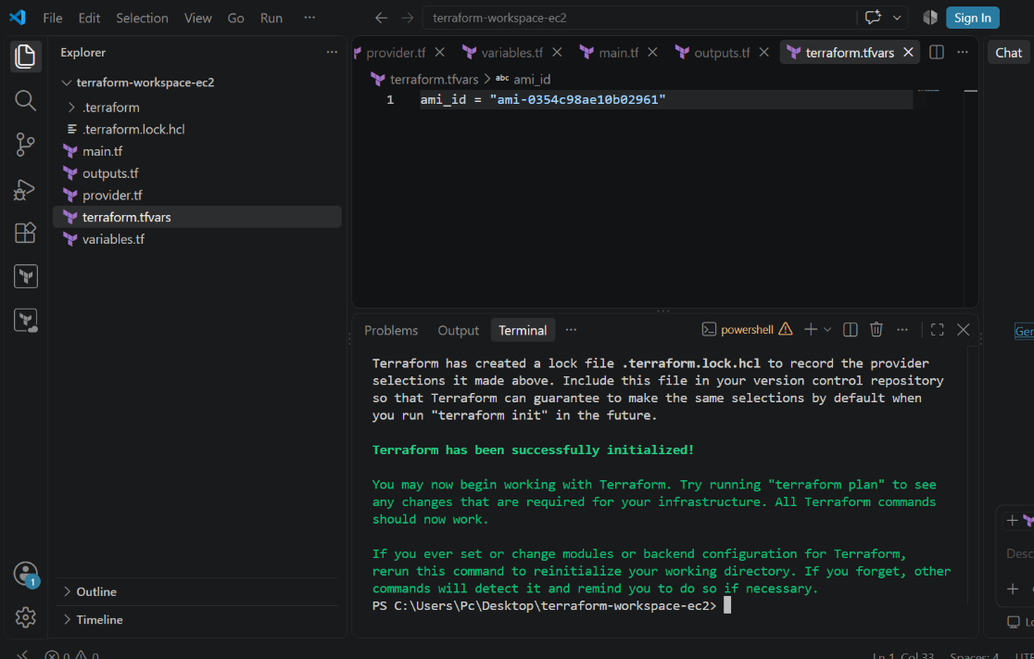

Step 8 — Create the 3 Workspaces
First:
$ terraform workspace list
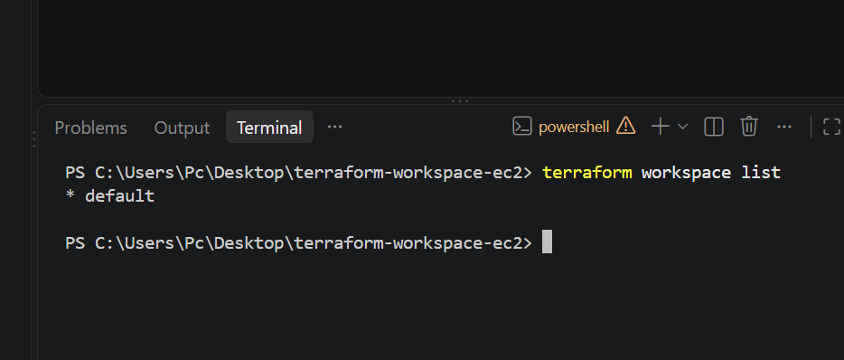

Then:
$ terraform workspace new dev
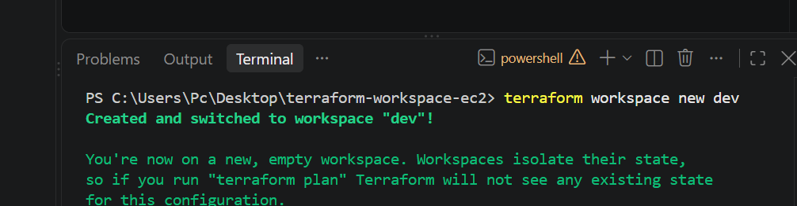

$ terraform workspace new staging
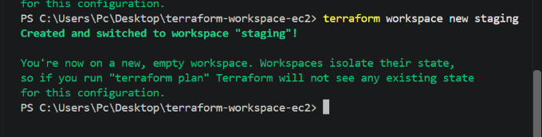

$ terraform workspace new prod
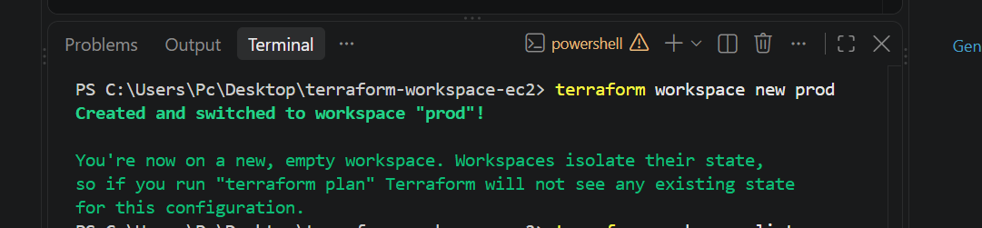

Finally:
$ terraform workspace list

Expected:
default
dev
staging
* prod
The * indicates the currently selected workspace.
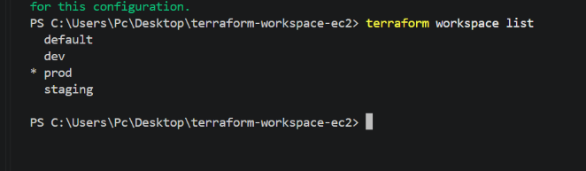

Step 9 — Deploy Dev
Select Dev:
$ terraform workspace select dev
Check:
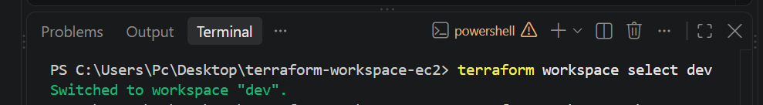
$ terraform workspace show
Expected:
Dev
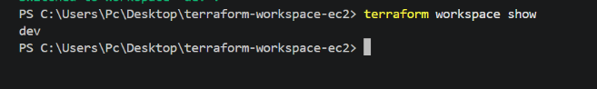

Now:
$ terraform workspace select Dev

$ terraform apply -var="ami_id=ami-0354c98ae10b02961"
Enter:
Yes

Dev gets:
Instance Type = t3.micro
Environment = dev
Name = dev-server
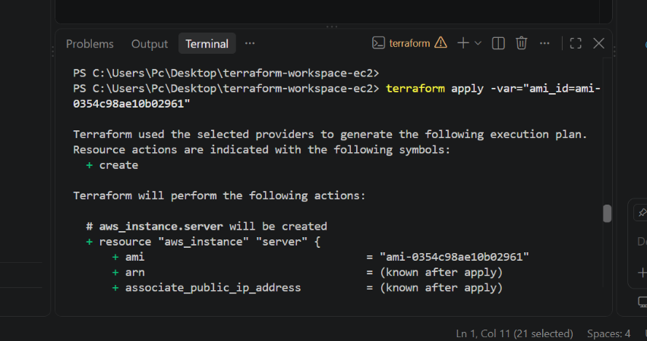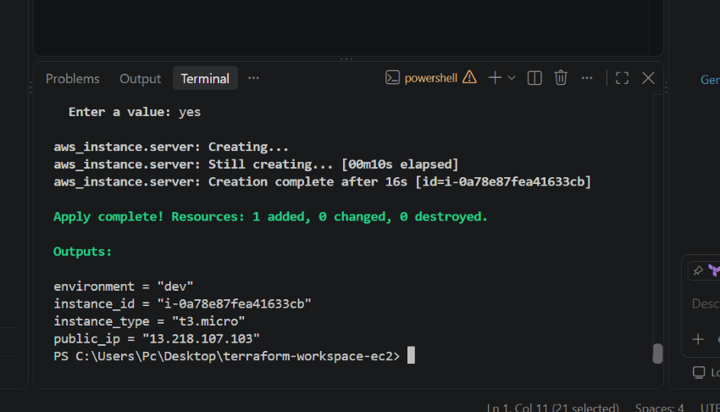

Step 10 — Deploy Staging
$ terraform workspace select staging

Then:
$ terraform apply -var="ami_id=ami-0354c98ae10b02961"

Enter:
yes
Staging gets:
Instance Type = t3.small
Environment = staging
Name = staging-server
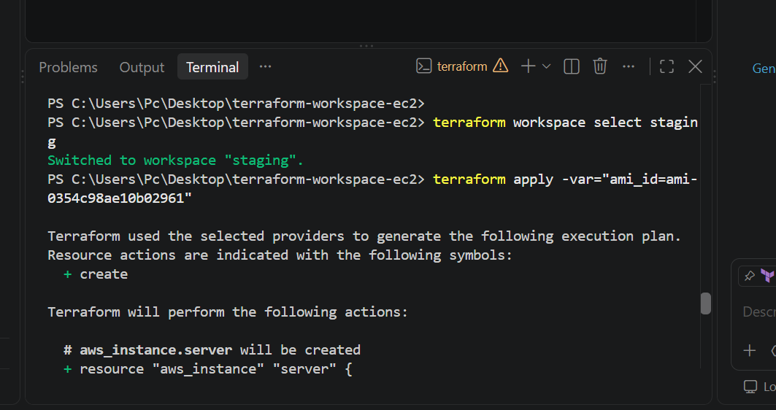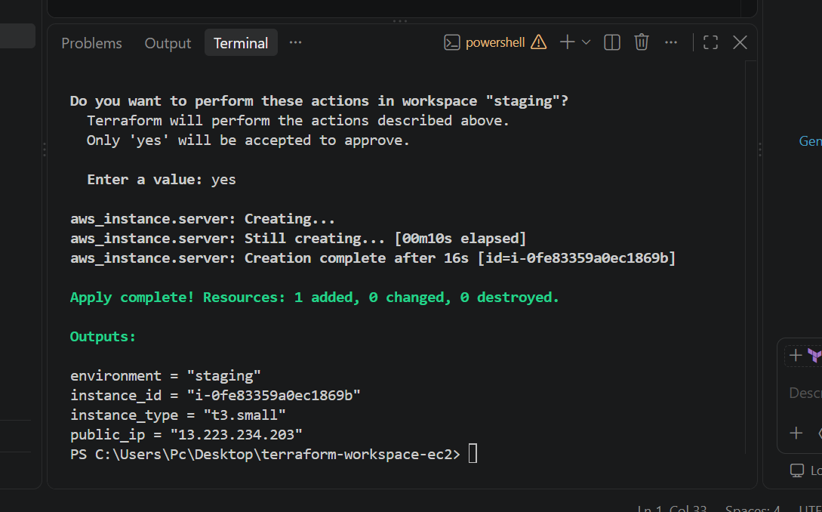

Step 11 — Deploy Prod
$ terraform workspace select prod

Then:
$ terraform apply -var="ami_id=ami-0354c98ae10b02961"

Enter:
yes
Prod gets:
Instance Type = t3.medium
Environment = prod
Name = prod-server
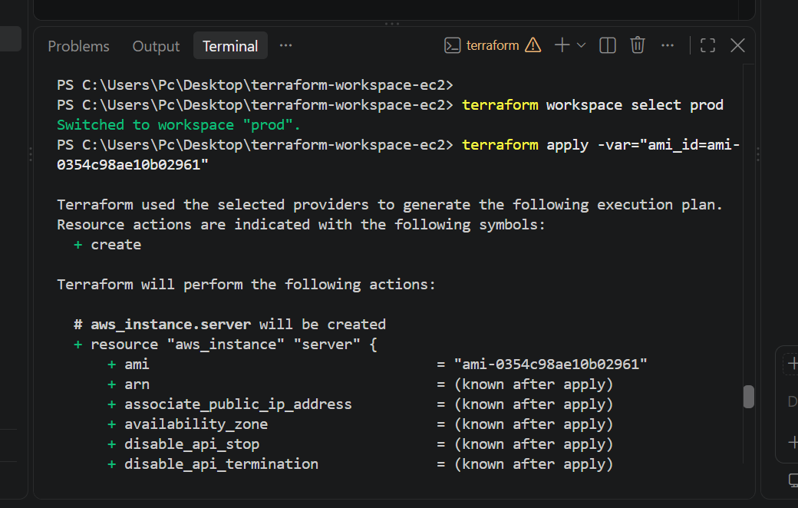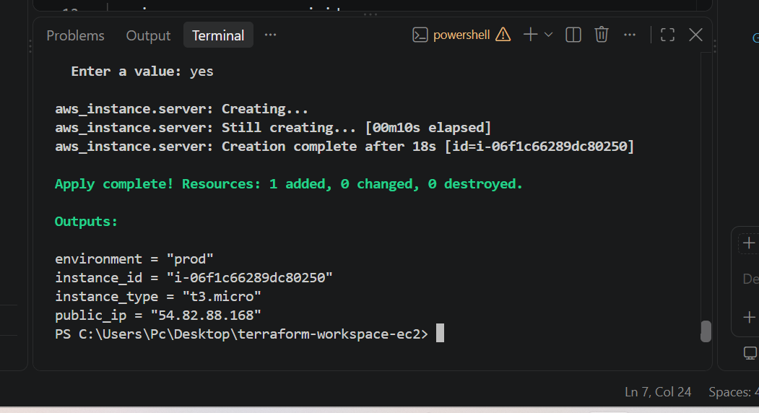

Step 12 — Verify
Run:
$ terraform workspace list

You should have:
default
dev
staging
* prod
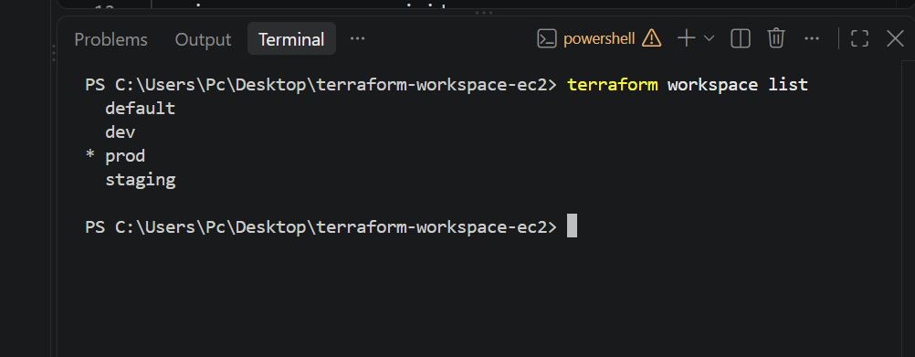

Then check each workspace:
$ terraform workspace select dev
$ terraform output

$ terraform workspace select staging
$ terraform output
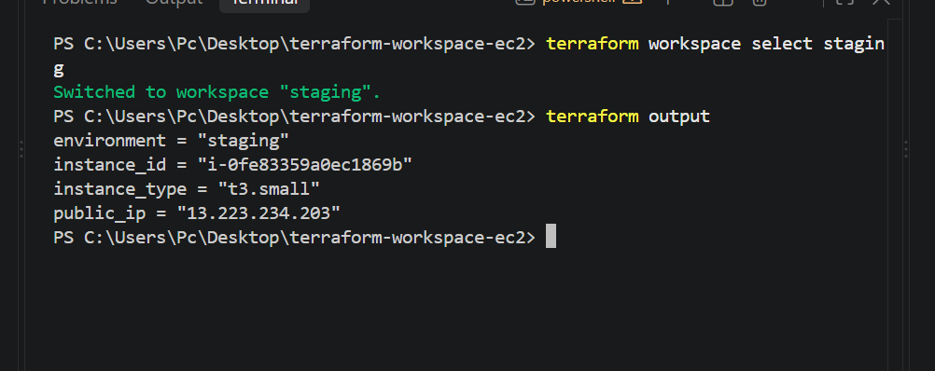

$ terraform workspace select prod
$ terraform output
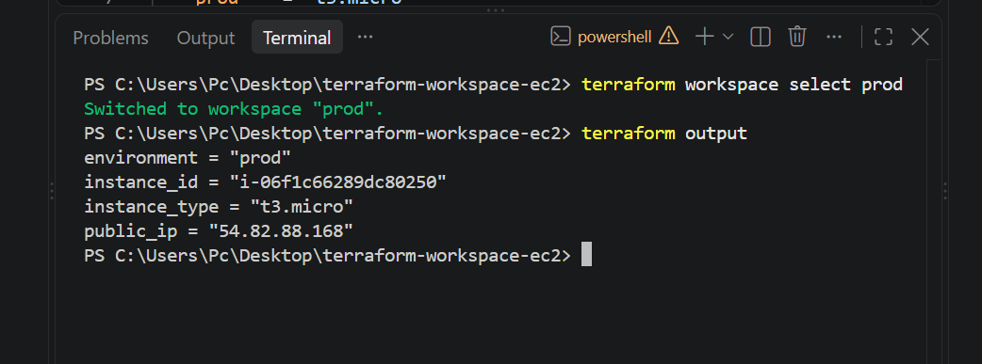

Final AWS Result
You should have:

Workspace | EC2 Name | Type
Dev | dev-server | T3.micro
Staging | staging-server | T3.small
Prod | prod-server | T3.micro
The key concept
Same Terraform code
↓
terraform.workspace
↓
┌──────┼────────┐
dev staging prod
↓ ↓ ↓
T3.micro t3.small t3.medium

