TERRAFORM TASK-01

Title
Implementation of Terraform Infrastructure Automation Using GitHub and Jenkins CI/CD Pipeline
Objective
The objective of this task is to install and configure Terraform, write basic Terraform configurations, manage infrastructure state, and automate Terraform execution using a Jenkins CI/CD pipeline integrated with a GitHub repository. The goal is to demonstrate Infrastructure as Code (IaC) practices along with continuous integration and automated deployment using Jenkins.
Prerequisites
- Windows system with internet access
- Visual Studio Code installed
- Terraform installed on local machine
- GitHub account
- Jenkins server running on Linux (EC2 instance)
- Git installed on Jenkins server
- Terraform installed on Jenkins server

- Install Terraform on your PC
- Open a web browser.
- Go to the official Terraform website: developer.hashicorp.com/terraform/install.
- This page contains Terraform installation options for different operating systems
- From the left menu, select Windows.
- Under Binary download, choose AMD64 (for 64-bit Windows systems).
- Click on Download to download the Terraform ZIP file.
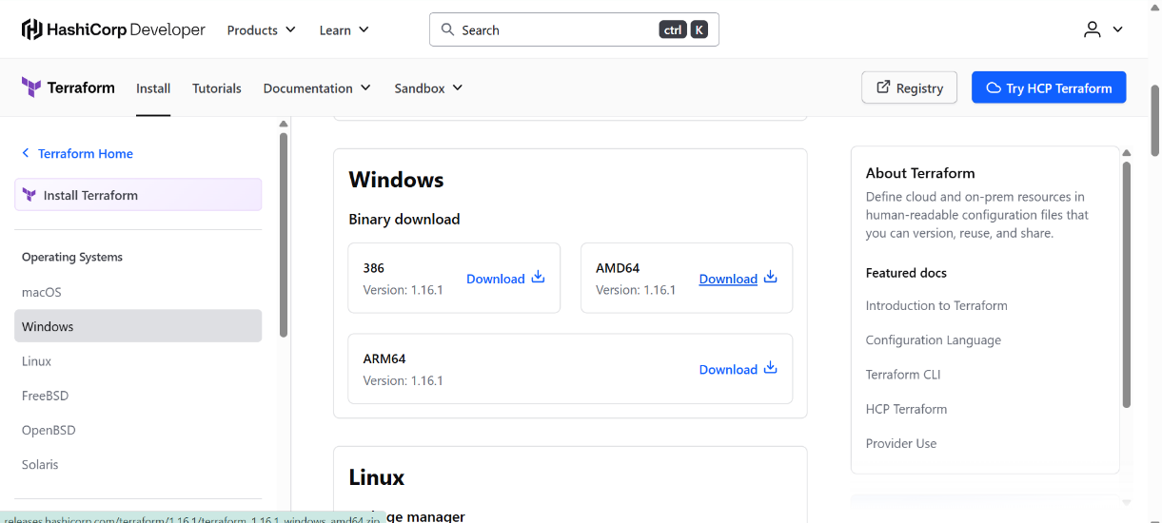
- Open File Explorer.
- Navigate to the Downloads folder.
- Locate the downloaded file: terraform_1.14.3_windows_amd64.zip.
- Right-click or select Extract All.
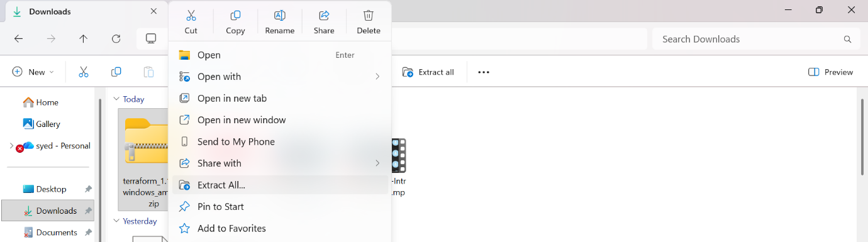

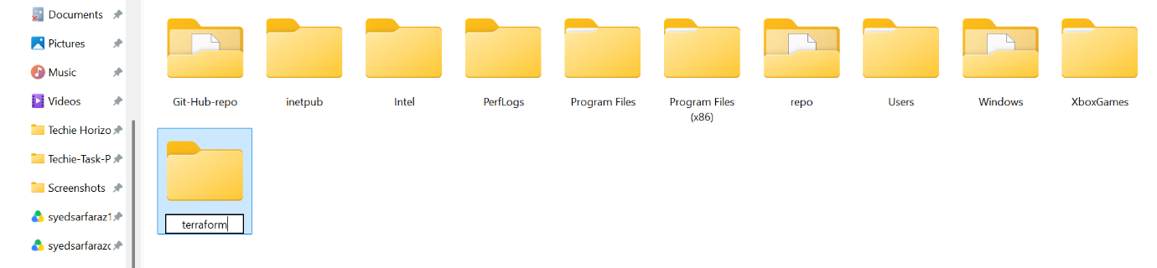
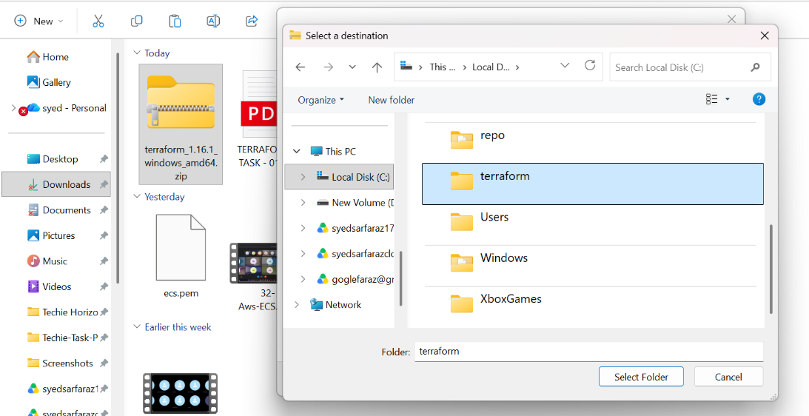
- The “Extract Compressed (Zipped) Folders” window opens.
- Click on Browse to choose a custom extraction location.
- Navigate to This PC → (C:).
- Select or create a folder named Terraform.
- Click Select Folder to confirm the destination.

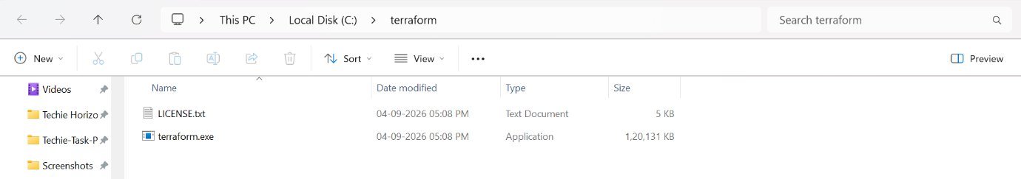
- Confirm that the destination path is C:\Terraform.
- Click on Extract.
- Terraform files are extracted to the selected folder.
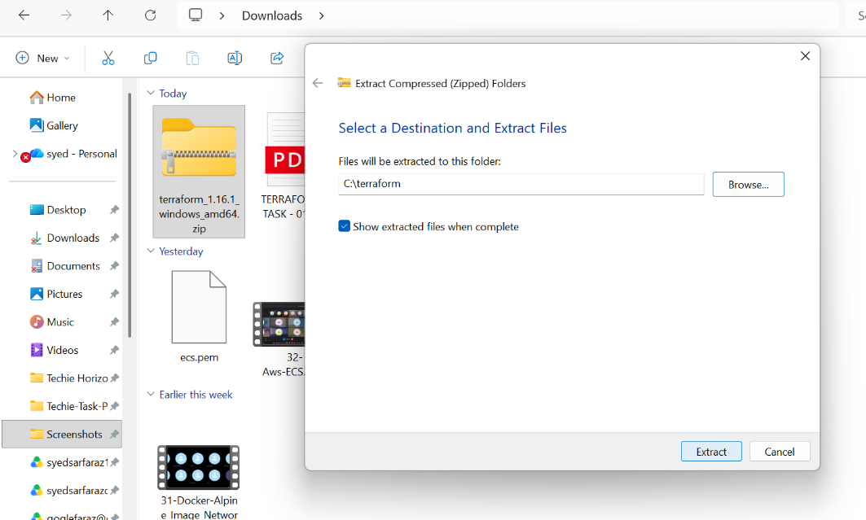

Click on the Start Menu.
Search for Edit the system environment variables.
Click Open to launch system properties.

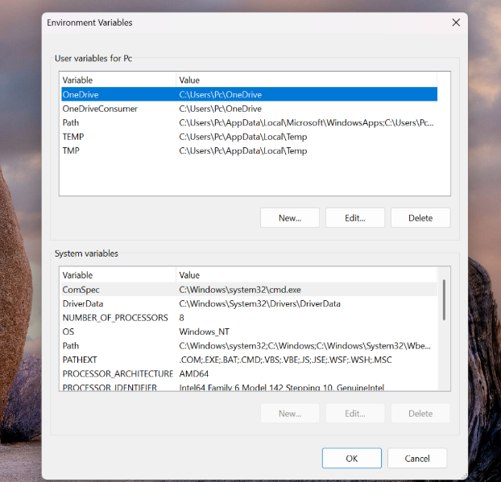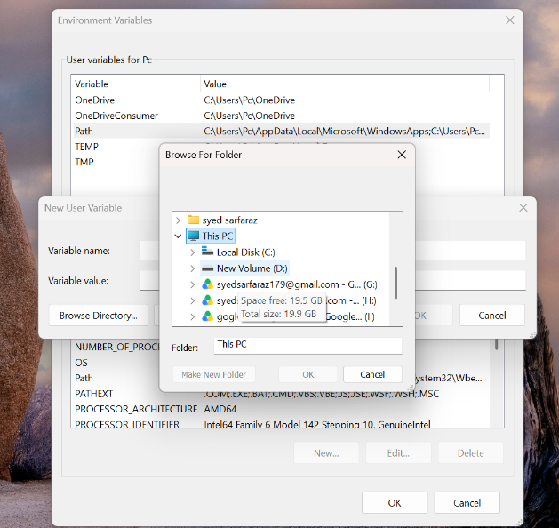

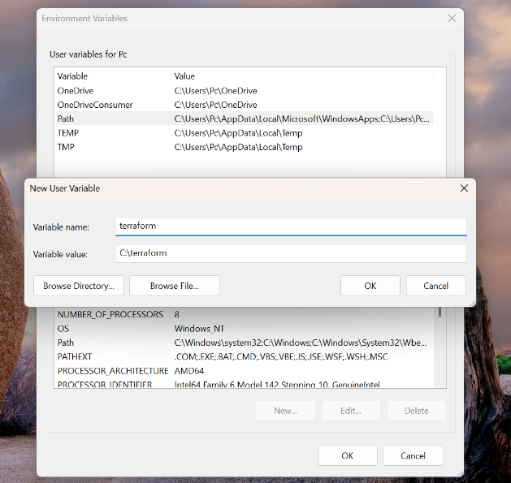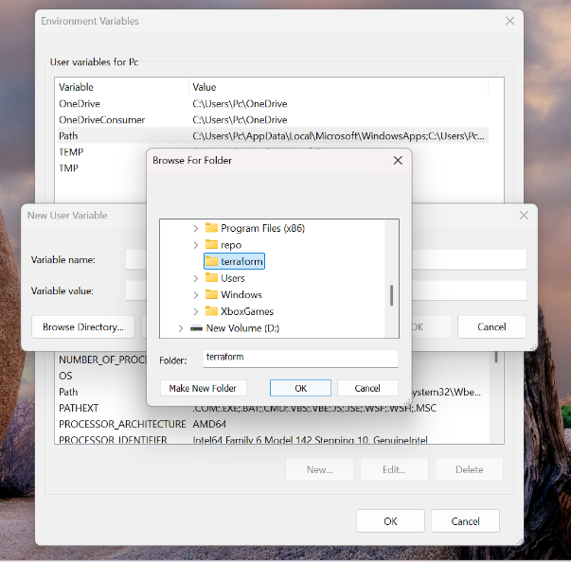
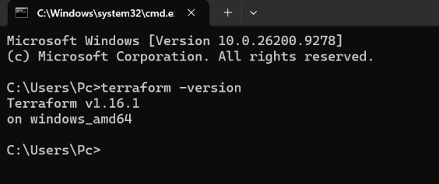
- Open Visual Studio Code.
- Go to the Extensions tab.
- Search for Terraform.
- Install HashiCorp Terraform extension (verified publisher).

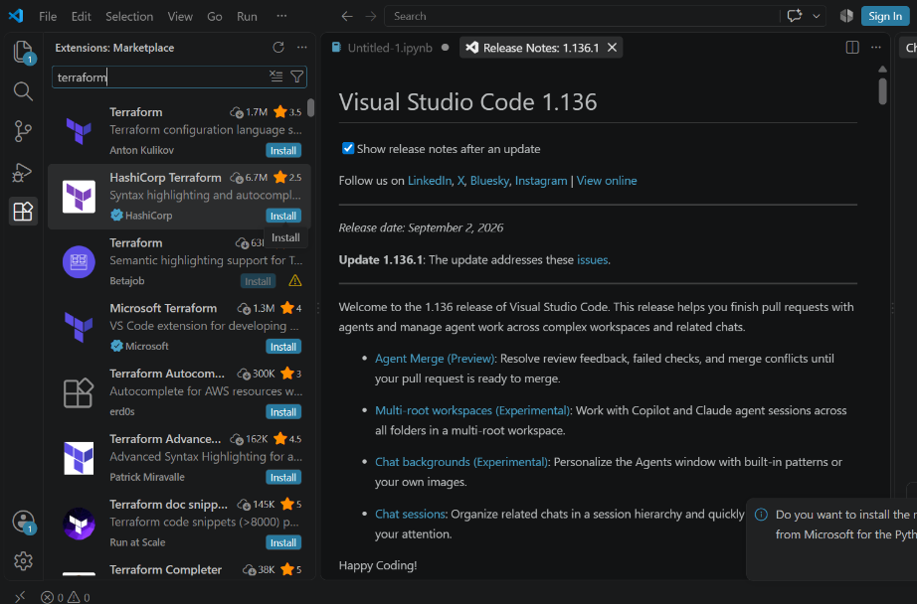
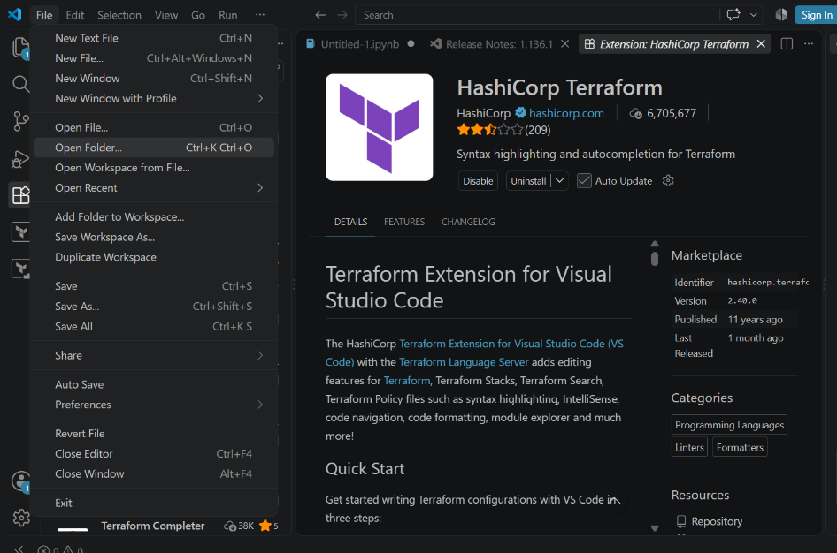
- In VS Code, go to Explorer.
- Click on Open Folder.
- Select the folder where you want to write Terraform code (example: Terraform Basic).

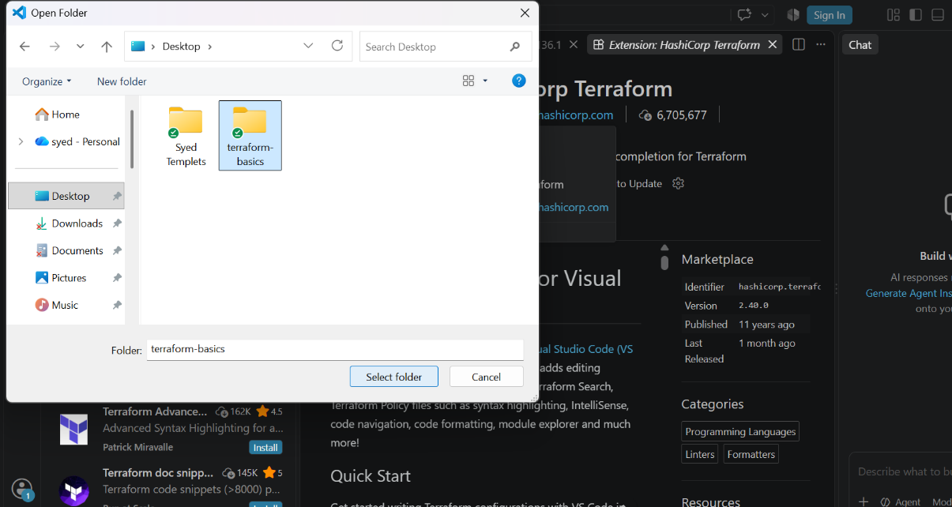

- Inside the opened folder, click New File.
- Create a file named main.tf.
- This file will be used to write Terraform configuration code.
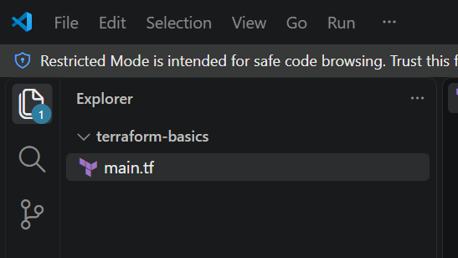
- Open main.tf in VS Code.
- Define a Terraform resource using the local_file provider.
- Specify the resource name and the filename.
- Save the file using Ctrl + S.

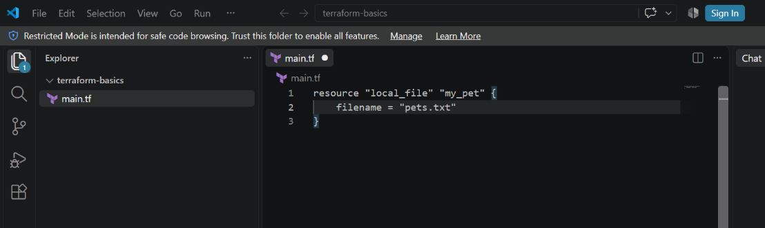
- Open the integrated terminal in VS Code.
- Navigate to the Terraform working directory.
- Run the command:
- terraform init
- Terraform downloads the required provider plugins.
- A .terraform.lock.hcl file is created.
- Initialization completes successfully.
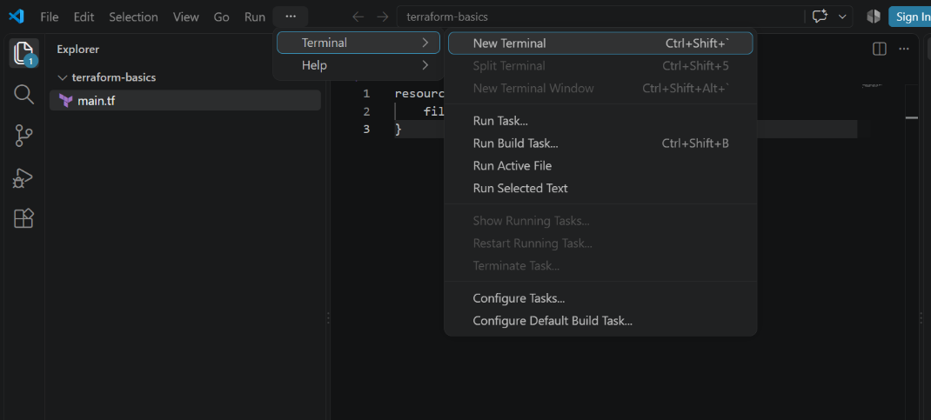

- Update main.tf to include file content.
- Run the command:
- terraform apply
- Terraform displays the execution plan.
- Type yes to approve the changes.
- Terraform creates the file and updates the state file.
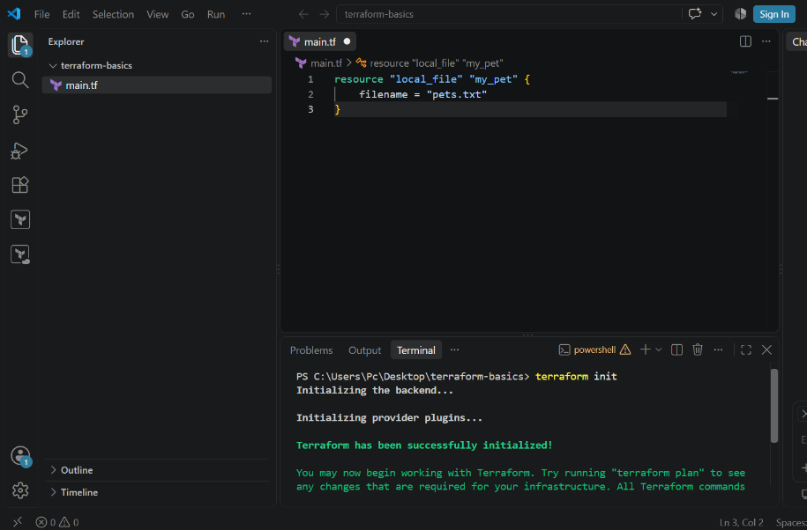
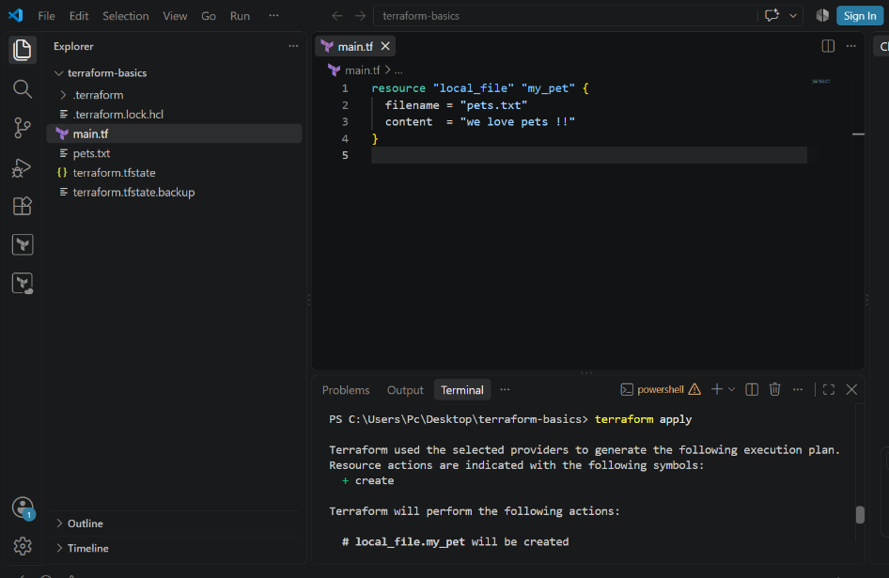
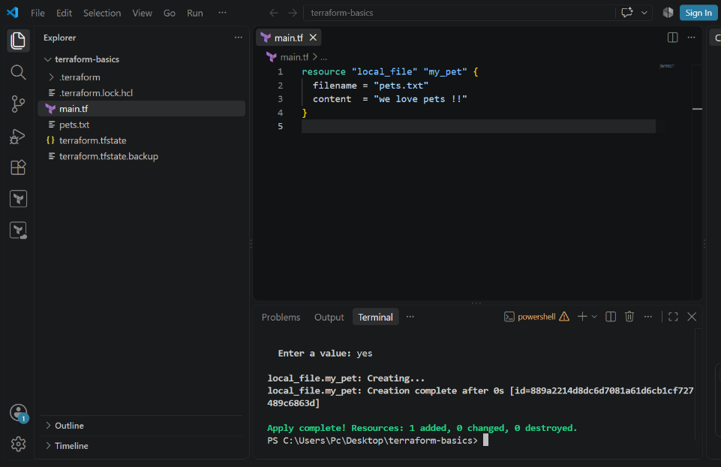

- Replace the local file resource with a random_pet resource.
- Define attributes such as prefix, separator, and length.
- Save the updated configuration file.
- Run:
- terraform apply
- Terraform throws an inconsistent dependency lock file error.
- Error occurs due to provider mismatch after configuration change
- Fix the issue by running:
- terraform init
- Terraform reinitializes backend and providers.
- Required providers are installed successfully.
- Dependency lock file is updated
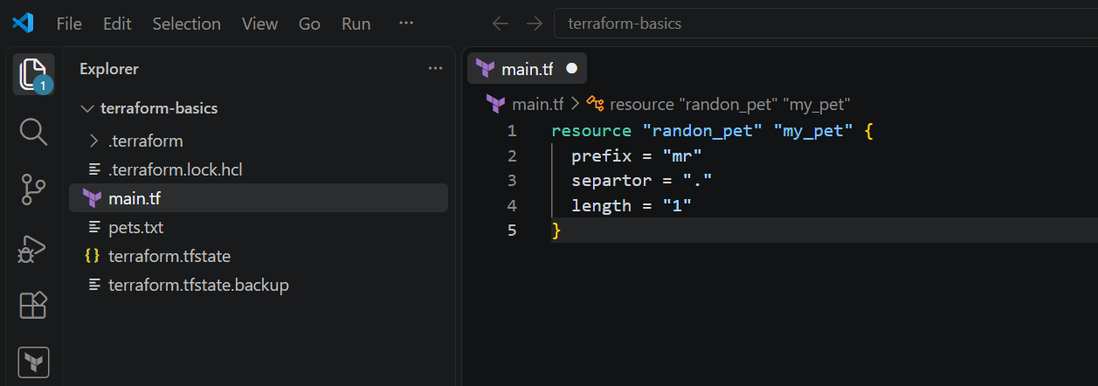
Run:
terraform apply
Terraform plans to destroy the old resource and create a new one.
Confirm by typing yes.
Local file resource is destroyed.
Random pet resource is created successfully
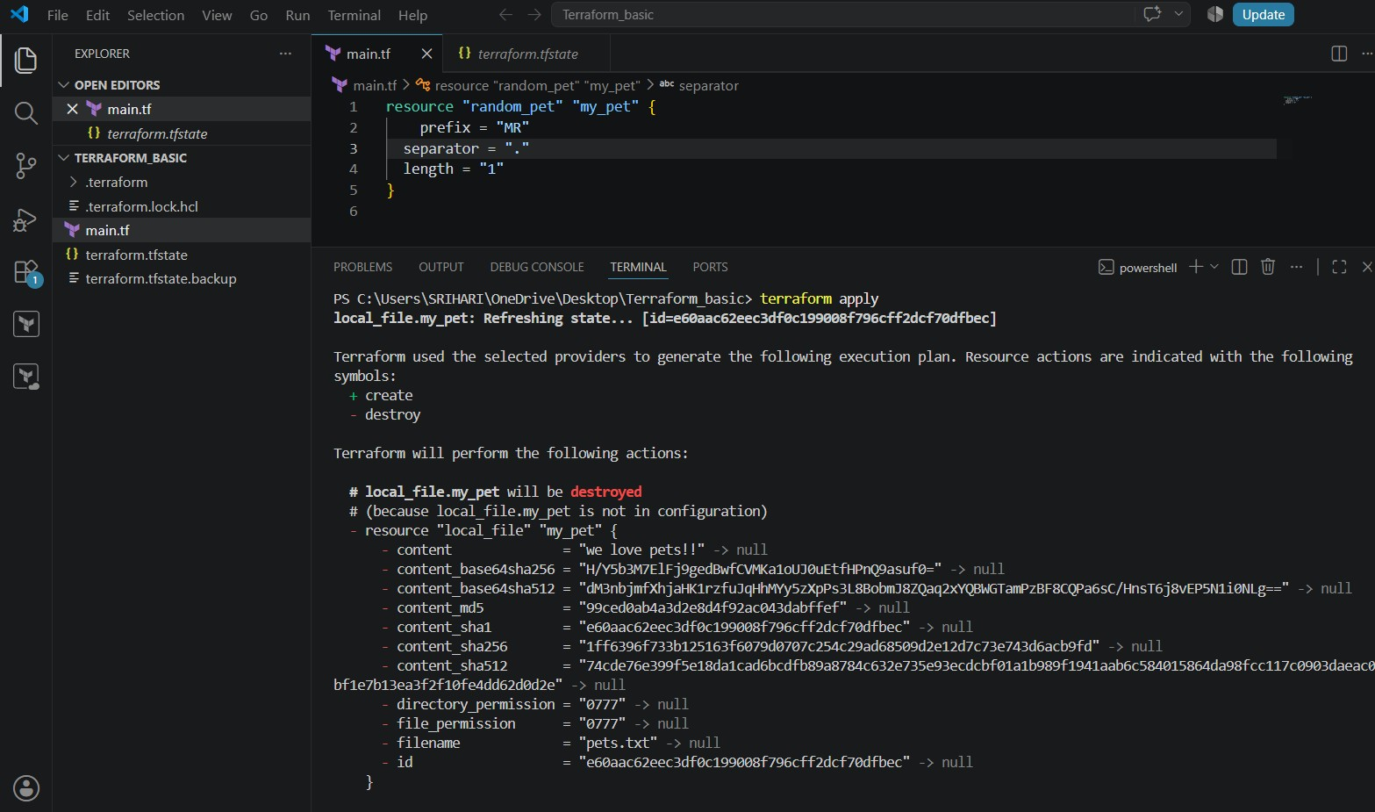

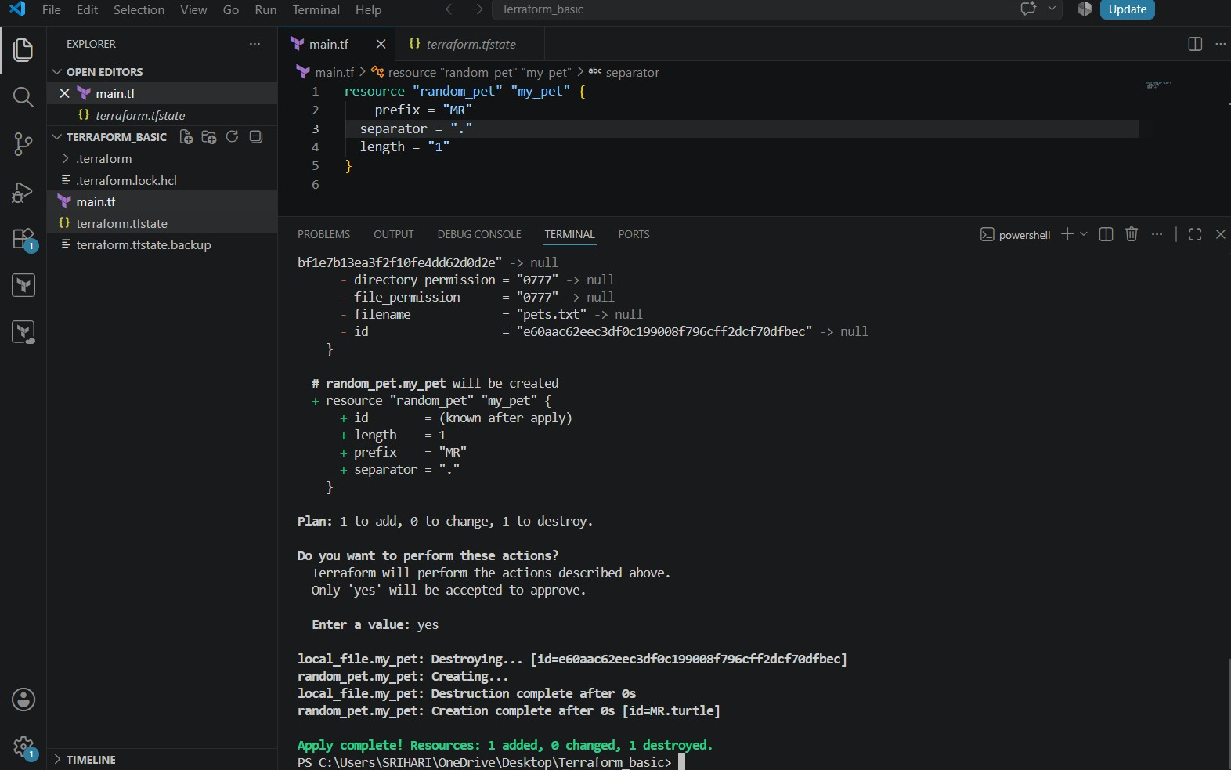
Run:
terraform plan
Terraform refreshes the state.
Output shows no changes.
Infrastructure matches the configuration

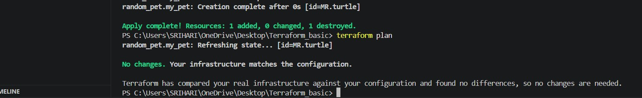
- Open terraform.tfstate in VS Code.
- Observe stored resource details.
- State file contains resource ID, attributes, and provider metadata.
- This file tracks the current infrastructure state.

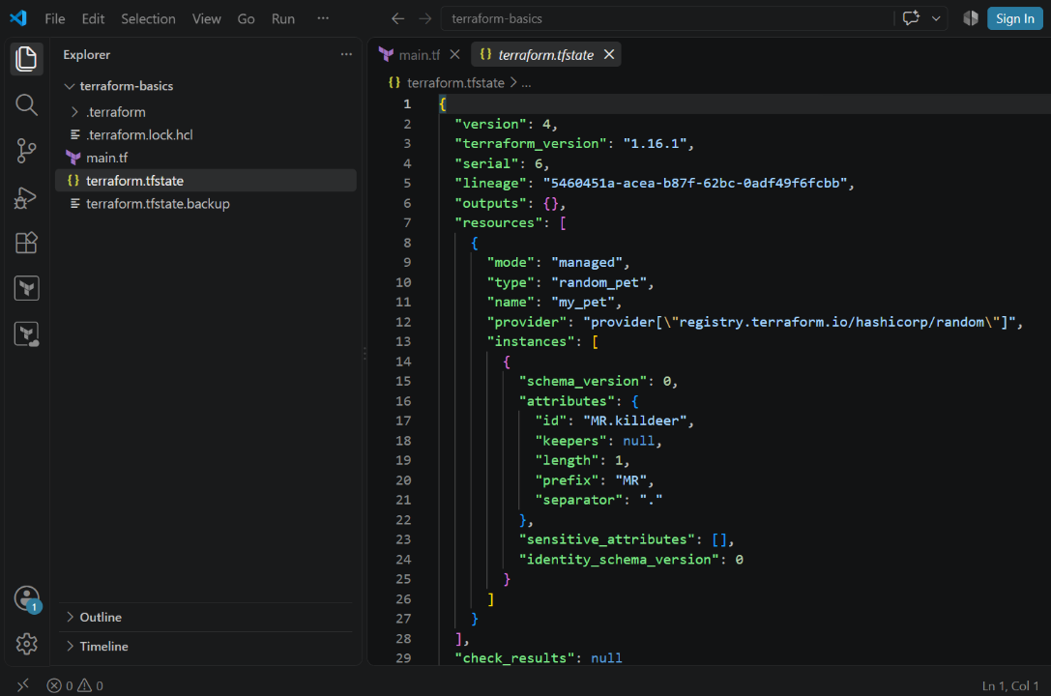
- Modify main.tf to use local_file resource again.
- Define filename and content.
- Save the file.
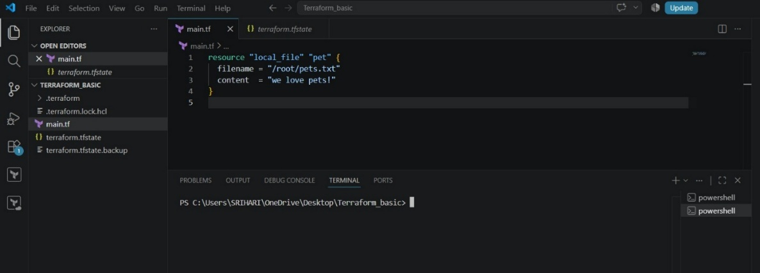
- Run:
- terraform init
- Terraform reuses existing providers.
- Initialization completes successfully

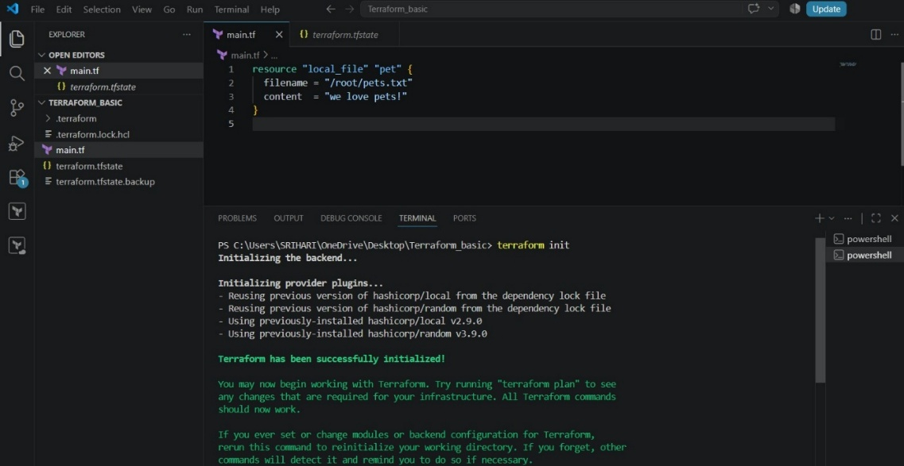

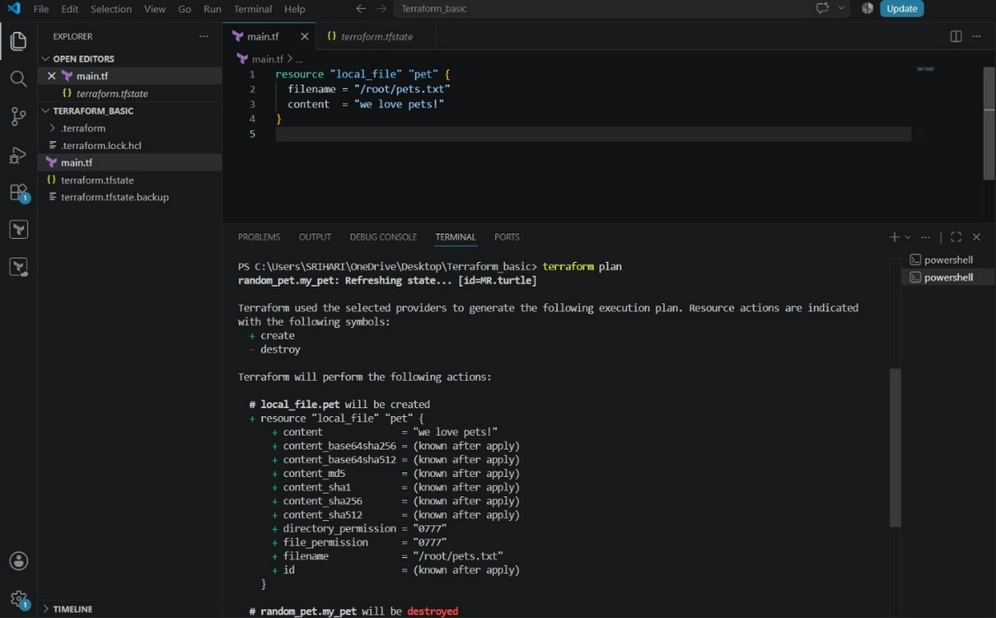
- Run:
- terraform apply
- Review the execution plan.
- Type yes to confirm.
- Terraform applies changes and updates the state file.

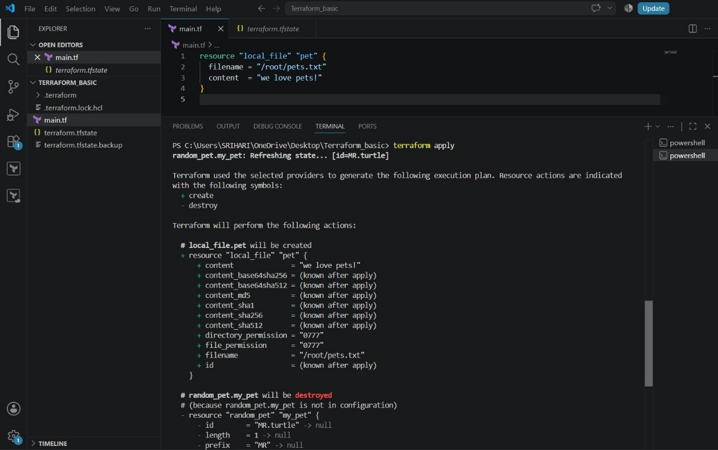
- Open main.tf containing the local_file resource.
- In the terminal, run:
- terraform destroy
- Terraform refreshes the state.
- An execution plan is shown indicating the resource will be destroyed.
- Terraform asks for confirmation before destroying resources
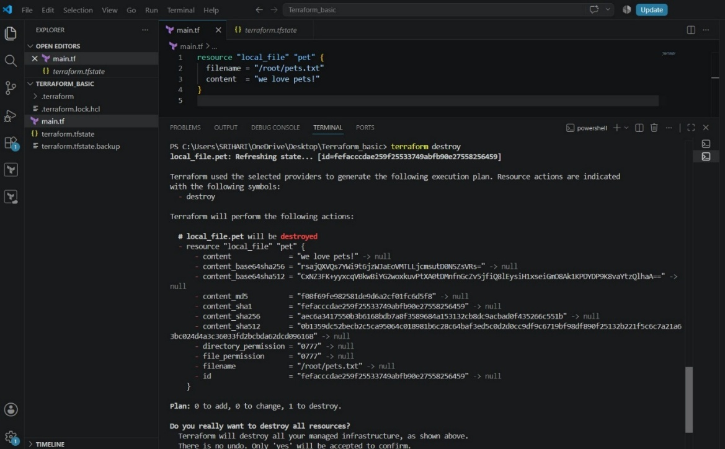

- Modify main.tf.
- Define the resource:
- Resource type: local_file
- Resource name: my_pet
- Filename: pet.txt
- Content: My pet name is Bruno

- Save the file
- Run the command:
- terraform init
- Terraform initializes the backend and providers.
- Then run:
- terraform plan
Terraform shows that a new local_file resource will be created

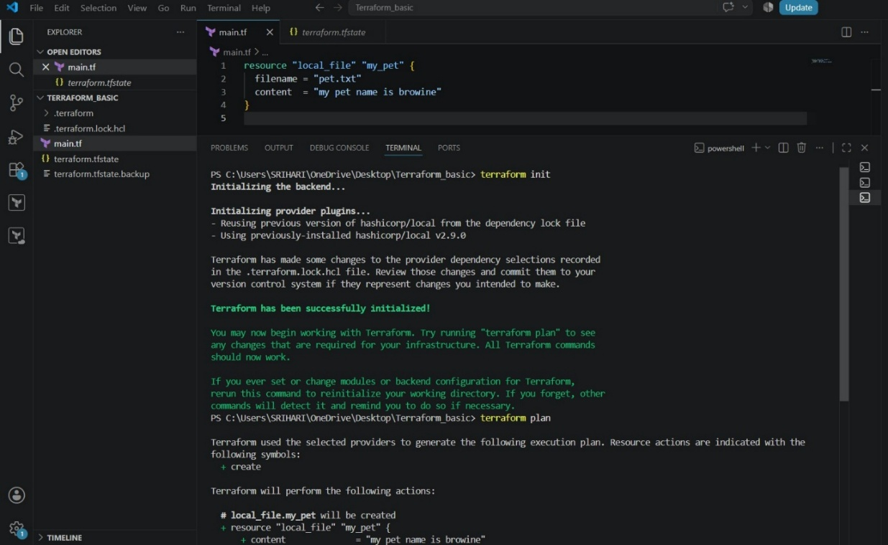
- Run:
- terraform apply
- Terraform displays the execution plan.
- Type yes to approve the changes.
- Terraform creates the pet.txt file.
- Apply completes successfully.

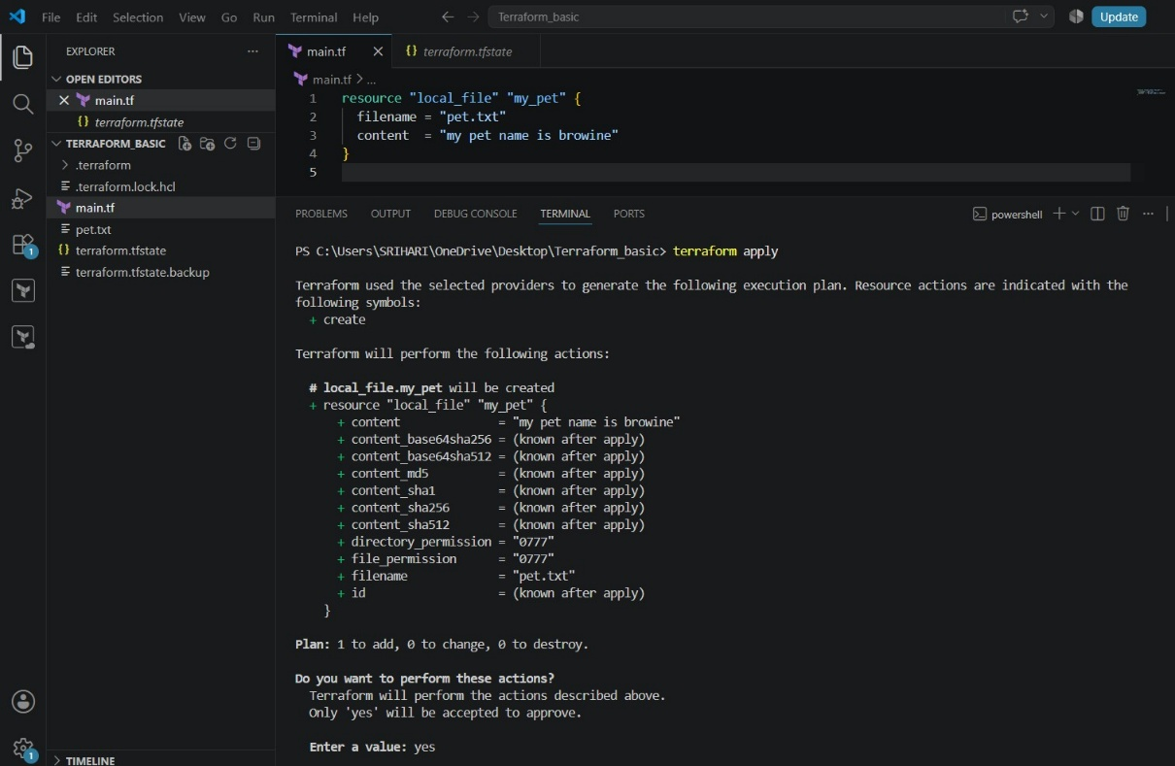
- In VS Code Explorer, locate the newly created pet.txt file.
- Open pet.txt.
- Verify that the content is:
- My pet name is Browine
- This confirms Terraform created the file successfully.
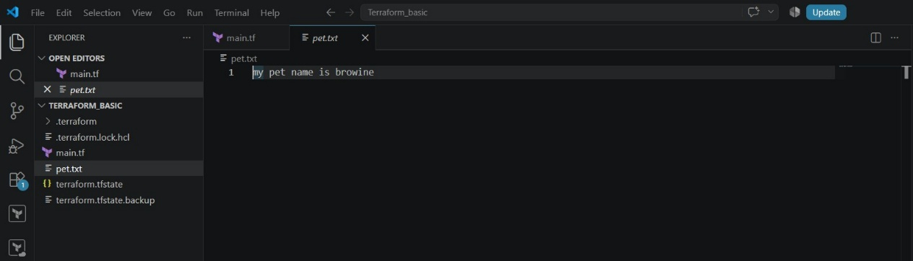

4.Integrate a sample Terraform template in Jenkins.

- Open GitHub and click New repository.
- Enter the repository name as terraform.
- Choose visibility as Public.
- Enable Add README option.
- Click Create repository to finalize

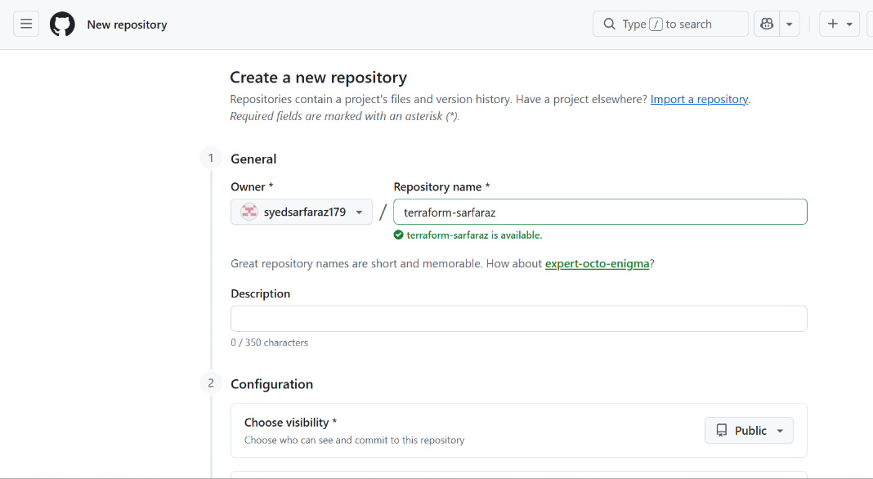
- Open the newly created repository.
- Create or edit /
- Add Terraform configuration:
- Define required providers.
- Use local_file resource.
- Add file name and content.
- Commit the changes to the main branch
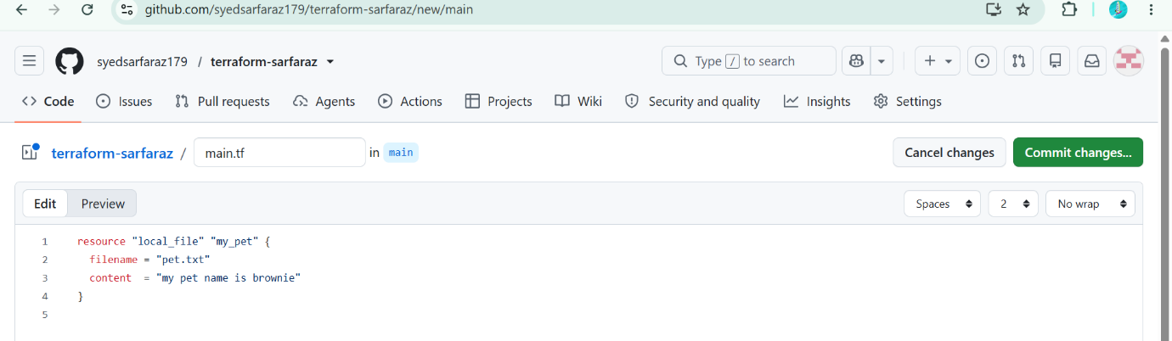

- Log in to the Jenkins EC2 instance.
- Add HashiCorp repository.
- Install Terraform using package manager.
- Terraform binary is downloaded and installed successfully.
- Verify installation completes without errors.
Commands:
sudo yum install -y yum-utils sudo yum-config-manager --add-repo https://rpm.releases.hashicorp.com/AmazonLinux/hashicorp.repo sudo yum install -y terraform
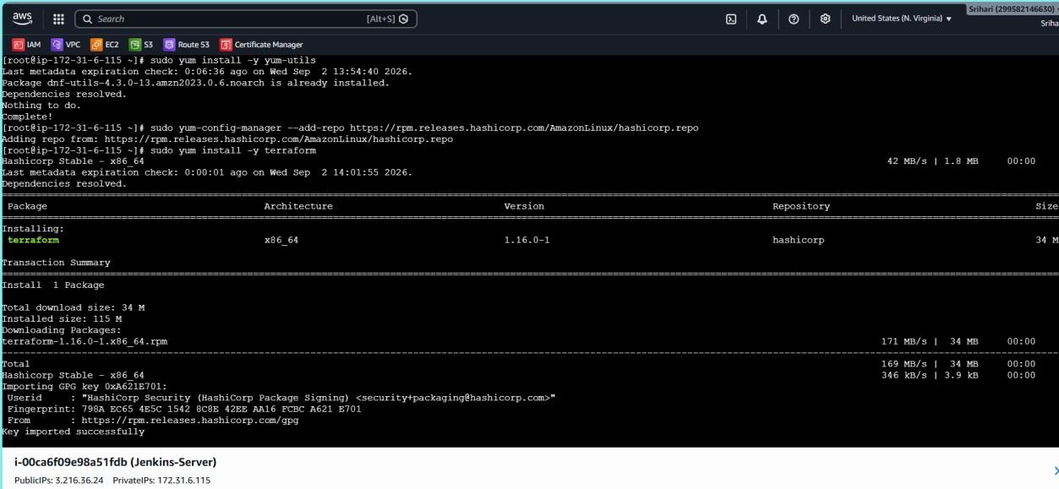
- Run:
- terraform -v
- Terraform version is displayed.
- Confirms Terraform is successfully installed on Jenkins server.
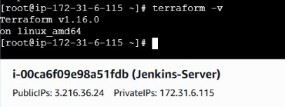
- Open Jenkins dashboard.
- Click New Item.
- Enter job name: terraform-pipeline.
- Select Pipeline as job type.
- Click OK.

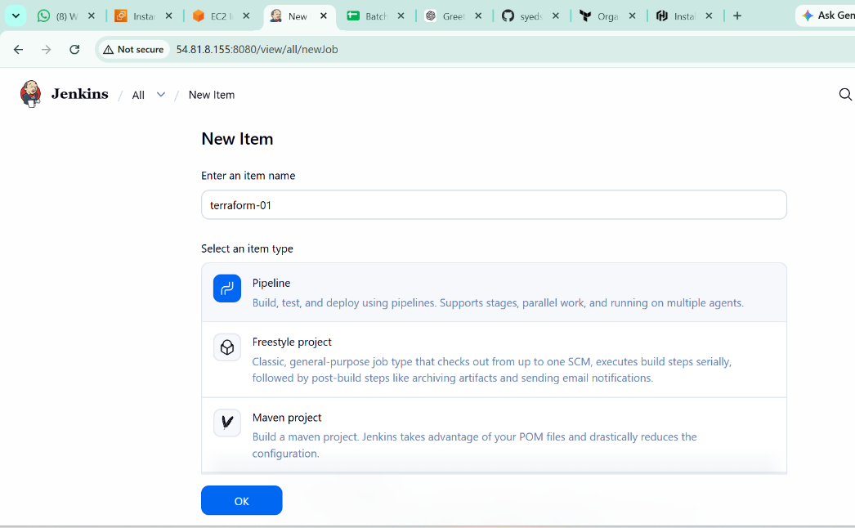

- In Pipeline configuration, select Pipeline script.
- Add stages:
o Clone GitHub repository o Terraform Init o Terraform Validate o Terraform Plan
- Use GitHub repository URL in clone stage.

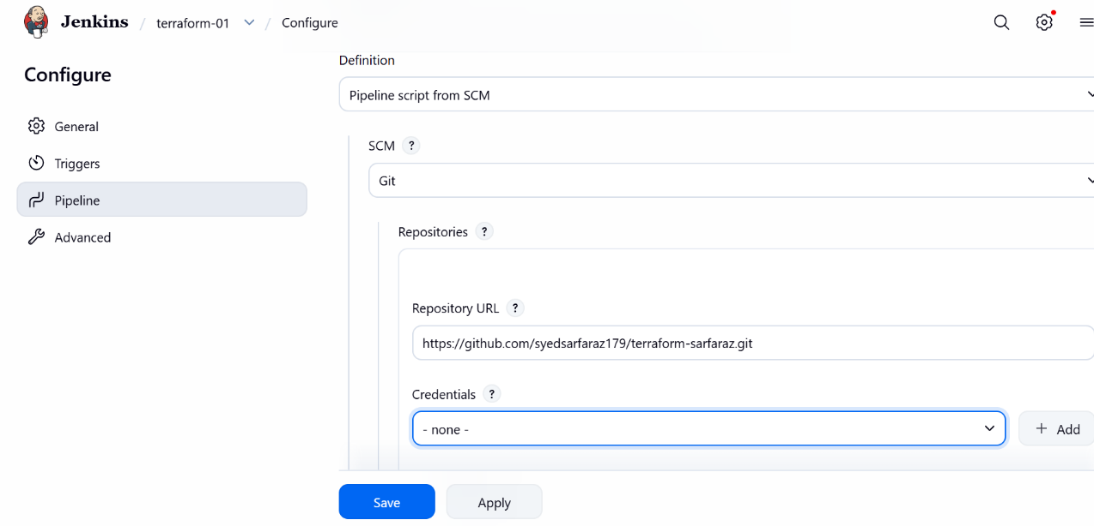
- Add Terraform Apply stage with auto-approve option.
- Add post actions:
- Success message on pipeline success.
- Failure message on pipeline failure.
- Save the pipeline configuration

pipeline {
agent any

stages {

stage('Clone Repo') {
steps {
git branch: 'main',
url: 'https://github.com/syedsarfaraz179/terraform-sarfaraz.git`
}
}

stage('Terraform Init') {
steps {
sh 'terraform init'
}
}

stage('Terraform Validate') {
steps {
sh 'terraform validate'
}
}

stage('Terraform Plan') {
steps {
sh 'terraform plan'
}
}

stage('Terraform Apply') {
steps {
sh 'terraform apply --auto-approve'
}
}
}

post {
success {
echo 'Terraform pipeline executed successfully'
}

failure {
echo 'Terraform pipeline failed'
}
}
}

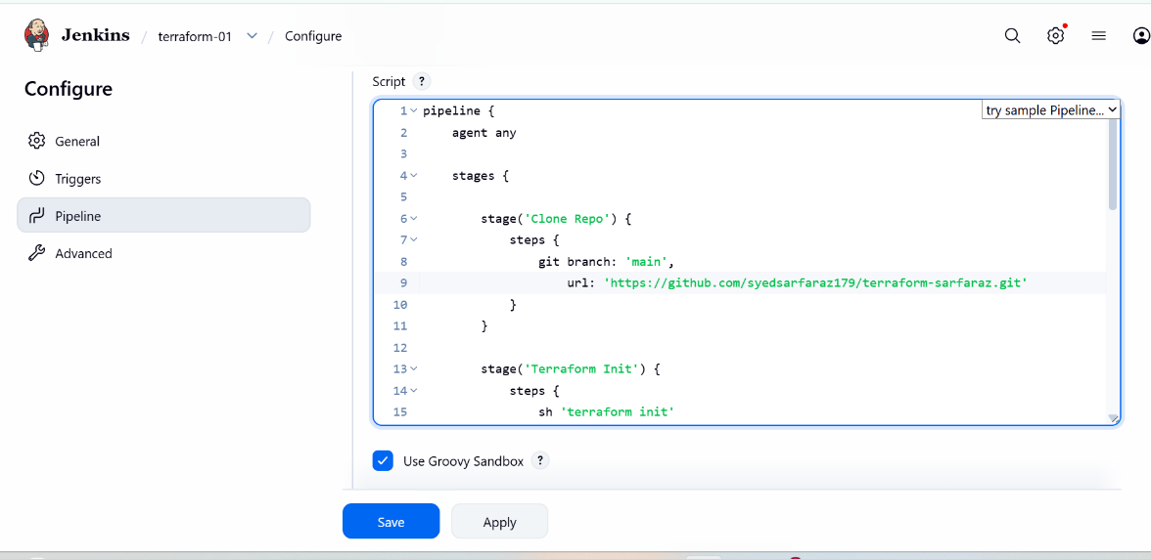
- Trigger the pipeline build.
- Jenkins executes stages sequentially:
- Clone Repo
- Terraform Init
- Terraform Validate
- Terraform Plan
- Terraform Apply
- All stages complete successfully (green status)

- Install Terraform in Jenkins server
- Download the Terraform Plugin

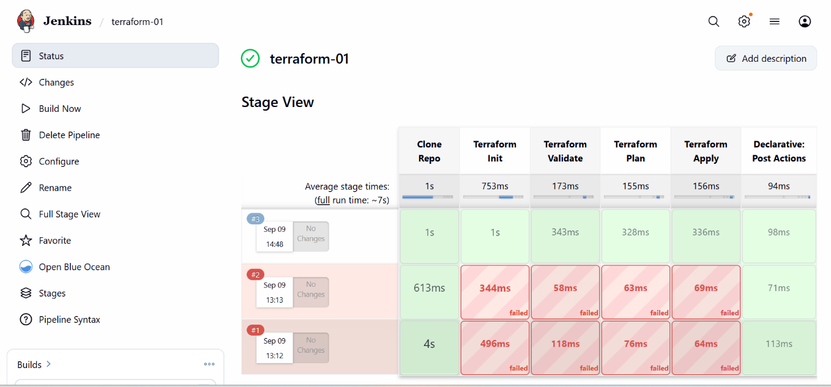
- Log in to Jenkins server.
- Navigate to workspace directory:
- /var/lib/jenkins/workspace/terraform-pipeline
- List files using ls.
- Terraform files, state file, and output files are present.

