Use Case: Setting up Transit Gateway and VPC Endpoints for a Multi-VPC Architecture
Scenario
A company is migrating its applications from an on-premises data center to AWS. Instead of deploying everything in a single VPC, the company separates workloads into multiple VPCs.
Example:
- VPC-1 → HR Department
- VPC-2 → Finance Department
- VPC-3 → Production Application
- VPC-4 → Shared Services
These VPCs need to communicate with each other securely.
The company also wants EC2 instances in private subnets to access AWS services such as Amazon S3 without using the public internet.
Objectives
1. Use AWS Transit Gateway
- Connect multiple VPCs using one centralized router.
- Eliminate the need for multiple VPC peering connections.
- Make the network scalable.
- Simplify route management.

2. Use VPC Endpoints
- Allow private EC2 instances to access AWS services.
- Avoid Internet Gateway (IGW).
- Avoid NAT Gateway.
- Keep traffic inside the AWS network.
- Improve security.

Architecture
AWS Transit Gateway
|
-----------------
| |
VPC-A VPC-B
(Production) (Finance)
|
|
Private EC2
|
S3 Gateway Endpoint
|
Amazon S3

Task 1: Set Up AWS Transit Gateway
Architecture
Transit Gateway
/ \
VPC-A VPC-B
(10.0.0.0/16) (20.0.0.0/16)

EC2-A EC2-B

Step 1: Create VPC-A
- Login to the AWS Management Console.
- In the search bar, type VPC and open the VPC Dashboard.
- In the left menu, click Your VPCs.
- Click Create VPC.
Enter the following details:
Field | Value
Resources to create | VPC only
Name tag | VPC-A
IPv4 CIDR block | 10.0.0.0/16
IPv6 CIDR | No IPv6
Tenancy | Default
- Click Create VPC.
Expected Output: VPC-A is created successfully.
Evidence: Screenshot of VPC-A.
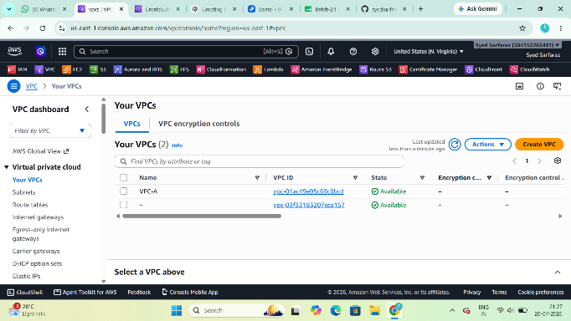

Step 2: Create Public Subnet for VPC-A
- In the left menu, click Subnets.
- Click Create subnet.
Fill in:
Field | Value
VPC ID | VPC-A
Subnet name | Public-Subnet-A
Availability Zone | us-east-1a (or any available AZ)
IPv4 CIDR | 10.0.1.0/24
Click Create subnet.

Enable Auto-Assign Public IP
- Select Public-Subnet-A.
- Click Actions → Edit subnet settings.
- Enable Auto-assign public IPv4 address.
- Click Save.
Evidence: Screenshot of subnet settings.
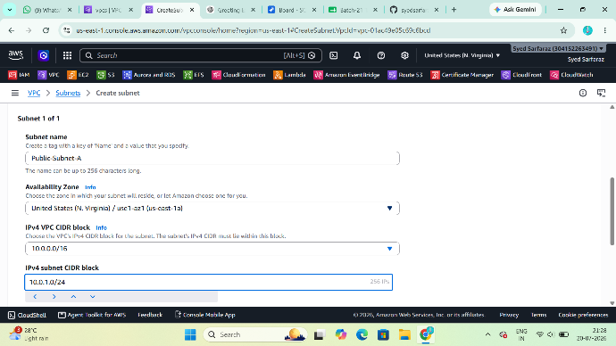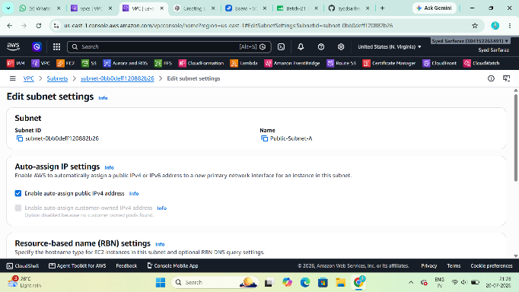

Step 3: Create Internet Gateway
- Click Internet Gateways.
- Click Create internet gateway.
Enter:
Field | Value
Name | IGW-A
Click Create.

Attach Internet Gateway
- Select IGW-A.
- Click Actions → Attach to VPC.
- Select VPC-A.
- Click Attach.
Evidence: Screenshot showing the IGW attached to VPC-A.
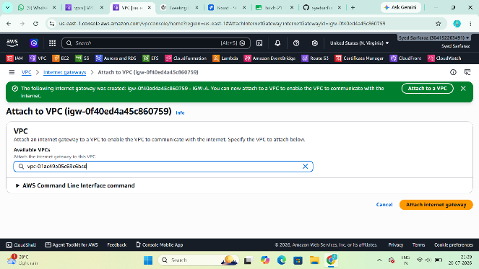

Step 4: Create Route Table
- Click Route Tables.
- Click Create Route Table.
Enter:
Field | Value
Name | Public-RT-A
VPC | VPC-A
Click Create.
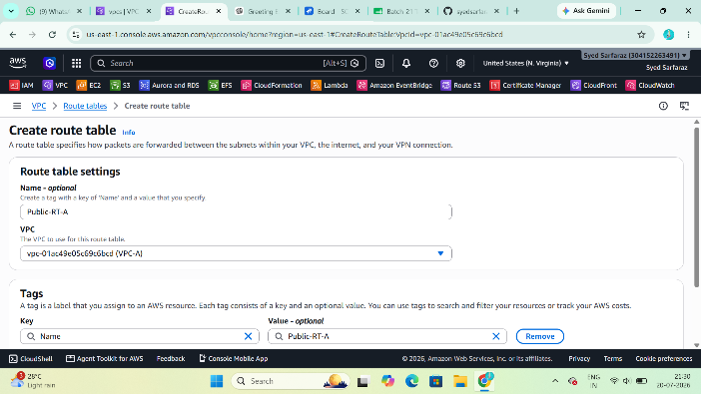

Add Internet Route
- Select Public-RT-A.
- Open the Routes tab.
- Click Edit routes → Add route.
Destination | Target
0.0.0.0/0 | Internet Gateway (IGW-A)
Click Save.
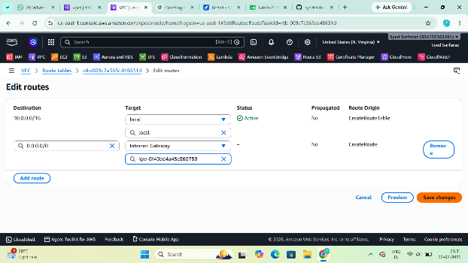

Associate Route Table
- Open the Subnet Associations tab.
- Click Edit subnet associations.
- Select Public-Subnet-A.
- Click Save.
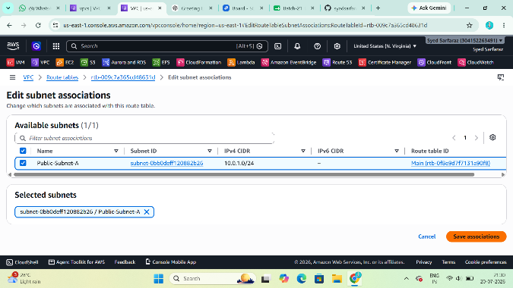

Step 5: Create VPC-B
Repeat the same steps as VPC-A with these values:
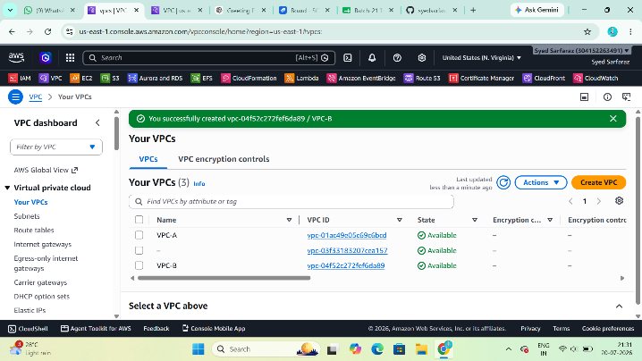
Field | Value
VPC Name | VPC-B
CIDR | 20.0.0.0/16
Subnt | Public-Subnet-B
CIDR | 20.0.1.0/24
Internt Gatewy | IGW-B
Route Table | Public-RT-B
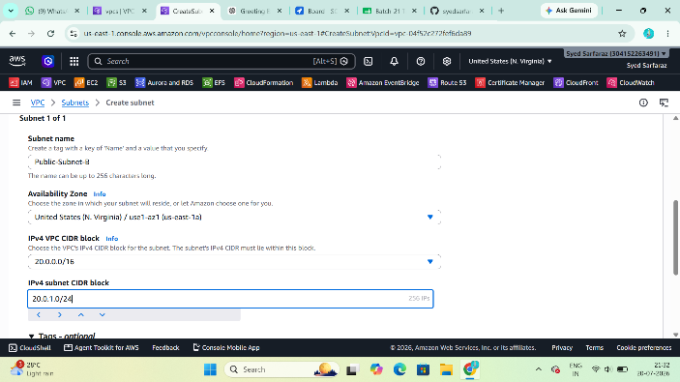
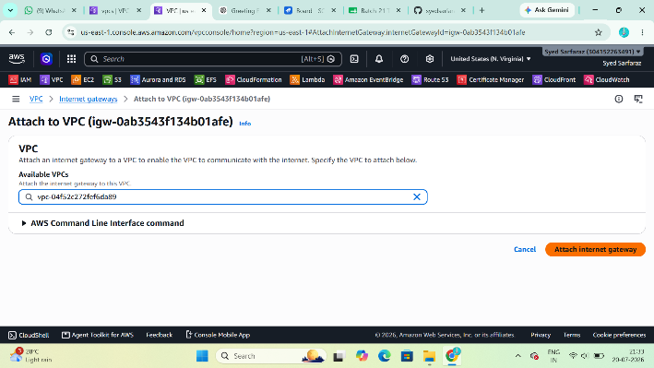
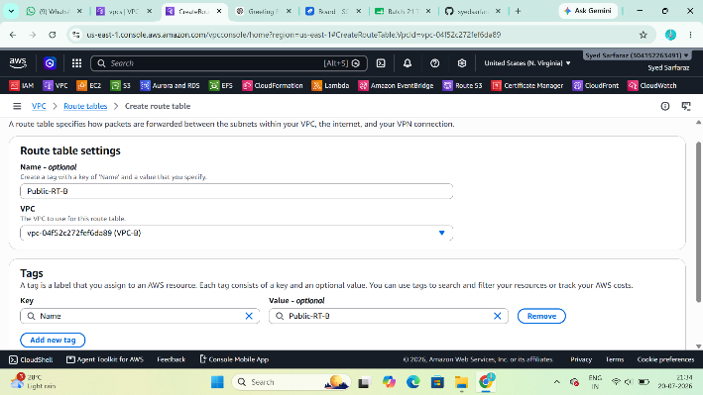
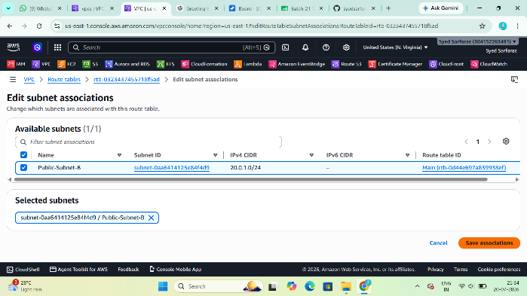
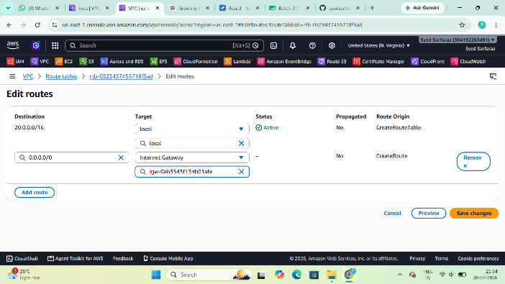

Step 6: Launch EC2 in VPC-A
Go to EC2 → Launch Instance.
Enter:
Field | Value
Name | EC2-A
AMI | Amazon Linux 2
Instance Type | t2.micro
Key Pair | Select your key
Network | VPC-A
Subnet | Public-Subnet-A
Auto Assign Public IP | Enable
Security Group | Create new
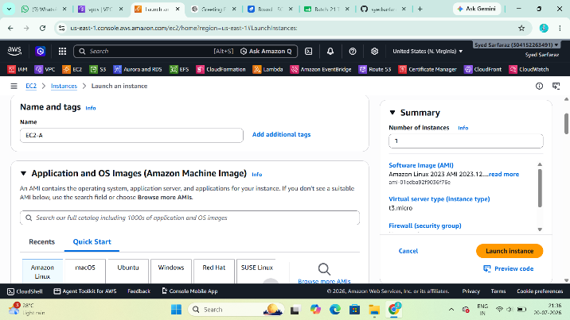 | 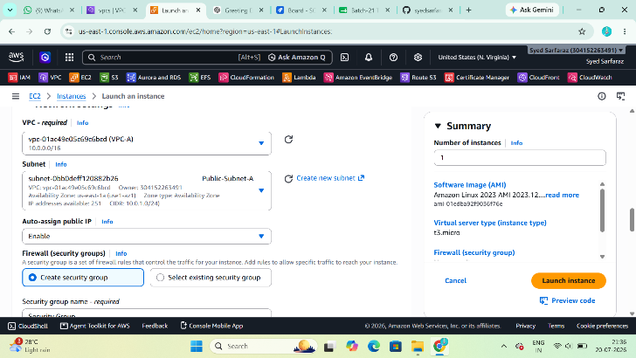

Security Group Rules
Inbound
Type | Port | Source
SSH | 22 | My IP
ICMP | All | Anywhere
All Traffic | All | 20.0.0.0/16
Launch the instance.
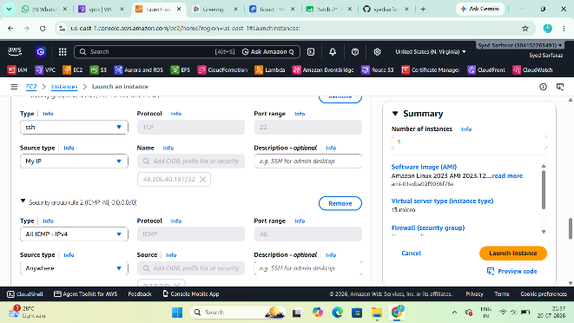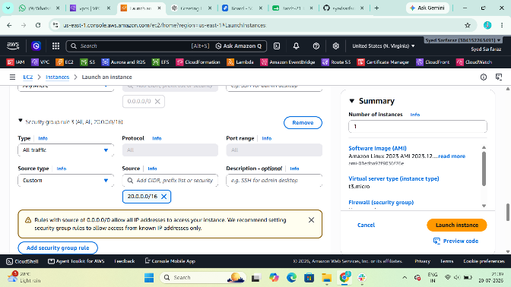

Step 7: Launch EC2 in VPC-B
Repeat the same steps:
Field | Value
Name | EC2-B
VPC | VPC-B
Subnet | Public-Subnet-B
Security Group:
Type | Source
SSH | My IP
ICMP | Anywhere
All Traffic | 10.0.0.0/16
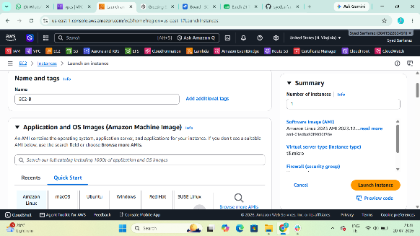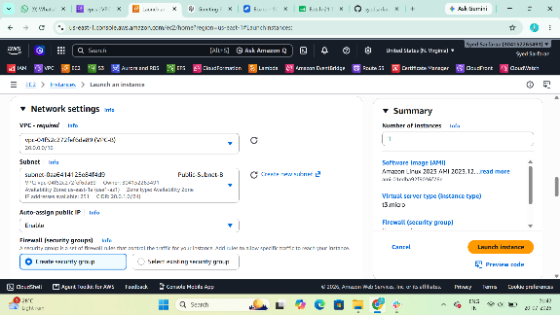

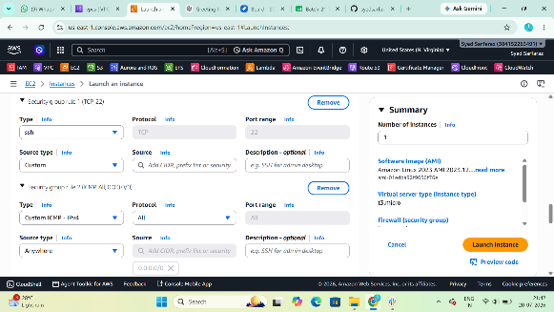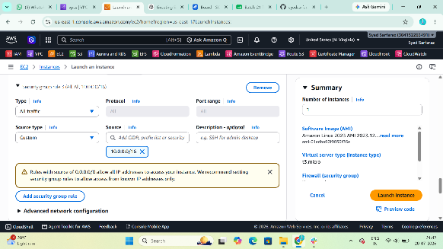

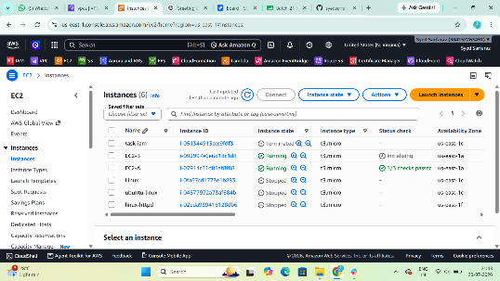

Step 8: Create Transit Gateway
- Open VPC Dashboard.
- Click Transit Gateways.
- Click Create Transit Gateway.
Enter:
Field | Value
Name | My-TGW
Description | Transit Gateway
Amazon ASN | Default
DNS Support | Enable
VPN ECMP | Enable
Leave the remaining settings as default.
Click Create Transit Gateway.
Wait until the state changes to Available.
Evidence: Screenshot of the Transit Gateway.
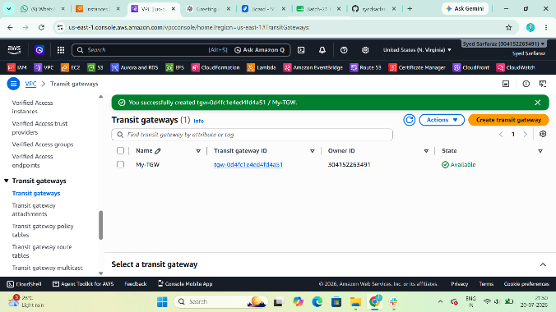

Step 9: Attach VPC-A to Transit Gateway
- Click Transit Gateway Attachments.
- Click Create Attachment.
Fill in:
Field | Value
Transit Gateway | My-TGW
Resource Type | VPC
Attachment Name | VPC-A-Attachment
VPC | VPC-A
Subnet | Public-Subnet-A
Click Create Attachment.
Wait until the attachment state becomes Available.
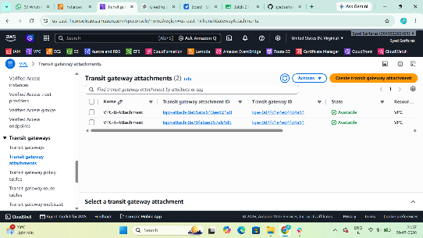

Step 10: Attach VPC-B to Transit Gateway
Repeat the same steps:
Field | Value
Attachment Name | VPC-B-Attachment
VPC | VPC-B
Subnet | Public-Subnet-B
Wait until the state is Available.


Step 11: Update Route Table of VPC-A
Go to Route Tables.
Open Public-RT-A.
Click Routes → Edit Routes → Add Route.
Destination | Target
20.0.0.0/16 | Transit Gateway
Save the changes.
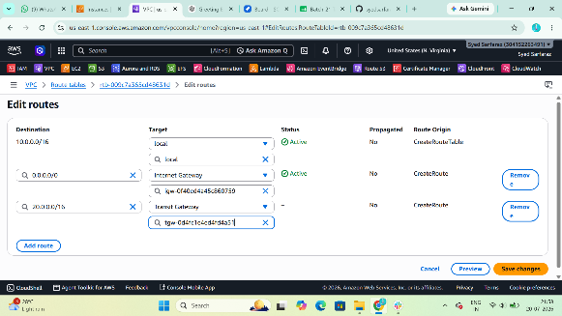

Step 12: Update Route Table of VPC-B
Open Public-RT-B.
Add:
Destination | Target
10.0.0.0/16 | Transit Gateway
Save the changes.
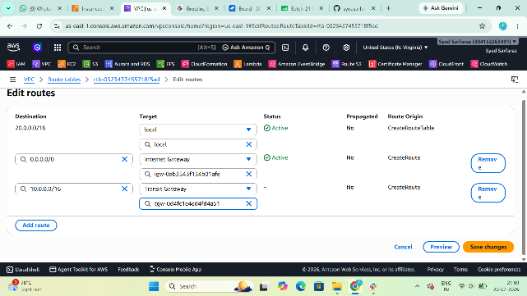

Step 13: Test Connectivity
SSH to EC2-A.
Run:
ping <Private-IP-of-EC2-B>
If the security groups and routes are configured correctly, the ping should succeed.
Evidence:
- Screenshot of successful ping.
- Screenshot of route tables.
- Screenshot of Transit Gateway attachments.
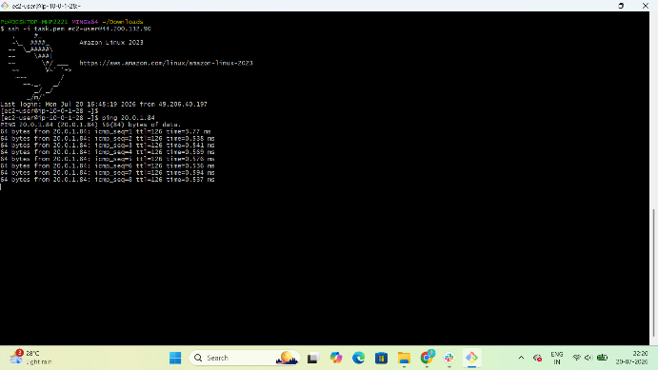

Task 2: Create a VPC Endpoint (Amazon S3)
Step 1: Open Endpoints
- Go to VPC Dashboard.
- In the left menu, click Endpoints.
- Click Create Endpoint.

Step 2: Configure the Endpoint
Field | Value
Name | S3-Endpoint
Service Category | AWS Services
Service | com.amazonaws.<region>.s3
Endpoint Type | Gateway
Replace <region> with your AWS Region (for example, us-east-1).

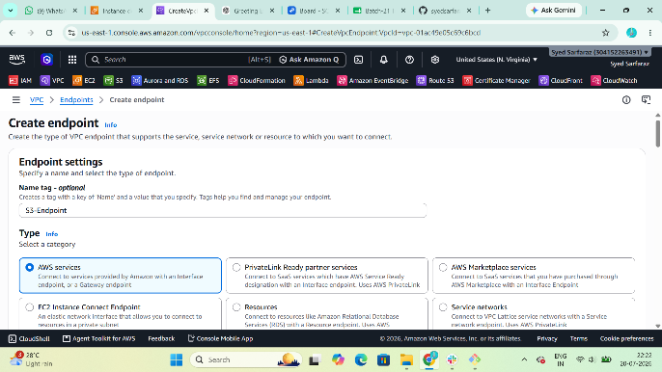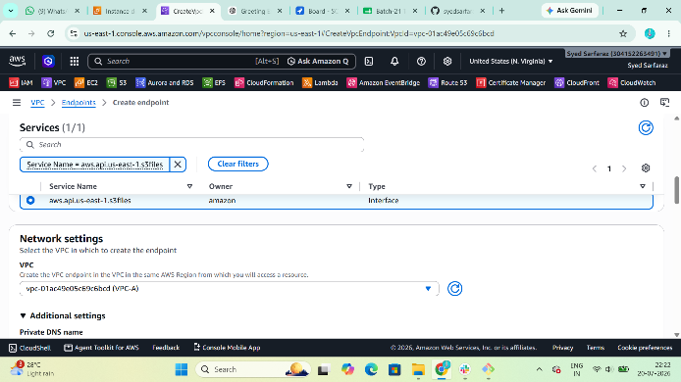

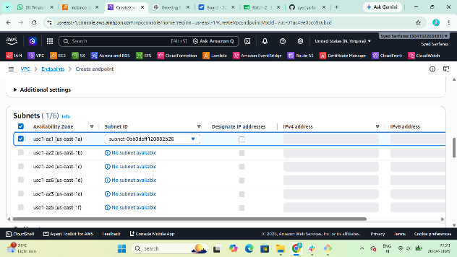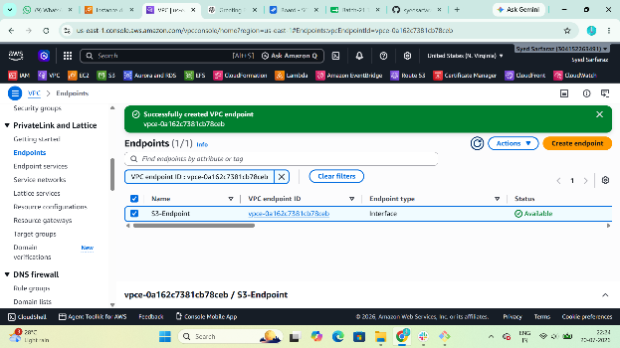

Step 3: Create Role
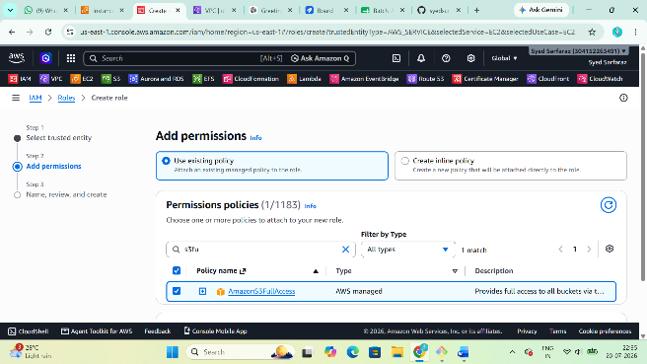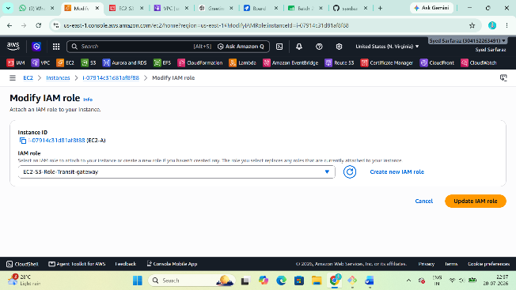
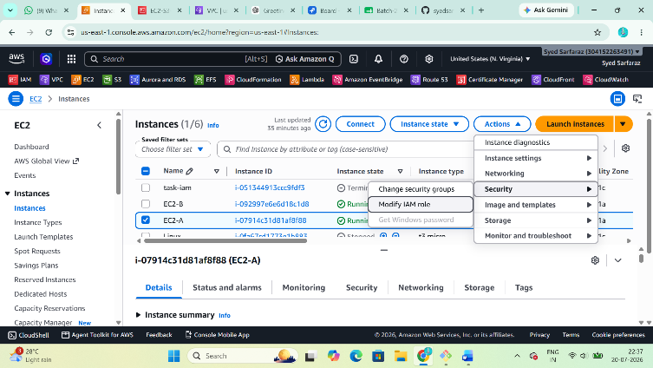

Step 4: Select Route Table
Select Public-RT-A (or the private route table if your EC2 is in a private subnet).
AWS automatically updates the route table with the S3 prefix list and the VPC endpoint target.

Step 5: Create the Endpoint
Click Create Endpoint.
Wait until the endpoint status is Available.
Evidence: Screenshot of the VPC Endpoint.

Step 6: Verify the Endpoint
SSH into EC2-A.
Check the AWS CLI version:
aws --version
List S3 buckets (the instance must have an IAM role with S3 permissions):
aws s3 ls
Or upload a test file:
echo "Hello AWS" > test.txt
aws s3 cp test.txt s3://<your-bucket-name>/
The request should succeed using the VPC Endpoint without requiring an Internet Gateway or NAT Gateway for S3 access.
