Docker-03

- Create a image from running container.
- Copy image from local machine to docker server and load the image.
- Create Docker image using alpine and customize with tomcat.
- Create single stage and multi stage docker file using this source code:https://github.com/betawins/multi-stage-example.git
- Install docker compose and execute sample application.
- Implement solution to scan images when pushed to docker registry.
- Implement solution to scan images when pushed to AWS ECR.
- Create a Jenkins pipeline to create a docker image and push the image to Docker hub.

1. Create an image from a running container
Step 1: Check running containers
On the machine where the container is running:
$ docker ps
Example:
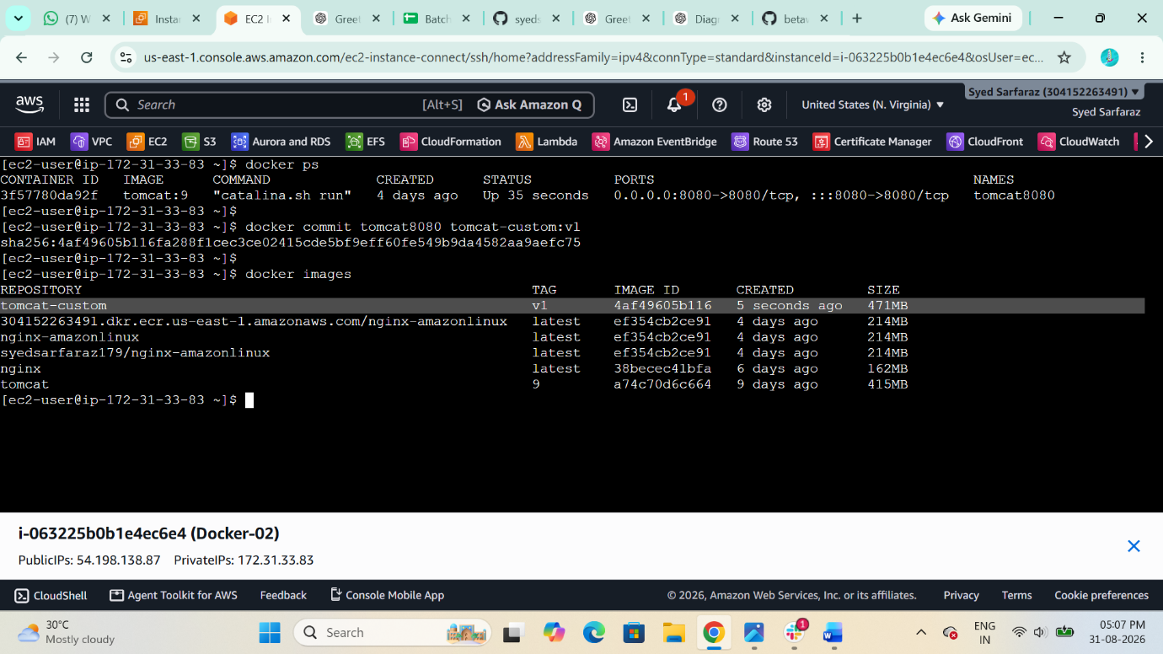
CONTAINER ID IMAGE NAMES
44b70a8fdcc6 jenkins/jenkins jenkins
Here, the container name is jenkins.

Step 2: Create an image from the running container
Use docker commit:
$ docker commit jenkins jenkins-custom:v1
Format:
docker commit <container-name> <new-image-name>:<tag>


Step 3: Verify the image
$ docker images
You should see:
REPOSITORY TAG IMAGE ID
jenkins-custom v1 xxxxxxxxx


2. Copy image from local machine to Docker server
The easiest method is to save the image as a .tar file, copy it to the Docker server, and then load it.

Step 1: Insatll Docker Desktop in your local windows machine and open the its console wait till I will loads the interface
Step 2: Open git bash in Desktop
Step 3: $docker –version check docker version
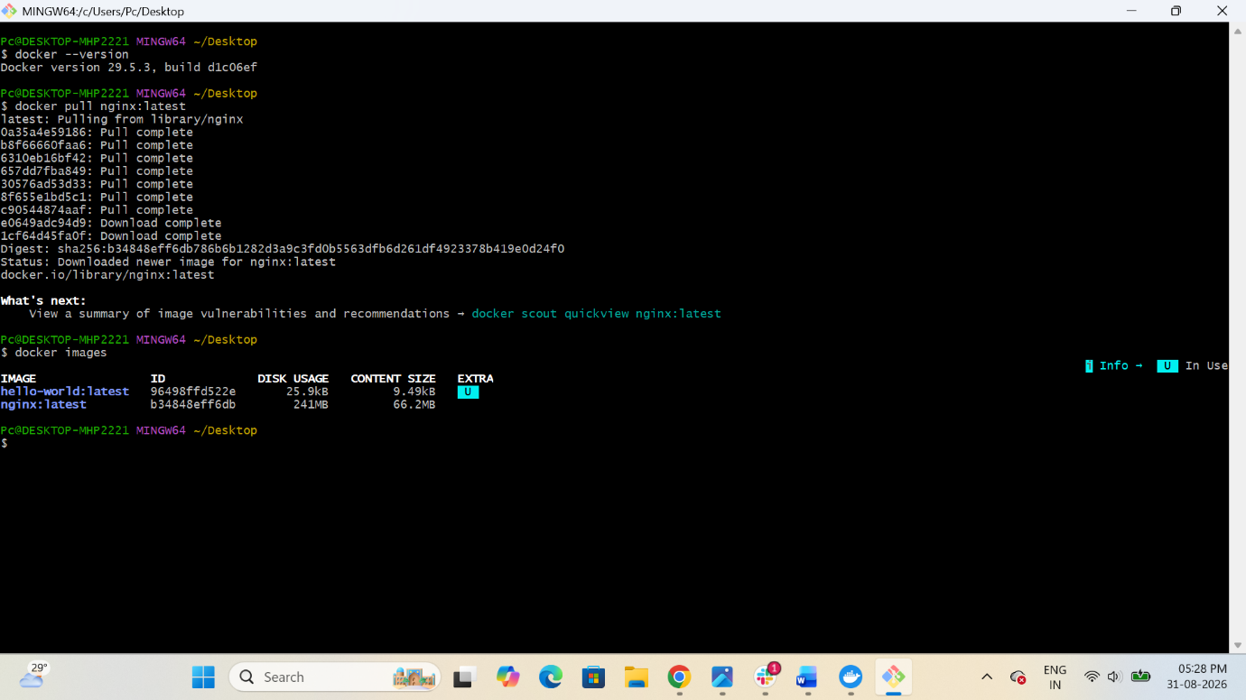
Step 4: $ docker pull nginx Then Pull a nginx Image


Step 5: $ docker images check the image


Step 6: $ docker save -o nginx.tar nginx:latest Save the image
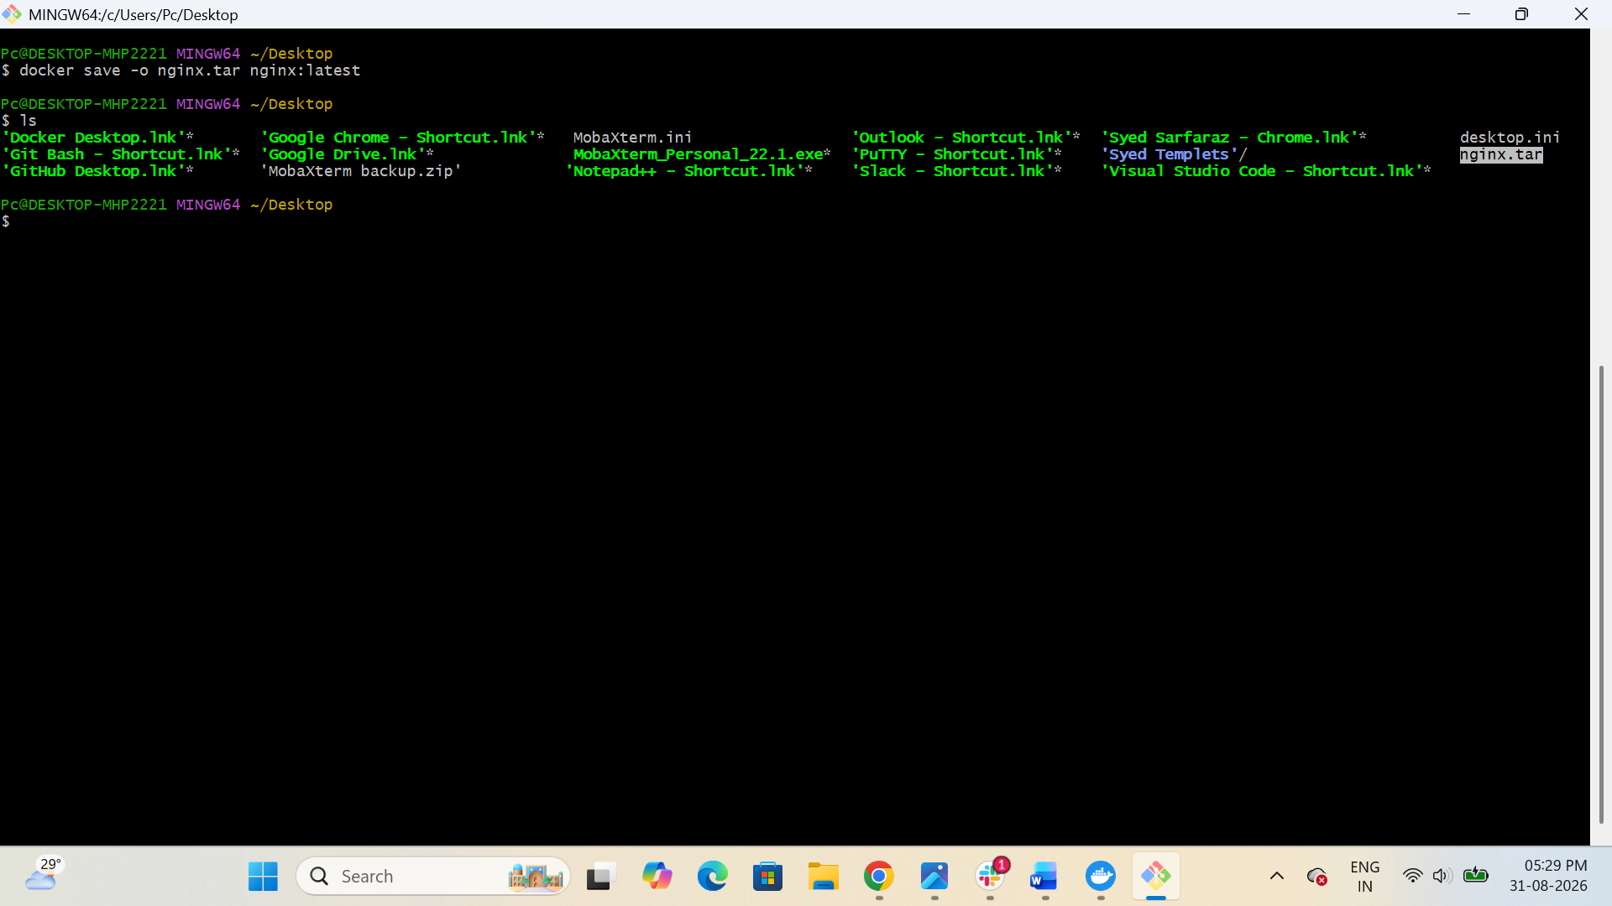

Step 7: $ ls = nginx.tar
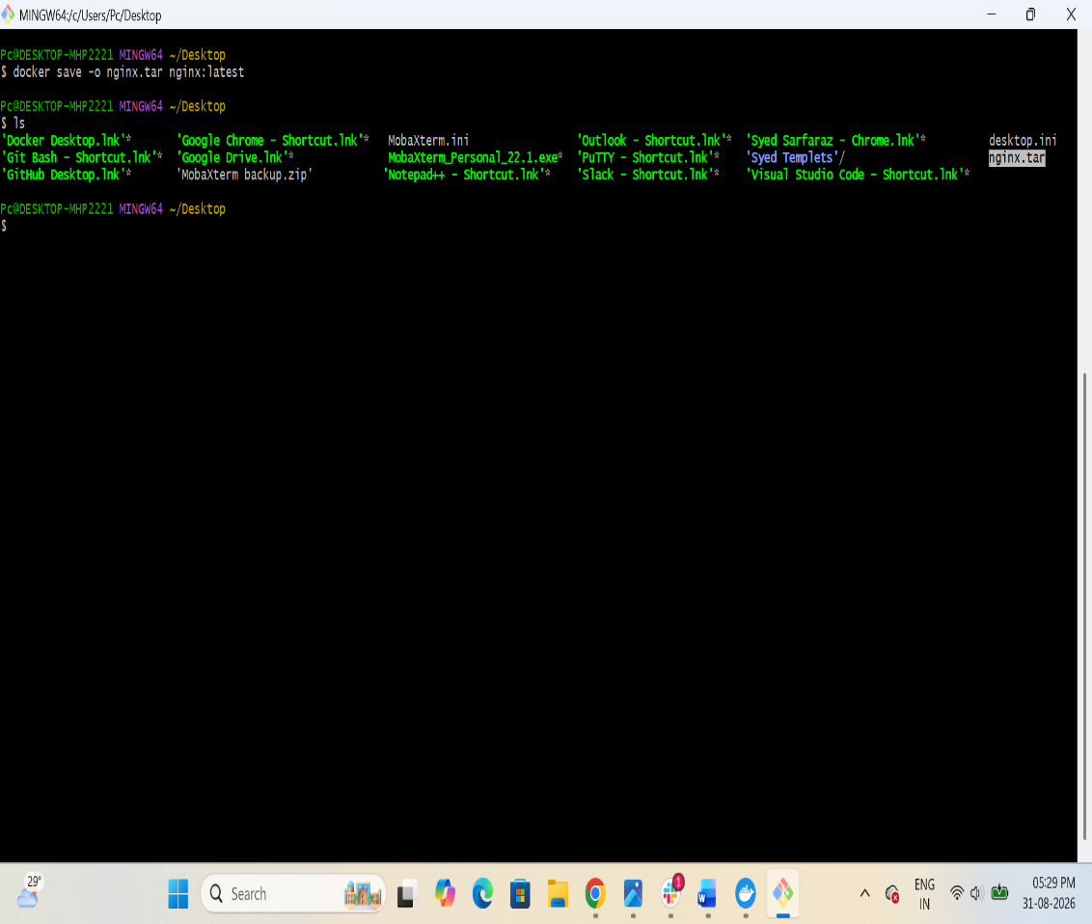

Step 8: $ pwd = /c/Users/Pc/Desktop
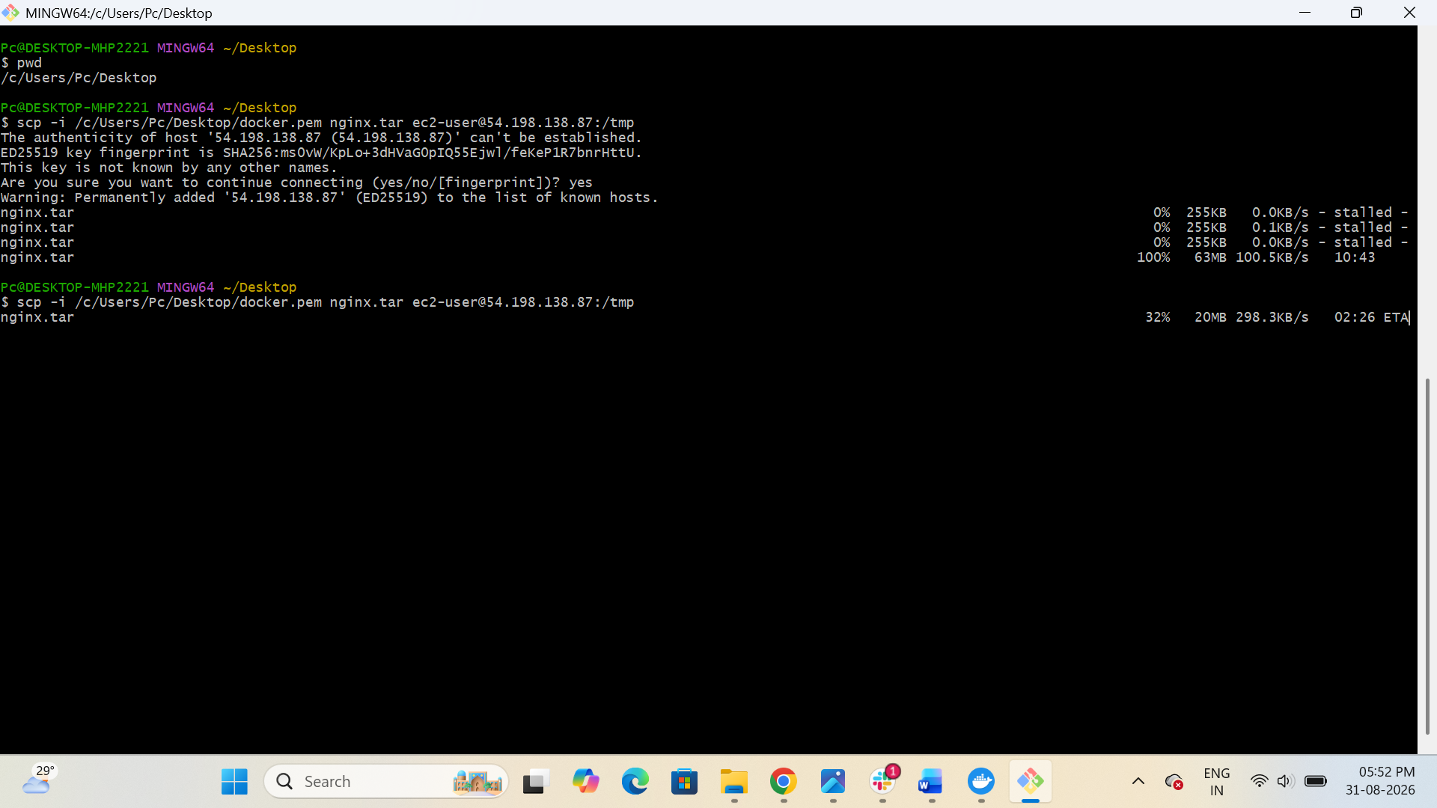

Step 9: $ scp -i /c/Users/Pc/Desktop/docker.pem nginx.tar ec2-user@54.198.138.87:/tmp


Now migrate this image to Docker ec2 server from Local machine

Now Go to Docker Server
Step 10: cd /tmp change to Tempt directory
Step 11: ls = nginx.tar here you can find your Image
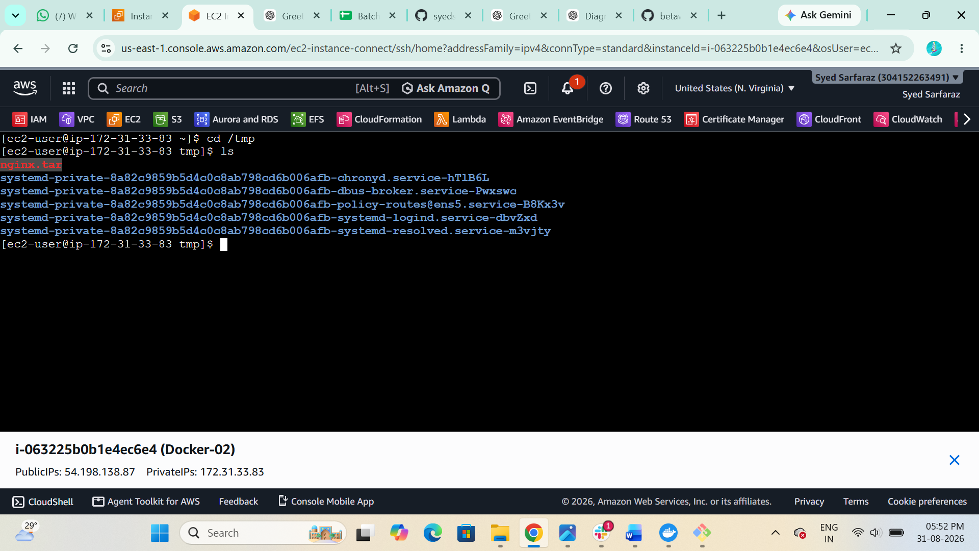

Step 11: $ Docker load -i nginx.tar Now Extract that Image
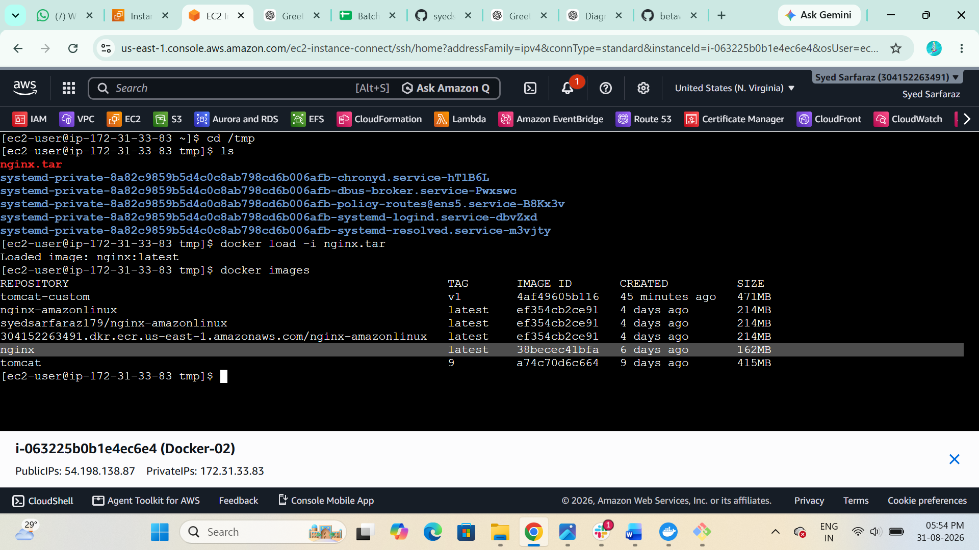

Step 12: $ docker images here you will get your Nginx Image


Now we can run container of nginx image

3. Create Docker image using Alpine and customize with Tomcat
Step 1: Pull Alpine image
docker pull alpine:latest
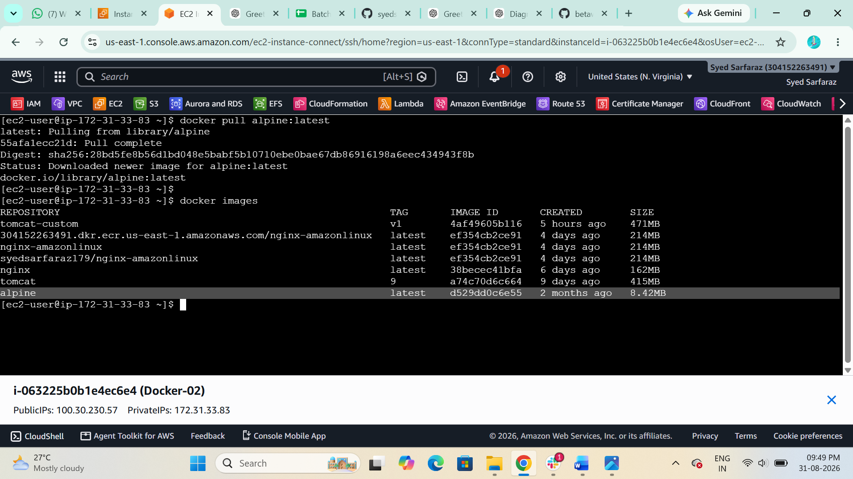
Verify:
docker images


Step 2: Create a Dockerfile
Create a directory:
$ mkdir alpine-tomcat
$ cd alpine-tomcat
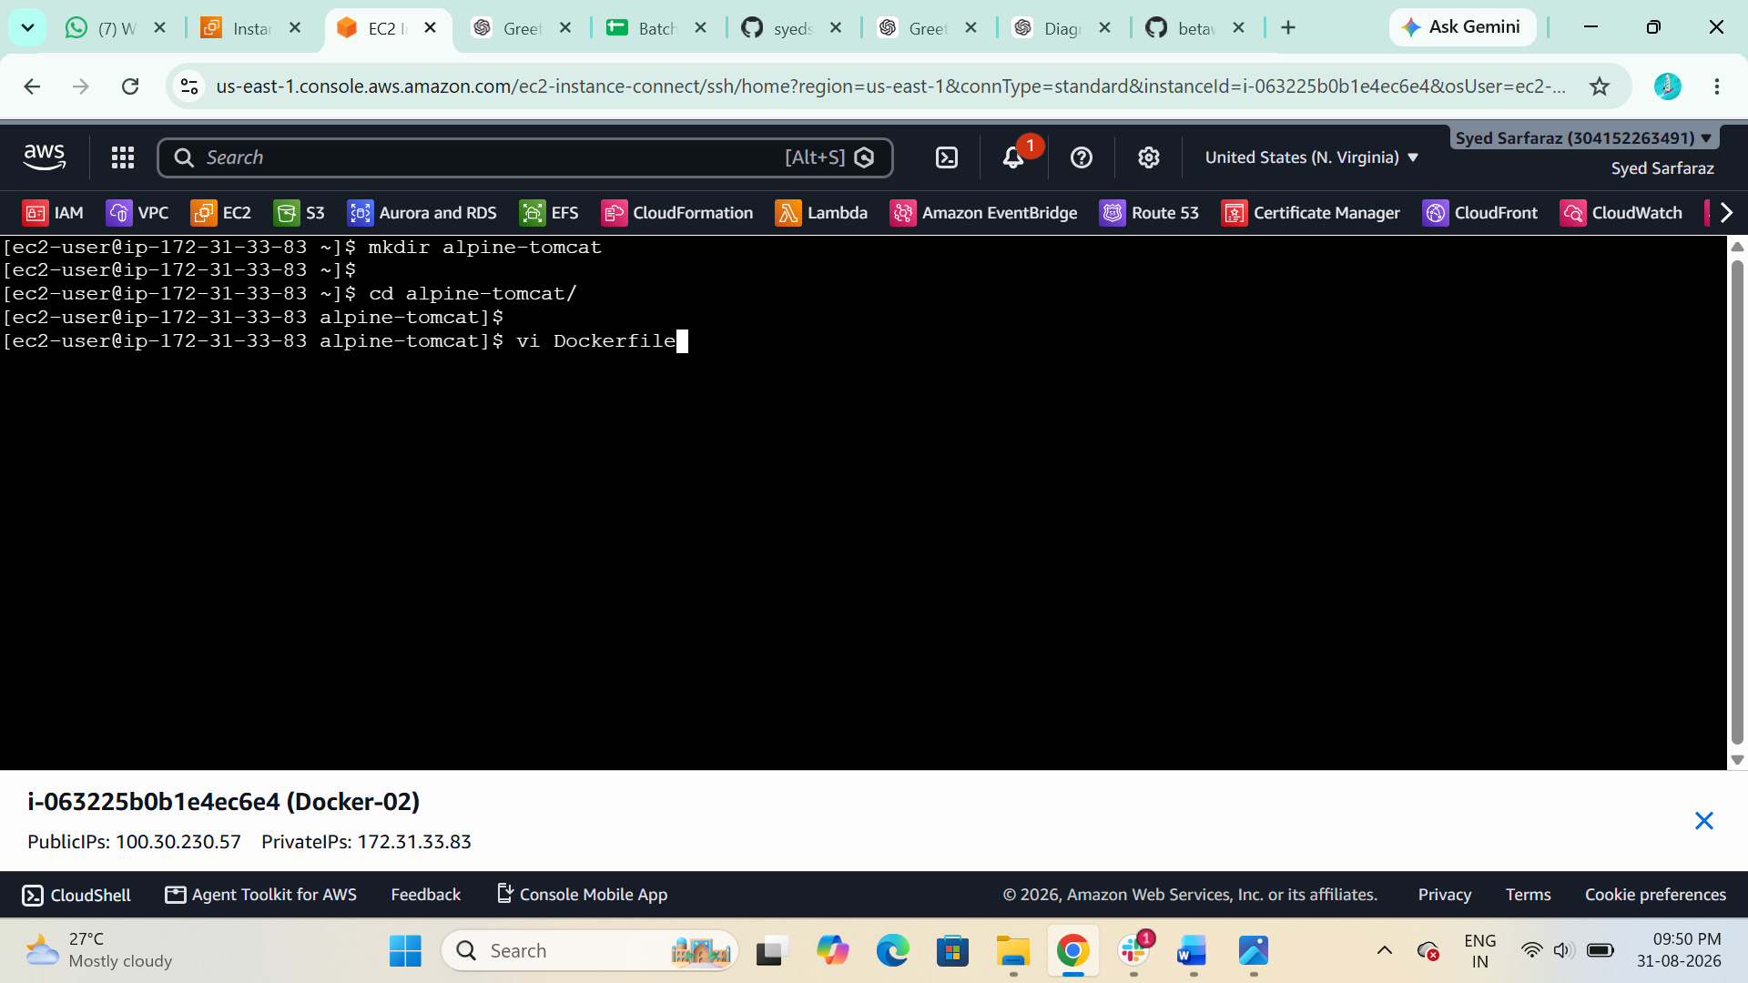

Create the Dockerfile:
$ vi Dockerfile
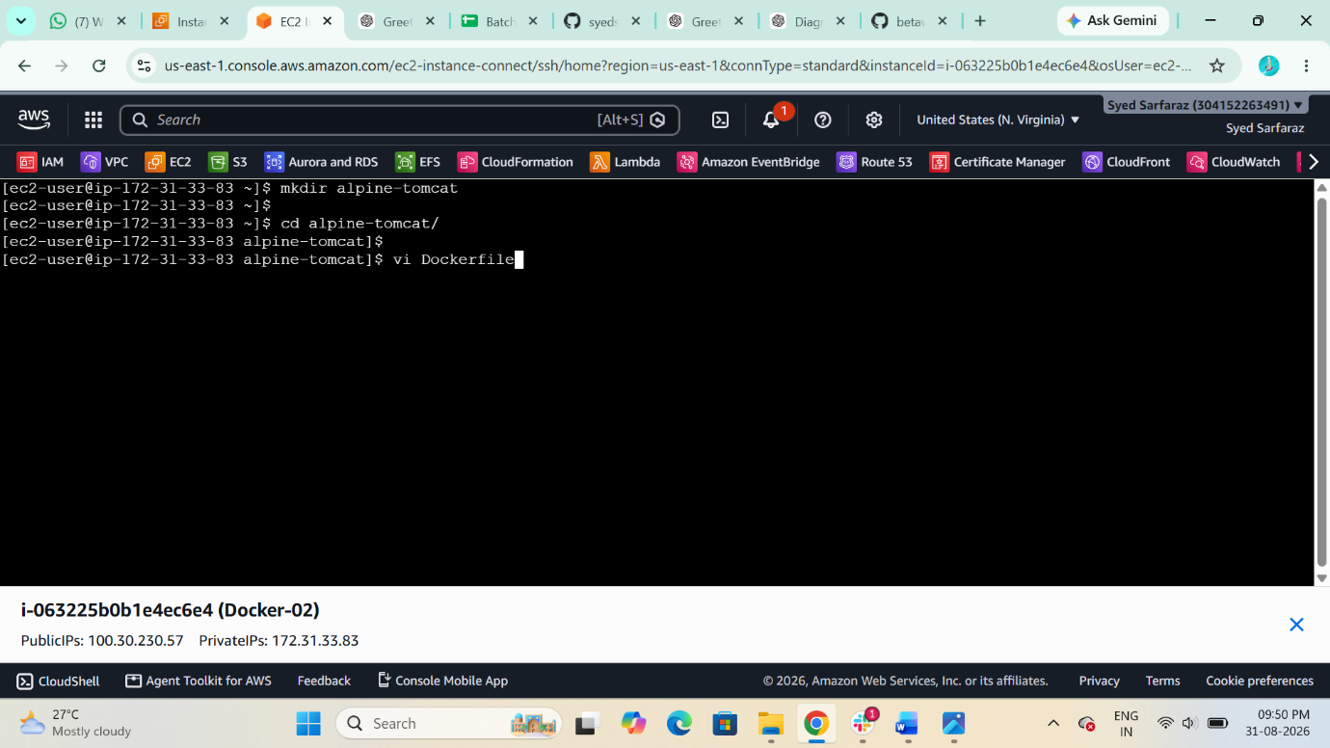
Add:

FROM alpine:latest

RUN apk add --no-cache \
openjdk17-jre \
wget \
bash

ENV CATALINA_HOME=/opt/tomcat
ENV PATH=$CATALINA_HOME/bin:$PATH

RUN wget -q https://dlcdn.apache.org/tomcat/tomcat-11/v11.0.25/bin/apache-tomcat-11.0.25.tar.gz && \
mkdir -p $CATALINA_HOME && \
tar -xzf apache-tomcat-11.0.25.tar.gz \
-C $CATALINA_HOME \
--strip-components=1 && \
rm apache-tomcat-11.0.25.tar.gz

EXPOSE 8080

CMD ["catalina.sh", "run"]

Save and exit.
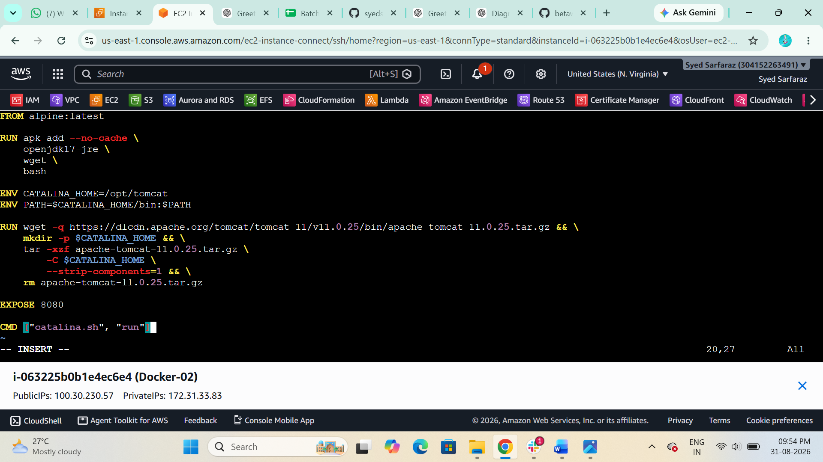

Step 3: Build the Docker image
From the directory containing the Dockerfile:
docker build -t alpine-tomcat .
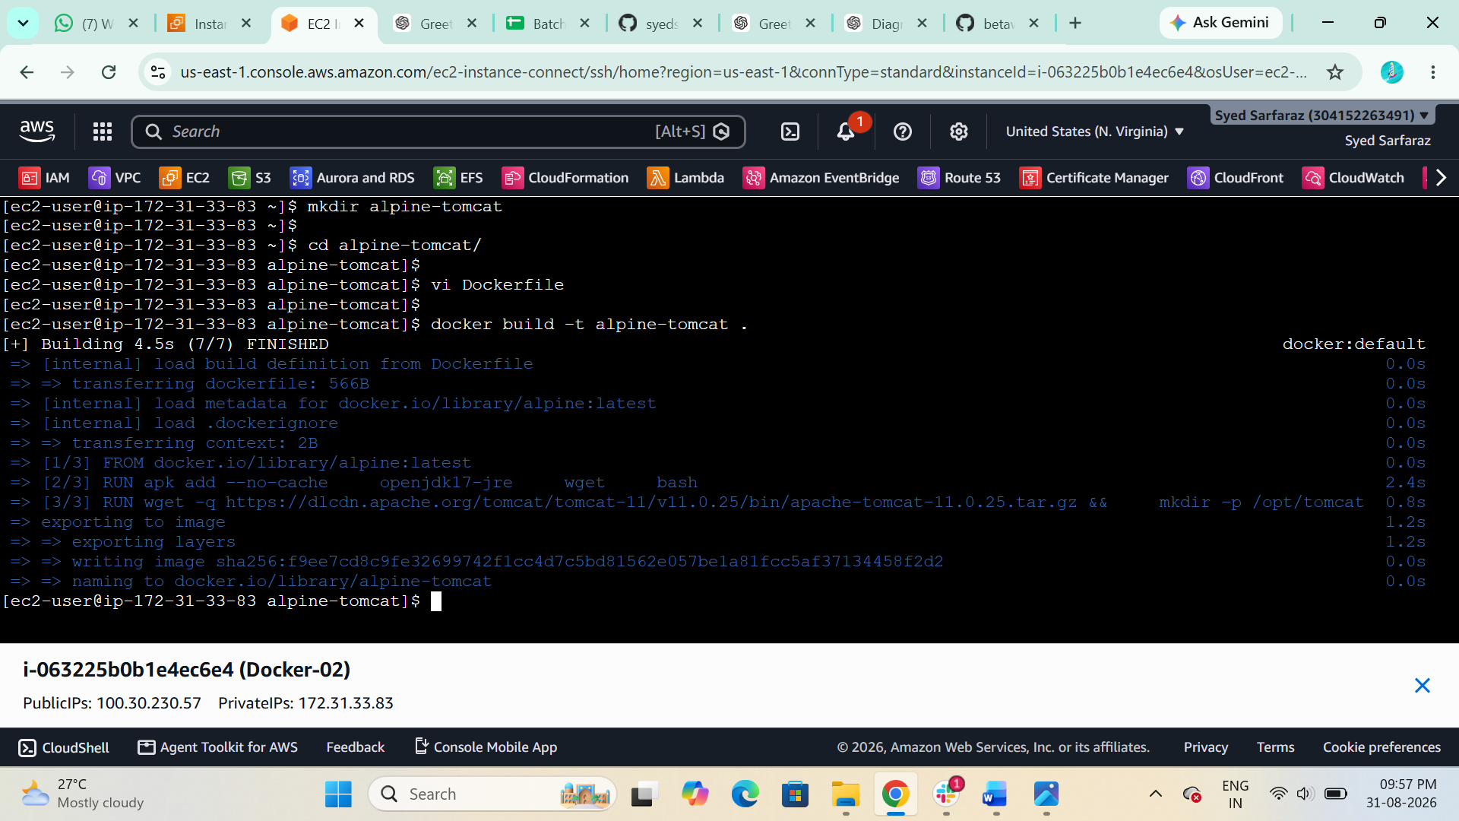

Check the image:
$ docker images
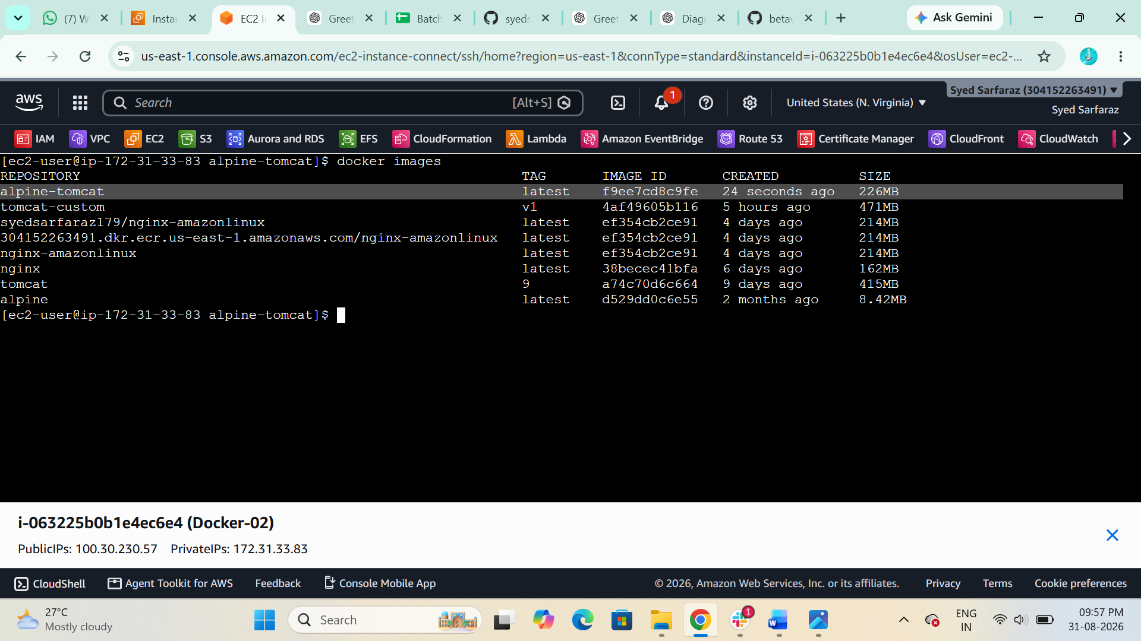

Step 4: Run the container
$ docker run -d --name tomcat-alpine -p 8080:8080 alpine-tomcat:v1
Check:
$ docker ps
You should see:
tomcat-alpine alpine-tomcat:latest 0.0.0.0:8080->8080/tcp
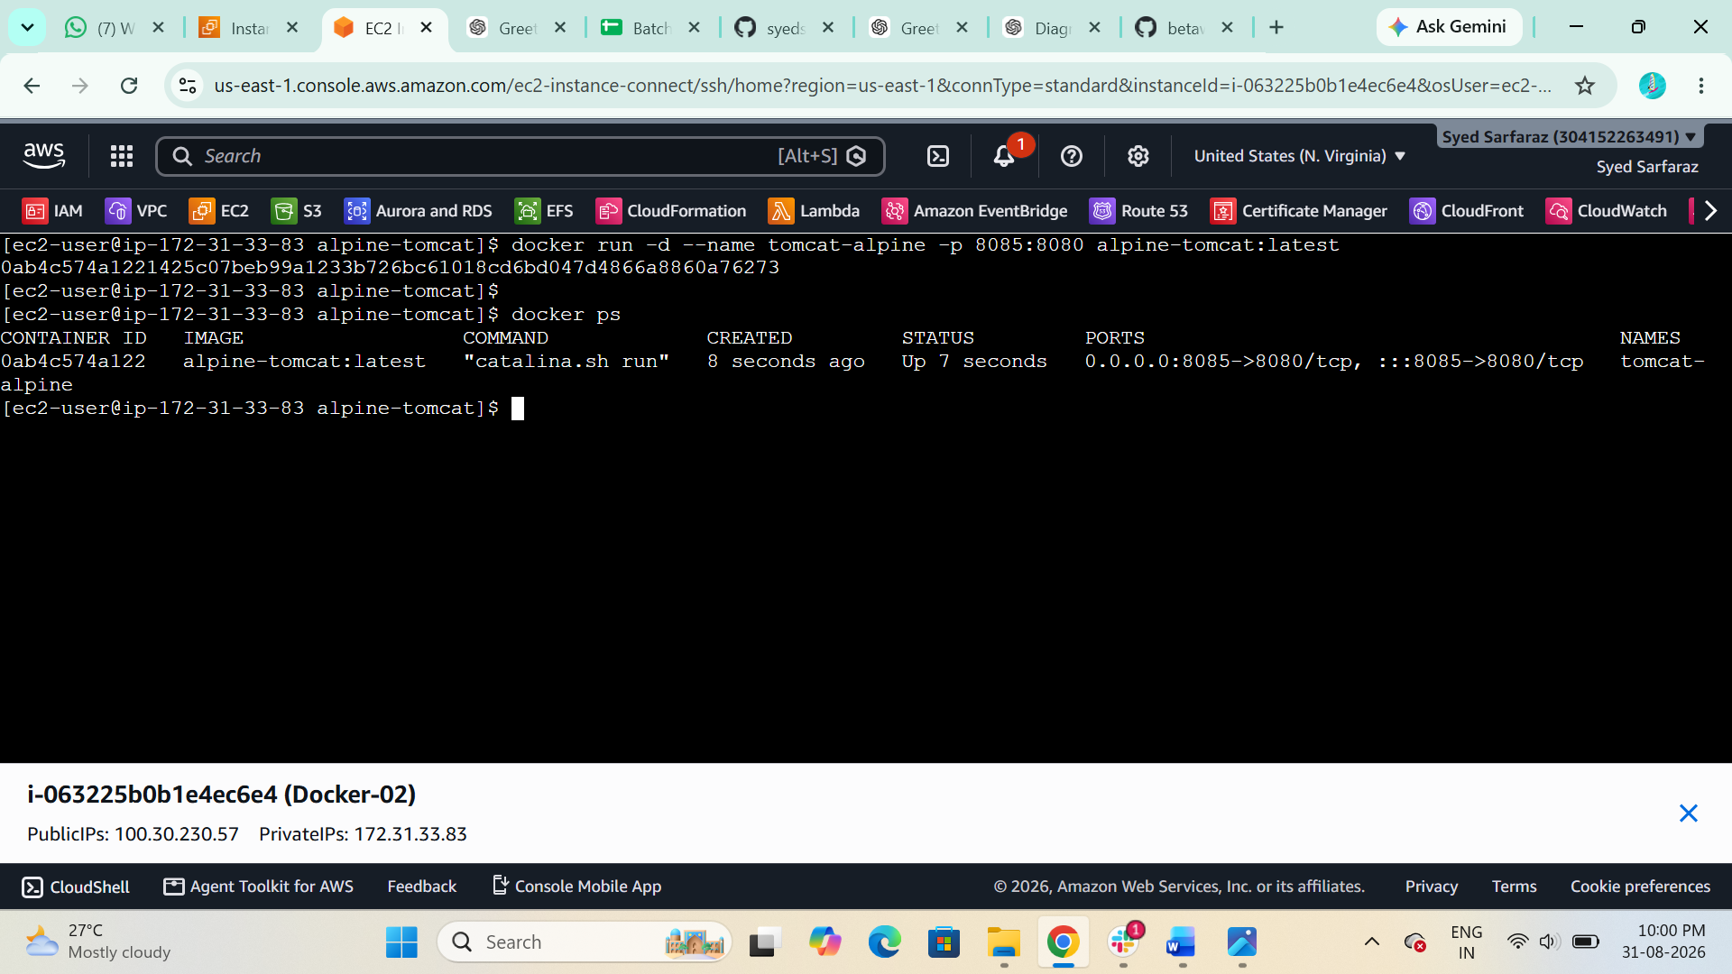

Step 5: Verify Tomcat
Open in your browser:
http://localhost:8080
You should get the Apache Tomcat page.
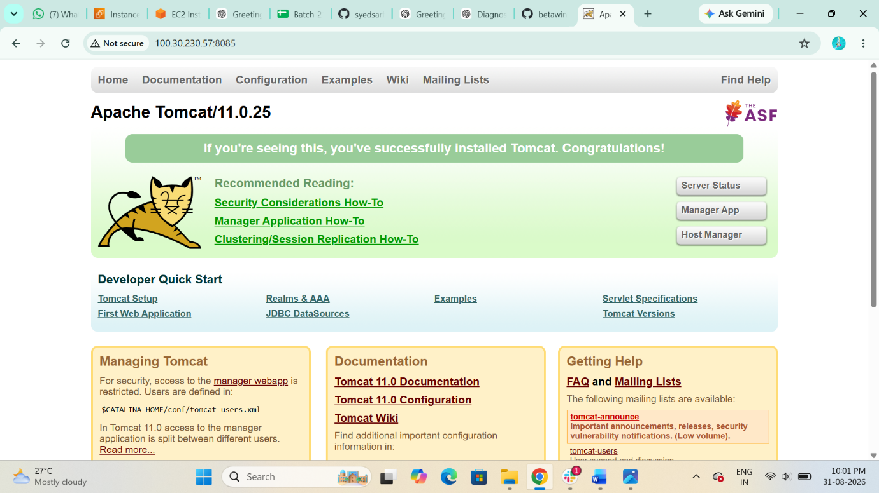

- Create single stage and multi stage docker file using this source code:https://github.com/betawins/multi-stage-example.git

You need to create two Dockerfiles:
- Single-stage Dockerfile
- Multi-stage Dockerfile

1. Clone the source code
On your AWS Linux machine:
$ git clone https://github.com/betawins/multi-stage-example.git
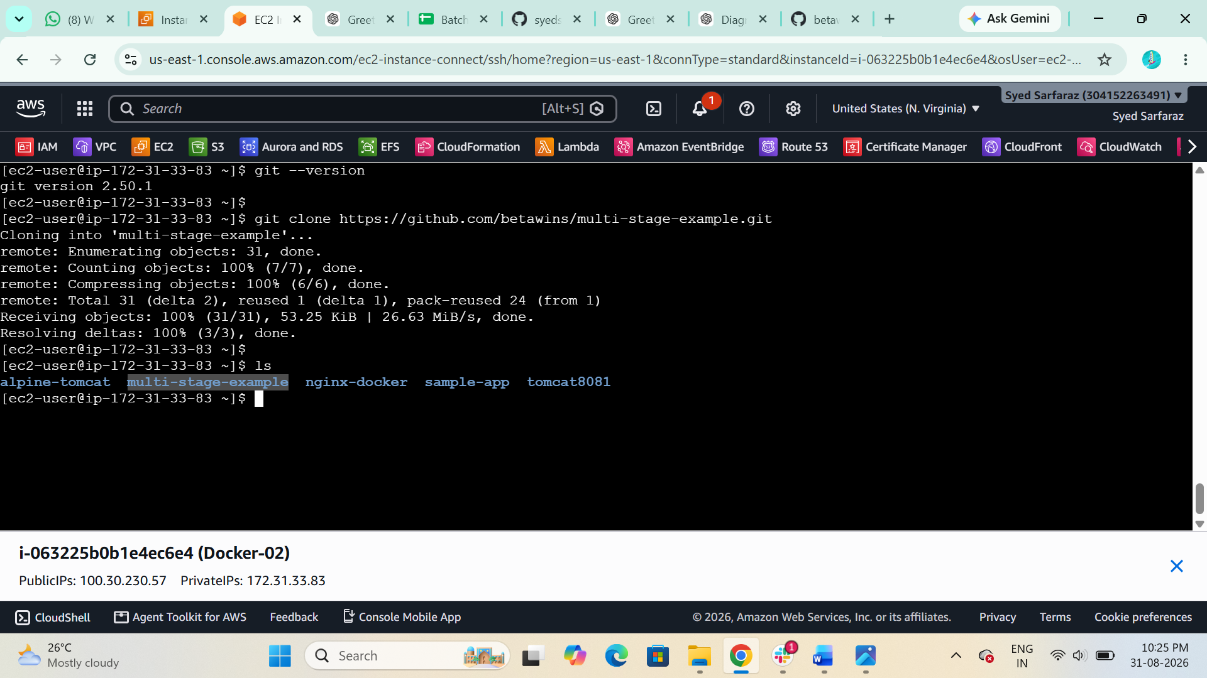
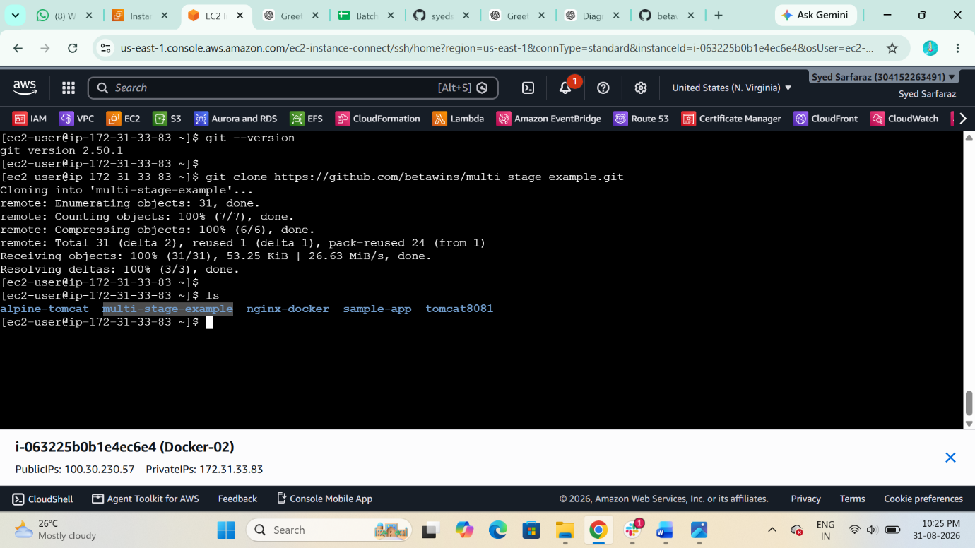

$ cd multi-stage-example
Check the files:
$ ls
You should see:
Dockerfile, pom.xml, src, mvnw
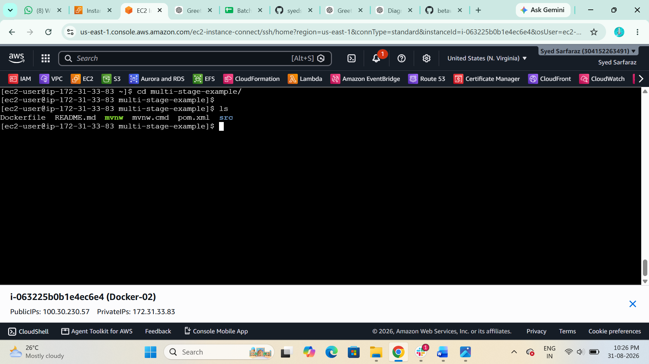

2. Create Single-Stage Dockerfile
$ vi Dockerfile.single

FROM maven:3.9-eclipse-temurin-17

WORKDIR /app

COPY pom.xml .
COPY src ./src

RUN mvn clean package -DskipTests

EXPOSE 8080

CMD ["java", "-jar", "target/*.jar"]

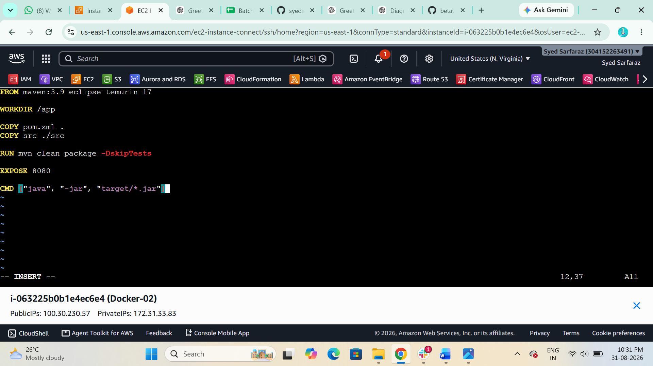

3. Build Single-Stage Image
$ docker build -f Dockerfile.single -t single-stage-single:v1 .
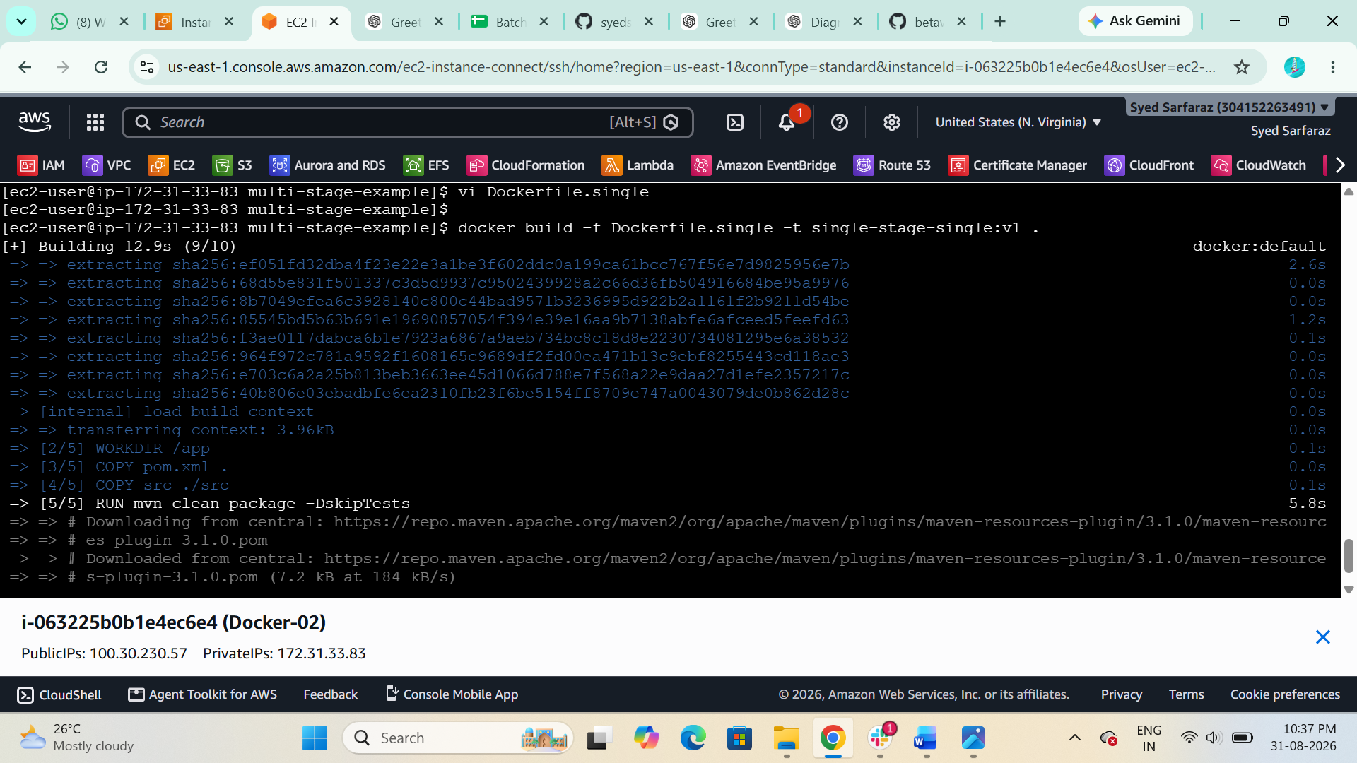
Verify:
$ docker images
You should see:
single-stage-single v1
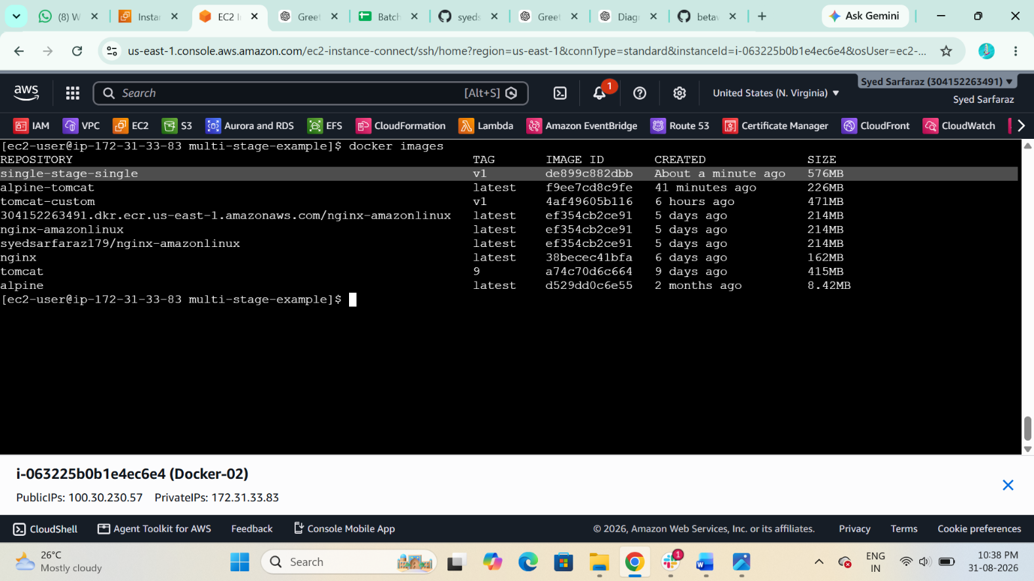

4. Run Single-Stage Container
$ docker run -d --name single-single -p 8080:8080 single-stage-single:v1
Check:
$ docker ps
Test:
curl http://localhost:8080
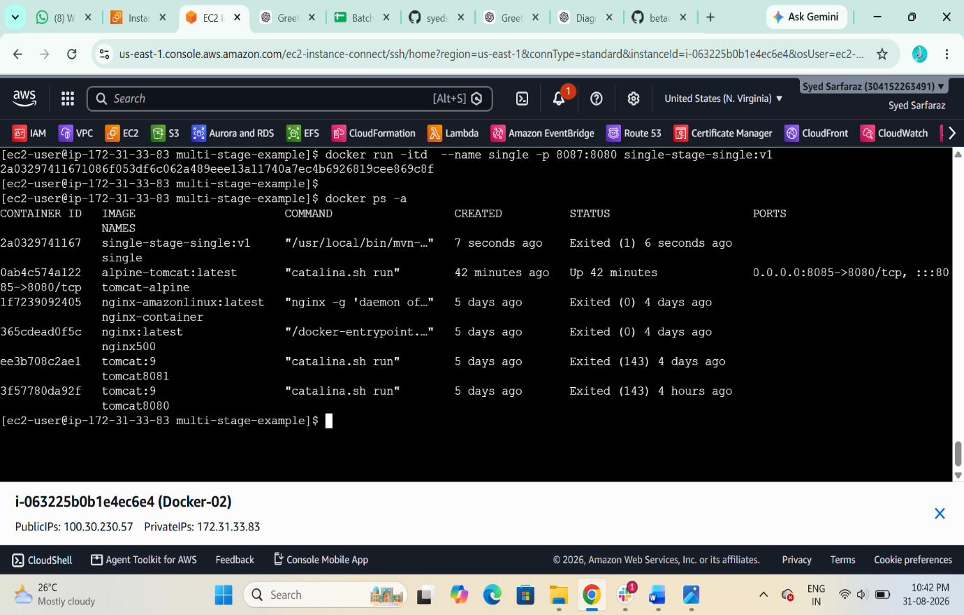

5. Create Multi-Stage Dockerfile
Now create:
vi Dockerfile.multi

# Stage 1: Build
FROM maven:3.9-eclipse-temurin-17 AS builder

WORKDIR /app

COPY pom.xml .
COPY src ./src

RUN mvn clean package -DskipTests

# Stage 2: Runtime
FROM eclipse-temurin:17-jre

WORKDIR /app

COPY --from=builder /app/target/*.jar app.jar

EXPOSE 8080

CMD ["java", "-jar", "app.jar"]

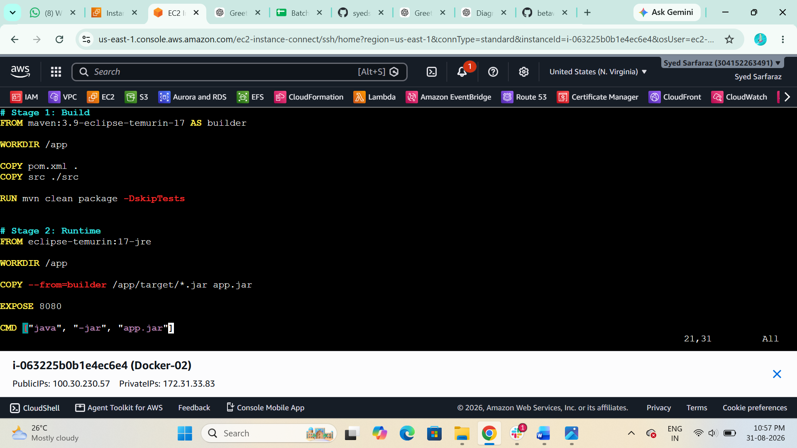

6. Build Multi-Stage Image
$ docker build -f Dockerfile.multi -t multi-stage:v1 .
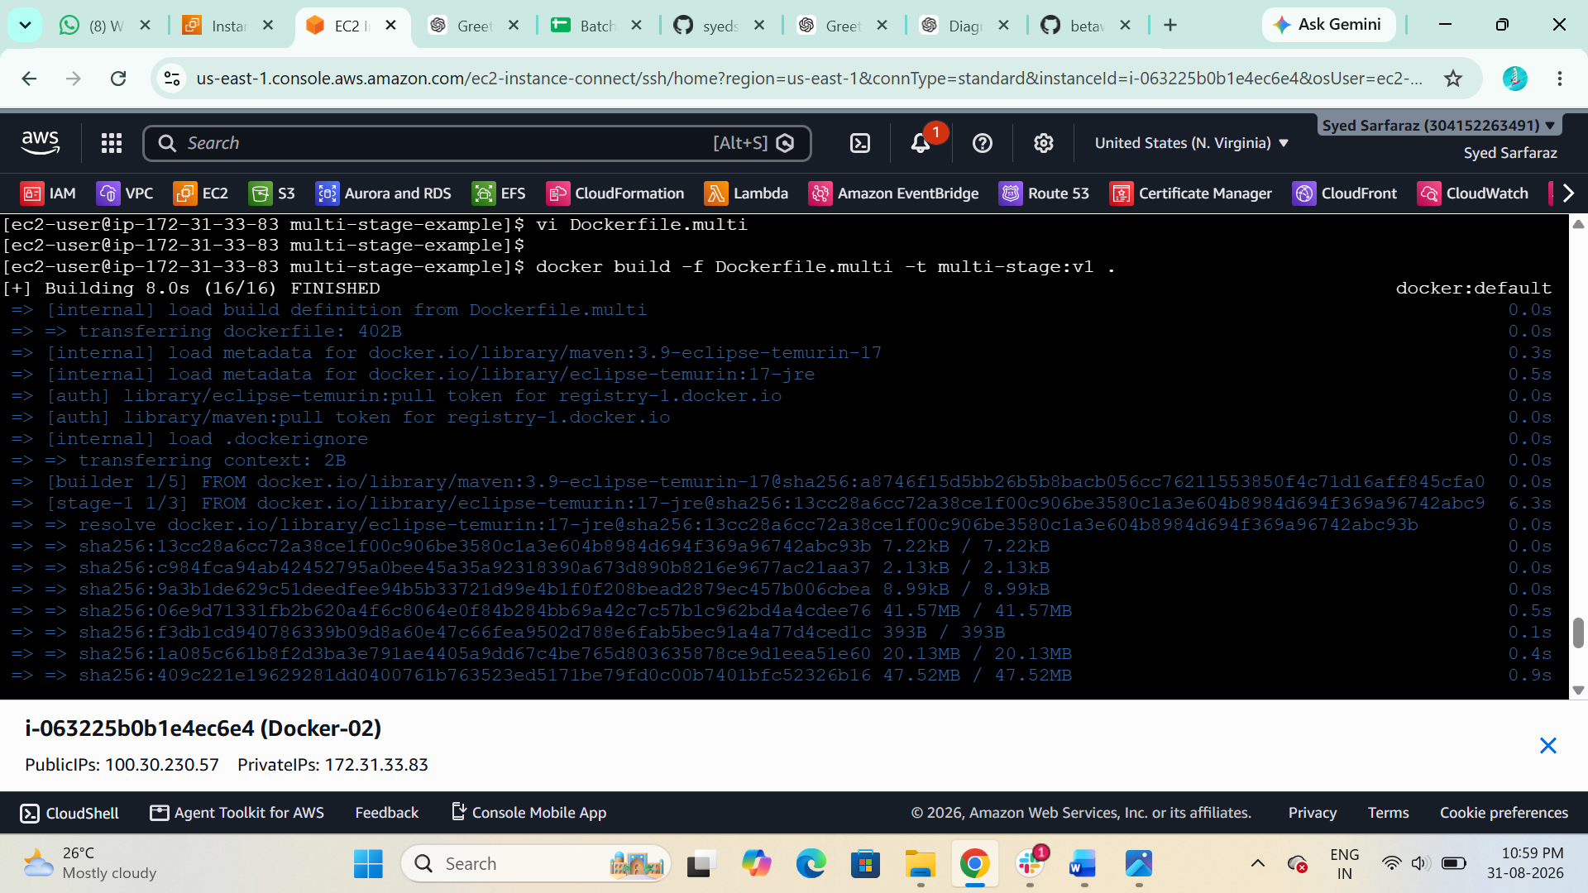
Verify:
$ docker images
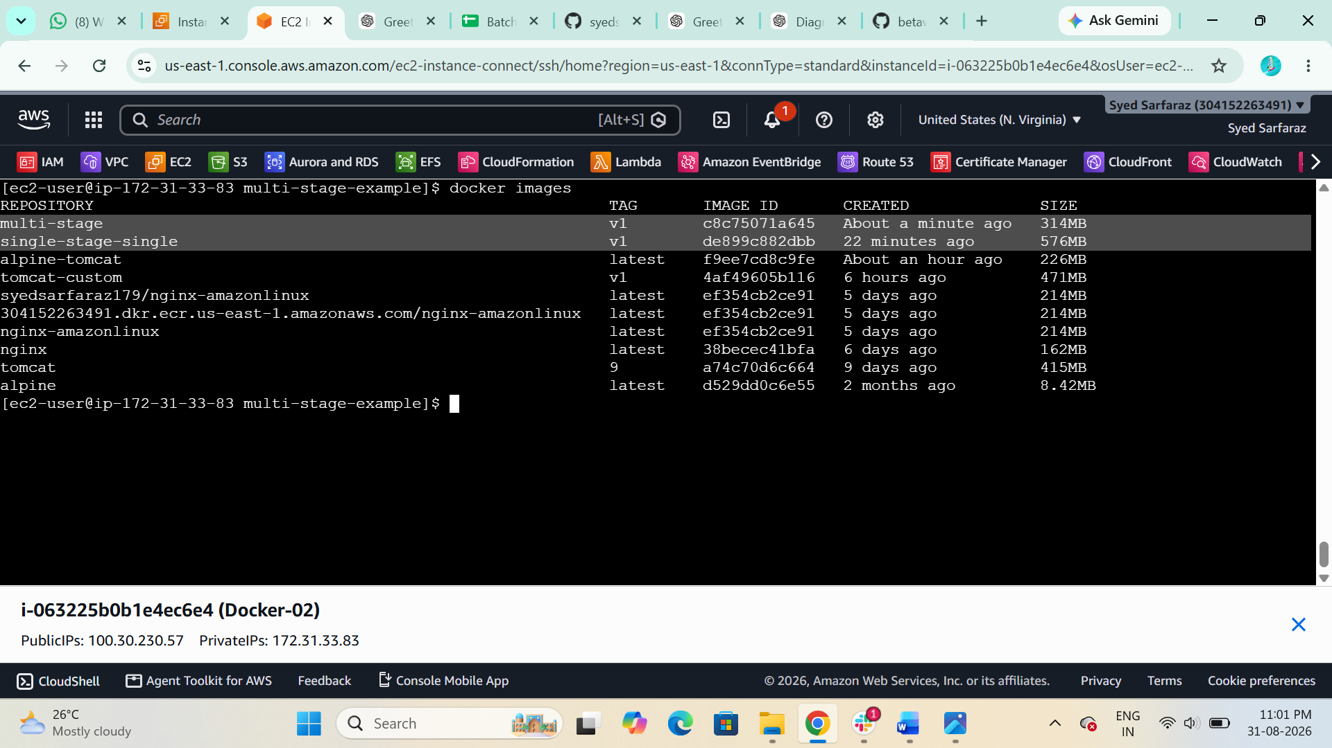

7. Run Multi-Stage Container
Now run the multi-stage image:
$ docker run -d --name multi-stage -p 8080:8080 multi-stage:v1

Check:
$ docker ps
Test:
curl http://localhost:8080
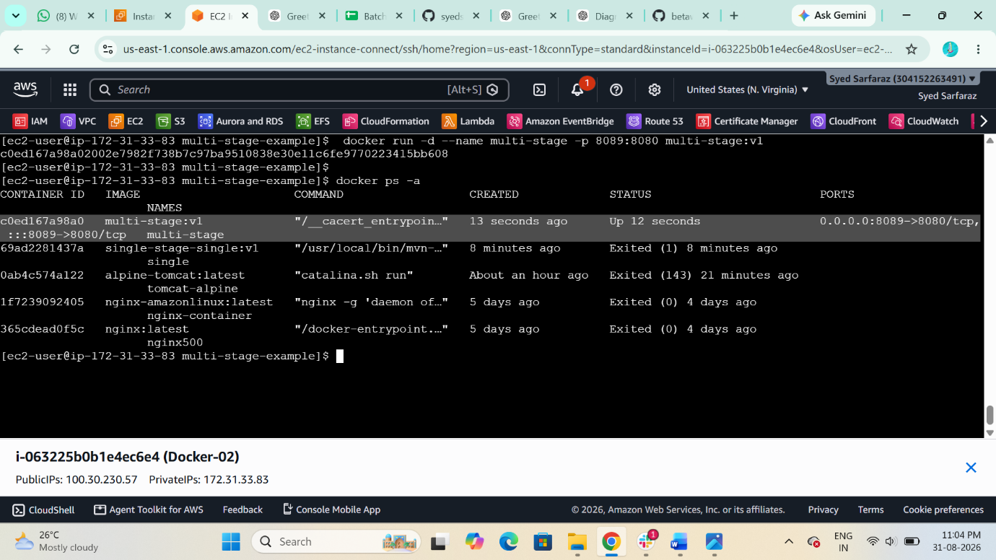

Final verification
You should have:
$ docker images

REPOSITORY TAG IMAGE ID CREATED SIZE
multi-stage v1 c8c75071a645 9 minutes ago 314MB
single-stage-single v1 de899c882dbb 31 minutes ago 576MB

- Install docker compose and execute sample application.

1. Verify Docker
docker --version
Also check:
docker ps
If Docker is running, continue.

Step 2 — Download Docker Compose
Run:
sudo curl -SL https://github.com/docker/compose/releases/latest/download/docker-compose-linux-x86_64 \
-o /usr/local/bin/docker-compose
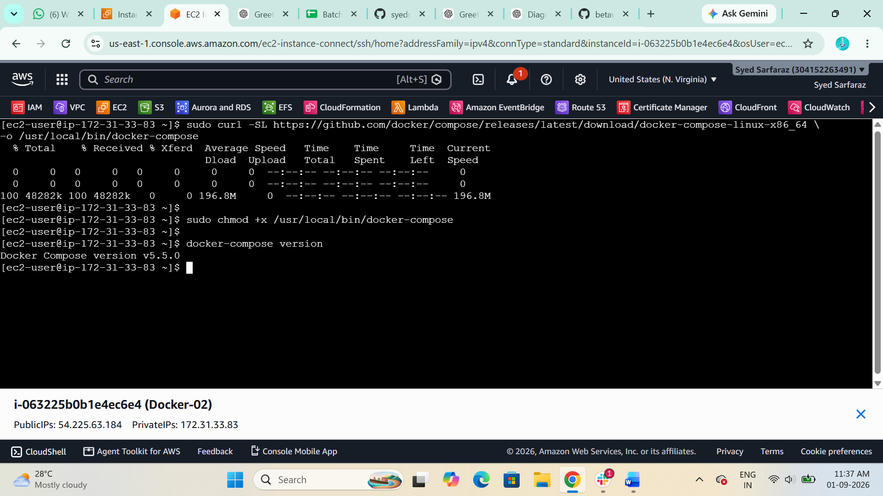

Step 3 — Give execute permission
sudo chmod +x /usr/local/bin/docker-compose

Step 4 — Verify installation
docker-compose version


Step 5 — Continue your sample application
Create the directory:
$ mkdir compose-demo
$ cd compose-demo
Create the Compose file:
$ vi docker-compose.yml
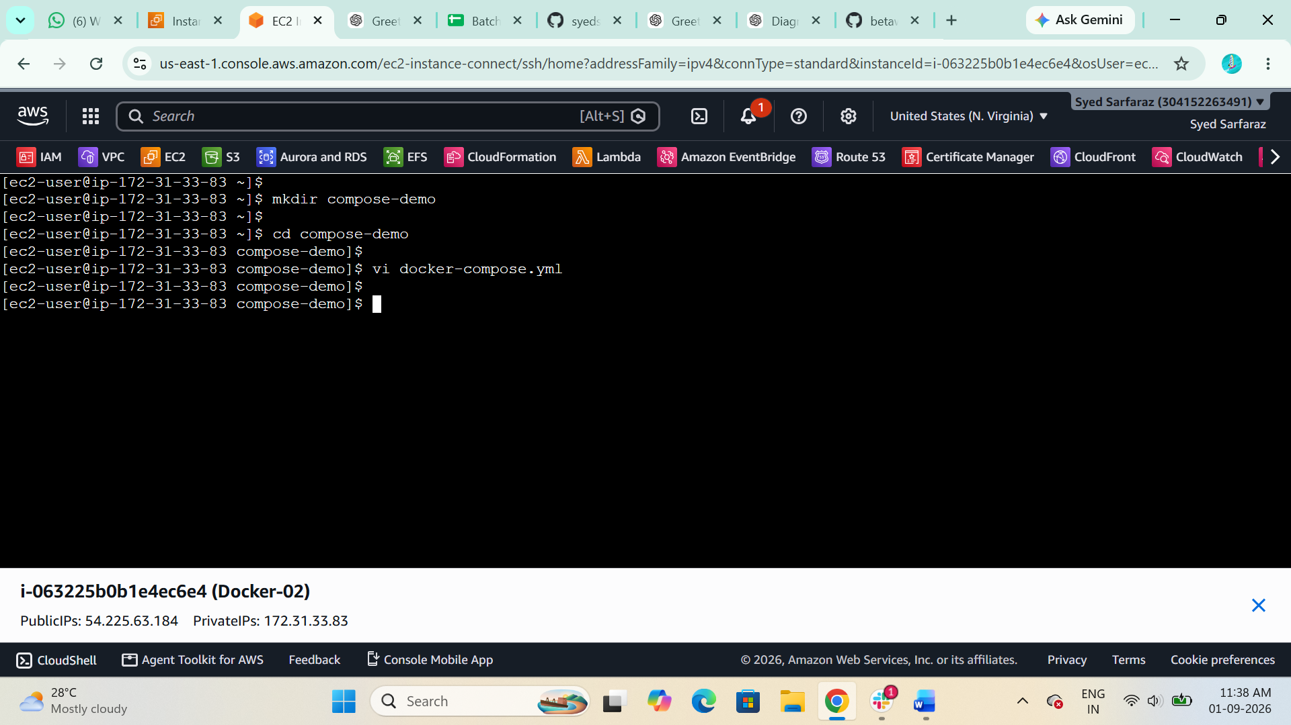
Add:
services:
web:
image: nginx:latest
ports:
- "8080:80"
Save:
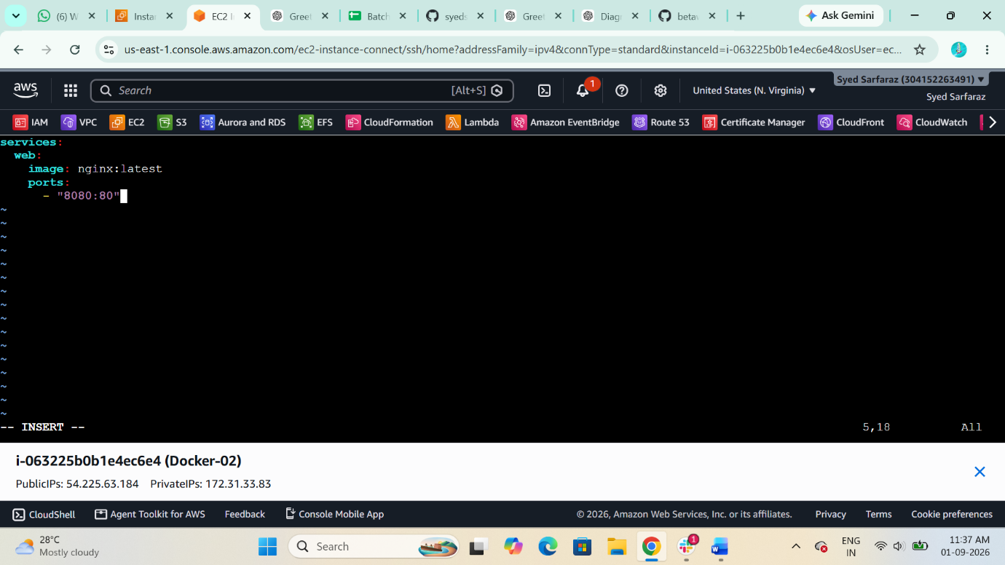
Start it:
docker-compose up -d

Verify:
docker-compose ps
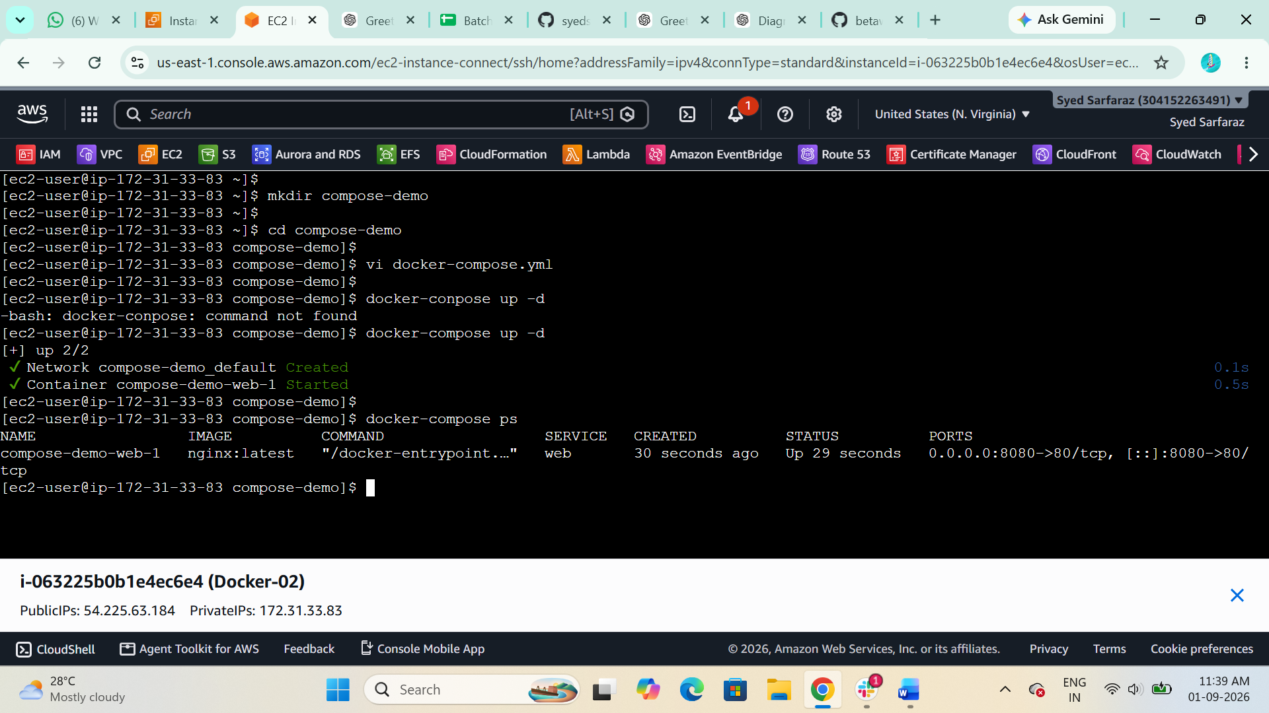
Test:
curl http://localhost:8080
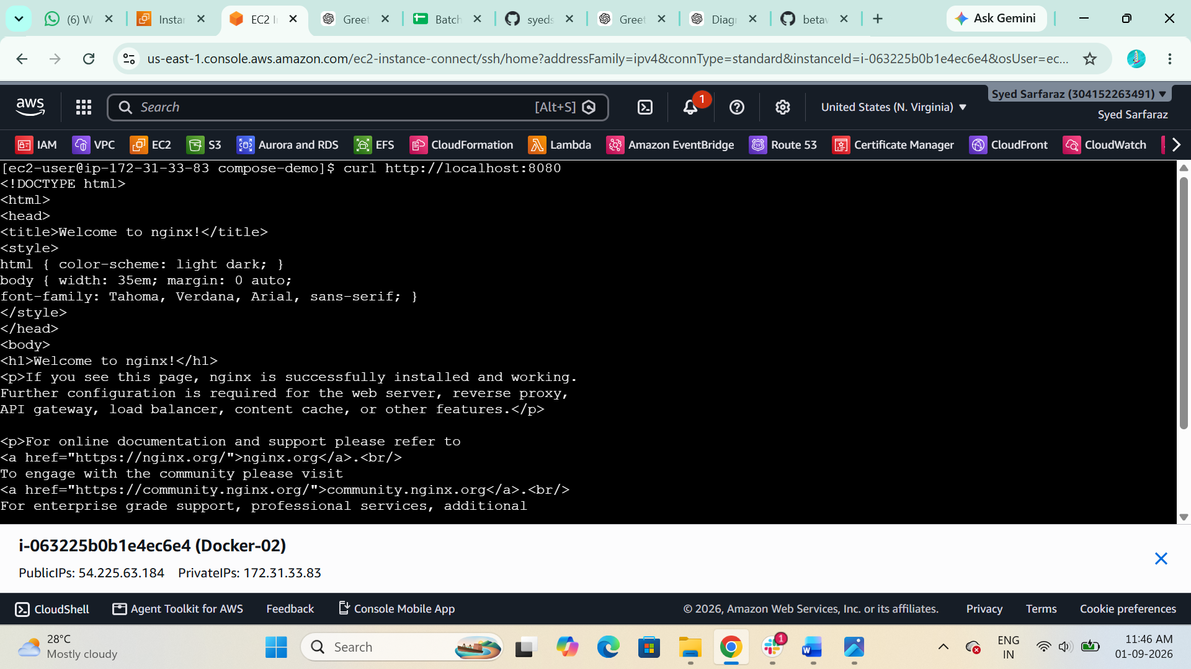

- Implement solution to scan images when pushed to docker registry.

Login to your Docker Hub Account

- Docker Hub Create a New Repositories Settings Docker Scout image analysis
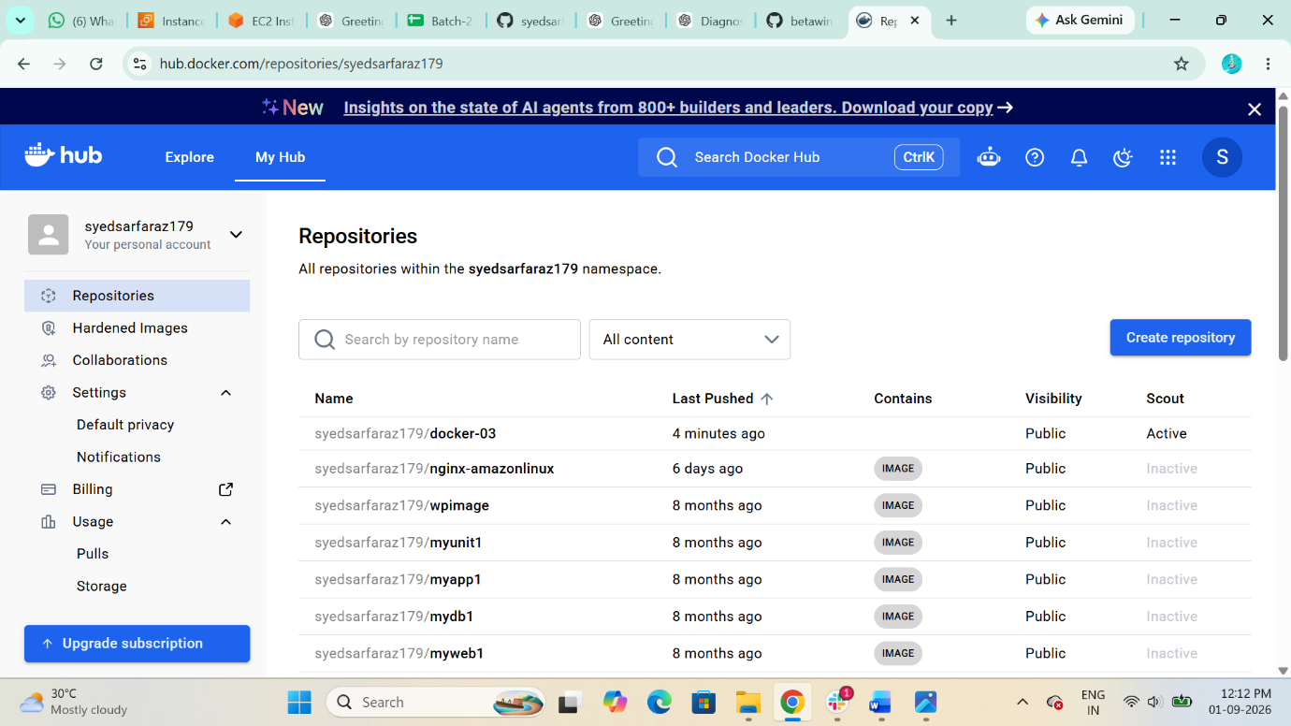

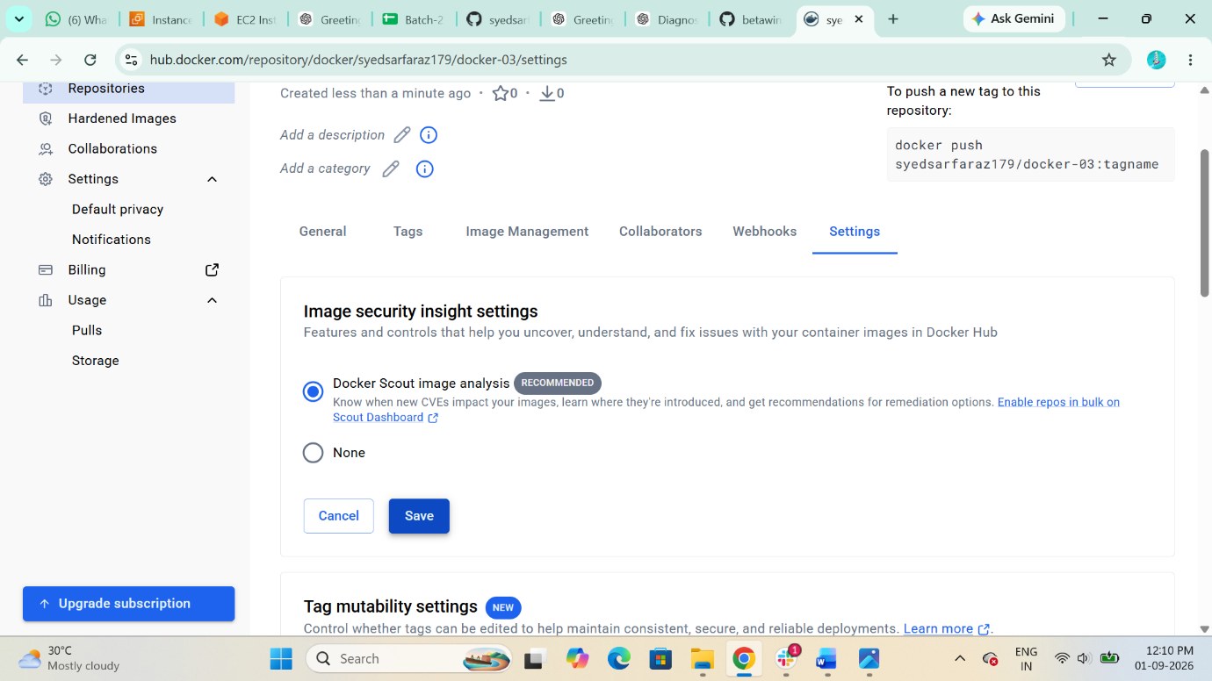
Now Docker Scout image analysis is Activated

Now Log to you Docker hub from your docker host to push the image
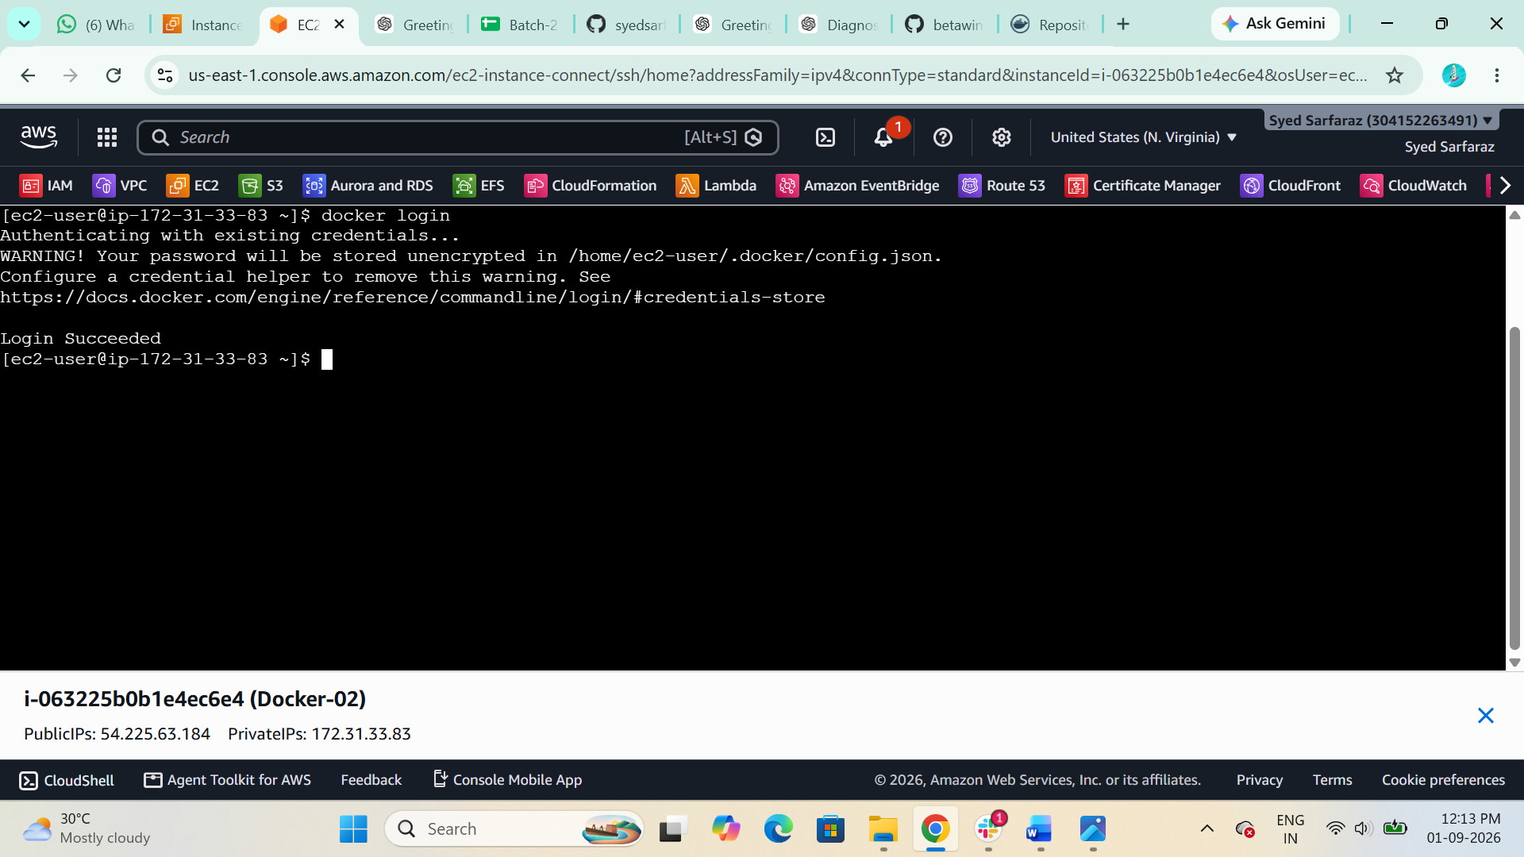

Now Tag your Image and Push the Image to docker hub
$ docker tag multi-stage:v1 syedsarfaraz179/docker-03
$ docker push syedsarfaraz179/docker-03
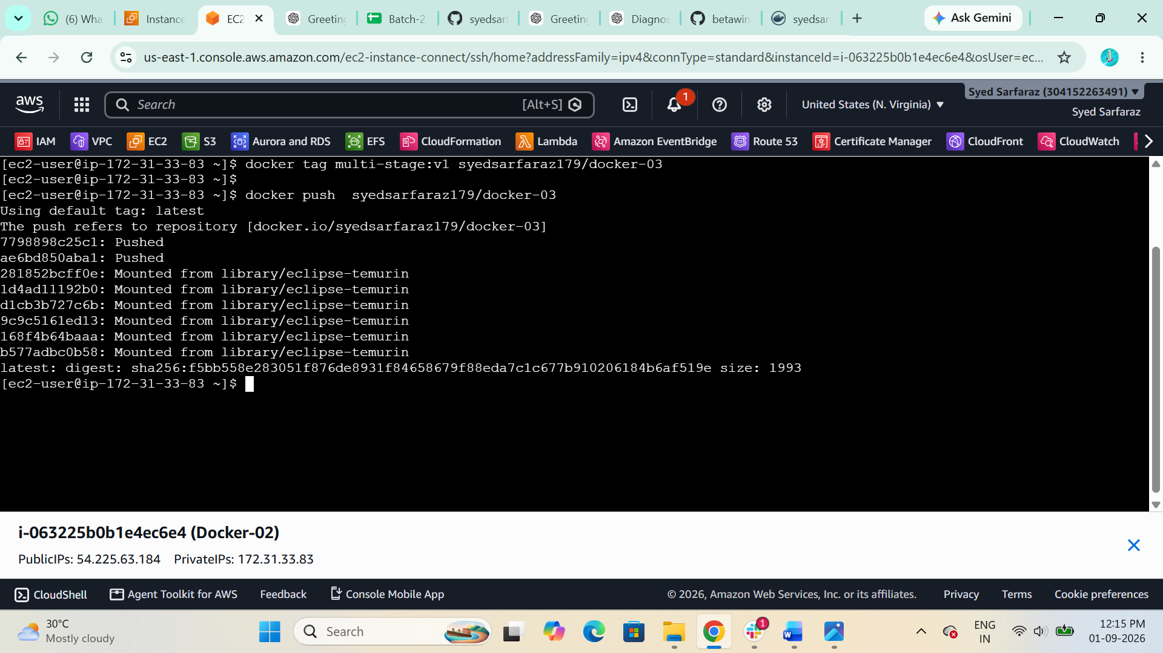

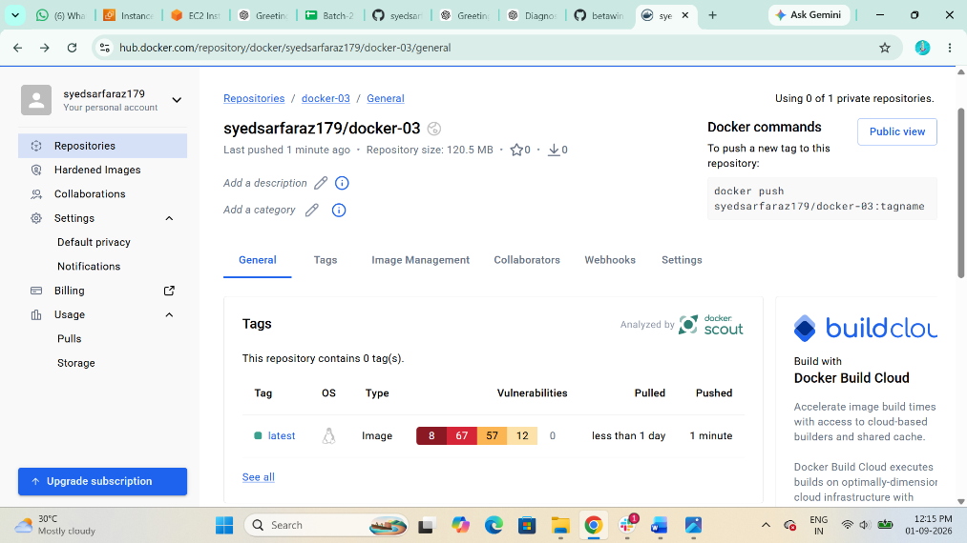
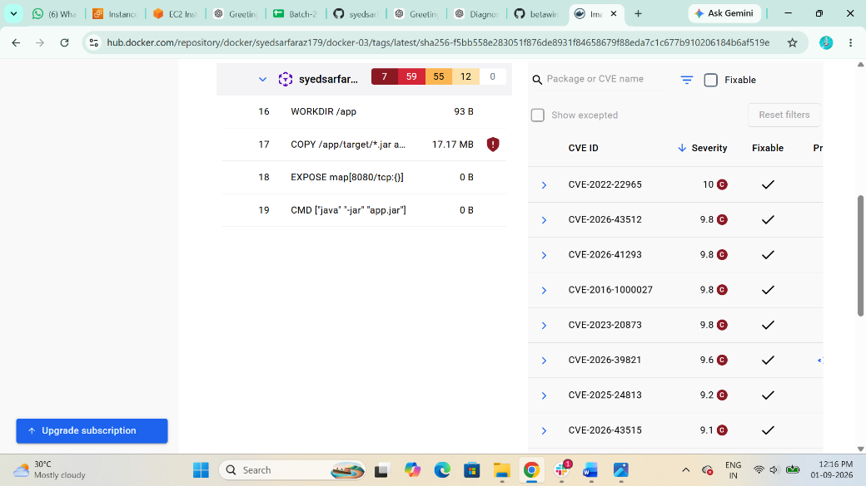

- Implement solution to scan images when pushed to AWS ECR
1 Search Amazon ECR Private Registry Repositories create New Repositories
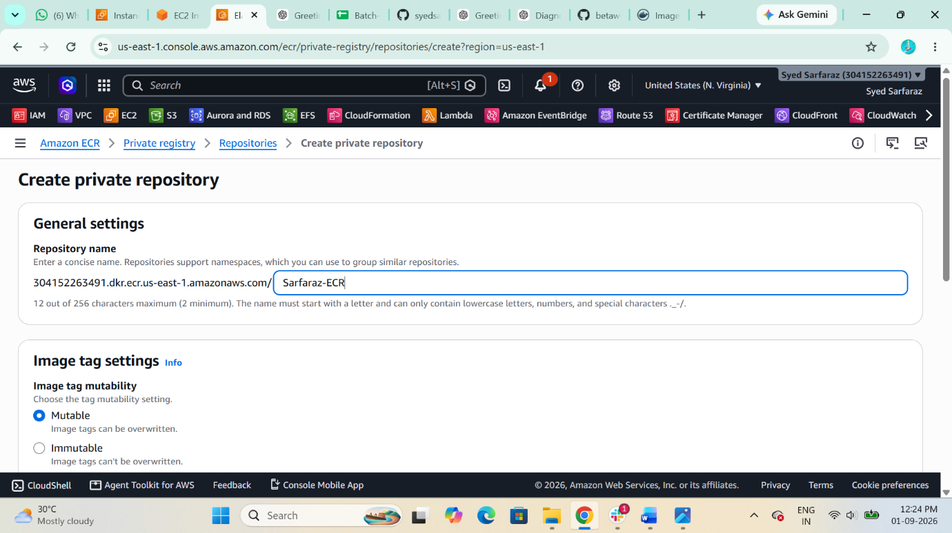

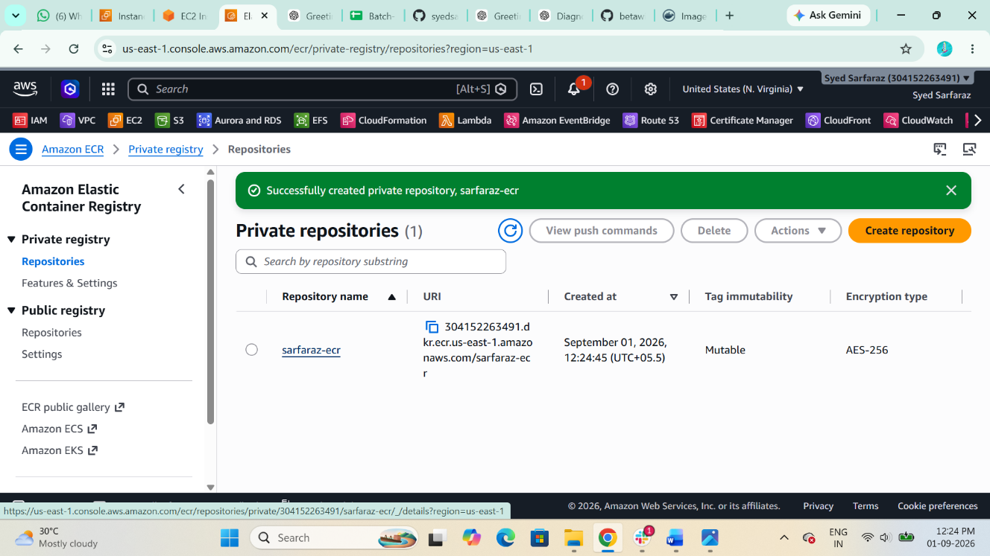

Turn On the Scan in Repositorie: Scanning Scan type Basic scanning select on push all Repositories
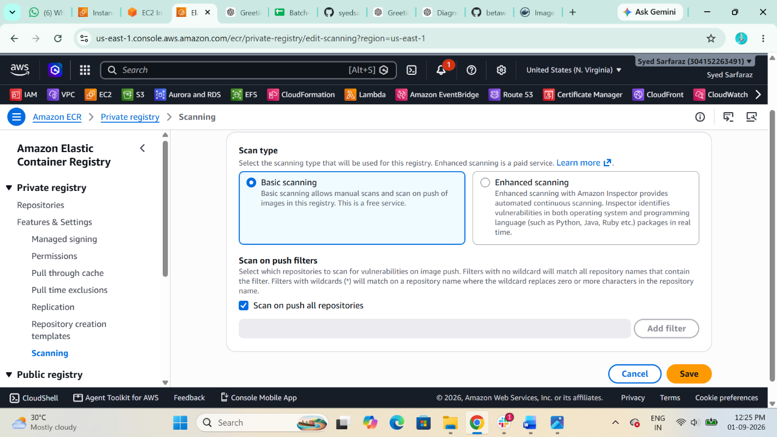

Configure AWS with Access key and Secret Access Key
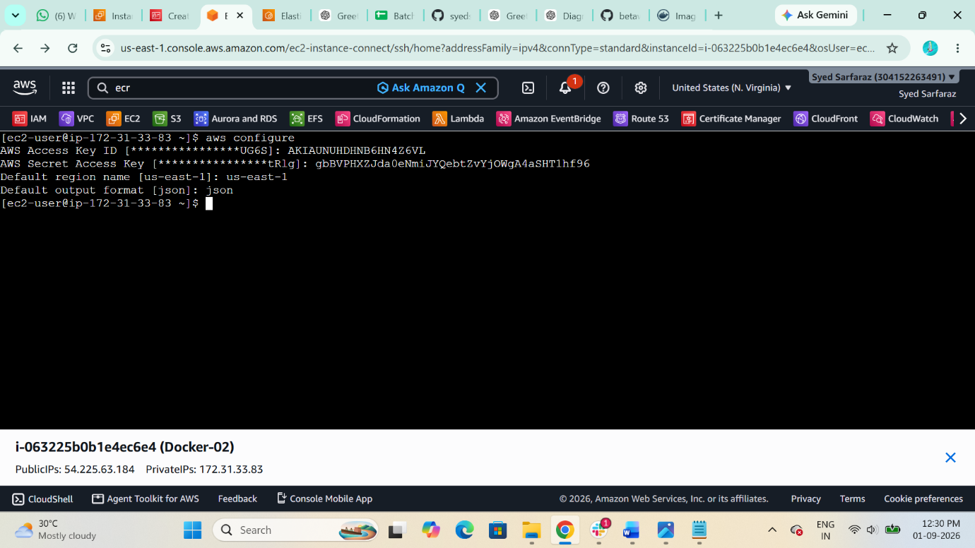

Now login to your ECR with Docker Host
$ aws ecr get-login-password --region us-east-1 | docker login --username AWS --password-stdin 304152263491.dkr.ecr.us-east-1.amazonaws.com
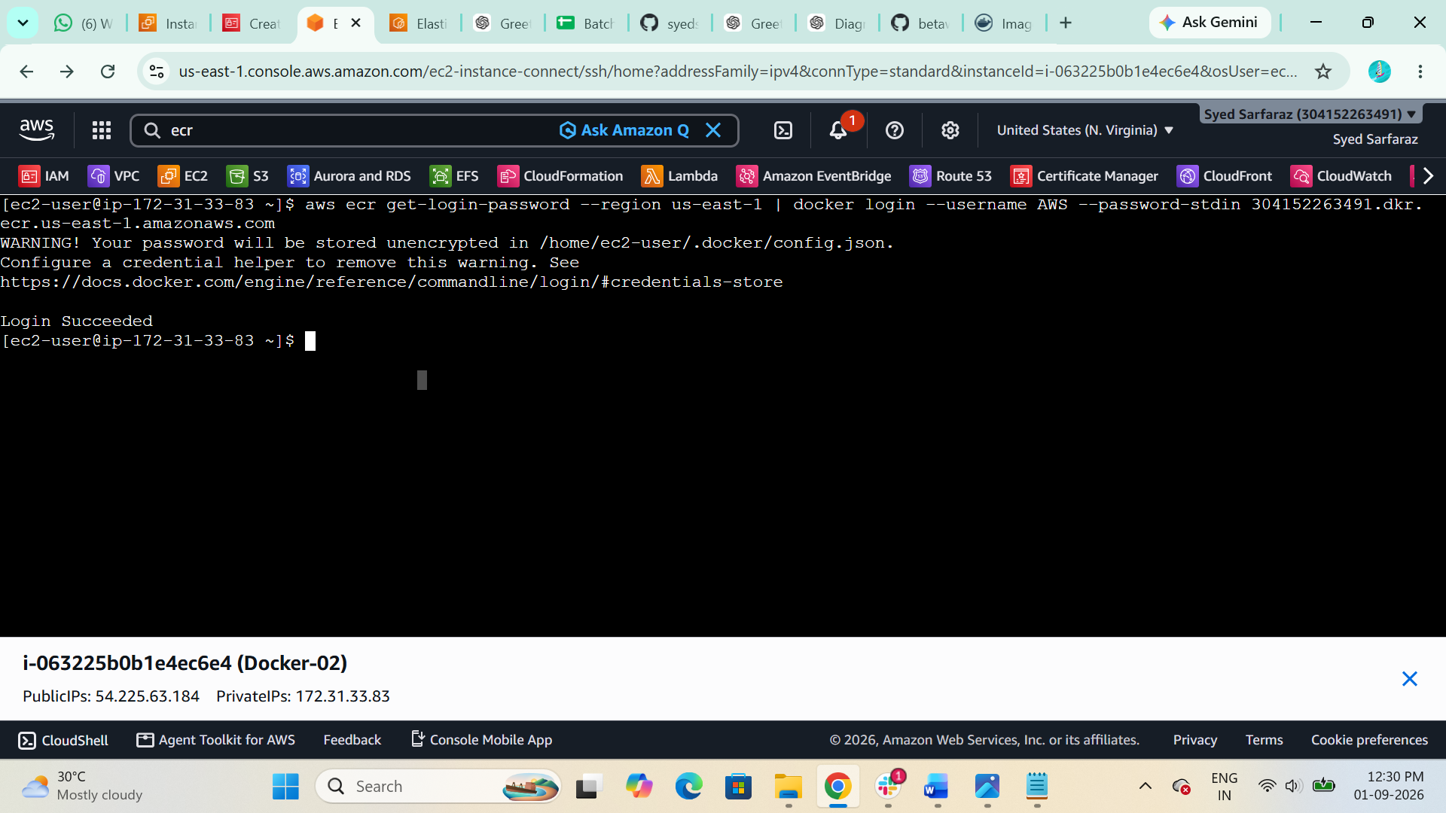

Now Tag you Image
$ docker tag multi-stage:v1 304152263491.dkr.ecr.us-east-1.amazonaws.com/sarfaraz-ecr:latest
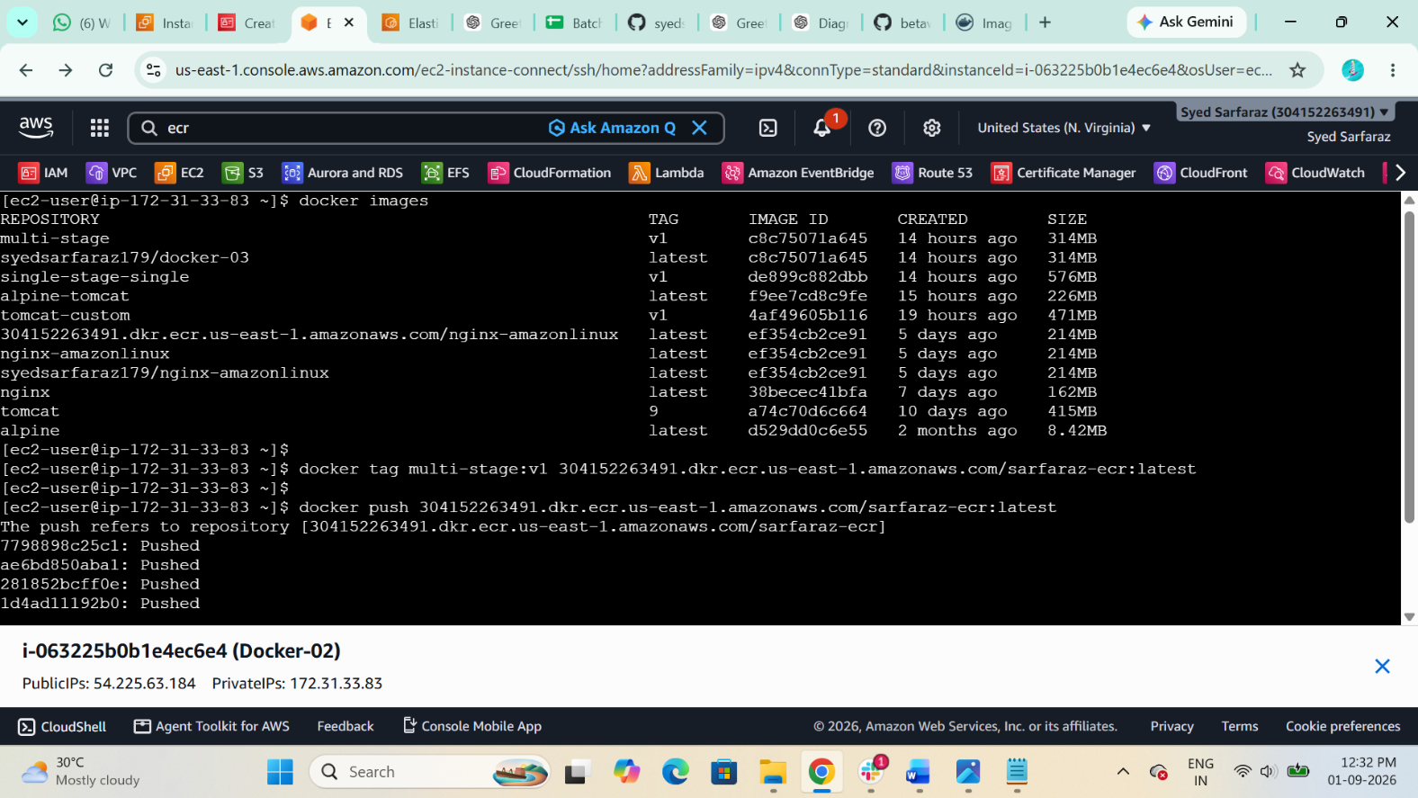

Now push you Image to AWS ECR
docker push 304152263491.dkr.ecr.us-east-1.amazonaws.com/sarfaraz-ecr:latest
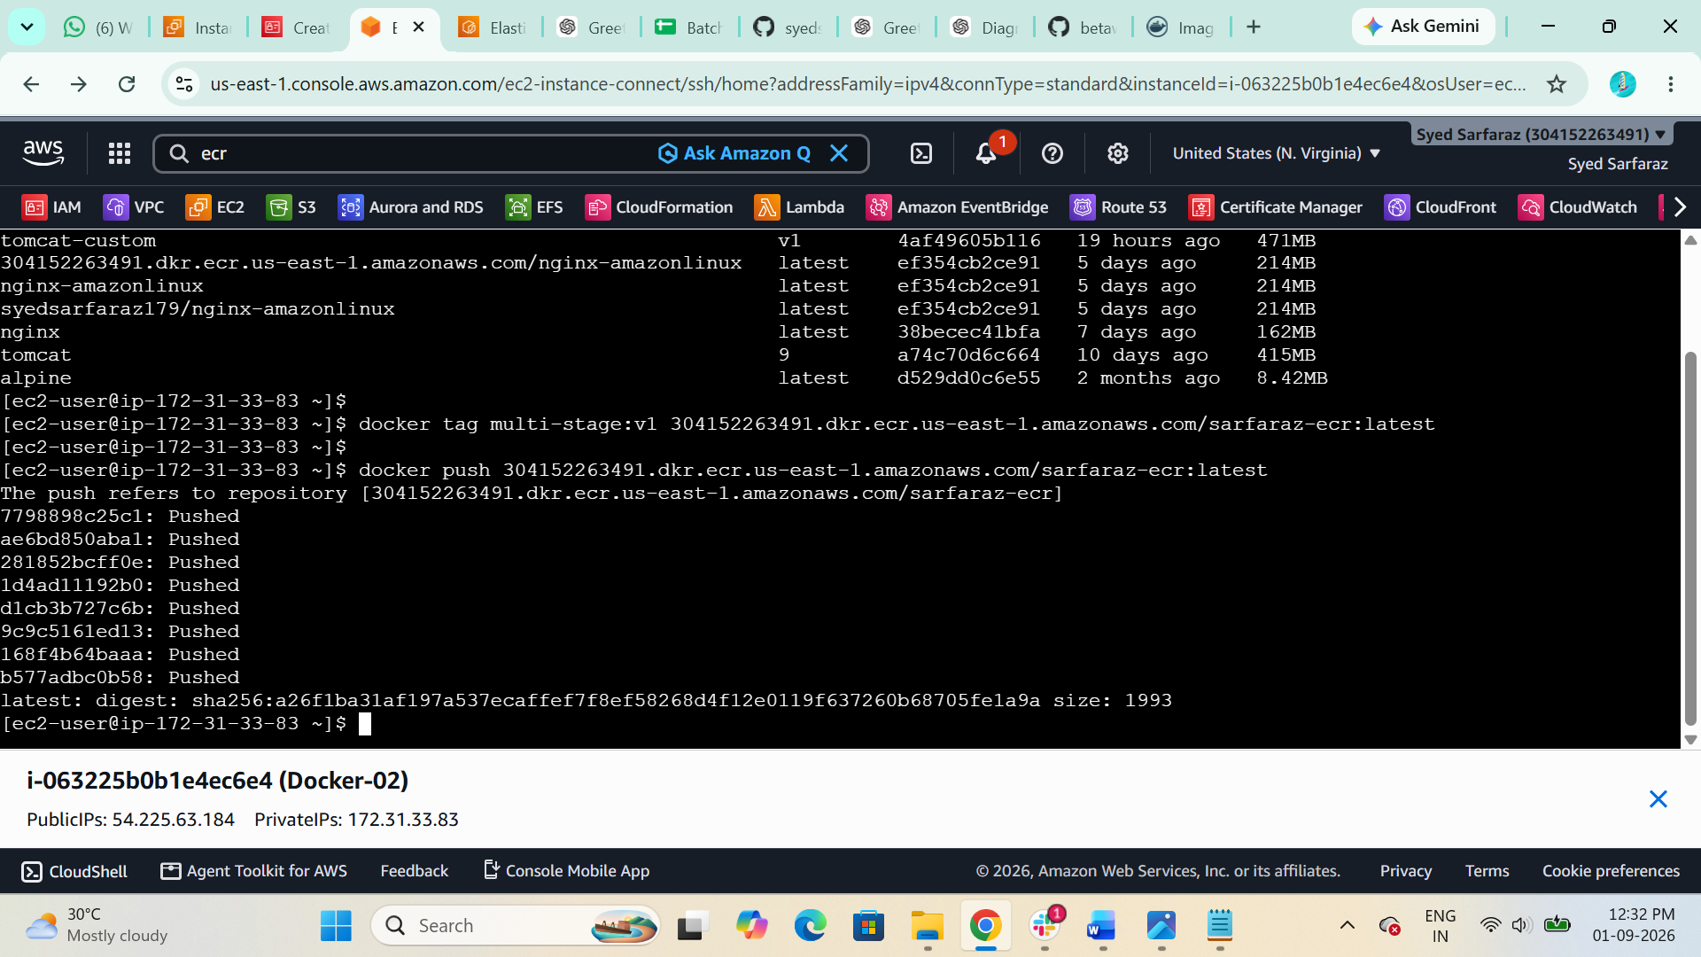

Image has successfully Pushed to AWS ECR and Scanning images also Completed
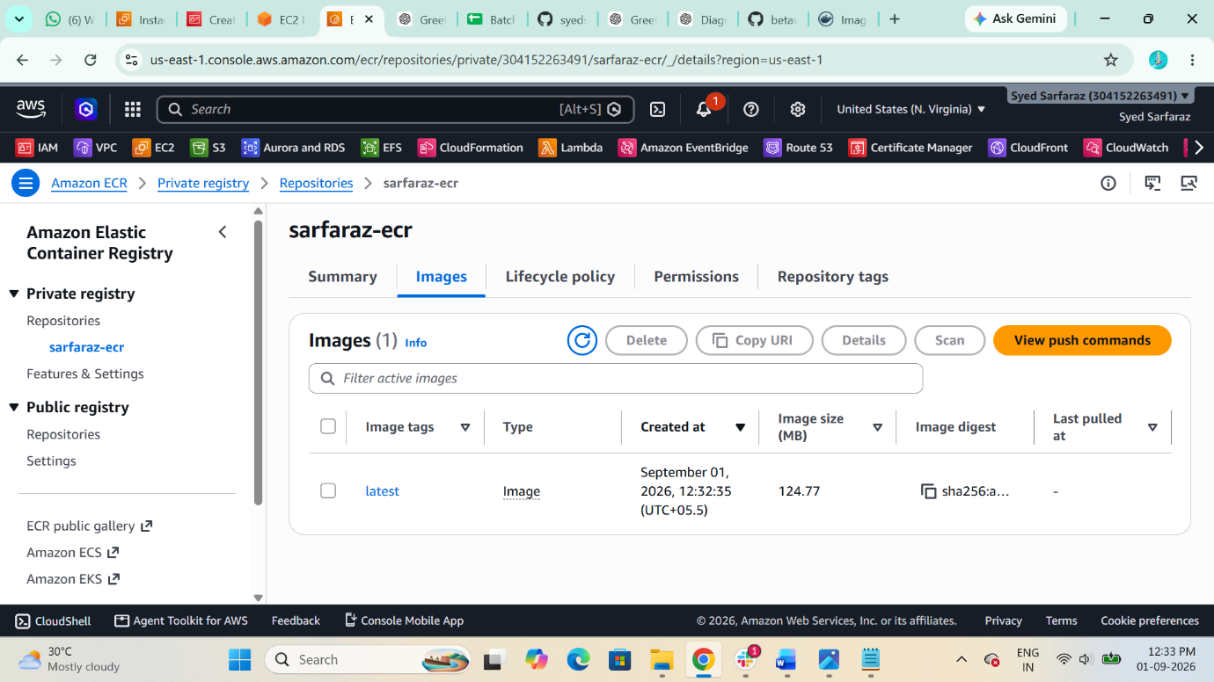

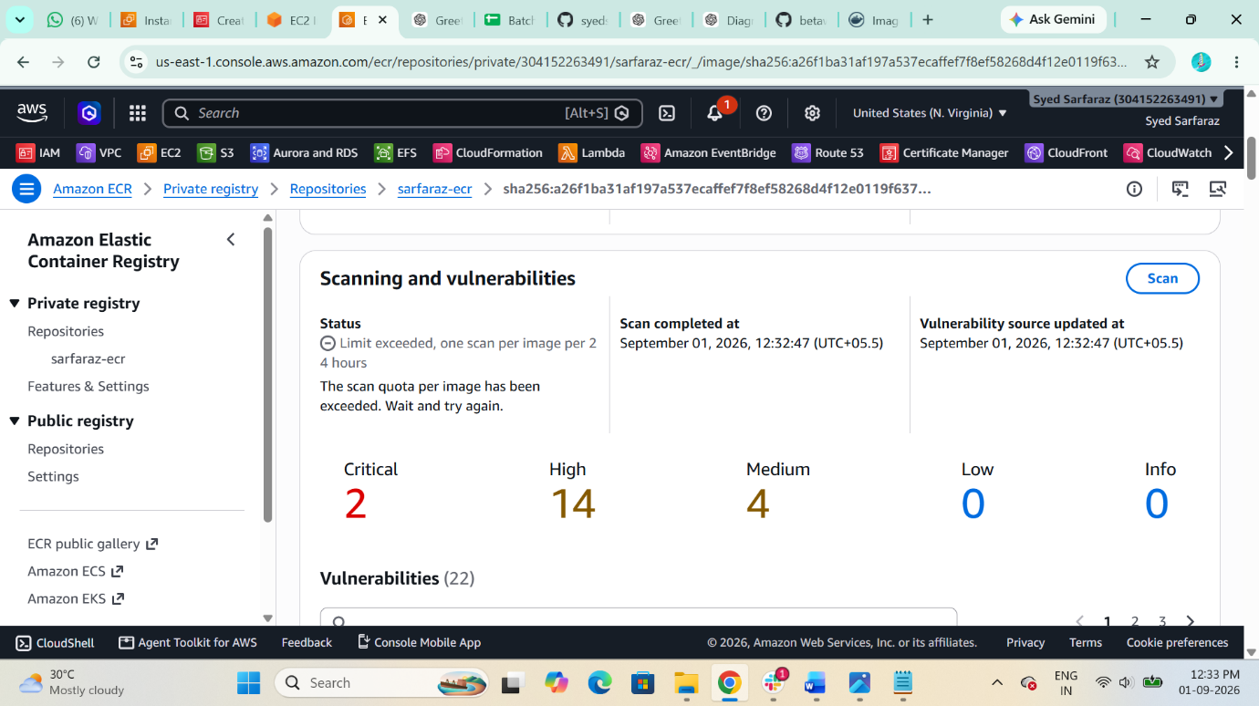

- Create a Jenkins pipeline to create a docker image and push the image to Docker hub.

Step 1 Run Jenkins with Docker socket access:
$ docker run -d --name jenkins -p 8080:8080 -p 50000:50000 -v jenkins_home:/var/jenkins_home -v /var/run/docker.sock:/var/run/docker.sock jenkins/jenkins:lts
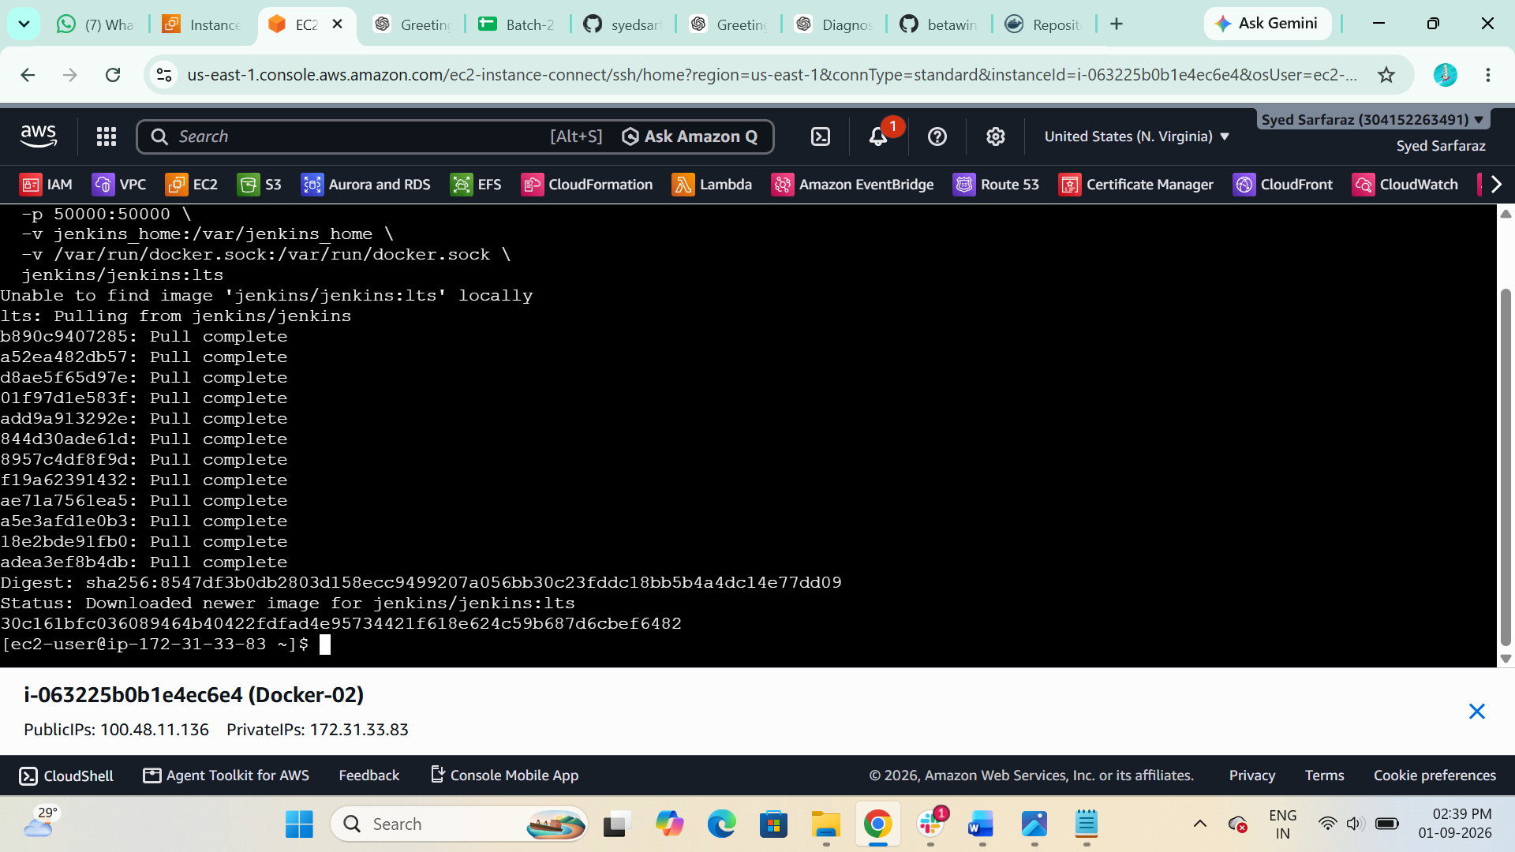

Install docker in Jenkins container
Step 2 Enter Jenkins container
$ docker exec -it -u sudo jenkins bash

Check OS:
$ cat /etc/os-release

For the official Jenkins image, install Docker CLI:
$ apt-get update
$ apt-get install -y docker.io

Verify:
$ docker –version

Then:
exit

Step 3 — Check Docker socket GID
You're currently able to enter the container as root. Run:
$ s -ln /var/run/docker.sock
You should see something like:
srw-rw---- 1 0 993 ... /var/run/docker.sock
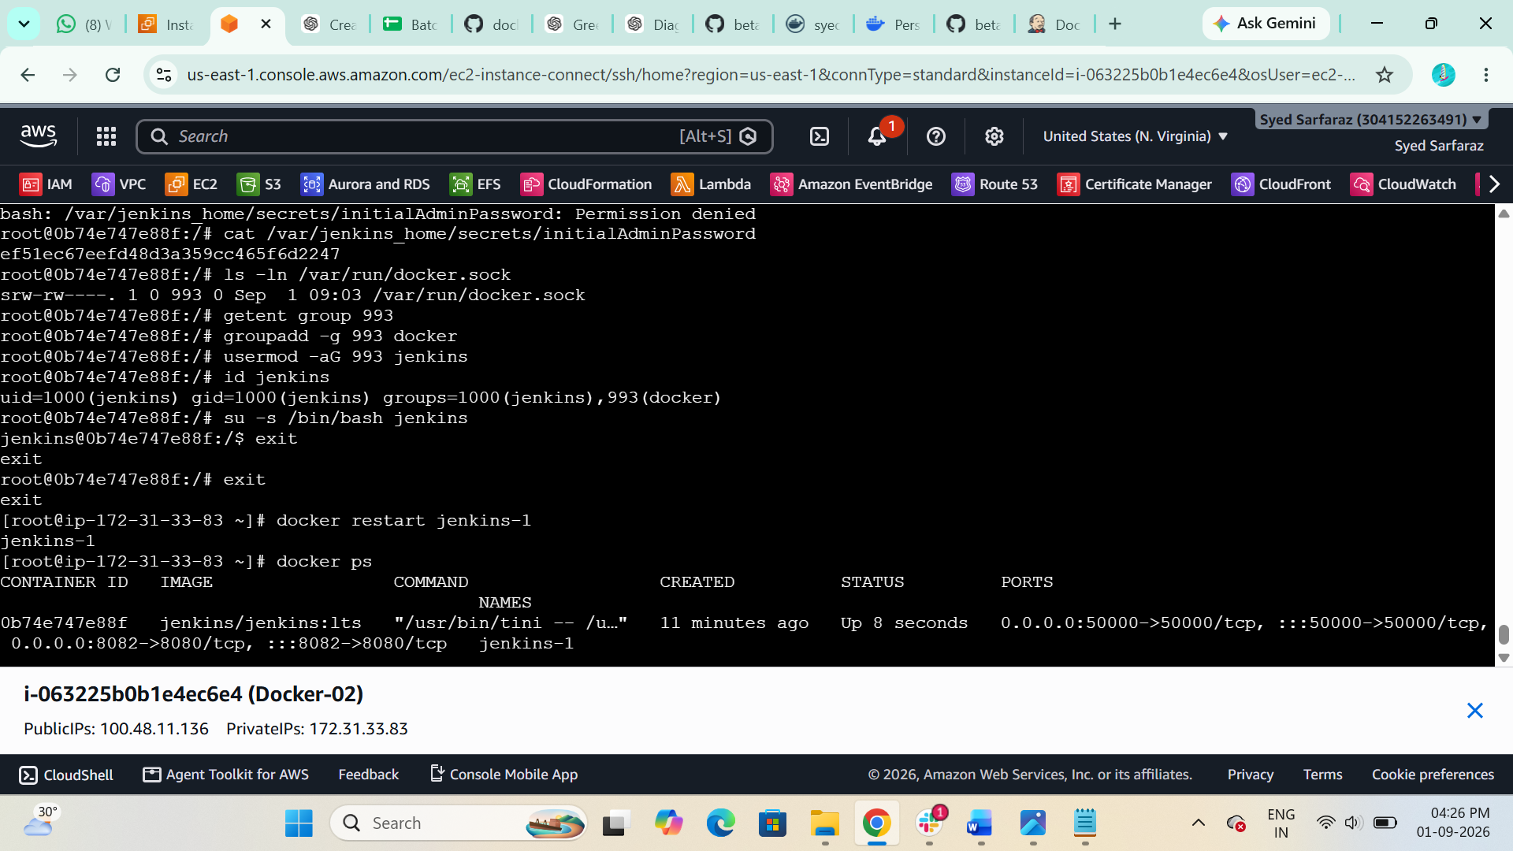
The important number is:
993

Step 4 — Check whether group 993 exists
Run:
$ getent group 993
It may return something like:
docker:x:993:
If it returns nothing, create a group with GID 993:
$ groupadd -g 993 docker
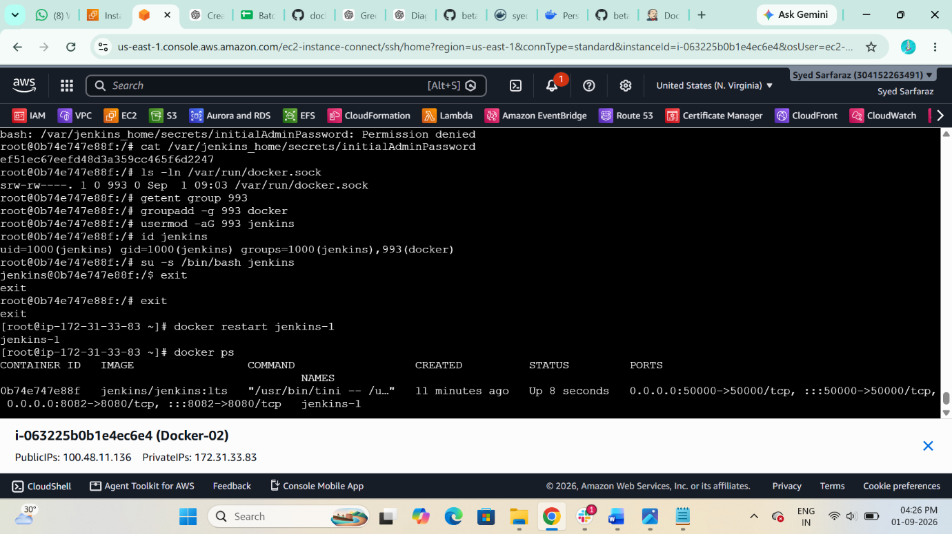

Step 5 — Add Jenkins user to that group
Run:
$ usermod -aG 993 jenkins
Then verify:
$ id jenkins


Step 6 Restart your Jenkins container
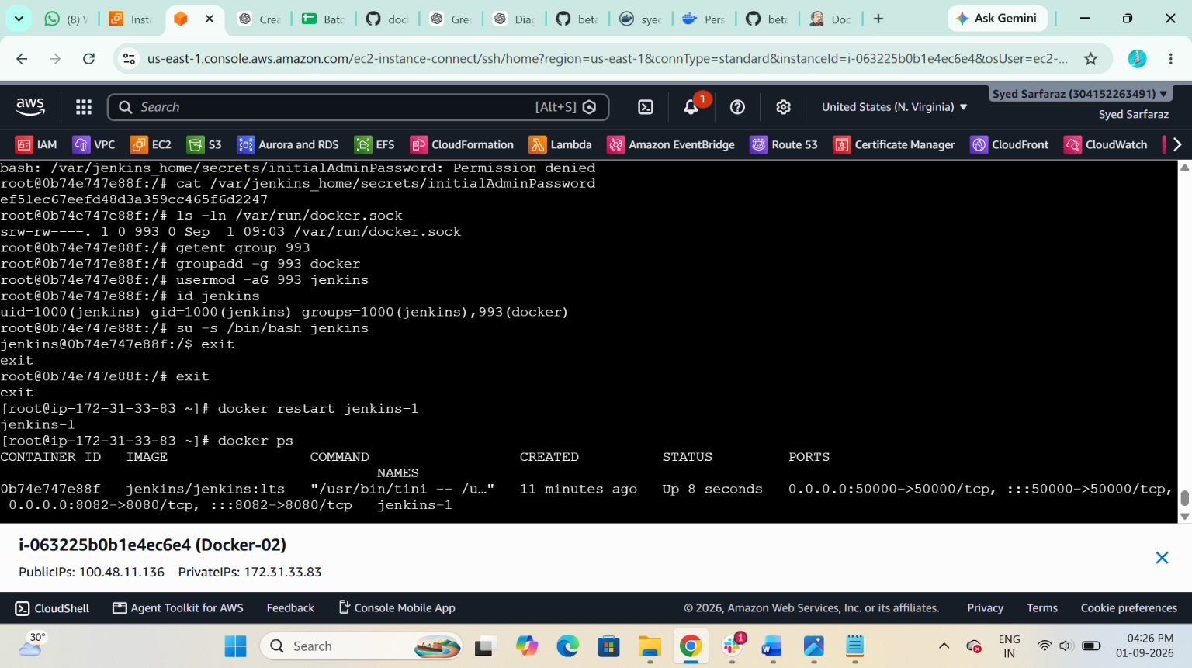

Step 7 Create Docker Hub repository
Log in to Docker Hub and create a repository, for example:
jenkins-docker-demo
Suppose your Docker Hub username is:
yourusername
Your image will be:
yourusername/jenkins-docker-demo:latest
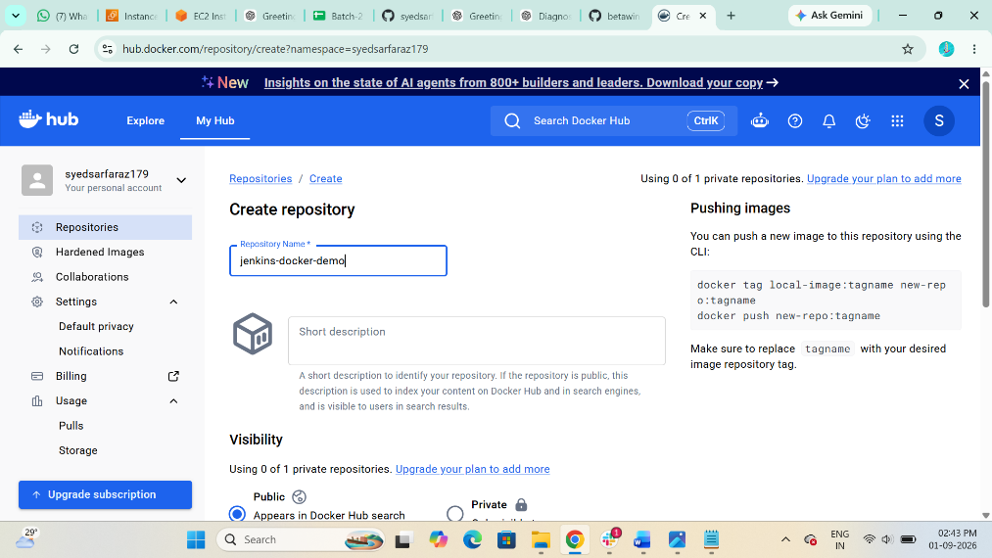

8 Create Docker Hub credentials in Jenkins
“ALSO INSTALL DOCKER PLUGIN IN JENKINS”
In Jenkins:
Dashboard → Manage Jenkins → Credentials → System → Global credentials → Add Credentials
Select:
Kind: Username with password
Enter:
Username: your Docker Hub username
Password: Docker Hub Access Token
ID: dockerhub-creds
Use a Docker Hub access token, not your Docker Hub account p
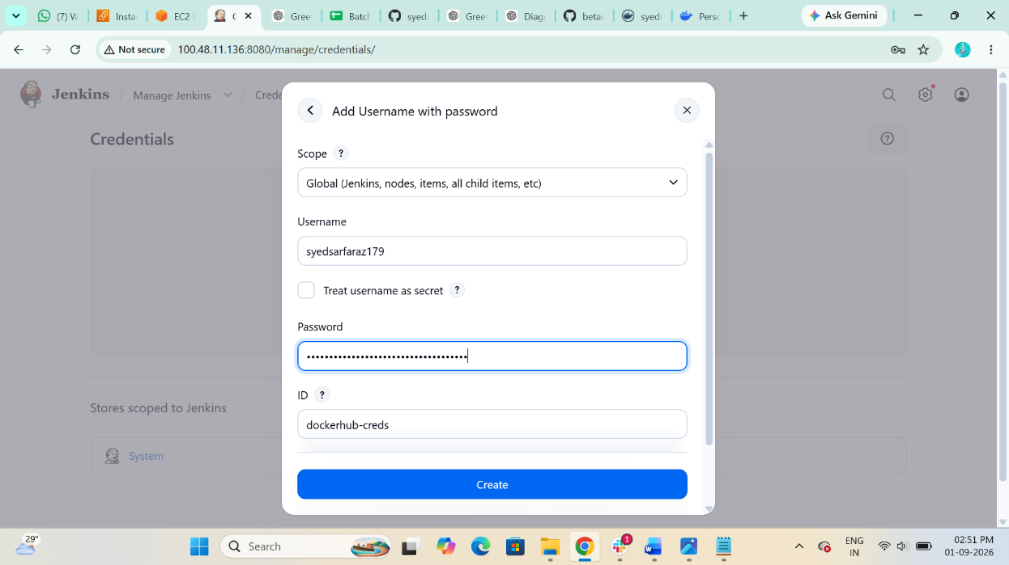
Step 9 Create Token into Docker Hub
Account Settings Personal access token create a new token
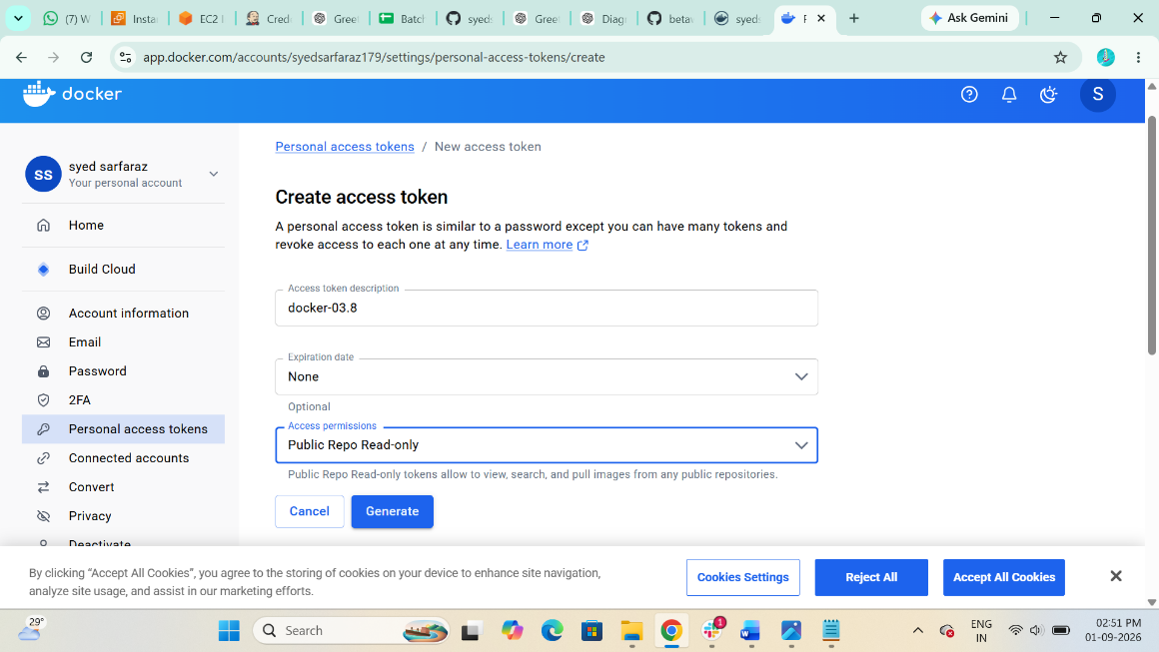
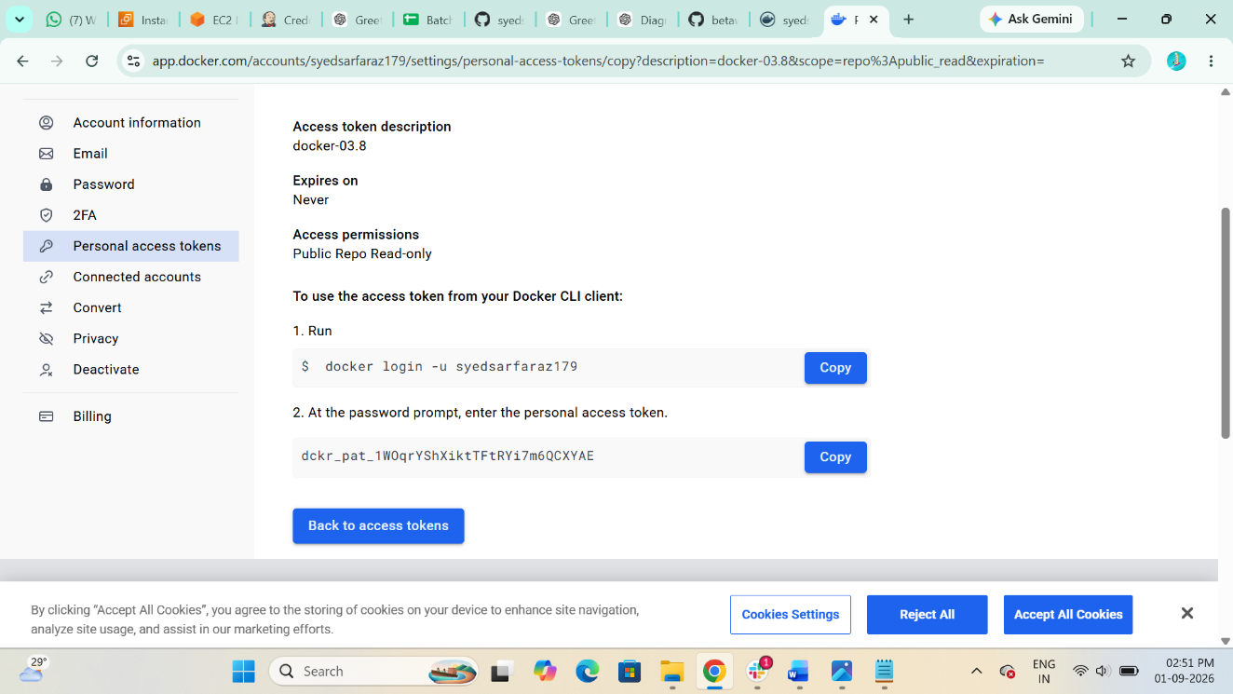

Step 10 Create a Dockerfile in your project
In your Git project, create:
vi Dockerfile
For a simple test:

FROM nginx:latest

EXPOSE 80
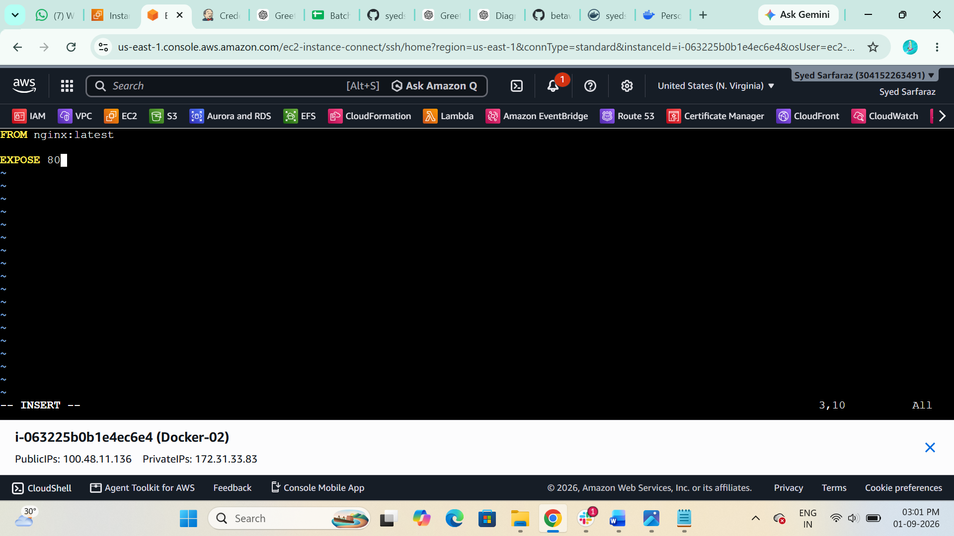

Step 11. Create Jenkins Pipeline
Create a new Jenkins job:
Jenkins Dashboard → New Item → Pipeline
Select:
Pipeline
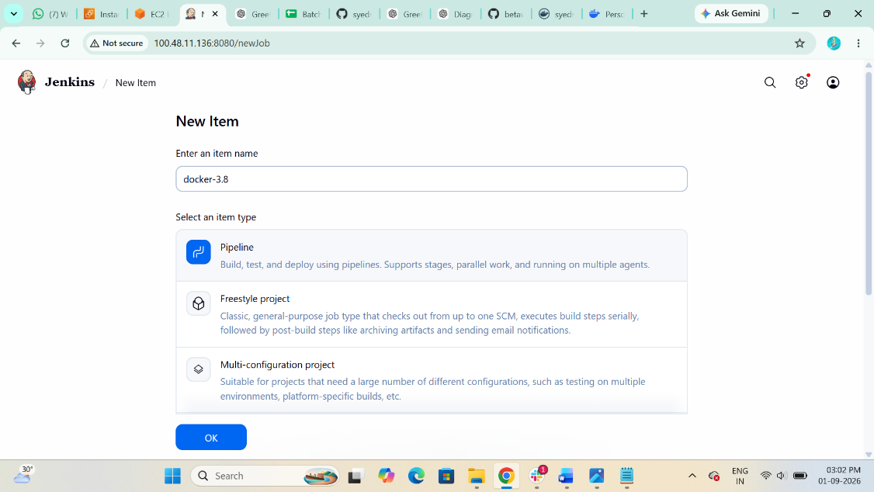

Then select:
Pipeline → Definition → Pipeline script
Use this Jenkinsfile:

pipeline {

agent any

environment {
DOCKER_IMAGE = 'yourusername/jenkins-docker-demo'
DOCKER_TAG = 'latest'
}

stages {

stage('Checkout') {
steps {
git branch: 'main',
url: 'YOUR_GITHUB_REPOSITORY_URL'
}
}

stage('Build Docker Image') {
steps {
sh '''
docker build -t ${DOCKER_IMAGE}:${DOCKER_TAG} .
'''
}
}

stage('Docker Login') {
steps {
withCredentials([
usernamePassword(
credentialsId: 'dockerhub-creds',
usernameVariable: 'DOCKER_USERNAME',
passwordVariable: 'DOCKER_PASSWORD'
)
]) {
sh '''
echo "$DOCKER_PASSWORD" | docker login \
-u "$DOCKER_USERNAME" \
--password-stdin
'''
}
}
}

stage('Push to Docker Hub') {
steps {
sh '''
docker push ${DOCKER_IMAGE}:${DOCKER_TAG}
'''
}
}
}

post {
always {
sh 'docker logout || true'
}
}
}
Change these two values:
DOCKER_IMAGE = 'yourusername/jenkins-docker-demo'
and:
url: 'YOUR_GITHUB_REPOSITORY_URL'
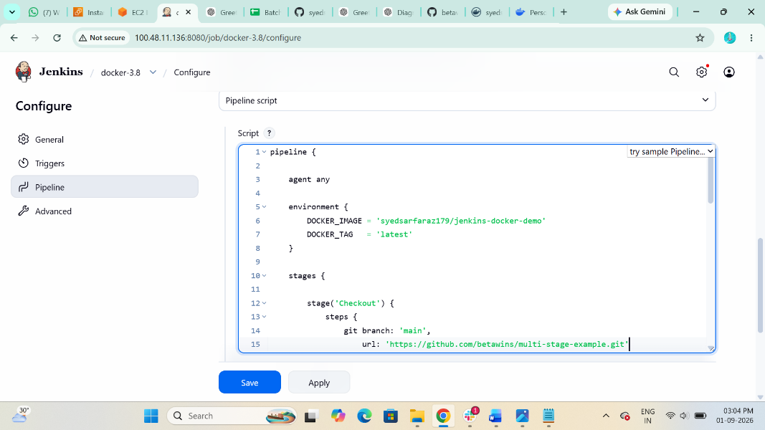

Step 12 Run the Jenkins Pipeline
Click:
Build Now
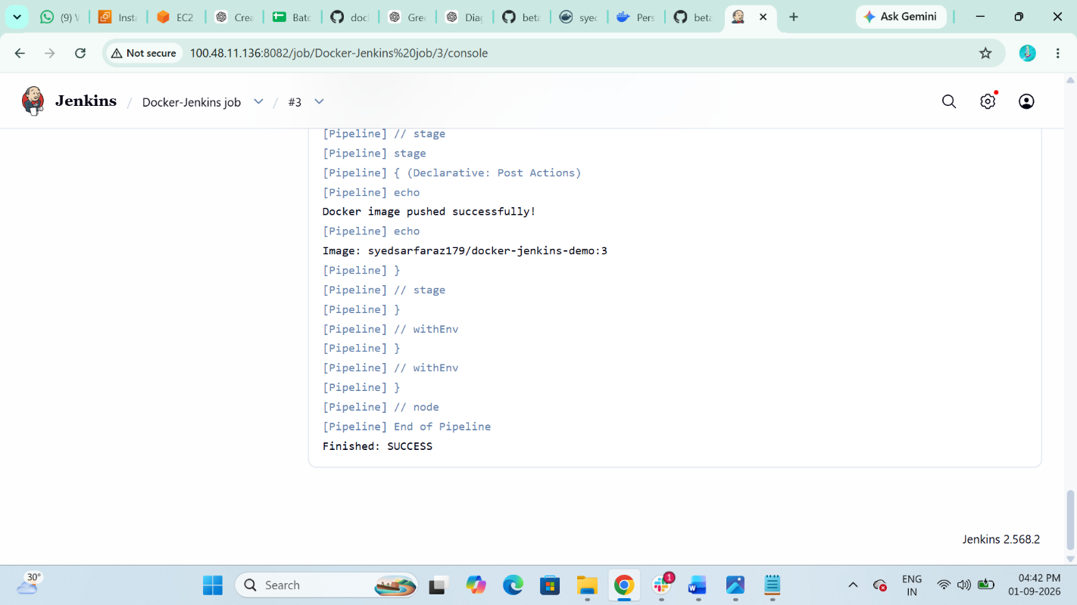

The pipeline should execute:
Checkout
↓
Build Docker Image
↓
Docker Login
↓
Push to Docker Hub

Step 13 Verify the image
On your AWS server:
$ docker images
You should see:
yourusername/jenkins-docker-demo latest
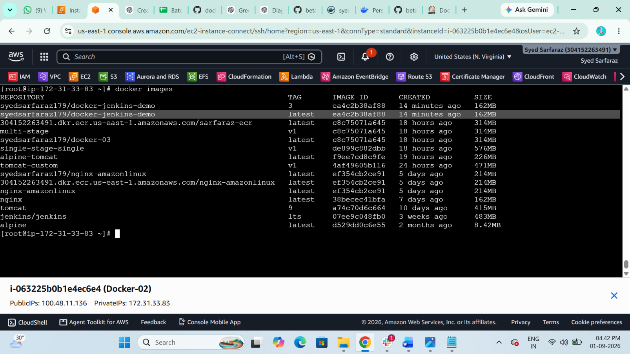

The Image is Successfully Pushed to Docker Hub
