Terraform-02

1. Execute all the templates shown in the video.

- created main.tf.
- Defined two resources:
local_file.pet → creates /root/pets.txt o random_pet.mypet → generates a random name
- No Terraform initialization yet.

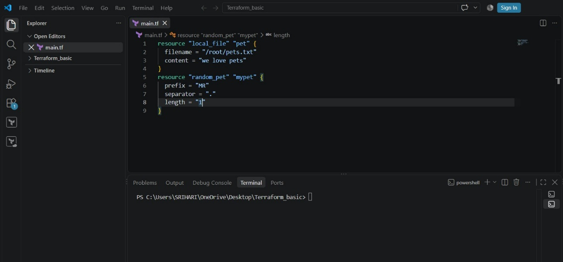
- terraform init is executed.
- Providers are downloaded:
hashicorp/local o hashicorp/random
- .terraform/ directory and .terraform.lock.hcl file are created.
- Terraform project is initialized successfully

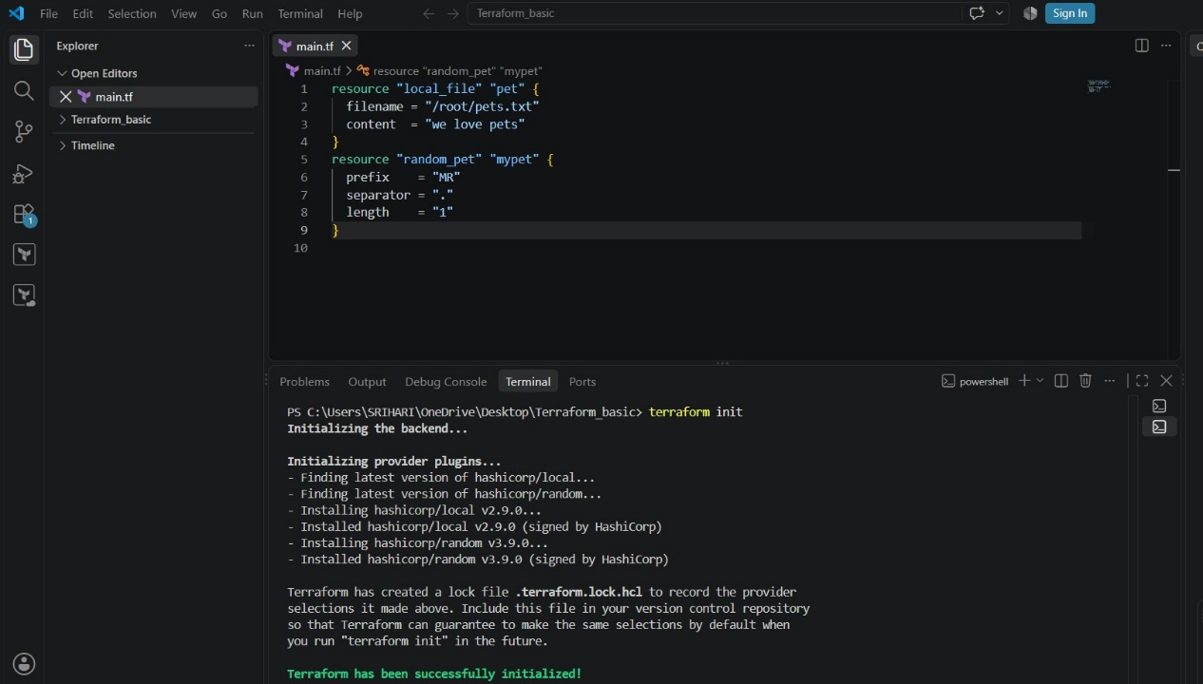
- Terraform apply
- Terraform shows an execution plan.
- Both resources will be created.
- You type yes.
- pets.txt file is created.
- random_pet value is generated

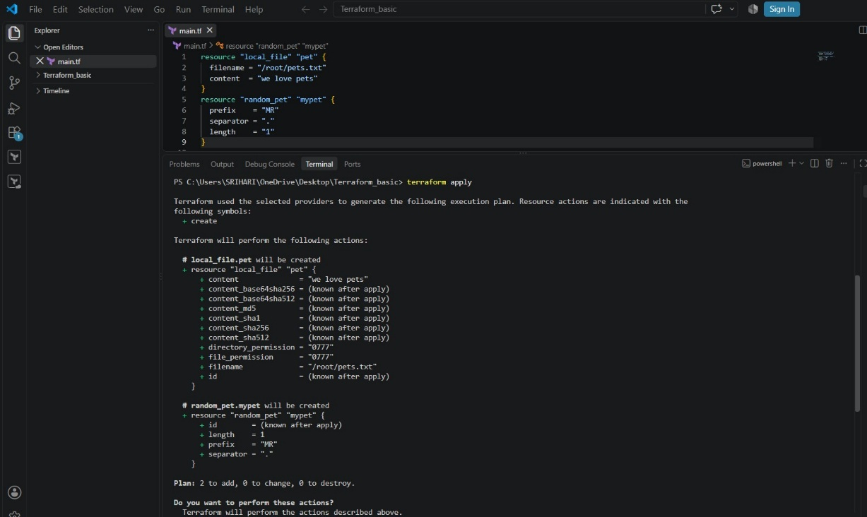
terraform.tfstate file appears.
- State stores:
Resource IDs o File content hash o Provider metadata
- Terraform now tracks real infrastructure

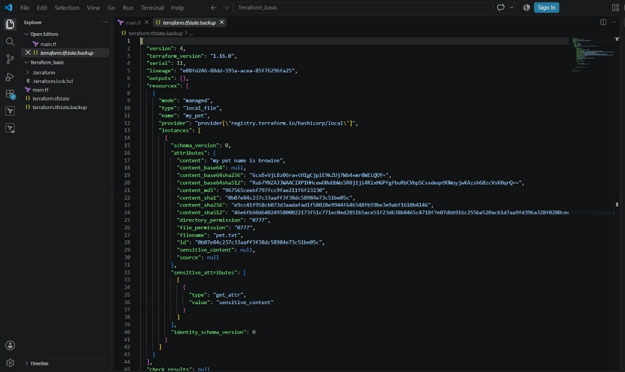
- modified content inside local_file.
- This causes a ForceNew change.
- Terraform detects drift between config and state
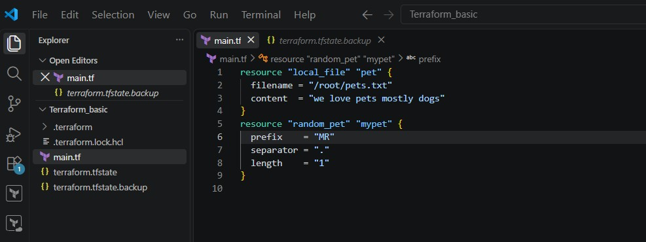

Plan shows:
- local_file.pet must be replaced
- Old file is destroyed.
- New file is created.
Key point
- Default behavior = destroy → create

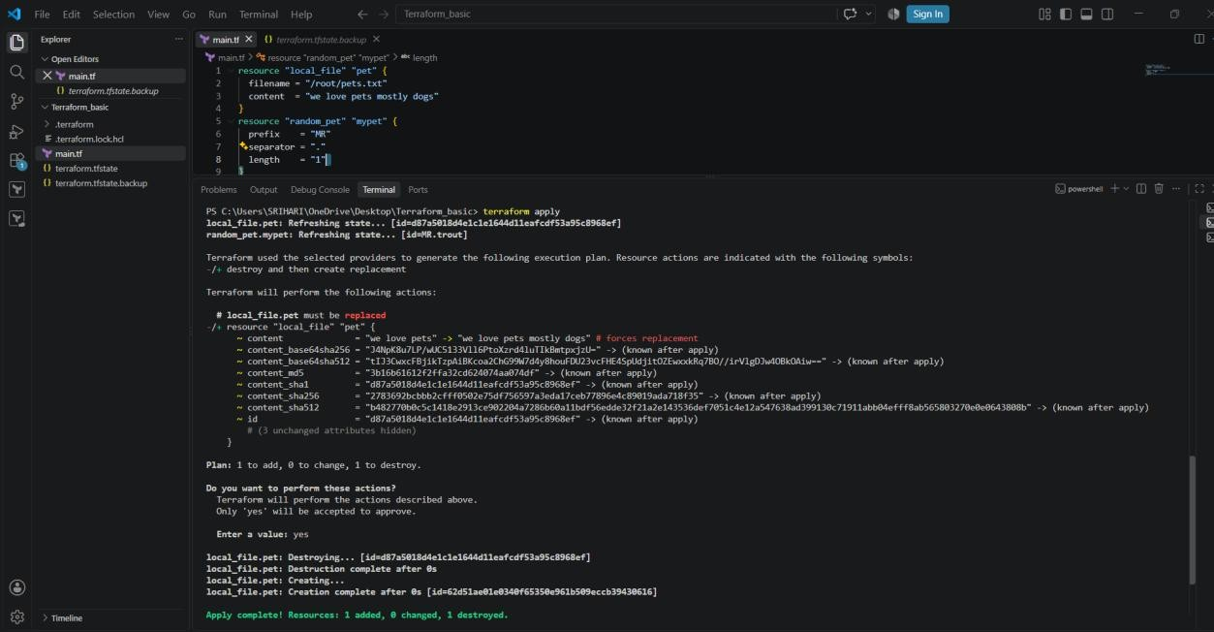
- added:
- lifecycle {
- create_before_destroy = true
- }
Key point
- Ensures zero downtime replacement.

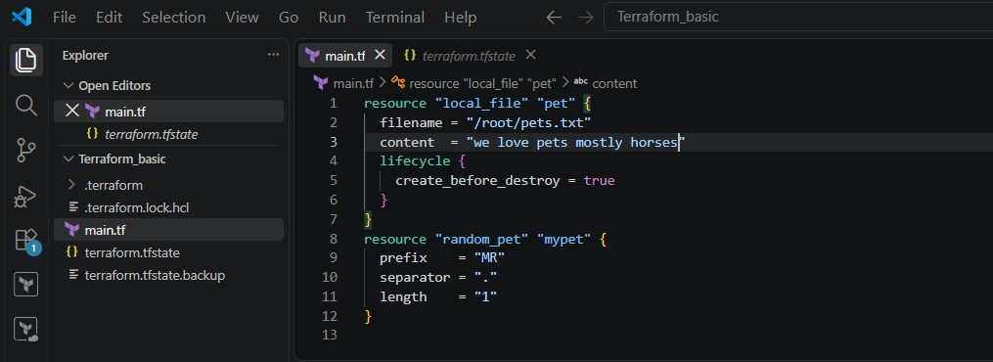
- New file is created first.
Old file is destroyed after.
Key point
- Safe replacement strategy.

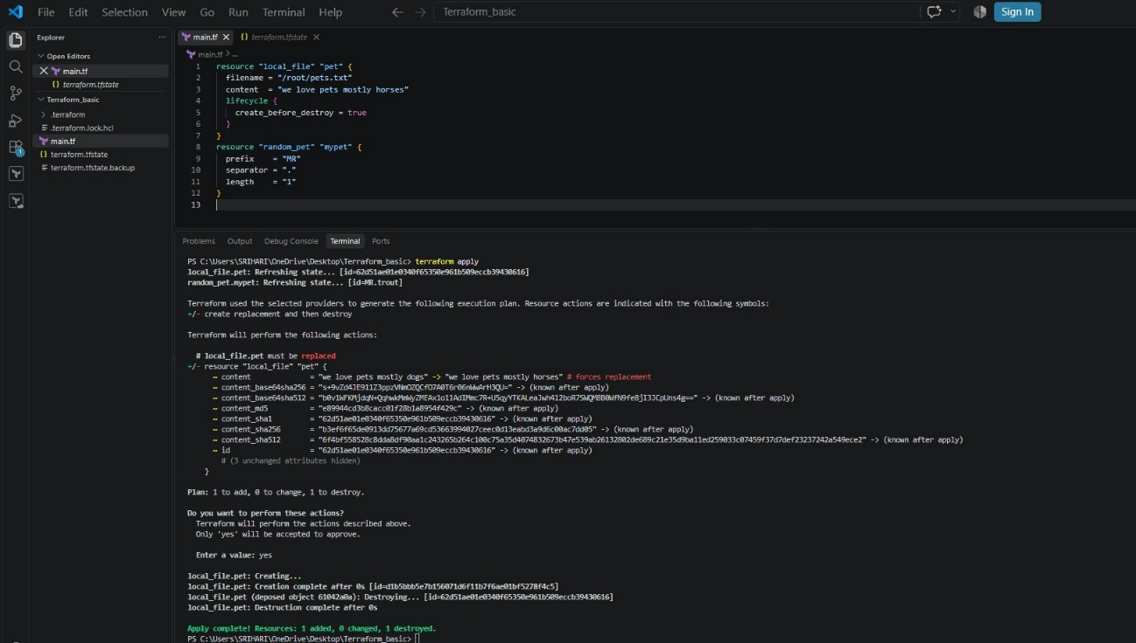
- added:
- lifecycle {
- prevent_destroy = true
- }
Key point
- Protects critical resources from deletion.

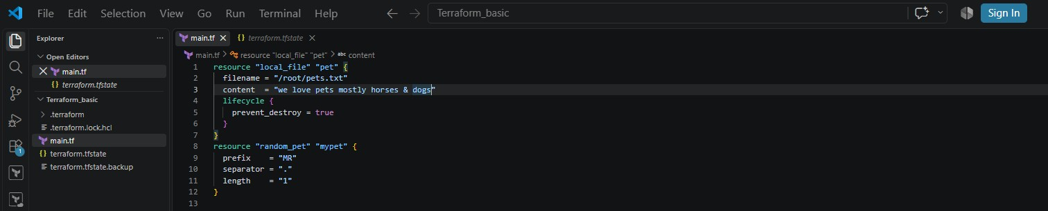
- Terraform refuses to destroy the resource.
- Apply fails if replacement is required.
Key point
Manual intervention required to remove protection

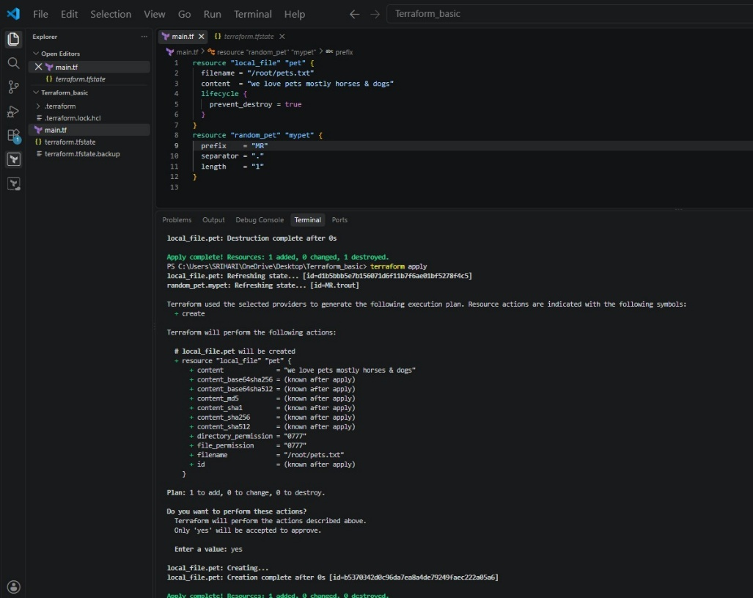

- Created a new file called variables.tf
- Defined reusable input variables:
  - file_name o content o prefix o separator o length
  - Key points
- Each variable has:
  - type o default
- Defaults allow Terraform to run without passing values manually

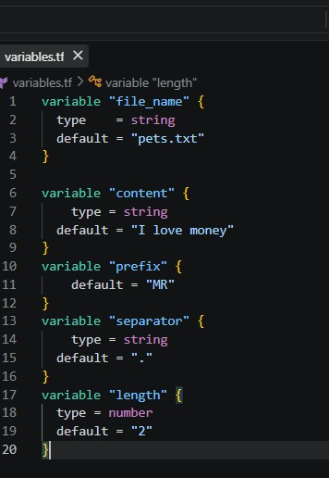
- Replaced hardcoded values with variables:
- filename = var.file_name
- content = var.content
- Updated random_pet resource:
- prefix = var.prefix
- separator = var.separator
- length = var.length
Key points
- var.<variable_name> is how Terraform references variables
- Configuration becomes dynamic and reusable

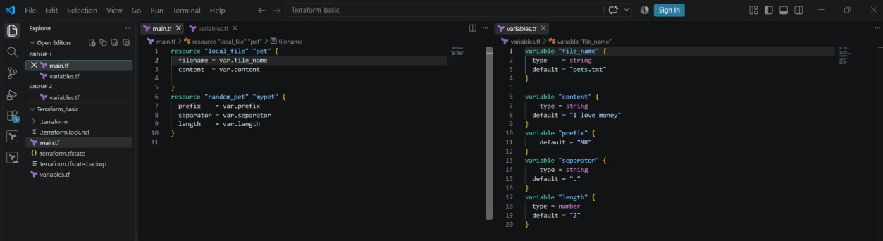

terraform apply
Terraform shows:

# random_pet.mypet must be replaced
-/+ resource "random_pet" "mypet" {
~ id = "MR.trout" -> (known after apply)
~ length = 1 -> 2 # forces replacement
# (2 unchanged attributes hidden)
}

Plan: 2 to add, 0 to change, 2 to destroy. Enter a value: yes random_pet.mypet: Destroying... [id=MR.trout] local_file.pet: Destroying... [id=b5370342d0c96da7ea8a4de79249faec222a05a6] random_pet.mypet: Destruction complete after 0s local_file.pet: Destruction complete after 0s random_pet.mypet: Creating...
random_pet.mypet: Creation complete after 0s [id=MR.smiling.joey] local_file.pet: Creating...
local_file.pet: Creation complete after 0s [id=2c5125d3e93950d4302855fcd2942a31151a62c2] Content taken from variable

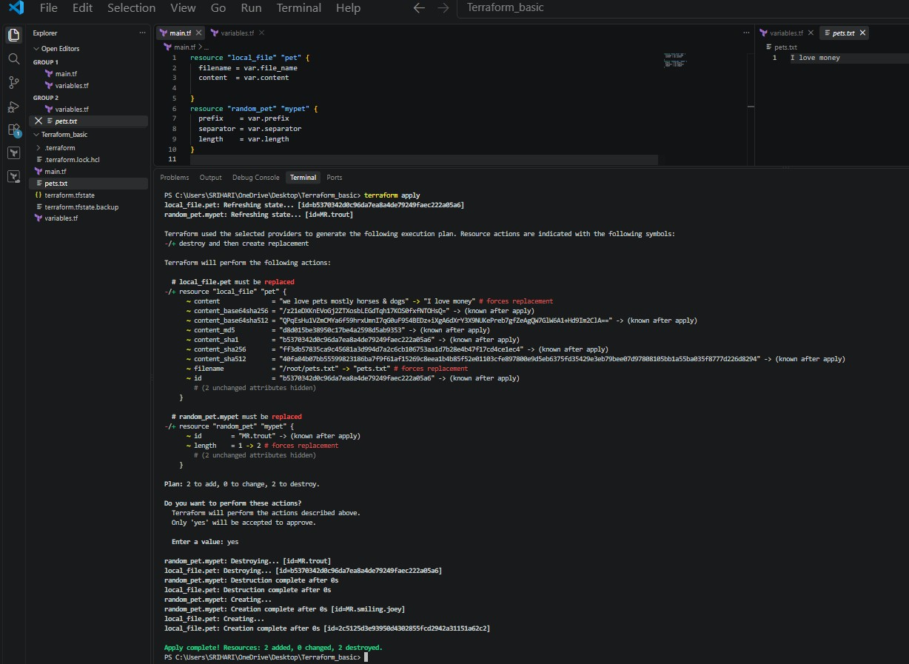
Next:
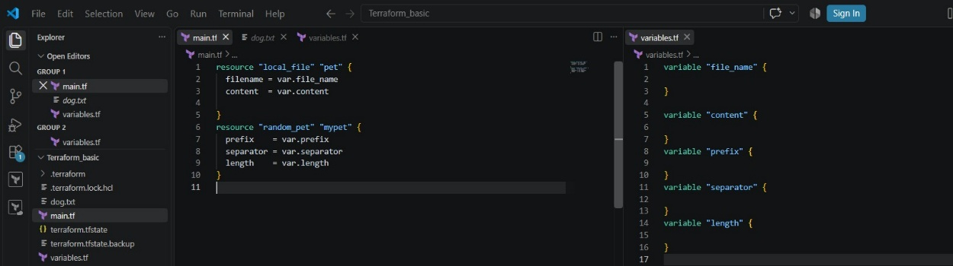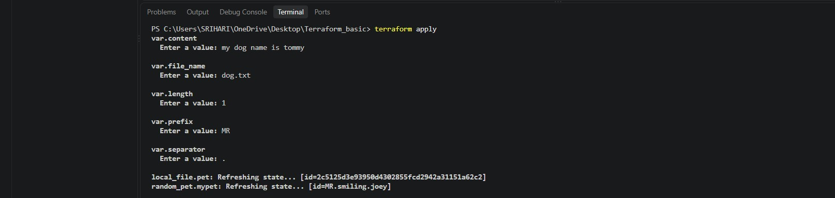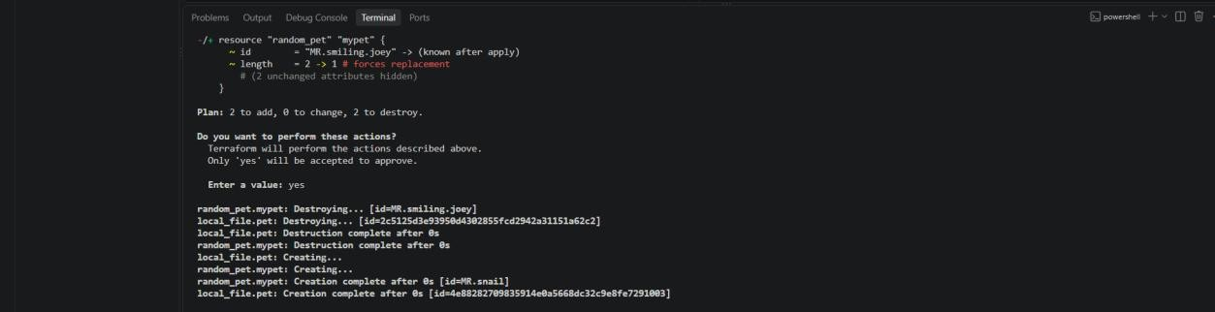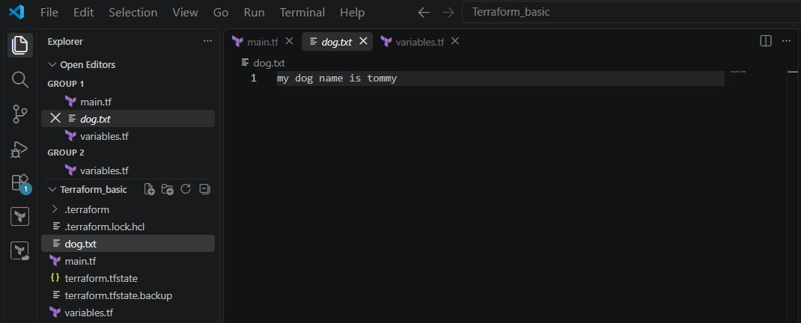

Next:
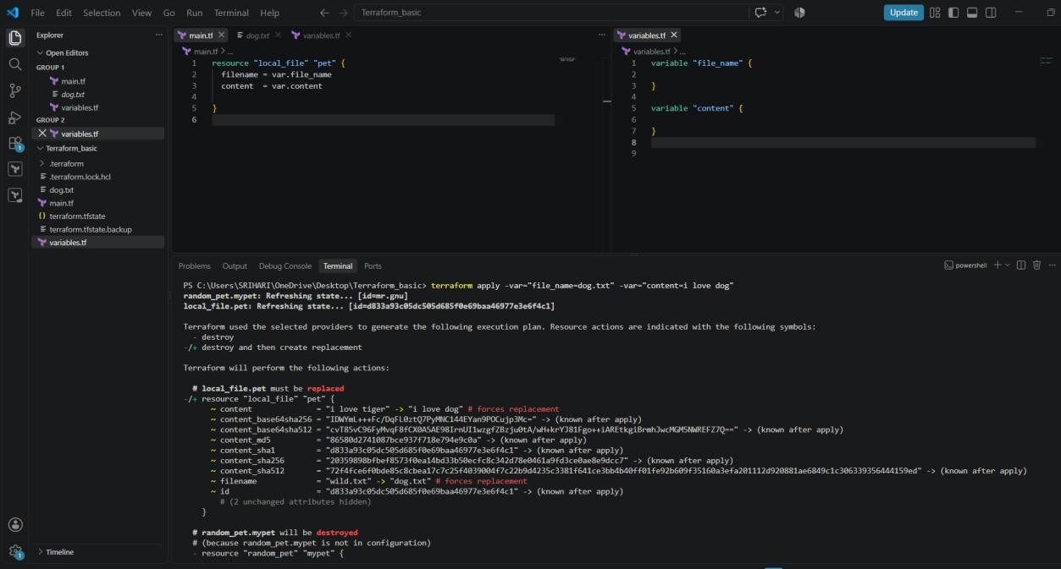

2.Integrate Terraform in Jenkins using the Terraform plugin

- opened main.tf directly in GitHub.
- local_file and random_pet resources reference variables using var.*.
Why this matters
- No hard-coded values.
- Configuration is reusable and CI/CD friendly.

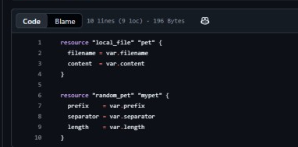

- defined all input variables:
- filename (now /tmp/pets.txt) o content o prefix o separator o length
Why this matters
- Fixes Jenkins permission issue.
- Ensures Terraform config is valid
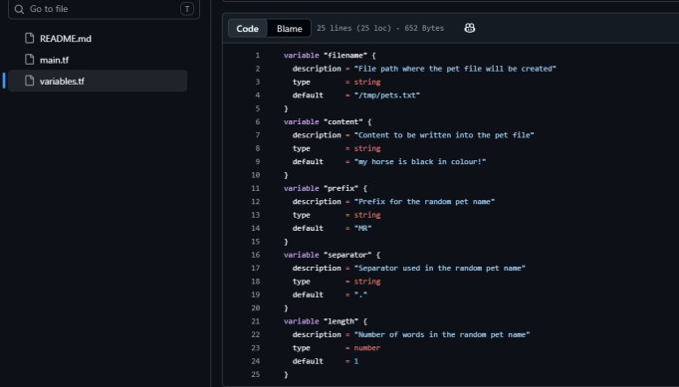
- created a file named Jenkinsfile
- Pipeline stages included:
  - Checkout o Terraform Init o Terraform Plan o Terraform Apply (manual approval)
Why these matters
- Jenkins reads pipeline directly from SCM.
- Follows DevOps best practice (pipeline as code)

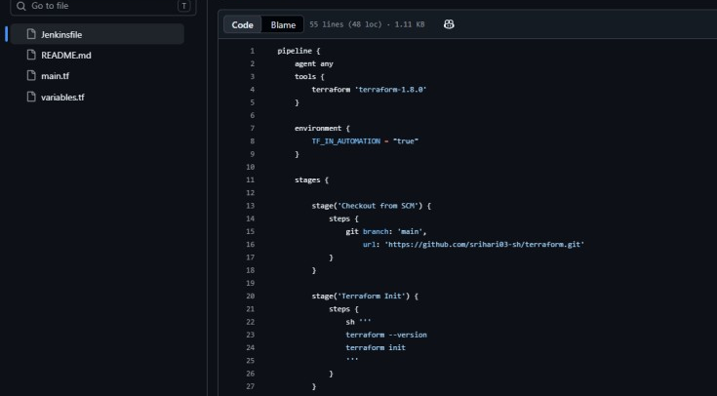

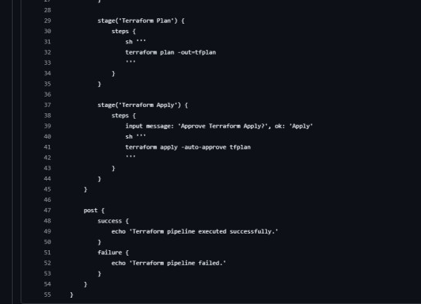
Install the Terraform Plugin
- Navigate to Manage Jenkins > Plugins > Available plugins.
- Search for Terraform, select it, and click Install.
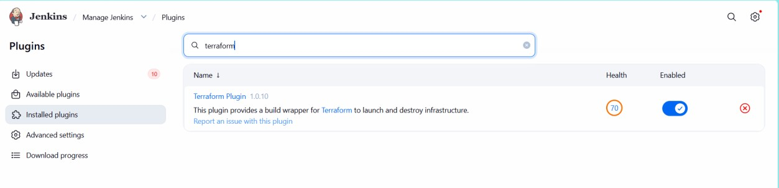
Configure the Terraform Tool in Jenkins
- Go to Manage Jenkins > Tools (or Global Tool Configuration).
- Scroll down to the Terraform section and click Add Terraform.
- Give it a distinct name (e.g., terraform-1.8.0).
- Either check Install automatically to let Jenkins fetch the binary, or specify the path where the Terraform binary exists on the Jenkins server.
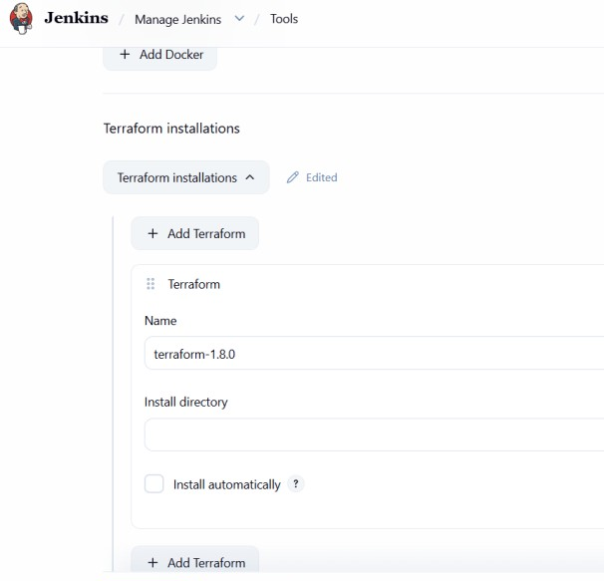
- Select new item
- Enter item name: terraform -03
- Select pipeline
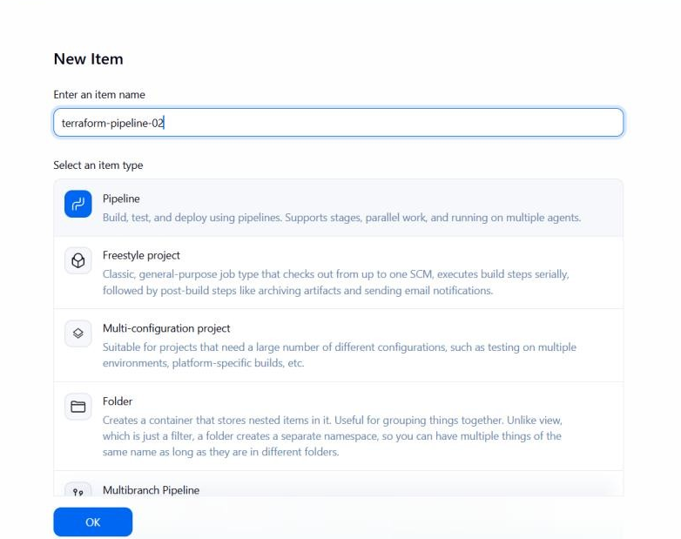
- Definition: Pipeline script from SCM
- SCM: Git
- Repository URL:
- https://github.com/srihari03-sh/terraform.git
Why this matters
- Jenkins automatically fetches pipeline code from GitHub.

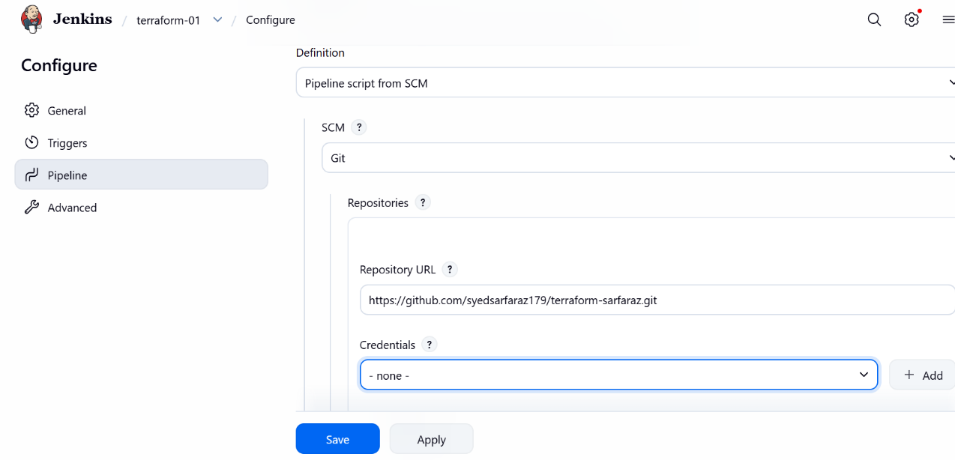
- Branch Specifier:
- */main
- Script Path:
- Jenkinsfile

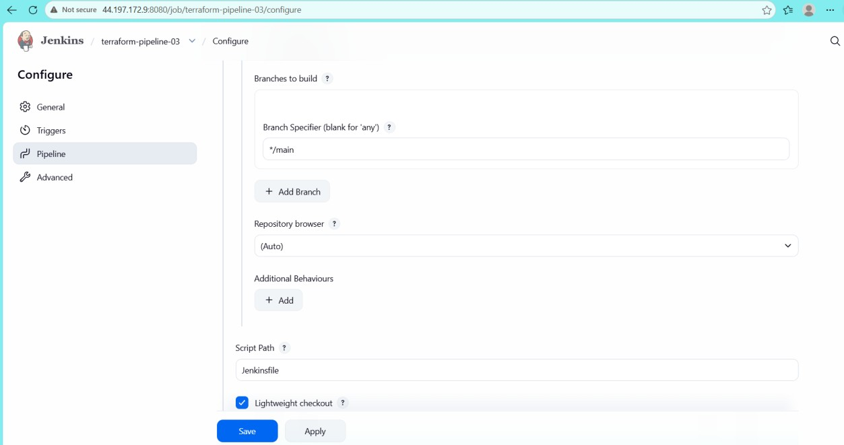
- Build is triggered manually.
- Jenkins performs:
  - Git checkout
  - terraform init
  - terraform plan
  - Manual approval
  - terraform apply
Result
- Resources created successfully.
- File written to /tmp/pets.txt.
- Random pet name generated.

