Terraform-03

- Watch the Terraform-03 video.
- Execute the script shown in the video.
- Integrate Terraform in Jenkins using the Terraform plugin.
- Create one Jenkins job using Maven Project for the code below with two stages:
  - Stage 1:Git clone
  - Stage 2:Maven CompilationCode:https://github.com/betawins/java-Working-app.git
- Use the same code and create a parameterized job in Jenkins with:
  - Stage 1:Git clone
  - Stage 2:Maven CompilationCode:https://github.com/betawins/java-Working-app.git
- What are the global variables in Jenkins?

2. Execute the script shown in the video.
1. Terraform Life Cycle of Create_before_destroy
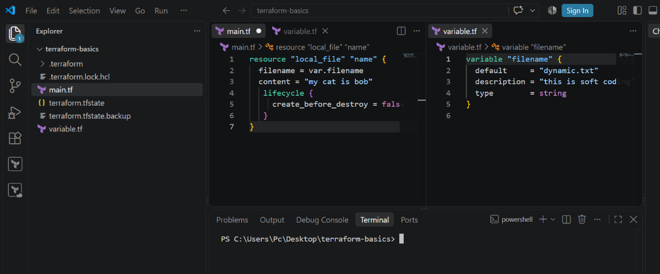

Run Create_before_destroy Life Cycle
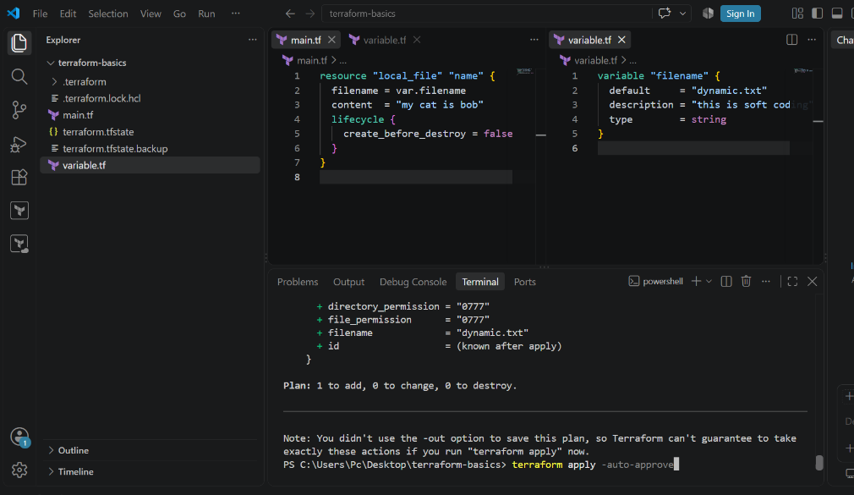
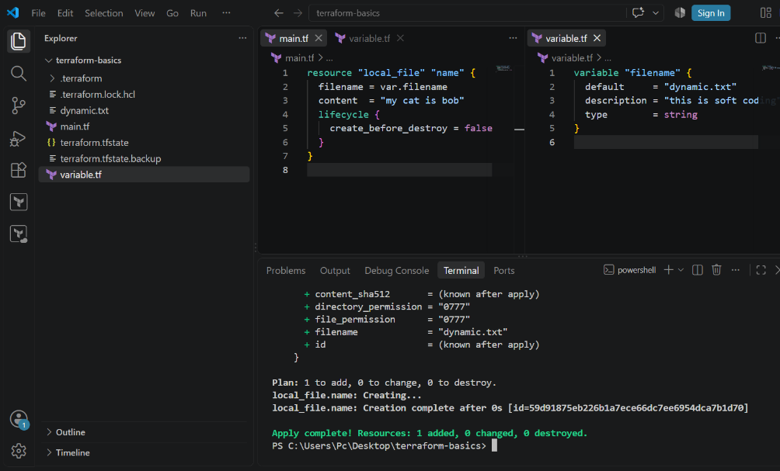

2. Variable.tf File

3. Interactive Mode
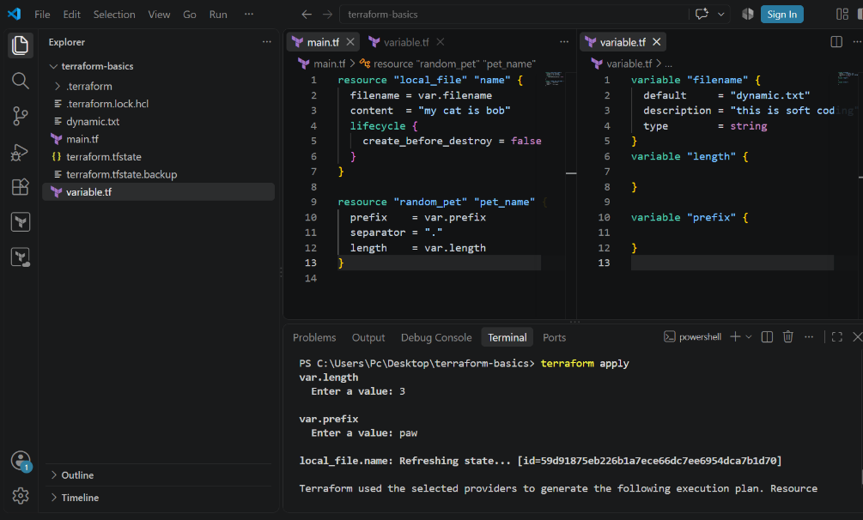
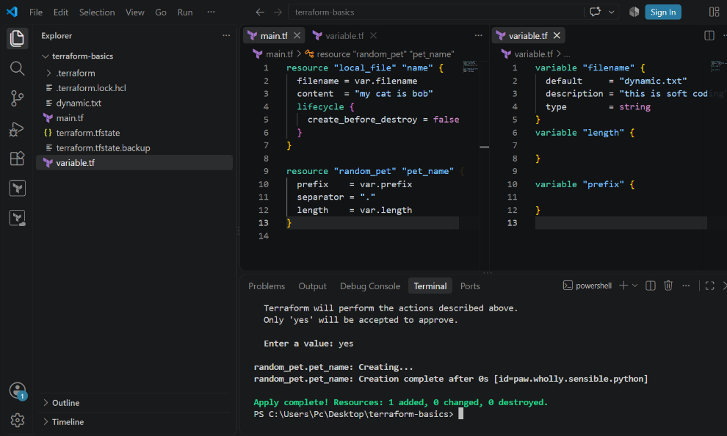

4. Environmental Variable
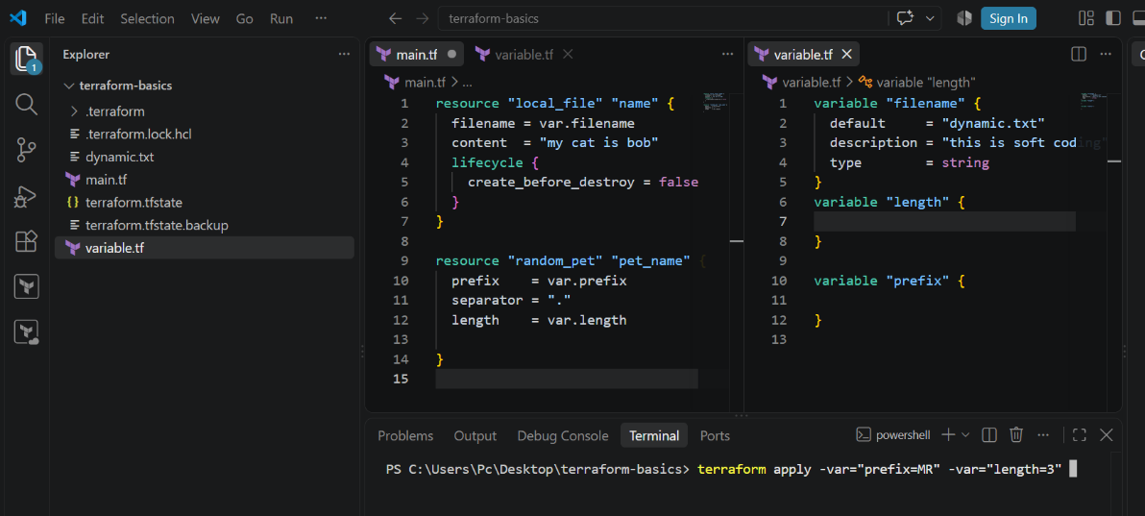
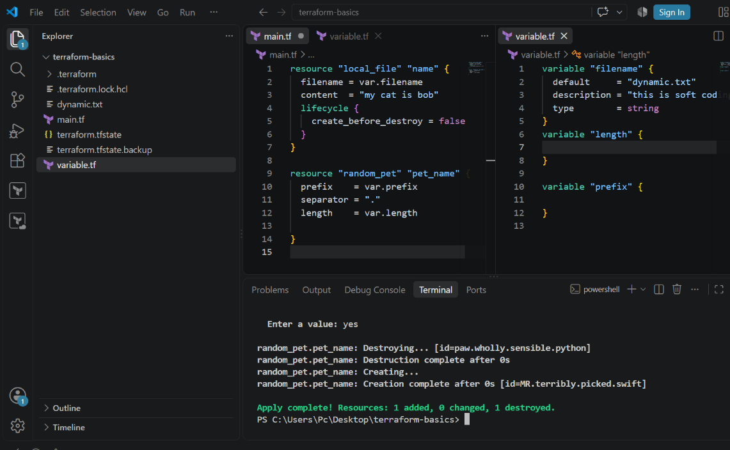
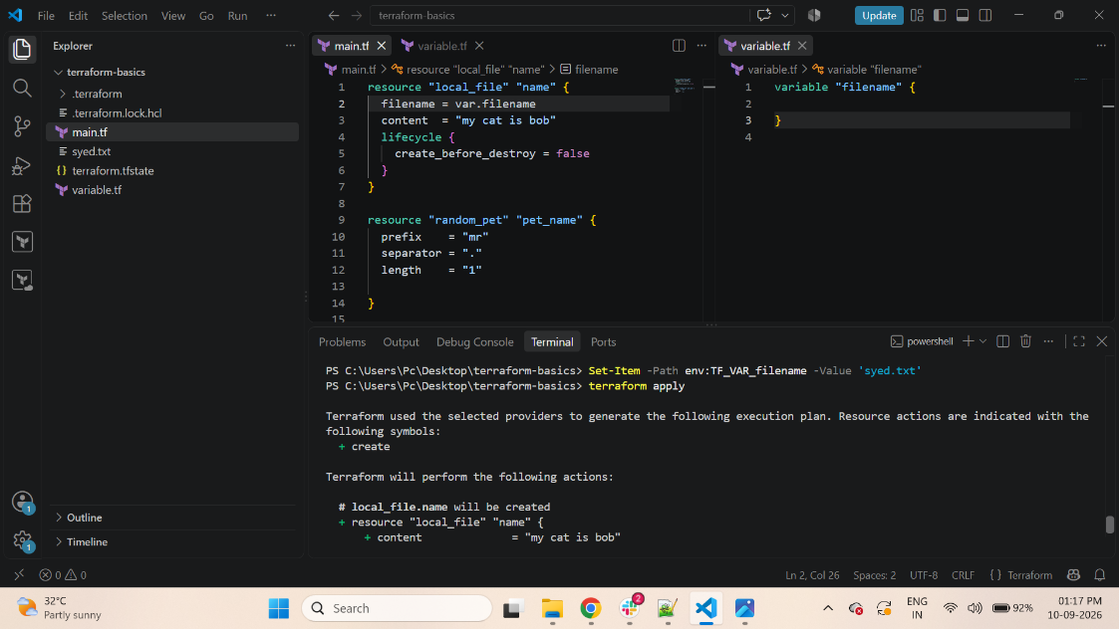
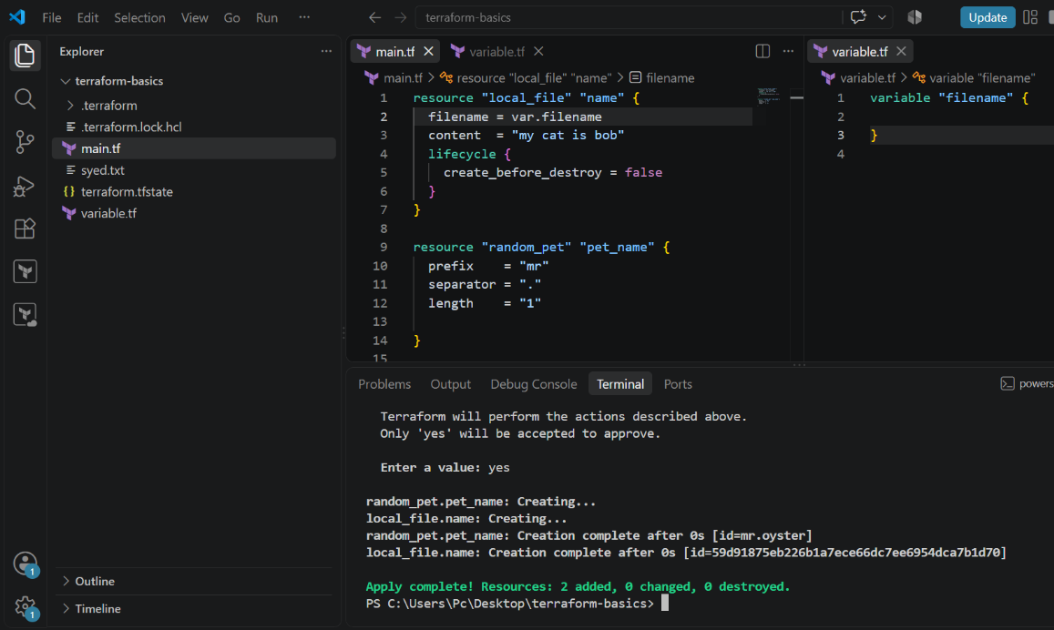

5. Presidential Order
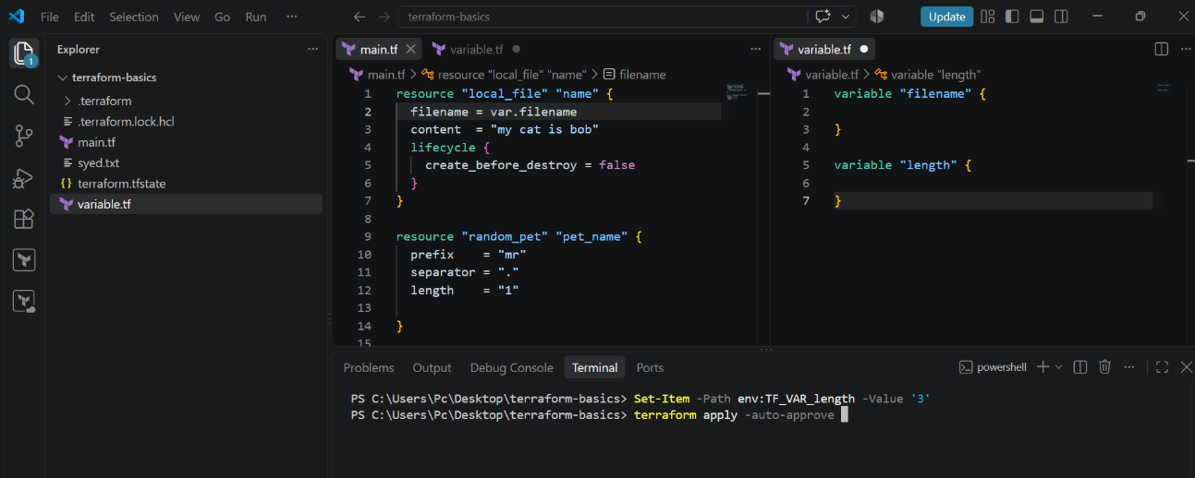
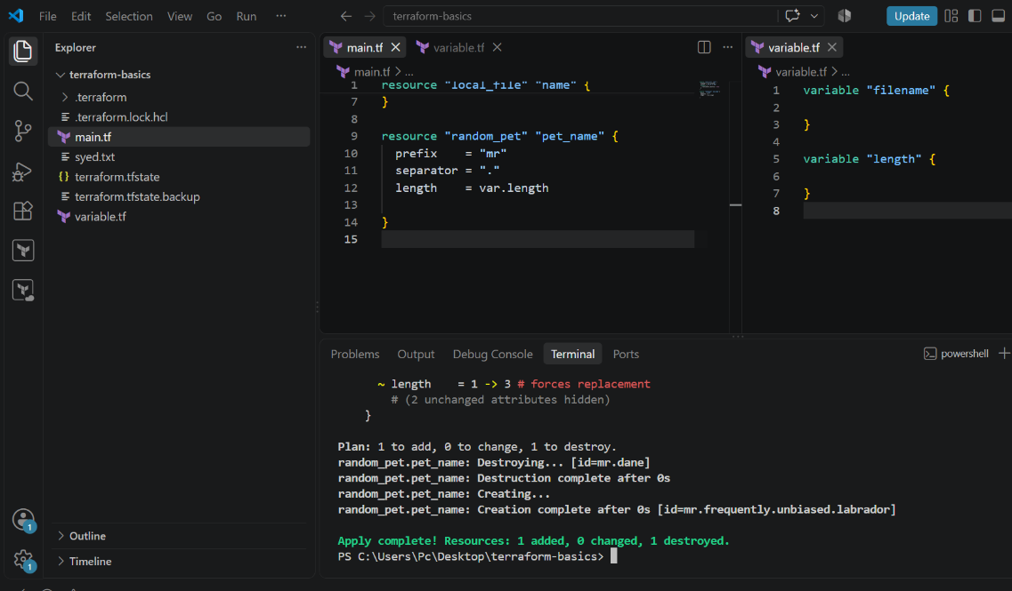
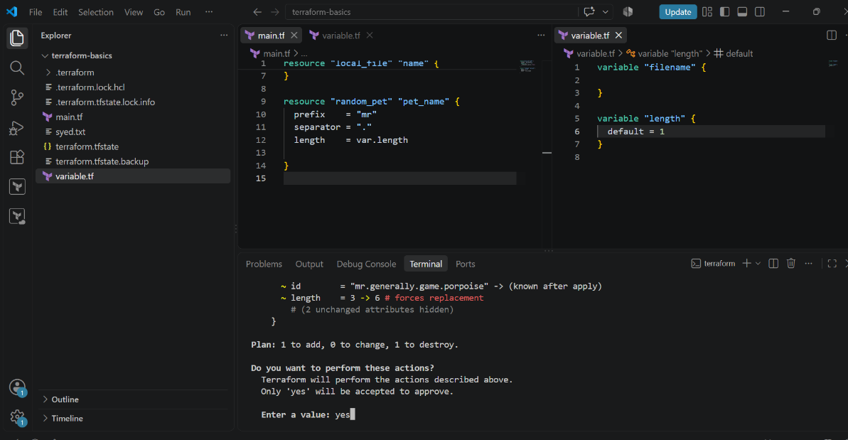
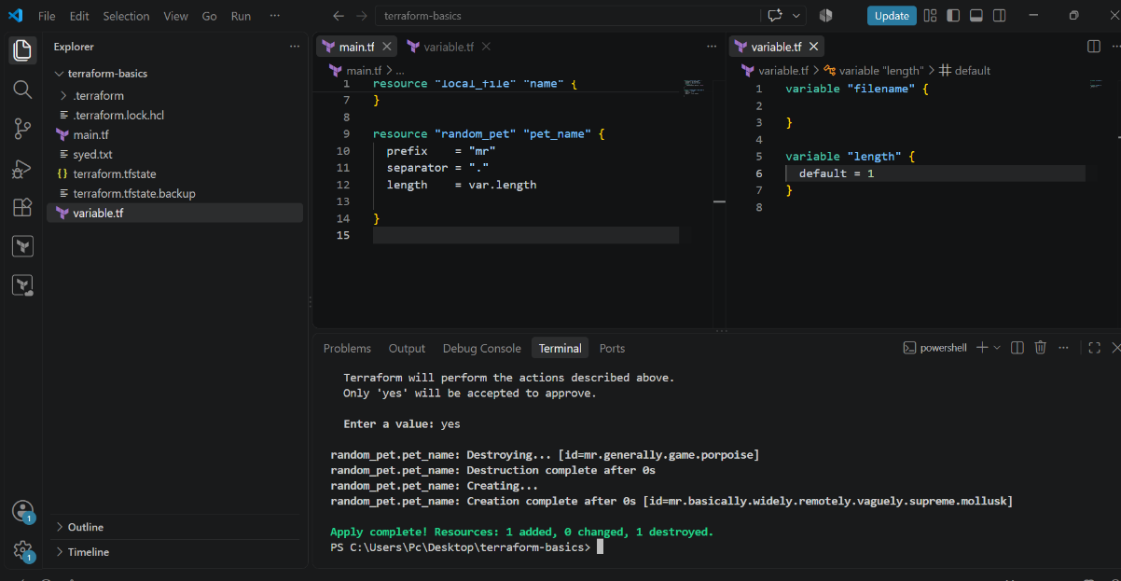

- Integrate Terraform in Jenkins using the Terraform plugin.
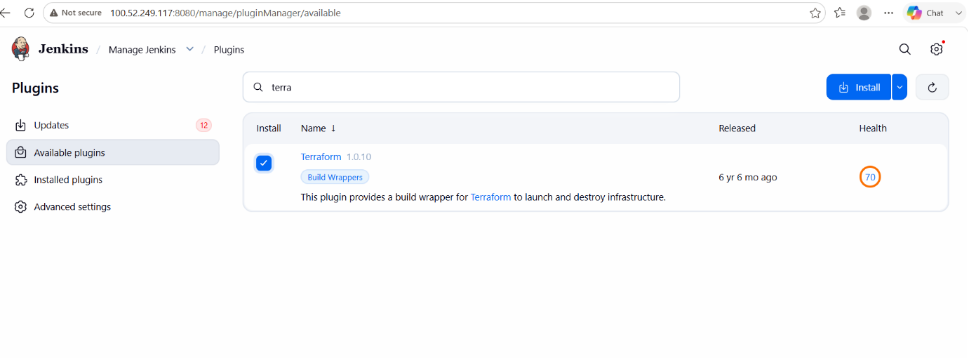

- Create one Jenkins job using Maven Project for the code below with two stages:
  - Stage 1:Git clone
  - Stage 2:Maven CompilationCode:https://github.com/betawins/java-Working-app.git

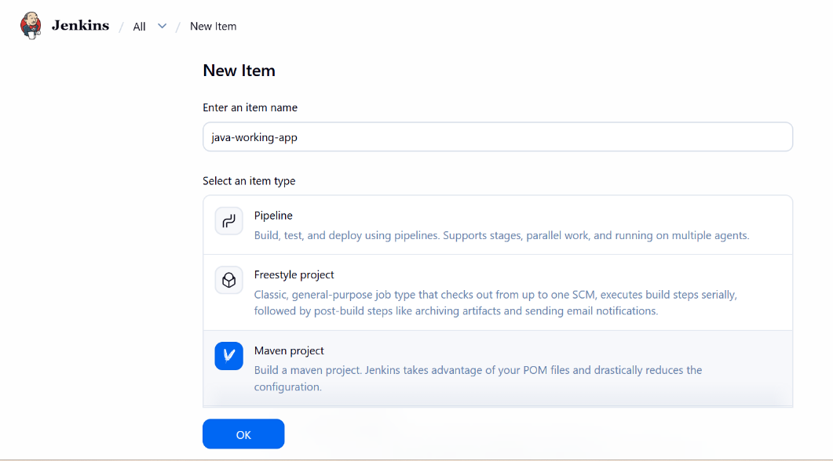
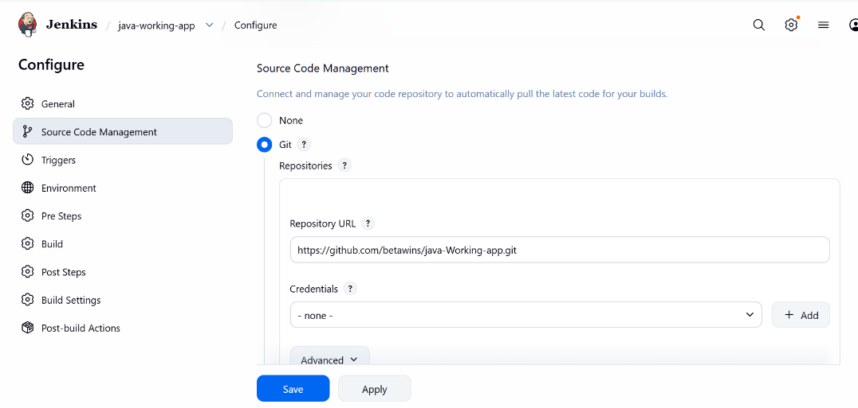

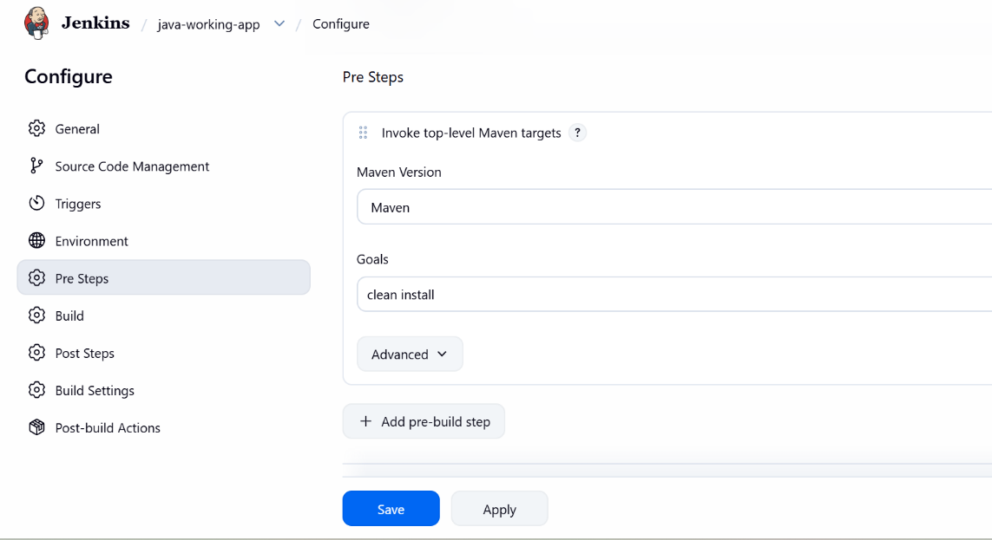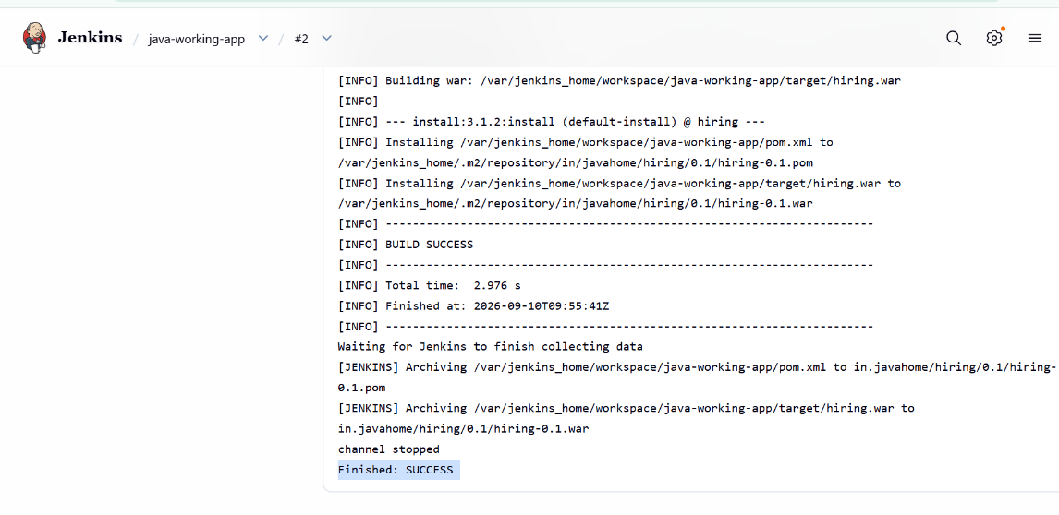

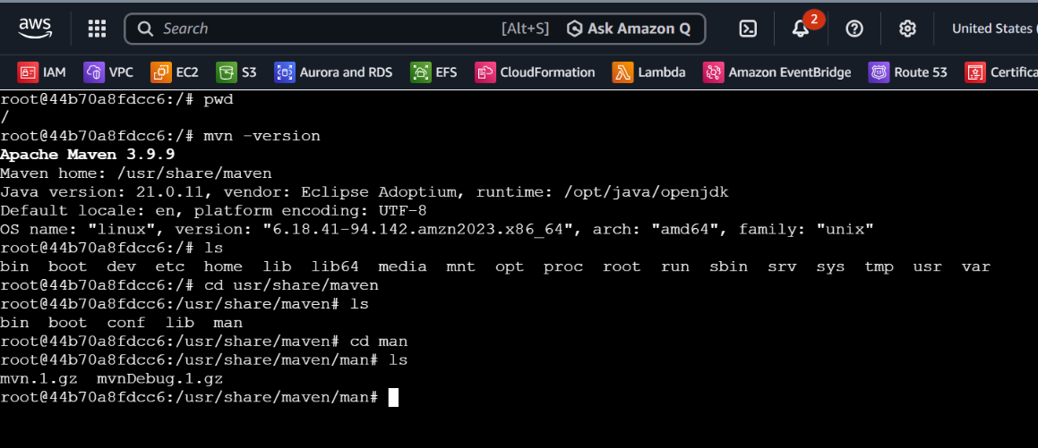

- Use the same code and create a parameterized job in Jenkins with:
  - Stage 1:Git clone
  - Stage 2:Maven CompilationCode:https://github.com/betawins/java-Working-app.git

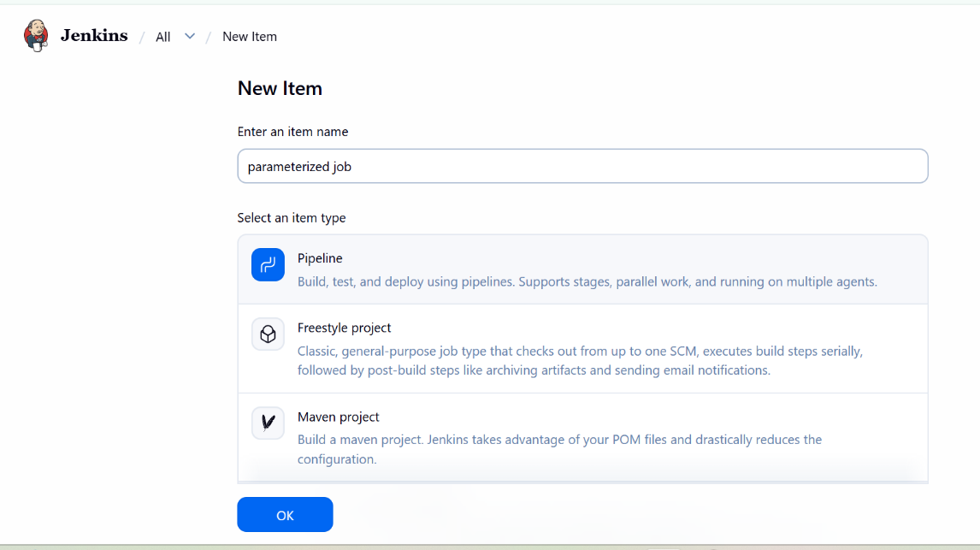
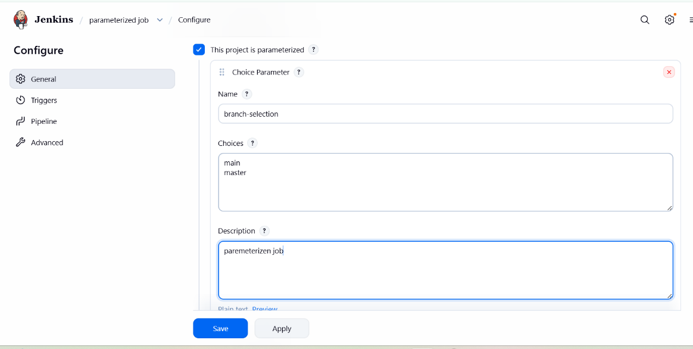
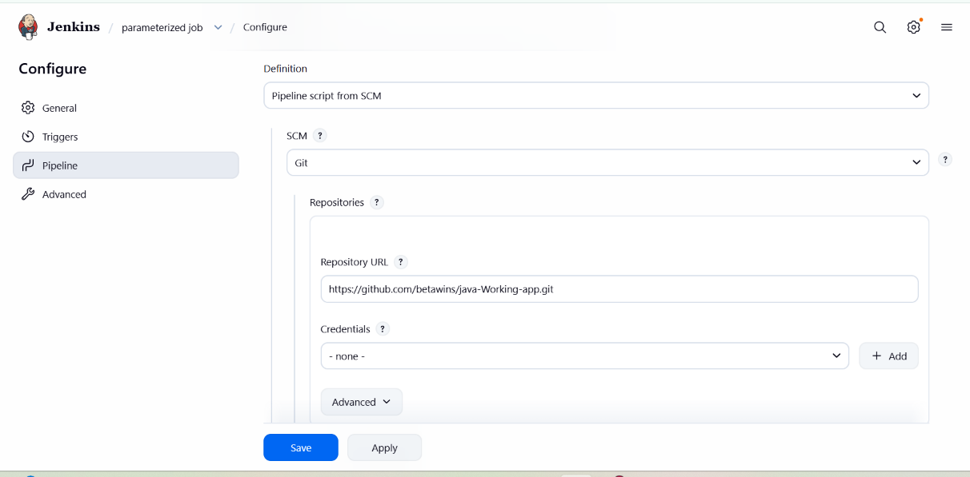

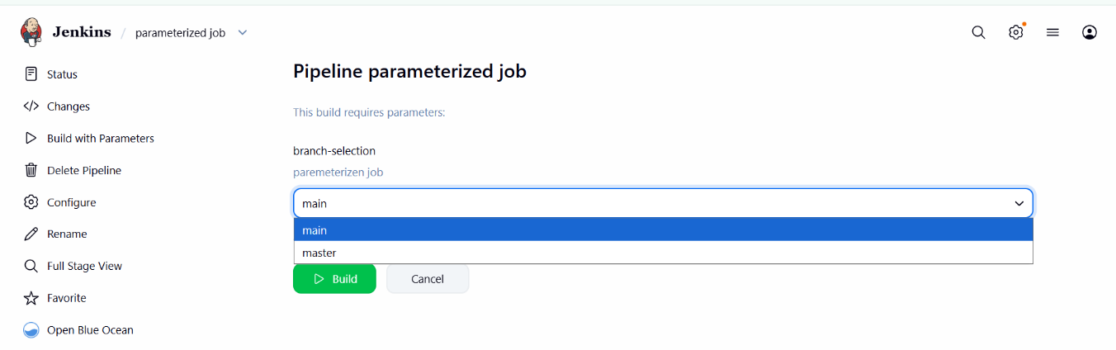

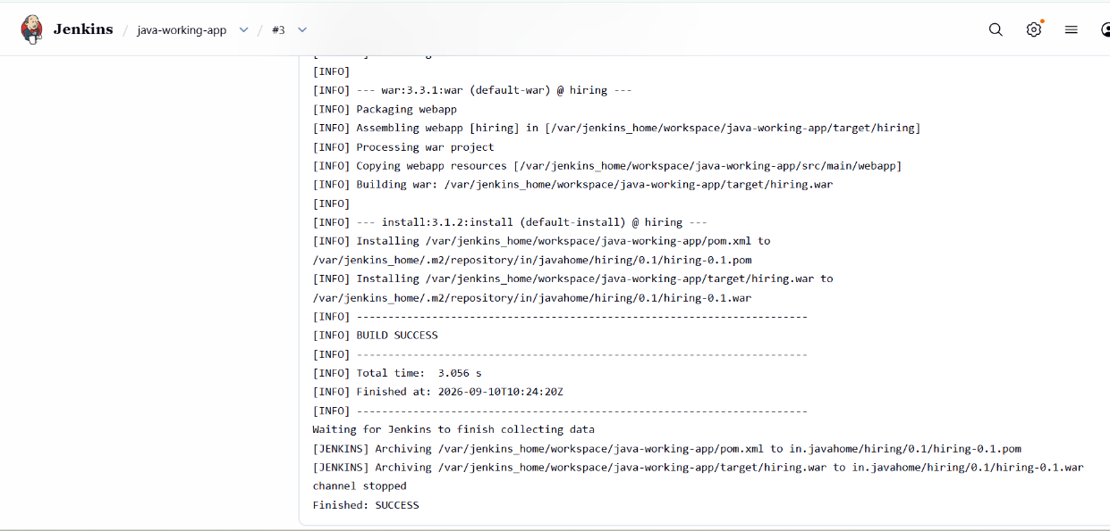

- What are the global variables in Jenkins?

In Jenkins, global variables are variables that are available throughout the Jenkins Pipeline and can be used across different stages.
Common Jenkins global variables
Variable | Meaning
BUILD_NUMBER | Current build number
BUILD_ID | Current build ID
BUILD_URL | URL of the current build
JOB_NAME | Name of the Jenkins job
WORKSPACE | Workspace directory of the job
NODE_NAME | Name of the Jenkins agent/node running the job
JENKINS_URL | Jenkins server URL
GIT_COMMIT | Git commit checked out for the build
GIT_BRANCH | Git branch being built
EXECUTOR_NUMBER | Executor number running the build

Example
pipeline {
agent any

stages {
stage('Show Variables') {
steps {
echo "Build Number: ${BUILD_NUMBER}"
echo "Job Name: ${JOB_NAME}"
echo "Workspace: ${WORKSPACE}"
echo "Git Commit: ${GIT_COMMIT}"
}
}
}
}

