Docker Task-01

1. Launch Ubuntu EC2 Instance
- Open AWS Console → EC2 → Instances → Launch instance.
- Configure:
  - Name: docker-ubuntu
  - AMI: Ubuntu Server 24.04 LTS
  - Instance type: t3.small
  - Key pair: Select key pair.
  - Security Group: Allow:
    - SSH — 22 — My IP
    - Custom TCP — 81 — 0.0.0.0/0
    - Jenkins — 8080 — 0.0.0.0/0 (needed later to access Jenkins)
- Launch the instance.
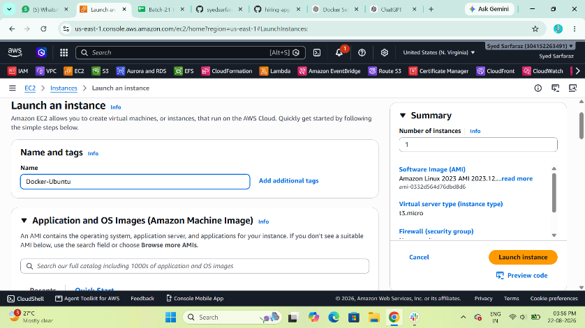
- Connect through SSH:
$ ssh -i your-key.pem ubuntu@<EC2-PUBLIC-IP>
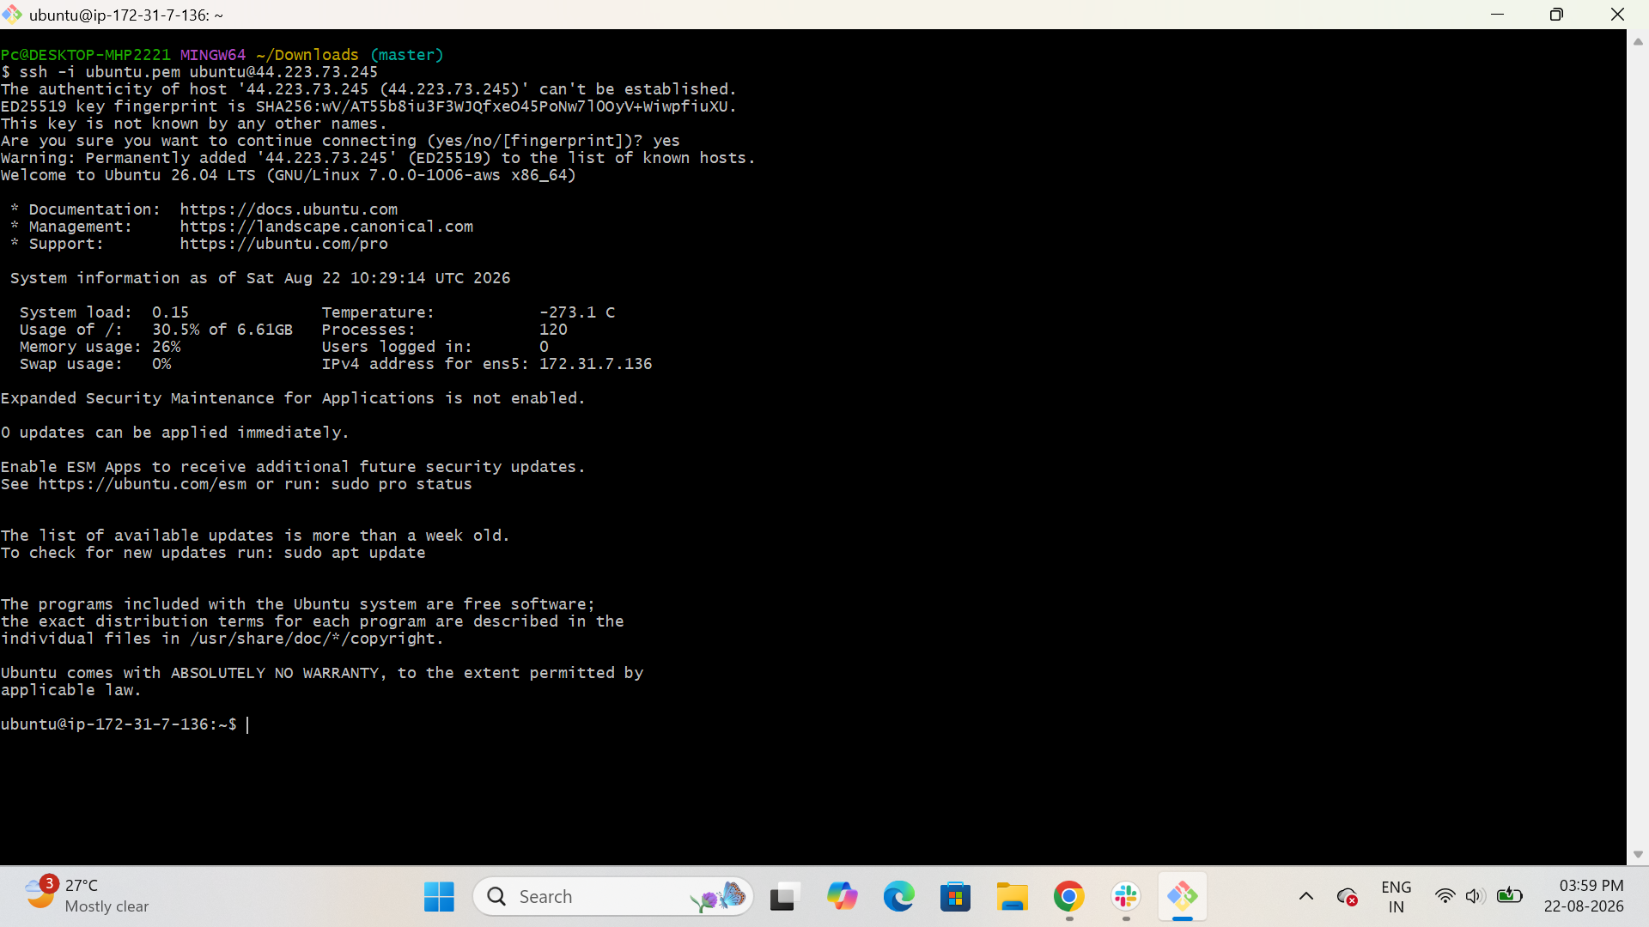

- Verify Ubuntu:
$ cat /etc/os-release
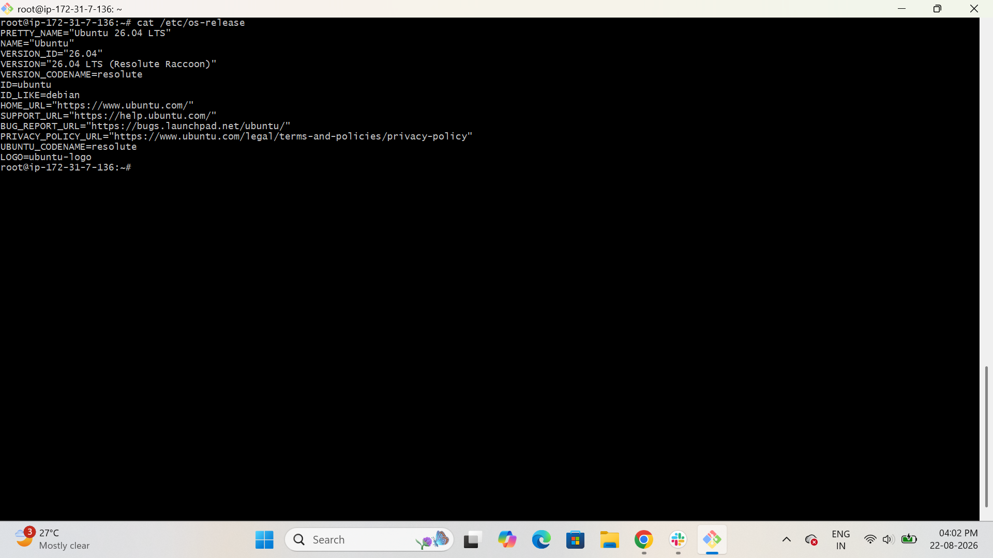

2. Install Docker on EC2
Step 1: Update packages
$ sudo apt update
$ sudo apt upgrade -y
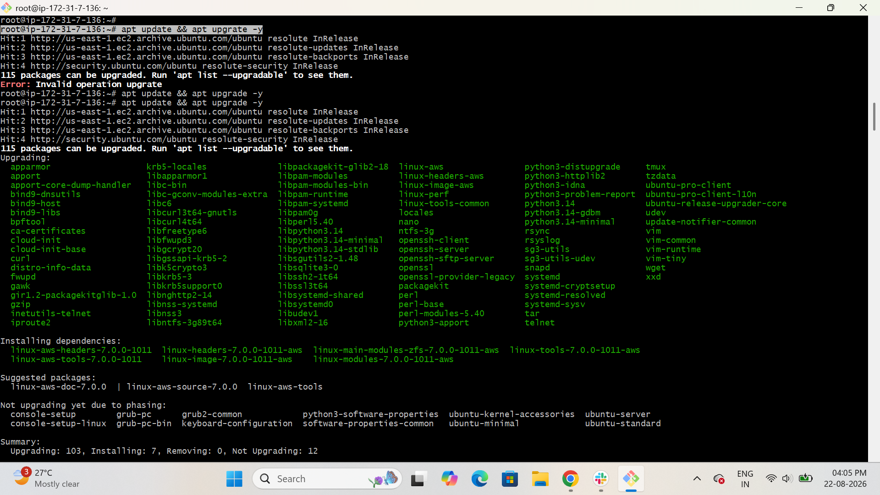
Step 2: Install Docker
$ sudo apt install docker.io -y
Step 3: Start Docker
sudo systemctl start docker
Step 4: Enable Docker at boot
$ sudo systemctl enable docker
Step 5: Check Docker
$ docker –version
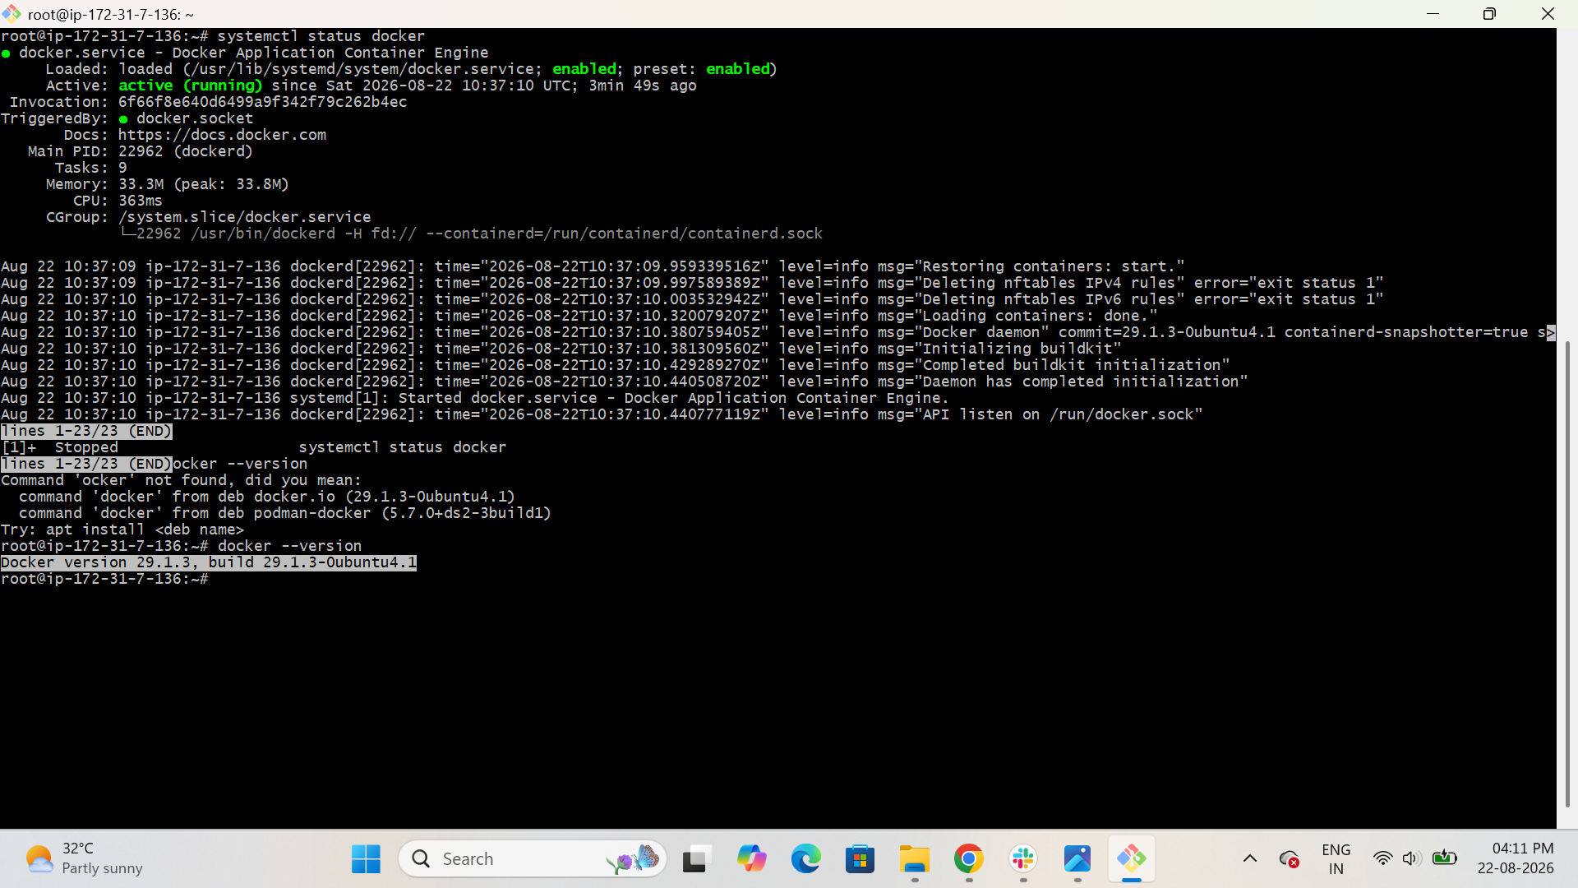
Step 6: Check Docker service
$ sudo systemctl status docker
You should see:
Active: active (running)
Step 7: Allow Ubuntu user to run Docker without sudo
$ sudo usermod -aG docker ec2-user
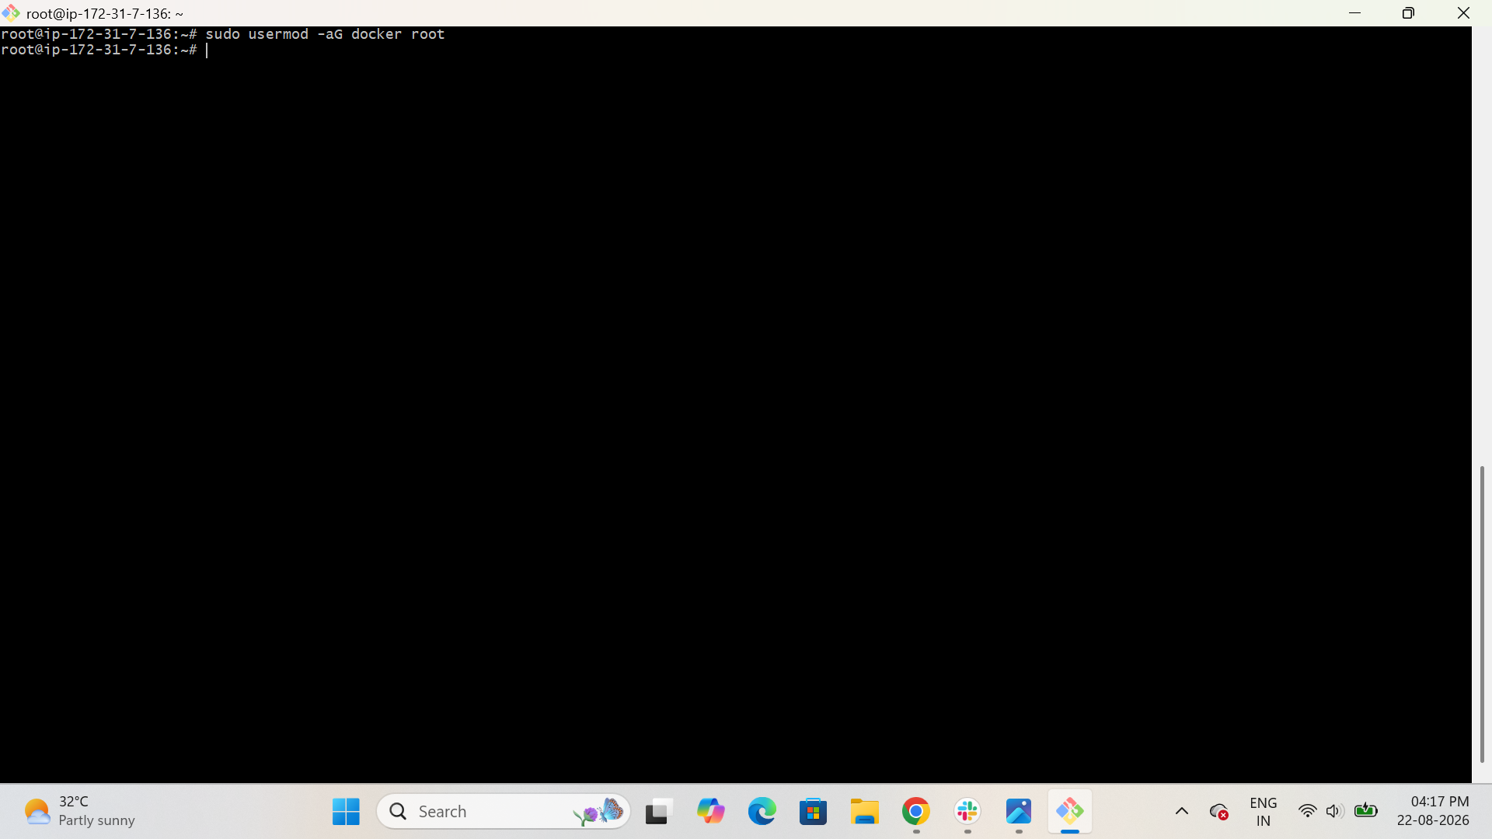

3. Pull 5 Docker Images
You need:
- Nginx
- Apache Tomcat
- Ubuntu
- Jenkins
- SonarQube
Pull Nginx
$ docker pull nginx
Pull Apache Tomcat
$ docker pull tomcat
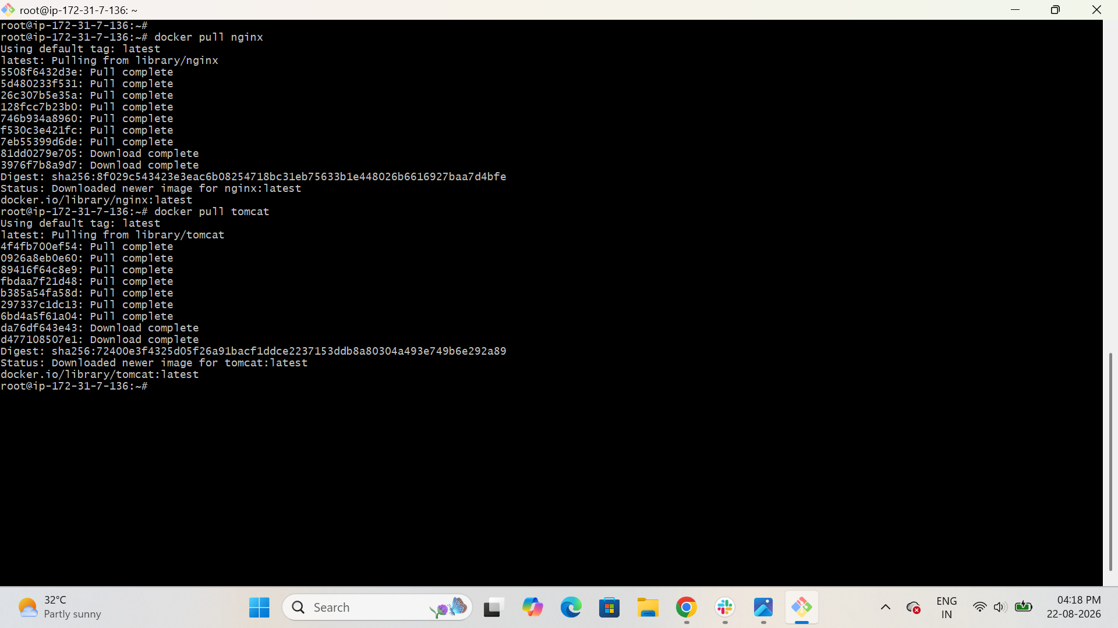
Pull Jenkins
$ docker pull jenkins/jenkins:lts
Pull SonarQube
$ docker pull sonarqube
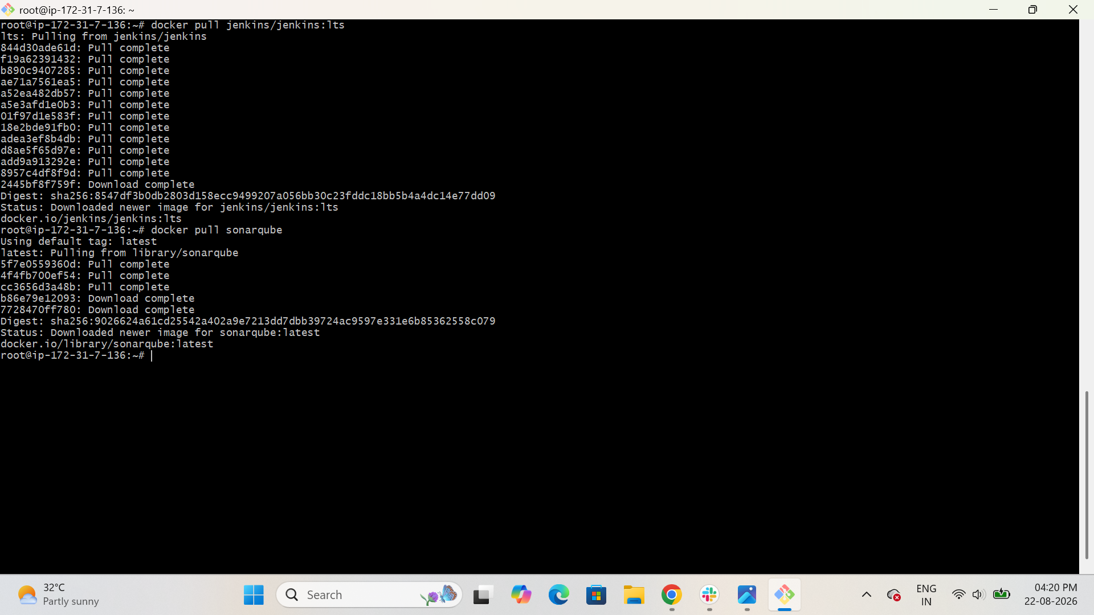
Pull Ubuntu
$ docker pull ubuntu
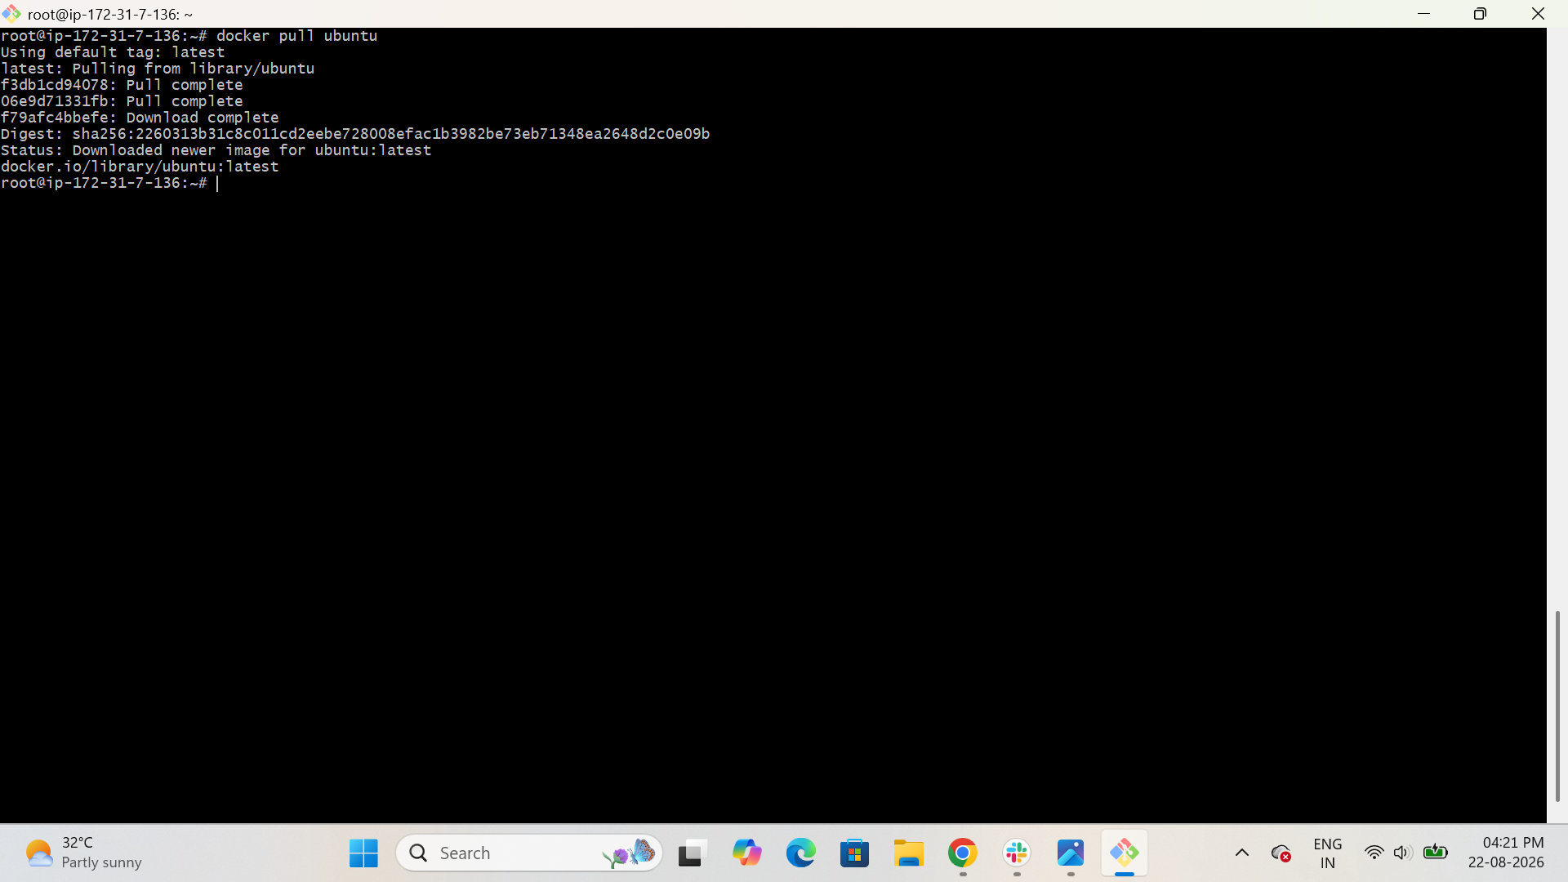
Verify all images
docker images
You should see images similar to:
nginx
tomcat
ubuntu
jenkins/jenkins
sonarqube
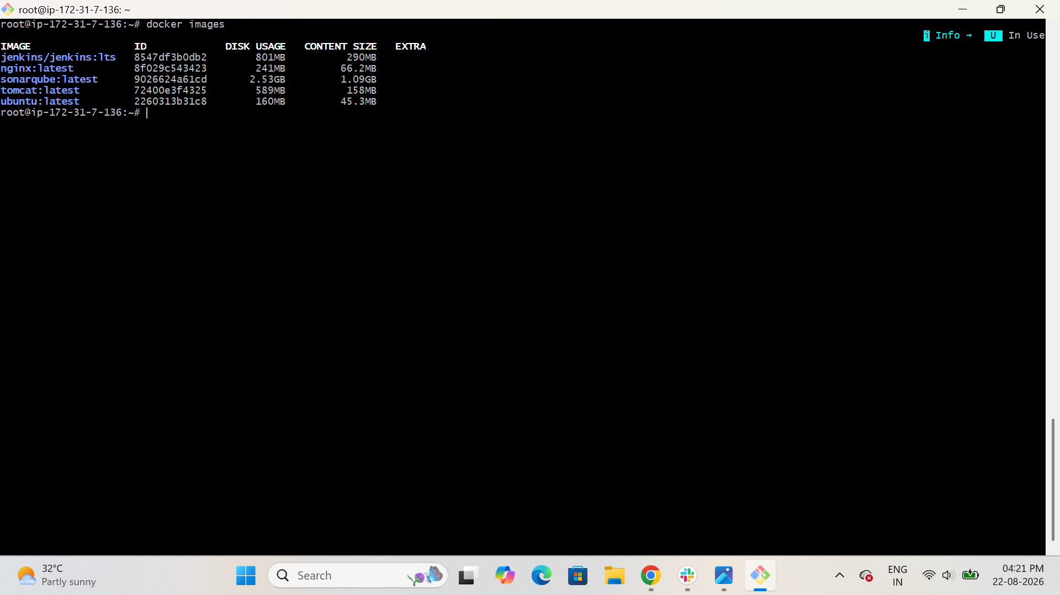

4. Run Nginx Container on Port 81
Run the Nginx container:
docker run -d --name nginx-container -p 81:80 nginx
Check container
docker ps
You should see:
0.0.0.0:81->80/tcp
Test locally from EC2
curl http://localhost:81
You should receive Nginx HTML output.
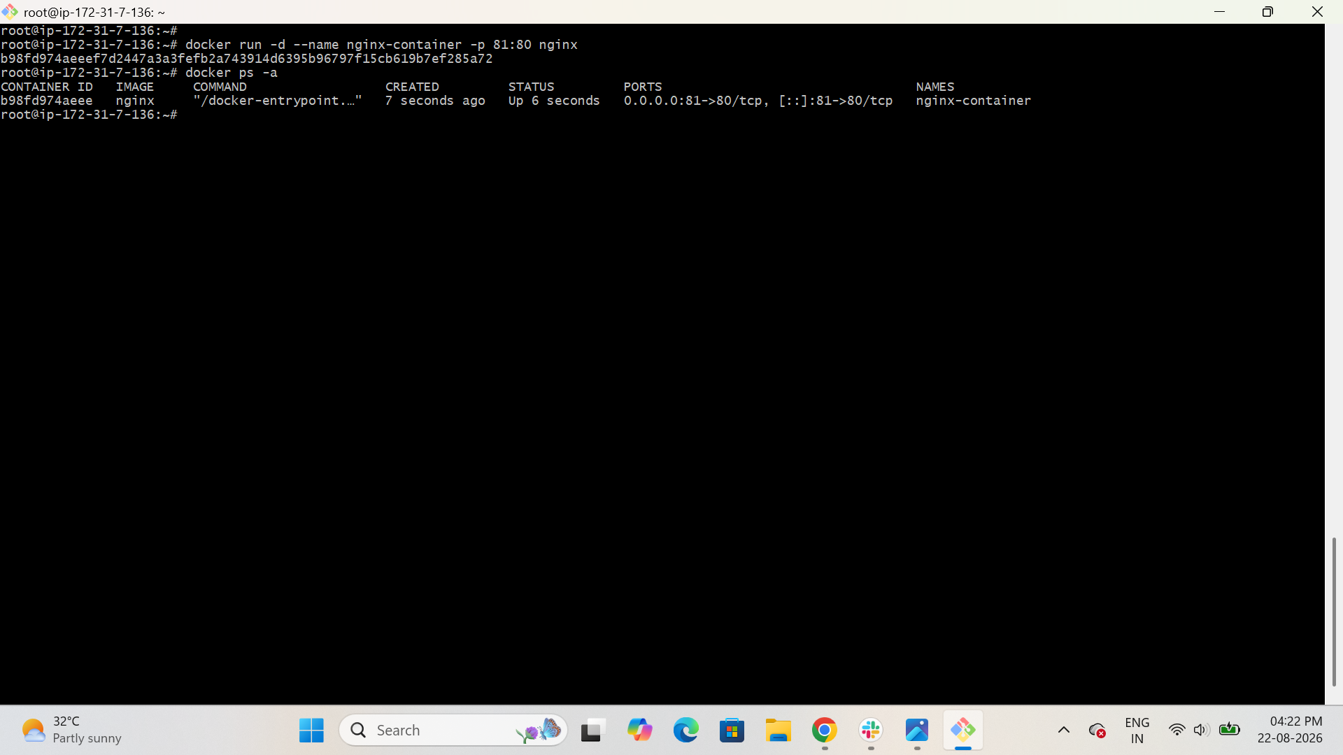
Test from your browser
Open:
http://<EC2-PUBLIC-IP>:81
You should see:
Welcome to nginx!
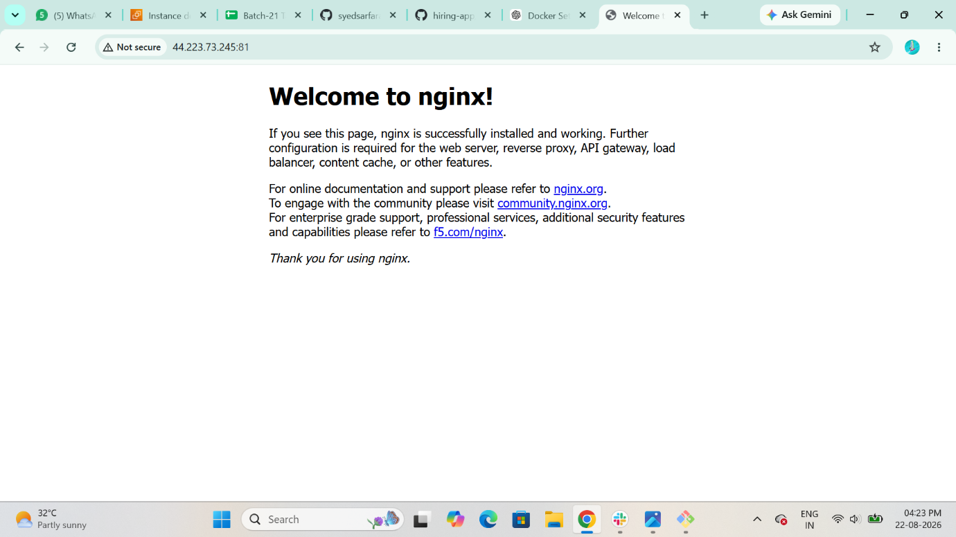

5. Delete Apache Tomcat Image
First check the image:
$ docker images
Stop/remove a Tomcat container if one exists:
$ docker ps -a
If you created a Tomcat container, remove it:
$ docker rm -f <tomcat-container-id>
Now delete the Tomcat image:
$ docker rmi tomcat
Verify:
$ docker images
The tomcat image should no longer be present.
If Docker says the image is being used, remove the container using it first.
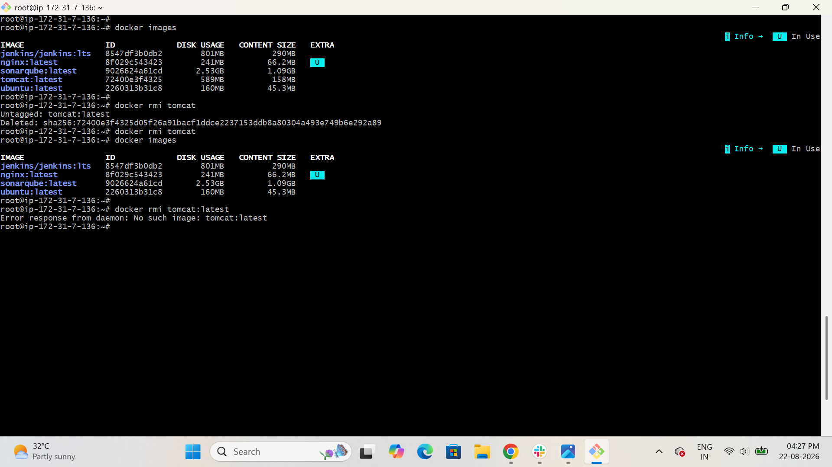

6. Inspect Jenkins Image
Run:
$ docker image inspect jenkins/jenkins:lts
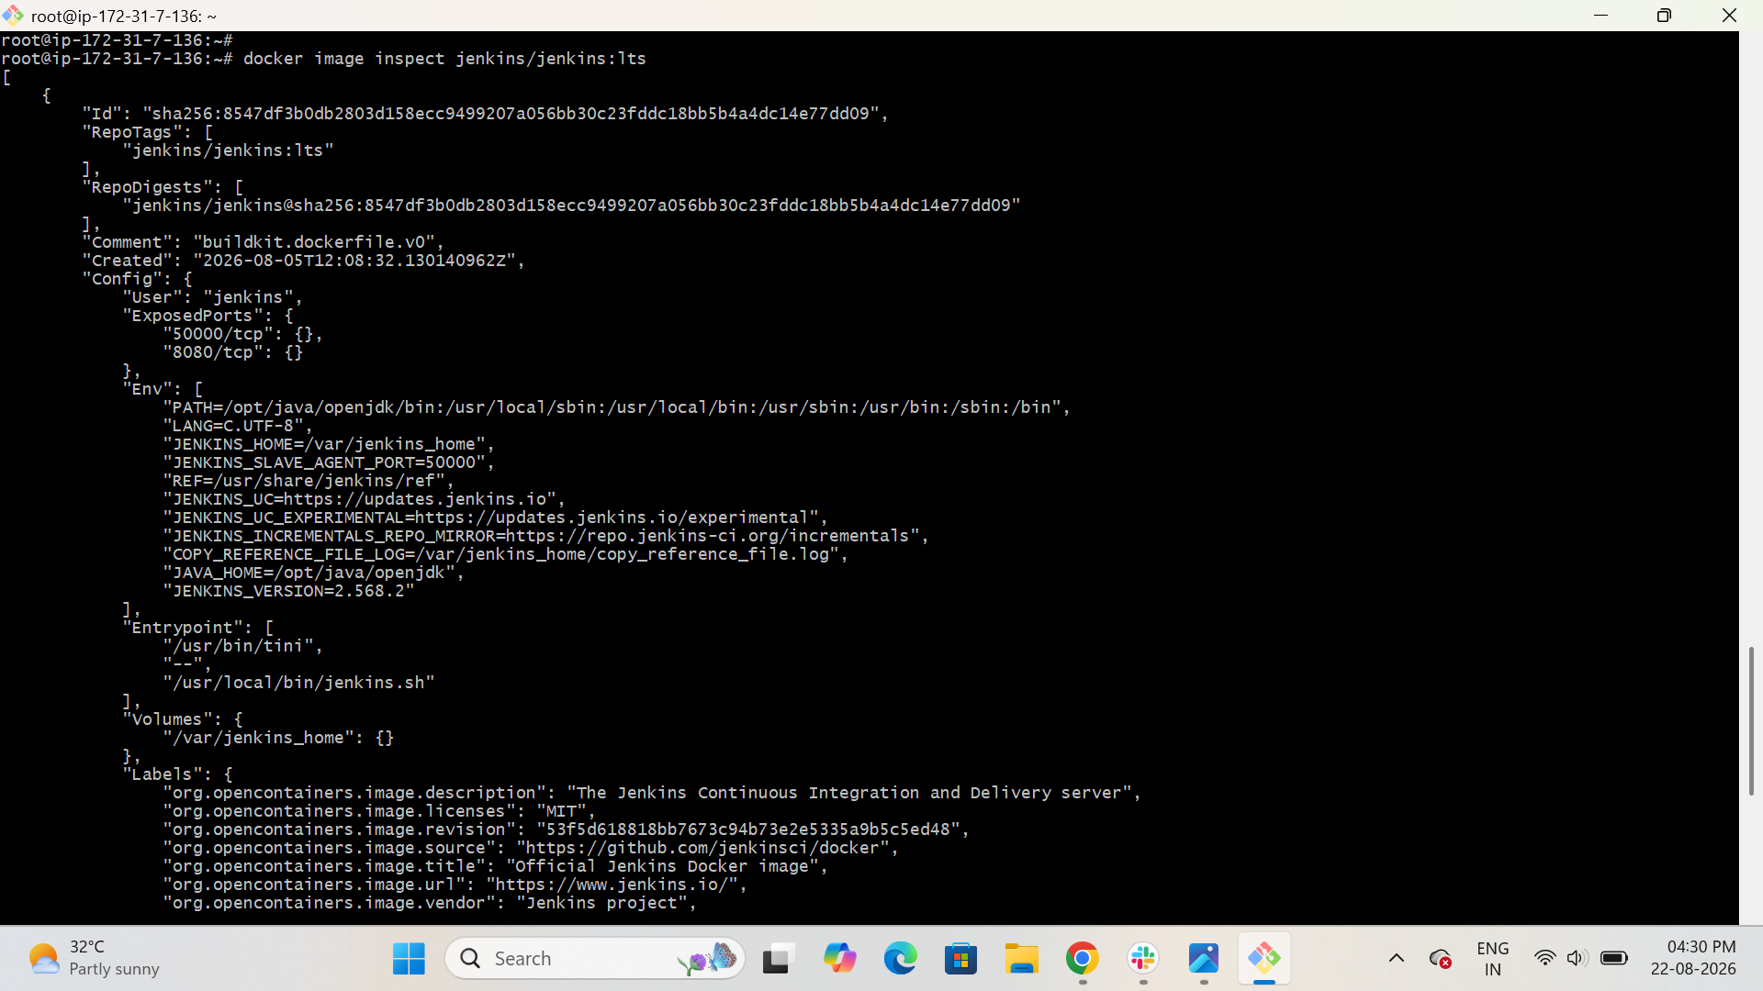
This displays detailed information about the Jenkins image.
For easier viewing:
docker image inspect jenkins/jenkins:lts | less
You can check important information such as:
- Image ID
- Created date
- Architecture
- OS
- Environment variables
- Exposed ports
- Volumes
- Entrypoint
- CMD
You can also check:
docker history jenkins/jenkins:lts

7. Inspect SonarQube Image
Run:
$ docker image inspect sonarqube
For image history:
$ docker history sonarqube
You can also check:
$ docker inspect sonarqube
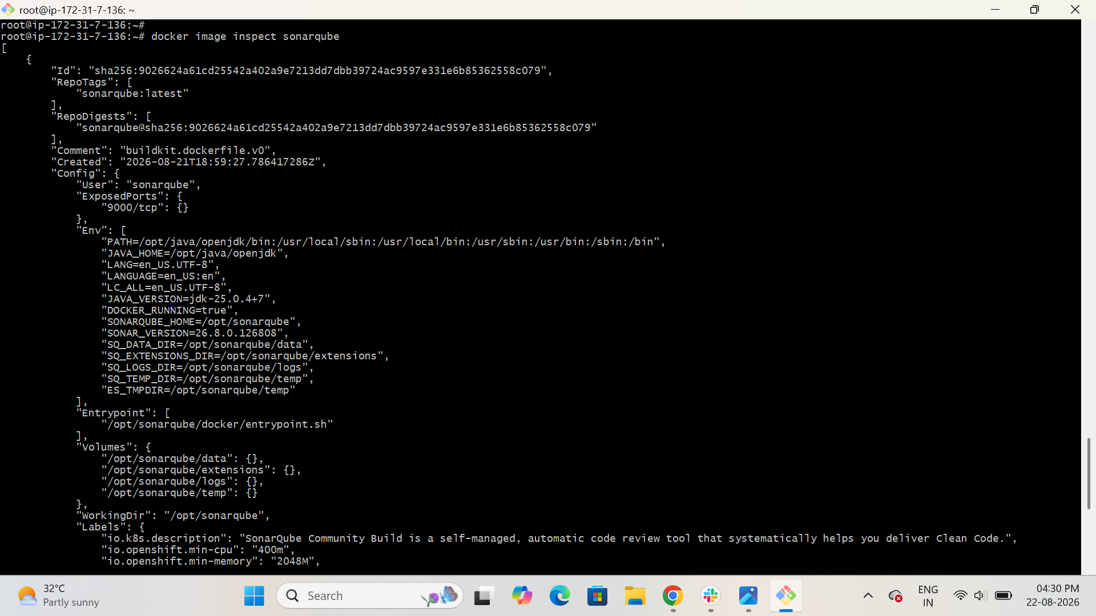

8. Run Jenkins Container
Run Jenkins:
docker run -d --name jenkins -p 8080:8080 jenkins/jenkins:lts
Check Jenkins container
docker ps
You should see:
0.0.0.0:8080->8080/tcp
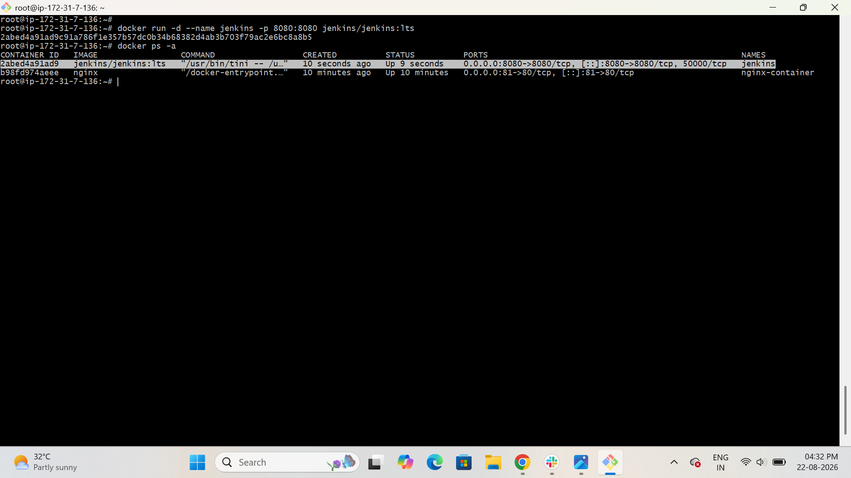

9. Get Jenkins Initial Admin Password
Run:
docker exec jenkins cat /var/jenkins_home/secrets/initialAdminPassword
Copy the password.
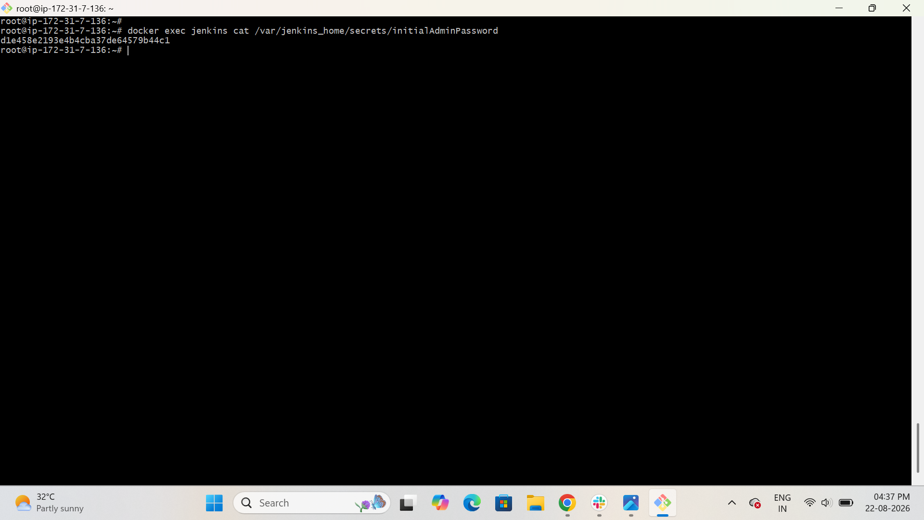

10. Open Jenkins
Open your browser:
http://<EC2-PUBLIC-IP>:8080
You will see the Jenkins unlock page.
Enter the password obtained from:
docker exec jenkins cat /var/jenkins_home/secrets/initialAdminPassword
Then:
- Click Continue
- Select Install suggested plugins
- Wait for installation
- Create your Jenkins admin user
- Click Save and Continue
- Click Start using Jenkins
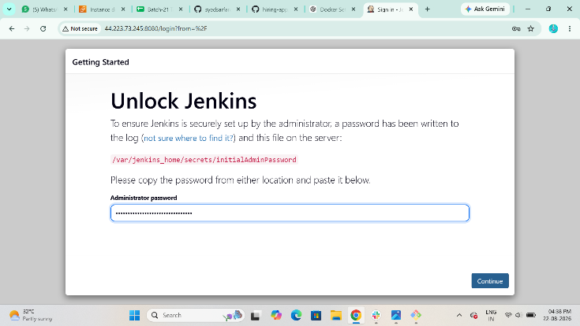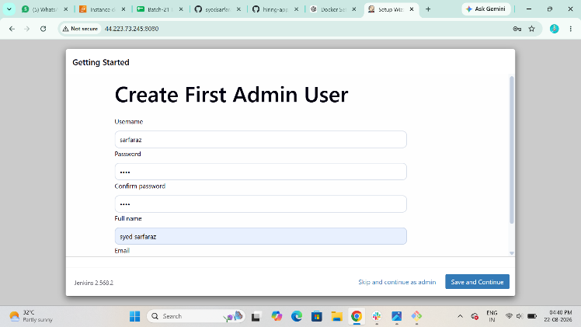

11. Create One Sample Jenkins Job
Step 1: Create job
From Jenkins dashboard:
New Item
Enter:
Sample-Job
Select:
Freestyle project
Click:
OK
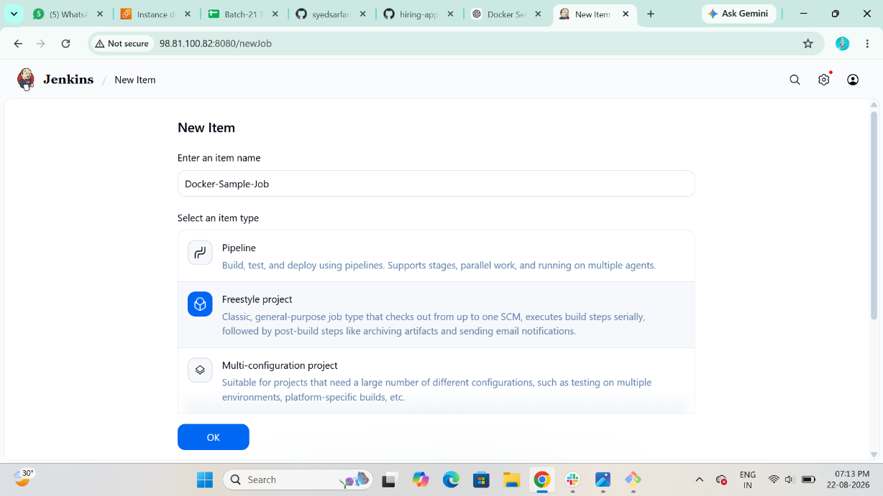
Step 2: Add build step
Go to:
Build Steps → Add build step → Execute shell
Enter:
echo "Hello from Jenkins"
echo "This is my first sample Jenkins job"
date
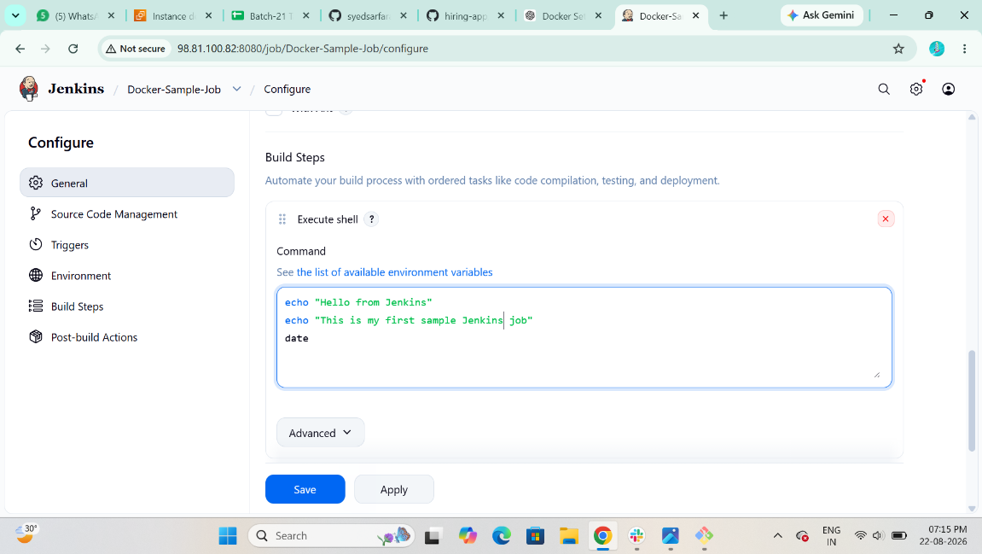
Step 3: Save
Click:
Save
Step 4: Run the job
Click:
Build Now
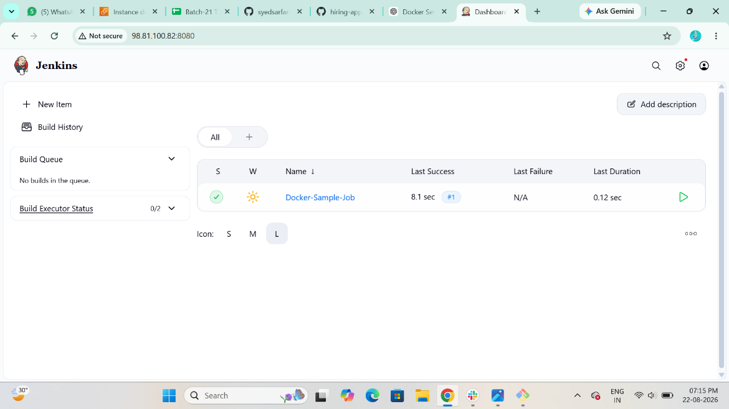
Step 5: Check result
Go to:
Build History → #1 → Console Output
You should see something like:
Hello from Jenkins
This is my first sample Jenkins job
And:

Finished: SUCCESS
