

Submitted by:
Syed Saleh-Ud-Din (F22BINFT1E02118)

Submitted to:
Sir Muzammil Ur Rehman

Department of Information Technology
Faculty of Computing
The Islamia University of Bahawalpur

Summary
This Software Requirement Specification (SRS) describes the functional and non-functional requirements of the Environmental Awareness Web Application, a platform created to promote eco-friendly knowledge among the public, especially students. The system provides reliable environmental information, blogs, news, challenges and quizzes related to climate change, pollution, recycling, and sustainability.

Table of Contents
- Introduction
1.1 Purpose
1.2 Scope
1.3 Product Perspective
1.4 User Characteristics
1.5 Similar Apps/Systems & Literature Review
1.6 Proposed Technologies
- Requirements
2.1 Functional Requirements
2.2 Non-Functional Requirements
- Use Cases and Flow of Processes
3.1 Use Case 1
- References

- INTRODUCTION
Environmental pollution, global warming, and waste management issues are increasing due to lack of public awareness. To address this, the Environmental Awareness Web Application will enable users to access verified environmental knowledge from a trusted admin-controlled source. It aims to educate through blogs, quizzes, news, and eco-friendly tips.

1.1 Purpose
The purpose of this project is to develop a reliable and interactive web platform to:
- Educate users about environmental issues.
- Provide verified and trustworthy eco-information.
- Encourage people to adopt environmentally responsible behavior through quizzes and eco-challenges.
- Eliminate misinformation by allowing only admin-controlled blog publishing.

1.2 Scope
Included Features:
- User Sign Up / Login
- View blogs, environmental news, and educational content
- Take quizzes and participate in eco-challenges
- View real-time environmental data (e.g., air quality)
- Admin controls all content (CRUD for blogs/news)

Not Included:
- Users cannot publish blog posts or news
- No real-time chat or messaging (only optional discussion in future)
- No e-commerce features (selling products)

1.3 Product Perspective
This web application acts as an independent educational platform. Admin is responsible for updating and managing content. Registered users can log in to track engagement, while guests can only view public content without participation in quizzes or challenges.

1.4 User Characteristics
User Type | Characteristics | Privileges
Admin | IT-skilled person trained to manage content | Add/Edit/Delete blogs, news, quizzes
Registered User | Student/general user with basic internet skills | View content, attempt quizzes, join challenges
Guest User | Visitor without login | Read public content only

1.5 Similar App & Literature Review
App/System | Features | Shortcomings
WWF Pakistan Website | Awareness content | No quizzes/challenges
UNEP Climate Page | Research-based info | Not user friendly
ECO Web Portals | Articles and data | Allow user posts → misinformation risk

Our System Advantage:
✔ Verified content only
✔ Interactive quizzes & challenges
✔ User-friendly with admin control

1.6 Proposed Technologies
Category | Tools
Back End | Node.js (Express) / PHP (Laravel)
Front End | HTML5, CSS3, JavaScript, React.js / Vue.js
Database | MySQL / MongoDB
APIs | OpenWeatherMap, Air Quality API, NewsAPI
Design | Figma, Canva
Hosting | Firebase / AWS / Heroku
Version Control | Git, GitHub

2. REQUIRMENTS
This section describes all system functions like user authentication, reading resources, admin management of blogs, quizzes, and environmental news, along with storing user quiz performance and generating eco-awareness engagement.

2.1 Functional Requirements

FR001 — User Sign Up
- Purpose: Register new user.
- User(s): Registered User.
- Input:
Name, Email, Password (min 8 chars), Phone (optional).
- Output: Account created, user can log in.

FR002 — User Login
- Purpose: Allow registered users to access features.
- User(s): Registered User, Admin.
- Input: Email, Password.
- Output: User dashboard access.

FR003 — View Blogs & Tips
- Purpose: Provide educational content.
- User(s): Guest User, Registered User.
- Input: Blog selection click.
- Output: Display content.

FR004 — Admin Blog Management
- Purpose: Admin manages blogs.
- User(s): Admin.
- Input: Title, Category, Description, Image.
- Output: Create/Update/Delete blogs.

FR005 — Take Quiz
- Purpose: Educate via quiz.
- User(s): Registered User.
- Input: Quiz answers.
- Output: Score display & save result.

FR006 — View Environmental News
- Purpose: Show verified news.
- User(s): Guest User, Registered User.
- Input: Click on News.
- Output: Display verified news.

FR007 — View Real Time Environmental Data
- Purpose: Show air quality/temperature.
- User(s): Guest/Registered User.
- Input: Location/API.
- Output: Display real-time data.

2.2 Non Functional Requirements

Requirement | Description
Usability | System must be user-friendly and responsive (mobile/desktop).
Security | Password encryption, admin authorization required.
Reliability | System available 99% with regular backups.
Performance | Pages load within 5 seconds; fast API response.
Scalability | Architecture should support future modules.
Maintainability | Code must follow MVC for easy updates.
Compatibility | Must run on all modern browsers.

3. Use Cases & Flow of Processes
System level Use Case Diagram

3.1 Use Case 1: User Sign Up
Field | Details
ID | UC001
Name | User Sign Up
Description | Process where a user registers to system
Requirement | FR001
Actors | Registered User
Precondition | User not registered
Postcondition | User created and can log in
Basic Flow | User enters credentials → System validates → Account created
Alternative Flow | Login if already registered
Exceptions | Invalid email/password

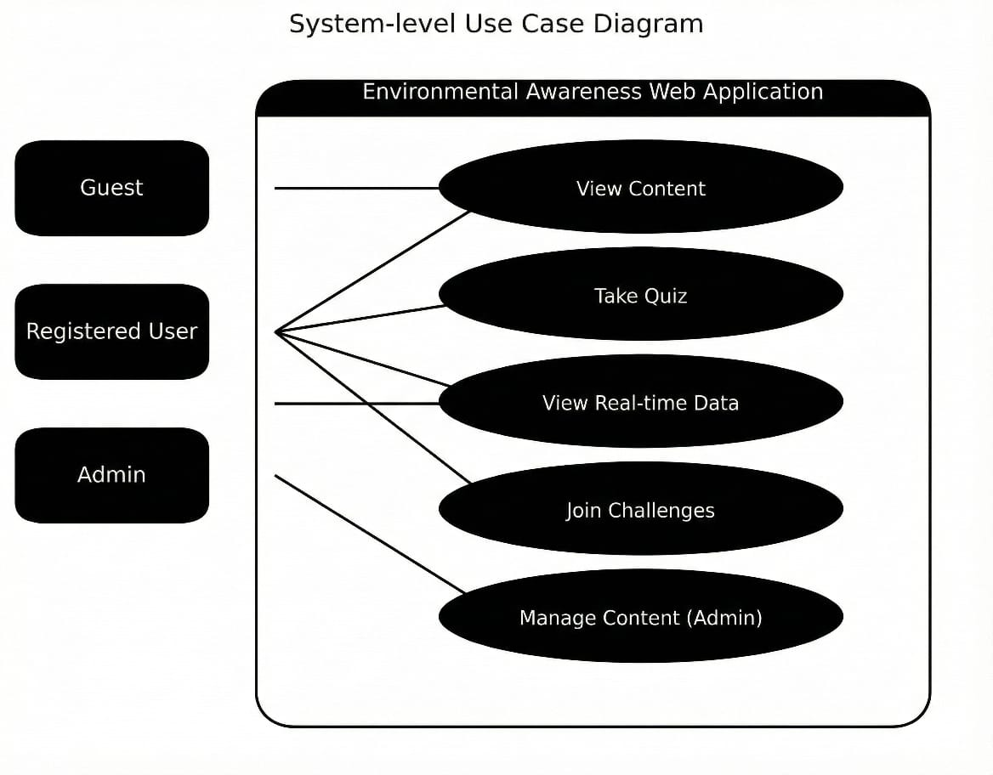

- REFERNCES
- WWF Pakistan. Climate Change and Awareness.
- UNEP. Global Warming and Sustainability Reports.
- Air Quality API Documentation.
- OpenWeatherMap API Documentation.

