**ITU SWE 610 Ruby on Rails MidTerm Exam 04/21/2016**

This exam is open book, open notes, open internet. Please do not collaborate with other students as I have tools to identify plagiarism specially in programming questions. You are suppose to complete this exam on your own. This Exam is timed at 4 hours. You should be able to complete this exam in 4 hours. You can take 30 minutes extra if needed. So after 4.5 hours I will start deducting points at the rate of 1 point per hour late.  Your time will start as soon as you download this exam from EMS. If you use the textbook, the internet, or other external sources, give references.

**Name: ITU Student ID:**

**Start Time: End Time:**

**Uploaded all the exercises under**

[**https://github.com/syedsearch/MidTermQuestions**](https://github.com/syedsearch/MidTermQuestions)

1. This Question involves writing scripts in ruby in order to get a feel for the Ruby programming language.

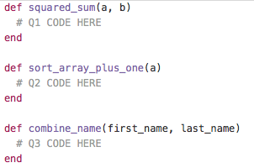

1. In above Ruby Code there is a function called check_squared_sum. This function takes two integers, a and b, and calculates the sum of a and b, then returns the square of the sum.
2. The second method you have to fill in is sort_array_plus_one. This method takes in an array of integers, sorts it, then increments every element by 1, and returns it. It does not matter if this method is destructive or not.
3. The third method takes in two strings, a first_name and last_name. It will return the first_name concatenated with the last_name, along with a space in between.

Example:

combine_name 'Howard', 'Chen'

* + 'Howard Chen'

1. Following exercises reinforces your knowledge into Ruby Programming. Please review attached Ruby code for Number Guessing Game we discussed in the class. Ruby Code can be found at following location: <https://www.dropbox.com/s/k3agw2ie3unbt3r/NumberGuess.rb?dl=0>

Run the above code as shown in the class and experience the Number Guessing Game. Based on the questions below make improvements to number guessing game, the Ruby Number Guessing Game.

1. Currently, the game allows players to play as many times as they wish. It does not provide any feedback on how the players are doing, however. Modify the game so that it keeps track of the number of games played as well as the average number of guesses made per game.
2. The game challenges the player to guess a randomly generated number between 1 and 100 in as few guesses as possible. Make the game more challenging by increasing the range of numbers to between 1 and 1000.
3. The game lets players know whether their guesses are too high or too low. It also rejects any guesses outside of its supported range of numbers, such as negative numbers, numbers greater than 1000, or alphabetic or special characters. Modify the game so that it notifies players when invalid guesses have been made and reminds players of what constitutes valid input.
4. Currently, the game allows players to make an unlimited number of guesses. Therefore, players cannot lose the game. Modify it so that players are allowed a maximum of 10 guesses, after which the game is declared lost.
5. You should thoroughly test all your Ruby scripts to make sure they are running as expected. With the Number Guessing game, that means playing the game repeatedly. To make this easier on you, add a hidden “cheat” to the game that allows you to display the game’s number.

Solve each questions above and submit your answers by pushing it to github repository as SolutionA, SolutionB etc. Post your github link. Please explain how you went about making the change and what data structures, programming concepts you used to solve the problems.

1. Consider the following Ruby code:

def method1

x = 11

method2 do |x|

puts x

end end

def method2

x = 22

yield 33 end

def method3

x = 11

method2 do |y|

puts x

end end

* + 1. What output (if any) is generated when method1 is called?
       1. Value is 33
    2. What output (if any) is generated when method3 is called?
       1. Values is 11
    3. Give 2 examples of how Rails takes advantage of meta-programming facilities in the Ruby language.
       1. #Two Advantages -
       2. #1. Implementing Test Coverage and Profilers - Able to check if the particluar code is invoked by your test suites.
       3. #2. Language Migration - #I've gotten the most use out of metaprogramming for bridging between different APIs.

#A working example would be FireBreaths JSAPIAuto1 that eases writing C++ classes that are exposed to JavaScript. By providing a registering facility for the functions that are to be exposed, the argument types can be inspected and from that fitting code generated at compile-time that converts from the script-API-types to native C++ types and back, even directly supporting map, vector, etc.

#(d) In your opinion, which programming language is better, Ruby or Javascript? List 2 specific reasons to justify your choice.

(d) In your opinion, which programming language is better, Ruby or Javascript? List 2 specific reasons to justify your choice.

**3.** Label each of the tasks below with “Model”, “View”, or “Controller” to indicate where that task would typically be implemented in a Web application using an MVC architecture.

(a)  Validate form data - **Model**

(b)  Make sure a user is logged in - **Controller**

(c)  Invoke the link_to method - **Controller**

(d)  Return a “redirect” to the browser - **Controller**

(e)  Define an event handler for a custom form element - Controller

(f)  Generate a new session token - Controller

(g)  Invoke the find_all_by_name method - Controller

(h)  Create a “salt” for a password - Model

1. **Write a Ruby class definition that meets the following criteria:**
   1. class is called Troll
   2. class has publicly accessible attributes ugliness, smelliness, and strength
   3. upon instantiation, an object of this class has a member variable, a String, called grunt, whose initial value is "UNGAH" (that's pronounce "oon-guh").
   4. class has an instance method called speak() that prints the value of the instance variable grunt 42 times
   5. class has an instance method called reverse() that prints the value of the instance variable grunt backwards
   6. class has a static/class method called propagate(), which returns a Troll instance whose grunt attribute is "eegah"
   7. Imagine a Troll instance fred, which, when the following method is called:
   8. fred.respond_to?("fight")  returns true. What is missing from your class definition in order for this example to be accurate?
2. **Short Answer Questions:**
3. Does the respond_to?() method illustrate object-oriented polymorphism? If so, in what manner?
4. According to Ruby conventions, what kind of value would you expect to receive from a method that ends in a question mark (?) ?
5. According to Ruby conventions, what is the difference between pairs of methods like do_this and do_this! (notice the bang) ?
6. Briefly explain Ruby's type system. What is it (by name)? What does it mean?
7. What type of Ruby object does the following expression yield? %w( master rails and then try another framework you'll never go back)
8. Given an array of strings called @happy_places, would these two snippets of code do the same thing?
9. @happy_places.each do |happy_place|
   1. puts happy_place end
10. @happy_places.each {|hp| puts hp}
11. Given a function that needs to return a value to its caller, does the function need an explicit return statement? If so, explain why. If not, then what can you always expect a Ruby function to return?

**6.** The Hash class supports 50 methods, which is many more than can be covered in this chapter. To round out your understanding of arrays, visit *http://ruby-doc.org/core/classes/Hash.html* and view the documentation for the various methods. Then complete the following exercises using IRB:

1. Create a hash named Accounts and add the following items to it:
   1. 10001, AFord
   2. 20001, JAlex
   3. 30001, AJolie
2. Use the Hash class’s delete method to remove the key-value pair with a key of 30001 from the Accounts hash.
3. Use the Hash class’s inspect method to verify the contents of the hash.

.delete

1. Use the Hash class’s invert method to convert the Accounts hash’s keys to values and convert its value to keys.
2. Use the Hash class’s has_key? method to determine if any of the following keys are stored in the Accounts hash: JAlex, 10001.
3. Use the Hash class’s size method to display a count of the number of key-value pairs stored in the Accounts hash.
4. Use the Hash class’s clear method to remove all items from the Accounts hash and then display the contents of the hash.
5. Use the Hash class’s inspect method to verify that the array is now empty.

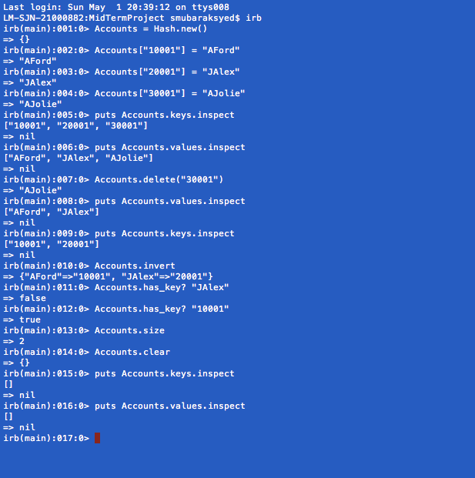

**7.** String substitution is an important feature of regular expressions. The following exercises are designed to give you the opportunity to demonstrate your knowledge and understanding of how to perform string substitutions using the sub and gsub methods. Solve each of these exercises using IRB and the sub and gsub methods. Capture and turn in your results using screen prints.

1. Enter the following statement into IRB, then use the sub method to replace the first vowel found in the string with an asterisk character:

"Jack and Jill went up the hill to fetch a pail of water."

1. Enter the following statement into IRB. then use the gsub method to replace each vowel found in the string with an asterisk character.

"Jack and Jill went up the hill to fetch a pail of water."

1. Enter the following statement into IRB, then use the gsub method to replace the string may be more than with the string can only be.

"In the end there may be more than one."

1. Enter the following statement into IRB, then use the gsub method to replace the word bob with the word Bob throughout the string.

"Big bob told little bob to take baby bob home."

1. Enter the following statement into IRB, then use the gsub method to replace a comma for each blank space in the string.

"Bob Sue Sam Dick Jane Peter Paul John"

1. Enter the following statement into IRB, then use the sub method to remove the pound sign and all the characters that follow it.

"804-991-3434 #Client phone number"

1. Modify your solution to the above exercise to include a second regular expression that removes any blank space and hyphens from the string.

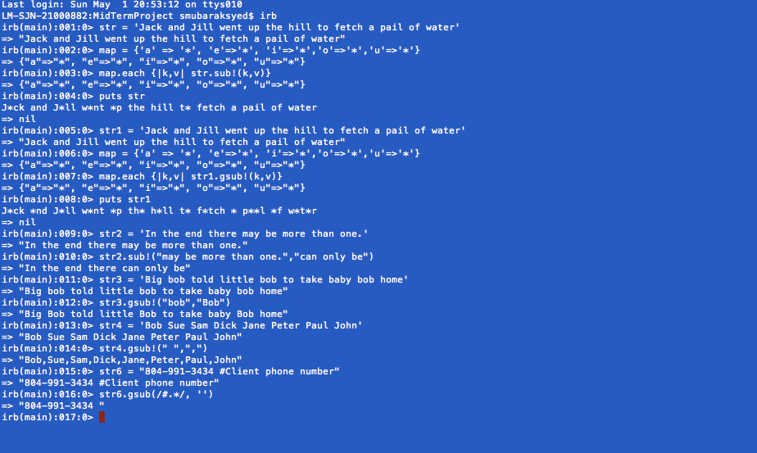

**8. Rails related questions**

1. Name four ActiveRecord callbacks that you can bind methods to.

:create, :update, :delete, :read

1. The Rails convention maps HTTP methods to certain controller methods, and those methods usually involve specific CRUD operations on models. Given the following CRUD database methods:

create, read, update, and delete

and the following HTTP methods:

GET, PUT, POST, DELETE

and the following controller actions: index, new, create, edit, update, destroy

Complete the following table.

|  |  |  |
| --- | --- | --- |
| **HTTP method** | **controller action** | **CRUD operation** |
| GET | index | CREATE |
| GET | new | CREATE |
| GET | create | CREATE |
| PUT | edit | UPDATE |
| PATCH | update | UPDATE |
| DELETE | destroy | DELETE |

1. Rails "simulates" PUT and DELETE requests. Why?
2. What is the difference between the two Rails environments 'production' and 'development' ?

Development environment is used for all the development and testing of the Application. None of the debugging code should be enabled in Production. Rails allow the application to be executed as ‘development’ or ‘production’

1. Usually, Rails controllers incorporate plural nouns, such as ProtestsController and RevolutionsController. In what case should a controller have a singular name like GeocodingController?

If the controller corresponds to only user action then the controller can have a singular name.

1. What is a Rails "helper method" and when should they be defined and used by you, the developer?

Rails helper method are used to execute a ruby code that could be reused in lot of places in Ruby. This is in adherence to the rail’s principle to not repeat the codes.

**9.** Textbook: Ruby S., Thomas D., Heinemeier Hansson D. - Agile Web Development with Rails, 4th Edition. Skim through Chapter 5 and Chapter 6 and discuss the “Canonical Depot Application” explained and built in these chapters with respect to Rails Framework, Steps followed and potential pain points you may observe in this process. (no more than 1-2 page or flowchart) This book can be downloaded at: [https://www.dropbox.com/s/1hm9itzdaztsr1n/Agile Web Development with Rails.pdf?dl=0](https://www.dropbox.com/s/1hm9itzdaztsr1n/Agile%20Web%20Development%20with%20Rails.pdf?dl=0)

**10. Project Based Questions:**

A. Explain what REST means and how it relates to Rails. (About 1/4 to 1/2 page.) Include CRUD and HTTP in your discussion. If you use the textbook, the internet, or other external sources, give references.

<https://en.wikipedia.org/wiki/Representational_state_transfer>

REST by definition means Representational State Transfer. This is the Architectural style of the world wide web. Here the data used by your Applications are called resources. A set of API’s are defined to operate on those resources. These API’s follow the HTTP convention to operate on a resource. So all resources are bounded to the HTTP Method operations. The HTTP Methods are GET, POST, PUT, UPDATE AND DELETE. Since Rails is a web application framework, it fits as the right candidate to follow the REST Principles. All resources defined in RAILS are bound by interfaces that corresponds to the HTTP methods.

B. Create Scaffold Project. Give commands, screenshots, code where applicable. Exam submitted without explanation, steps, commands and code won’t be graded.

<https://github.com/syedsearch/MidTermProject>

1. Create a Rails scaffold-based project named MidtermPartC that keeps track of medal winners in the 2012 London Olympics. Use a scaffold with the model name Olympic medals with the fields athlete_name, event, country, medal_type (gold, silver, bronze), event_date.
2. Change the dropdown menu for event_date so that only 2012 is displayed.
3. Use validations to insure that athlete, and country are non empty.
4. Use a validation with the :inclusion argument to insure that medal_type is "gold", "silver", or "bronze".
5. validates :medal_type, :inclusion => { :in => ["gold", "silver", "bronze"] }
6. Use the layout page to display this image of olympic rings on all pages of the project.
   1. In the CSS file scaffolds.css.scss:
   2. Change the text color to white.
   3. Change the background color to black.
   4. Set the color of all hyperlinks to white.
   5. Set the font size to 110% of the default.
   6. Set the width of the olympic rings image in Part d to be 150 pixels.
7. Start the server and view your project in a browser. Use the new view of your project to enter the following olympic medal information in your project's database:

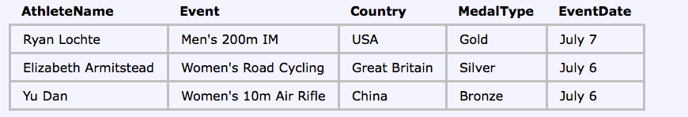

C. Find the Errors.

* Did not have time and did not complete it

Fix the errors in the following source code. All your code should be XHTML complient. To check your answer, you can build a Rails project named MidtermPartC using the corrected source code. Generate a controller named ShowDateTime with a view named display. Copy these images to the assets/images folder before viewing the project.

jan.jpg feb.jpg mar.jpg apr.jpg may.jpg jun.jpg

jul.jpg aug.jpg sep.jpg oct.jpg nov.jpg dec.jpg

sun.png moon.jpg

Images can be downloaded from: <https://www.dropbox.com/s/v7fyrsefs84pu5i/images.zip?dl=0>

**There are about 20 intentional mistakes. Complete these layout elements and push the static page RoR app to github print your repo link here. Deploy this to Heroku and print your Heroku link after fixing the above 20 mistakes and noting them here.**

----- View code in app/views/show_date_time/display.html.erb -----------------------

<p>Date and Time: <%= @datetime %><br>

<%= image_tag @timeimg, :class => "img" %>

<p>Month: <%= @monthname %><br />

<% image-tag @monthimg, :class = "img" %></p>

----- Layout code in app/views/layouts/application.html.erb ------------------------

<!DOCTYPE html PUBLIC "-//W3C//DTD XHTML 1.0 Transitional//EN"

"http://www.w3.org/TR/xhtml1/DTD/xhtml1-transitional.dtd">

<html>

<head>

<title><%= @title %>

<%= stylesheet_tag "application" %>

<body>

<h2><%= @title %></h2>

yield

</body>

</html>

----- Controller code in app/views/show_date_time_controller/display.html.erb ------

class ShowDateTimeController < ApplicationController

def display

@title = "Takehome Midterm -- Show Date and Time"

t = Time.now

@date_time = t

if t.hour >= 6 && t.hour <= 18

@timeimg = "sun.png"

else

@timeimg = "moon.jpg"

end

if t.mon == 1

@monthname = "January"

@monthimg = "jan.jpg'

elsif t.mon = 2

@monthname = "February"

@monthimg = "feb.jpg"

elsif t.mon == 3

@monthname = "March"

@monthimg = "mar.jpg"

elseif t.mon == 4

@monthname = "April"

@monthimg = "apr.jpg"

elsif t.mon == 5

@monthname = "May"

@monthimg = "may.jpg"

elsif t.mon == 6

@monthname = "June"

@monthimg = "jun.jpg"

elsif t.mon == 7

@monthname = "July"

@monthimg = "jul.jpg"

elsif t.mon == 8

@monthname = "August"

@monthimg = "aug.jpg"

elsif t.mon == 9

@monthname = "September"

@monthimg = "sep.jpg"

elsif t.mon == 10

@monthname = "October"

@monthimg = "oct.jpg"

elsif t.mon == 11

@monthname = "November"

@monthimg = "nov.jpg"

elsif t.mon == 12

@monthname = "December"

@monthimg = "dec.jpg"

end

end

----- Stylesheet code in assets/stylesheets/application.html.erb -------------------

/*

*= require_self

*= require_tree .

*/

body { font-family; Helvetica:

font-size: 110%;

text-color: navy;

background_color: lightblue;

.img { width: 200px; }