**CRONTAB**

**1.To view the Crontab entries**

To view your crontab entries type “crontab -l “

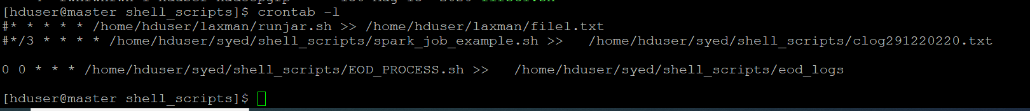

**2. Edit Crontab Entries**

To edit crontab entry, use -e option as shown below. In the below example will open schedule jobs in **VI** editor. Make a necessary changes and quit pressing **:wq** keys which saves the setting automatically.

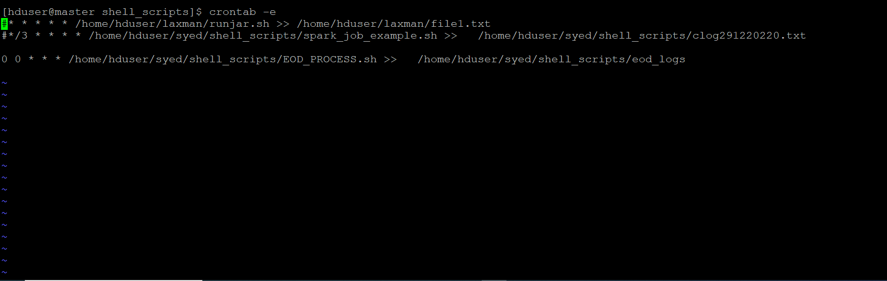

**3. List Scheduled Cron Jobs(to see this login as root)**

crontab -u hduser –l

To list scheduled jobs of a particular user called **hduser** using option

as -u (User) and -l (List).



**4. Remove Crontab Entry**

**Caution:** Crontab with -r parameter will remove complete scheduled jobs without confirmation from crontab. Use -i option before deleting user’s crontab.

**# crontab -r**

**5.To schedule a job for every minute using Cron.**  
Ideally you may not have a requirement to schedule a job every minute. But understanding this example

* * * * * CMD

**Cron tabe with shell script**

1. Write a shell script and place that shell script location in cron tab

For example we have below shell script we are placing this in crontab for running end of the day

/home/hduser/syed/shell_scripts/**EOD_PROCESS.sh**

0 0 * * * /home/hduser/syed/shell_scripts/EOD_PROCESS.sh >> /home/hduser/syed/shell_scripts/eod_logs



We can store logs by specifying “>>” with log location

Example cron expression:

**Crontab Format:**

MIN HOUR DOM MON DOW CMD

**Field Description Allowed Value**

MIN Minute field 0 to 59

HOUR Hour field 0 to 23

DOM Day of Month 1-31

MON Month field 1-12

DOW Day Of Week 0-6

CMD Command Any command to be executed.

Examples:

1. for running every five minute

*/5 * * * * /cmd/

2.every day 1pm

0 1 * * * /cmd/

Ref link for cron expression: https://crontab.guru/examples.html