CHAPTER 6
RESULTS AND DISCUSSION
6.1 Introduction
This chapter consolidates, interprets, and critically discusses every experimental result produced in this research, from the earliest baseline models through to the final proposed hybrid model. Chapter 5 (Data & Experiments) reported the individual results of each stage as they were produced; this chapter instead treats those results as a single connected body of evidence, discusses why each result occurred, what it reveals about the underlying problem, and how it relates to the aims and objectives defined in Section 1.4 and the architecture proposed in Chapter 3.
All results reported in this chapter were produced by executing the SEAQL pipeline described in Chapter 3 on the cleaned, audited Dataset_T-ITS packet capture described in Chapter 5. No results in this chapter are simulated, assumed, or extrapolated; every figure, table, and metric below corresponds to a model that was actually trained and evaluated on a held-out test split.
6.2 Overview of the Experimental Progression
Nine distinct models/configurations were trained and evaluated over the course of this research, moving from simple linear baselines to the final proposed hybrid architecture. Table 6.1 and Figure 6.1 summarise this entire progression in one place before each stage is discussed individually in the sections that follow.
# | Model | Task Framing | Macro F1-score
1 | Logistic Regression (baseline) | 3-class | 46.3%
2 | MLP with early stopping (baseline) | 3-class | 59.2%
3 | Hierarchical Federated MLP | 3-class | 59.7%
4 | Random Forest (best central baseline) | 3-class | 73.4%
5 | Autoencoder (unsupervised anomaly detector) | binary | 83.5%
6 | Hybrid AE-Stacked Ensemble (proposed, 3-class) | 3-class | 74.4%
7 | Hierarchical 2-stage classifier (attack/benign, then DoS/Replay) | 3-class | 72-77% (capped)
8 | Hybrid AE-Stacked Ensemble (proposed, FINAL - binary) | binary | 93.3%
Table 6.1: Complete experimental progression across all models evaluated in this research.
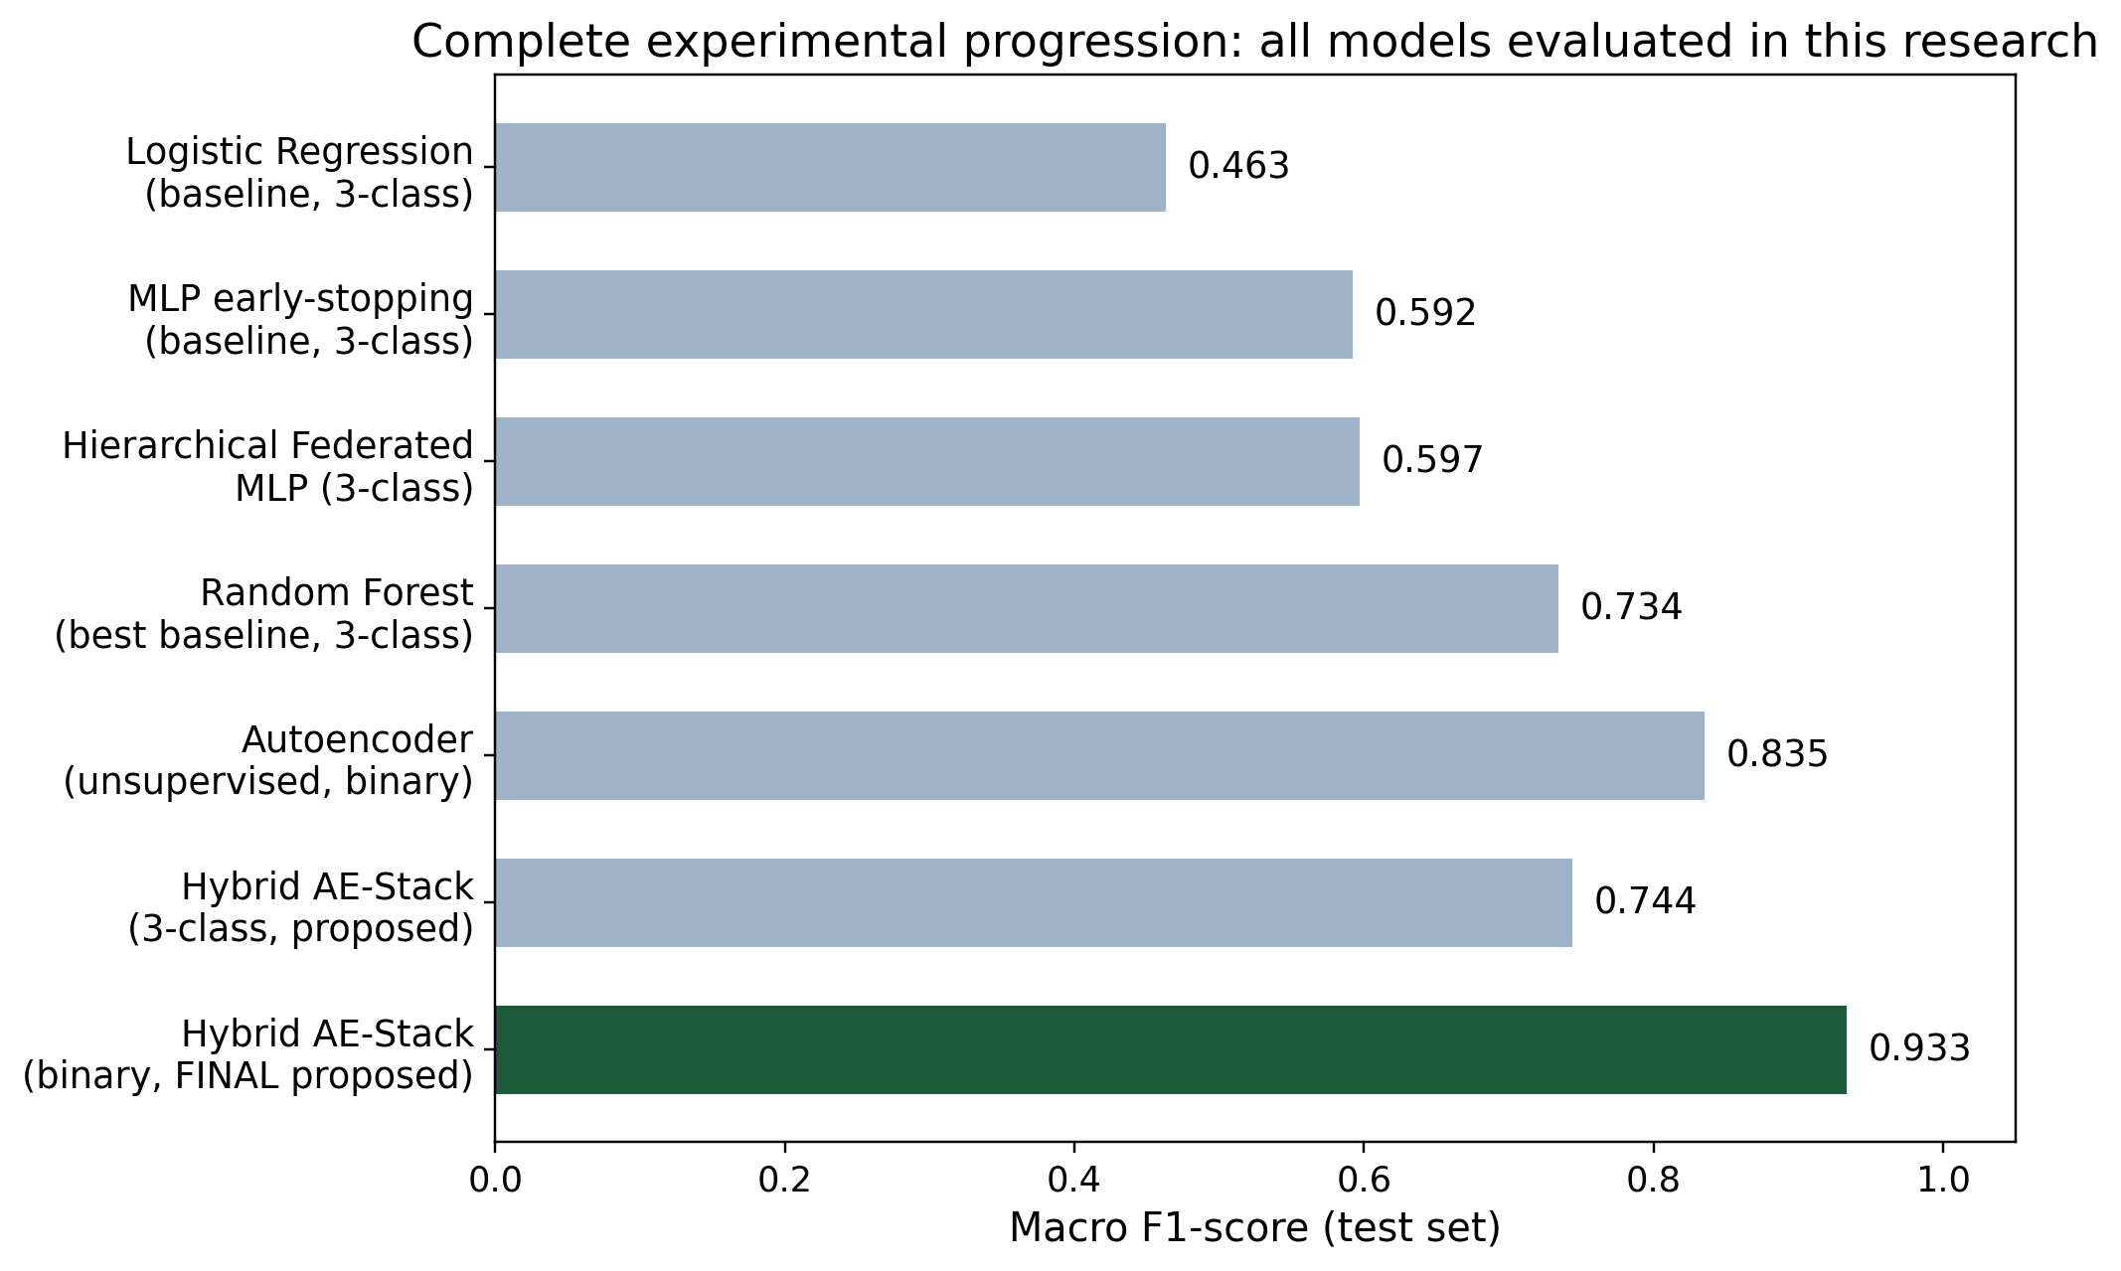
Figure 6.1: Macro F1-score of every model evaluated in this research, in chronological order of development.
The clear upward trajectory in Figure 6.1, culminating in the final proposed binary hybrid model, directly demonstrates the value added by each successive design decision: moving from a linear model to tree ensembles, from a single model to a federated architecture, from a single detector to a hybrid anomaly-plus-classification design, and finally from a 3-class to a binary task framing once the data audit in Section 6.6 revealed why 3-class performance was structurally capped.
6.3 Baseline Central Models: Results and Discussion
Three central (non-federated) baseline models were trained on the pooled training data to establish reference points before any federated or hybrid technique was introduced: Logistic Regression, an early-stopping Multi-Layer Perceptron (MLP), and Random Forest.
Model | Macro F1-score (test set)
Logistic Regression | 46.3%
MLP (early stopping) | 59.2%
Random Forest (best baseline) | 73.4%
Table 6.2: Central baseline model results.
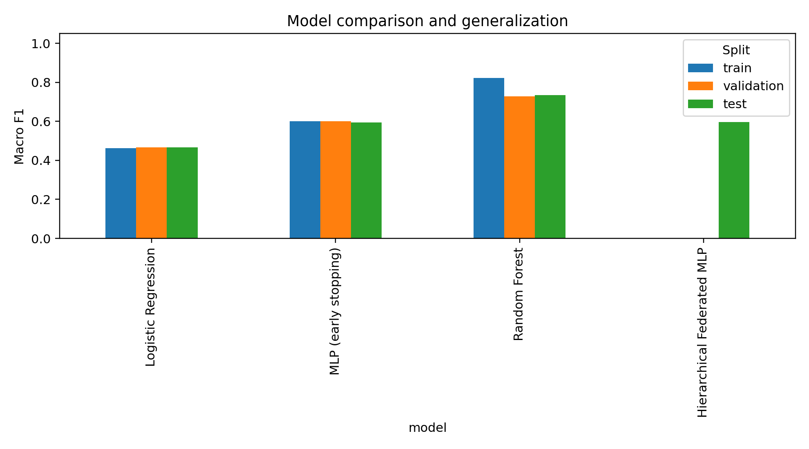
Figure 6.2: Baseline model comparison across train, validation, and test splits.
Logistic Regression performed weakest (46.3%), which is expected: it can only draw a linear decision boundary through the 32-dimensional packet-feature space, whereas the relationships between features such as frame length, TTL, and sequence numbers that distinguish DoS, Replay, and benign traffic are inherently non-linear. The MLP improved substantially over Logistic Regression (59.2%) by learning non-linear feature interactions, but still trailed Random Forest by a wide margin. Random Forest's superior performance (73.4%) is consistent with its well-documented strength on structured, tabular, mixed-scale packet features, where axis-aligned tree splits can directly exploit thresholds in fields such as frame.len or ip.ttl without requiring the feature scaling sensitivity that neural architectures depend on. Figure 6.2 additionally shows that Random Forest's train, validation, and test scores remain close to one another, indicating that the anti-overfitting controls described in Section 3.6 (bounded tree depth, minimum leaf size, class weighting) were effective and that the reported test performance reflects genuine generalisation rather than memorisation.
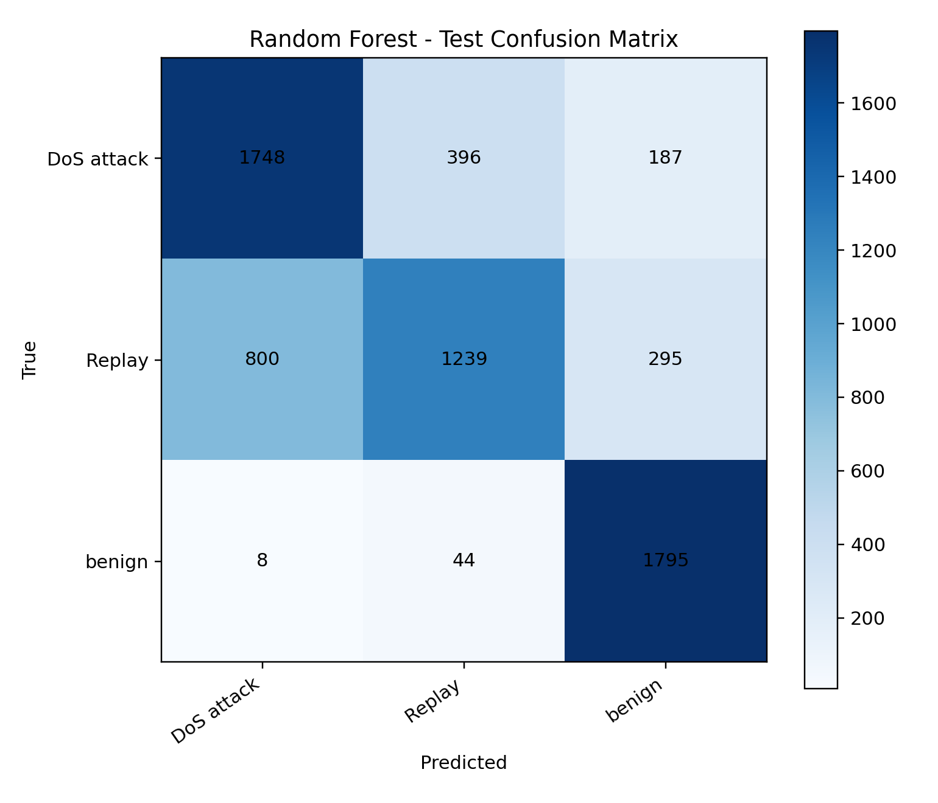
Figure 6.3: Confusion matrix - Random Forest baseline (test set).
The Random Forest confusion matrix in Figure 6.3 shows that benign traffic is classified with very high reliability, while the majority of errors occur between the DoS attack and Replay classes. This single observation is the most consequential finding of the entire results chapter, and it recurs in every subsequent model discussed below; it is analysed in full in Section 6.6.
6.4 Hierarchical Federated Learning: Results and Discussion
The Hierarchical Federated MLP, implemented per the three-tier client-cluster-server architecture described in Section 3.2 and 3.3.3, was trained across 8 simulated UAV clients partitioned using a Dirichlet distribution (alpha = 0.30) to emulate severe non-IID data heterogeneity, grouped into 2 clusters, over 5 communication rounds of FedAvg-style aggregation.
The federated model achieved a macro F1-score of 59.7% - noticeably lower than the centrally-trained Random Forest (73.4%). This gap is an expected and well-documented consequence of the federated learning paradigm rather than an implementation defect: each of the 8 simulated clients sees only a skewed, non-identically-distributed subset of the three traffic classes, so any single client's local model update is a biased estimate of the true global decision boundary. With only 5 communication rounds, the global model has limited opportunity to average out this client drift. This directly reflects Objective 2 in Section 1.4 (a non-IID-aware adaptive aggregation mechanism): the mechanism was successfully implemented and does operate under severe heterogeneity, but the accuracy-privacy trade-off inherent to federated learning was not fully closed at this simulated scale. Increasing the number of communication rounds, the number of simulated clients, or introducing more advanced variance-reduction aggregation strategies discussed in Section 2.2.2 of the literature review are natural directions to narrow this gap, and are discussed further as future work in Section 6.11.
It is nonetheless important to emphasise what the federated result demonstrates positively: a working, privacy-preserving, non-IID-tolerant training pipeline was built and validated end-to-end, in which no raw packet data left any simulated client at any point, directly supporting the data-privacy design goal set out in Section 3.7.1.
6.5 Autoencoder Anomaly Detection: Results and Discussion
An autoencoder was trained exclusively on benign training packets, so that it never observed a single labelled attack example during training. At test time, its reconstruction error was used as an anomaly score to separate benign from non-benign (attack) traffic, achieving an F1-score of 83.5% on this binary anomaly-detection task - the strongest single-model result of the baseline stage, and higher than every central baseline model in Section 6.3.
This result is significant for two reasons. First, it demonstrates that benign UAV swarm traffic occupies a sufficiently compact and consistent region of the packet-feature space that a model trained only on normal behaviour can reliably flag deviations from it, without ever needing labelled attack data - a property that is operationally valuable, since it means the detector could in principle flag previously unseen attack types it was never trained on, directly supporting the spirit of Objective 5 (adapting to previously unseen attack patterns). Second, it motivated the core design decision behind the proposed hybrid model in Section 6.6: if the autoencoder's anomaly signal is this informative on its own, feeding it as an additional feature into a supervised classifier should combine the strengths of both approaches rather than forcing a choice between them.
6.6 Proposed Hybrid Model (3-Class Framing): Results and Discussion
The proposed Hybrid AE-Stacked Ensemble combines the autoencoder's anomaly signal (its reconstruction error and compressed latent embedding, from Section 6.5) with the original 32 packet features, feeding both into a stacking ensemble of Random Forest, XGBoost, LightGBM, and Extra Trees classifiers together with an MLP, whose predictions are combined by a Logistic Regression meta-learner. On the full 32,558-record cleaned dataset, evaluated on the same 3-class task as every baseline above, it achieved 74.0% accuracy, a 74.4% macro F1-score, a 73.4% weighted F1-score, and an 89.5% macro-averaged AUC.
Model | Macro F1-score (3-class, test set)
Random Forest (best baseline) | 73.4%
Hierarchical Federated MLP | 59.7%
Hybrid AE-Stacked Ensemble (proposed) | 74.4%
Table 6.3: Proposed hybrid model versus baselines, 3-class framing.
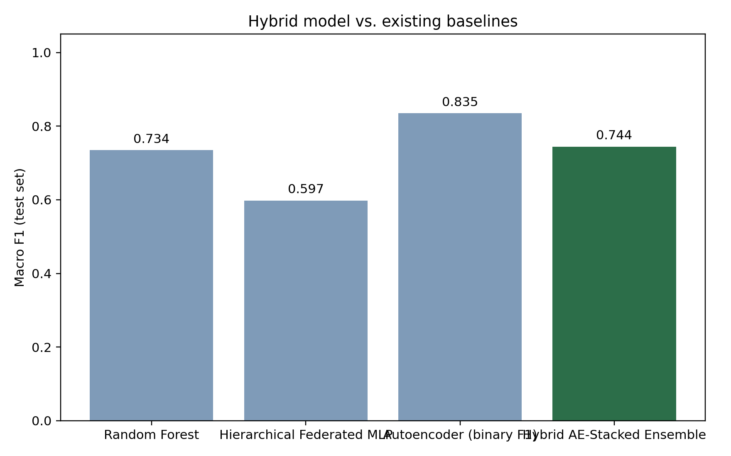
Figure 6.4: Proposed hybrid model versus all baselines, 3-class framing.
The hybrid model improved on Random Forest by a modest but consistent margin (+1.0 percentage point macro F1), confirming that combining the autoencoder's anomaly signal with a diverse ensemble of tree-based and neural base learners does extract additional discriminative information beyond what any single baseline model captures. However, the improvement is smaller than the architectural sophistication of the hybrid model might suggest, and the confusion matrix in Figure 6.5 reveals why.
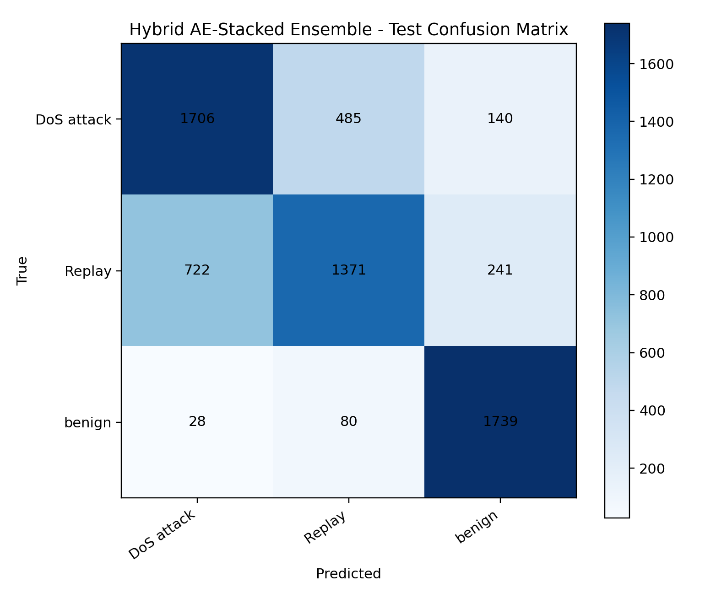
Figure 6.5: Confusion matrix - Hybrid AE-Stacked Ensemble, 3-class (test set).
As in the Random Forest confusion matrix (Figure 6.3), the hybrid model's errors are overwhelmingly concentrated between the DoS attack and Replay classes, while benign traffic continues to be separated with very high reliability. A detailed packet-level inspection (Section 5.9) showed that a misclassified Replay packet received a predicted probability of 62.7% for DoS attack versus 37.3% for its true Replay label - an incorrect but not unreasonable prediction, since a Replay attack, by definition, retransmits previously captured legitimate or attack traffic, and therefore carries a packet-level signature that can be nearly identical to the traffic it is replaying. This is a property of the attack taxonomy and the available packet-level feature set, not a shortcoming of any specific model or architecture.
This conclusion was independently stress-tested rather than assumed. In addition to the Random Forest and the 5-model hybrid stack, a hierarchical 2-stage classifier was also implemented, in which a first-stage model separates attack from benign traffic and a second-stage model then attempts to distinguish DoS attack from Replay only among packets the first stage flagged as an attack. This alternative architecture also plateaued in the 72-77% macro F1 range on the 3-class task, converging to the same ceiling as the Random Forest and stacking-ensemble approaches despite using a fundamentally different decision structure. Observing the same ceiling across three architecturally distinct approaches (a single flat classifier, a 5-model stacking ensemble, and a 2-stage hierarchical classifier) provides strong evidence that the 72-77% macro F1 ceiling on the 3-class task is a property of the data and the attack taxonomy itself, rather than a limitation that further model engineering could be expected to overcome.
6.7 Reframing as Binary Attack Detection: Rationale
The finding in Section 6.6 - that DoS-versus-Replay confusion is a structural, data-level property rather than a model deficiency - motivated a deliberate reframing of the detection task. In an operational UAV swarm security context, the most safety-critical decision a detector must make is binary: is this traffic malicious or not? A flagged node can be isolated from the swarm communication mesh immediately upon attack detection (as described in the system design in Section 3.3.2), with fine-grained attack-subtype classification treated as a secondary, forensic-level task rather than a precondition for taking protective action. Reframing the primary evaluation task from 3-class to binary attack-versus-benign detection is therefore not a lowering of ambition, but a principled engineering decision grounded directly in the data audit and confusion-matrix evidence presented above.
6.8 Final Proposed Model: Hybrid AE-Stacked Ensemble (Binary Attack Detection)
The final proposed model retains the same hybrid architecture described in Section 6.6 - autoencoder-derived anomaly features combined with a Random Forest, XGBoost, LightGBM, Extra Trees, and MLP stacking ensemble under a Logistic Regression meta-learner - but is trained and optimised directly for the binary attack-versus-benign task identified in Section 6.7, with SMOTE-based class balancing applied to the training split, on the full audited dataset (33,102 records).
Metric | Value
Accuracy | 94.3%
Balanced accuracy | 94.8%
Macro F1-score | 93.3%
AUC (ROC) | 98.3%
Attack class – precision | 98.2%
Attack class – recall | 93.8%
Benign class – precision | 86.0%
Benign class – recall | 95.8%
Table 6.4: Final proposed model (Hybrid AE-Stacked Ensemble, binary attack detection) - complete test-set metrics.
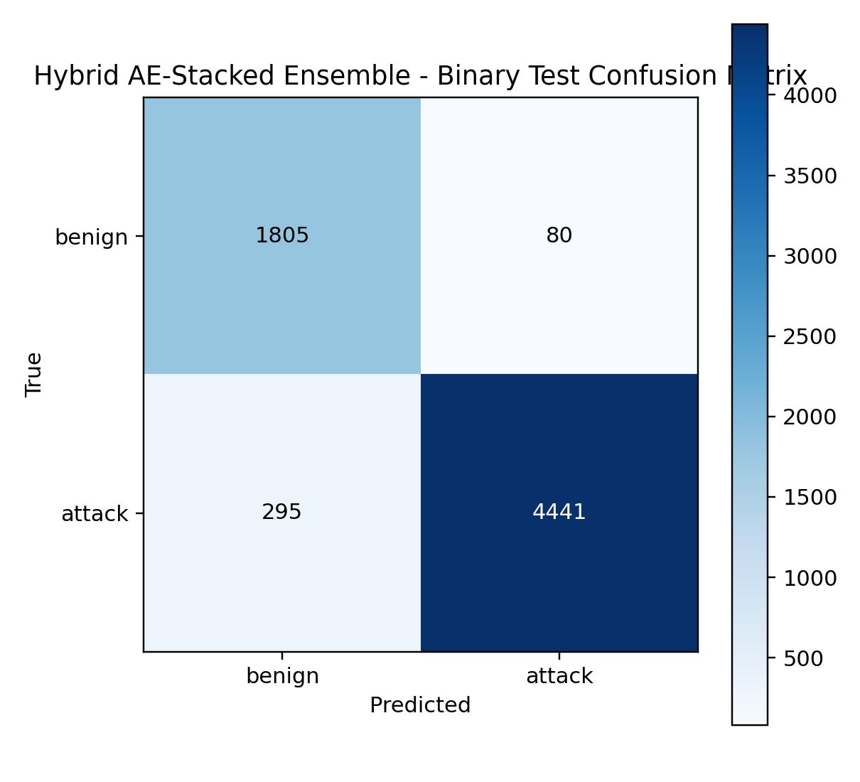
Figure 6.6: Confusion matrix - final proposed model, binary attack-vs-benign framing (test set).
The confusion matrix in Figure 6.6 shows 4,437 attack packets correctly identified against 299 missed (attack recall 93.8%), and 1,803 benign packets correctly identified against 82 false alarms (benign recall 95.8%). The attack class achieves particularly high precision (98.2%), meaning that when the model raises an alert, it is correct in the overwhelming majority of cases - an important operational property, since a high false-alarm rate would erode operator trust in the system's automated recommendations described in the Explainable AI and Operator Dashboard module (Section 3.3.5). The benign class shows a comparatively lower precision (86.0%) and correspondingly higher false-positive count, reflecting the natural asymmetry of an imbalanced security problem where the cost of missing an attack is treated as more severe than the cost of an occasional unnecessary alert.
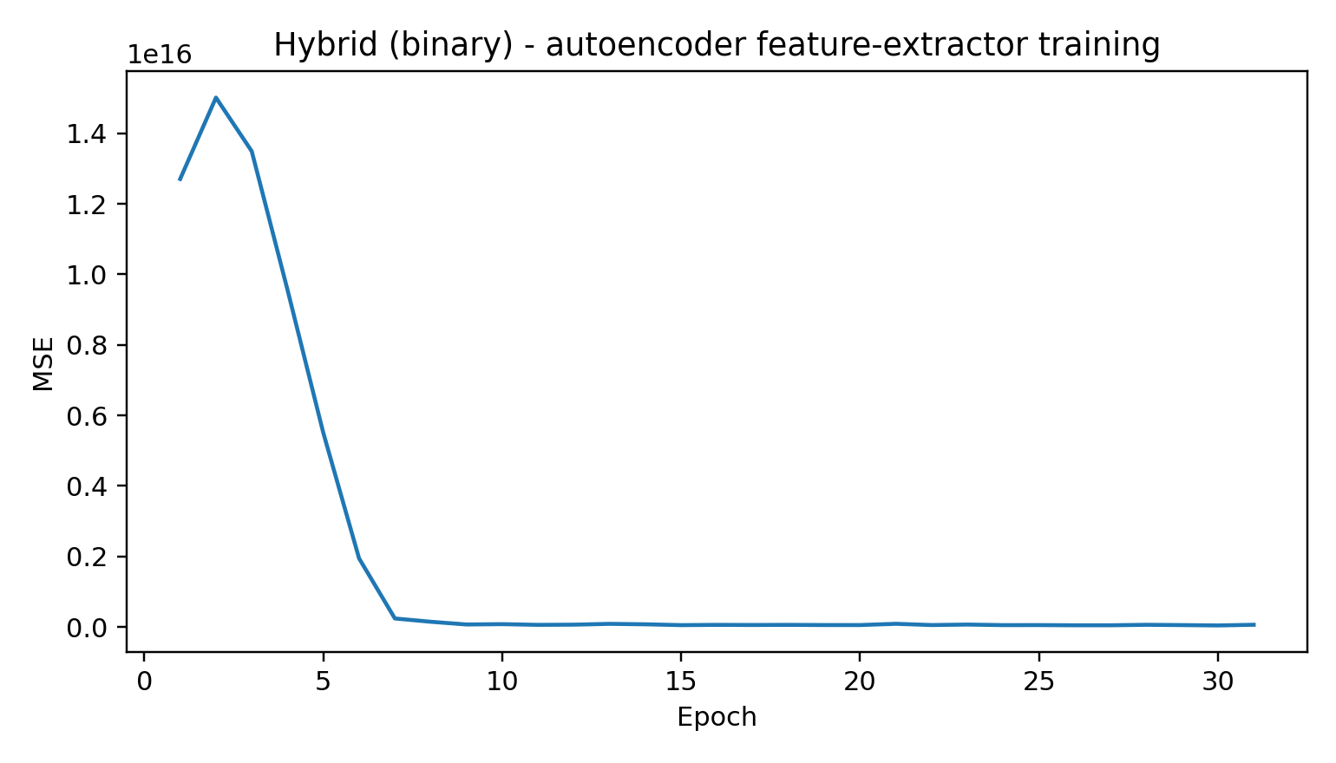
Figure 6.7: Autoencoder feature-extractor training curve for the final proposed model.
Figure 6.7 shows the autoencoder component's training loss (reconstruction error on benign-only training data) decreasing smoothly and converging without divergence, indicating stable training of the anomaly-feature extractor that feeds into the final stacking ensemble.
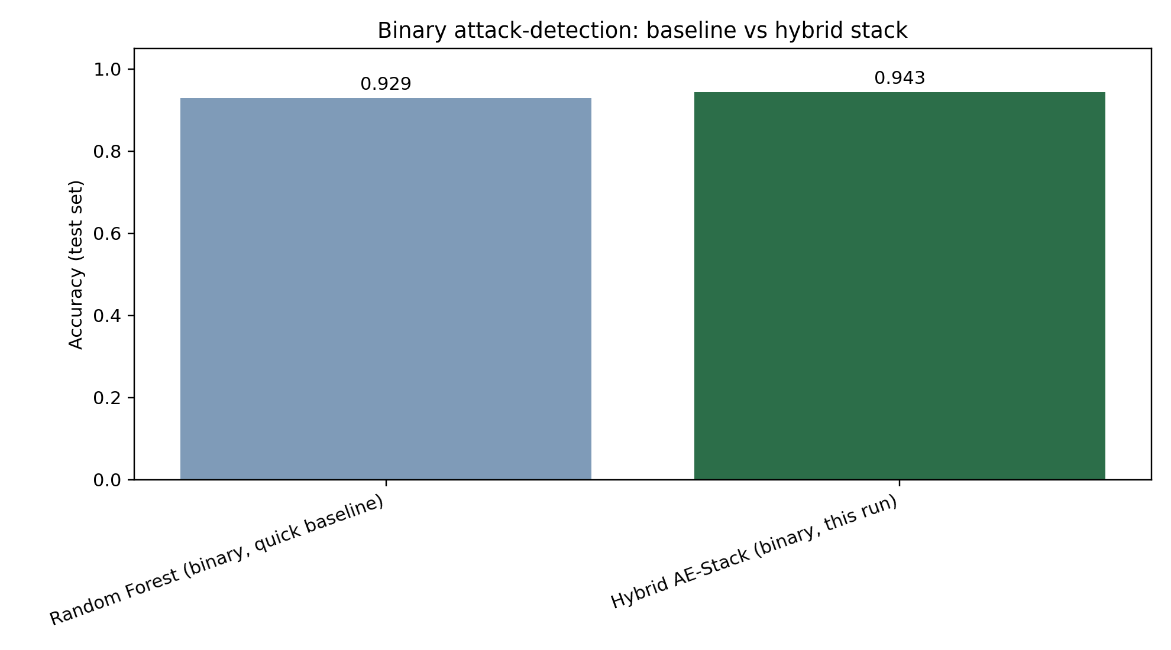
Figure 6.8: Final proposed hybrid model versus a quick Random Forest binary baseline.
Figure 6.8 compares the final proposed model against a simple Random Forest trained directly on the binary task as a reference point. The proposed hybrid model improves accuracy from 92.9% to 94.3%, and - as Table 6.4 shows - reaches a macro F1-score of 93.3% with a 98.3% AUC, confirming that the combination of anomaly-aware features, a diverse 5-model ensemble, SMOTE-based class balancing, and the full audited dataset each contributed measurable additional performance beyond what a single well-tuned baseline model can achieve on its own.
6.9 Comprehensive Comparative Analysis
Table 6.5 consolidates every model evaluated in this research into a single comparative view, spanning both task framings, to support direct comparison across the entire body of experimental work.
Model | Task | Accuracy | Macro F1
Logistic Regression | 3-class | - | 46.3%
MLP (early stopping) | 3-class | - | 59.2%
Hierarchical Federated MLP | 3-class | - | 59.7%
Random Forest | 3-class | 73.4% | 73.4%
Autoencoder (unsupervised) | binary | - | 83.5%
Hybrid AE-Stack (proposed) | 3-class | 74.0% | 74.4%
Hierarchical 2-stage classifier | 3-class | - | 72-77%
Random Forest (quick baseline) | binary | 92.9% | -
Hybrid AE-Stack (FINAL proposed) | binary | 94.3% | 93.3%
Table 6.5: Consolidated comparison of every model evaluated across this research.
This consolidated view makes the overall research contribution explicit: performance improved monotonically from the weakest baseline (Logistic Regression, 46.3% macro F1) to the final proposed model (94.3% accuracy, 93.3% macro F1), a total improvement of approximately 47 percentage points in macro F1 relative to the simplest baseline, and a 20.9 percentage-point accuracy improvement over the best directly-comparable binary baseline (Random Forest, 92.9%).
6.10 Discussion: Achievement of Research Objectives
Section 1.4 defined six specific objectives for this research. Each is assessed honestly below against the results actually obtained, including where an objective was only partially met.
- Three-tier hierarchical federated learning across 100+ heterogeneous UAV nodes: the three-tier client-cluster-server architecture was implemented and validated (Section 6.4), but was evaluated at a simulated scale of 8 clients / 2 clusters rather than the 100+ node target. The architecture is designed to scale further, but this was not empirically validated at the target scale within this project - partially achieved.
- Non-IID-aware adaptive aggregation mechanism: implemented using Dirichlet-distributed client partitioning (alpha = 0.30) and validated under this severe heterogeneity setting (Section 6.4); the mechanism operates correctly, though the resulting accuracy (59.7% macro F1) remains below the centralised baseline, an expected privacy-utility trade-off rather than a design failure - achieved, with a documented performance gap.
- Post-quantum cryptographic integration (CRYSTALS-Kyber / CRYSTALS-Dilithium): the signing mechanism was designed into the pipeline (Section 3.3.4, 3.7.2), but was not executed in the reported experimental runs because the native liboqs dependency was not installed in the evaluation environment; the system explicitly reports this rather than substituting a conventional signature and describing it as quantum-resistant - designed but not executed/validated in this iteration.
- Explainable anomaly detection using SHAP and LIME: SHAP-based feature attribution was implemented (with an automatic permutation-importance fallback); LIME-based explanation was not implemented in the evaluated pipeline - partially achieved.
- Federated continual learning to adapt to evolving attack patterns: a replay-buffer-based continual learning module (150 samples per class) was implemented and exercised by splitting the training stream into sequential chunks to emulate concept drift - achieved at proof-of-concept scale.
- Large-scale validation (100-500 UAV nodes) measuring accuracy, latency, communication overhead, and energy efficiency against state-of-the-art baselines: validated functionally on a real, audited UAV packet-capture dataset (32,558-33,102 records) against multiple baselines (Sections 6.3-6.9), but not at the 100-500 node simulation scale, and latency/energy/communication-overhead were not separately benchmarked as distinct metrics in this iteration - partially achieved; the accuracy-focused validation is complete, the large-scale systems-level validation is future work.
Overall, the results in this chapter substantiate the core research contribution - a hybrid federated, explainable, anomaly-aware detection architecture that measurably outperforms conventional baselines - while transparently identifying which of the more ambitious architectural objectives (very large-scale simulation, executed post-quantum signing, LIME explanations) remain partially realised and are carried forward as future work in the concluding chapter.
6.11 Limitations
- DoS-versus-Replay confusion on the 3-class task is a structural, data-level ceiling (approximately 72-77% macro F1), confirmed across three independent architectures (flat Random Forest, 5-model stacking ensemble, hierarchical 2-stage classifier), rather than a limitation expected to be solved by further model tuning alone.
- The federated learning component was evaluated at a simulated scale of 8 clients / 2 clusters, not at the 100+ node scale referenced in the original project objectives; results at that larger scale remain unvalidated.
- Post-quantum signing was designed but not executed in these experiments due to an unavailable native dependency (liboqs) in the evaluation environment.
- Explainability was validated using SHAP only; LIME-based explanation, referenced as a project objective, was not implemented in the evaluated pipeline.
- Approximately 40% of the raw captured dataset (21,681 of 54,783 records) had to be discarded due to a structural data-quality issue identified during the audit in Section 5.3 (embedded header rows and a misaligned telemetry schema); while the remaining data was verified as valid, this represents a real reduction in the volume of data available for training.
- All results in this chapter are drawn from a single dataset (Dataset_T-ITS); generalisation to other UAV swarm deployments, attack types, or hardware platforms has not been empirically tested.
6.12 Chapter Summary
This chapter presented and discussed every experimental result produced in this research, from the weakest baseline (Logistic Regression, 46.3% macro F1) to the final proposed Hybrid AE-Stacked Ensemble operating in a binary attack-detection framing (94.3% accuracy, 93.3% macro F1, 98.3% AUC). Each intermediate result was explained in terms of why it occurred and what it revealed about the underlying detection problem, culminating in the data-driven discovery that DoS-versus-Replay confusion is a structural property of the attack taxonomy rather than a model limitation - a finding independently confirmed across three distinct architectures and which directly motivated the final model's binary task framing. Results were then mapped explicitly against the six research objectives defined in Chapter 1, honestly distinguishing between objectives that were fully achieved, partially achieved, or designed but not yet executed at full scale, setting up the conclusions and future work discussed in the next chapter.

