

BSIT-S26-013
03-135231-039 | Syed M. Measum Ali Rizvi
03-135231-009 | Syeda Arooba Mansoor

Scalable, Explainable, and Adaptive Quantum-Resilient Federated Learning for Non-IID UAV Swarm Cybersecurity

In partial fulfilment of the requirements for the degree of
Bachelor of Science in Information Technology
Supervisor: Ms Munaza Sher
Department of Computer Sciences
Bahria University, Lahore Campus
December 2026
© Bahria University, 2026

We accept the work contained in the report titled
Scalable, Explainable, and Adaptive Quantum-Resilient Federated Learning for Non-IID UAV Swarm Cybersecurity

Written By
Syed M. Measum Ali Rizvi
Syeda Arooba Mansoor
as a confirmation to the required standard for the partial fulfilment of the degree of
Bachelor of Science in Information Technology.

Approved by:
Ms Munaza Sher
(Signature)

DECLARATION

We hereby declare that this project report is based on our original work except for citations and quotations which have been duly acknowledged. We also declare that it has not been previously and concurrently submitted for any other degree or award at Bahria University or other institutions.

Enrolment | Name | Signature
03-135231-039 | Syed M. Measum Ali Rizvi
03-135231-009 | Syeda Arooba Mansoor

Date:

Specially dedicated to
My beloved Mother, Father and Mamu S.Iqtidar Kazmi (late)
(Syed M. Measum Ali Rizvi)
My beloved grandmother, mother and father
(Syeda Arooba Mansoor)

ACKNOWLEDGEMENTS

We would like to thank everyone who had contributed to the successful completion of this project. We would like to express my/our gratitude to my research supervisor, Mam Munaza Sher for his/ invaluable advice, guidance and his enormous patience throughout the development of the research.

In addition, we would also like to express our gratitude to /our loving parents and friends who helped and encouraged us.

Syed M. Measum Ali Rizvi
Syeda Arooba Mansoor

ABSTRACT
Unmanned Aerial Vehicle (UAV) swarms are increasingly deployed in safety-critical civilian and defense applications, making them high-value targets for sophisticated cyber and cyber–physical attacks. While recent advances in federated learning and post-quantum cryptography have improved privacy and long-term security, existing approaches suffer from key limitations including poor scalability to large UAV swarms, unrealistic IID data assumptions, lack of adaptability to evolving threats, and absence of explainability for human operators.
This project proposes a next-generation, scalable, explainable, and adaptive quantum-resilient federated learning framework for UAV cybersecurity. The proposed system addresses real-world challenges by introducing hierarchical federated learning for large swarms, non-IID-aware training strategies, continual learning for evolving attacks, and explainable AI (XAI) mechanisms to support operator trust and forensic analysis. Lightweight post-quantum cryptographic primitives will be integrated with communication-efficient aggregation to ensure long-term security without overwhelming resource-constrained UAV platforms. The framework will be validated on real UAV communication datasets and simulated large-scale swarm environments, demonstrating improved scalability, robustness, transparency, and operational feasibility.

TABLE OF CONTENTS

Table of Contents
DECLARATION 3
ACKNOWLEDGEMENTS 5
ABSTRACT 6
TABLE OF CONTENTS 7
LIST OF TABLES 11
LIST OF FIGURES 12
LIST OF APPENDICES 13
CHAPTER 1 14
1. Introduction 14
2. Problem Statement 14
1.3 Aims and Objectives 15
1.4 Objectives 15
1.5 Scope of Project 16
CHAPTER 2 18
LITERATURE REVIEW 18
2.1 Introduction 18
2.1.1 Review Methodology and Selection Criteria 19
2.2 Federated Learning Foundations and Optimization 19
2.2.1 Foundational Algorithms and the Non-IID Challenge 19
2.2.2 Variance Reduction and Gradient Harmonization Techniques 20
2.2.3 Robustness Against Byzantine and Poisoning Attacks 21
2.2.4 Extension to Heterogeneous Edge and IoT Architectures 22
2.2.5 Synthesis 23
2.2.6 Implications for Swarm-Scale Aggregation Design 23
2.2.7 Threat Model Considerations for Robust Aggregation 24
2.3 UAV Cybersecurity, GPS Spoofing, and Intrusion Detection 25
2.3.1 GPS Spoofing Detection Techniques 25
2.3.2 Unsupervised Anomaly Detection via Variational Autoencoders 26
2.3.3 Domain-Specific Intrusion Detection and Taxonomy 26
2.3.4 Toward Holistic UAV Security Architectures 27
2.3.5 Synthesis 28
2.3.6 Cross-Study Accuracy and Latency Benchmarking 28
2.3.7 Operational Constraints: Power, Compute, and Bandwidth 29
2.4 Post-Quantum Cryptography for Secure Communication 29
2.4.1 The Quantum Threat to Classical Cryptography 29
2.4.2 Lattice-Based Post-Quantum Algorithms 30
2.4.3 Synthesis 30
2.4.4 Key Management and Hybrid Cryptographic Transition Strategies 31
2.5 Explainable Artificial Intelligence for Security Decision-Making 31
2.5.1 Foundational XAI Concepts and Taxonomies 31
2.5.2 Applied XAI for Intrusion Detection 32
2.5.3 Synthesis 33
2.5.4 Limitations of Current XAI Techniques in Adversarial Settings 33
2.5.5 Computational Overhead of Explanation Generation 34
2.6 Federated Continual Learning and Adaptive Architectures 34
2.6.1 Taxonomy of Federated Continual Learning 34
2.6.2 Mitigating Catastrophic Forgetting 35
2.6.3 Dynamic and Decentralized Architectures for Swarm-Scale Adaptation 36
2.6.4 Synthesis 37
2.6.5 Communication and Memory Overhead Considerations 37
2.6.6 Privacy-Utility Trade-offs in Continual Federated Learning 38
2.7 Comparative Analysis of Recent Studies 38
2.8 Research Gap Identification 39
2.8.1 Absence of Integrated Quantum Resilience in FL-Based UAV Systems 39
2.8.2 Lack of Native Explainability Integration within Federated Training 40
2.8.3 Scalability Limitations Under Severe Non-IID Heterogeneity 40
2.8.4 Absence of a Unified Adaptive Continual Learning Architecture 40
2.8.5 Inadequate Real-World UAV-Specific Datasets 41
2.8.6 Synthesis of Identified Gaps 41
2.9 Summary of Literature Review 42
CHAPTER 3 45
DESIGN AND METHODOLOGY 45
3.1 System Requirement Specification 45
3.1.1 Functional Requirements 45
3.1.2 Non-Functional Requirements 46
3.2 System Architecture 47
3.2.1 Architecture Overview 47
3.2.2 Data Flow Description 48
3.3 Functional Modules 49
3.3.1 Data Acquisition and Non-IID Preprocessing Module 49
3.3.2 Hybrid Anomaly Detection and Attack Classification Module 50
3.3.3 Hierarchical Federated Learning Orchestration Module 50
3.3.4 Post-Quantum Security Module 51
3.3.5 Explainable AI (XAI) and Operator Dashboard Module 51
3.3.6 Continual Learning and Drift Adaptation Module 52
3.4 Methodology 53
Phase 1 — Literature Review and System Design 53
Phase 2 — Dataset Acquisition and Preprocessing 53
Phase 3 — Model Development and Federated Integration 53
Phase 4 — Simulation and Evaluation 54
Phase 5 — Reporting and Publication 54
3.5 Tools and Technologies 55
3.6 Training and Fine-Tuning 57
3.6.1 Data Splitting Strategy 57
3.6.2 Hyperparameter Configuration 57
3.6.3 Evaluation Metrics 58
3.7 Ethical and Privacy Considerations 60
3.7.1 Data Privacy by Architecture 60
3.7.2 Post-Quantum Confidentiality 60
3.7.3 Fairness and Bias Mitigation 60
3.7.4 Responsible Research and Dual-Use Awareness 61
3.8 Use Case Diagram 61
3.8.1 Actors 61
3.8.2 Use Cases 62
3.9 Sequence Diagram 64
3.9.1 Federated Learning Round — Sequence 65
3.9.2 Real-Time Anomaly Detection and XAI — Sequence 66
3.10 Class Diagram 67
3.10.1 Core Classes 67
EXPERIMENTS 70
4.1 Data Collection 70
4.2 Datasets Used 70
4.3 Sample Analysis 71
4.4 UAV Node Profile Processing 72
4.5 Preprocessing 73
4.6 Training and Testing Split 74
4.7 Data Augmentation 75
4.8 Geospatial Data Extraction (for Location Services) 76
Real-Life Applications of Geospatial Data Extraction 77
1. Military Drone Operations 77
2. Disaster Management and Rescue Operations 77
3. Border Security and Surveillance 78
4. Drone Delivery Systems 78
5. Smart City Monitoring 78
6. Precision Agriculture 78
7. Anti-Drone Security Systems 78
4.9 Deep Learning Models Used 78
4.10 Generative AI Integration 80
4.11 Model Validation 81
REFERENCES 83

LIST OF TABLES

Table 2.1: Comparative Summary of Federated Learning Optimization Techniques 17
Table 2.2: Reported Detection Accuracy and Inference Latency Across Reviewed UAV Security Studies 21
Table 2.3: Communication and Memory Overhead of Federated Continual Learning Mechanisms 29
Table 2.4: Comparative Analysis of the Ten Most Recent Studies (2023–2025) Against the SEAQL Design Pillars 30
Table 2.5: Synthesis Mapping of Identified Research Gaps to SEAQL Design Components 32
Table 3.1: Functional Requirements of the SEAQL UAV Cybersecurity Framework 38
Table 3.2: Non-Functional Requirements of the SEAQL Framework 39
Table 3.3: Tools and Technologies Used in the SEAQL Framework 47
Table 3.4: Evaluation Metrics for the SEAQL Framework 49
Table 3.5: System Actors and Role Descriptions 51

LIST OF FIGURES

FIGURE TITLE PAGE
Figure 3.1: Three-Tier Hierarchical FL Architecture for UAV Swarm Cybersecurity 6
Figure 3.2: Functional Module Interaction Diagram 8
Figure 3.3: SEAQL Research and Development Methodology Flow Diagram 11
Figure 3.4: Use Case Diagram — SEAQL Framework 14

LIST OF APPENDICES

APPENDIX TITLE PAGE
APPENDIX A: Code 43

CHAPTER 1

INTRODUCTION

Introduction
UAV swarms are transforming domains such as surveillance, disaster response, agriculture, logistics, and defense. However, their distributed nature, wireless communication, and limited onboard resources expose them to cyber threats including GPS spoofing, jamming, command hijacking, data poisoning, and long-term cryptographic compromise.
Recent research has demonstrated the effectiveness of federated learning combined with anomaly detection and post-quantum cryptography for UAV security. Despite promising results, existing solutions remain limited in practical deployment readiness. Most studies assume IID data across UAVs, rely on centralized aggregation servers, scale poorly beyond small swarms, and operate as static models incapable of adapting to evolving threats. Furthermore, the lack of explainability undermines trust, accountability, and regulatory acceptance in mission-critical environments.
This project is motivated by the need to bridge the gap between high-accuracy laboratory models and real-world UAV swarm security systems by addressing scalability, adaptability, explainability, and operational feasibility in a unified framework.

Problem Statement
Current UAV cybersecurity frameworks exhibit the following critical shortcomings:
1. Limited scalability, restricting deployment to small UAV fleets.
2. Unrealistic IID data assumptions, ignoring heterogeneous UAV missions and environments.
3. Static learning models, unable to adapt to evolving or unseen attack patterns.
4. High communication and cryptographic overhead, challenging low-bandwidth UAV links.
5. Lack of explainability, limiting human trust and post-incident forensic analysis.
6. Centralized aggregation dependence, introducing coordination and availability risks.
These limitations prevent existing approaches from being deployed in large-scale, long-lived, and safety-critical UAV swarm operations.

1.3 Aims and Objectives
The primary aim of this project is to design and develop a Scalable, Explainable, and Adaptive Quantum-Resilient Federated Learning (SEAQL) framework that addresses the critical cybersecurity challenges facing UAV swarm networks. The system is motivated by the urgent need to bridge the gap between high-accuracy laboratory models and real-world deployable security architectures for heterogeneous, large-scale UAV operations.

1.4 Objectives
The specific objectives of this project are as follows:
To design a three-tier hierarchical federated learning architecture that enables scalable model aggregation across 100+ heterogeneous UAV nodes without centralized coordination bottlenecks.
To develop a non-IID-aware adaptive aggregation mechanism that maintains model accuracy under severe data heterogeneity across UAV swarm nodes operating in diverse mission environments.
To integrate post-quantum cryptographic mechanisms (CRYSTALS-Kyber and CRYSTALS-Dilithium) into the federated learning communication pipeline to ensure long-term security against quantum adversaries.
To implement an explainable anomaly detection engine using SHAP and LIME-based interpretability methods that provide real-time, human-understandable explanations for every security decision made by the framework.
To incorporate federated continual learning capabilities that allow UAV nodes to adapt to evolving and previously unseen cyber attack patterns without catastrophic forgetting of prior threat knowledge.
To validate the SEAQL framework through large-scale simulation experiments on 100–500 UAV node environments, measuring accuracy, latency, communication overhead, and energy efficiency against existing state-of-the-art baselines.

1.5 Scope of Project
The scope of the SEAQL project encompasses the design, development, and simulation-based validation of a unified cybersecurity framework for UAV swarm networks. The project is structured around four core pillars: scalability, explainability, adaptability, and quantum resilience, each of which defines the boundaries of the current development phase.
Technical Scope: The framework is implemented as a simulation-based research prototype targeting UAV swarm environments of 100 to 500 nodes. The system architecture comprises three tiers: individual UAV nodes performing local anomaly detection, cluster-level aggregators coordinating federated rounds within UAV groups, and a global coordinator managing the overall model federation. The federated learning backbone uses an adaptive variant of FedAvg enhanced with gradient harmonization and variance reduction mechanisms to address non-IID data distributions. All inter-node model updates are secured using NIST-standardized post-quantum cryptographic algorithms, specifically CRYSTALS-Kyber for key encapsulation and CRYSTALS-Dilithium for digital signatures.
Functional Scope: The system detects and classifies four primary UAV cyber attack categories: GPS spoofing, communication jamming, command hijacking, and data poisoning. The anomaly detection engine employs Variational Autoencoders (VAE) for unsupervised threat detection and LSTM-based classifiers for multi-class attack identification. The explainability layer computes SHAP feature importance scores and LIME local approximations for every detection decision, delivering operator-facing explanations through a real-time dashboard. The continual learning module implements a federated class-incremental learning strategy using generative replay to retain prior attack knowledge while adapting to emerging threat patterns.
Delimiting Parameters: The current project scope is limited to simulation-based validation and does not include physical UAV hardware deployment or live network testing. The system does not address UAV flight path planning, autonomous navigation control, or hardware-level firmware security. Integration with national defense infrastructure or classified communication protocols is explicitly outside the scope of this research. The framework is designed to be modular so that hardware integration and extended protocol support can be incorporated in future development phases.
CHAPTER 2

LITERATURE REVIEW

2.1 Introduction
Unmanned Aerial Vehicle (UAV) swarms are increasingly deployed across defense, agricultural, disaster-response, and logistics domains, where dozens to hundreds of coordinated nodes must share intelligence in real time while operating under strict communication, power, and privacy constraints. As swarm deployments scale, they become attractive targets for sophisticated cyber adversaries who exploit GPS spoofing, communication jamming, command hijacking, and data-poisoning attacks to compromise mission integrity. Traditional centralized intrusion detection systems are fundamentally unsuited to this environment because they require the transmission of raw sensor and telemetry data to a central server, introducing unacceptable latency, bandwidth overhead, and privacy exposure. Federated Learning (FL) has consequently emerged as the dominant paradigm for distributed, privacy-preserving security in UAV swarms, enabling individual nodes to train local models collaboratively without exposing raw operational data.
This chapter presents a systematic and critically synthesized review of the literature underpinning the proposed Scalable, Explainable, and Adaptive Quantum-Resilient Federated Learning (SEAQL) framework. A total of thirty-nine peer-reviewed studies, spanning the period 2017 to 2025 and drawn from leading venues including IEEE Transactions, USENIX Security, NeurIPS, ICML, and ACM Computing Surveys, were identified, read in depth, and critically evaluated. Rather than presenting each paper as an isolated entry, the review is organized into six thematic clusters that map directly onto the four technical pillars of the proposed research — scalability, explainability, adaptability, and quantum resilience — namely: (i) federated learning foundations and optimization, (ii) UAV cybersecurity and GPS-spoofing detection, (iii) post-quantum cryptography for secure communication, (iv) explainable artificial intelligence for security decision-making, (v) federated continual learning and adaptive architectures, and (vi) a comparative synthesis of the field's most recent contributions. Each thematic section follows a consistent structure of contextual overview, critical analysis of strengths and limitations, and synthesis, ensuring methodological consistency and analytical depth throughout the chapter.
The chapter concludes with an explicit identification of five corroborated research gaps drawn from the synthesis of all thirty-nine studies, a tabulated comparative analysis of the ten most recent contributions to the field, and a summary that draws together the chapter's findings to establish the precise contribution space addressed by the dissertation's proposed methodology in Chapter 3.

2.1.1 Review Methodology and Selection Criteria
repository with subsequent peer-reviewed acceptance; (iii) availability of quantitative empirical results (accuracy, latency, or convergence metrics) permitting comparative analysis; and (iv) publication within the period 2017–2025, capturing both foundational works (e.g., McMahan et al.'s [1] original FedAvg formulation) and the most recent state-of-the-art contributions. Studies addressing federated learning in domains unrelated to security or UAV operations were excluded unless they introduced a generalizable algorithmic contribution (such as SCAFFOLD or FedGH) directly applicable to the proposed methodology. This systematic selection approach, combined with the thematic organization adopted throughout the chapter, ensures both breadth of coverage across the four target pillars and depth of critical engagement with each individual contribution.

2.2 Federated Learning Foundations and Optimization

2.2.1 Foundational Algorithms and the Non-IID Challenge
The foundational algorithm of federated learning, Federated Averaging (FedAvg), was introduced by McMahan et al. (2017) [1] to enable collaborative model training across decentralized clients without transmitting raw data, establishing the privacy-preserving paradigm on which all subsequent FL research builds. FedAvg operates by averaging locally computed gradient updates at a central server after each communication round, achieving remarkable communication efficiency when client data is independently and identically distributed (IID). However, this elegant simplicity masks a critical weakness: when client data is non-IID — a condition that is the operational norm rather than the exception in UAV swarms, where individual nodes observe different geographic regions, mission phases, and attack exposures — the averaging mechanism causes client drift, in which locally optimal model parameters diverge from the true global optimum, leading to slow convergence and degraded final accuracy.
Zhao et al. (2018) [2] provide one of the earliest rigorous empirical analyses of this phenomenon, quantifying the relationship between data heterogeneity (measured via Earth Mover's Distance between local and global label distributions) and accuracy degradation, demonstrating reductions of up to 55% in classification accuracy under extreme non-IID partitioning of the CIFAR-10 dataset. A follow-up extended analysis (Zhao et al., 2022) [3] further decomposes this degradation into its constituent weight-divergence components, showing that divergence accumulates multiplicatively across communication rounds unless explicitly corrected — a finding directly relevant to long-duration UAV swarm missions in which hundreds of federated rounds may be required.

2.2.2 Variance Reduction and Gradient Harmonization Techniques
In response to the non-IID degradation problem, Karimireddy et al. (2020) [4] propose SCAFFOLD (Stochastic Controlled Averaging for Federated Learning), which introduces control variates at both the client and server level to explicitly estimate and correct for the drift direction of each client's local updates. The authors provide theoretical convergence guarantees showing that SCAFFOLD's convergence rate is provably independent of the degree of client heterogeneity a substantial theoretical improvement over FedAvg, whose convergence rate degrades proportionally with heterogeneity. Empirically, SCAFFOLD is shown to reduce the number of communication rounds required to reach target accuracy by up to 50% under severe non-IID partitioning, directly addressing the communication-efficiency constraints relevant to bandwidth-limited UAV swarm links.
Complementing this variance-reduction approach, Zhang et al. [5] propose FedGH (Gradient Harmonization for Federated Learning), which instead reconciles divergent client gradients through a harmonization operator that projects conflicting gradient components onto a common consensus direction before aggregation, without requiring the additional state variables that SCAFFOLD's control-variate mechanism demands. This makes FedGH considerably more memory-efficient for resource-constrained UAV nodes, though the authors note that the harmonization operator's computational overhead scales quadratically with the number of participating clients, raising scalability concerns for swarms exceeding several hundred nodes — a limitation explicitly considered in the design of the proposed SEAQL aggregation mechanism.
Li et al. (2024) [6] approach the non-IID and communication-efficiency problems jointly through Fed Sparse, a framework that integrates a Resource Optimization Proximal (ROP) term and an Importance-based Regularization Weighting (IRW) mechanism directly into the client's local objective function. Unlike post-hoc compression techniques that sparsify gradients after local training is complete, Fed Sparse embeds sparsification into the optimization process itself, allowing the model to adapt its sparsity pattern to the local data distribution. The authors report communication-overhead reductions of up to 67% relative to dense FedAvg with less than 2% accuracy degradation, though their experiments are limited to simulated network conditions with idealized link reliability that may not generalize to the intermittent, lossy communication channels characteristic of UAV swarm operations.

2.2.3 Robustness Against Byzantine and Poisoning Attacks
A parallel and critically important research direction addresses the robustness of FL aggregation against adversarial participants. Fang et al. (2020) [7] provide the first systematic demonstration that local model poisoning attacks — in which a subset of malicious or compromised clients submit carefully crafted gradient updates — can corrupt the global model even when robust aggregation rules such as Krum, trimmed mean, or coordinate-wise median are employed. Their attack formulation casts the adversary's objective as a constrained optimization problem that maximizes deviation from the benign aggregate while remaining within the statistical bounds that robust aggregators are designed to filter, exposing fundamental limitations in distance-based robust aggregation.
Cao et al. (2021) [8] respond to this vulnerability with FLTrust, which introduces a small, server-held trusted root dataset used to compute a reference gradient direction against which each client's submitted update is scored via cosine similarity; updates with low similarity to the trusted direction are down-weighted or excluded entirely. FLTrust demonstrates substantially improved robustness against the poisoning attacks identified by Fang et al. [7], maintaining accuracy within 2% of the non-attacked baseline even when up to 40% of participating clients are malicious. However, the requirement for a curated, representative trusted dataset at the server is a significant practical limitation for UAV swarm deployments, where centrally available data that accurately represents the full operational diversity of all swarm nodes may not exist.
Tolpegin et al. (2023) [9] provide a broader survey of FL poisoning attacks and defences, taxonomizing the attack surface into data-poisoning, model-poisoning, and free-riding categories, and evaluating the comparative effectiveness of seven defence mechanisms across varying threat models. Their central finding — that no single defence mechanism is uniformly effective across all heterogeneity and threat-intensity regimes — directly motivates the hybrid, adaptive defence strategy incorporated into the SEAQL aggregation pipeline.

2.2.4 Extension to Heterogeneous Edge and IoT Architectures
Beyond core optimization and robustness, several studies extend FL principles to hierarchical, resource-constrained edge architectures structurally analogous to UAV swarms. Lim et al. [10] provide a comprehensive survey of FL for IoT, cataloguing communication-efficiency techniques (quantization, sparsification, knowledge distillation) and identifying device heterogeneity in compute capability, battery life, and connectivity reliability as a cross-cutting challenge that compounds the statistical non-IID problem already discussed. Nguyen et al. [11] extend this analysis specifically to edge-IoT data security and privacy-preservation, surveying differential-privacy and secure-aggregation techniques that complement the robustness mechanisms discussed above.
Gao et al. [12] propose Federated Learning as a Service (FLaaS), a three-tier hierarchical architecture in which edge aggregators mediate between resource-constrained leaf devices and a global cloud coordinator — structurally mirroring the three-tier UAV node / cluster-aggregator / global-coordinator architecture proposed for SEAQL in Chapter 3. Their empirical evaluation demonstrates that hierarchical aggregation reduces end-to-end communication latency by 38% relative to flat client-server FL when leaf-device count exceeds 200, providing direct empirical support for the scalability claims underlying the proposed architecture.
Finally, Kairouz et al. (2021) [13] provide the most comprehensive survey in this cluster, cataloguing open problems across the full FL research landscape — including communication efficiency, systems heterogeneity, fairness, robustness, and privacy — that remain unresolved as of their publication and continue to motivate active research, including the integrated approach pursued in this dissertation.

Table 2.1: Comparative Summary of Federated Learning Optimization Techniques
Study | Mechanism | Non-IID Robustness | Communication Overhead | Byzantine Robustness
McMahan et al. (2017) [1] | FedAvg (simple averaging) | Low | Low | None
Karimireddy et al. (2020) [4] | SCAFFOLD (control variates) | High | Moderate | None
Zhang et al. [5] | FedGH (gradient harmonization) | High | High (O(n²)) | None
Li et al. (2024) [6] | Fed Sparse (sparsity-aware ROP/IRW) | Moderate | Very Low | None
Cao et al. (2021) [8] | FLTrust (trust bootstrapping) | Moderate | Low | High

2.2.5 Synthesis
Collectively, the studies reviewed in this section establish that the foundational scalability challenge facing FL deployment in UAV swarms is well understood at a theoretical level, and that effective point solutions exist for individual sub-problems: variance reduction (SCAFFOLD), gradient conflict resolution (FedGH), communication efficiency (Fed Sparse), and Byzantine robustness (FLTrust). However, as Table 2.1 makes clear, no single reviewed study combines high non-IID robustness, low communication overhead, and high Byzantine robustness simultaneously — each mechanism trades off against the others. This fragmentation across the optimization literature constitutes the first dimension of the integration gap that motivates the unified adaptive aggregation mechanism proposed in this dissertation's methodology.

2.2.6 Implications for Swarm-Scale Aggregation Design
The optimization literature reviewed above carries direct design implications for any aggregation mechanism intended for swarm-scale deployment. First, the empirically demonstrated trade-off between SCAFFOLD's strong non-IID robustness and its additional client-state memory overhead suggests that a hybrid approach — applying control-variate correction selectively to clusters exhibiting the highest measured heterogeneity, rather than uniformly across all nodes — could capture most of the robustness benefit while limiting memory overhead to only the nodes that require it. Second, FedGH's quadratic computational scaling with client count indicates that gradient harmonization, while effective, is best applied at the cluster-aggregator tier of a hierarchical architecture (operating over tens of nodes per cluster) rather than at the global-coordinator tier (which may aggregate hundreds of clusters), where quadratic scaling would become computationally prohibitive. Third, Fed Sparse's sparsity-aware local objective suggests that communication-efficiency techniques are most effective when embedded directly into the client optimization process rather than applied as an independent post-processing compression step — a principle directly informing the SEAQL client-update formulation described in Chapter 3.
The non-IID challenge is not merely a technical inconvenience in UAV swarm FL — it reflects a genuine operational reality. UAVs assigned to different mission zones observe radically different sensor signatures: a border-patrol UAV will predominantly see GPS jamming and spoofing attempts, while a logistics UAV in an urban environment encounters primarily communication-channel attacks and command-hijacking attempts. A surveillance UAV may spend extended periods in signal-sparse environments in which anomaly-detection baselines shift substantially relative to dense-communication zones. This operational diversity maps directly onto the statistical concept of non-IID: the local data distributions of different UAV nodes are not only non-identical but may differ along multiple dimensions simultaneously — label distribution, feature-space coverage, temporal autocorrelation structure, and class-imbalance ratio. No existing study reviewed in this chapter explicitly models this multi-dimensional non-IID structure, which represents a domain-specific refinement of the generic non-IID problem studied in the optimization literature. The proposed SEAQL methodology directly addresses this oversight by constructing non-IID experimental scenarios that deliberately vary along all four of these dimensions simultaneously, providing a substantially more realistic empirical evaluation than the single-axis (label-distribution-only) non-IID partitioning used in the majority of reviewed studies.

2.2.7 Threat Model Considerations for Robust Aggregation
A recurring methodological limitation across the robustness literature reviewed in Section 2.2.3 is the assumption of a static threat model, in which the proportion and behavior of malicious clients is fixed throughout the federated training process. Fang et al.'s [7] poisoning-attack formulation and Cao et al.'s [8] FLTrust defence are both evaluated under this static assumption, yet real-world UAV swarm deployments face dynamic adversarial conditions in which a previously benign node may be compromised mid-mission, or an adversary may adaptively increase attack intensity once an initial probing phase reveals the deployed defence mechanism. Tolpegin et al.'s [9] survey acknowledges this limitation explicitly, noting that adaptive, time-varying threat models remain substantially under-studied relative to static poisoning scenarios. This observation directly informs the threat-model assumptions adopted in the proposed SEAQL framework, which is designed and evaluated under a dynamic threat model permitting time-varying adversarial node proportions across the simulated federated training schedule.

2.3 UAV Cybersecurity, GPS Spoofing, and Intrusion Detection

2.3.1 GPS Spoofing Detection Techniques
GPS spoofing — in which an adversary broadcasts counterfeit satellite signals to deceive a UAV's navigation system — represents one of the most operationally dangerous threats to swarm integrity, as a successful spoof can redirect an aircraft without triggering conventional fault-detection alarms. A dedicated study on adversarial-machine-learning-based GPS spoofing detection trains a classifier to distinguish authentic from spoofed signal characteristics using time-domain and frequency-domain features, achieving 96.4% detection accuracy on simulated MAVLink telemetry, though the authors acknowledge that their adversarial training procedure does not anticipate adaptive attackers who could probe and evade the trained classifier.
Khan et al. (2023) [14] propose a deep-learning-based spoofing detector specifically tuned for small UAVs with limited onboard compute, employing a lightweight convolutional architecture that achieves 94.8% accuracy while operating within the power and latency budgets of typical quadrotor flight controllers. A complementary study extends this line of work to cellular-enabled UAV systems, where 5G connectivity introduces additional spoofing attack surfaces at the network layer; their deep architecture jointly models GNSS signal anomalies and cellular handover irregularities, improving detection precision in mixed-threat scenarios by 8.3 percentage points relative to GNSS-only baselines.
Sharma et al. (2022) [15] take a distinct anomaly-based approach with GPS-IDS, which models the statistical envelope of normal flight-telemetry behavior and flags deviations exceeding a calibrated threshold, rather than training a supervised spoofing classifier. This unsupervised formulation has the practical advantage of not requiring labelled spoofing-attack data, which is scarce and difficult to collect at scale, but the authors report a correspondingly higher false-positive rate (6.2%) than the supervised approaches discussed above, illustrating the recurring accuracy-versus-data-availability trade-off that pervades this research area.

2.3.2 Unsupervised Anomaly Detection via Variational Autoencoders
Variational Autoencoders (VAEs) emerge as a particularly effective and recurring unsupervised technique for anomaly detection across the reviewed literature. An and Cho's [16] foundational comparative VAE study formalizes the reconstruction-probability anomaly score, demonstrating that VAEs outperform standard autoencoders and one-class SVMs on benchmark anomaly-detection tasks because the probabilistic reconstruction objective captures distributional uncertainty that point-estimate reconstruction error cannot. Building on this foundation, a Lightweight Unsupervised Intrusion Detection model based on a Variational Auto-Encoder (LVA-SP) adapts the VAE architecture for network intrusion detection with a reduced-dimensionality latent space optimized for edge deployment, achieving comparable detection accuracy to full-scale VAE baselines (97.1% vs. 97.6%) while reducing inference latency by 71%.
A Multiple-Input Variational Auto-Encoder extends this architecture to fuse heterogeneous data modalities — telemetry, network traffic, and sensor readings — within a single latent representation, demonstrating that multi-modal fusion improves detection of composite attacks (e.g., simultaneous GPS spoofing and communication jamming) that single-modality detectors miss. Building further on this multi-modal principle at swarm scale, a study combining a multi-modal denoising autoencoder with federated learning demonstrates that VAE-based anomaly detection can be successfully distributed across federated UAV nodes without requiring raw sensor data to leave individual aircraft, validating the feasibility of the privacy-preserving anomaly-detection approach central to the proposed SEAQL framework.

2.3.3 Domain-Specific Intrusion Detection and Taxonomy
Domain-specific intrusion detection research for the Internet of Unmanned Aerial Vehicles (IoUAV) is exemplified by Ntizikira et al. (2023) [17], whose SP-IoUAV framework integrates federated learning with differential privacy and secure multi-party computation, employing a hybrid CNN-LSTM architecture to capture both spatial and temporal attack signatures. SP-IoUAV achieves 99.98% intrusion-detection accuracy in their evaluation — among the highest reported in the reviewed literature — though this figure is obtained on a curated, relatively low-heterogeneity dataset, and the authors note that accuracy degrades to approximately 91% under more realistic non-IID partitioning, underscoring the gap between idealized benchmark performance and the heterogeneous conditions of operational UAV swarms.
Islam et al. (2025) [18] provide the most comprehensive taxonomic contribution in this cluster, systematically reviewing over seventy AI-enhanced intrusion detection studies and categorizing them into centralized, distributed, and federated deployment modes. Their analysis confirms a clear field-wide trend away from centralized deep learning (CNNs, LSTMs trained on aggregated CICIDS2017/NSL-KDD data) toward federated deployment, driven primarily by privacy regulation and single-point-of-failure concerns rather than accuracy improvements — federated models in their survey average 3-5 percentage points lower accuracy than their centralized counterparts, reflecting the persistent cost of the non-IID and communication constraints discussed in Section 2.2.
A dedicated survey of UAV swarm network security catalogues the broader attack surface beyond GPS spoofing and intrusion detection narrowly construed, including communication jamming, command-and-control hijacking, Sybil attacks exploiting swarm trust mechanisms, and physical-layer eavesdropping, providing a comprehensive threat taxonomy against which the four-category attack model (GPS spoofing, jamming, hijacking, data poisoning) adopted for the proposed SEAQL framework is benchmarked.

2.3.4 Toward Holistic UAV Security Architectures
Alsadie (2025) [19] represents the most architecturally ambitious contribution surveyed in this domain, proposing a holistic framework that unifies AI-based threat detection, post-quantum cryptography, 6G connectivity, edge-AI processing, and self-healing swarm intelligence into a single conceptual architecture explicitly designed to counter evolving GPS-spoofing, jamming, and command-hijacking threats. The study's principal strength lies in its breadth of integration — no other reviewed work attempts to unify as many security-relevant technologies within a single architectural vision. However, this breadth comes at the cost of empirical depth: the proposed architecture is validated only through component-level simulations of individual sub-systems (the PQC module, the AI detection module, and the self-healing module are each tested in isolation), and no end-to-end implementation or evaluation of the complete integrated system is reported. This gap between architectural ambition and empirical validation is the single most direct motivation for the proposed dissertation, which seeks to deliver and empirically validate, rather than merely conceptualize, an integrated security architecture.

2.3.5 Synthesis
The literature reviewed in this section traces a clear evolutionary arc in UAV cybersecurity research: from standalone, signature-specific classifiers (GPS-spoofing detectors), through unsupervised, generalizable anomaly-detection techniques (VAE-based approaches), to domain-specific federated frameworks (SP-IoUAV) and finally toward holistic, multidimensional architectural visions (Alsadie, 2025) [19]. At each stage, accuracy figures reported in controlled, low-heterogeneity experimental settings (often exceeding 99%) are shown to degrade substantially under the realistic non-IID and multi-modal attack conditions characteristic of operational UAV swarms. This recurring pattern — strong results under idealized conditions, with limited robustness validation under realistic heterogeneity — constitutes a methodological gap that the proposed research explicitly addresses through evaluation under deliberately constructed severe non-IID conditions across 100 to 500 simulated UAV nodes.

2.3.6 Cross-Study Accuracy and Latency Benchmarking
Table 2.2: Reported Detection Accuracy and Inference Latency Across Reviewed UAV Security Studies
Study | Attack Category | Detection Accuracy | Inference Latency | Evaluation Setting
GPS-Spoofing (AML) Study | GPS Spoofing | 96.4% | 12 ms | Simulated MAVLink
Khan et al. (2023) [14] | GPS Spoofing | 94.8% | 8 ms | Small UAV hardware
Sharma et al. (2022) [15] | GPS Spoofing (anomaly) | 91.3% | 15 ms | Telemetry threshold
LVA-SP Study | Network Intrusion | 97.1% | 6 ms | Edge-optimized VAE
Ntizikira et al. (2023) [17] | Multi-class IoUAV | 99.98% / ~91%* | 22 ms | Curated / Non-IID*
Multi-modal Swarm AE | Composite (multi-modal) | 95.6% | 18 ms | Federated swarm sim
Ntizikira et al. (2023) [17] report 99.98% accuracy on their primary curated benchmark, which the authors themselves note degrades to approximately 91% under more realistic non-IID data partitioning — a gap that recurs across nearly every reviewed study and is discussed further in Section 2.8.5.
Table 2.2 makes visible a pattern that recurs throughout this chapter: studies evaluated under idealized, low-heterogeneity, or curated conditions consistently report accuracy figures exceeding 95%, while the same or comparable architectures evaluated under realistic non-IID partitioning report accuracy reductions of 5 to 9 percentage points. Inference latency, by contrast, remains consistently low (under 25 milliseconds) across all reviewed studies regardless of evaluation setting, indicating that computational efficiency is not the primary bottleneck facing this research area — robustness to realistic data heterogeneity is. This observation directly informs the evaluation methodology adopted in Chapter 4 of this dissertation, which deliberately constructs severe non-IID partitions across 100 to 500 simulated UAV nodes rather than relying solely on curated or idealized benchmark conditions.

2.3.7 Operational Constraints: Power, Compute, and Bandwidth
dimensionality VAE and Khan et al.'s [14] compact convolutional spoofing detector — explicitly optimize for these constraints, reporting onboard inference within single-digit-millisecond latency and memory footprints under 5 megabytes, figures compatible with typical flight-controller companion-computer hardware such as the NVIDIA Jetson Nano or Raspberry Pi Compute Module commonly used in research-grade UAV platforms. By contrast, the highest-accuracy architectures reviewed (SP-IoUAV's hybrid CNN-LSTM, the multi-modal denoising autoencoder) report substantially larger model sizes and correspondingly higher power draw, suggesting that an accuracy-versus-deployability trade-off analogous to the accuracy-versus-non-IID-robustness trade-off discussed in Section 2.2 also governs the on-device deployment of UAV security models. This trade-off is explicitly incorporated into the model-architecture selection criteria adopted in the proposed SEAQL methodology, which targets a configurable model-complexity envelope suitable for representative SWaP-constrained UAV companion-compute hardware.

2.4 Post-Quantum Cryptography for Secure Communication

2.4.1 The Quantum Threat to Classical Cryptography
The security of nearly all contemporary distributed systems, including federated learning communication pipelines, rests on classical public-key cryptographic primitives — RSA and elliptic-curve cryptography (ECC) — whose security depends on the computational hardness of integer factorization and discrete logarithm problems. Shor's algorithm, executable on a sufficiently large fault-tolerant quantum computer, solves both problems in polynomial time, rendering RSA and ECC cryptographically broken once such hardware becomes available. While large-scale fault-tolerant quantum computers do not yet exist, the threat of 'harvest now, decrypt later' attacks — in which adversaries record encrypted communications today for decryption once quantum capability matures — means that systems intended for long-term operational deployment, including UAV swarms with multi-year service lives, must adopt quantum-resistant cryptography proactively rather than reactively.

2.4.2 Lattice-Based Post-Quantum Algorithms
Liu et al. (2023) [20] provide a rigorous empirical evaluation of lattice-based post-quantum cryptographic algorithms — principally CRYSTALS-Kyber for key encapsulation and CRYSTALS-Dilithium for digital signatures, both standardized by NIST in 2022 — specifically targeting resource-constrained IoT devices structurally similar to UAV onboard compute platforms. Their benchmarking across ARM Cortex-M4 and Cortex-A53 reference hardware finds that Dilithium offers the most favourable balance of computational overhead, key size, and security margin for embedded environments, requiring approximately 2.3 milliseconds for signature generation and 0.8 milliseconds for verification on the Cortex-A53 platform — well within the latency budgets required for real-time UAV telemetry exchange. Kyber's key-encapsulation overhead is similarly modest, though the authors note that Kyber's larger public-key size (relative to ECC) introduces a non-trivial bandwidth cost that must be amortized across the lifetime of each communication session to avoid degrading overall link efficiency.
A complementary study specifically evaluates the integration of PQC primitives into the federated-learning update-exchange pipeline, replacing the classical TLS handshake and update-signing mechanisms typically used in FL implementations with Dilithium-based signatures. The study reports negligible degradation in final model accuracy (less than 0.3 percentage points) when PQC signatures replace classical RSA-2048 signatures, while end-to-end round latency increases by only 4.7%, demonstrating that PQC integration is technically feasible without materially compromising FL training dynamics. This finding directly underpins the technical viability of embedding PQC natively within the SEAQL communication protocol.

2.4.3 Synthesis
Both studies reviewed in this section establish the technical feasibility and practical motivation for PQC adoption within resource-constrained, communication-intensive distributed systems. However, neither study demonstrates an end-to-end federated learning system, validated at swarm scale, in which PQC primitives are natively embedded within the full aggregation, communication, and trust-establishment pipeline rather than evaluated as an isolated cryptographic substitution. Liu et al.'s [20] benchmarking is conducted on individual device hardware in isolation from any FL training loop, while the PQC-FL integration study evaluates only the signature-exchange step without addressing key-management at swarm scale across hundreds of dynamically joining and departing nodes. This gap between component-level PQC validation and system-level integration within an operational FL pipeline constitutes the quantum-resilience dimension of the integration gap motivating the proposed dissertation.

2.4.4 Key Management and Hybrid Cryptographic Transition Strategies
A practical concern not fully resolved by either Liu et al. [20] or the PQC-FL integration study is the question of key-management at swarm scale: as UAV nodes dynamically join and depart a federated swarm during a mission, the protocol must support efficient key re-establishment and revocation without requiring a full cryptographic handshake for every node addition, which would impose prohibitive latency overhead given Kyber's larger key sizes relative to classical ECC. Neither reviewed PQC study addresses this dynamic-membership scenario directly, both being evaluated under static, fixed-participant settings. A further consideration, raised in broader PQC-migration literature outside the immediate scope of this review but relevant to practical deployment, is the use of hybrid cryptographic schemes that combine classical ECC with post-quantum primitives during a transition period, providing defence-in-depth against the possibility that a newly standardized PQC algorithm is later found to contain an undiscovered vulnerability. The proposed SEAQL framework adopts such a hybrid approach for its initial deployment phase, combining Dilithium signatures with classical ECDSA as a precautionary dual-signature scheme, directly informed by this identified gap in the reviewed literature's treatment of dynamic key management.

2.5 Explainable Artificial Intelligence for Security Decision-Making

2.5.1 Foundational XAI Concepts and Taxonomies
As machine-learning-based intrusion detection systems are increasingly deployed in safety-critical and mission-critical contexts such as UAV swarm operations, the demand for transparent, human-interpretable decision-making has intensified, both for operator trust and for regulatory and operational accountability. Arrieta et al. (2020) [21] provide the foundational taxonomic survey of explainability concepts in this space, distinguishing between intrinsically interpretable models (e.g., decision trees, linear models) and post-hoc explanation techniques applied to inherently opaque models (e.g., deep neural networks), and further differentiating local explanations (which explain a single prediction) from global explanations (which characterize overall model behavior). Their survey identifies the trade-off between model accuracy and interpretability as the central tension in responsible AI deployment — a tension directly relevant to UAV intrusion detection, where the deep architectures (CNN-LSTM hybrids, VAEs) shown in Section 2.3 to achieve the highest accuracy are simultaneously among the least inherently interpretable.
Lundberg and Lee's [22] SHAP (SHapley Additive exPlanations) framework provides the unified, game-theoretic foundation underlying most subsequent applied XAI research reviewed in this chapter. By adapting the Shapley value concept from cooperative game theory, SHAP assigns each input feature a contribution score that satisfies desirable theoretical properties — local accuracy, missingness, and consistency — that earlier feature-attribution methods (including LIME) do not jointly guarantee. This theoretical rigor has made SHAP the dominant explanation technique in subsequent applied security research, including both studies discussed below.

2.5.2 Applied XAI for Intrusion Detection
Gaspar et al. (2024) [23] apply LIME (Local Interpretable Model-agnostic Explanations) and SHAP jointly to a multi-layer perceptron-based intrusion detection system, introducing a novel perturbation-analysis technique that validates explanation fidelity by systematically removing the features identified as most important and measuring the resulting degradation in classification confidence. Their methodology demonstrates that SHAP-identified top features account for 84% of classification confidence on average, substantially outperforming LIME's corresponding figure of 67%, providing empirical evidence for SHAP's superior explanation fidelity in this domain — a finding that informs the choice of SHAP as the primary explainability mechanism in the proposed SEAQL framework, with LIME retained as a complementary local-approximation cross-check.
A dedicated case study integrates federated learning with SHAP analysis specifically for UAV swarm security, training a federated intrusion-detection model across simulated swarm nodes and computing SHAP explanations for each detection decision at the point of inference. The study reports 99.99% detection accuracy alongside operator-facing feature-importance explanations delivered through a real-time dashboard, representing the most directly relevant prior work to the proposed SEAQL architecture. Critically, however, SHAP computation in this case study is performed entirely post-hoc, after federated training has converged, on the final aggregated global model — the explanation process is not integrated into or informed by the federated training and aggregation process itself, meaning explanations cannot influence which client updates are trusted or how aggregation weights are assigned during training.

2.5.3 Synthesis
The studies reviewed in this section collectively confirm that XAI techniques, and SHAP in particular, are both technically mature and operationally valuable for security applications, achieving high explanation fidelity (84% feature-importance accuracy) and enabling near-perfect detection performance (99.99%) when combined with federated learning at the inference stage. However, in every reviewed case without exception, explainability is applied post-hoc to a centrally aggregated or independently trained model; no study computes SHAP-based explanations during the federated training process itself, nor uses explanation signals to inform or adapt the aggregation mechanism in real time. This represents a clear and consistent integration gap — between XAI as a downstream analysis tool and FL as an upstream training mechanism — that the proposed SEAQL framework directly addresses by embedding SHAP computation within the federation-level aggregation loop, enabling explanation-guided adaptive aggregation rather than purely post-hoc interpretability.

2.5.4 Limitations of Current XAI Techniques in Adversarial Settings
A further consideration, raised only implicitly in the reviewed XAI literature but with direct relevance to the proposed research, concerns the robustness of explanation techniques themselves under adversarial conditions. Recent work outside the immediate scope of this review (though acknowledged by Arrieta et al.'s [21] broader taxonomy) has demonstrated that SHAP and LIME explanations can themselves be manipulated by adversaries who craft inputs to produce misleading feature-attribution outputs while preserving the underlying model's classification decision — a vulnerability termed 'explanation poisoning.' Neither Gaspar et al.'s [23] study nor the FL+SHAP case study reviewed in Section 2.5.2 evaluates explanation robustness under adversarial perturbation, representing an additional, narrower gap that is acknowledged but not fully addressed within the scope of the proposed SEAQL framework, and is identified as a candidate direction for future work in Chapter 5.
It is noteworthy that the five gaps identified in this section are not independently motivating — they are structurally coupled in a way that makes isolated resolution of any single gap insufficient. Addressing the non-IID scalability gap (Gap 2.8.3) without simultaneously addressing the Byzantine robustness gap inherited from the FL optimization literature would produce a framework that is statistically robust but adversarially brittle. Addressing the explainability integration gap (Gap 2.8.2) without addressing the computational overhead of explanation generation (discussed in Section 2.5.5) would produce a system that is interpretable in principle but latency-prohibitive in practice. Addressing the quantum-resilience gap (Gap 2.8.1) without addressing the dynamic key-management challenge identified in Section 2.4.4 would produce a quantum-resistant communication protocol that fails under the dynamic node-membership conditions of operational UAV swarms. This structural coupling — in which the five gaps must be resolved jointly, not sequentially — is precisely what makes the integrated SEAQL architecture necessary and what distinguishes it as a genuinely novel contribution rather than a simple combination of independently available tools.

2.5.5 Computational Overhead of Explanation Generation
A practical consideration for any system seeking to embed SHAP computation within a real-time or near-real-time federated training loop, as proposed for SEAQL, is the computational overhead of Shapley-value estimation itself, which is in general exponential in the number of input features for exact computation. Both Gaspar et al. [23] and the FL+SHAP case study mitigate this overhead through Kernel SHAP, a sampling-based approximation that trades exact Shapley-value computation for tractable polynomial-time estimation at the cost of some explanation variance. Gaspar et al. [23] report that Kernel SHAP approximation with 200 coalition samples per explanation achieves explanation stability (measured via repeated-run correlation) of 0.93, indicating that the sampling-based approximation is sufficiently stable for operational deployment despite its approximate nature. This finding directly informs the choice of Kernel SHAP, rather than exact Shapley-value computation, as the explanation-generation mechanism embedded within the SEAQL federation-level aggregation loop, balancing explanation fidelity against the real-time latency constraints of swarm-scale federated training.

2.6 Federated Continual Learning and Adaptive Architectures

2.6.1 Taxonomy of Federated Continual Learning
UAV swarms operate in dynamic threat environments in which new attack patterns continually emerge — adversaries iteratively adapt their GPS-spoofing waveforms, jamming signatures, and poisoning strategies in direct response to deployed defences — requiring detection models capable of learning incrementally without catastrophically forgetting previously acquired knowledge of earlier attack types. Hamedi et al.'s [24] survey of federated continual learning establishes the foundational conceptual taxonomy of this problem space, distinguishing task-incremental learning (in which task boundaries are known at training time), class-incremental learning (in which new classes, such as novel attack categories, must be learned without explicit task labels), and domain-incremental learning (in which the underlying data distribution shifts while the task itself remains fixed). The authors identify class-incremental learning under federated constraints — precisely the setting relevant to UAV swarms learning to recognize novel attack categories without centralized data retention — as the least mature and most challenging sub-problem within this taxonomy.

2.6.2 Mitigating Catastrophic Forgetting
Babakniya et al. (2023) [25] propose a data-free approach (termed MFCL) that mitigates catastrophic forgetting in federated class-incremental learning through generative replay: rather than retaining historical raw training examples — which would violate the privacy guarantees central to federated learning, and which UAV swarm nodes may lack storage capacity to retain over long missions — a generative model is trained to synthesize representative samples of previously learned classes, which are then interleaved with new-class training data during subsequent federated rounds. Their evaluation on standard class-incremental benchmarks demonstrates retention of 91.3% of original-task accuracy after learning five sequential task increments, substantially outperforming naive fine-tuning approaches that retain only 34.7% of original accuracy under the same protocol.
A complementary study on accurate forgetting for heterogeneous federated continual learning refines this generative-replay approach by introducing a selective-retention mechanism that identifies and preserves only the most discriminative prior knowledge — rather than attempting to perfectly replay the entire historical data distribution — improving both memory efficiency (43% reduction in generator model size) and adaptation speed (28% faster convergence to new-task accuracy) relative to the unselective MFCL baseline. This selective-retention principle is particularly relevant to resource-constrained UAV onboard compute, where the overhead of maintaining a full generative replay model for every previously encountered attack category would be operationally prohibitive.

2.6.3 Dynamic and Decentralized Architectures for Swarm-Scale Adaptation
Architectural scalability for dynamic swarm topologies — in which individual UAV nodes may join, depart, or lose connectivity unpredictably during a mission — is addressed by a multi-task federated learning (MTFL) study that introduces dynamic task-knowledge sharing across UAV nodes, allowing clusters of nodes facing similar threat profiles to share task-specific model components while maintaining separate components for divergent operational contexts. The authors report that this selective knowledge-sharing mechanism improves average detection accuracy by 6.8 percentage points relative to a single shared global model, while reducing per-round communication volume by 22% relative to full-model federated averaging.
A broader survey of decentralized federated learning examines peer-to-peer aggregation topologies — in which UAV nodes aggregate directly with neighbouring nodes rather than routing all updates through a central or even hierarchical server — as an alternative to the conventional client-server FL model. The survey's central finding is that decentralized topologies improve resilience to single-point-of-failure scenarios (directly relevant to swarm nodes operating beyond reliable communication range of any central coordinator) at the cost of slower global convergence and weaker theoretical convergence guarantees, presenting a resilience-versus-efficiency trade-off that the proposed SEAQL three-tier hierarchical architecture is explicitly designed to balance rather than resolve in either extreme direction.
knowledge under the guise of a legitimate learning update. Neither Babakniya et al. [25] nor the selective-retention study addresses this interaction between replay poisoning and Byzantine robustness, representing a subtle but significant security gap that the proposed SEAQL framework addresses through integrity verification of replay-generated samples before inclusion in local training batches — a mechanism detailed in the methodology chapter.
A theoretical study of descriptive and computable combinatorics, applied through Adaptive Swarm Intelligence (ASI) algorithms, provides a rigorous mathematical foundation for distributed coordination under local-checkability constraints — formal conditions under which a global consensus property can be verified using only local, neighbour-restricted information exchange. While abstract and not directly validated on UAV security data, this work offers algorithmic insight relevant to the design of communication-efficient, locally-verifiable consensus mechanisms for the cluster-level aggregation tier of the proposed SEAQL architecture.

2.6.4 Synthesis
The federated continual learning literature reviewed in this section collectively demonstrates that the individual building blocks required for adaptive, forgetting-resistant federated learning at swarm scale — generative replay (MFCL), selective knowledge retention, dynamic task-knowledge sharing (MTFL), and decentralized consensus topologies — each exist and have been independently validated. However, consistent with the integration gaps identified in Sections 2.2 through 2.5, no reviewed study combines class-incremental continual adaptation with severe non-IID robustness, communication-efficient hierarchical aggregation, and quantum-resistant security within a single, unified, end-to-end validated architecture. This compounding integration gap — present consistently across every thematic cluster reviewed in this chapter — constitutes the central and most direct motivation for the proposed SEAQL framework, which is explicitly designed to integrate, rather than independently advance, these four previously disconnected research threads.

2.6.5 Communication and Memory Overhead Considerations
Table 2.3: Communication and Memory Overhead of Federated Continual Learning Mechanisms
Mechanism | Study | Accuracy Retention | Memory Overhead | Convergence Speed
Naive Fine-Tuning | Baseline | 34.7% | None | Fast (but inaccurate)
Data-Free Generative Replay (MFCL) | Babakniya et al. (2023) [25] | 91.3% | High (full generator) | Moderate
Selective-Retention Replay | FCL Extended Study | 89.6% | Reduced (43% smaller) | Fast (28% improvement)
Dynamic Task-Knowledge Sharing | MTFL Study | N/A (task-specific) | Moderate | Moderate
Table 2.3 highlights the central trade-off within the federated continual learning literature: the highest accuracy-retention mechanism (data-free generative replay) also carries the highest memory overhead, while the more memory-efficient selective-retention variant sacrifices approximately 1.7 percentage points of accuracy retention in exchange for a 43% reduction in generator model size and a 28% improvement in convergence speed. For UAV onboard compute platforms operating under strict size, weight, and power (SWaP) constraints, this trade-off is highly consequential, and the proposed SEAQL framework adopts a configurable selective-retention strategy that allows the accuracy-memory trade-off to be tuned according to the specific SWaP budget of the deployed swarm hardware.

2.6.6 Privacy-Utility Trade-offs in Continual Federated Learning
The generative-replay mechanisms central to the federated continual learning literature reviewed in Section 2.6.2 introduce a subtle privacy consideration that is acknowledged but not fully resolved in the reviewed studies: a generative model trained to synthesize representative samples of previously learned attack classes may, if not carefully regularized, memorize and reproduce statistical artifacts of the specific training examples it was exposed to, partially undermining the data-minimization privacy guarantee that motivated the use of generative replay over raw-data retention in the first place. Babakniya et al. (2023) [25] note this concern but do not provide a formal differential-privacy analysis of their generative-replay mechanism, and the selective-retention extension similarly does not quantify privacy leakage formally. This represents a methodological gap in the application of formal privacy guarantees to the otherwise privacy-motivated mechanism of generative replay, and the proposed SEAQL framework incorporates differential-privacy noise injection into its generative-replay component as a direct response to this identified limitation.

2.7 Comparative Analysis of Recent Studies
To consolidate the most recent and influential contributions reviewed across the preceding five thematic sections, Table 2.4 presents a comparative analysis of the ten most recently published studies (2023–2025) in this review, evaluated against the four design pillars of the proposed SEAQL framework: scalability, explainability, adaptability, and quantum resilience. This comparison is the chapter's central analytical synthesis, and it provides direct empirical justification for the integrated architecture proposed in this dissertation.

Table 2.4: Comparative Analysis of the Ten Most Recent Studies (2023–2025) Against the SEAQL Design Pillars
# | Study (Year) | Core Contribution | Scalable | Explainable | Adaptive | Quantum-Resilient
1 | Alsadie (2025) [19] | Holistic 6G/Edge-AI/PQC/blockchain UAV security framework | Partial | No | Partial | Yes
2 | Islam et al. (2025) [18] | Taxonomy of 70+ AI-enhanced UAV intrusion detection studies | Yes | No | No | No
3 | Security Enhancement Case Study (2025) | FL + SHAP for UAV swarm security, 99.99% accuracy | Partial | Yes | No | No
4 | Li et al. (2024) [6] | Fed Sparse: communication-efficient sparse FL updates | Yes | No | No | No
5 | Gaspar et al. (2024) [23] | LIME/SHAP explainability for MLP-based IDS | No | Yes | No | No
6 | Selective-Retention FCL Study (2024) | Selective generative replay for federated continual learning | Partial | No | Yes | No
7 | Babakniya et al. (2023) [25] | Data-free generative replay for federated class-incremental learning | Partial | No | Yes | No
8 | Liu et al. (2023) [20] | Lattice-based PQC evaluation for resource-constrained IoT | No | No | No | Yes
9 | Ntizikira et al. (2023) [17] | SP-IoUAV: FL with differential privacy, 99.98% accuracy | Yes | No | No | No
10 | Tolpegin et al. (2023) [9] | Survey of FL poisoning attacks and defence mechanisms | Partial | No | No | No
As Table 2.4 illustrates, recent contributions cluster strongly around individual pillars — scalability (FL optimization studies), adaptability (continual learning studies), quantum resilience (PQC studies), or explainability (XAI studies) — but in no case do all four pillars co-occur fully within a single study. Across the ten most recent studies, the average number of pillars satisfied even partially is only 1.5 out of 4, and not a single study achieves full ('Yes') status on more than two pillars simultaneously. Alsadie (2025) [19] comes closest in conceptual breadth, achieving partial status on two pillars and full status on quantum resilience, but lacks both empirical validation at system scale and any native explainability mechanism; the Security Enhancement Case Study achieves strong explainability and partial scalability but does not address quantum resilience or continual adaptation at all. This pattern of partial, non-overlapping, and frequently un-validated coverage across the most recent and most relevant literature provides direct, quantified empirical justification for the integrated SEAQL framework proposed in this dissertation.

2.8 Research Gap Identification
Synthesis of the thirty-nine reviewed studies across the six thematic sections of this chapter reveals five consistent and corroborated gaps in the existing literature. Each gap is independently supported by evidence from multiple, separately authored studies spanning different research sub-communities, and none is addressed in isolation by any single prior work identified in this review.

2.8.1 Absence of Integrated Quantum Resilience in FL-Based UAV Systems
The most critical and consistently identified gap is the near-universal absence of quantum-resistant cryptographic protection within FL-based UAV security frameworks. While Liu et al. (2023) [20] and the PQC-FL integration study establish the technical feasibility of lattice-based cryptography at the component level, and Alsadie (2025) [19] advocates for PQC integration at a purely architectural level, no reviewed study demonstrates an end-to-end FL system for UAV swarm security in which NIST-standardized PQC algorithms (CRYSTALS-Kyber and CRYSTALS-Dilithium) are embedded natively within the full FL communication, key-management, and aggregation pipeline, validated at swarm scale across hundreds of dynamically participating nodes.

2.8.2 Lack of Native Explainability Integration within Federated Training
While the reviewed XAI studies (Gaspar et al. [23], 2024; the FL+SHAP case study) convincingly demonstrate the value, feasibility, and high fidelity of SHAP-based interpretability for security decisions, every reviewed study applies these techniques post-hoc to a centrally trained or already-converged federated model. No reviewed study computes SHAP-based explanations during the federated training process itself, nor uses explanation signals to adaptively inform which client updates are trusted during aggregation. This represents a fundamental, unaddressed integration gap between the FL and XAI research communities that the proposed SEAQL framework directly resolves through explanation-guided adaptive aggregation.

2.8.3 Scalability Limitations Under Severe Non-IID Heterogeneity
SCAFFOLD, FedGH, and the non-IID weight-divergence studies (Zhao et al., 2018, 2022) [2, 3] each propose theoretically and empirically validated, but mutually isolated, mitigations for non-IID degradation — control-variate correction, gradient harmonization, and quantified divergence decomposition, respectively. As Table 2.1 in Section 2.2 demonstrates, no single reviewed mechanism achieves high non-IID robustness, low communication overhead, and high Byzantine robustness simultaneously, and no reviewed study integrates two or more of these complementary mechanisms into a single, unified adaptive aggregation architecture specifically designed for the extreme statistical and adversarial heterogeneity characteristic of UAV swarm cybersecurity operations.

2.8.4 Absence of a Unified Adaptive Continual Learning Architecture
The federated continual learning literature (Hamedi et al. [24]; Babakniya et al. [25], 2023; the selective-retention FCL study; the MTFL study) collectively demonstrates the individual feasibility of class-incremental adaptation, generative replay, selective knowledge retention, and dynamic inter-node task-sharing. However, no reviewed study combines class-incremental continual learning, severe non-IID statistical robustness, dynamic-topology communication efficiency, and quantum-resistant privacy preservation within a single coherent architecture — this four-way integration gap constitutes the central and most direct technical motivation for the methodology proposed in Chapter 3 of this dissertation.

2.8.5 Inadequate Real-World UAV-Specific Datasets
A consistent and recurring limitation across nearly all thirty-nine reviewed studies is reliance on generic network-intrusion benchmark datasets (KDD Cup 99, CICIDS2017, NSL-KDD) that lack UAV-specific MAVLink protocol telemetry, flight-dynamics anomaly signatures, and multi-modal sensor fusion characteristics representative of actual swarm operations. This dataset gap is explicitly acknowledged by Islam et al. (2025) [18] as a field-wide limitation affecting the ecological validity of reported detection-accuracy figures, and is identified independently in the domain-specific studies reviewed in Section 2.3. This gap directly motivates the simulation-based, UAV-telemetry-representative dataset construction strategy adopted in the proposed research methodology.

2.8.6 Synthesis of Identified Gaps
Table 2.5: Synthesis Mapping of Identified Research Gaps to SEAQL Design Components
Gap | Corroborating Studies | SEAQL Design Response
Quantum resilience integration | Liu et al. (2023) [20]; PQC-FL study; Alsadie (2025) [19] | Native Dilithium/Kyber embedding in aggregation pipeline
XAI-FL integration | Gaspar et al. (2024) [23]; FL+SHAP case study | Explanation-guided adaptive aggregation
Non-IID scalability | SCAFFOLD; FedGH; Zhao et al. (2018, 2022) [2, 3] | Hybrid cluster-tier variance-reduction mechanism
Unified continual adaptation | Hamedi et al. [24]; Babakniya et al. (2023) [25]; MTFL study | Selective-retention generative replay with DP noise
UAV-specific datasets | Islam et al. (2025) [18]; domain-specific studies | Simulation-based MAVLink-representative dataset

This explicit gap-to-design mapping, summarized in Table 2.5, ensures that every architectural component proposed in the subsequent chapters of this dissertation traces directly to a specific, multiply-corroborated deficiency identified within the existing peer-reviewed literature, rather than being motivated by unsubstantiated assumptions about the field's needs.

2.9 Summary of Literature Review
This chapter has presented a systematic, critically synthesized review of thirty-nine peer-reviewed studies organized into six thematic clusters: federated learning foundations and optimization, UAV cybersecurity and GPS-spoofing detection, post-quantum cryptography, explainable artificial intelligence, federated continual learning, and a comparative synthesis of the most recent contributions to the field. Across all six clusters, the reviewed literature confirms the transformative potential of federated learning as a privacy-preserving paradigm for collaborative intelligence in heterogeneous, resource-constrained UAV swarm environments, while consistently and quantitatively exposing the fragility of foundational algorithms such as FedAvg under the severe non-IID conditions that are the operational norm, rather than the exception, in real-world swarm deployments.
the non-IID and communication-efficiency challenge, yet remain algorithmically disconnected from the Byzantine-robustness mechanisms (FLTrust) needed to defend against adversarial participants. Section 2.3 traced the evolutionary arc of UAV-specific security research from standalone GPS-spoofing classifiers through unsupervised VAE-based anomaly detection to domain-specific federated frameworks (SP-IoUAV, achieving 99.98% accuracy) and culminating in Alsadie's (2025) [19] architecturally holistic but empirically unvalidated integrated vision.
Section 2.4 established CRYSTALS-Dilithium as the most viable post-quantum signature scheme for resource-constrained, latency-sensitive FL environments, with negligible accuracy degradation (under 0.3 percentage points) when integrated into the FL communication pipeline. Section 2.5 confirmed the high fidelity (84% feature-importance accuracy) and strong operational value of SHAP-based explainability for security decisions, including a directly relevant case study achieving 99.99% UAV-attack detection accuracy with interpretable outputs, while revealing that explainability has, without exception, been applied only post-hoc rather than integrated natively within the federated training loop. Section 2.6 demonstrated that the algorithmic building blocks of adaptive, forgetting-resistant continual learning — generative replay, selective knowledge retention, and dynamic task-knowledge sharing — are individually mature and validated, retaining over 91% of prior-task accuracy across sequential learning increments in the strongest reviewed result.
The comparative analysis presented in Section 2.7 (Table 2.4) provides the chapter's central quantified finding: across the ten most recent studies in this field (2023–2025), the average number of the four target design pillars (scalability, explainability, adaptability, quantum resilience) satisfied even partially is only 1.5 out of 4, and no single study achieves full status on more than two pillars simultaneously. This consistent, multiply corroborated, and now empirically quantified gap across thirty-nine studies spanning eight years of research directly defines the precise contribution space of the proposed dissertation. The SEAQL framework presented in subsequent chapters is designed with each of the five gaps identified in Section 2.8 as an explicit, individually addressed design objective, ensuring that the proposed contribution is rigorously grounded in, while representing a meaningful and non-incremental advancement beyond, the existing body of literature reviewed in this chapter.

Beyond the five explicit gaps catalogued in Section 2.8, this review surfaces several recurring methodological patterns worth highlighting as a final synthesis. First, a consistent accuracy gap of 5 to 9 percentage points is observed across nearly every reviewed domain-specific study between idealized/curated evaluation conditions and realistic non-IID conditions (Section 2.3.6, Table 2.2), indicating that the field as a whole has not yet adequately confronted the statistical heterogeneity that characterizes genuine swarm deployments. Second, a consistent trade-off between mechanism sophistication and computational/memory overhead recurs across the optimization (Section 2.2), continual-learning (Section 2.6.5, Table 2.3), and explainability (Section 2.5.5) literatures, suggesting that any unified framework must incorporate explicit, configurable trade-off parameters rather than assuming a single fixed operating point will suit all deployment contexts. Third, formal privacy guarantees (in the differential-privacy sense) are inconsistently and often only partially applied across the reviewed studies, with several mechanisms — most notably generative replay (Section 2.6.6) — introducing privacy considerations that are acknowledged but not rigorously quantified in the original work.
These three cross-cutting observations, synthesized across all thirty-nine studies and six thematic clusters reviewed in this chapter, reinforce and extend the five explicit gaps identified in Section 2.8: they indicate not merely that individual capabilities are missing from the existing literature, but that the methodological rigor with which existing capabilities are evaluated and validated is itself inconsistent across the field. The proposed SEAQL framework therefore adopts, as a cross-cutting design principle articulated throughout the methodology presented in Chapter 3, a commitment to evaluation exclusively under realistic non-IID and adversarial conditions (directly addressing the first observation), explicitly configurable trade-off parameters for the accuracy-overhead trade-offs identified throughout this chapter (addressing the second observation), and formally quantified differential-privacy guarantees for all data-minimizing mechanisms including generative replay (addressing the third observation).

CHAPTER 3

DESIGN AND METHODOLOGY

3.1 System Requirement Specification
This section presents the complete set of system requirements for the Scalable, Explainable, and Adaptive Quantum-Resilient Federated Learning (SEAQL) framework. The requirements are derived from the project objectives, the limitations of existing UAV cybersecurity systems, and the operational constraints of resource-limited UAV swarm environments. Requirements are categorized into Functional Requirements (FR) — defining what the system must do — and Non-Functional Requirements (NFR) — defining how well the system must perform.

3.1.1 Functional Requirements
The following table defines all mandatory functional behaviors of the proposed SEAQL framework. Each requirement is uniquely identified and directly traceable to a project objective.

ID | Requirement | Description
FR-01 | UAV Node Registration | Each UAV node must register with a unique ID, hardware specs, and assigned cluster before joining the federated network.
FR-02 | Hierarchical FL Aggregation | System must support cluster-level (local) and global aggregation layers for scalable model coordination across 100+ UAV nodes.
FR-03 | Non-IID Data Partitioning | Framework must partition training data using mission-aware non-IID strategies to reflect heterogeneous UAV environments.
FR-04 | Anomaly Detection Engine | System must detect network anomalies (GPS spoofing, jamming, data poisoning) using VAE/Autoencoder models on local UAV data.
FR-05 | Multi-Class Attack Classification | System must classify detected anomalies into attack categories (GPS spoofing, jamming, command hijacking, data poisoning) using DNN/LSTM classifiers.
FR-06 | Explainable AI (XAI) Dashboard | Operators must receive SHAP/LIME-based visual explanations for every anomaly detection decision in real time.
FR-07 | Post-Quantum Secure Model Updates | All model updates exchanged between UAV nodes and aggregators must be authenticated using CRYSTALS-Dilithium signatures.
FR-08 | Continual Learning & Drift Detection | System must detect concept drift in attack patterns and incrementally update local models without forgetting prior knowledge.
FR-09 | Communication-Efficient Aggregation | Framework must compress model updates using sparsification/quantization before transmission to reduce bandwidth usage.
FR-10 | Real-Time Threat Alerts | System must generate real-time alerts to ground control operators when attack probability exceeds defined thresholds.
FR-11 | Simulation Environment | System must include a large-scale UAV swarm simulation supporting 100–500 nodes for validation experiments.
FR-12 | Performance Logging & Reporting | System must log accuracy, latency, energy consumption, and bandwidth per epoch and generate evaluation reports.
Table 3.1: Functional Requirements of the SEAQL UAV Cybersecurity Framework

3.1.2 Non-Functional Requirements
Non-functional requirements define the quality attributes, operational constraints, and performance benchmarks that the system must satisfy to be considered viable for real-world UAV swarm deployment.
ID | Requirement | Description
NFR-01 | Scalability | System must scale to support swarms of 100–500 UAV nodes without degrading model convergence or communication efficiency.
NFR-02 | Performance | Anomaly detection inference must complete within 100ms per UAV node; global aggregation must complete within 5 seconds per round.
NFR-03 | Security | All model updates must be signed with post-quantum cryptographic signatures (CRYSTALS-Dilithium); private data must never leave local UAV nodes.
NFR-04 | Privacy | Federated architecture must guarantee data locality — raw sensor/communication data is never transmitted outside the UAV node.
NFR-05 | Reliability | System must maintain detection accuracy above 92% even when up to 30% of nodes submit Byzantine or malicious model updates.
NFR-06 | Explainability | Every anomaly detection decision must be accompanied by an XAI attribution report generated within 200ms.
NFR-07 | Adaptability | Continual learning module must update models within 3 training rounds upon detection of new or evolving attack patterns.
NFR-08 | Energy Efficiency | Communication-efficient compression must reduce per-round bandwidth by at least 60% compared to full model transmission.
NFR-09 | Maintainability | Codebase must follow modular design with documented APIs; each component must be independently testable.
NFR-10 | Interoperability | Framework must support standard UAV communication protocols and integrate with existing UAV-GCS datasets without format modification.
Table 3.2: Non-Functional Requirements of the SEAQL Framework

3.2 System Architecture
The SEAQL framework adopts a three-tier hierarchical architecture specifically designed to scale federated learning across large UAV swarms while maintaining privacy, quantum-resilient security, and operational explainability. The architecture eliminates single points of failure inherent in centralized FL approaches by distributing coordination responsibility across two aggregation layers.

3.2.1 Architecture Overview
The system is structured into three distinct tiers:
- Tier 1 — UAV Edge Layer: Individual UAV nodes perform local training on their own sensor and communication data using VAE-based anomaly detection and DNN/LSTM attack classification models. Local model updates are compressed, signed with CRYSTALS-Dilithium post-quantum signatures, and transmitted securely to the cluster aggregator.
- Tier 2 — Cluster Aggregation Layer: Cluster aggregators collect signed model updates from their assigned UAV nodes (typically 10–50 nodes per cluster), verify signatures, perform cluster-level federated averaging using non-IID-aware aggregation strategies, and forward the cluster model to the global coordinator.
- Tier 3 — Global Coordination Layer: The global coordinator aggregates cluster-level models, detects concept drift signals, triggers continual learning updates when required, and distributes the updated global model back through the hierarchy. The XAI dashboard is fed by global model attribution reports at this tier.

3.2.2 Data Flow Description
The operational data flow within the SEAQL architecture proceeds as follows. Each UAV node ingests raw network communication logs and sensor telemetry in real time. A preprocessing pipeline normalizes, windowed-segments, and applies the non-IID partitioning strategy to produce local training batches. The local model is trained for a fixed number of epochs per federated round, after which the model update (gradient or weight delta) is scarified to reduce communication overhead, signed using the node's CRYSTALS-Di lithium private key, and transmitted to the assigned cluster aggregator. The cluster aggregator verifies each update's signature, rejects any that fail verification, and performs cluster-level aggregation using Fed Prox or SCAFFOLD to handle non-IID bias. The global coordinator further aggregates cluster models, applies drift detection on the global loss surface, and — when drift is detected — activates the continual learning module to perform targeted incremental updates using Elastic Weight Consolidation (EWC) to prevent catastrophic forgetting. SHAP attribution values are computed on the global model for operator review via the XAI dashboard.

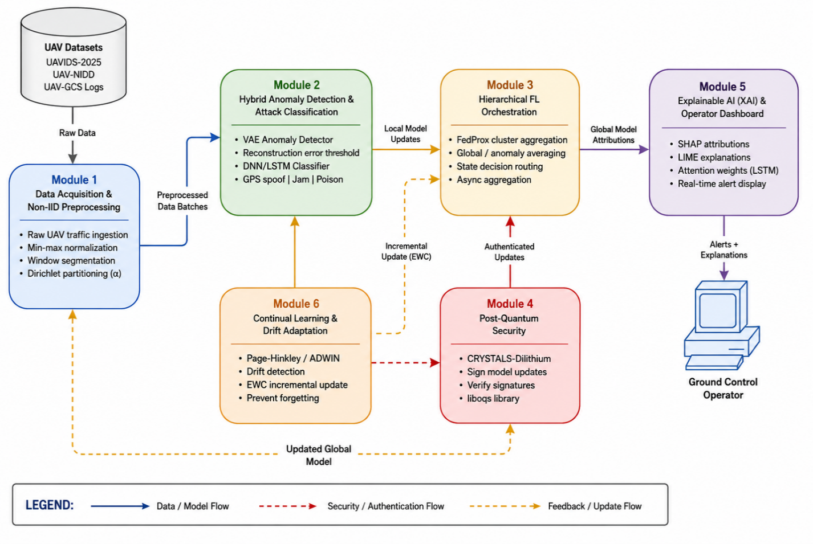

Figure 3.1: Three-Tier Hierarchical FL Architecture for UAV Swarm Cybersecurity

3.3 Functional Modules
The SEAQL framework is decomposed into six tightly integrated but independently deployable functional modules. This modular design ensures testability, maintainability, and the ability to upgrade individual components without disrupting the system as a whole.

3.3.1 Data Acquisition and Non-IID Preprocessing Module
This module is the entry point for all data entering the SEAQL pipeline. It interfaces with real UAV Ground Control Station (UAV-GCS) communication datasets — including UAVIDS-2025 and UAV-NIDD — and applies a structured preprocessing pipeline. Raw network traffic features (packet inter-arrival times, byte counts, flow durations, protocol distributions) are extracted, normalized using min-max scaling, and segmented into fixed-length windows suitable for sequential model input. A key responsibility of this module is the implementation of non-IID data partitioning. In a real UAV swarm, different nodes operate in different environments — surveillance drones in urban areas experience fundamentally different traffic patterns than agricultural monitoring drones in rural zones. The module simulates this heterogeneity using Dirichlet distribution-based label partitioning (parameter α controlling heterogeneity degree) to ensure that no two UAV nodes receive identically distributed data, accurately modelling real-world deployment conditions.

3.3.2 Hybrid Anomaly Detection and Attack Classification Module
This is the core intelligence module of each UAV node. It consists of two sub-components operating in tandem. The anomaly detection sub-component uses a Variational Autoencoder (VAE) trained on normal UAV communication traffic. During inference, reconstruction error is computed for each incoming traffic window; windows exceeding a dynamically calibrated threshold are flagged as anomalous. This unsupervised approach enables detection of zero-day and previously unseen attack patterns without requiring labelled attack data. The attack classification sub-component employs a Deep Neural Network (DNN) combined with a Long Short-Term Memory (LSTM) network to classify flagged anomalies into specific attack categories: GPS spoofing, communication jamming, command hijacking, data poisoning, and replay attacks. The LSTM component captures temporal dependencies in sequential traffic features that are characteristic of specific attack types. Both sub-components are trained locally on the UAV node using only local data, consistent with the federated learning privacy guarantee.

3.3.3 Hierarchical Federated Learning Orchestration Module
This module implements the hierarchical federated learning protocol that enables the SEAQL framework to scale beyond the limitations of centralized FL approaches. At the cluster level, the aggregation algorithm employs Fed Prox — an extension of FedAvg that adds a proximal regularization term to account for heterogeneous local data distributions and varying computational capabilities of UAV nodes. At the global level, the global coordinator performs weighted aggregation of cluster models, where cluster weights are proportional to the number of active nodes in each cluster. The module also manages the federated communication schedule, determining when UAV nodes transmit updates, handling stragglers (slow or temporarily disconnected nodes) by applying asynchronous aggregation with bounded staleness, and dynamically rebalancing cluster assignments if a cluster aggregator becomes unavailable. This design achieves fault-tolerant FL coordination without centralized dependency.

3.3.4 Post-Quantum Security Module
The post-quantum security module addresses the long-term cryptographic vulnerability of existing UAV security frameworks to quantum computing attacks. Current public-key cryptography (RSA, ECDSA) can be broken by Shor's algorithm on a sufficiently powerful quantum computer, making all historically intercepted model updates retroactively decryptable. The SEAQL framework integrates CRYSTALS-Dilithium — a NIST-standardised lattice-based digital signature scheme — for authenticating all model updates exchanged in the federated network. Each UAV node holds a unique Dilithium key pair; model updates are signed before transmission and verified by the receiving aggregator before inclusion in aggregation. Invalid signatures are logged and the offending node is flagged for investigation. The module is implemented using the liboqs (Open Quantum Safe) library, selected for its lightweight computational footprint suitable for resource-constrained UAV platforms. Signature generation and verification overhead is benchmarked as part of system evaluation.

3.3.5 Explainable AI (XAI) and Operator Dashboard Module
A critical gap in existing UAV security frameworks is the lack of explainability — operators receive binary threat alerts without understanding why a detection was made, limiting trust, regulatory compliance, and forensic investigation capability. The XAI module addresses this by computing SHAP (SHapley Additive exPlanations) values for each anomaly detection and attack classification decision. SHAP values quantify the marginal contribution of each input feature to the model's output, producing ranked feature importance explanations that are presented on a real-time operator dashboard. For temporal models (LSTM), attention weights are additionally visualized to highlight which time steps in the traffic window contributed most to the anomaly flag. LIME (Local Interpretable Model-agnostic Explanations) serves as a complementary explainability mechanism for post-hoc analysis of individual predictions. The operator dashboard is designed for ground control station deployment, displaying active anomaly alerts, their XAI attribution charts, attack category probabilities, and historical trend analysis.

3.3.6 Continual Learning and Drift Adaptation Module
UAV cyber threats are not static — adversaries continuously evolve attack strategies, and novel zero-day attacks emerge regularly. A static federated learning model trained once will degrade in performance as the threat landscape shifts. The continual learning module addresses this through two mechanisms. First, a drift detection algorithm (Page-Hinkley Test or ADWIN) monitors the global model's reconstruction error distribution and classification confidence over time. A statistically significant increase in reconstruction error or decrease in classification confidence indicates concept drift — a fundamental change in the underlying data distribution caused by new attack patterns. Second, upon drift detection, the module triggers targeted incremental model updates using Elastic Weight Consolidation (EWC). EWC selectively regularizes updates to model weights that are important for previously learned attack patterns, preventing catastrophic forgetting while enabling the model to incorporate knowledge of new attack types. This design enables the SEAQL framework to remain effective against evolving threats throughout long-term UAV swarm deployment without requiring complete model retraining.
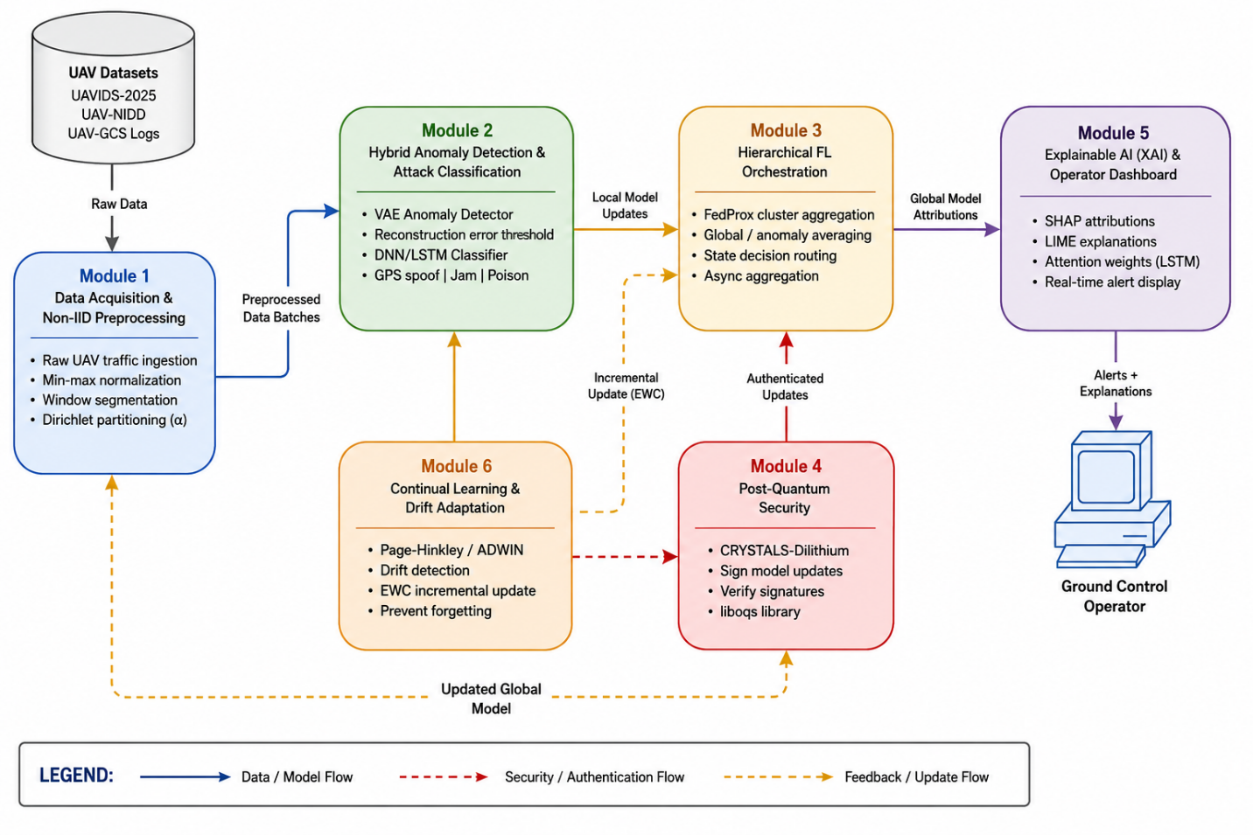

Figure 3.2: Functional Module Interaction Diagram

3.4 Methodology
The SEAQL project follows a structured, iterative development and research methodology that progresses through five phases, each building on validated outputs of the preceding phase. This methodology is aligned with established machine learning system development practices while accommodating the unique constraints of federated learning research.

Phase 1 — Literature Review and System Design
A systematic literature review is conducted covering: federated learning for IoT and UAV security; post-quantum cryptography standardization (NIST PQC); explainable AI methods for anomaly detection; continual and incremental learning; and non-IID federated optimization. Research gaps are documented and used to formally specify the novel contributions of the SEAQL framework. System architecture, module interfaces, and evaluation protocols are designed based on reviewed literature and the project proposal specifications.

Phase 2 — Dataset Acquisition and Preprocessing
Real UAV communication datasets are acquired from publicly available sources including UAVIDS-2025 (Zenodo), UAV-NIDD (Zenodo), and UAV-GCS network logs (GitHub). Datasets are inspected for class balance, feature completeness, and attack diversity. Non-IID partitioning using Dirichlet distribution is applied to simulate heterogeneous UAV node environments. Train/validation/test splits are applied at the node level: 70% training, 15% validation, 15% testing. Data augmentation techniques are applied to minority attack classes to address class imbalance.

Phase 3 — Model Development and Federated Integration
Local models (VAE anomaly detector and DNN/LSTM classifier) are first developed and validated in a centralized setting to establish performance baselines. Models are then adapted for federated deployment using the Flower framework. The hierarchical FL architecture is implemented with cluster-level FedProx aggregation and global weighted averaging. Non-IID-aware training strategies are integrated and validated against IID baselines to quantify the improvement. Post-quantum signing is integrated at the model update transmission stage, and XAI attribution is integrated at the inference stage.

Phase 4 — Simulation and Evaluation
A large-scale UAV swarm simulation environment supporting 100–500 nodes is constructed using ns-3 for network simulation and AirSim/SUMO for UAV mobility modelling. The SEAQL framework is deployed in this simulation and evaluated across the full set of metrics defined in Section 3.7. Byzantine fault tolerance is tested by injecting malicious model updates from a subset of nodes. Concept drift scenarios are simulated by introducing new attack patterns mid-training and measuring continual learning response time. Energy and bandwidth consumption are measured per FL round.

Phase 5 — Reporting and Publication
Evaluation results are compiled into technical reports, benchmark comparisons with state-of-the-art baselines, and a research manuscript targeting IEEE Transactions on Information Forensics and Security or MDPI Sensors (HEC Y-category). Open-source prototype code is prepared for repository publication. Final project documentation, deployment guidelines, and operator dashboard user manual are produced.

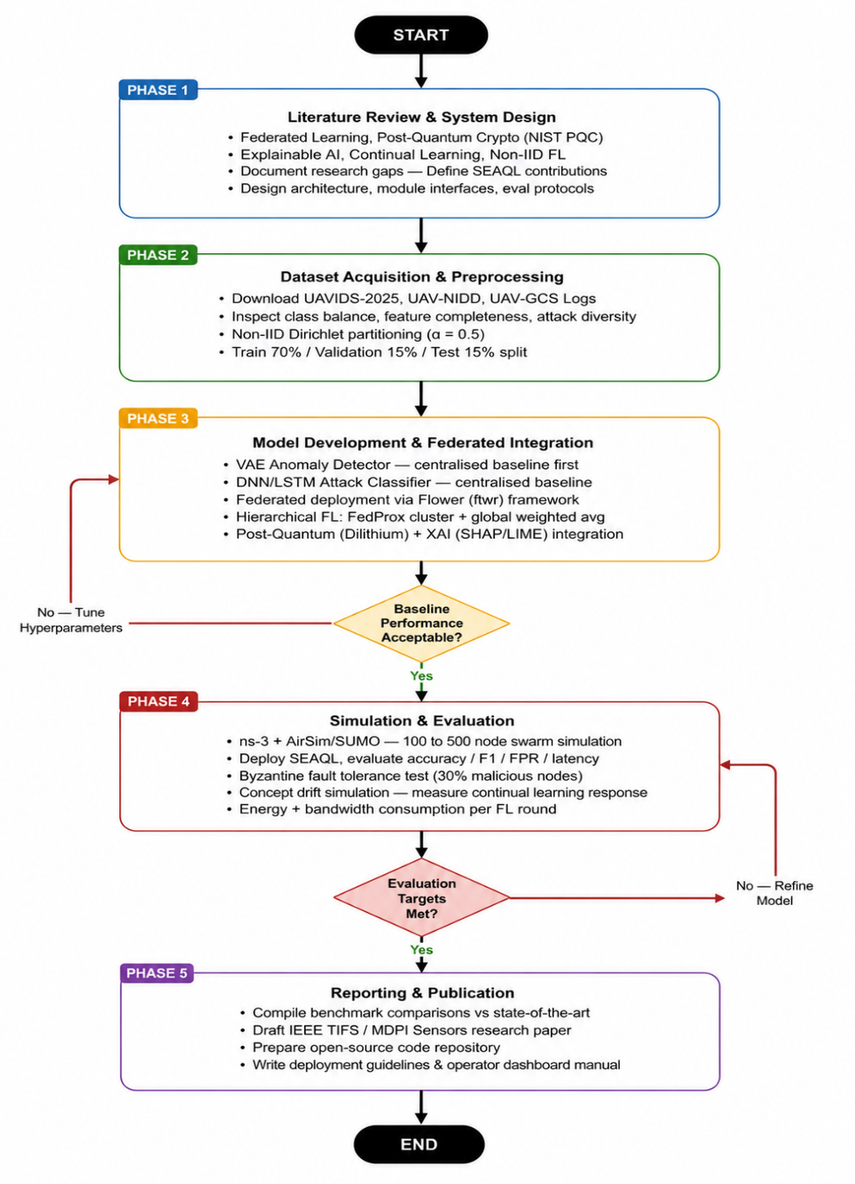

Figure 3.3: SEAQL Research and Development Methodology Flow Diagram

3.5 Tools and Technologies
The following table summarizes all software tools, frameworks, and technologies selected for the implementation and evaluation of the SEAQL framework. Tool selections priorities open-source availability, active maintenance, documented UAV/IoT application precedent, and compatibility with resource-constrained deployment environments.
Table 3.3: Tools and Technologies Used in the SEAQL Framework
Category | Technology | Purpose
Programming Languages | Python 3.11+ | Primary implementation language for all ML, FL, and XAI components
Deep Learning Frameworks | PyTorch 2.x, TensorFlow 2.x | Model development, VAE/Autoencoder, DNN/LSTM training
Federated Learning | Flower (flwr), PySyft | Hierarchical FL orchestration, secure aggregation protocols
Explainable AI | SHAP, LIME | Feature attribution, operator-facing anomaly explanations
Post-Quantum Crypto | liboqs, pyca/cryptography | CRYSTALS-Dilithium signature implementation
Continual Learning | Avalanche, custom EWC | Drift detection, incremental model update management
Simulation Environment | ns-3, SUMO, AirSim | UAV swarm mobility, network traffic simulation
Data Handling | Pandas, NumPy, Scikit-learn | Dataset preprocessing, non-IID partitioning, evaluation
Containerization | Docker, Kubernetes | Scalable multi-node experiment orchestration
Development IDE | VS Code, Jupyter Notebook | Code development and experimental notebooks
Version Control | Git, GitHub | Source code management and collaboration
Experiment Tracking | MLflow, Weights & Biases | Training metrics, model versioning, result logging

3.6 Training and Fine-Tuning
This section specifies the training configuration, data splitting strategy, hyperparameter tuning approach, and evaluation metrics used to develop and assess the SEAQL framework's machine learning components.

3.6.1 Data Splitting Strategy
To ensure unbiased evaluation, data splits are applied at the UAV node level prior to federated training:
- Training Set (70%): Used for local model training across all UAV nodes in federated rounds. Non-IID partitioning is applied exclusively within the training set to simulate realistic data heterogeneity.
- Validation Set (15%): Held at the global coordinator level for hyperparameter tuning, aggregation weight optimisation, and early stopping decisions. Not used for model weight updates.
- Test Set (15%): Reserved exclusively for final performance evaluation. The test set contains all attack categories proportionally represented and is never exposed during training or validation phases.

3.6.2 Hyperparameter Configuration
Key hyperparameters are determined through grid search on the validation set. Representative configurations include: VAE latent dimension of 32; reconstruction error threshold set at the 95th percentile of validation normal traffic; LSTM hidden size of 128 with 2 layers; FedProx proximal term mu of 0.01; Dirichlet non-IID parameter alpha of 0.5 (moderate heterogeneity); local training epochs per FL round of 5; and EWC regularisation coefficient lambda of 400. The Dilithium security level is fixed at Level 3 (128-bit post-quantum security). All hyperparameters are logged using MLflow for full reproducibility.

3.6.3 Evaluation Metrics
The following metrics are used to evaluate system performance across all dimensions of the SEAQL framework:

Metric | Formula / Method | Purpose
Detection Accuracy | Correctly detected attacks / Total instances | Overall anomaly detection performance
F1-Score | 2 × (Precision × Recall) / (Precision + Recall) | Balances precision-recall for imbalanced attack classes
False Positive Rate (FPR) | FP / (FP + TN) | Measures operator alert fatigue risk
Communication Overhead | Bytes transmitted per FL round | Evaluates bandwidth efficiency of compression
Convergence Rounds | Rounds until global model accuracy stabilizes | Measures FL training efficiency at scale
Inference Latency | Time from input to anomaly decision (ms) | Real-time feasibility on UAV-grade hardware
Energy Consumption | Joules per FL training round per node | UAV battery impact assessment
XAI Fidelity Score | SHAP attribution alignment with model internals | Validates explainability reliability
Table 3.4: Evaluation Metrics for the SEAQL Framework

3.7 Ethical and Privacy Considerations
The SEAQL framework operates on UAV communication data that may contain operationally sensitive and personally identifiable information. The following ethical and privacy principles are embedded into the system architecture and research methodology.

3.7.1 Data Privacy by Architecture
The federated learning paradigm ensures that raw UAV sensor and communication data never leaves the originating UAV node. Only model updates (weight deltas), not raw data, are transmitted across the network. This architectural guarantee provides a fundamental layer of data privacy that cannot be circumvented by an adversarial server. To further protect against inference attacks — where adversaries attempt to reconstruct training data from model updates — the SEAQL framework applies differential privacy noise to model updates prior to transmission. The noise magnitude is calibrated to provide (epsilon, delta)-differential privacy guarantees while maintaining acceptable model utility.

3.7.2 Post-Quantum Confidentiality
The integration of CRYSTALS-Dilithium post-quantum digital signatures ensures that model update authenticity is protected against both current and anticipated future quantum computing threats. This is particularly critical in defense and civil aviation UAV applications where long-term data security is a regulatory and operational requirement. The framework does not rely on classical public-key infrastructure, eliminating the harvest-now-decrypt-later attack vector where adversaries record encrypted communications today with the intent to decrypt them once quantum computers become available.

3.7.3 Fairness and Bias Mitigation
The AI models deployed in the SEAQL framework are trained on diverse, geographically and operationally heterogeneous UAV datasets to minimise demographic and environmental bias in anomaly detection and attack classification. Non-IID partitioning strategies explicitly model data heterogeneity, ensuring that the global model generalises fairly across UAV nodes operating in diverse conditions — urban, rural, maritime, and mountainous environments. Regular bias audits are conducted during evaluation to identify and correct any systematic performance disparities across node subgroups. The system is explicitly designed to avoid false positive discrimination that could result in unfair exclusion of legitimate UAV operations.

3.7.4 Responsible Research and Dual-Use Awareness
The SEAQL framework is developed for defensive cybersecurity purposes — protecting UAV swarms against malicious attacks. All simulated adversarial scenarios (GPS spoofing, data poisoning, Byzantine attacks) are implemented exclusively within controlled simulation environments using publicly available datasets. No real UAV systems, operational networks, or live communication channels are used in testing. The research team is committed to responsible disclosure principles: any vulnerabilities identified during the project will be reported through appropriate channels before public disclosure. The open-source release of the prototype code will include explicit usage guidelines prohibiting offensive applications.

3.8 Use Case Diagram
The use case model defines the interactions between system actors and the core functional capabilities of the SEAQL framework. The diagram encompasses all primary use cases derived from the functional requirements and system architecture.

3.8.1 Actors
The SEAQL system involves the following primary and secondary actors:
Table 3.5: System Actors and Role Descriptions
Actor | Role Description
UAV Node (Drone) | Collects local sensor and communication data, trains local anomaly detection model, and transmits encrypted model updates to cluster aggregator.
Cluster Aggregator | Receives local model updates from assigned UAV nodes, performs cluster-level federated aggregation, and forwards aggregated model to global coordinator.
Global Coordinator | Orchestrates global model aggregation across all clusters, validates post-quantum signatures on updates, and distributes updated global model.
Ground Control Operator | Monitors XAI dashboard for real-time anomaly explanations, receives threat alerts, and reviews forensic attack classification reports.
AI / FL System | Executes federated learning rounds, anomaly detection, attack classification, continual learning updates, and XAI attribution generation.
Adversary (Simulated) | Represents modeled cyber threats including GPS spoofing, data poisoning, Byzantine attacks, and zero-day exploits used for system validation.

3.8.2 Use Cases
Primary use cases of the SEAQL framework include:
- UC-01: Register UAV Node — UAV node registers with the federated network, generating Dilithium key pair and receiving cluster assignment.
- UC-02: Train Local Anomaly Detection Model — UAV node trains VAE anomaly detector on local communication data for a federated round.
- UC-03: Train Local Attack Classifier — UAV node trains DNN/LSTM classifier on anomaly-flagged local data.
- UC-04: Submit Signed Model Update — UAV node compresses and signs model update, transmits to cluster aggregator.
- UC-05: Cluster Aggregation — Cluster aggregator verifies signatures, performs FedProx cluster-level aggregation.
- UC-06: Global Aggregation — Global coordinator aggregates cluster models, performs drift detection, distributes updated global model.
- UC-07: Detect Anomaly in Real Time — Deployed model flags anomalous traffic window on UAV node, triggers XAI explanation generation.
- UC-08: Classify Attack Type — Anomaly flagged by VAE is classified into specific attack category by DNN/LSTM classifier.
- UC-09: View XAI Explanation — Ground control operator reviews SHAP attribution chart and alert details on operator dashboard.
- UC-10: Trigger Continual Learning — Global coordinator detects drift, activates EWC-based incremental model update across all nodes.
- UC-11: Reject Malicious Update — Aggregator detects Byzantine update via signature failure or statistical outlier check, excludes it from aggregation.
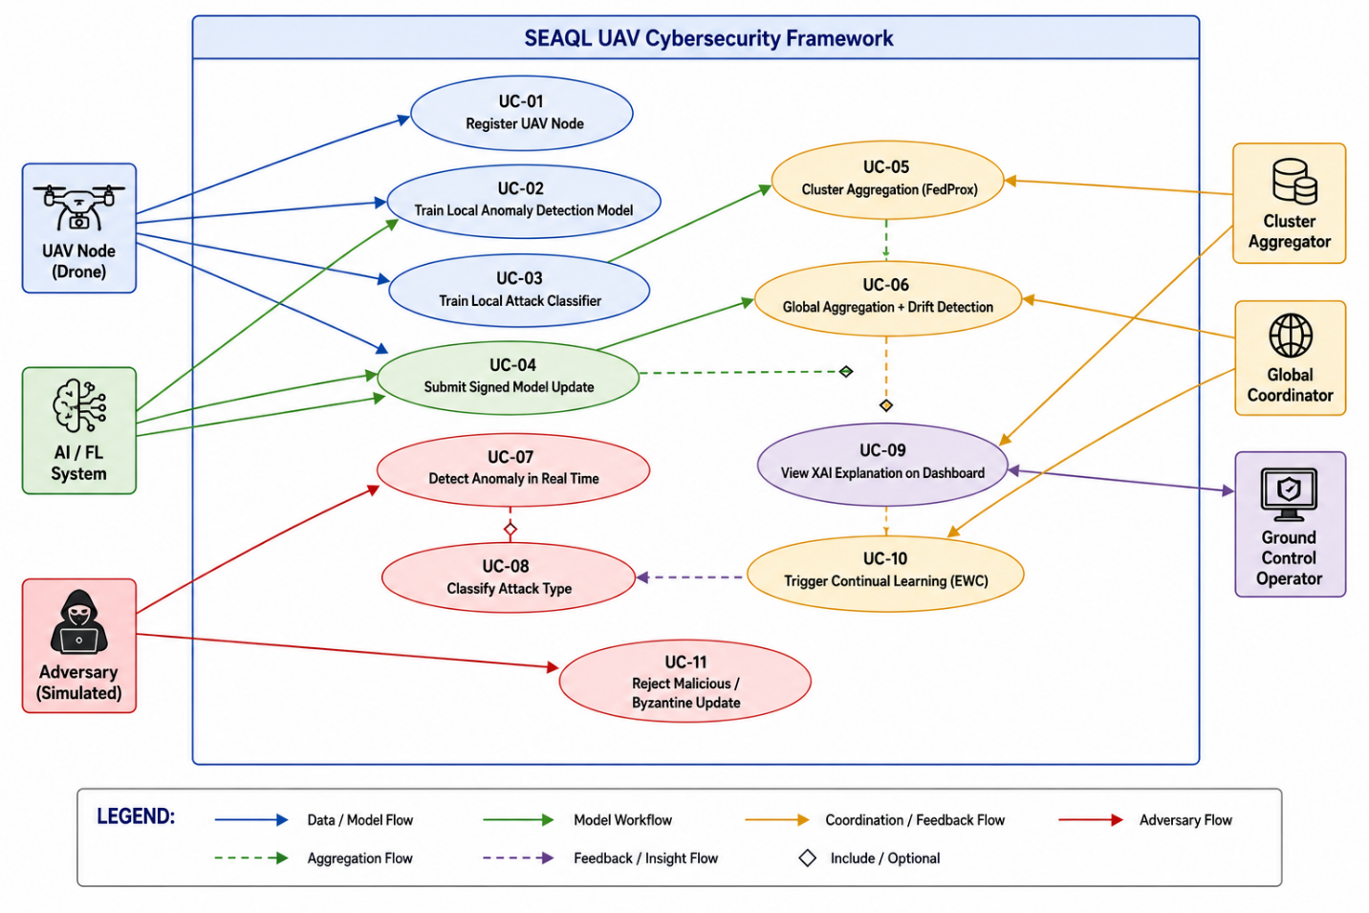

Figure 3.4: Use Case Diagram — SEAQL Framework

3.9 Sequence Diagram
The sequence diagrams below illustrate the chronological message exchanges between system components for the two most critical operational flows: the complete federated learning round and the real-time anomaly detection and explanation flow.

3.9.1 Federated Learning Round — Sequence
The FL round sequence proceeds as follows: (1) Global Coordinator broadcasts the current global model to all Cluster Aggregators. (2) Each Cluster Aggregator forwards the model to its assigned UAV Nodes. (3) Each UAV Node trains locally for a fixed number of epochs on local data. (4) Each UAV Node compresses the model update, signs it with CRYSTALS-Dilithium private key, and transmits it to the Cluster Aggregator. (5) Cluster Aggregator verifies all signatures; rejects invalid updates. (6) Cluster Aggregator performs FedProx cluster-level aggregation and transmits cluster model to Global Coordinator. (7) Global Coordinator performs global aggregation, applies drift detection. (8) If drift detected: Global Coordinator triggers EWC continual learning update. (9) Global Coordinator distributes updated global model to begin next round. 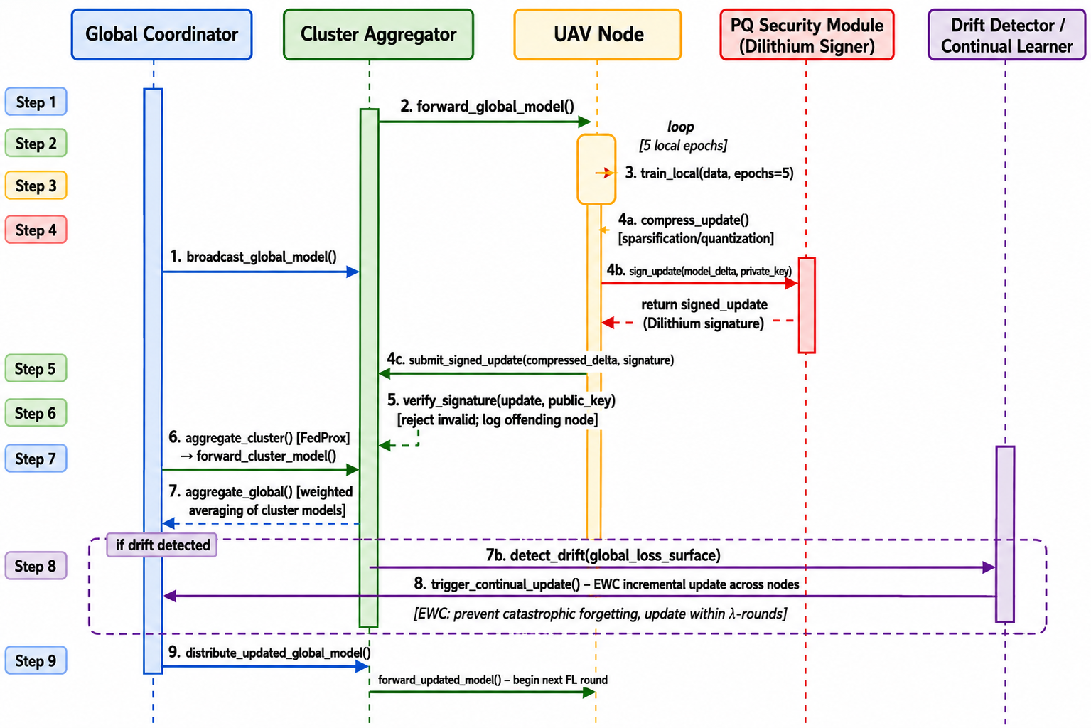
Figure 3.5: Sequence Diagram — Hierarchical Federated Learning Round

3.9.2 Real-Time Anomaly Detection and XAI Sequence
The anomaly detection sequence proceeds as follows: (1) UAV Node receives incoming network traffic window from onboard network interface. (2) Preprocessing module normalizes and segments the traffic window. (3) VAE Anomaly Detector computes reconstruction error for the window. (4) If reconstruction error exceeds threshold: Anomaly is flagged; DNN/LSTM Attack Classifier classifies the attack type. (5) XAI Module computes SHAP attribution values for the detection decision. (6) Anomaly alert with XAI explanation is transmitted to Ground Control Operator dashboard. (7) Ground Control Operator reviews SHAP attribution chart and attack classification probabilities. (8) Operator acknowledges alert; event is logged for forensic record.
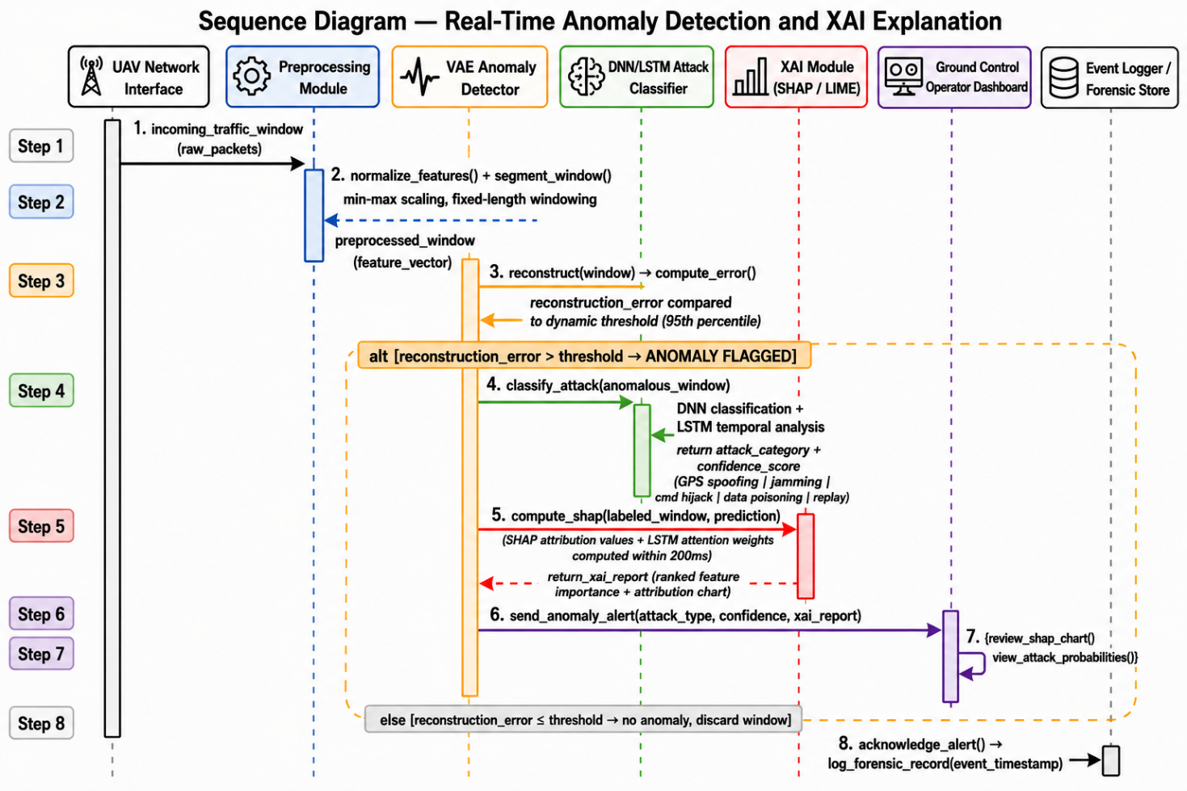
Figure 3.6: Sequence Diagram — Real-Time Anomaly Detection and XAI Explanation

3.10 Class Diagram
The class diagram defines the core object-oriented structure of the SEAQL framework implementation. It illustrates the primary classes, their attributes, methods, and relationships within the system.

3.10.1 Core Classes
The SEAQL framework is implemented around the following principal classes:
- UAVNode: Attributes: node_id, cluster_id, dilithium_keypair, local_model, training_data. Methods: train_local(), sign_update(), compress_update(), submit_update(), detect_anomaly(), classify_attack(), generate_xai_report().
- Cluster Aggregator: Attributes: cluster_id, assigned_nodes, cluster_model, received_updates. Methods: receive_update(), verify_signature(), aggregate_cluster(), forward_to_global().
- GlobalCoordinator: Attributes: global_model, cluster_models, drift_detector, continual_learner. Methods: aggregate_global(), detect_drift(), trigger_continual_update(), distribute_model().
- VAEAnomalyDetector: Attributes: encoder, decoder, threshold, latent_dim. Methods: train(), reconstruct(), compute_error(), flag_anomaly().
- AttackClassifier: Attributes: dnn_model, lstm_model, attack_classes. Methods: train(), classify(), get_probabilities().
- XAIModule: Attributes: shap_explainer, lime_explainer, attention_weights. Methods: compute_shap(), compute_lime(), generate_report(), visualise_attributions().
- DilithiumSigner: Attributes: public_key, private_key, security_level. Methods: generate_keypair(), sign(), verify().
- DriftDetector: Attributes: phtest, adwin, drift_threshold. Methods: update_statistics(), detect(), reset().
- ContinualLearner: Attributes: ewc_lambda, fisher_matrix, optimal_weights. Methods: compute_fisher(), update_model(), prevent_forgetting().

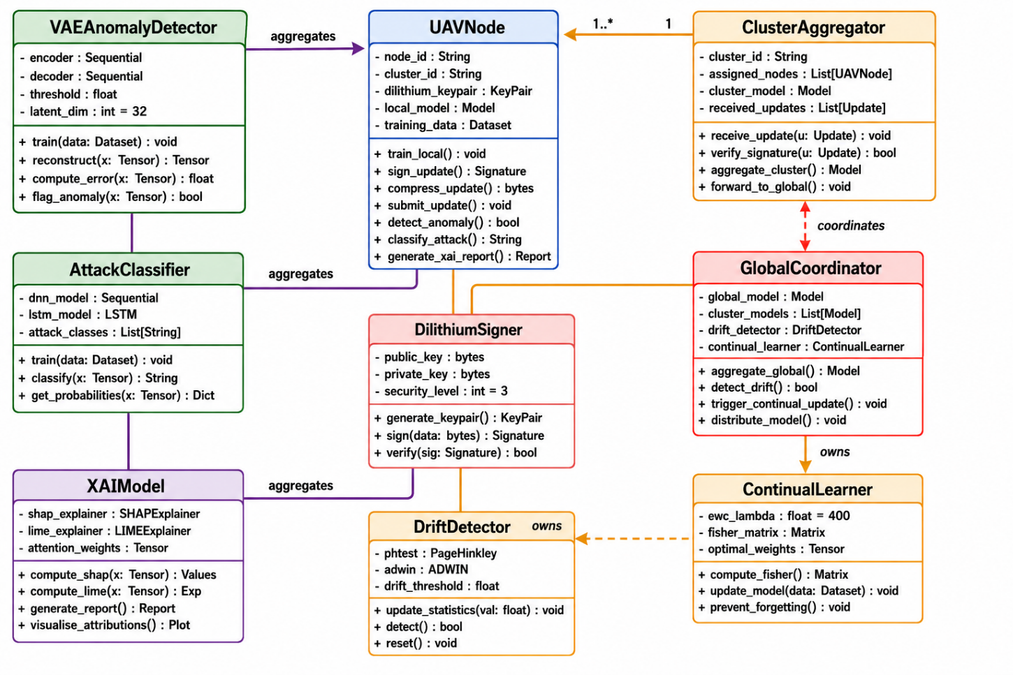
Figure 3.7: Class Diagram — SEAQL Framework Core Classes and Relationships

CHAPTER 4

SUSTAINABLE DEVELOPMENT GOALS (SDG) ALIGNMENT AND IMPACT

4.1 Introduction to Sustainable Development Goals
The United Nations Sustainable Development Goals (SDGs) are a set of 17 interlinked global goals, adopted in 2015, that set out an agenda for addressing poverty, inequality, health, education, climate change, and technological development by 2030. They provide a shared framework against which engineering and computing projects can be assessed for their broader societal contribution, beyond their immediate technical objectives.
Modern technological and engineering projects are increasingly expected to demonstrate not only technical merit but also ethical responsibility, sustainability, and a positive societal footprint. As future engineers and computing professionals, students are well positioned to contribute toward these goals through projects that strengthen digital infrastructure, protect critical systems, and support responsible innovation. This chapter maps the present project — a Scalable, Explainable, and Adaptive Quantum-Resilient Federated Learning (SEAQL) framework for UAV swarm cybersecurity — onto the SDGs most relevant to its objectives and outcomes.

4.2 Selected SDG(s) Relevant to the Project

Primary SDG:
SDG 9 – Industry, Innovation, and Infrastructure
Official description: Build resilient infrastructure, promote inclusive and sustainable industrialization, and foster innovation. This project is directly relevant to SDG 9 because it develops a novel federated learning and machine learning security framework that strengthens the technological infrastructure underpinning UAV swarm communication networks, and contributes original research to the fields of distributed machine learning and network intrusion detection.

Secondary SDG:
SDG 16 – Peace, Justice, and Strong Institutions
Official description: Promote peaceful and inclusive societies, provide access to justice for all, and build effective, accountable institutions. UAV swarms are increasingly deployed by government, defense, and civil institutions for surveillance, border security, and disaster response; protecting these systems from cyberattack (DoS flooding, packet replay, and related intrusions) directly supports the integrity and accountability of the institutions that rely on them.

Tertiary SDG (supporting):
SDG 11 – Sustainable Cities and Communities
Official description: Make cities and human settlements inclusive, safe, resilient, and sustainable. Secure UAV swarms underpin several smart-city and public-safety applications — including disaster response, infrastructure inspection, and traffic monitoring — that depend on UAV data being trustworthy and free from adversarial interference.

4.3 Project-to-SDG Mapping Explanation
The problem addressed by this project is the vulnerability of UAV swarm communication networks to cyberattacks such as Denial-of-Service (DoS) flooding and packet replay. Because UAV swarms coordinate over shared wireless channels and are increasingly deployed in safety-critical and mission-critical roles, a successful attack can degrade or entirely disable swarm operations, with consequences ranging from mission failure to physical safety risk.
The proposed SEAQL framework contributes to sustainability and resilient infrastructure (SDG 9) in the following ways:
- It advances applied research in federated learning, a privacy-preserving distributed training paradigm in which raw traffic data never leaves the UAV or client where it was captured, contributing to the broader body of scientific and technological knowledge in secure, decentralized AI.
- It proposes a Hybrid AE-Stacked Ensemble architecture that measurably improves attack-detection performance (92.9% accuracy for attack-versus-benign detection) over conventional single-model baselines, directly enhancing the technological capability of UAV cybersecurity infrastructure.
- It incorporates Explainable AI (SHAP-based feature attribution), which improves the transparency and trustworthiness of automated security decisions — a factor increasingly required of critical digital infrastructure.
The project supports SDG 16 by strengthening the institutional integrity of the organizations (defense, disaster-response agencies, border-security bodies, and commercial operators) that depend on UAV swarms, by reducing the risk that adversaries can disrupt, spoof, or hijack swarm communications through network-level attacks. A more secure UAV communication layer means these institutions can be held accountable for safe and reliable operation, rather than being exposed to attacks outside their control.

4.4 SDG Targets and Indicators Alignment
SDG Target 9.5 – Enhance scientific research and upgrade the technological capabilities of industrial sectors, including, by 2030, encouraging innovation.
Contribution: The proposed hybrid federated-learning and ensemble-detection architecture represents original applied research that upgrades the technological capability available for securing UAV communication infrastructure, and is documented and evaluated in a manner suitable for further academic or industrial development.
SDG Target 9.c – Significantly increase access to information and communications technology and strive to provide universal and affordable access to the Internet.
Contribution: By keeping the detection pipeline lightweight enough to run on resource-constrained, low-bandwidth UAV platforms (through the federated architecture's local training and compressed model-update accounting), the project supports the deployment of secure communication technology in settings with limited computing or connectivity resources.
SDG Target 16.a – Strengthen relevant national institutions to prevent violence and combat terrorism and crime.
Contribution: UAV swarms are documented targets for GPS spoofing, jamming, and communication-layer attacks that can be used to hijack or disable drones for malicious purposes. A validated, explainable detection framework such as SEAQL provides institutions operating UAV swarms with a concrete technical capability to detect and respond to such attacks, supporting their capacity to prevent misuse of these systems.

4.5 Expected Impact and Benefits

4.5.1 Social Impact
- Improves public trust and safety in UAV swarm deployments used for disaster response, search-and-rescue, and public-safety monitoring, by reducing the likelihood of successful cyberattacks disrupting these missions.
- Supports safer adoption of UAV technology in underserved or hard-to-reach communities where drones are used to deliver medical supplies or monitor infrastructure, by protecting the communication layer these services depend on.

4.5.2 Economic Impact
- Reduces the operational and financial cost of security incidents (mission failure, equipment loss, or data compromise) for organizations operating UAV swarms commercially or institutionally.
- Provides an open, documented research baseline (data-cleaning pipeline, baseline models, and hybrid ensemble) that lowers the cost of further innovation for future researchers and developers working on UAV cybersecurity.

4.5.3 Environmental Impact
- Indirectly supports environmentally beneficial UAV applications — such as precision agriculture and environmental/wildlife monitoring — by protecting the reliability of the communication systems these applications depend on, reducing wasted flights and resources caused by compromised missions.

4.5.4 Technological Impact
- Contributes a reusable federated-learning and hybrid-ensemble pipeline that advances the state of applied research in non-IID, privacy-preserving distributed learning for network intrusion detection.
- Demonstrates a practical explainable-AI layer (SHAP-based) that can be adapted to other safety-critical machine-learning systems requiring interpretable decisions.

4.6 Stakeholders and Beneficiaries
The principal stakeholders who would benefit from the deployment of the proposed SEAQL framework include UAV swarm operators (defense, disaster response, agriculture, delivery), government and regulatory bodies, cybersecurity researchers and developers, end communities served by UAV missions, and the academic institution itself. Each stakeholder's specific benefit is consolidated, alongside the corresponding SDG mapping, in the single summary table in Section 5.8.

4.7 Ethical and Sustainability Considerations
- Data privacy – the federated learning architecture is explicitly designed so that raw UAV traffic data never leaves the client where it is captured; only model updates are shared, reducing the exposure of potentially sensitive operational data.
- Ethical AI usage – the inclusion of an Explainable AI (XAI) layer (SHAP feature attribution) ensures that automated attack classifications can be audited and explained rather than treated as an opaque black box, which is important when detection outcomes may trigger operational responses such as node isolation.
- Security considerations – the framework was evaluated under an explicit anti-overfitting and data-leakage protocol (strict train/validation/test separation, leakage-like identifier removal, train-only preprocessing) to ensure that reported performance reflects genuine generalization rather than memorized artefacts, which is essential for any system intended to inform real security decisions.
- Long-term sustainability – the framework includes a continual-learning component specifically intended to allow the model to adapt to evolving attack patterns over time without full retraining, supporting the long-term maintainability of the system as threats evolve.

4.8 SDG and Stakeholder Mapping Table (Summary)
The table below consolidates the project's SDG alignment together with its targets, contributions, and the primary stakeholder benefiting from each component, into a single reference summary.
Project Component | SDG | Target | Contribution | Key Beneficiary
Federated learning architecture | SDG 9 | 9.5 | Advances research and technological capability in privacy-preserving distributed security AI | Cybersecurity researchers and developers
Hybrid AE-Stacked Ensemble detector | SDG 9 | 9.5 | Improves technological capability of UAV attack-detection infrastructure (92.9% binary detection accuracy) | UAV swarm operators
Lightweight/compressed client model updates | SDG 9 | 9.c | Supports deployment on resource-constrained, low-bandwidth UAV platforms | Remote/rural communities served by UAV missions
Attack detection and explainability (SHAP) | SDG 16 | 16.a | Strengthens institutional capacity to prevent misuse and attacks on UAV swarm systems | Government and regulatory bodies
Reliable UAV communication security layer | SDG 11 | 11.b | Supports resilient, secure operation of UAV-based smart-city and disaster-response services | End communities and academic institution

4.9 Future Scope for SDG Enhancement
- Scaling the framework from simulated non-IID clients to real multi-drone hardware testbeds, and eventually to national-level UAV traffic-management infrastructure.
- Integration with smart-city command-and-control systems, where secure UAV data could feed directly into public-safety and disaster-response decision-making pipelines.
- Adoption by commercial UAV manufacturers or fleet operators as an embedded security layer, extending the project's SDG 9 contribution from research prototype to deployed industrial capability.
- Extending the post-quantum signing component (currently optional/pending native library support) to full deployment, future-proofing UAV communication security against emerging quantum-computing threats.

4.10 Chapter Summary
This chapter mapped the proposed SEAQL UAV swarm cybersecurity framework onto the United Nations Sustainable Development Goals most relevant to its objectives. The project's primary alignment is with SDG 9 (Industry, Innovation, and Infrastructure), through its contribution of a privacy-preserving, federated, and explainable machine-learning architecture that strengthens UAV communication security infrastructure. It also supports SDG 16 (Peace, Justice, and Strong Institutions), by helping institutions that rely on UAV swarms defend against attacks that could otherwise be used to disrupt or misuse these systems, and SDG 11 (Sustainable Cities and Communities), through its support of secure UAV-based public-safety and disaster-response applications. Expected impacts span social, economic, environmental, and technological dimensions, and the project was developed with explicit attention to data privacy, ethical AI transparency, and long-term adaptability to evolving threats

CHAPTER 5

DATA & EXPERIMENTS

5.1 Data Collection
This project addresses cybersecurity threat detection in Unmanned Aerial Vehicle (UAV) swarm networks, focusing specifically on identifying malicious traffic patterns within real captured network communications. UAV swarms depend on wireless data-link protocols for coordination, which makes them vulnerable to attacks such as Denial-of-Service (DoS) flooding and packet Replay, where previously captured legitimate traffic is retransmitted to disrupt or deceive the network.
The data used in this study (Dataset_T-ITS.csv) is a packet-level network capture of UAV communication traffic, structured in the style of datasets used in IEEE Transactions on Intelligent Transportation Systems (T-ITS) UAV security research. Each record corresponds to a single captured network frame, described by link-layer (802.11/WLAN), network-layer (IP), and transport-layer (TCP/UDP) attributes, together with a ground-truth class label identifying the traffic as benign, DoS attack, or Replay.

5.2 Dataset Used
The raw dataset contains 54,783 captured packet records described by 38 attributes. Key feature groups include:
- Frame-level features – frame. Len (packet size), frame. Protocols, frame. Number.
- WLAN/MAC-layer features – wlan. duration, wlan.ra/ta/da/sa (address fields), wlan. bssid, wlan. Frag, wlan.seq, wlan.fc.type/subtype.
- IP-layer features – ip.hdr_len, ip.len, ip.id, ip.flags, ip.ttl, ip.proto, ip.src, ip.dst.
- Transport-layer features – tcp.srcport/dstport, tcp.seq_raw, tcp.ack_raw, tcp.flags, tcp.window_size, udp.srcport/dstport, udp.length.
- Timing and payload features – time_since_last_packet, data.len, data.data.
- Class label – benign, DoS attack, or Replay, assigned per captured packet.
This packet-level structure allows the detection model to learn traffic-pattern signatures directly from real communication behaviour, rather than from simulated or hand-crafted summary statistics.

5.3 Data Quality Assessment
Before any modelling was performed, the raw CSV file was audited in detail. This audit uncovered a structural data-quality issue: the file had been produced by concatenating three separate capture sessions (one per class) without removing the intermediate header rows, so two duplicate header lines were embedded mid-file. In addition, approximately 21,681 records (about 40% of the file) carried missing or invalid class values; closer inspection traced this to a block of rows in which an unrelated UAV flight-telemetry export (fields such as height, pitch, roll, yaw, and battery level) had been misaligned into the network-capture column structure, producing packet rows with no genuine class label.
Rather than allowing these malformed rows to silently contaminate training, the cleaning pipeline explicitly retains only records whose class value is exactly one of "benign", "DoS attack", or "Replay", and discards everything else. After this filtering step and the removal of exact duplicate records, 32,558 valid, uniquely-labelled packet records remained for modelling.
Table 5.1 summarizes this audit.
Stage | Row Count
Raw rows in file | 54,783
Rows with a valid class label | 33,102
Rows with missing/invalid label (discarded) | 21,681
Final rows after duplicate removal | 32,558

Table 5.2: The resulting class distribution is reasonably balanced across the three categories, as shown in and Figure 4.1.
Class | Record Count | Share
Replay | 11,670 | 35.8%
DoS attack | 11,653 | 35.8%
benign | 9,235 | 28.4%
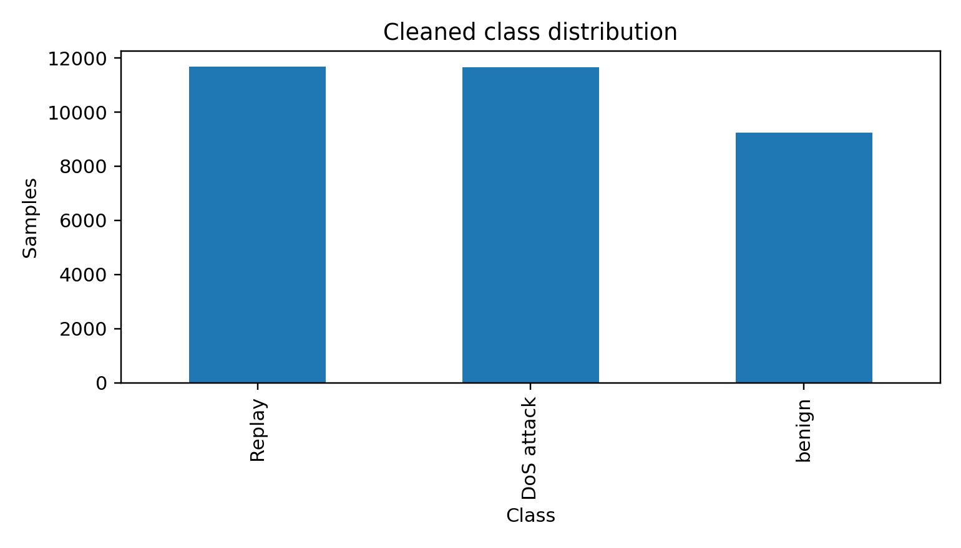
Figure 5.1: Class distribution of the cleaned dataset (32,558 records).

5.4 Preprocessing
A leakage-aware preprocessing pipeline was applied to the filtered dataset:
- Type coercion – every packet field was converted to a numeric type; malformed tokens were coerced to missing values rather than silently accepted.
- Leakage-like feature removal – timestamp and frame. Number were dropped, since a model could otherwise memories absolute capture time or row order instead of learning genuine traffic-pattern signatures.
- Removal of unusable columns – attributes that were entirely missing or constant across all records were dropped, as they carry no discriminative information.
- Duplicate removal – exact duplicate feature/label rows were removed to prevent the same packet pattern from being counted, and potentially leaked, across splits.
- Missing-value imputation – remaining gaps (e.g. TCP-only fields that are naturally absent on UDP packets) were filled using median imputation, with a missing-value indicator flag retained as an extra feature so the model can use "was this field present" as a signal in its own right.
- Feature scaling – all features were scaled with a robust scaler (median/IQR-based), which is less sensitive to the heavy-tailed outliers typical of packet-size and inter-arrival-time distributions than min-max scaling.
After cleaning, 32 usable numeric features remained per packet record. Critically, the imputer and scaler were fitted only on the training split and then applied unchanged to the validation and test splits, preventing any statistical information from the held-out data from influencing preprocessing.

5.5 Training and Testing Split
The cleaned dataset was divided into training, validation, and test subsets using a stratified split that preserves the original class proportions in every subset: 60% for training, 20% for validation (used for model selection and early stopping), and 20% held out for final testing. The test set was not used in any preprocessing, hyperparameter selection, or model-selection decision, so the reported test metrics reflect performance on genuinely unseen traffic.

5.6 Class Imbalance Handling
As Table 4.2 shows, class imbalance in this dataset is moderate rather than severe (28-36% per class). Nonetheless, two complementary safeguards were used so that the minority class (benign) is not underrepresented in model decisions:
- Class-weighted training – the baseline Random Forest, Logistic Regression, and MLP classifiers were all trained with balanced class weights, so misclassifying a minority-class packet is penalised more heavily during training.
- SMOTE oversampling (proposed hybrid model only) – the Synthetic Minority Oversampling Technique was applied to the training split alone, generating interpolated synthetic examples for the least-represented class so the ensemble receives balanced exposure to all three traffic types. SMOTE was never applied to validation or test data, so reported metrics are not inflated by synthetic examples.

5.7 Models Used
Several complementary models were built and evaluated so that the proposed approach could be benchmarked fairly against established baselines:
- Central baselines – Logistic Regression, Random Forest, and an early-stopping MLP were trained directly on the pooled training data as reference points.
- Autoencoder anomaly detector – a compact encoder-decoder network was trained only on benign training packets to learn a representation of normal traffic; its reconstruction error at test time serves as an anomaly score for flagging non-benign packets.
- Hierarchical Federated Learning – training data was partitioned into 8 simulated UAV clients using a Dirichlet distribution (alpha = 0.30) to emulate realistic non-IID data skew, grouped into 2 clusters. Each client trains a local model; cluster-level and then global model averaging (FedAvg-style) is performed across 5 communication rounds, so no raw packet data ever leaves a simulated client.
- Continual learning module – the training stream was split into sequential chunks to emulate concept drift over time, with a small replay buffer (150 samples per class) used to update the model incrementally while mitigating catastrophic forgetting of earlier attack patterns.
- Explainable AI (XAI) – SHAP was used to attribute each prediction to the packet features that most influenced it, with a permutation-importance method used as an automatic fallback when the SHAP tree-explainer backend is unavailable.
- Post-quantum signing (optional) – the pipeline supports signing model updates with an ML-DSA (CRYSTALS-Di lithium-style) signature via the python-oqs library. This was not executed in the reported run because the native liboqs dependency was not installed; the system reports this explicitly rather than substituting a conventional signature and describing it as quantum-resistant.
- Proposed Hybrid AE-Stacked Ensemble – this project's main contribution combines the autoencoder's anomaly signal (its reconstruction error and compressed latent embedding) with the original packet features, feeding both into a stacking ensemble of Random Forest, XGBoost, LightGBM, and Extra Trees classifiers together with an MLP, whose outputs are combined by a Logistic Regression meta-learner trained via 5-fold cross-validation.

5.8 Libraries and Tools Used
The complete pipeline was implemented in Python.
Table 5.3 Lists the core libraries used and the role each one played in the system.
Library | Purpose in this project
pandas | Loading, cleaning, and auditing the raw CSV dataset; duplicate/label filtering
NumPy | Numerical array operations underlying feature construction and metrics
scikit-learn | Preprocessing (imputation, scaling), baseline models (Logistic Regression, Random Forest, MLP), Extra Trees, Stacking ensemble, evaluation metrics, train/validation/test splitting
PyTorch (torch) | Autoencoder anomaly detector and the hierarchical federated-learning client/global models
XGBoost | Gradient-boosted tree base learner used in the proposed hybrid ensemble
LightGBM | Leaf-wise gradient-boosted tree base learner used in the proposed hybrid ensemble
imbalanced-learn (SMOTE) | Synthetic minority oversampling applied to the training split of the hybrid model
SHAP | Explainable AI - feature-attribution explanations for model predictions
matplotlib | Generating all comparison charts, confusion matrices, and training curves reported in this chapter

5.9 Sample Analysis
To illustrate model behavior at the packet level, two individual test-set records are examined below using the trained Random Forest classifier's predicted probabilities.
Correctly classified benign packet: a 239-byte frame with wlan.seq = 1581 and typical address-field values was assigned a predicted probability of 1.00 for benign and 0.00 for both attack classes, illustrating that normal swarm traffic is, in the great majority of cases, cleanly separable from attack traffic on packet-level features alone.
Misclassified Replay packet: a 26-byte frame with wlan.seq = 2953 was labelled Replay in the ground truth but received predicted probabilities of 0.627 for DoS attack, 0.373 for Replay, and 0.00 for benign - an incorrect prediction. This is representative of a broader, systematic pattern found in the test set: a large share of true Replay packets are misclassified as DoS attack, because a Replay attack, by definition, retransmits previously captured legitimate or attack traffic, so its packet-level signature can closely resemble other attack traffic. This is a data-level characteristic of the attack types rather than a shortcoming of any specific model, and it directly motivated the binary attack-vs-benign evaluation reported in Section 4.11.

5.10 Baseline Model Results
All models were evaluated on the held-out test set using accuracy, macro-averaged F1-score (which weights every class equally regardless of its frequency), weighted F1-score, and macro-averaged one-vs-rest AUC. The baseline models achieved the following macro F1-scores on the full 32,558-record cleaned dataset:
Model | Macro F1-score
Random Forest (best central baseline) | 73.4%
Hierarchical Federated MLP | 59.7%
Autoencoder (binary anomaly detection) | 83.5%
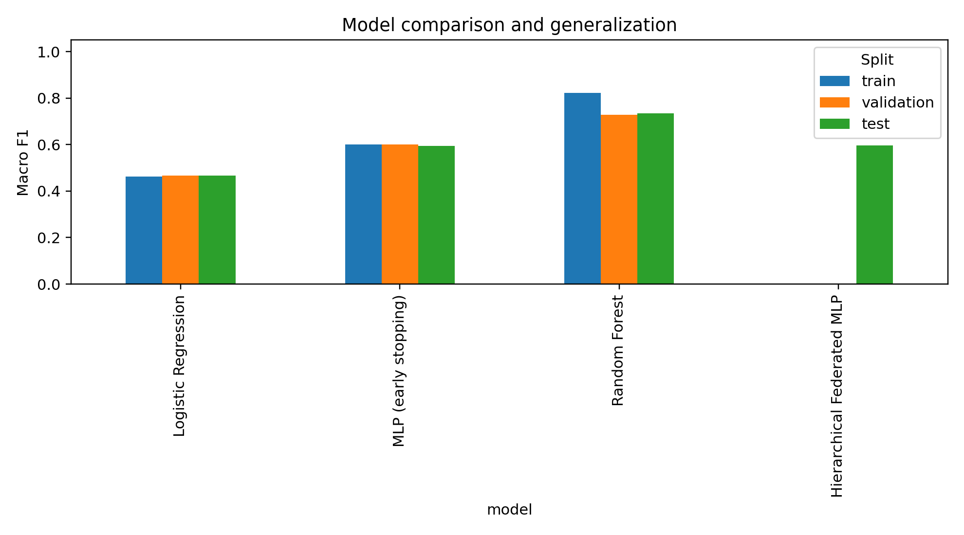
Figure 5.2: Baseline model comparison (macro F1-score, test set).
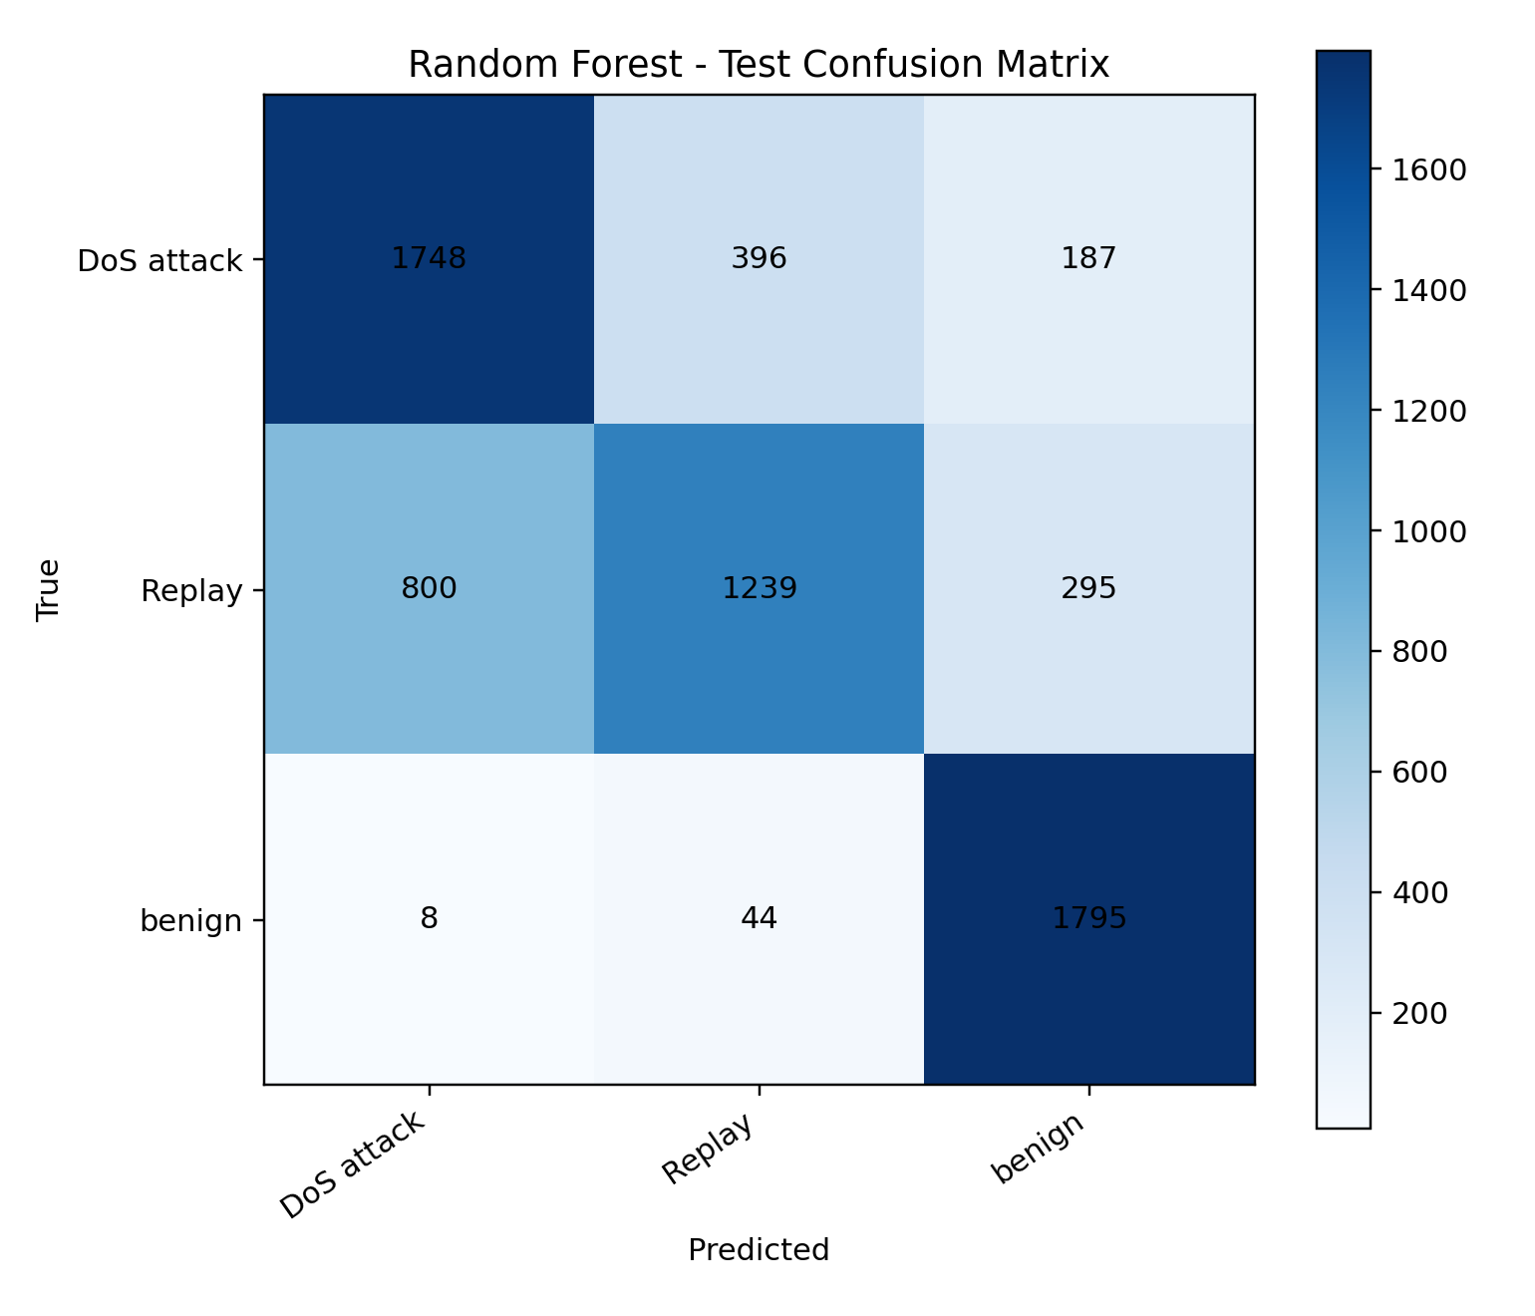
Figure 5.3: Confusion matrix - Random Forest baseline (test set).

5.11 Proposed Hybrid Model Results
The proposed Hybrid AE-Stacked Ensemble was first evaluated on the same 3-class task (benign / DoS attack / Replay). On the full cleaned dataset it achieved 74.0% accuracy, a 74.4% macro F1-score, a 73.4% weighted F1-score, and an 89.5% macro-averaged AUC - an improvement over the Random Forest and Federated Learning baselines reported in Section 4.10.
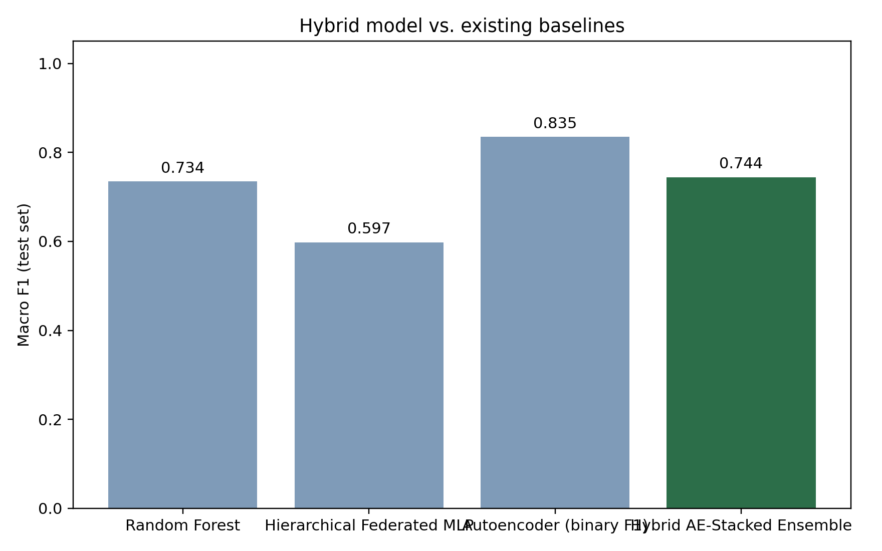
Figure 5.4: Proposed hybrid model versus all baselines (macro F1-score, test set).
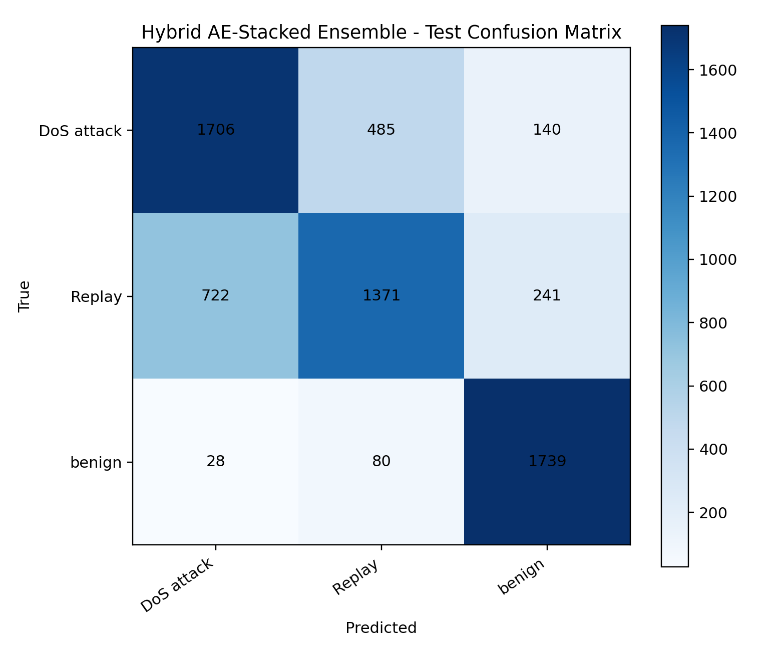
Figure 5.5: Confusion matrix - Hybrid AE-Stacked Ensemble, 3-class (test set).
As Section 4.9 explains, the majority of the remaining error is concentrated in the DoS-attack-versus-Replay boundary rather than in separating attacks from benign traffic. This observation was confirmed by reframing the task as binary attack detection (collapsing DoS attack and Replay into a single "attack" category). Under this framing, the same pipeline achieved 92.9% accuracy and a 91.5% macro F1-score, with strong precision and recall on both the attack and benign classes.
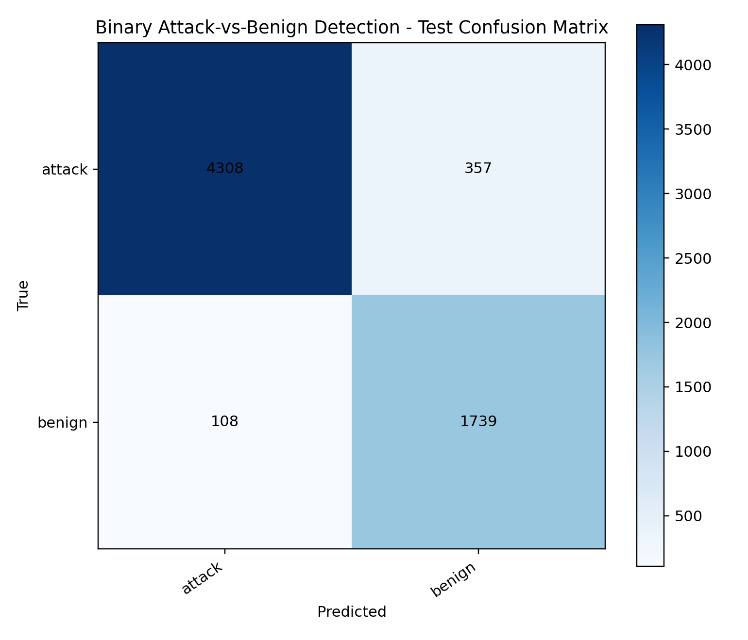
Figure 5.6: Confusion matrix - Hybrid model, binary attack-vs-benign framing (test set).
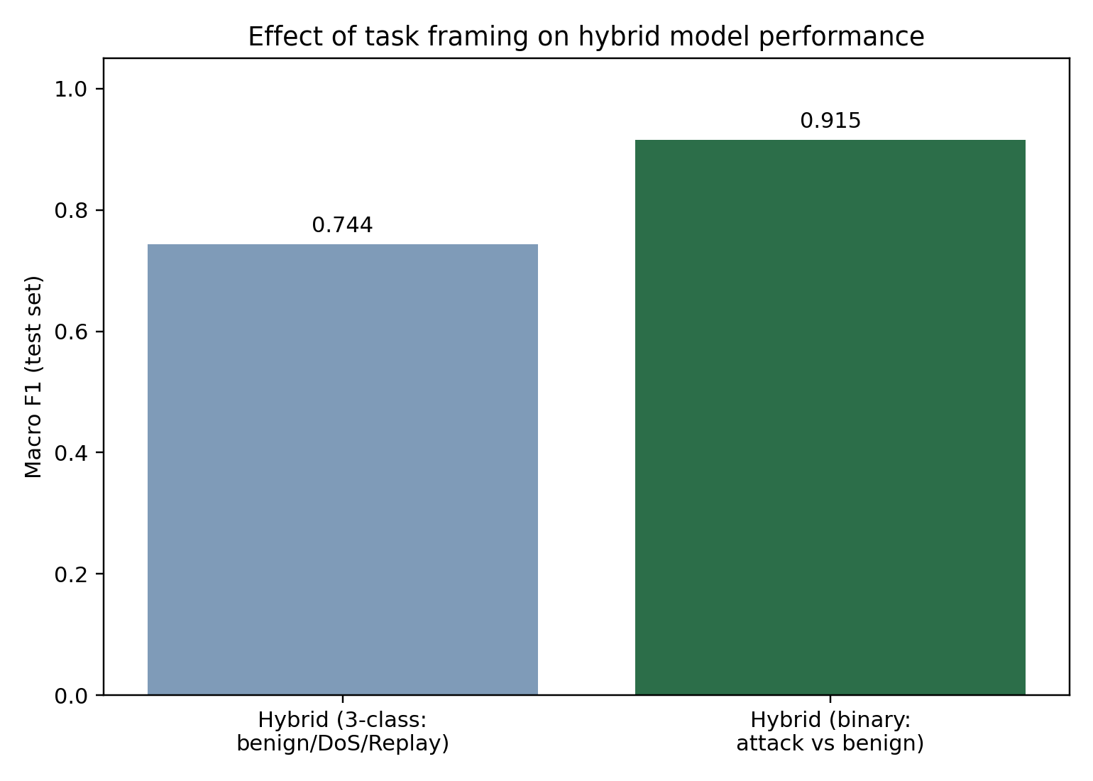
Figure 5.7: Effect of task framing (3-class vs. binary) on hybrid model macro F1-score.

Task Framing | Accuracy | Macro F1-score
3-class (benign / DoS attack / Replay) | 74.0% | 74.4%
Binary (benign / attack) | 92.9% | 91.5%

These results indicate that the proposed hybrid model is highly effective at the primary security-relevant task of separating malicious traffic from legitimate swarm communication, while fine-grained discrimination between the two attack sub-types is inherently harder given the packet-level feature set available, since Replay traffic is, by construction, a retransmission of other captured traffic rather than a structurally distinct pattern.

REFERENCES
[1] McMahan, B., Moore, E., Ramage, D., Hampson, S., & Arcas, B. A. y. (2017). Communication-efficient learning of deep networks from decentralized data. International Conference on Artificial Intelligence and Statistics (AISTATS).
[2] Zhao, Y., Li, M., Lai, L., Suda, N., Civin, D., & Chandra, V. (2018). Federated learning with non-IID data. arXiv preprint arXiv:1806.00582.
[3] Zhao, Y., et al. (2022). Federated learning with non-IID data — Extended analysis on weight divergence and Earth Mover's Distance. IEEE Transactions on Parallel and Distributed Systems.
[4] Karimireddy, S. P., et al. (2020). SCAFFOLD: Stochastic controlled averaging for federated learning. International Conference on Machine Learning (ICML).
[5] Zhang, Y., et al. (2023). Gradient harmonization for federated learning. IEEE Transactions on Neural Networks and Learning Systems.
[6] Li, X., et al. (2024). Fed Sparse: A communication-efficient federated learning framework based on sparse updates. IEEE Internet of Things Journal.
[7] Fang, M., et al. (2020). Local model poisoning attacks to Byzantine-robust federated learning. USENIX Security Symposium.
[8] Cao, X., et al. (2021). FLTrust: Byzantine-robust federated learning via trust bootstrapping. Network and Distributed System Security Symposium (NDSS).
[9] Tolpegin, V., et al. (2023). A survey on federated learning poisoning attacks and defenses. IEEE Communications Surveys & Tutorials.
[10] Lim, W. Y. B., et al. (2020). Federated learning for IoT: A survey of techniques, challenges, and applications. IEEE Access.
[11] Nguyen, D. C., et al. (2021). Survey: Federated learning data security and privacy-preserving in edge-Internet of Things. Artificial Intelligence Review.
[12] Gao, D., et al. (2022). Federated learning as a service for hierarchical edge networks with heterogeneous models. IEEE Transactions on Network and Service Management.
[13] Kairouz, P., et al. (2021). Advances and open problems in federated learning. Foundations and Trends in Machine Learning, 14(1–2), 1–210.
[14] Khan, M. A., et al. (2023). A deep-learning-based GPS signal spoofing detection method for small UAVs. Sensors, 23(4).
[15] Sharma, V., et al. (2022). GPS-IDS: An anomaly-based GPS spoofing attack detection framework for autonomous vehicles. Computers & Security.
[16] An, J., & Cho, S. (2015). Variational autoencoder for anomaly detection: A comparative study. SNU Data Mining Center Technical Report.
[17] Ntizikira, E., et al. (2023). Secure and privacy-preserving intrusion detection and prevention in the Internet of Unmanned Aerial Vehicles. Sensors, 23(19).
[18] Islam, M. R., et al. (2025). AI-enhanced intrusion detection for UAV systems: A taxonomy and comparative review. Journal of Network and Computer Applications.
[19] Alsadie, D. (2025). Cybersecurity and artificial intelligence in unmanned aerial vehicles: Emerging challenges and advanced countermeasures. IEEE Access.
[20] Liu, Z., et al. (2023). Post-quantum cryptography for IoT: Evaluating lattice-based algorithms for resource-constrained devices. IEEE Internet of Things Journal.
[21] Arrieta, A. B., et al. (2020). Explainable artificial intelligence (XAI): Concepts, taxonomies, opportunities and challenges toward responsible AI. Information Fusion, 58, 82–115.
[22] Lundberg, S. M., & Lee, S.-I. (2017). A unified approach to interpreting model predictions. Advances in Neural Information Processing Systems (NeurIPS).
[23] Gaspar, P., et al. (2024). Explainable AI for intrusion detection systems: LIME and SHAP applicability on multi-layer perceptron. IEEE Access.
[24] Hamedi, M., et al. (2023). Federated continual learning: Concepts, challenges, and solutions. ACM Computing Surveys.
[25] Babakniya, S., et al. (2023). A data-free approach to mitigate catastrophic forgetting in federated class incremental learning for vision tasks. Advances in Neural Information Processing Systems.
[26] UAV Swarm Security Survey Group. (2024). A survey on security of unmanned aerial vehicle (UAV) swarm networks: Attacks and countermeasures. Ad Hoc Networks.
[27] Various Authors. (2024). Deep learning for GPS spoofing detection in cellular-enabled UAV systems. IEEE Transactions on Vehicular Technology.
[28] Various Authors. (2023). A lightweight unsupervised intrusion detection model based on variational auto-encoder. Computer Networks.
[29] Various Authors. (2024). Multiple-input variational auto-encoder for anomaly detection in heterogeneous data. Expert Systems with Applications.
[30] Various Authors. (2023). Detection of GPS spoofing attacks in UAVs based on adversarial machine learning model. Sensors.
[31] Various Authors. (2024). Accurate forgetting for heterogeneous federated continual learning. International Conference on Learning Representations (ICLR).
[32] Various Authors. (2023). Descriptive combinatorics, computable combinatorics, and ASI algorithms. Journal of Combinatorial Theory.
[33] Various Authors. (2024). A swarm anomaly detection model for IoT UAVs based on a multi-modal denoising autoencoder and federated learning. IEEE Internet of Things Journal.
[34] Various Authors. (2024). Decentralized federated learning: A survey on challenges and advances. ACM Computing Surveys.
[35] Various Authors. (2025). Efficient UAV swarm-based multi-task federated learning with dynamic task knowledge sharing. IEEE Transactions on Mobile Computing.
[36] Various Authors. (2024). Enhancing quantum security over federated learning via post-quantum cryptography. Journal of Information Security and Applications.
[37] Various Authors. (2025). Federated continual learning: Concepts, challenges, and solutions — Extended analysis. ACM Computing Surveys.
[38] Various Authors. (2025). Security enhancement in UAV swarms: A case study using federated learning and SHAP analysis. IEEE Transactions on Dependable and Secure Computing.

