BMI CALCULATOR
Made by Sarim Hassan

BMI introduction
BMI is a measurement of a person's leanness or corpulence based on their height and weight, and is intended to quantify tissue mass. It is widely used as a general indicator of whether a person has a healthy body weight for their height. Specifically, the value obtained from the calculation of BMI is used to categorize whether a person is underweight, normal weight, overweight, or obese depending on what range the value falls between. These ranges of BMI vary based on factors such as region and age, and are sometimes further divided into subcategories such as severely underweight or very severely obese. Being overweight or underweight can have significant health effects, so while BMI is an imperfect measure of healthy body weight, it is a useful indicator of whether any additional testing or action is required. Refer to the table below to see the different categories based on BMI that are used by the calculator.

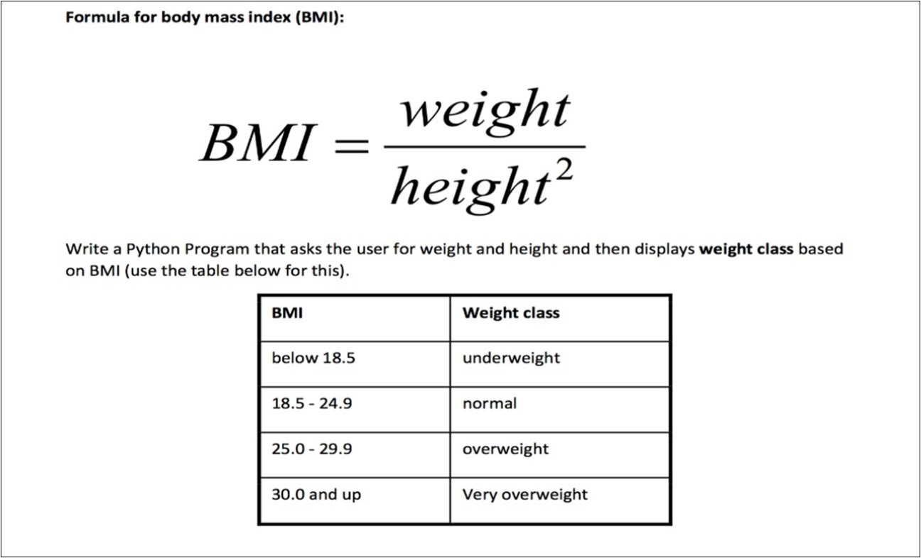
This Photo by Unknown Author is licensed under CC BY

PROJECT DESCRIPTION
It is a BMI calculator website which contain a Headi ng of B,I calculator and a calculation area where we have to enter the weight and the height to calculate the BMI score of the following data entered by the user it is a good thing whichn assist the user to calculate the BMI of hi Information

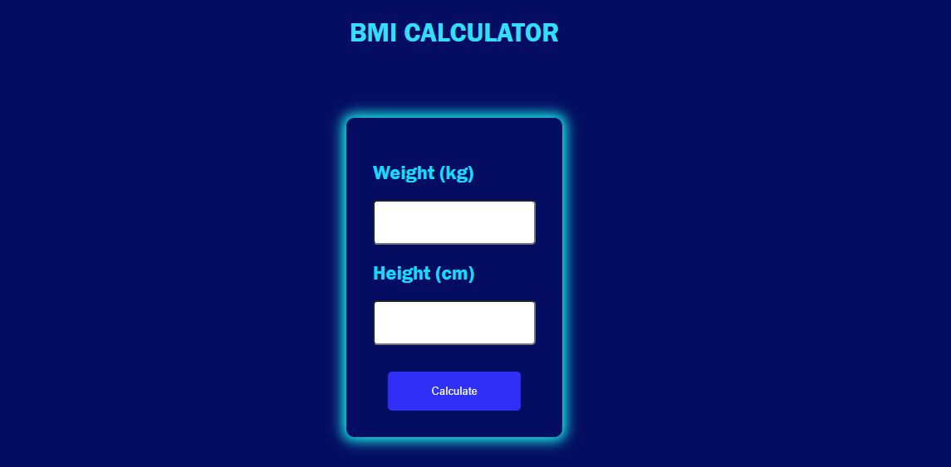

HOW IT WORKS
It works on the basic principle of calculating BMI of an information . it’s calculating performance is functionalized by using jawa script by using the formula for BMI weight/(height height) if we do not enter any one one pof them or all of the information it will give a message of please enter all the information.

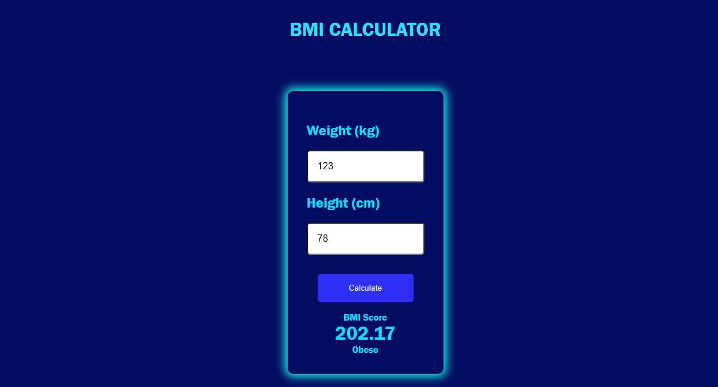

Git Hub Repository Link:
https://github.com/syedshahsarim15-ai/sarimgithubassigment.git

THANK YOU!

