**Azure Blob Implementation in Java via Console**

Step 1: Uploading a blob (.docx) via local Program

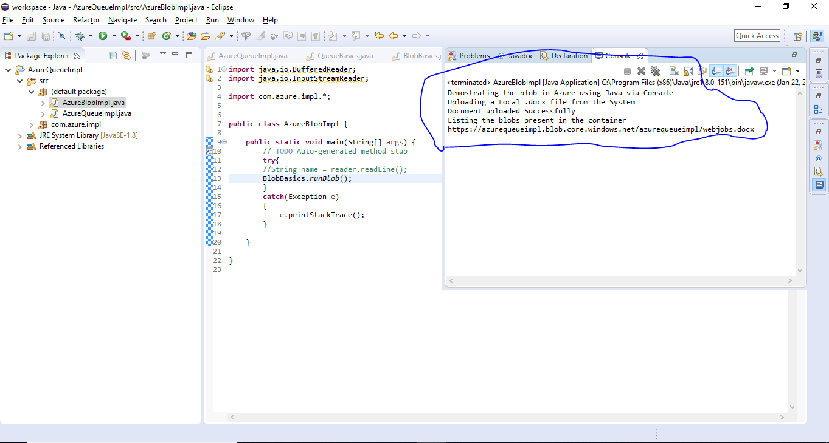

Step 2: Verifying from Portal

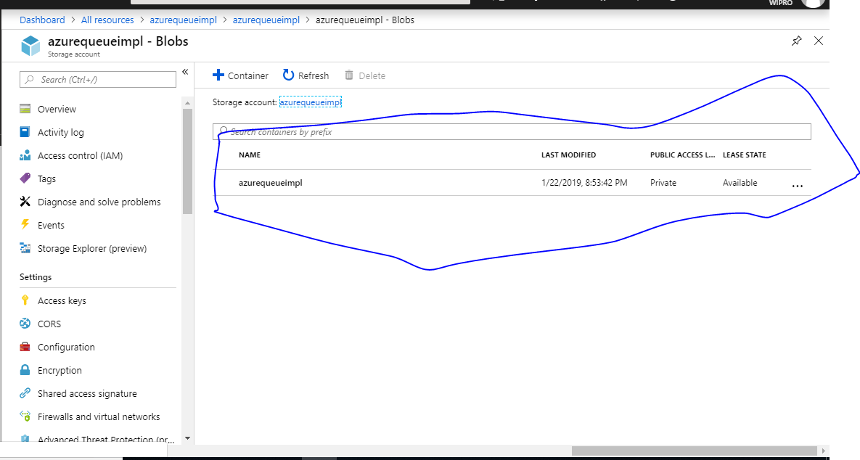

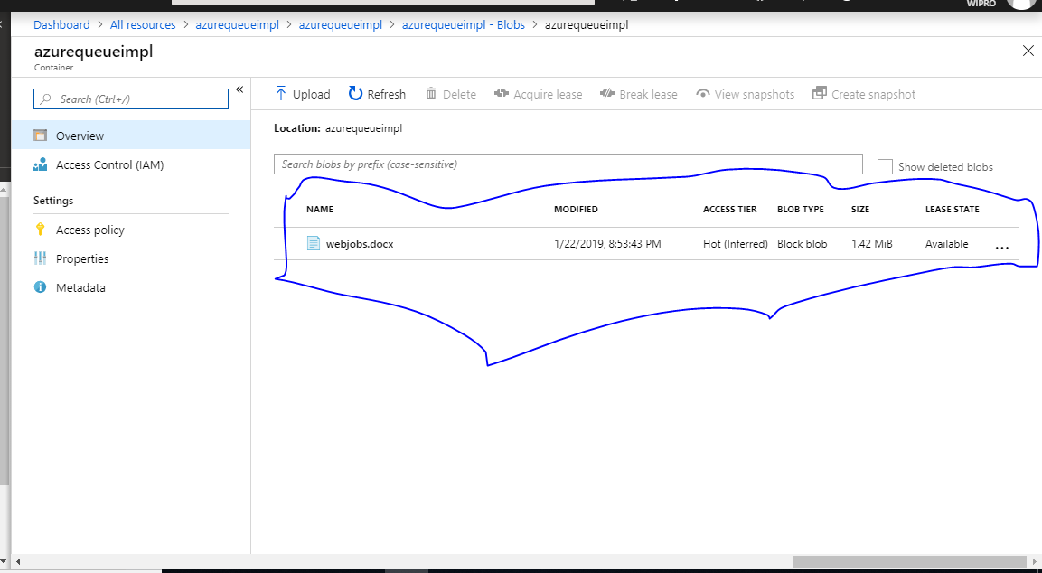

Step 3: Uploading few blob from Portal and verifying it via Java Program

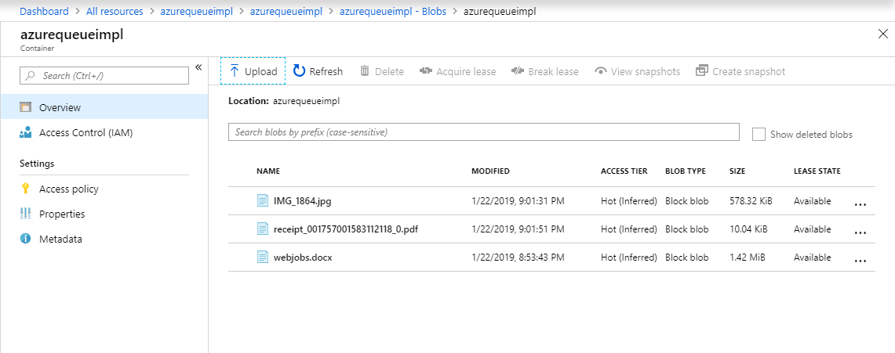

Listing all the blobs via Java Program:

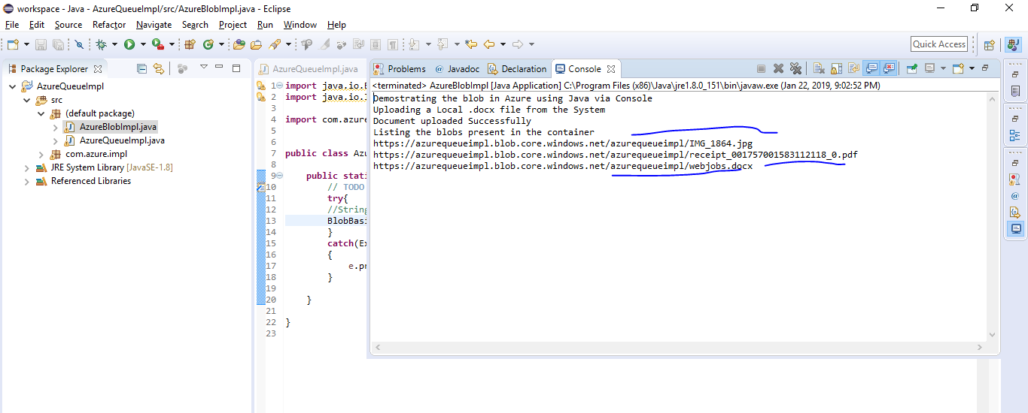

Here is the source code :

AzureBlobImpl.java

------------------------------

**import** java.io.BufferedReader;

**import** java.io.InputStreamReader;

**import** com.azure.impl.*;

**public** **class** AzureBlobImpl {

**public** **static** **void** main(String[] args) {

// **TODO** Auto-generated method stub

**try**{

//String name = reader.readLine();

BlobBasics.*runBlob*();

}

**catch**(Exception e)

{

e.printStackTrace();

}

}

}

BlobBasics.java

---------------------------------

**package** com.azure.impl;

**import** java.io.*;

**import** java.io.IOException;

**import** java.util.Scanner;

**import** java.io.InputStream;

**import** java.io.PrintWriter;

**import** java.io.StringWriter;

**import** java.net.URISyntaxException;

**import** java.security.InvalidKeyException;

**import** java.util.EnumSet;

**import** java.util.Properties;

**import** java.util.Scanner;

**import** java.util.UUID;

**import** com.microsoft.azure.storage.*;

**import** com.microsoft.azure.storage.blob.*;

**public** **class** BlobBasics {

**public** **static** **final** String ***storageConnectionString*** =

"DefaultEndpointsProtocol=https;" +

"AccountName=azurequeueimpl;" +

"AccountKey=6E86jjYlvjhjHuUr493ZpRtG2faC4uGY0Bev7nkIIfj+AzKqzKLqHMzxcgNq2SD6YizXow3AAB+dkqPiMDtA1A==";

**public** **static** **void** runBlob() **throws** Exception

{

**try**{

System.***out***.println("Demostrating the blob in Azure using Java via Console");

CloudStorageAccount storageAccount = CloudStorageAccount.*parse*(***storageConnectionString***);

CloudBlobClient blobClient = storageAccount.createCloudBlobClient();

CloudBlobContainer container = blobClient.getContainerReference("azurequeueimpl");

container.createIfNotExists();

System.***out***.println("Uploading a Local .docx file from the System");

**final** String filePath = "D:\\Azure\\webjobs.docx";

CloudBlockBlob blob = container.getBlockBlobReference("webjobs.docx");

File source = **new** File(filePath);

blob.upload(**new** FileInputStream(source), source.length());

System.***out***.println("Document uploaded Successfully");

System.***out***.println("Listing the blobs present in the container");

**for** (ListBlobItem blobItem : container.listBlobs()) {

System.***out***.println(blobItem.getUri());

}

}//end of try

**catch**(Exception e){

e.printStackTrace();

}//end of catch

}//end of method

}