Step 1: Creation of First VM with SQL Server Installed

Creation of resource group

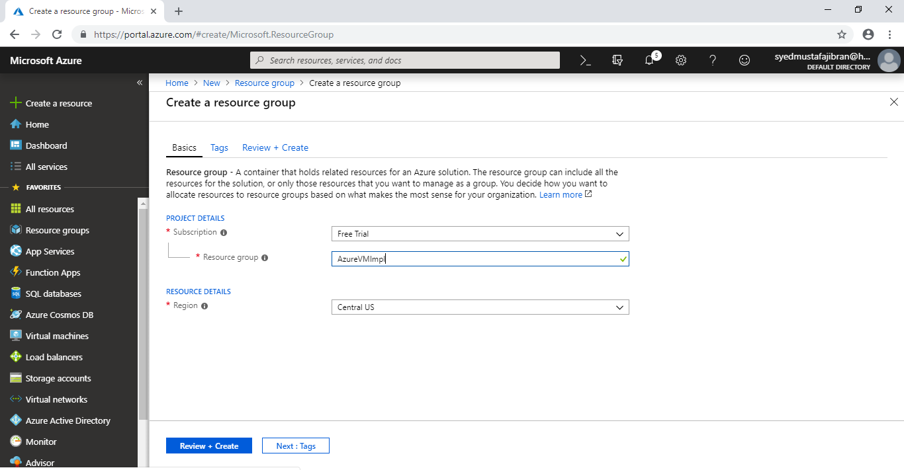

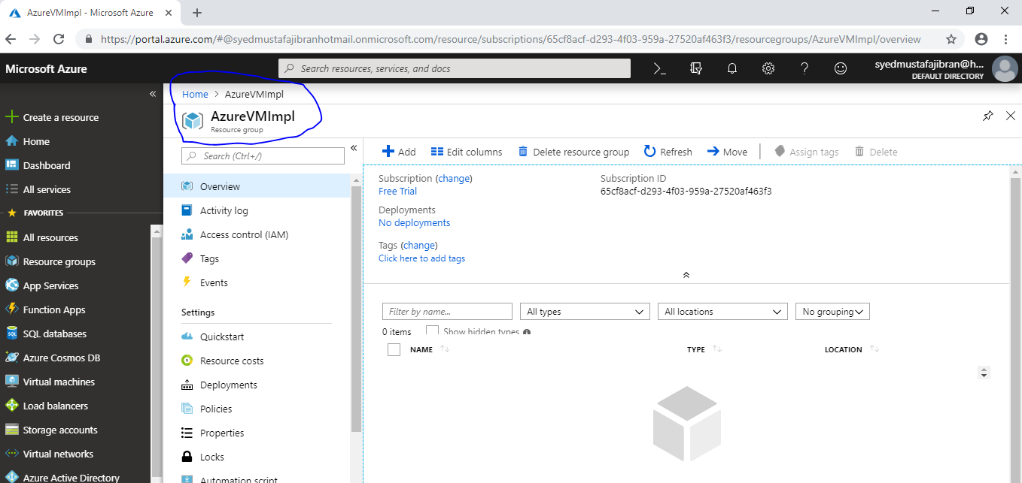

Step 2 : Creation of First Virtual Machine in above resource group from Market Space

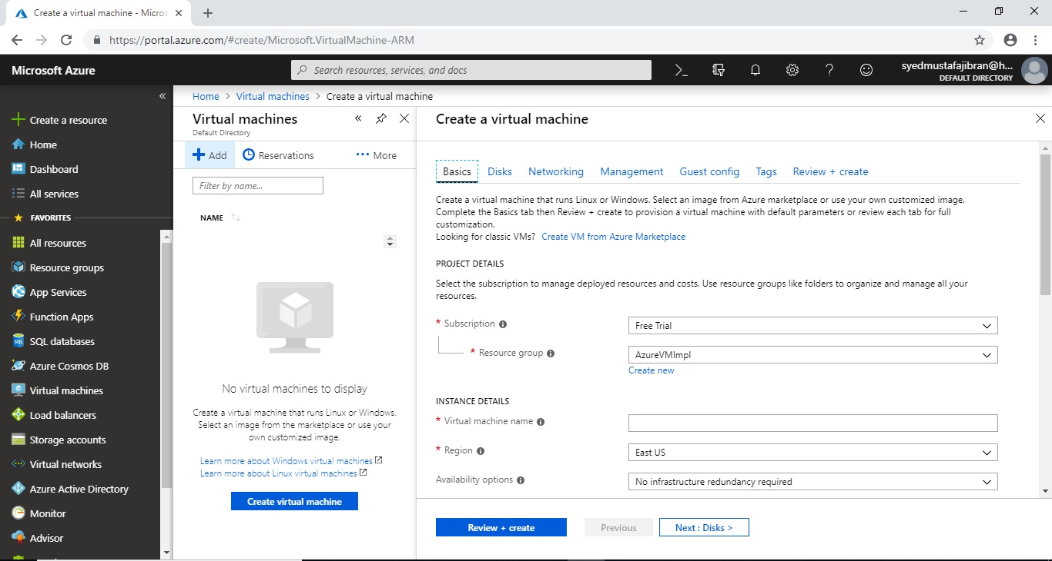

Creation of SQL Server VM with “Public” Connectivity

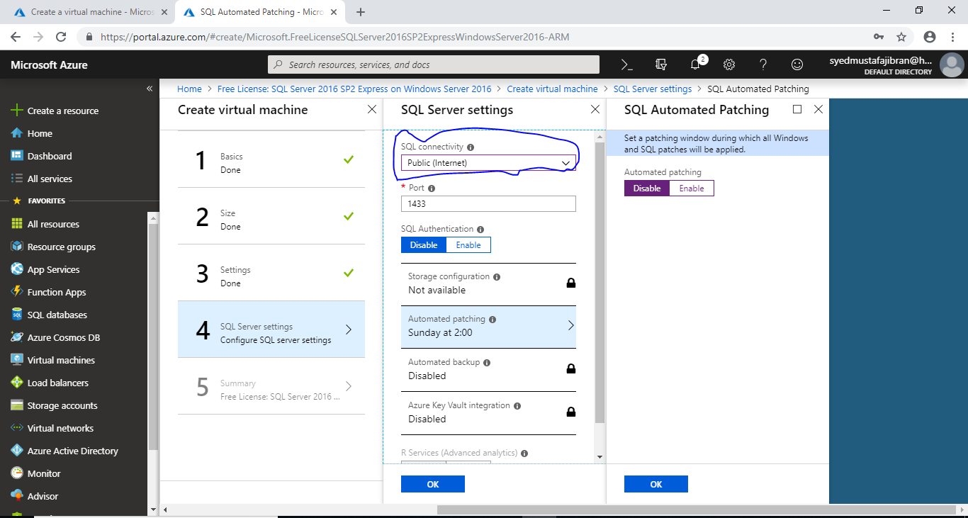

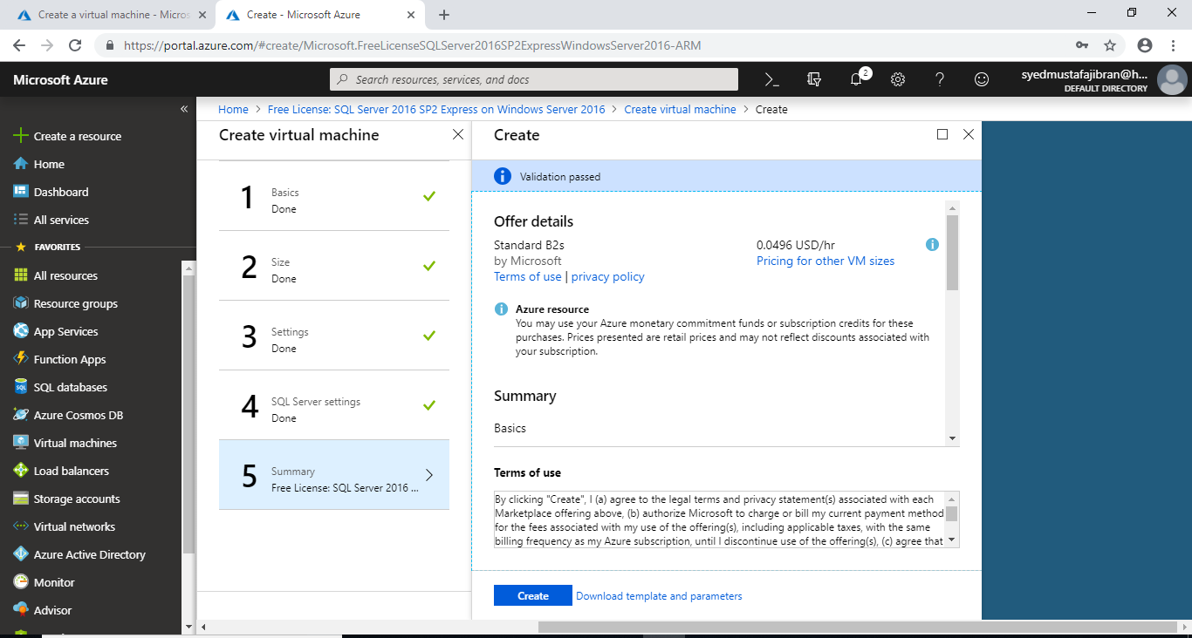

Step 3 : Creation of Second Virtual Machine in above resource group from Market Space

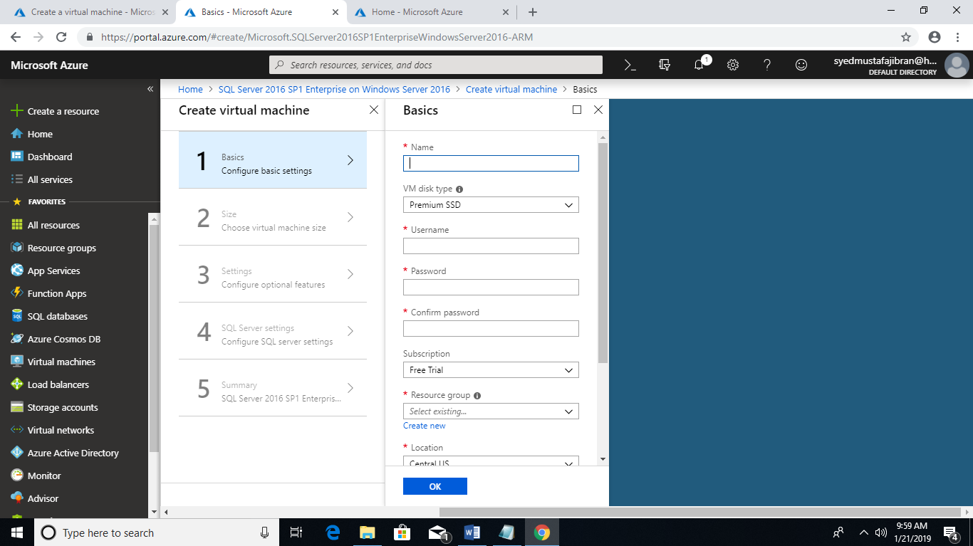

SQL Connectivity of SQLVM2 is Local (inside VM only)

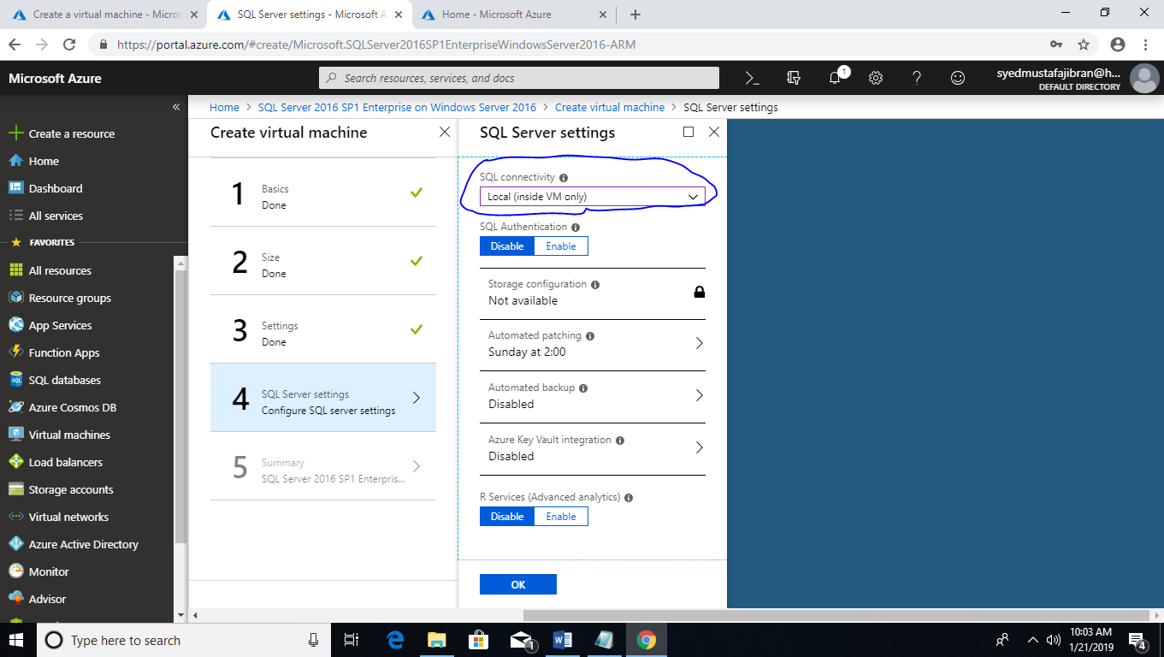

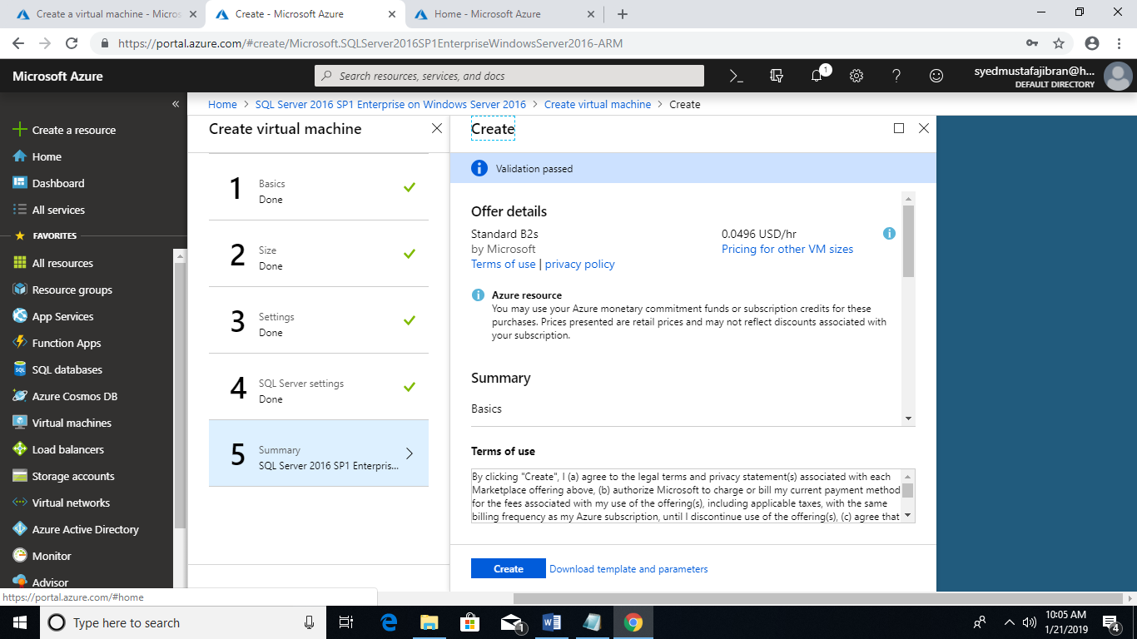

Second SQL VM 2 Snapshot

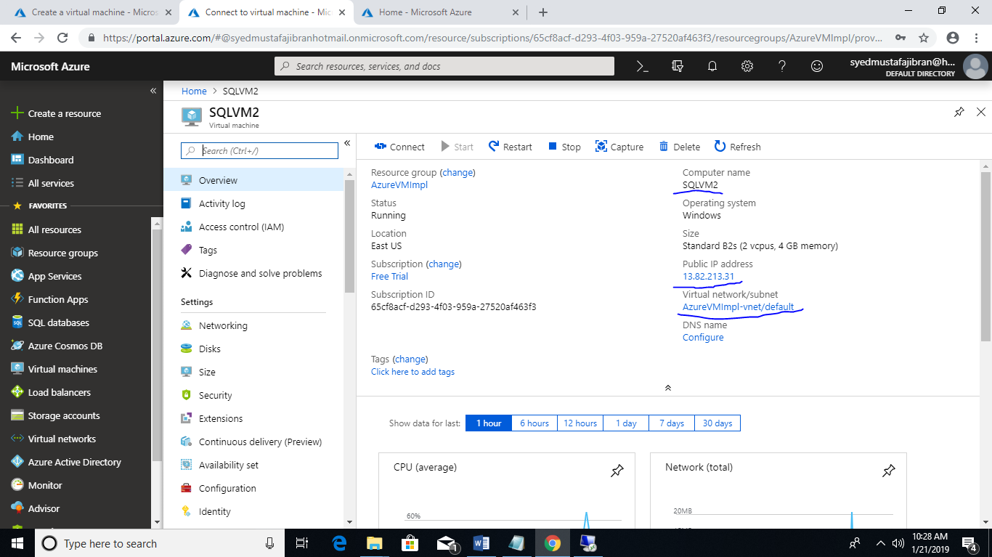

Public IP of Second SQL VM is : 13.82.213.31

First SQL VM Snapshot :

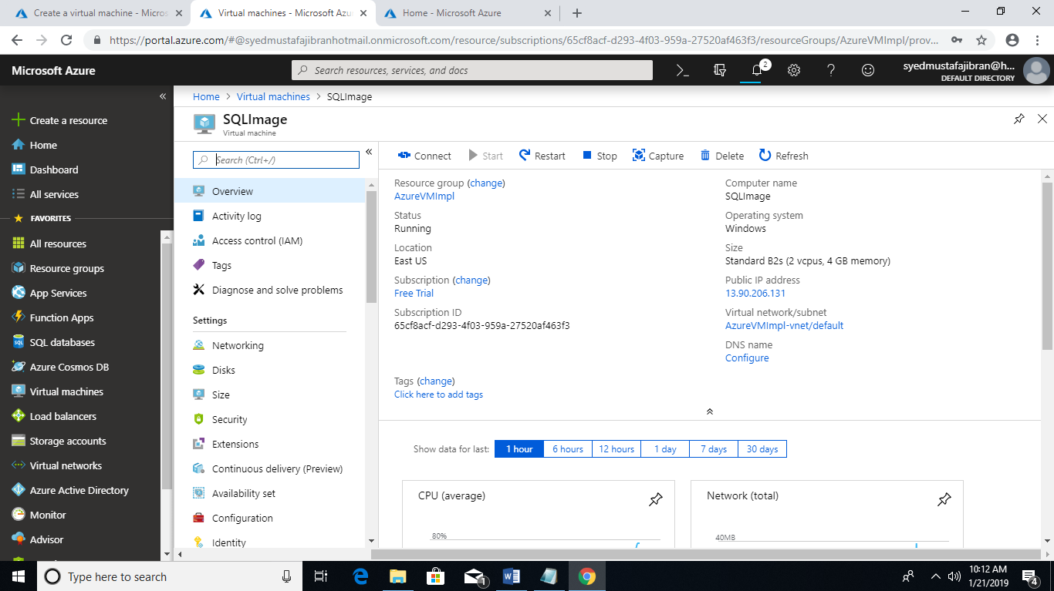

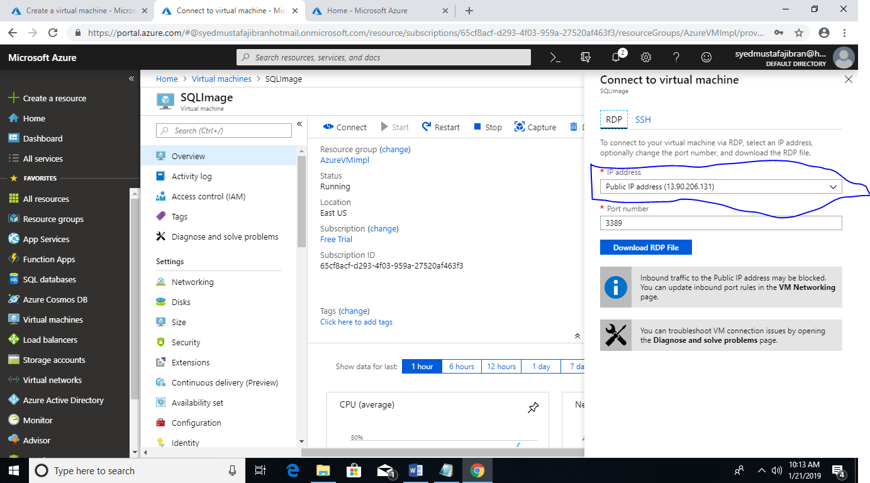

Public IP for First SQL VM is : 13.90.206.131

Step 5 : Verification of RDP Connection SQL VM 1 from Local System

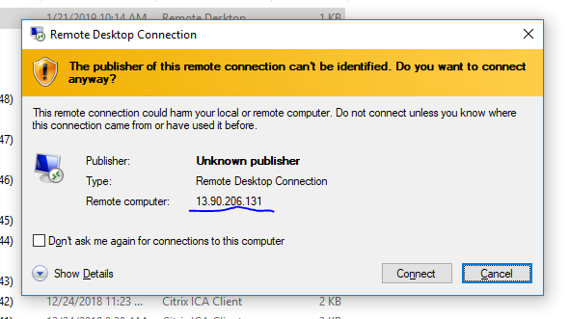

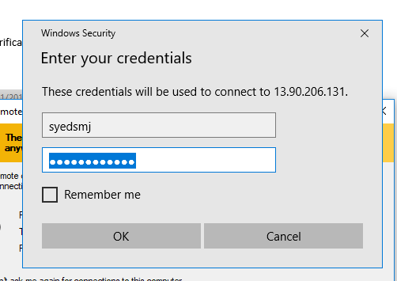

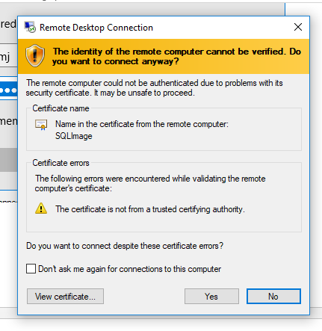

Able to launch SQL Server and able to connect to SQLImage DB

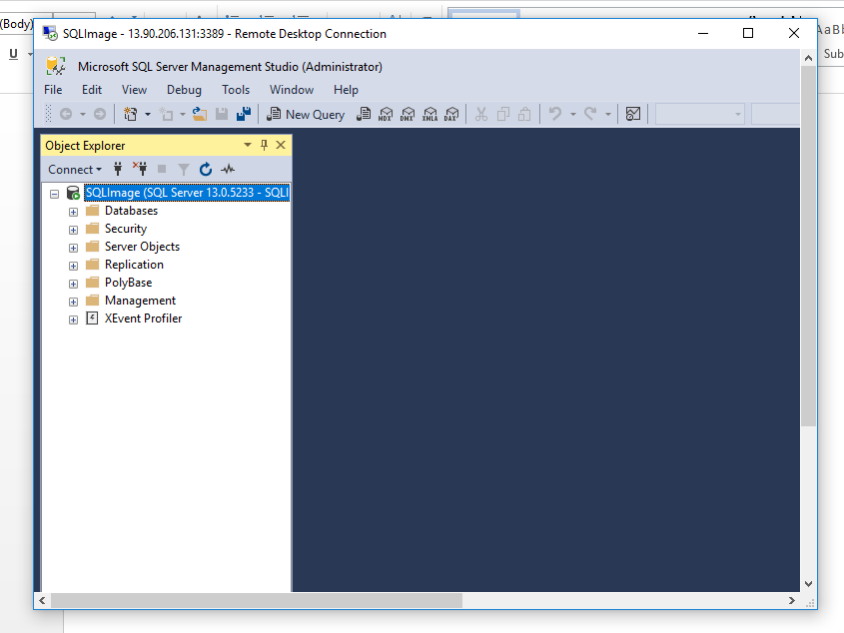

Step 6 : Verification of RDP Connection SQL VM 2 from Local System (It should not be allowed )

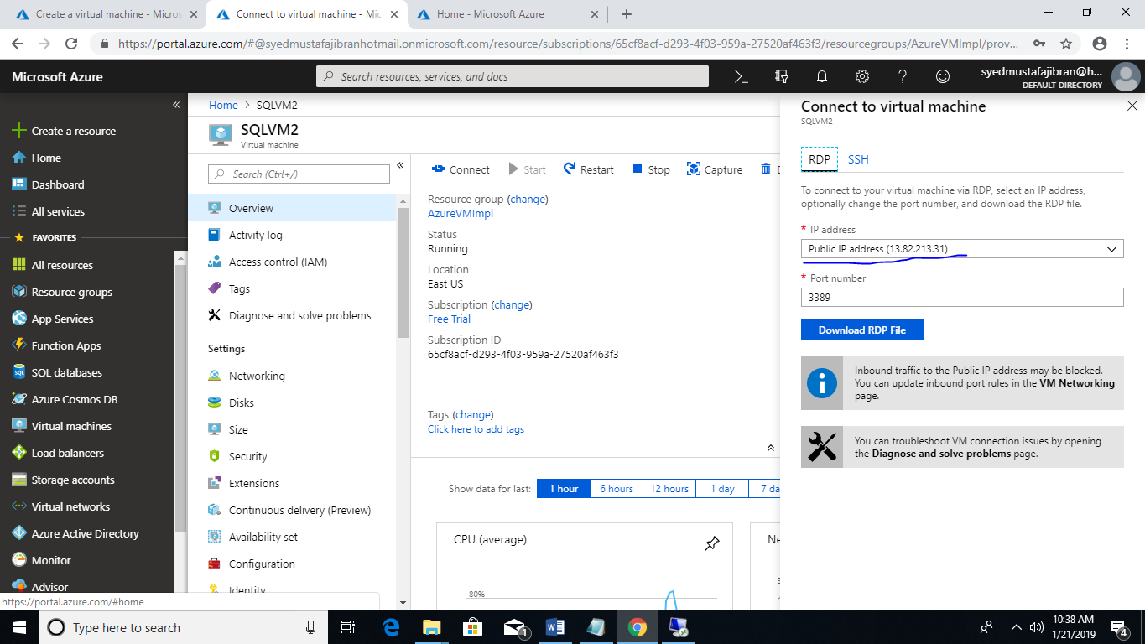

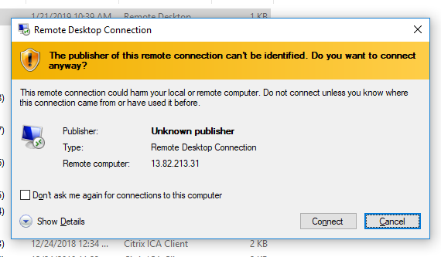

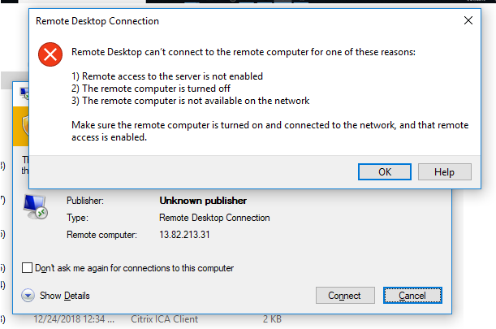

Step 7 : Verification of RDP Connection SQL VM 1 to SQL VM 2 (It should not be allowed )

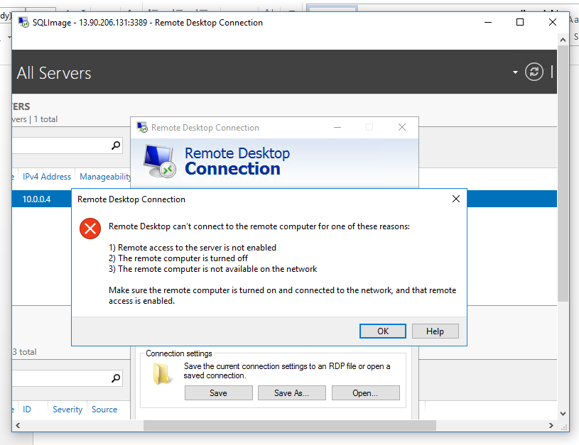

Step 8 : Verification of RDP Connection SQL VM 2 to SQL VM 1 (It should not be allowed )

1. Allowing RDP login in SQL VM 2

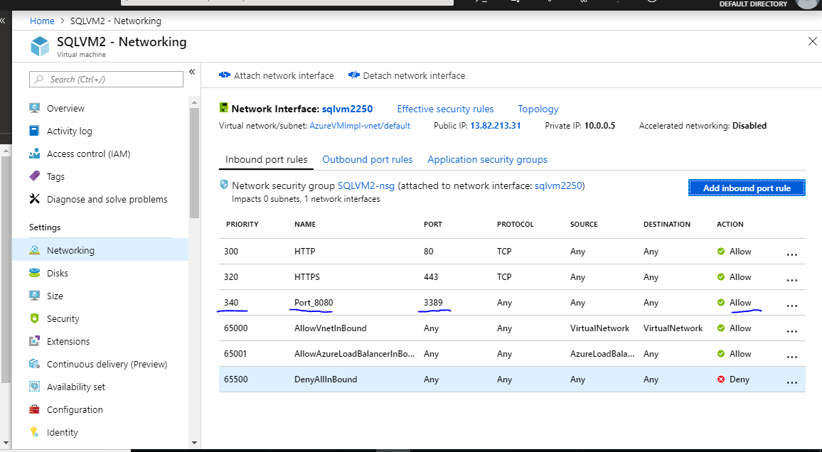

RDP into SQL VM 2 :

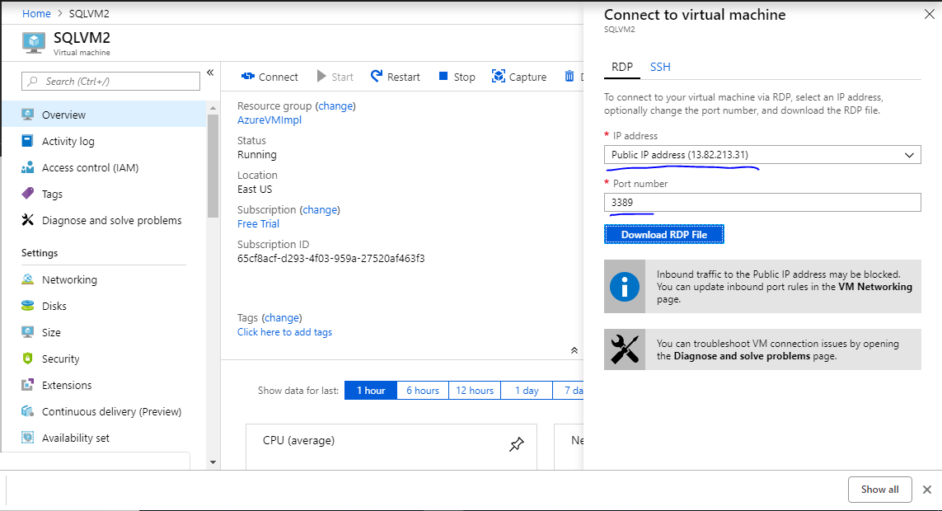

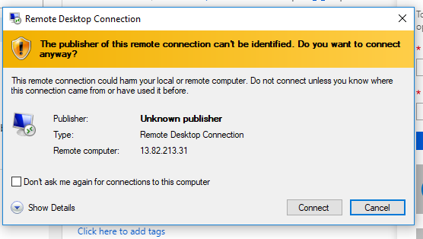

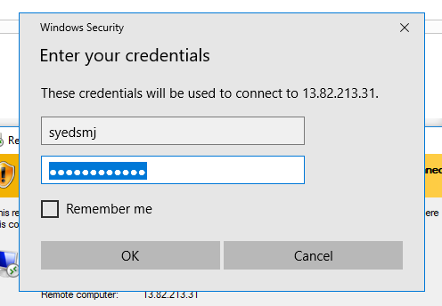

Step 9 : unable to connect SQL DB from SQL VM 1 due to Local access on SQL VM2 Server.

