How to Create user and Enable Password based Authentication in Ubuntu
Step:1 First connect the Available instance in MobaXterm, in Jump Server if the IP is white Listed in the Security groups of the instances.
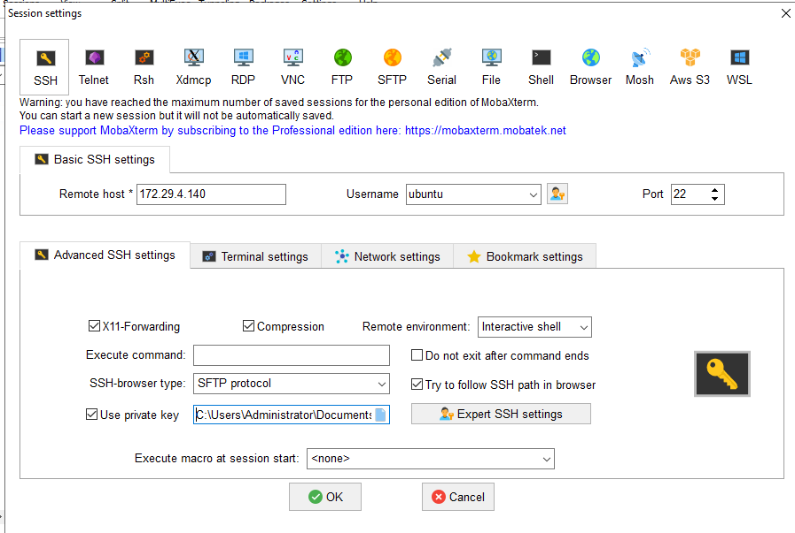
Here give the available IP Address of the Instance in Remote host and the Username in the Username Section (Mostly its default ubuntu for ubuntu machines) then enable the Use Private Key option and import the associated .pem file for the instance.
Once this is done you will be inside that machine
Step:2 We have To Enable the PasswordAuthentication in a sshd_config file
It’s best to be in the root user to avoid any confusions,
>> sudo -i this lets you in the root user
Then we have to edit this file which is in this directory /etc/ssh/sshd_config
>> vi /etc/ssh/sshd_config you can use nano too but vi is best for editing the files so that’s preferred
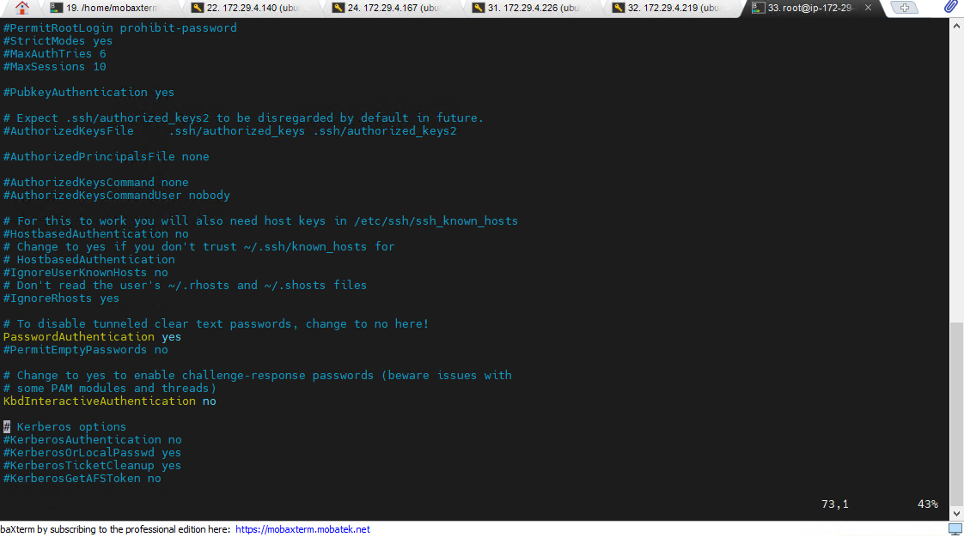
As you can see this file contents there is a term “PasswordAuthenication” check whether its “yes” or “no” if its “yes” and commented then uncomment it if its “no” then change to yes a we want Password based Authentication.
After changing it we have to also check if there is any mechanism which is overriding this value as “no”.
Just go inside that directory and check if there are any files in it for, example type this command
>> cd /etc/ssh/sshd_config.d/
you will find a file like this
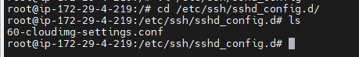
as you can see there is a file named “60-cloudimg-settings.conf” check in this file too, if there is any overriding over here.
type >>vi 60-cloudimg-settings.conf
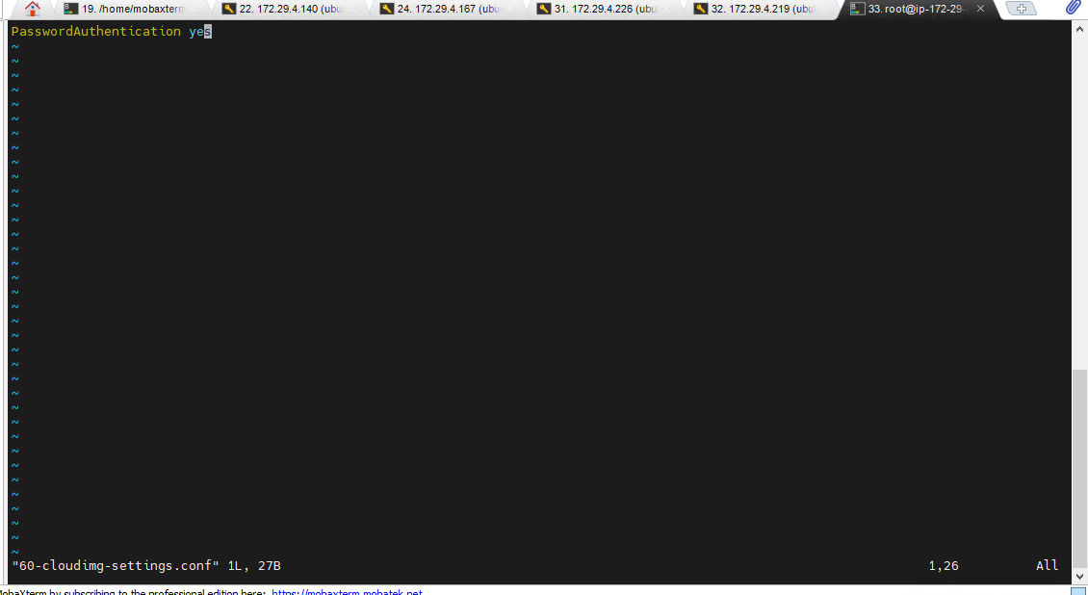
As you can see here the value was getting overridden, as we have already corrected the values as ‘yes’ its being shown as ‘yes’ here but it was ‘no’ so make sure its also kept as ‘yes’.
and then you are good to go.
Also after enabling this don’t forget to do a ssh restart that’s very important
>>systemctl restart ssh
to check the status of your changes you can also type
>>systemctl status ssh
Step:3 Changing the password of the ubuntu user
For changing the password we have to type this command
>>passwd ubuntu here “ubuntu” is the username
After changing the password then you are good to go
you can then test it on another session if its working or not
just type
>> ssh ubuntu@private_ip_address

