Sample 1
addi x1,x0,5
add x2,x1,x1
add x3,x1,x1
add x4,x1,x1
sw x3,0(x0)
lw x5,0(x0)
add x4,x5,x5
lw x2,0(x0)
sw x2,2(x0)

00500093
00108133
001081b3
00108233
00302023
00002283
00528233
00002103
00202123

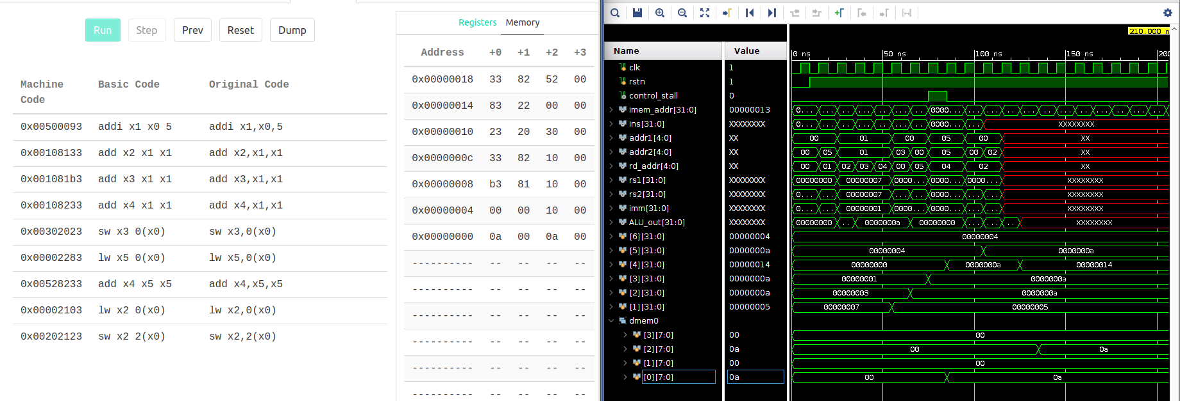

Sample 2
addi x0, x0,10 //nothing should happen
addi x1, x0, 5
addi x2, x0, 1
addi x3, x0, 2
addi x4, x0, 1
add x5, x1, x3
sw x5, 0(x0)
lw x7, 0(x0) //use after load. STALL
sub x1, x7, x1
add x1,x1,x2// rd used as rs1 handled
add x1,x1,x3
add x1,x1,x4
lw x1, 0(x0) //mem2mem transfer
sw x1, 1(x0)

00a00013
00500093
00100113
00200193
00100213
003082b3
00502023
00002383
401380b3
002080b3
003080b3
004080b3
00002083
001020a3

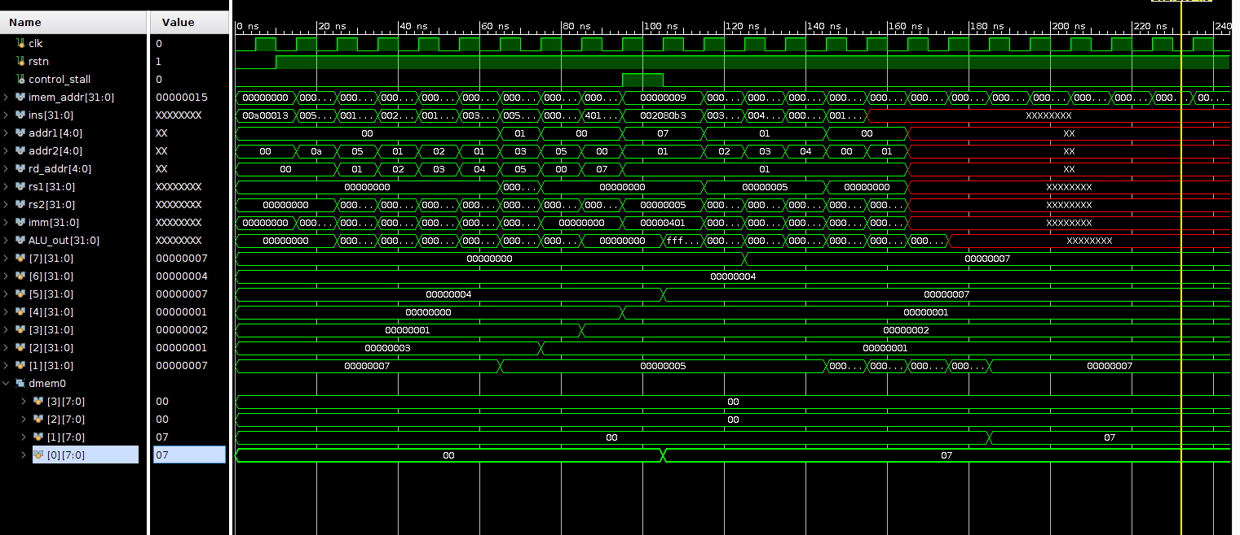

Sample 3

addi x1, x0, -431
sw x1, 0(x0)
lb x2, 1(x0)
lbu x3,1(x0)
lh x4, 2(x0)
lhu x5, 2(x0)

e5100093
00102023
00100103
00104183
00201203
00205283

