
April 22, 2026 at 3:00 PM

PROJECT | Evaluating the Claim that Preregistration and Registered Reports Restrict Exploratory Research.pdf
OWNER | Ashleigh Blersch
TARGET VENUE | —
PROJECT ID | 7FZL-cNEuO6AhhjYYDlWJxZfPpQ
FILE ID | 3beb58b1-5dda-4aa1-99e7-1aee48e82886
ANALYSIS OVERVIEW
20  TOTAL PAGES | 1  PAGES WITH ISSUES | 1  TOTAL ISSUES

Issue Summary
Analysis Type | Needs review | Suggestion | Total Analyzed
Figure Integrity | – | – | 1 figures
Panel Analysis | – | – | 4 panels
Statistical Checks | – | – | 0 statistics
Table Integrity | – | 0 duplications
AI Text Detection | – | – | 6 paragraphs
Plagiarism Detection | 1 | – | 6 paragraphs
Reference Validation | – | – | 0 references

PAGE 1 • 1 issue
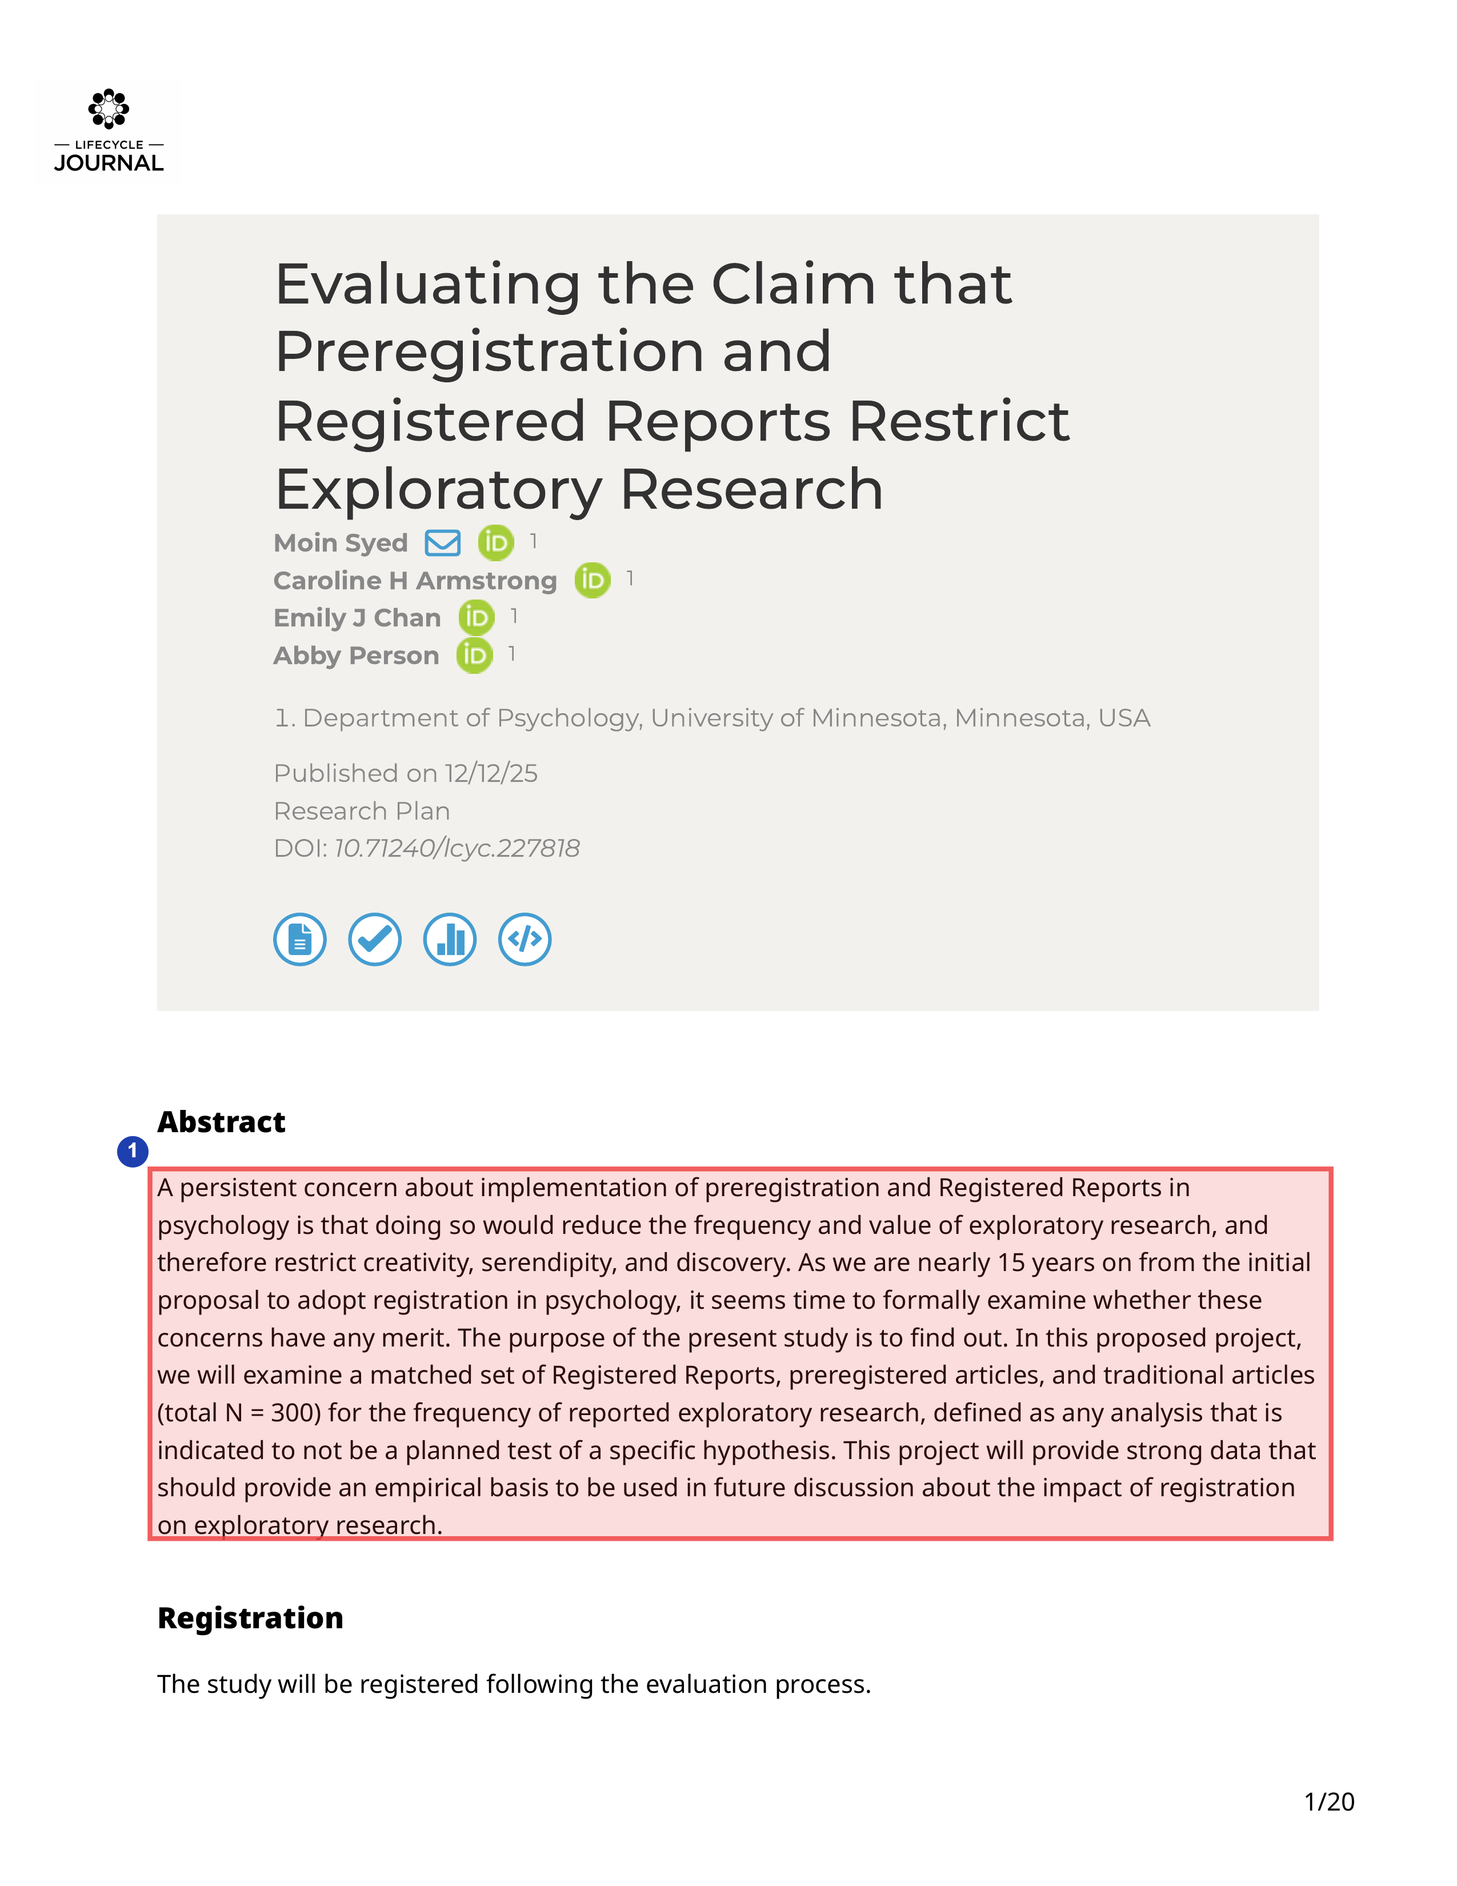
PLAGIARISM DETECTION
(1) NEEDS REVIEW
Plagiarism risk
Potential overlap across 99.6% of the paragraph.
"A persistent concern about implementation of preregistration and Registered Reports in psychology is that doing so would reduce the frequency and value of exploratory research, and therefore restrict creativity, serendipity, and discovery. As we are nearly 15 years on from the initial proposal to adopt registration in psychology, it seems time to formally examine whether these concerns have any merit. The purpose of the present study is to find out. In this proposed project, we will examine a matched set of Registered Reports, preregistered articles, and traditional articles (total N = 300 ) for the frequency of reported exploratory research, defined as any analysis that is indicated to not be a planned test of a specific hypothesis. This project will provide strong data that should provide an empirical basis to be used in future discussion about the impact of registration on exploratory research."
PLAGIARIZED | 99.6%
Matching Sources (1)
https://www.researchgate.net/publication/398645328_REvaluating_the_Claim_that_Preregistration_and_Registered_Reports_Restrict_Exploratory_Research

Additional Findings
The following findings are not linked to specific PDF pages.
Author Verification
FEEDBACK
Emily J Chan
Author verified successfully
VERIFICATION SCORE | 100%
AFFILIATION | Department of Psychology, University of Minnesota, Minnesota, USA
VERIFICATION DETAILS
Author Verification Summary
Name Matches:
• The queried author is Emily J Chan. Search results consistently identify Emily J. Chan (with middle initial J.), who uses the email jone4982@umn.edu and was formerly known as Emily A. Jones . The first name Emily is an exact match or common variation, and the last name Chan matches exactly across multiple sources .
Affiliation Matches:
• The queried affiliation is Department of Psychology, University of Minnesota, Minnesota, USA. Emily J. Chan is explicitly affiliated with the University of Minnesota, including the Department of Psychology (e.g., Social Interaction Lab in Psychology, umn.edu email, Psychology fellowships) . She is a current PhD student in social psychology and has held formal positions like Graduate Summer Research Fellowship and Department of Psychology Fellowship . A publication lists her with the Institute of Child Development at University of Minnesota, which falls under the broader university psychology ecosystem . This confirms formal employment/study affiliation, not mere informal engagement.
Confidence Rationale:
• High confidence (1.0) due to exact last name match, first name consistency, verified umn.edu email, CVs hosted on psych.umn.edu sites, Google Scholar verification, and lab membership . No conflicting authors with the same exact last name Chan at this institution; prior name (Jones) is explicitly linked to Chan .
Plausibility: Not assessed as no specific paper is provided in the query.
Sources:
[1] https://scholar.google.com/citations?user=hiyzzfAAAAAJ&hl=en
[2] https://socialinteractionlab.psych.umn.edu/sites/socialinteractionlab.psych.umn.edu/files/2023-12/emilyjones_cv_9-2023.docx
[3] https://pubmed.ncbi.nlm.nih.gov/38949674/
[4] https://bsky.app/profile/emilyjchan.bsky.social
[5] https://socialinteractionlab.psych.umn.edu/sites/socialinteractionlab.psych.umn.edu/files/2025-10/ejchan_cv_10-2025.docx.pdf
[6] https://ugresearch.umn.edu/presentation-opportunities/spring-symposium/presenters-2024/emily-chan
[7] https://socialinteractionlab.psych.umn.edu/people/lab-members
FEEDBACK
Caroline H Armstrong
Author verified successfully
VERIFICATION SCORE | 95%
AFFILIATION | Department of Psychology, University of Minnesota, Minnesota, USA
VERIFICATION DETAILS
Name Verification: The author name "Caroline H Armstrong" is strongly supported by the search results. The first name "Caroline" and last name "Armstrong" are exact matches across multiple sources . The middle initial "H" is also present in several key sources .
Affiliation Verification: Caroline H Armstrong is confirmed to have a strong affiliation with the Department of Psychology at the University of Minnesota. Multiple sources document this connection:
• She is listed as a contributor to the "Handbook of Body Image-Related Measures" with affiliation to the Department of Psychology, University of Minnesota .
• She appears in the University of Minnesota College of Liberal Arts directory as a PhD student in the Psychology department .
• She is listed among graduate students in the Psychology department at the College of Liberal Arts .
• Her Google Scholar profile indicates affiliation with the University of Minnesota and lists relevant publications .
Overall Assessment: All verifiable information is consistent and corroborates the author's identity and affiliation. The multiple independent sources (university directories, publisher information, and a Google Scholar profile) provide a high degree of certainty. The high confidence score is justified.
Sources:
[1] https://www.cambridge.org/core/books/handbook-of-body-imagerelated-measures/contributors/D76101A7F6BDA4042C0B9EC5F4FFC4E3
[2] https://cla.umn.edu/about/directory/profile/armst874
[3] https://societyforpsychotherapy.org/wp-content/uploads/2018/11/2008-Psychotherapy-Bulletin-Volume-43-Number-3.pdf
[4] https://scholar.google.com/citations?user=ignoB7oAAAAJ&hl=en
[5] https://pmc.ncbi.nlm.nih.gov/articles/PMC11846683/
[6] https://cla.umn.edu/psychology/people/graduate-students
FEEDBACK
Abby Person
Author verified successfully
VERIFICATION SCORE | 100%
AFFILIATION | Department of Psychology, University of Minnesota, Minnesota, USA
VERIFICATION DETAILS
Author Verification Summary
Name Matches:
• The first name Abby is an exact match.
• The last name Person is an exact match across all sources.
Affiliation Matches:
• Multiple sources confirm Abby Person's affiliation with the Department of Psychology, University of Minnesota:
• CV lists education (BA Psychology, 2017-2021), research roles (e.g., Stress and Trauma Research Lab, 2018-2021), teaching (PSY 1001 TA, 2020-2021), and contact perso204@umn.edu.
• Google Scholar profile: "Psychology, University of Minnesota".
• Social Interaction Lab member with CV link.
• Listed as second-year PhD student in Social Psychology.
• Department graduate student directory: "Person, Abby, Social".
Confidence Rationale: Perfect matches on exact last name "Person" and first name "Abby" (English origin, no variation needed). Strong, ongoing affiliation as PhD student and lab member, exceeding formal employment/study criteria. No conflicting information; sources from university sites and CV indicate high reliability.
Sources:
[1] https://socialinteractionlab.psych.umn.edu/sites/socialinteractionlab.psych.umn.edu/files/2022-10/Person_CV_9.19.22.pdf
[2] https://scholar.google.com/citations?user=UVsxmXEAAAAJ&hl=en
[3] https://socialinteractionlab.psych.umn.edu
[4] https://cla.umn.edu/psychology/news-events/story/psychologys-2024-nsf-graduate-research-fellowship-program-grfp-recipients
[5] https://socialinteractionlab.psych.umn.edu/people/lab-members
[6] https://cla.umn.edu/psychology/people/graduate-students
FEEDBACK
Moin Syed
Author verified successfully
VERIFICATION SCORE | 100%
AFFILIATION | Department of Psychology, University of Minnesota, Minnesota, USA
VERIFICATION DETAILS
Author Verification Summary
Name Match:
• The first name Moin is an exact match across all sources.
• The last name Syed is an exact match across all sources.
Affiliation Match:
• Multiple sources confirm Moin Syed is a Professor (or McKnight Presidential Endowed Professor) in the Department of Psychology at the University of Minnesota.
• University of Minnesota websites explicitly list him in the Department of Psychology.
• His CV confirms current position as Professor in the Department of Psychology, University of Minnesota Twin Cities (2023-present).
• Google Scholar profile lists him as Professor of Psychology, University of Minnesota.
Confidence Assessment:
• Confidence: 1.0 - Overwhelming evidence from primary sources (university pages, CV, Google Scholar) confirms exact name match and current employment in the specified department and institution. No conflicting information or multiple authors with the same name identified.
Overall Assessment:
• Perfect match across all criteria. Moin Syed is definitively affiliated with the Department of Psychology, University of Minnesota.
Sources:
[1] https://metascience.info/speakers/syed/
[2] https://cla.umn.edu/psychology/news-events/profile/moin-syed
[3] https://cla.umn.edu/about/directory/profile/moin
[4] https://about.citiprogram.org/authors/moin-syed-phd/
[5] https://www.fourbeers.com/guests/moin
[6] https://docs.google.com/document/d/1eGtccGz_RVpnvEiyWyq9joM6RvCOx8ukquzd2v45b3o/edit
[7] https://scholar.google.com/citations?user=mshMvCwAAAAJ&hl=en

— End of Report —
This report is provided for informational purposes. Please review all findings carefully.

