High Levels of Reporting of Exploratory Research in
Registered Reports and Preregistered Articles

Moin Syed, Caroline H. Armstrong, Emily J. Chan, and Abby I. Person
Department of Psychology, University of Minnesota

This is an Outcomes Report of the Research Plan:
Evaluating the Claim that Preregistration and Registered Reports
Restrict Exploratory Research
https://osf.io/4vbtq/

Submission for Lifecycle Journal

Version Date: September 1, 2026

Declarations

Funding: No specific funding was received in support of this research. A small stipend was provided by the Center for Open Science for submitting the research plan and this outcome report prior to specified deadlines.

Open data: All data, code, materials, and preregistration are openly available at https://osf.io/4vbtq/

Conflicts of interest: None to declare

Ethics: This is an archival study of published research and does not involve human subjects.

GenAI: No Generative AI or LLMs were used by the authors in preparation of this manuscript. PaperWizard and ReviewerZero were two AI-based evaluation services used by Lifecycle Journal, and the manuscript was revised based on the feedback provided.

Address correspondence to Moin Syed, moin@umn.edu
Abstract

A persistent concern about implementation of preregistration and Registered Reports in psychology is that doing so would reduce the frequency and value of exploratory research. As we are nearly 15 years on from the initial proposal to adopt registration in psychology, it seems time to formally examine whether these concerns have any merit. The purpose of the present preregistered study was to examine the frequency of reports of exploratory research in registered and non-registered articles. We replicated and extended a study by O’Mahony (2023) by examining a matched set of Registered Reports, preregistered articles, and traditional articles (total N = 300) from 30 psychology journals for the frequency of reported exploratory research, defined as any analysis that is indicated to be exploratory in nature or that is indicated to not be a planned test of a specific hypothesis. Across three different indicators, the results strongly supported the hypotheses that Registered Reports and preregistered articles would include more exploratory research than traditional articles. There was only weak evidence for the hypothesis that Registered Reports would contain greater reporting of exploratory research than preregistered articles. Exploratory analyses examined variations by journal, journal policies, and change over time, but found little of note. The results from this study establish an empirical basis to be used in future discussion about the impact of registration on the reporting of exploratory research.

Keywords: exploratory research, preregistration, registered reports, metascience, open science

Psychology’s replication crisis has led to a host of new policies and practices meant to improve the state of our science (Munafò et al., 2017). A practice that is central to the reform movement is preregistration, which involves creating a supposedly accessible and unalterable record of a study plan prior to collecting data and/or conducting analyses (Nosek et al., 2018). Rooted in the clinical trial registry previously developed for medical research (Boutron et al., 2016), preregistration is a practice that supports transparency about researchers’ plans, and facilitates comparisons between how those plans correspond to what they actually report (Claesen et al., 2021; Willroth & Atherton, 2024). An early and persistent concern about widescale implementation of preregistration in psychology is that doing so would reduce the frequency and value of exploratory work, and therefore restrict creativity, serendipity, and discovery (Goldin-Meadow, 2016; Scott, 2013). As we are nearly 15 years on from the initial proposal to adopt preregistration in psychology, it seems time to formally examine whether the concern about preregistration restricting exploratory work has any merit. Accordingly, the purpose of the present study is to examine the frequency of reports of exploratory research in registered and non-registered articles.

Fallout from the Confirmatory/Exploratory Divide

The function that preregistration is meant to serve is not always clear or consistent (Lakens, 2019). Resolving debates about the function of preregistration is outside of the scope of the current project, as are debates about the utility of preregistration (see Lakens, 2019; Syed, 2024; Szollosi et al., 2020 for a discussion of these issues). An early prominent argument for preregistration is that it allows for a clearer separation between confirmatory analyses, or hypotheses generated prior to the study, and exploratory analyses, or analyses for which there were no prior hypotheses (Wagenmakers et al., 2012). This framing was in direct response to concerns about questionable research practices (or p-hacking, researcher degrees of freedom, garden of forking paths; Gelman & Loken, 2013; Head et al., 2015; Simmons et al., 2011), in which researchers fail to disclose all of the analyses that were conducted other than the statistically significant results presented in their papers, as well as HARKing (hypothesizing after results are known; Kerr, 1998), in which researchers reframe exploratory findings as though they were confirmatory.

The distinction between confirmatory and exploratory is not always so clear in practice (Szollosi & Donkin, 2021; Wagenmakers et al., 2012). Part of the problem is that there is not a clear or consistent definition of what constitutes exploratory research. Indeed, this is an active area of discussion (Feest & Devezer, 2025). Lack of clarity is partially related to the fact that confirmatory/exploratory forms a continuum of potential data analytic approaches (Wagenmakers et al., 2012). Accordingly, many have moved away from emphasizing the distinction in the context of preregistration in favor of a distinction between data-independent and data-dependent decision-making (e.g., Srivastava, 2018). Nevertheless, the confirmatory/exploratory distinction was prominent as preregistration was gaining momentum. Despite proponents of preregistration arguing to the contrary (Chambers, 2013; Wagenmakers et al., 2012), there were quickly concerns expressed that preregistration would both restrict and devalue exploratory research, with exploratory in this context meaning any analysis that is indicated to not be a planned test of a specific hypothesis. The message about the utility of preregistration was seemingly taken by many to mean that only confirmatory research via preregistration was research worth doing.

Registered Reports are a more restrictive version of preregistration that embeds the practice into the process of peer review (Chambers, 2013), and similar concerns about the format restricting exploration have been made (see Besançon et al., 2021). The review process for Registered Reports is separated into two distinct sections: Stage 1, consisting of the Introduction, Method, and Planned Analyses, which are prepared prior to executing the study; and Stage 2, consisting of the previous sections plus the Results and Discussion, submitted for review following completion of the study. Review platforms make acceptance decisions based on the Stage 1 manuscript and review process, addressing the question: will this study produce worthwhile knowledge, regardless of the results? If the answer is yes, then the review platform agrees to accept the full Stage 2 once complete, regardless of the results. Registered Reports are intended to address the problem of publication bias, or the fact that the published literature does not adequately represent the universe of studies completed, but rather studies have been selected via a biased process (most typically in favor of statistically significant findings). Addressing the problem of publication bias reduces the motivation to engage in questionable research practices, HARKing, and other unscientific behaviors (Chambers, 2013).

The formal guidelines for Registered Reports specify the need to make a very clear distinction between confirmatory and exploratory analyses, because anything not specified as hypothesized in the Stage 1 manuscript is considered to be exploratory. Importantly, there is absolutely no restriction on including exploratory analyses within Registered Reports. Researchers can include planned exploratory analyses in their Stage 1 proposal and are free to add whatever they wish at Stage 2, within reason, so long as they are clearly labeled as exploratory and are not given undue weight when interpreting the full findings of the study (Chambers & Tzavella, 2022).

Nevertheless, Registered Reports are confirmatory-focused, and indeed use language and procedures that are much more aligned with quantitative hypothesis-testing approaches compared to other approaches. That said, Registered Reports can and have been used with a wide variety of research designs, including qualitative studies (Karhulahti et al., 2023), secondary data (Davis-Kean et al., 2024), meta-analyses (Kathawalla & Syed, 2021), and many more. Concerns about the heavy focus on confirmatory approaches led to the development of a companion format, Exploratory Reports, wherein researchers largely eschew inferential statistics in favor of extensive descriptive statistics and data visualizations (McIntosh, 2017). Despite the fact that they were introduced many years ago, Exploratory Reports have been taken up by few review platforms and are seldom used.

Taken together, both preregistration and Registered Reports seek to improve the transparency and clarity with which researchers describe the epistemic status of their work. The intention is not to favor one form of inquiry over another, although we recognize that in practice this could very well be what happens. Rather, the intention is to support clearer delineation of confirmatory/planned and exploratory/unplanned analyses via a dedicated subsection of the Results section or clear and specific language that denotes an analysis as exploratory. Despite many proponents of preregistration being clear about this intention (Wagenmakers et al., 2012), concerns persist (McDermott, 2022). As an ostensibly empirical science, however, at some point concerns need to be adjudicated via data.

The most directly relevant data of which we are aware comes from a recent Ph.D. thesis from O’Mahony (2023). Embedded within a much larger examination of similarities and differences between Registered Reports (n = 170) and traditional articles (n = 340), the findings indicated that exploratory research was in fact more commonly identified in the Registered Reports (75%) compared with the traditional articles (57%). This finding runs counter to the many critics claiming that preregistration would reduce the frequency of exploratory research. Additionally, Soderberg et al. (2021) found that Registered Reports and traditional reports were statistically indistinguishable on ratings of creativity and novelty, again running counter to critics’ claims. Our focus in the present study is to replicate and extend O’Mahony’s (2023) study with a narrow focus on the frequency of reported exploratory research across article types.

A major challenge to drawing any conclusions about the frequency of exploratory research between registered and non-registered articles is that the ability to do so is entirely dependent on researchers’ reporting (henceforth, we use the term “registration” to refer to both preregistered studies and Registered Reports). Given the widespread prevalence of HARKing, in which exploratory findings are reframed and presented as confirmatory, it is simply not possible to derive an accurate estimate of how often exploratory research is occurring when there are no reporting restrictions in place (Wagenmakers et al., 2018). Thus, when making such comparisons, examining the reporting practices in articles is the best available indicator. Although reports are an imperfect proxy for actual practice, they remain highly relevant to the debate about the status of exploration in registered articles, and specifically address the claims that registration would restrict exploratory research. That is, if registration does in fact restrict exploration, there should be low levels of exploration reported in registered research articles.

The Present Study

The purpose of the present study was to conduct an initial investigation into whether preregistration and Registered Reports restrict investigators’ reports of exploratory research, or any analysis that is indicated to not be a planned test of a specific hypothesis. We do so by comparing the prevalence of exploratory research reported across articles with preregistered studies, Registered Reports, and traditional articles. The purpose of the study was not to get a population estimate of exploratory research in psychology, but rather to examine the specific claims that registration would lead to a decrease in reported exploratory research.

The competing views on the practice of registration and its relation to exploratory research would lead to two divergent data patterns: If registration restricts exploratory research, then traditional articles should include higher prevalence of reported exploratory research than registered studies (assuming no or low prevalence of HARKing). In contrast, if registration clarifies the status of exploratory research, then registered studies should include higher prevalence of reported exploratory research than traditional articles. The only empirical examination of this question that we are aware of found higher prevalence of exploratory research in Registered Reports compared to traditional reports. Accordingly:

Hypothesis 1: There will be a higher prevalence of reported exploratory research in preregistered articles compared to traditional articles.

Hypothesis 2: There will be a higher prevalence of reported exploratory research in Registered Reports compared to traditional articles.

As noted, the current study was not able to actually assess the frequency of exploratory research, per se, but rather the frequency with which exploratory research is reported and transparently described. Differences in reporting expectations could lead to differences between preregistered articles and Registered Reports. Several studies have reported that researchers often do not adhere to their preregistration plans nor do they transparently disclose deviations from their plans (Claesen et al., 2021; van den Akker et al., 2023; Willroth & Atherton, 2024). Thus, an article could be preregistered but essentially indistinguishable from a traditional article in its reporting. Registered Reports, however, are much more regulated given how the review process operates, and should thus have clear and transparent reporting. Accordingly:

Hypothesis 3: There will be a higher prevalence of reported exploratory research in Registered Reports compared with preregistered articles.

We additionally take on some exploratory analyses to examine whether reporting practices have changed over time. Although exploratory, our interest in this question is sparked by several possibilities that we can imagine. First, because of the heightened interest in transparent reporting over the last 15 years, we may see an increase in traditional articles labeling analyses as exploratory. Comparing traditional articles before and after implementation of registration in psychology would address this point.

Second, the early days of registration in psychology may have been associated with less than ideal implementation by authors, reviewers, and editors, due to the fact that it was a new and unfamiliar practice. Accordingly, some may have had more rigid views about what was permissible to include in registered studies. Thus, there could be less exploratory research reported in registered studies when the practices were initially adopted but have subsequently increased over time. We explored this possibility for both preregistered articles and Registered Reports.

Method

Preregistration and Article Context

The context of the current project is complex and requires some explanation. The project was conducted as part of a pilot initiative for Lifecycle Journal run by the Center for Open Science. Participants in the pilot were required to submit a research plan, which would be subject to review, and then an outcomes report, which would again be subject to review. This process is akin to the Stage 1 and Stage 2 review process used in the Registered Reports format (Chambers & Tzavella, 2022). However, Lifecycle Journal does not issue in-principle acceptances and allows authors to decide when they are finished revising a submission. In this way, the research plan that was submitted and reviewed for this project (Syed et al., 2026) is somewhere between a Stage 1 Registered Report and a traditional preregistration. Due to an error on OSF and oversight by the authors, the research plan was not formally registered. However, the final version for registration was posted to OSF on April 30, 2026, and all documents and changes across the initial research plan submission (Nov 30), the revised research plan submission (April 30), and this initial outcomes report (Sep 1) are available at https://osf.io/4vbtq.

Additionally, Lifecycle Journal does not typically itself solicit peer reviews in the traditional sense, but rather makes sense of a number of external human and machine-based review services. The research plan for the current project was evaluated by two machine-based services, PaperWizard and ReviewerZero, and was also sent out to MetaROR for human evaluation. MetaROR is itself a publish-review-curate (Corker et al., 2024) platform that conducts evaluations of preprints related to metascience. They take a more traditional approach, with a handling editor who solicits peer reviews. The full review history for the research plan is available at https://osf.io/4vbtq.

Finally, the pilot initiative included firm deadlines for submitting the research plan (Nov 30, 2025) and the outcomes report (Sep 1, 2026). Although Lifecycle Journal indicates a maximum evaluation window of 60 days, we did not receive all evaluations until approximately 150 days after submission. This was due to the use of MetaROR for evaluation, which was not beholden to the maximum evaluation period of Lifecyle Journal. This context is important, because it helps understand some of the decisions that were made for this project, both in terms of scope and in terms of deviations from our registered plan. All reported methods and analyses were preregistered unless otherwise indicated, and a table of deviations using the Willroth and Atherton (2024) template is provided in Table S1.

Primary Article Selection Process

The corpus of articles for the primary analysis consists of three types of articles as detailed below (n = 100 of each; total N = 300). To reduce heterogeneity, only quantitative articles that include statistical analysis of experimental or observational data were included. Articles based on qualitative, mixed methods, or meta-analytic approach were excluded. This exclusion is not because that work is less valuable, but rather because it is less frequently registered than quantitative research.

Articles reporting a preregistered study (“preregistered articles”): An empirical article, a) in which all studies are stated to be preregistered and b) for which the registration document can be located (either via an included link in the manuscript or via manual search). Because of the wide variety in implementation quality, we did not require that the registration document be formally registered, as long as it could be located (e.g., a registration document is on the OSF project page as a file, but not as a formal registration).

Articles reporting a Registered Report (“Registered Reports”): An empirical article that is a) stated, or clearly implied, to be a Registered Report and b) for which the accepted Stage 1 manuscript can be located (either via an included link in the published Stage 2 manuscript or via manual search). Because of the wide variety in implementation quality, we did not require that the Stage 1 manuscript be formally registered, as long as it could be located (e.g., a registration document is on the OSF project page as a file, but not as a formal registration).

Articles with no reported registrations (“traditional articles”): An empirical article that includes no statements or link regarding any form of registration. This group of articles consisted of two sub-groups: a group of articles that is matched to the target registered articles (N = 100) and a second group of articles published in 2010, prior to the adoption of registration in psychology (N = 82). The year 2010 was selected because it immediately predates major awareness of the replication crisis in psychology, and registration had not yet been introduced to psychology.

Most of the meta-scientific research on preregistration has relied on one of two datasets: articles that were 1) part of the Center for Open Science Preregistration Challenge or 2) included in a public database listing articles that received a preregistration badge. Both are limited: the Preregistration Challenge was a unique experience with specific guidelines and a review process by the Center for Open Science. The badge database includes articles published only up to 2020. Neither is specific to psychology. The reason these limited resources have been used is that identifying a proper set of articles is no easy task. We adopted an approach that we believe was well-suited to our research questions. Following calls to make metascientific data transparent and openly available (Elson et al., 2026), all articles included in the analysis as well as our coding are posted at https://osf.io/4vbtq/. This matched set of articles has high reuse potential among metascientists.

We first started with journals that are documented to publish Registered Reports. These journals are a good starting point, because publishing Registered Reports is a strong signal that the journal values registration for empirical studies. Accordingly, if the criticism that registration restricts exploratory work is true, it should be most evident in the registered articles published in these journals. As a check on the implications of using this starting point, we also identified a small set (n = 30) of traditional articles from journals that do not publish Registered Reports. Details about the article selection process for this supplemental set are described below.

Liu et al. (2025) recently published a metascientific study of Registered Reports in psychology that serves as a useful starting point. Through their search process, they identified 47 journals that publish Registered Reports and were classified as psychology journals by the 2023 Clarivate Journal Citation Report (see list at https://osf.io/jwaf9). This is not an exhaustive list, as some journals that publish the format were not included. This is not a problem for the current study, as we did not seek to generate population estimates of how often exploratory work is published in the literature, but rather the relative prevalence of exploratory work in different article types.

Within these journals, they identified 237 Registered Reports published up to April 1, 2023, with the first published Registered Report appearing in Cortex on February 13, 2015. Liu et al. (2025) excluded replication studies from their set, as well as articles for which they could not identify a match, and one article that had been retracted, bringing the total for analysis to 119. We also chose to exclude replication studies from the current project, as they have a different function from original research and thus could show disparate patterns. We did, however, use a different match procedure, as described below. For this reason, and as a check on the coding of articles as direct replications, the 237 articles identified by Liu et al. (2025) was our initial set (see list at https://osf.io/xmdv7). This set was then augmented by a search in Web of Science of the 47 journals for additional Registered Reports published between April 1, 2023 and April 1, 2026 (see https://osf.io/4vbtq/for search and screening details). After screening, this led to an additional 137 articles. All articles included in this combined set (N = 374) were examined by the authorship team to ensure they met the criteria of a Registered Report given previously. After the screening was complete, we decided to omit articles from Advances in Methods and Practices in Psychological Science because it is a methods journal that publishes substantive Registered Reports, and we thought it would be difficult to locate appropriate matches.This decision was not specified in our preregistration. After all screening, we obtained a final set of 182 articles that met our inclusion criteria (see Figure 1 for PRISMA diagram of the search process).

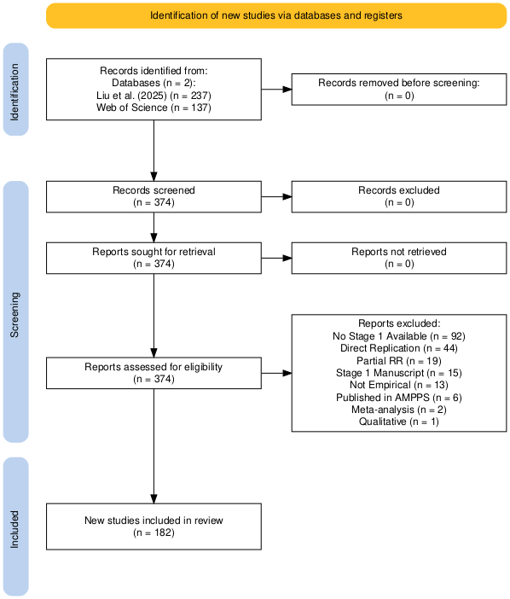

Figure 1. PRISMA diagram illustrating the article search and screening process. Created using the Shiny App developed by Haddaway et al. (2022).

From this final set of 182 articles we randomly selected 100 articles for further analysis. Using these 100, we located companion articles for the 100 preregistered and 100 traditional articles. The total sample of articles was 300 across the three types, which was informed by our power analysis (described in the subsequent section).

Our process for selecting companion articles is a substantial deviation from the project proposal. We had specified that we would use a process modified from the criteria used by O’Mahony (2023), which sought to make matches based on journal, timeframe, topic, and design. We immediately ran into problems with this approach. Primarily, O’Mahony (2023) only matched two article types (Registered Reports and traditional articles) whereas we matched three; those two in addition to preregistered articles. This additional article type made the matching process exponentially more difficult, and in some cases impossible. Accordingly, we opted to formally match only on journal and year of publication. Topic and design were considered when selecting articles, and all efforts were made to ensure similarities, but doing so was often not possible. More details on the challenges and implications of the matching procedure are provided in the Discussion section.

Exploratory Article Selection Process

We include two additional sets of articles for exploratory analyses and assessments of generalizability:

First, an additional group of 82 traditional articles published in 2010 were selected from the same journals as the Registered Reports. Starting with the first issue published in 2010, we identified an empirical article that matched the previously selected companion traditional articles as close as possible. Our plan was to include 100 articles in this category to align with the focal article set, but three journals (Collabra: Psychology, Cognitive Research: Principles and Implication, and Nature Human Behavior) did not exist in 2010, so no matches were possible.

Second, to assess the implications of using journals that publish Registered Reports as our starting point for article selection, we selected an additional sample (n = 30) of traditional articles from journals that do not publish Registered Reports. These journals were selected from the Clarivate Journal Citation Report, prioritizing journals with the closest journal impact factor within the same category to the target journal as a way to match scope (see https://osf.io/4vbtq/). The first article listed alphabetically for each of the 30 journals in the primary article set was selected. These 30 articles were the basis for finding a match in non-Registered Report journals, based on the criteria for matches described above.

Analysis of Journal Guidelines

Journals differ greatly in both policies and practices related to open science, including standards for clearly and accurately labeling exploratory and confirmatory research (Montoya et al., 2021). Assessing the direct impact of journal policies on article contents is difficult given that journal policies change over time, old policies are rarely archived, and it may not be possible to identify which articles were reviewed under specific policies. One way this was addressed is by accounting for clustering by journal in the analysis, as described subsequently. Additionally, we partially addressed the influence of journal policies by conducting an analysis of journal policies as indicated on the journal homepages in August 2026 (archived at https://osf.io/4vbtq/). The policies were coded for whether or not they included any guidance on distinguishing between exploratory and confirmatory analysis (required, suggested, or nothing), and whether this guidance was specified for Registered Reports, preregistered articles, and/or traditional articles.

Article Coding

The full detailed coding protocol is available at https://osf.io/4vbtq/. Here, we provide a summary of the main features of the protocol. Each article serves as the unit of analysis for coding, that is, the unit to which the coding categories were applied.

Importantly, in the current project we remain agnostic about the quality of the registrations themselves. There have been several studies indicating that registrations lack specificity and that researchers often engage in undisclosed deviations from their registrations (Claesen et al., 2021; van den Akker et al., 2023). These are important issues but not our concern here, as we are focused on the implications of the practice of registration regardless of how that practice is implemented, and to what degree (if any) it restricts reporting of exploratory research.

Each article was coded for the following:

Statements of Exploratory Research

One of the limits of the O’Mahony (2023) study is that it did not include a clear definition of what constitutes “exploratory.” In the current project, the presence of exploratory research was coded in accordance with our definition, “any analysis that is indicated to be exploratory in nature or indicated to not be a planned test of a specific hypothesis.” We coded for any explicit or implied mention of exploratory tests, exploratory analysis, unplanned analysis, or speculative analyses. “Implied” is a subjective criterion but is included here for cases where raters can determine that the analyses were exploratory absent an explicit statement. For example, if researchers state a research question, but indicate that they made no hypotheses about that question, then that would be considered exploratory even if they did not explicitly label it as such. Additionally, any tests that are labeled as robustness tests, sensitivity tests, or tests of alternative explanations, and are explicitly or implied to be exploratory or unplanned, will be coded as exploratory research. In this way, we are not limited only to direct reporting (i.e., labeling) of research as exploratory, but rather any work that can be reasonably discerned as exploratory based on the information provided in the article.

Importantly, not all uses of the word “explore” or “exploratory” necessarily indicate exploratory research. For example, following a hypothesized statistically significant interaction effect, authors may state that they “explored” or “probed” the interaction via simple slopes analysis. That kind of follow-up test is directly related to the hypothesis about the interaction and is conducted to gain greater clarity on the specific nature of the interaction. It also reflects the broader problem in psychology with the lack of specificity when proposing hypotheses about interaction effects (Baranger et al., 2023). An additional case that does not necessarily meet the criteria for exploratory research is the use of "exploratory factor analysis” as an analytic technique. This type of analysis is sometimes used in an exploratory way that is consistent with our definition, and sometimes used to test confirmatory hypotheses (despite its name). In both of these cases, the type of analysis could reflect exploratory research by our definition, but it will depend on the specific use in that study. Thus, the context was taken into account when coding rather than simply examining the articles for keywords.

All sections of each article were inspected and coded for the presence of exploratory research: 1) Title; 2) Abstract; 3) the end of the Introduction section, where the researchers discuss the aims of the study; 4) Method section(s); 5) Results sections(s); and 6) the Discussion section(s). Data Analysis Plan sections are not standard in the literature, and could constitute a separate section, a subsection of the Method or Results sections, or could be omitted altogether. They were coded in the section in which they appear. If it constituted a separate section, then it was considered as part of the Method section. For articles that contain multiple studies, the multiple sections that serve the same function (e.g., Results for Study 1, Results for Study 2) were treated as one, as all studies were registered or not registered. For each section, raters coded for the presence or absence of mentions of exploratory research. Although O’Mahony (2023) also included an “uncertain” category, our criteria is “explicit or implied” references to exploratory analyses, therefore articles that would potentially be coded as uncertain would not meet our coding criteria and thus were coded as absent.

The coding was used to create two indices. Presence of exploratory research was a binary (0 = no, 1 = yes) category collapsed across the six coded sections of each article that corresponds to any inclusion of exploratory research. Prominence of exploratory research was a count variable (0-6) that sums across the six coded sections, and therefore corresponds to how much exploratory research is represented across the article.

Section Headers Indicating Exploratory Research

Raters coded presence/absence for the inclusion of section headers that explicitly indicate exploratory analyses. The full articles were examined, but these were most likely to appear in the Results section when present.

Coding Difficulty

Raters coded for how difficult it was to determine their rating, which also serves as a useful indicator of their confidence in their ratings. We used the system from O’Mahony (2023): 1 - Very easy, 2 = Somewhat easy, 3 = Somewhat difficult, and 4 = Very difficult. Raters provided a global rating for difficulty, rather than for each section.
Rater Training and Reliability
The training phase consisted of the four authors, a professor of psychology and three doctoral students in social psychology. We conducted a pilot coding process of six articles based on the preliminary coding categories. This pilot process indicated that the coding system was sufficiently clear and applicable, and led to some minor refinements in the definition and scope of the categories.

Formal training and establishing reliability was completed after registration. The training phase used articles that are not part of the focal set but share similar characteristics (i.e., articles of the three types that were published in psychology journals across the same time range). We drew from the following journals that were not included in the focal set: Assessment, Clinical Psychological Science, Journal of Personality, PloS ONE, and Social Psychological Bulletin. These are journals drawn from diverse subfields of psychology and all currently publish Registered Reports, and thus are comparable to our focal set of journals.

The training phase consisted of four steps:

Step 1 was for the rating team to become familiar with the coding system and how to apply it to the articles. We independently coded two articles during a project meeting and then had a discussion about our coding system.

Step 2 involved the raters independently coding a set of five articles. This coding was subject to reliability analysis using average pairwise percent agreement and Fleiss’s Kappa to quantify the degree of agreement. Reliability was examined for each of the eight components to be coded (six sections of the articles, section headers, and coding difficulty). The raters then had a meeting in which they discussed the disagreements.

Step 3 was a repeat of Step 2 but with 10 new articles. Once again, average pairwise percent agreement and Kappa were used to quantify the degree of agreement. Averages across sections (excluding difficulty) were 91% agreement and Κ = .79, exceeding our registered thresholds of 80% and .60, respectively. Thus, the training phase was complete and we moved to full article coding.

After establishing reliability, the first author coded all articles with the fourth author coding 20% for reliability. This is a deviation from the preregistered plan, which had specified a more elaborate plan involving all four authors coding independent and overlapping subsets. This change was made due to the highly compressed schedule for completion of the project and the difficulty of working around all of the authors’ schedules during the summer months. Percent agreement across sections ranged from 89-100%. Cohen’s K ranged from .41-1.0, with coding for the introduction section being the only value that fell out of acceptable range (.74-1.0 for all others). This low value is understandable, given the low rate of positive coding that led to very unbalanced marginal distributions, which drives kappa down (Syed & Nelson, 2015). This problem is evident in the fact that percent agreement for the introduction section was 89%. Accordingly, we proceeded without any further action. All data and code are openly available at https://osf.io/4vbtq/.

Analysis Plan

Each hypothesis was tested using three indices: presence (binary yes/no for exploratory research), prominence (count across all sections), and section headings. Analytic code using simulated data is available at https://osf.io/4vbtq/. Alpha was set at .05, but we used the false discovery rate (FDR) adjustment (Benjamini & Hochberg, 1995) using the p.adjust() function in R to account for multiple tests. For primary tests, we report both the raw (p) and the FDR adjusted (p_{FDR}) p-values, but inferences were based only on the latter. All analyses were conducted in R version 4.4.2 (R Core Team, 2024), using RStudio 2026.08.0 (Posit Team, 2026) with support from the following packages: dplyr (Wickham, François, et al., 2023), tidyr (Wickham, Vaughan, et al., 2023), stringr (Wickham, 2025), summarytools (Comtois, 2022), irr (Gamer et al., 2026), readxl (Wickham & Bryan, 2026), htestClust (Gregg et al., 2022), rcompanion (Mangiafico, 2026), forcats (Wickham, 2023), ggplot2 (Wickham, 2016), and cowplot (Wilke, 2020).

Regarding probable effect sizes, the arguments made in the literature that registration will restrict exploratory research has often used extreme language such as that it will “put researchers in chains” (Scott, 2013), “stifle discovery” (Goldin-Meadow, 2016) and serve as a “stranglehold” on research (McDermott, 2022). The severity of this language clearly implies a large effect, that we would see a dramatically lower rate of exploratory work in registered compared to non-registered studies. The only available evidence, however, indicates a moderate difference in the other direction, with a greater prevalence of exploratory research in Registered Reports compared with standard reports (O’Mahony, 2023). The effect size phi, appropriate for 2x2 chi-square tests, was not reported in O’Mahony (2023), but we can use the reported test statistic, ꭕ²(1, N = 510) = 16.19, p < 0.001, to calculate it as ɸ =.18.

It is difficult to say what effect size is the smallest that would be meaningful. Our goal in this project, however, was to address the extreme claims about the damaging impact of registration, and we were thus primarily interested in large effects. Given that we are conducting a more tightly controlled analysis than O’Mahony (2023), in terms of assessment of reported exploratory research, we opted to use ɸ =.20 as the target effect size for 2x2 chi squares and the corresponding Cohen’s d = .40 for t-tests. Power analyses were conducted using the pwr.chisq.test() and pwr.t.test() functions from the pwr package in R (Champely et al., 2020). Power analysis based on ɸ =.20, power = .80, and alpha = .05 indicated a total sample size of 196 articles. Power analysis based on d =.40, power = .80, and alpha = .05 (two-sided) indicated a sample size of 99 for each group.

Analyses were conducted using chi-square tests of independence (binary data) and two-sample group-weighted tests of means, similar to a t-test (continuous data), which accounted for journal-level clustering using the htestClust (Gregg et al., 2022) package. However, the power analysis does not consider clustering because it was unknown a) how many journals would be included in the final analysis, b) how many articles would come from each included journal, and c) how much journal-level variation to expect. As preregistered sensitivity tests, all analyses were also conducted without accounting for clustering by journal. As a non-registered secondary sensitivity test, we also conducted tests that accounted for clustering based on the matching procedure (e.g., treating a Registered Report and its traditional article match as clustered), given that the selection process was non-independent. All reported analyses were preregistered unless otherwise specified, and Table S1 includes a list of deviations.

Results

Dataset Description

Although we drew from a pool of 47 journals publishing Registered Reports, our final dataset included articles from only 30 of these journals. This difference is a result of randomly selecting a subset for inclusion, as well as the uneven distribution of Registered Reports published across the journals. Indeed, as seen in Table 1, nearly 40% of the articles came from just three journals (Cortex, Nature Human Behavior, and Journal of Experimental Social Psychology). This is a clear limitation of the dataset and the conclusions we can draw, but it also represents the reality of the Registered Reports landscape.

Descriptive Statistics

The raw frequencies of exploratory research reported across article types are displayed in Figures 2-4. Figure 2 shows the results for the binary count measure, meaning any reporting of exploratory research across the seven coding categories, ranging from a low of 16% in the traditional articles from 2010 to a high of 84% in Registered Reports. In between these, 29% of the traditional matches and 71% of the preregistered articles reported any exploratory research. Figure 3 shows binary presence across six of the seven categories that were coded; exploratory research in the articles titles is omitted because this was not detected in any article in the entire set. The highest frequencies of presence were for Results sections, followed by Discussion and Method sections.
Table 1
Frequency of Registered Report Articles by Journal
Journal | Number | Cumulative Frequency
Cortex | 19 | 19%
Nature Human Behaviour | 11 | 30%
Journal of Experimental Social Psychology | 8 | 38%
Journal of Research in Personality | 6 | 44%
Cognitive Research: Principles and Implications | 5 | 49%
Psychophysiology | 5 | 54%
Quarterly Journal of Experimental Psychology | 4 | 58%
Cognition and Emotion | 3 | 61%
Developmental Science | 3 | 64%
Infant and Child Development | 3 | 67%
Memory | 3 | 70%
Psychology & Health | 3 | 73%
Psychology of Addictive Behaviors | 3 | 76%
Attention, Perception, & Psychophysics | 2 | 78%
British Journal of Health Psychology | 2 | 80%
Collabra: Psychology | 2 | 82%
International Journal of Psychophysiology | 2 | 84%
Judgment and Decision Making | 2 | 86%
Psychology of Sport and Exercise | 2 | 88%
Psychonomic Bulletin & Review | 2 | 90%
British Journal of Educational Psychology | 1 | 91%
British Journal of Psychology | 1 | 92%
British Journal of Social Psychology | 1 | 93%
Consciousness and Cognition | 1 | 94%
European Journal of Personality | 1 | 95%
Evolution and Human Behavior | 1 | 96%
Experimental Psychology | 1 | 97%
Journal of Personality and Social Psychology | 1 | 98%
Law and Human Behavior | 1 | 99%
Legal and Criminological Psychology | 1 | 100%
Note: Total number of articles = 100

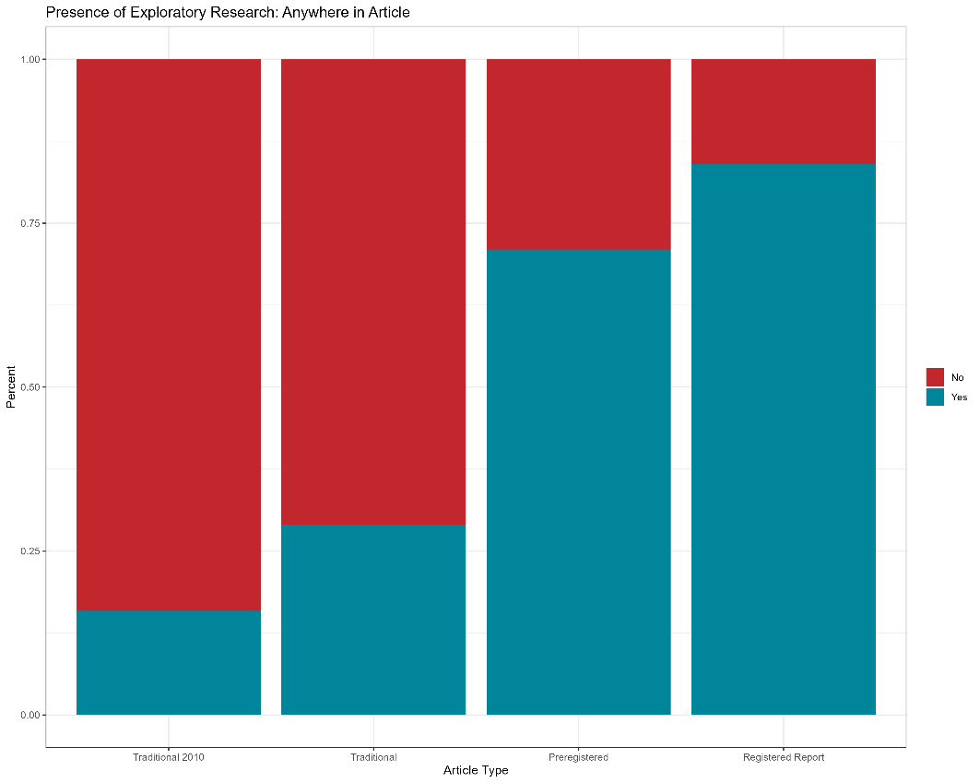
Figure 2. Binary presence of exploratory research reported anywhere in the article.

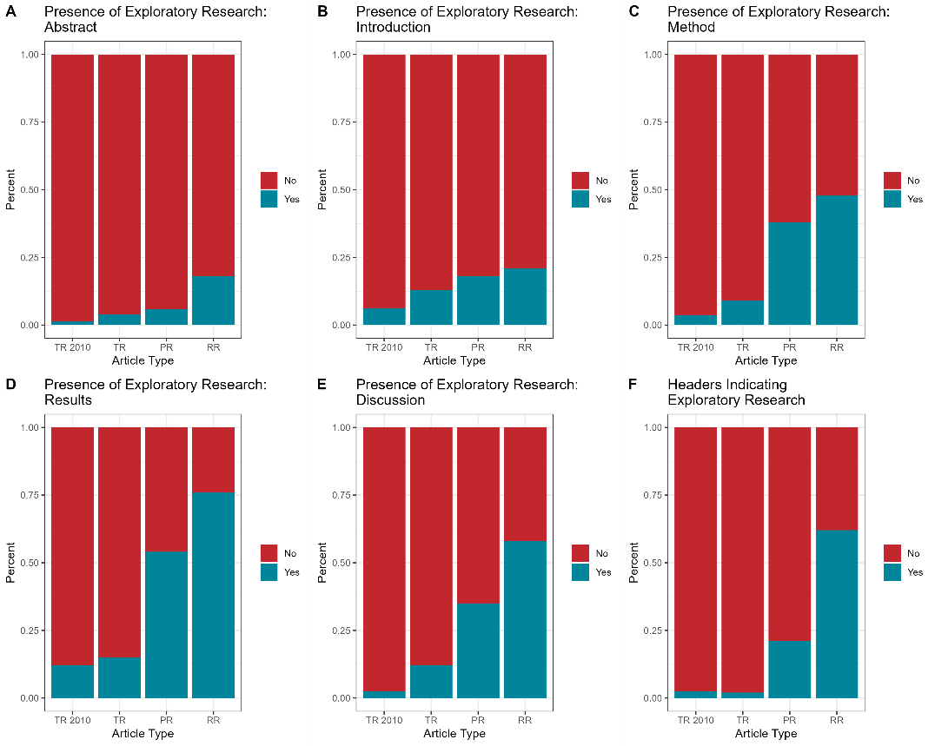
Figure 3. Binary presence of exploratory research reported by each section of the article. Title is omitted from the plot because no references to exploratory research were recorded. TA 2010 = Traditional Articles published in 2010, TA = Traditional Articles, PR = Preregistered Articles, RR = Registered Reports.

Figure 4 displays the distribution of the prominence measure, which is a sum score across the six articles sections (headings were not included in this measure, as registered), resulting in a possible range of 0-6. The violin plots show heavy positive skew for the two traditional article types (M = 0.53, SD = 0.97, range = 0-4 for traditional matches; M = 0.26, SD = 0.72, range = 0-4 for traditional 2010 articles) and relatively flat distributions for preregistered articles (M = 1.51, SD = 1.31, range = 0-5) and Registered Reports (M = 2.21, SD = 1.43, range = 0-5). In other words, most traditional articles report very low rates of exploratory research, whereas the registered articles are highly variable, with representation across the full spectrum of possible scores.

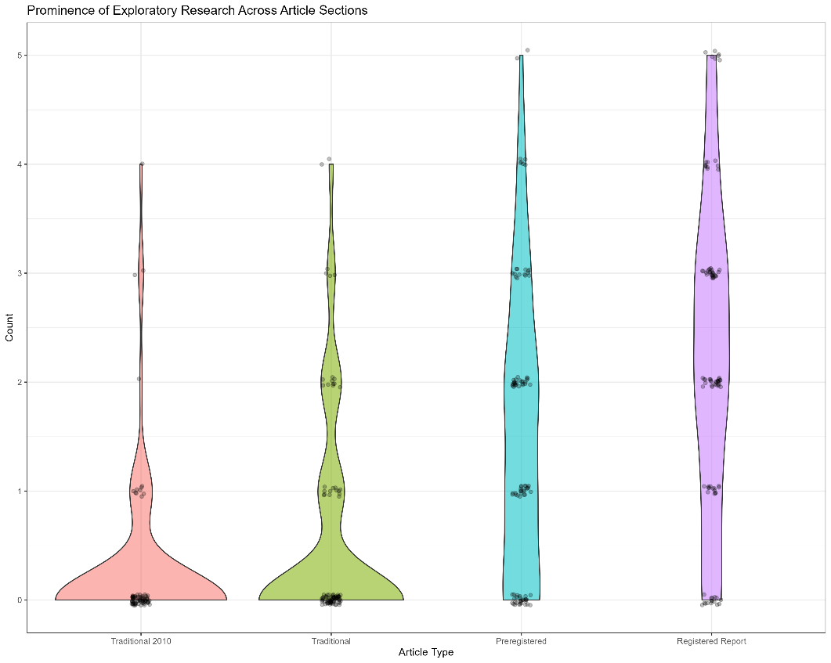
Figure 4. Count prominence of exploratory research reported across article sections.

Hypothesis 1: Preregistered Articles Compared to Traditional Articles

Hypothesis 1 was that there would be a higher prevalence of reported exploratory research in preregistered articles compared to traditional articles. This hypothesis was tested using the measure of presence (binary count), prominence (sum across sections), and section headings, comparing preregistered (n = 100) and traditional (n = 100) articles.

Test 1, Presence: The 2x2 chi-square test of independence, accounting for journal-level clustering, comparing article type with the binary outcome of presence/absence of exploratory research supported our hypothesis, ꭕ² = 9.26, p = .002, ɸ =.42, p_{FDR} = .004. Whereas exploratory research was present in 71% of preregistered articles, it was only present in 29% of traditional articles. This result held up when not accounting for clustering (ꭕ² = 32.62, p < .001) and when clustering by match (ꭕ² = 28.45, p < .001).

Test 2, Prominence: This test was conducted using a two-sample group-weighted test of means, similar to a t-test, which accounted for journal-level clustering. The findings supported the hypothesis that prominence of exploratory research would be higher in preregistered compared to traditional articles, z = 3.91, p < .001, d = 0.55, p_{FDR} < .001. This result held up when not accounting for clustering (t = 6.00, p < .001) and when clustering by match (z = 6.01, p < .001).

Test 3, Section headings: The 2x2 chi-square test of independence, accounting for journal-level clustering, comparing article type with the binary outcome of presence/absence of a section heading indicating exploratory research supported our hypothesis, ꭕ² = 8.01, p = 0.005, ɸ =.30, , p_{FDR} = .006, with 21% of preregistered articles including a section heading vs. only 2% of traditional articles. This result held up when not accounting for clustering (ꭕ² = 15.92, p < .001) and when clustering by match (ꭕ² = 19.00, p < .001).

Hypothesis 2: Registered Reports Compared to Traditional Articles

Hypothesis 2 was that there would be a higher prevalence of reported exploratory research in Registered Reports compared to traditional articles. This hypothesis was tested using the measure of presence (binary count), prominence (sum across sections), and section headings, comparing Registered Reports (n = 100) and traditional articles (n = 100).

Test 1, Presence: A 2x2 chi-square test of independence, accounting for journal-level clustering, comparing article type with the binary outcome of presence/absence of exploratory research supported our hypothesis, ꭕ² = 12.87, p < .001, ɸ =.55, , p_{FDR} < .001. Whereas exploratory research was present in 84% of Registered Reports, it was only present in 29% of traditional articles. This result held up when not accounting for clustering (ꭕ² = 59.32, p < .001) and when clustering by match (ꭕ² = 45.15, p < .001).

Test 2, Prominence: The two-sample group-weighted test of means, accounting for journal-level clustering, supported the hypothesis, with prominence of exploratory research significantly higher in Registered Reports compared to traditional articles, z = 5.05, p < .001, d = 0.71, p_{FDR} < .001. This result held up when not accounting for clustering (t = 9.72, p < .001) and when clustering by match (z = 9.43, p < .001).

Test 3, Section headings: A 2x2 chi-square test of independence, accounting for journal-level clustering, comparing article type with the binary outcome of presence/absence of a section heading indicating exploratory research supported our hypothesis, ꭕ² = 20.88, p < 0.001, ɸ = .64, p_{FDR} < .001, with 62% of Registered Reports including a section heading vs. only 2% of traditional articles. This result held up when not accounting for clustering (ꭕ² = 59.32, p < .001) and when clustering by match (ꭕ² = 45.15, p < .001).

Hypothesis 3: Registered Reports Compared to Preregistered Articles

Hypothesis 3 was that there would be a higher prevalence of reported exploratory research in Registered Reports compared to preregistered articles. This hypothesis was tested using the measure of presence (binary count), prominence (sum across sections), and section headings, comparing Registered Reports (n = 100) and preregistered articles (n = 100).

Test 1, Presence: A 2x2 chi-square test of independence, accounting for journal-level clustering, comparing article type with the binary outcome of presence/absence of exploratory research failed to support the hypothesis, ꭕ² = 0.92, p = .34, ɸ =.16, p_{FDR} = .34. We did not find evidence that Registered Reports (84%) and preregistered articles (71%) differentially included any mention of exploratory research. There were, however, significant differences when not accounting for clustering (ꭕ² = 4.13, p = .04) and when clustering by match (ꭕ² = 4.57, p = .03).

Test 2, Prominence: The two-sample group-weighted test of means, accounting for journal-level clustering, failed to support the hypothesis, z = 1.98, p = .048, d = 0.28, p_{FDR} = .054. There were, however, significant differences when not accounting for clustering (t = 3.60, p < .001) and when clustering by match (z = 3.87, p < .001).

Test 3, Section headings: A 2x2 chi-square test of independence, accounting for journal-level clustering, comparing article type with the binary outcome of presence/absence of a section heading indicating exploratory research supported our hypothesis, ꭕ² = 13.04, p < 0.001, ɸ = .42, p_{FDR} < .001, with 62% of Registered Reports including a section heading vs. 21% of preregistered articles. This result held up when not accounting for clustering (ꭕ² = 32.95, p < .001) and when clustering by match (ꭕ² = 29.49, p < .001).

Preregistered Exploratory Analyses

Descriptive Analysis of Reporting by Manuscript Section. As already noted, the highest frequencies of presence were for Results sections, followed by Discussion and Method sections (Figures 2-4). Despite the very different levels of reporting across article types, the relative presence in each section was more or less the same for all, going from Results, Discussion, Method, Introduction, Abstract, and down to Title, which did not receive any presence codes across the 382 articles. Taking all of the different sections together, we can make some general statements about reporting habits with respect to exploratory research. First, even when reporting on exploratory research in the Results section of articles, authors are not necessarily interpreting those results as exploratory in the Discussion section, nor highlighting them in the Abstract. Second, exploratory research is relatively less often set up as something that is planned in the Introduction section, but rather that “emerges” when analyzing the data.

Change in Reporting by Article Type Over Time. We examined change in reporting over time in two ways, first by the three main articles types and second by comparing traditional articles in the primary set to the traditional articles published in 2010. Change over time in binary presence is displayed in Figure 5. Overall, the only notable pattern is the increase in reporting of exploratory research in traditional articles, with the figure indicating a stepped increase from 2021 to 2022 that has since been sustained. There is an apparent regression in 2026, but these estimates are based on a small number of articles. The change over time in the prominence measure shows a similar pattern, with increasing prominence in traditional articles over time (Figure 6). Both Registered Reports and preregistered articles show a slight decreasing trend, but this is likely due to the influence of the small number of articles from 2026.

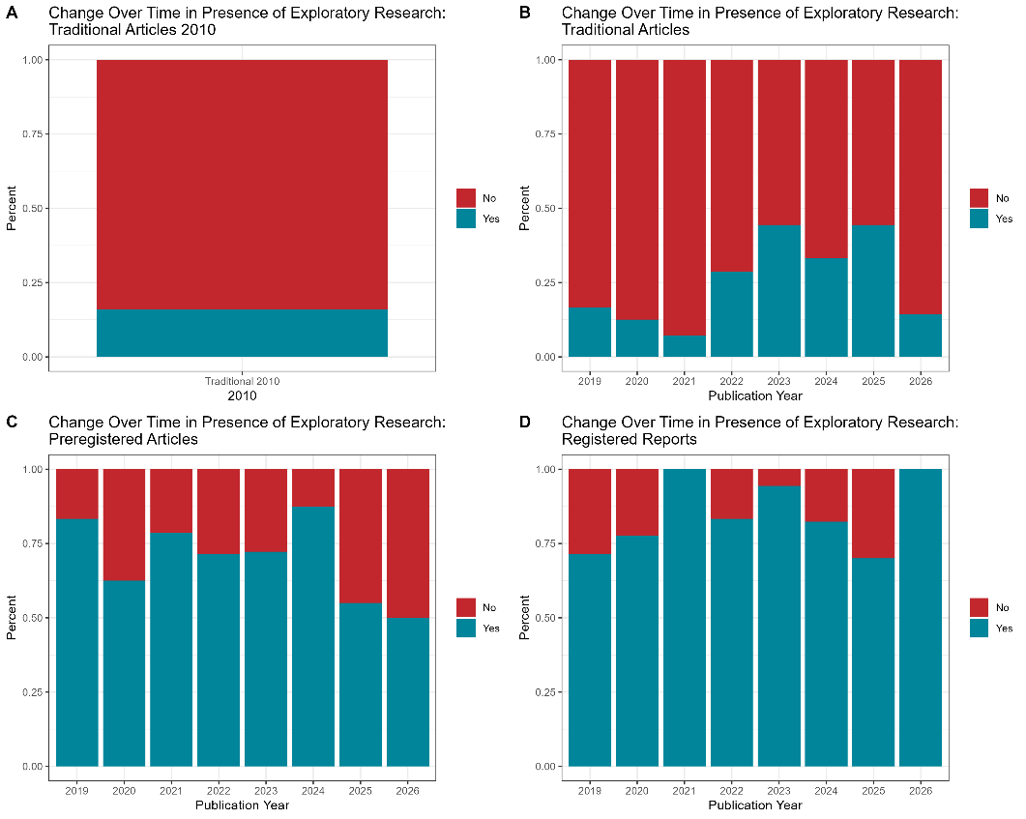
Figure 5. Changes in binary presence of exploratory research over time.

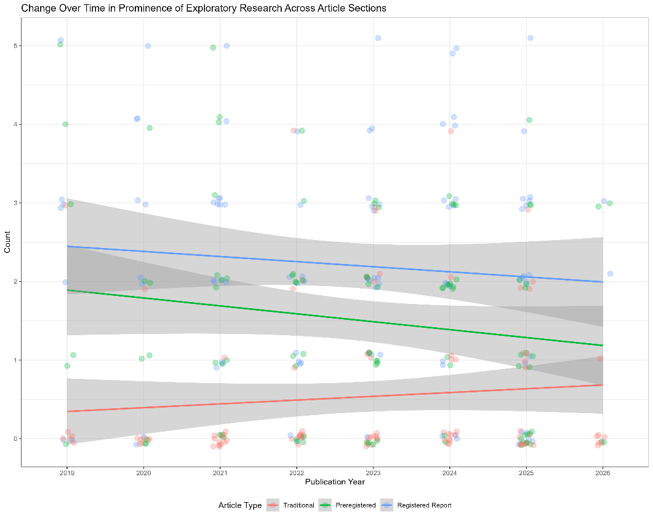
Figure 6. Changes in count prominence of exploratory research over time.

A companion set of traditional articles published in 2010, before the onset of the replication crisis in psychology, were also included in the dataset but were not part of the primary analysis reported above. Here, we make some exploratory comparisons between the two sets of traditional articles. Comparing the frequencies and means portrayed in Figures 2-4 shows a clear, but modest, increase in reporting of exploratory research in traditional articles. Binary presence in 2010 was 16%, compared with 29% in the primary set. Similarly, prominence for the 2010 articles was, M = 0.26, SD = 0.72, range = 0-4, whereas for the primary set it was slightly higher, M = 0.53, SD = 0.97, range = 0-4. One interesting pattern is that the rate of reporting in the Results section is comparable across the two sets (12% and 15%), but reporting in the Discussion section has increased since 2010 (from 2% to 12%). This finding suggests that researchers may now not only be reporting exploratory findings, but interpreting them as exploratory as well.

Generalizability Test: Comparison of Traditional Articles from Journals that Do and Do Not Publish Registered Reports. The starting point for the construction of our dataset was journals that publish Registered Reports. It is possible that these journals also handle traditional articles differently from journals that publish strictly traditional articles. As an examination of the potential generalizability of our findings, we compared a small subset of traditional articles from our dataset to a matched set of traditional articles from journals that do not publish Registered Reports. The traditional articles from non-Registered Report journals had a presence rate of 23% and prominence of M = 0.40, SD = 0.86, range = 0-3. This is a little lower than the subset of traditional journals that was selected from the primary dataset to create the matches, which showed a presence of 40% and prominence of M = 0.63, SD = 0.93, range = 0-3. This subset of 30 articles happened to show a higher rate than the full sample of 100 articles, which had a presence of 29% and prominence of M = 0.53, SD = 0.97, range = 0-4, which is well in line with what was observed in the new set of articles. All told, these values are all in the same ballpark, and suggest that the primary article set was not grossly unrepresentative of the broader literature, and certainly not biased downward with respect to reporting of exploratory research.

Non-registered Exploratory Analyses

Variations by Journal. As previously noted, a small number of journals have published an outsized number of Registered Reports. We compared the three most prolific journals (Cortex, Nature Human Behavior, and Journal of Experimental Social Psychology), which accounted for 38% of Registered Reports, with all others (Figure 7). One question we wondered about is whether reporting of exploratory research was higher in Registered Reports and preregistration in the three prolific journals compared to the others. Cortex and Journal of Experimental Social Psychology clearly showed this pattern, with very high rates of reporting in terms of binary presence for Registered Reports in particular–95% and 100%, respectively. Nature Human Behaviour, in contrast, looked very similar to the rest of the set. Another question we wondered about is whether there might be greater “spillover” from how journals handle registered articles to how they handle their traditional counterparts, wherein we would see higher rates of reporting in the traditional articles for journals that prolifically published Registered Reports. There does not appear to be any evidence in support of this idea. One interesting pattern, however, is that rates of reporting exploratory research in traditional articles published in Nature Human Behavior is especially low, suggesting possible differential article handling processes, but the number of articles is small (n = 11) so this observation may not be meaningful.

Analysis of Journal Policies. Ideally, we would be able to directly link journal-level policies to our article-level coding, to determine what role journal policy may have in how authors report their work. This was not possible in the current project because journal policies are described on dynamic websites, and it is difficult to know what policies were in effect at the time that each article was submitted and reviewed. Nevertheless, we analyzed journal policies as described in early August 2026 (see https://osf.io/4vbtq for an archive of the policies). We coded for whether or not they included any guidance on distinguishing between exploratory and confirmatory analysis (required, suggested, or nothing), and whether this guidance was specified for Registered Reports, preregistered articles, and/or traditional articles.

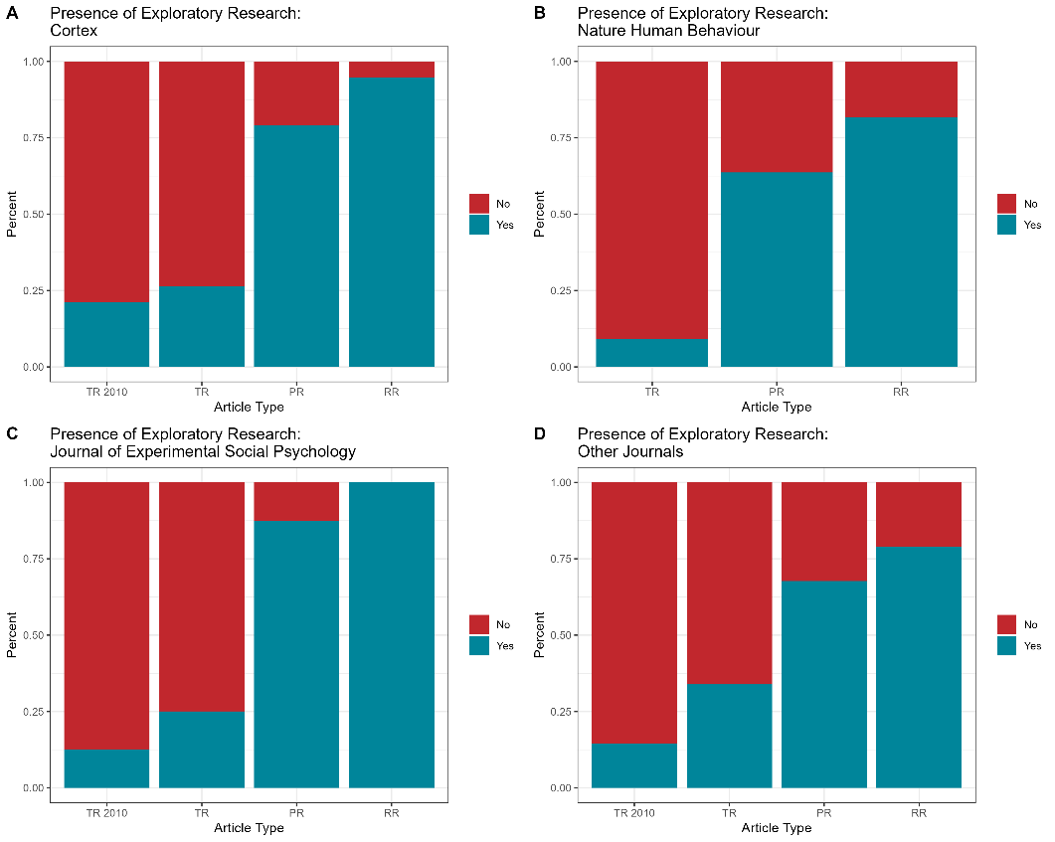

Figure 7. Binary presence of exploratory research by journal. TA 2010 = Traditional Articles published in 2010, TA = Traditional Articles, PR = Preregistered Articles, RR = Registered Reports. Nature Human Behaviour did not exist in 2010, so there is no TA 2010 column.

First, we looked at the guidance provided for each article type separately. The majority of journals (67%) required a distinction between confirmatory and exploratory analyses for Registered Reports, whereas the remaining journals suggested that authors do so (3%) or provided no guidance at all (30%). In contrast, most journals provided no guidance for making the distinction for preregistered articles (80%) or traditional articles (93%), with the remaining journals requiring the distinction (20% and 7 %, respectively).

Second, we looked at patterns of requiring distinctions across the three article types at the journals, finding that 47% required the distinction only for Registered Reports, 13% for Registered Reports and preregistered articles, 7% for all article types, and the remaining 33% had no requirements at all for the distinction. Figure 8 shows the binary presence of reporting of exploratory research by each of the preceding classifications (required for Registered Reports only, required for Registered Reports and preregistered articles, required for all article types, or not required for any). We caution that these data are based on small numbers of articles for most categories, and are being examined for any large or startling patterns. Generally speaking, there were none; the distributions look approximately similar across categories. The one pattern that sticks out is Figure 8B, which shows the distribution for journals that had required distinctions for both Registered Reports and preregistered articles. For this category, traditional articles had a higher presence of exploratory research than preregistered articles. This finding runs counter to all others in this study, and is likely a product of the small number of articles per article type. In all, although there are great variations in journal policies, we don’t see much evidence of those policies being related to the article reporting.

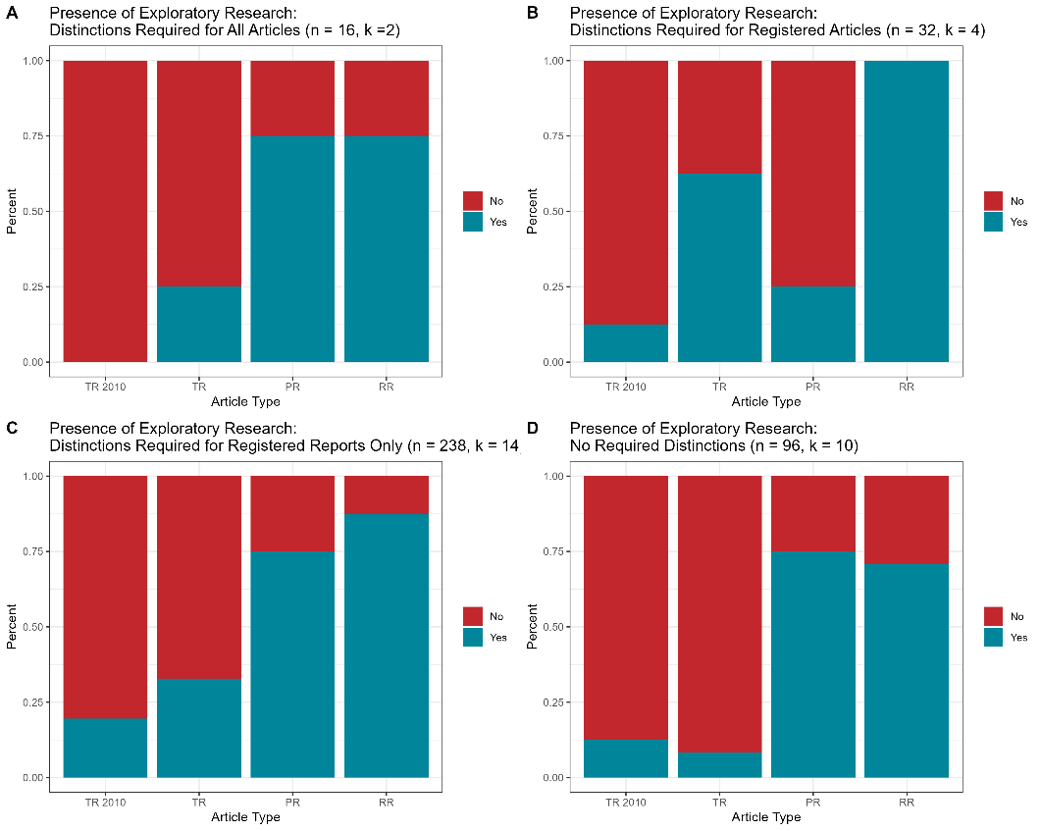
Figure 8. Binary presence of exploratory research by journal policy category. TA 2010 = Traditional Articles published in 2010, TA = Traditional Articles, PR = Preregistered Articles, RR = Registered Reports.

Discussion

The purpose of the present study was to examine whether preregistration and Registered Reports restrict reports of exploratory research, which we defined as any analysis that is indicated to not be a planned test of a specific hypothesis. Based on a sample of Registered Reports, preregistered articles, and traditional articles, all taken from journals that publish Registered Reports, our findings provide clear empirical evidence against the claims in the literature that preregistration will restrict exploratory research (Goldin-Meadow, 2016; McDermott, 2022 ) or “put researchers in chains” (Scott, 2013). After reviewing the core findings, we provide a discussion of what our results do and do not mean.

Much Higher Reporting of Exploratory Research in Registered Articles

Our registered hypotheses 1 and 2, that preregistered articles and Registered Reports would have a higher prevalence of exploratory research reported than traditional articles, was clearly supported. Across three different indicators of reporting (i.e., presence of any reporting at all, prominence of reporting throughout the articles, and the inclusion of specific headings), we found evidence for moderate to large effects for all comparisons. These results are largely in line with O’Mahony’s (2023) study comparing Registered Reports with traditional articles. However, we documented a higher rate of exploratory research in Registered Reports (84% vs. 75% in O’Mahony) and a lower rate in traditional reports (29% vs. 57%), and thus found a much larger difference (ɸ =.55 vs. 18). Our comparison of preregistered and traditional articles, which was not included in O’Mahony (2023), yielded a similar pattern but smaller difference (ɸ =.42), with 71% of preregistered studies including the presence of exploratory research (vs. 29% for traditional articles). The reasons for the different findings are not clear, but is most likely due to the fact that O’Mahony did not have a clearly specified definition of what constitutes exploratory research, nor an elaborated coding manual describing what should and should not count. During the coding, we encountered many instances of the word “explore” or some variation thereof that did not constitute exploratory research according to our definition. For example, it was fairly common to come across authors who would write something like, “The purpose of this study was to explore the hypothesis that…” and then go on to state confirmatory-worded hypotheses. Thus, it is likely that we weren’t capturing identical research behavior. Additionally, O’Mahony (2023) had a much stronger article matching process than what we were able to employ in our study. That said, it is not clear how much the article matching process matters or in what direction it would bias the findings. Despite the differences, the findings from both studies lead to the same conclusions: there is much more reporting of exploratory research in registered articles compared to traditional articles (cf. Soderberg et al. 2021).

Mostly No Evidence for Difference in Reporting of Exploratory Research in between Preregistered Articles and Registered Reports

Our third registered hypothesis, that there would be greater reporting of exploratory research in Registered Reports than preregistered articles, was largely unsupported. This hypothesis was based on the well-documented practice of researchers failing to disclose deviations to their preregistration plans (e.g., van den Akker et al., 2023), and thus perhaps a higher likelihood of reframing exploratory research as confirmatory. Yet, we found little evidence in support of this idea. We found support for the hypothesis in only one of the three tests, finding that Registered Reports had a higher frequency of including section headings for exploratory research than preregistered articles. Of all of the indicators that we examined, section headers showed the biggest difference between the two articles types–and are almost completely absent from traditional articles–suggesting that they are often seen as most suitable for Registered Reports. Section headers are a useful signal that helps frame the contents therein, and therefore it would be advantageous for authors of preregistered and traditional articles to include them as well, when relevant.

Although our other two tests failed to find support for our hypothesis, there were some indicators of possible differences that could be found in future work. For presence, the focal test that accounted for journal-level clustering failed to show a difference, but there was a difference when clustering by the matching process and when removing clustering altogether. For prominence, the raw p-value indicated a significant difference, but it did not survive our FDR correction for multiple testing. Once again, there was a difference when clustering by the matching process and when removing clustering altogether. To be clear, the most appropriate and rigorous tests showed no difference. It is likely that there is a small difference between the article types, perhaps of negligible meaning, that would require a large sample to detect. Additionally, the differential results by clustering suggests that there may be important journal-level factors at play, where the difference may be more evident in some journals than others.

Exploratory Findings about Exploratory Research

We conducted a number of exploratory analyses, some of which were registered and some of which were not. Most of these analyses did not reveal much of note. The analyses of differences by journal and journal policies did not indicate any major variations. The analyses of changes over time only suggested that authors of traditional articles are increasingly reporting exploratory research, and that there is a notable increase in reporting in the Discussion sections, to accompany the primary reporting that occurs in the Results sections. Taken together, these results suggest that not only is reporting of exploratory research increasing, but interpretation of it is increasing as well. Notably, we had a restricted timeframe in the current study, with articles spanning 2019-2026, but not including the earliest days of registration in psychology, where the situation could be notably different.

Conclusions to Draw–And Not Draw–From This Study

Did We Assess Actual Exploratory Research? No. All that we assessed was authors’ reports of their exploratory research. We chose to do this because it was the only option that was really possible. When analyzing published articles, the only information available is the information that is provided in the article itself. We know, however, that in the past–and to some degree the present–authors were unclear or dishonest in their presentations about what was exploratory and what was confirmatory (e.g., HARKing). This lack of transparency makes it difficult to know the truth of the matter.

One way to interpret our results is not in terms of exploratory research per se, but in terms of transparent reporting. It is entirely possible that the actual rate of exploratory research is the same across articles types and that it is just more clearly labeled in registered articles. That said, it is of course possible that the mere act of labeling analyses, and thinking in terms of the confirmatory/exploratory distinction, could lead to higher rates of exploratory research. We are agnostic on this issue for now, as the data cannot adjudicate between these two interpretations. The data do, however, cast doubt on a common talking point against preregistration. Authors have not traditionally indicated that they have been doing exploratory research, despite it supposedly being widespread and under threat by introducing registration. If exploratory research is so important, how come authors in traditional articles do not state that is what they are doing?

Another way in which we did not assess “actual” exploratory research is that we used a restricted definition of the concept, one that frames exploratory research only in relation to confirmatory research. The definition we used was sensible given the aims of the project and that it was situated within the particular debate about registration, in which the definition we used is the explicit or implicit one used by those involved. Thus, we used this definition because it is what made sense in the context of our research question, not because we believed it is a singular or correct definition. Interested readers are encouraged to consult Feest and Devezer (2025) and Ditroilo et al. (2025) on broader conceptualizations of exploratory research.

Registered Articles Do Not Come with Guarantees. Although we found much higher rates of exploratory research in registered vs. traditional articles, there were still plenty of registered articles with no mention of or few references to exploratory research. This could be because even in Registered Reports some exploratory research is reframed as confirmatory, or because some hold on to the mistaken view that exploratory research cannot or should not be reported in Registered Reports. The variability is best communicated via Figure 3, which shows the distribution of prominence scores by article type. The relatively flat distributions for the two registered article types indicate scores across the full continuum. There were many registered articles that looked identical to traditional articles with respect to their reporting. Whether that was due to differences in reporting practices or actual exploratory research, we cannot say. There were very few traditional articles, however, that looked similar to registered articles.

What About Adherence to the Registered Plans? We verified the existence of registrations for all registered articles included in the set, but we did not analyze them in this project. Some might see this as a limitation or a missed opportunity. Adherence and transparent deviations from registration plans is an important issue that has been taken up in several high-quality articles (e.g., Claesen et al., 2021; van den Akker et al., 2023). We chose not to do this because it is not entirely clear how to think about registration quality in relation to our research questions about exploratory research, as well as the fact that we were also examining traditional articles, for which there are no registrations to compare. Some might say that any deviation at all from a registered plan should be considered exploratory. Others might say it is impossible to assess exploratory research at all without a registration document. We disagree with both claims in the context of the present study, which was focused on reporting–what authors actually claimed they were doing. We strongly encourage any readers interested in further exploring registration quality and plans to make use of our open dataset.

Can The Present Findings Be Generalized? The current study selected articles from 30 psychology journals that publish Registered Reports, used Registered Reports as the starting point for article selection and matching, excluded partial Registered Reports and partial registrations (i.e., articles in which there is a mix of registered and non-registered studies), excluded direct replication studies, and excluded meta-analyses, qualitative studies, and mixed methods studies. All of this suggests that we examined a small slice of the relevant universe of articles.

Nevertheless, based on our exploratory analyses there is good reason to believe that our results are generalizable beyond these constraints. Our formal investigation into generalizability, in which we examined traditional articles published in journals that do not publish Registered Reports, did not show any differences. Our analyses into variations by journal, journal policies, and year of publication, indicated mostly similar results. Taken together, it seems unlikely that our findings are highly restricted to the context in which they were generated. The likeliest possibility for weak generalization is replication studies and partially registered studies, which could be examined in future work.

Dataset Construction, Reuse Potential, and the Challenges of Matching

The dataset constructed for the current project has high reuse potential for metascientists, and we encourage anyone interested to do so. There are three key features that make the dataset unique and highly useful. First, it includes equal numbers of matched Registered Reports, preregistered articles, and traditional articles, as well as a supplementary set of traditional articles collected in 2010 and a snapshot of journal policies as of August 2026. Second, all of the Registered Reports and preregistered articles were verified to have links to the registration plans. Finally, the articles are matched by journal and by year of publication (for the most part), and so have a reasonable level of control for variations across the article types.

Our initial registered plan for matching articles was highly elaborate, and ultimately completely unrealistic. There were a number of factors that contributed. Matching three articles by journal, year, topic, and design–while representing the three articles types of Registered Reports, preregistered articles, and traditional articles–was, in many cases, simply impossible. One interesting barrier that we did not expect is that some journals publish very few of one of the article types. For example, Cortex has the highest number of Registered Reports, but publishes very few preregistered articles. Journal of Experimental Social Psychology publishes almost all Registered Reports and preregistered articles, especially in recent years, and many of the preregistered articles are mixed, with some studies reported in a single article registered and some not. Every single quantitative article published in Organizational Behavior and Human Decision Processes in 2024 was preregistered, and so we had to dip back into 2023 to find a traditional article. Indeed, even matching for year of publication is difficult due to most articles having two publication dates–online and in an issue–and these can sometimes be different years. For this reason, for some of our matches even the year of publication was not exactly the same.

Although our matching process fell short of our registered plans, we believe our dataset is strong with respect to the existing metascience literature that has compared registered and non-registered articles. For example, Scheel et al. (2021) matched articles only on the broad timeframe of 2013-2018 and nothing else. Liu et al. (2025) matched based on article keywords within two years on either side of the publication date. Similarly, van den Akker (2024) used Web of Science’s related papers tool, and selected articles that were published in the same year. These methods all have their limitations, and we believe that our matching by journal and publication year is just as defensible as any of the aforementioned.

Limitations

Many of the limitations of the study have already been discussed: we did not assess actual exploratory research, started with journals that publish Registered Reports, excluded several articles types (direct replication, partial registrations, meta-analyses, qualitative, mixed-methods), included a restricted timeframe, and had a large imbalance of articles per journal. An additional limitation is that we only narrowly addressed criticisms of registration in terms of exploratory research. Critics additionally suggested that registration would restrict creativity, serendipity, and discovery (Goldin-Meadow, 2016; Scott, 2013). The current study cannot speak directly to those concerns. That said, implied in those arguments is that exploratory research is what leads to those other qualities that we did not assess. The present findings, along with Soderberg et al.’s (2021) data indicating that Registered Reports and traditional reports were rated similarly for creativity and novelty, cast doubt on the critics’ claims.

Conclusion

Does registration restrict reporting of exploratory research? The results of the present study indicate an emphatic “no.” Comparisons across preregistered studies, Registered Reports, and traditional articles showed a clear pattern, with reports of exploratory research substantially higher in the two registered articles formats compared with traditional articles. Even though we were only able to assess the reporting of exploratory research, the very high rates in registered articles are not compatible with arguments that registration would put researchers in “chains” or any other such dramatic claims.

References

Baranger, D. A. A., Finsaas, M. C., Goldstein, B. L., Vize, C. E., Lynam, D. R., & Olino, T. M. (2023). Tutorial: Power Analyses for Interaction Effects in Cross-Sectional Regressions. Advances in Methods and Practices in Psychological Science, 6(3), 25152459231187531. https://doi.org/10.1177/25152459231187531
Benjamini, Y., & Hochberg, Y. (1995). Controlling the false discovery rate: A practical and powerful approach to multiple testing. Journal of the Royal Statistical Society: Series B (Methodological), 57(1), 289–300. https://doi.org/10.1111/j.2517-6161.1995.tb02031.x
Besançon, L., Bezerianos, A., Dragicevic, P., Isenberg, P., & Jansen, Y. (2021). Publishing Visualization Studies as Registered Reports: Expected Benefits and Researchers’ Attitudes. https://doi.org/10.31219/osf.io/3z7kx
Bottesini, J. G., Chambers, C. D., Howard, A., Lucas, R. E., Moore, D. A., Sbarra, D., Tackett, J. L., & Syed, M. (2025). Peer Community in Psychology: A platform for peer review of preprints across psychology. PsyArXiv. https://doi.org/10.31234/osf.io/m456e_v1
Boutron, I., Dechartres, A., Baron, G., Li, J., & Ravaud, P. (2016). Sharing of Data From Industry-Funded Registered Clinical Trials. JAMA, 315(24), 2729–2730. https://doi.org/10.1001/jama.2016.6310
Chambers, C. D. (2013). Registered Reports: A new publishing initiative at Cortex. Cortex, 49(3), 609–610. https://doi.org/10.1016/j.cortex.2012.12.016
Chambers, C. D., & Tzavella, L. (2022). The past, present and future of Registered Reports. Nature Human Behaviour, 6, 29–42. https://doi.org/10.1038/s41562-021-01193-7
Champely, S., Ekstrom, C., Dalgaard, P., Gill, J., Weibelzahl, S., Anandkumar, A., Ford, C., Volcic, R., & Rosario, H. D. (2020). pwr: Basic Functions for Power Analysis (Version 1.3-0) [Computer software]. https://cran.r-project.org/web/packages/pwr/
Claesen, A., Gomes, S., Tuerlinckx, F., & Vanpaemel, W. (2021). Comparing dream to reality: An assessment of adherence of the first generation of preregistered studies. Royal Society Open Science, 8(10), 211037. https://doi.org/10.1098/rsos.211037
Comtois, D. (2022). summarytools: Tools to Quickly and Neatly Summarize Data [Computer software]. R package version 1.0.1. https://CRAN.R-project.org/package=summarytools
Corker, K., Waltman, L., & Coates, J. (2024). Understanding the publish-review-curate (PRC) model of scholarly communication. MetaArXiv. https://doi.org/10.31222/osf.io/h7swt
Davis-Kean, P. E., Ellis, A., & Syed, M. (2024). Registered Reports with secondary developmental data: Introduction to the special issue. Infant and Child Development, 33(2), e2506. https://doi.org/10.1002/icd.2506
Ditroilo, M., Mesquida, C., Abt, G., & Lakens, D. (2025). Exploratory research in sport and exercise science: Perceptions, challenges, and recommendations. Journal of Sports Sciences, 43(12), 1108–1120. https://doi.org/10.1080/02640414.2025.2486871
Elson, M., Hussey, I., Clarke, B., Norwood, S. F., Grinschgl, S., Arslan, R. C., Wilkinson, J., Page, M., Cristea, I., Cuijpers, P., Vazire, S., DeVito, N. J., & Cummins, J. (2026). Against anonymising meta-scientific data (6eyjf_v1). PsyArXiv. https://osf.io/preprints/psyarxiv/6eyjf_v1/
Feest, U., & Devezer, B. (2025, January). Toward a More Accurate Notion of Exploratory Research (And Why it Matters) [Preprint]. https://philsci-archive.pitt.edu/24482/
Gamer, M., Lemon, J., Fellows, I., & Singh, P. (2026). irr: Various Coefficients of Interrater Reliability and Agreement (Version 0.85) [Computer software]. https://cran.r-project.org/web/packages/irr/index.html
Gelman, A., & Loken, E. (2013). The garden of forking paths: Why multiple comparisons can be a problem, even when there is no “ﬁshing expedition” or “p-hacking” and the research hypothesis was posited ahead of time. https://sites.stat.columbia.edu/gelman/research/unpublished/
Goldin-Meadow, S. (2016). Why Preregistration Makes Me Nervous. APS Observer, 29. https://www.psychologicalscience.org/observer/why-preregistration-makes-me-nervous
Gregg, M., Datta, S., & Lorenz, D. (2022). htestClust: Reweighted Marginal Hypothesis Tests for Clustered Data (Version 0.2.2) [Computer software]. https://cran.r-project.org/web/packages/htestClust/index.html
Haddaway, N. R., Page, M. J., Pritchard, C. C., & McGuinness, L. A. (2022). PRISMA2020: An R package and Shiny app for producing PRISMA 2020‐compliant flow diagrams, with interactivity for optimised digital transparency and Open Synthesis. Campbell Systematic Reviews, 18(2), e1230. https://doi.org/10.1002/cl2.1230
Head, M. L., Holman, L., Lanfear, R., Kahn, A. T., & Jennions, M. D. (2015). The Extent and Consequences of P-Hacking in Science. PLOS Biology, 13(3), e1002106. https://doi.org/10.1371/journal.pbio.1002106
Karhulahti, V.-M., Branney, P., Siutila, M., & Syed, M. (2023). A primer for choosing, designing and evaluating registered reports for qualitative methods. Open Research Europe, 3, 22. https://doi.org/10.12688/openreseurope.15532.2
Kathawalla, U.-K., & Syed, M. (2021). Discrimination, Life Stress, and Mental Health Among Muslims: A Preregistered Systematic Review and Meta-Analysis. Collabra: Psychology, 7(1), 28248. https://doi.org/10.1525/collabra.28248
Kerr, N. L. (1998). HARKing: Hypothesizing After the Results are Known. Personality and Social Psychology Review, 2(3), 196–217. https://doi.org/10.1207/s15327957pspr0203_4
Lakens, D. (2019). The value of preregistration for psychological science: A conceptual analysis. Japanese Psychological Review, 62(3), 221–230. https://doi.org/10.31234/osf.io/jbh4w
Liu, Z., Wang, X. T. (XiaoTian), Wang, Z., Yan, W., & Hu, M. (2025). Registered reports in psychology across scholarly citations and public dissemination: A comparative metaevaluation of more than a decade of practice. American Psychologist. https://doi.org/10.1037/amp0001503
Mangiafico, S. (2026). rcompanion: Functions to Support Extension Education Program Evaluation (Version 2.5.4) [Computer software]. https://cran.r-project.org/web/packages/rcompanion/index.html
McDermott, R. (2022). Breaking free: How preregistration hurts scholars and science. Politics and the Life Sciences, 41(1), 55–59. https://doi.org/10.1017/pls.2022.4
McIntosh, R. D. (2017). Exploratory reports: A new article type for Cortex. Cortex, 96, A1–A4. https://doi.org/10.1016/j.cortex.2017.07.014
MetaROR. (n.d.). About MetaROR. MetaROR. Retrieved November 28, 2025, from https://metaror.org/about-metaror/
Montoya, A. K., Krenzer, W. L. D., & Fossum, J. L. (2021). Opening the door to registered reports: Census of journals publishing registered reports (2013–2020). Collabra: Psychology, 7(1), 24404. https://doi.org/10.1525/collabra.24404
Munafò, M. R., Nosek, B. A., Bishop, D. V. M., Button, K. S., Chambers, C. D., Percie du Sert, N., Simonsohn, U., Wagenmakers, E.-J., Ware, J. J., & Ioannidis, J. P. A. (2017). A manifesto for reproducible science. Nature Human Behaviour, 1(1), Article 1. https://doi.org/10.1038/s41562-016-0021
Nosek, B. A., Ebersole, C. R., DeHaven, A. C., & Mellor, D. T. (2018). The preregistration revolution. Proceedings of the National Academy of Sciences, 115(11), 2600–2606. (world). https://doi.org/10.1073/pnas.1708274114
Nosek, B. A., & Lakens, D. (2014). Registered reports: A method to increase the credibility of published results. Social Psychology, 45(3), 137–141. https://doi.org/10.1027/1864-9335/a000192
O’Mahony, A. (2023). Comparative Analysis of Registered Reports and Standard Research Literature final copy [Dissertation, Cardiff University]. https://orca.cardiff.ac.uk/id/eprint/167686
Posit Team. (2026). Rstudio: Integrated development environment for R [Computer software]. Posit Software, PBC. http://www.posit.co/
R Core Team. (2024). R: A language and environment for statistical computing [Computer software]. R Foundation for Statistical Computing. https://www.R-project.org/
Sassenhagen, J., & Bornkessel-Schlesewsky, I. (2015). The P600 as a correlate of ventral attention network reorientation. Cortex, 66, A3–A20. https://doi.org/10.1016/j.cortex.2014.12.019
Scheel, A. M., Schijen, M. R. M. J., & Lakens, D. (2021). An excess of positive results: Comparing the standard psychology literature with registered reports. Advances in Methods and Practices in Psychological Science, 4(2), 25152459211007467. https://doi.org/10.1177/25152459211007467
Scott, S. (2013, July 25). Pre-registration would put science in chains. Times Higher Education (THE). https://www.timeshighereducation.com/comment/opinion/pre-registration-would-put-science-in-chains/2005954.article
Simmons, J. P., Nelson, L. D., & Simonsohn, U. (2011). False-Positive Psychology: Undisclosed Flexibility in Data Collection and Analysis Allows Presenting Anything as Significant. Psychological Science, 22(11), 1359–1366. https://doi.org/10.1177/0956797611417632
Soderberg, C. K., Errington, T. M., Schiavone, S. R., Bottesini, J., Thorn, F. S., Vazire, S., Esterling, K. M., & Nosek, B. A. (2021). Initial evidence of research quality of registered reports compared with the standard publishing model. Nature Human Behaviour, 5(8), 990–997. https://doi.org/10.1038/s41562-021-01142-4
Srivastava, S. (2018). Sound Inference in Complicated Research: A Multi-Strategy Approach [Preprint]. PsyArXiv. https://doi.org/10.31234/osf.io/bwr48
Syed, M. (2024). Three Persistent Myths about Open Science. Journal of Trial and Error. https://doi.org/10.36850/mr11
Syed, M., Armstrong, C., Chan, E., & Person, A. (2026). Evaluating the claim that preregistration and registered reports restrict exploratory research. Lifecycle Journal. https://doi.org/10.71240/lcyc.227818
Syed, M., & Nelson, S. C. (2015). Guidelines for Establishing Reliability When Coding Narrative Data. Emerging Adulthood, 3(6), 375–387. https://doi.org/10.1177/2167696815587648
Szollosi, A., & Donkin, C. (2021). Arrested Theory Development: The Misguided Distinction Between Exploratory and Confirmatory Research. Perspectives on Psychological Science, 1745691620966796. https://doi.org/10.1177/1745691620966796
Szollosi, A., Kellen, D., Navarro, D. J., Shiffrin, R., van Rooij, I., Van Zandt, T., & Donkin, C. (2020). Is Preregistration Worthwhile? Trends in Cognitive Sciences, 24(2), 94–95. https://doi.org/10.1016/j.tics.2019.11.009
van den Akker, O. R., van Assen, M. A. L. M., Enting, M., de Jonge, M., Ong, H. H., Rüffer, F., Schoenmakers, M., Stoevenbelt, A. H., Wicherts, J. M., & Bakker, M. (2023). Selective Hypothesis Reporting in Psychology: Comparing Preregistrations and Corresponding Publications. Advances in Methods and Practices in Psychological Science, 6(3), 25152459231187988. https://doi.org/10.1177/25152459231187988
Wagenmakers, E.-J., Dutilh, G., & Sarafoglou, A. (2018). The creativity-verification cycle in psychological science: New methods to combat old idols. Perspectives on Psychological Science, 13(4), 418–427. https://doi.org/10.1177/1745691618771357
Wagenmakers, E.-J., Wetzels, R., Borsboom, D., van der Maas, H. L. J., & Kievit, R. A. (2012). An Agenda for Purely Confirmatory Research. Perspectives on Psychological Science, 7(6), 632–638. https://doi.org/10.1177/1745691612463078
Wickham, H. (2016). ggplot2: Elegant Graphics for Data Analysis [Computer software].
Wickham, H. (2023). forcats: Tools for Working with Categorical Variables (Factors) (Version 1.0.1) [Computer software]. https://cran.r-project.org/web/packages/forcats/index.html
Wickham, H. (2025). stringr: Simple, Consistent Wrappers for Common String Operations (Version 1.6.0) [Computer software]. https://cran.r-project.org/web/packages/stringr/index.html
Wickham, H., & Bryan, J. (2026). readxl: Read Excel Files (Version 1.5.0) [Computer software]. https://cran.r-project.org/web/packages/readxl/index.html
Wickham, H., François, R., Henry, L., Müller, K., & Vaughan, D. (2023). dplyr: A grammar of data manipulation [Computer software]. R package version 1.1.3. https://CRAN.R-project.org/package=dplyr
Wickham, H., Vaughan, D., & Girlich, M. (2023). tidyr: Tidy messy data [Computer software]. R package version 1.3.0. https://CRAN.R-project.org/package=tidyr
Wilke, C. O. (2020). cowplot: Streamlined Plot Theme and Plot Annotations for “ggplot2” [Computer software]. R package version 1.1.1. https://CRAN.R-project.org/package=cowplot
Willroth, E. C., & Atherton, O. E. (2024). Best laid plans: A guide to reporting preregistration deviations. Advances in Methods and Practices in Psychological Science, 7(1), 1–14. https://doi.org/10.1177/25152459231213802

We use the term “review platforms” instead of the more common “journals” in recognition of the growing prominence of journal-independent review platforms, such as PCI Psychology (Bottesini et al., 2025) and MetaROR (MetaROR, n.d.). Thus, “review platforms” is a more inclusive term for the current landscape of scientific dissemination.
This is not a reasonable assumption, however
e.g., Comprehensive Results in Social Psychology, likely excluded at least in part because it only publishes Registered Reports, and thus no companion traditional article could be included for comparison.
For accuracy, it is important to note that Sassenhagen and Bornkessel-Schlesewsky (2015) is the first Registered Report published in Cortex, a journal that pioneered the format, but that a special issue of the journal Social Psychology published in 2014 (Nosek & Lakens, 2014), one year earlier, consisted of 15 Registered Reports that were all replications (and thus were excluded from Liu et al. (2025).
Because of the compressed timeline for completion of this project, this screening process was begun prior to registration.

