Project Title: RUSH HOUR GAME
Course: Computer Organization & Assembly Language
Submitted By: Syeda Ummamah Bilal
Roll Number: i24-0030
Section: AI-3C
Instructor: Hammad Rasheed
Submission Date: 3 December, 2025

- Introduction:
The main purpose of this project was to gain deep knowledge and core core programming concepts in assembly.
Project game is written is Aseembly language using Irvine32.
Project includes :
1. Clear program flow
2. Interactive UI
3.Multiple screens (menu, instructions, gameplay, exit)
4.Procedures for cleaner code
Project flow is as follows:
- Main Menu appears.
- User selects an option.
- Based on input, the game or instructions screen opens.
- Gameplay continues until the user exits.
Features :
1.Keyboard input handling.
2.Multiple menus/screens.
3.Visual formatting using ASCII characters.
4.Error handling for invalid inputs.
5. Leaderboard Management (proper sorting and then filling the leaderboard).
6. Added colours to ensures the program looks visually appealing and easy to navigate.
Screenshots and Code Explanation:
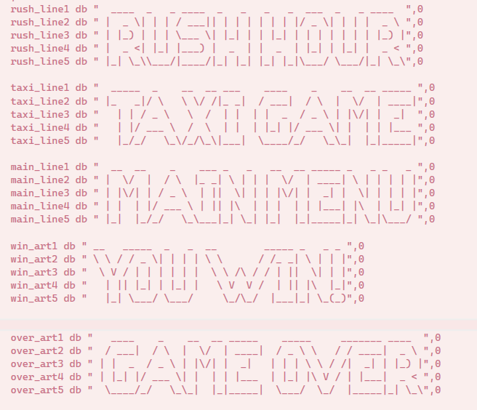

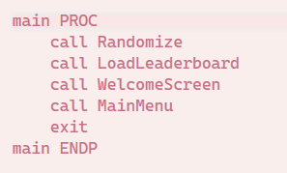
WelcomeScreen:
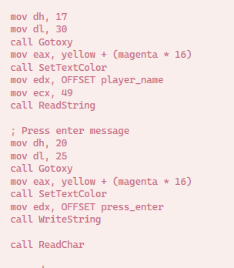
Taking user name input.
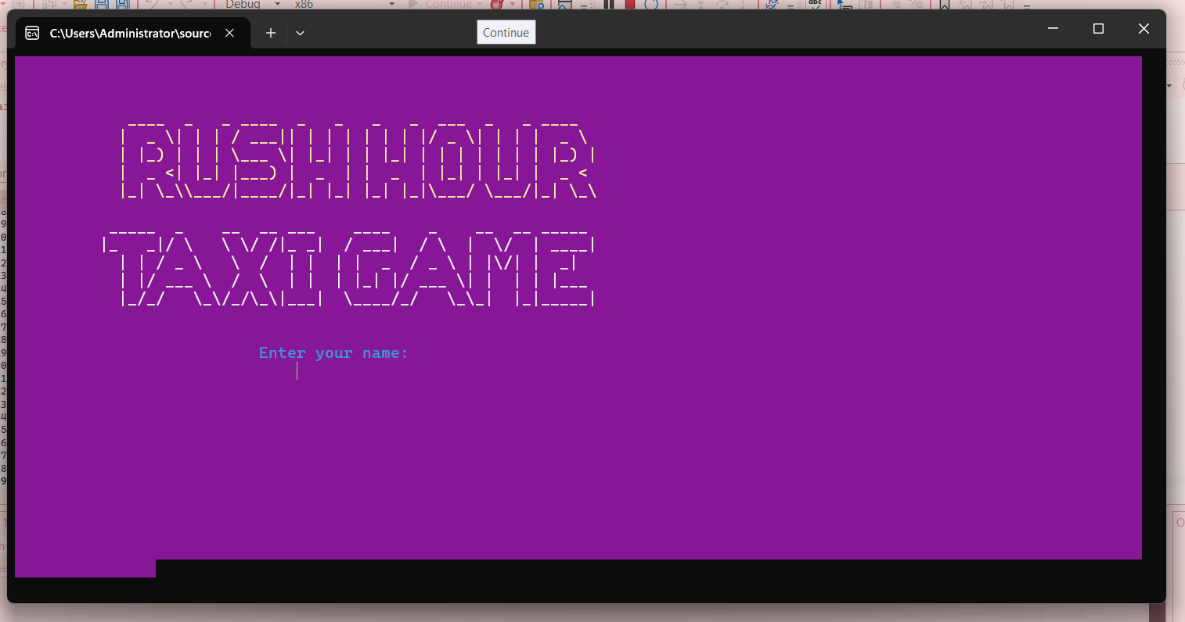
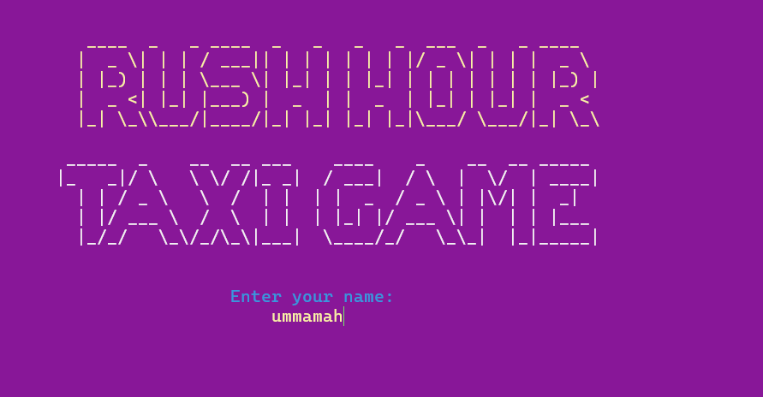
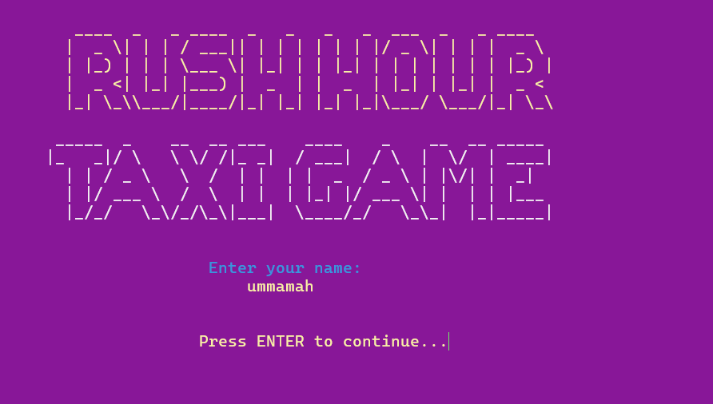

Main Menu Screen:

Box chars and background color code
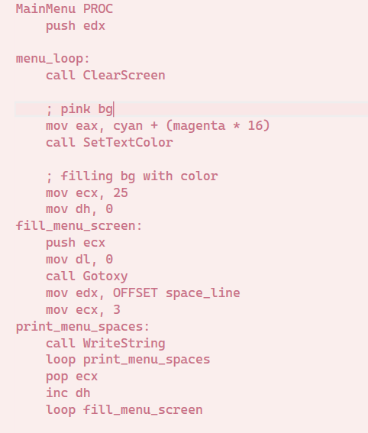
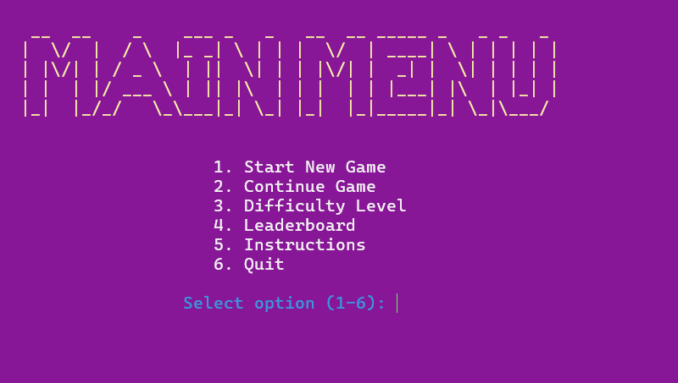
1.Start New Game :
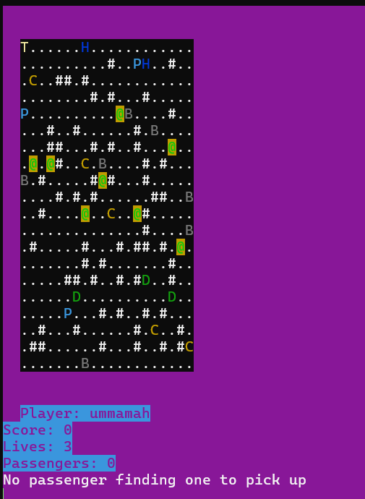
Difficulty level change :
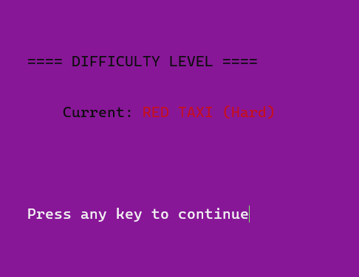
Instructions :
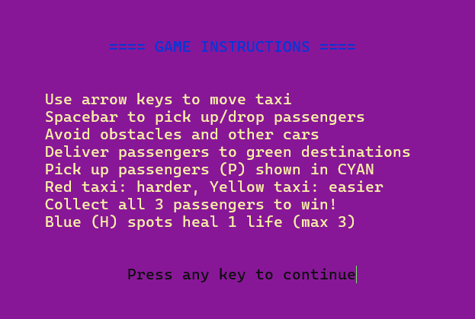
LeaderBoard:
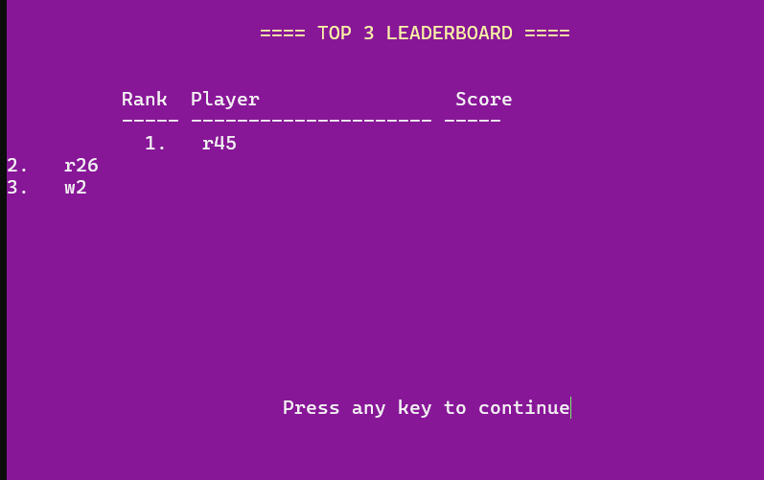
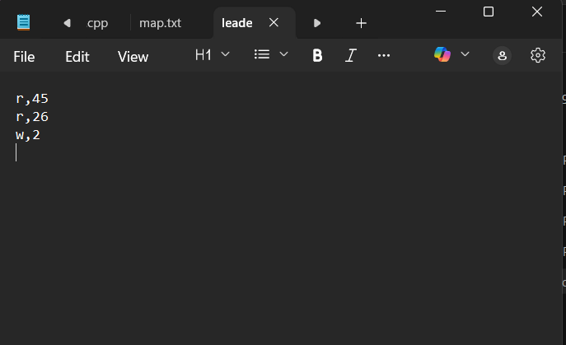

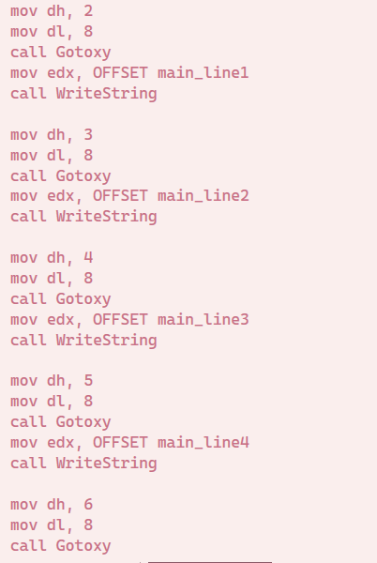
Game Loop:
user and game interaction Logic:
game_active is a type of bool variable to constantly check the status of game.

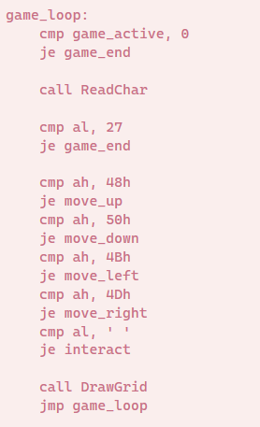
Did GridSize-1 for boundary checks 19 could’ve been hardCoded but it seemed unprofessional.
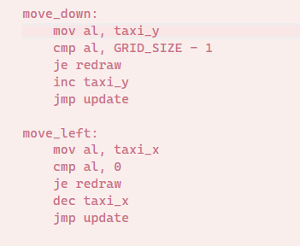

VIDEO LINK:
Easy:
https://drive.google.com/file/d/1M6eatYO8rg0XGEEgAM0UsFBANDNiI4dw/view?usp=drive_link
hard:
https://drive.google.com/file/d/1Jk67tXbrEIDMWihIaSL3IK3viQEhCzpP/view?usp=drive_link

Penalties :
There are a total of 2 modes yellow taxi easier and red taxi hard.
Red taxi:
Hits obstacle(B or @) -2 points.
Hits another Car(C) –3 points.
Yellow Taxi:
Hits obstacle(B or @) -4 points.
Hits another Car(C) –2 points.
For this requirement there is a healing spot (H) where it’s checked if the passengers' live is greater 0 and less then 3 it’s lives are made 3 (3 is max ) and is given 10 points. There are a total of two healing spots if one gets accessed it can’t be accessed again. H is accessible one time.

Code : if by any chance .asm gets corrupted
include Irvine32.inc

.stack 100h

.data
; Game constants
GRID_SIZE = 20
ROAD_CHAR = '.'
BUILDING_CHAR = '#'
TAXI_CHAR = 'T'
PASSENGER_CHAR = 'P'
DESTINATION_CHAR = 'D'
CAR_CHAR = 'C'
OBSTACLE_CHAR = 'O'
PARKING_CHAR = 'H' ; H inc lives by cmp with 0 & 3 , and inc score by 10

grid db GRID_SIZE * GRID_SIZE dup(0)
taxi_x db 0
taxi_y db 0
taxi_color db 14 ; Yellow
score dd 0
lives db 3
passengers_collected db 0

; for passenger data
passenger_x db 3 dup(0)
passenger_y db 3 dup(0)
passenger_dest_x db 3 dup(0)
passenger_dest_y db 3 dup(0)
passenger_active db 3 dup(0)
passenger_delivered db 3 dup(0)
current_passenger db -1

; npc
car_x db 5 dup(0)
car_y db 5 dup(0)
car_dx db 5 dup(0)
car_dy db 5 dup(0)

; H
parking_x db 2 dup(0)
parking_y db 2 dup(0)
parking_used db 2 dup(0)

; Player name
player_name db 50 dup(0)

; visuals
rush_line1 db " ____ _ _ ____ _ _ _ _ ___ _ _ ____ ",0
rush_line2 db " | _ \| | | / ___|| | | | | | | |/ _ \| | | | _ \ ",0
rush_line3 db " | |_) | | | \___ \| |_| | | |_| | | | | | | | |_) |",0
rush_line4 db " | _ <| |_| |___) | _ | | _ | |_| | |_| | _ < ",0
rush_line5 db " |_| \_\\___/|____/|_| |_| |_| |_|\___/ \___/|_| \_\",0

taxi_line1 db " _____ _ __ __ ___ ____ _ __ __ _____ ",0
taxi_line2 db " |_ _|/ \ \ \/ /|_ _| / ___| / \ | \/ | ____|",0
taxi_line3 db " | | / _ \ \ / | | | | _ / _ \ | |\/| | _| ",0
taxi_line4 db " | |/ ___ \ / \ | | | |_| |/ ___ \| | | | |___ ",0
taxi_line5 db " |_/_/ \_\/_/\_\|___| \____/_/ \_\_| |_|_____|",0

main_line1 db " __ __ _ ___ _ _ __ __ _____ _ _ _ _ ",0
main_line2 db " | \/ | / \ |_ _| \ | | | \/ | ____| \ | | | | |",0
main_line3 db " | |\/| | / _ \ | || \| | | |\/| | _| | \| | | | |",0
main_line4 db " | | | |/ ___ \ | || |\ | | | | | |___| |\ | |_| |",0
main_line5 db " |_| |_/_/ \_\___|_| \_| |_| |_|_____|_| \_|\___/ ",0

win_art1 db " __ _____ _ _ __ _____ _ _ _ ",0
win_art2 db " \ \ / / _ \| | | | \ \ / /_ _| \ | | |",0
win_art3 db " \ V / | | | | | | \ \ /\ / / | || \| | |",0
win_art4 db " | || |_| | |_| | \ V V / | || |\ |_|",0
win_art5 db " |_| \___/ \___/ \_/\_/ |___|_| \_(_)",0

over_art1 db " ____ _ __ __ _____ _____ _______ ____ ",0
over_art2 db " / ___| / \ | \/ | ____| / _ \ \ / / ____| _ \ ",0
over_art3 db " | | _ / _ \ | |\/| | _| | | | \ \ / /| _| | |_) |",0
over_art4 db " | |_| |/ ___ \| | | | |___ | |_| |\ V / | |___| _ < ",0
over_art5 db " \____/_/ \_\_| |_|_____| \___/ \_/ |_____|_| \_\",0

; declared some msgs to print
score_str db "Score: ",0
lives_str db "Lives: ",0
passengers_str db "Passengers: ",0
player_str db "Player: ",0
game_title db "RUSH HOUR GAME",0
menu1 db "1. Start New Game",0
menu2 db "2. Continue Game",0
menu3 db "3. Difficulty Level",0
menu4 db "4. Leaderboard",0
menu5 db "5. Instructions",0
menu6 db "6. Quit",0

; wlcome msgs
welcome_msg db "WELCOME TO",0
game_title_big db "RUSH HOUR TAXI GAME",0
enter_name_msg db "Enter your name: ",0
press_enter db "Press ENTER to continue...",0
menu_prompt db "Select option (1-6): ",0

; instructions
instructions_title db "==== GAME INSTRUCTIONS ====",0
instructions1 db "Use arrow keys to move taxi",0
instructions2 db "Spacebar to pick up/drop passengers",0
instructions3 db "Avoid obstacles and other cars",0
instructions4 db "Deliver passengers to green destinations",0
instructions5 db "Pick up passengers (P) shown in CYAN",0
instructions6 db "Red taxi: harder, Yellow taxi: easier",0
instructions7 db "Collect all 3 passengers to win!",0
instructions8 db "Blue (H) spots heal 1 life (max 3)",0

; difficlty chng
difficulty_title db "==== DIFFICULTY LEVEL ====",0
current_diff db "Current: ",0
yellow_taxi_txt db "YELLOW TAXI (Easy)",0
red_taxi_txt db "RED TAXI (Hard)",0
diff_changed db "Difficulty changed!",0

game_over_msg db "GAME OVER",0
win_msg db "YOU WIN!",0
press_any_key db "Press any key to continue",0
final_score db "Final Score: ",0
carrying_passenger db "Carrying passenger to destination",0
no_passenger_msg db "No passenger finding one to pick up",0
life_restored_msg db "Life restored at parking spot!",0

newline db 0Dh, 0Ah, 0
space_line db " ",0

; type of bool variable to check game is still running or not
game_active db 1

; filehandle
leaderboard_file db "leaderboard.txt",0
leaderboard_title db "==== TOP 3 LEADERBOARD ====",0
no_leaderboard_msg db "No leaderboard records found.",0
leaderboard_header db "Rank Player Score",0
leaderboard_separator db "----- --------------------- -----",0

lb_names db 3 dup(50 dup(0))
lb_scores dd 3 dup(0)
lb_count dd 0

; file handle
file_buffer db 1000 dup(0)
temp_score dd 0
temp_name db 50 dup(0)

TREE_CHAR = '@' ; tree
BOX_CHAR = 'B' ; box
car_color db 5 dup(0) ; any color other then yellow and red
tree_x db 10 dup(0)
tree_y db 10 dup(0)
box_x db 10 dup(0)
box_y db 10 dup(0)
hit_passenger_msg db "Hit passenger! -5 points",0

buffer1 BYTE 50 DUP(0)

;music using beeps

.code

;made clearscreen proc toreduce redundancy
ClearScreen PROC
push eax
push edx
call Clrscr
pop edx
pop eax
ret
ClearScreen ENDP

;initial page
WelcomeScreen PROC
push eax
push edx

call ClearScreen

; Set pink background with cyan text
mov eax, cyan + (magenta * 16)
call SetTextColor

; Fill screen with bg color
mov ecx, 25
mov dh, 0
fill_screen:
push ecx
mov dl, 0
call Gotoxy
mov edx, OFFSET space_line
mov ecx, 3
print_spaces:
call WriteString
loop print_spaces
pop ecx
inc dh
loop fill_screen

; printing the block writing rush hour
mov eax, yellow + (magenta * 16)
call SetTextColor

mov dh, 3
mov dl, 10
call Gotoxy
mov edx, OFFSET rush_line1
call WriteString

mov dh, 4
mov dl, 10
call Gotoxy
mov edx, OFFSET rush_line2
call WriteString

mov dh, 5
mov dl, 10
call Gotoxy
mov edx, OFFSET rush_line3
call WriteString

mov dh, 6
mov dl, 10
call Gotoxy
mov edx, OFFSET rush_line4
call WriteString

mov dh, 7
mov dl, 10
call Gotoxy
mov edx, OFFSET rush_line5
call WriteString

; Display TAXI GAME
mov eax, white + (magenta * 16)
call SetTextColor

mov dh, 9
mov dl, 8
call Gotoxy
mov edx, OFFSET taxi_line1
call WriteString

mov dh, 10
mov dl, 8
call Gotoxy
mov edx, OFFSET taxi_line2
call WriteString

mov dh, 11
mov dl, 8
call Gotoxy
mov edx, OFFSET taxi_line3
call WriteString

mov dh, 12
mov dl, 8
call Gotoxy
mov edx, OFFSET taxi_line4
call WriteString

mov dh, 13
mov dl, 8
call Gotoxy
mov edx, OFFSET taxi_line5
call WriteString

; Get player name
mov dh, 16
mov dl, 26
call Gotoxy
mov eax, cyan + (magenta * 16)
call SetTextColor
mov edx, OFFSET enter_name_msg
call WriteString

mov dh, 17
mov dl, 30
call Gotoxy
mov eax, yellow + (magenta * 16)
call SetTextColor
mov edx, OFFSET player_name
mov ecx, 49
call ReadString

; Press enter message
mov dh, 20
mov dl, 25
call Gotoxy
mov eax, yellow + (magenta * 16)
call SetTextColor
mov edx, OFFSET press_enter
call WriteString

call ReadChar

pop edx
pop eax
ret
WelcomeScreen ENDP

;printing instrs
ShowInstructions PROC
call ClearScreen

mov eax, Blue + (magenta * 16)
call SetTextColor

mov dh, 3
mov dl, 22
call Gotoxy
mov edx, OFFSET instructions_title
call WriteString

mov dh, 6
mov dl, 15
call Gotoxy
mov eax,yellow + (magenta * 16)
call SetTextColor
mov edx, OFFSET instructions1
call WriteString

mov dh, 7
mov dl, 15
call Gotoxy
mov edx, OFFSET instructions2
call WriteString

mov dh, 8
mov dl, 15
call Gotoxy
mov edx, OFFSET instructions3
call WriteString

mov dh, 9
mov dl, 15
call Gotoxy
mov edx, OFFSET instructions4
call WriteString

mov dh, 10
mov dl, 15
call Gotoxy
mov edx, OFFSET instructions5
call WriteString

mov dh, 11
mov dl, 15
call Gotoxy
mov edx, OFFSET instructions6
call WriteString

mov dh, 12
mov dl, 15
call Gotoxy
mov edx, OFFSET instructions7
call WriteString

mov dh, 13
mov dl, 15
call Gotoxy
mov edx, OFFSET instructions8
call WriteString

mov dh, 16
mov dl, 24
call Gotoxy
mov eax, Black + (magenta * 16)
call SetTextColor
mov edx, OFFSET press_any_key
call WriteString

call ReadChar
ret
ShowInstructions ENDP

;showing difficult ans changing it if user press it smthg
;two modes in tot one is easy that is taxi one the other hard the red taxi one

ShowDifficulty PROC
call ClearScreen

mov eax, Black + (magenta * 16)
call SetTextColor

mov dh, 8
mov dl, 24
call Gotoxy
mov edx, OFFSET difficulty_title
call WriteString

mov dh, 11
mov dl, 28
call Gotoxy
mov edx, OFFSET current_diff
call WriteString

; displ curr difficul befor chnging it
cmp taxi_color, 14
je show_yellow
mov eax, red + (magenta * 16)
call SetTextColor
mov edx, OFFSET red_taxi_txt
jmp print_diff
show_yellow:
mov eax, yellow + (magenta * 16)
call SetTextColor
mov edx, OFFSET yellow_taxi_txt
print_diff:
call WriteString

;wait for key press bfr chnging difficult
mov dh, 17
mov dl, 24
call Gotoxy
mov eax, white + (magenta * 16)
call SetTextColor
mov edx, OFFSET press_any_key
call WriteString

call ReadChar

; chnging difficul
cmp taxi_color, 14
jne set_yellow
mov taxi_color, 12 ; make to red taxi
jmp diff_done
set_yellow:
mov taxi_color, 14 ; make to lellow taxi

diff_done:
; making npc cars extra cars making them brown cause mehtioned in manual that they can be any color except red and yellow
mov ecx, 5
mov esi, 0
init_car_colors:
mov car_color[esi], 6 ; 6 is brown
inc esi
loop init_car_colors

call ClearScreen

mov eax, Black + (magenta * 16)
call SetTextColor

mov dh, 8
mov dl, 24
call Gotoxy
mov edx, OFFSET difficulty_title
call WriteString

mov dh, 11
mov dl, 28
call Gotoxy
mov edx, OFFSET current_diff
call WriteString

; displ new dfficult
cmp taxi_color, 14
je show_new_yellow
mov eax, red + (magenta * 16)
call SetTextColor
mov edx, OFFSET red_taxi_txt
jmp print_new_diff
show_new_yellow:
mov eax, yellow + (magenta * 16)
call SetTextColor
mov edx, OFFSET yellow_taxi_txt
print_new_diff:
call WriteString

mov dh, 14
mov dl, 26
call Gotoxy
mov eax, cyan + (magenta * 16)
call SetTextColor
mov edx, OFFSET diff_changed
call WriteString

mov dh, 17
mov dl, 24
call Gotoxy
mov eax, white + (magenta * 16)
call SetTextColor
mov edx, OFFSET press_any_key
call WriteString

call ReadChar
ret
ShowDifficulty ENDP

; making grid making it 20 cross 20 this was told by sir
InitializeGrid PROC
push eax
push ebx
push ecx
push edx
push esi
push edi

mov edi, OFFSET grid
mov ecx, GRID_SIZE * GRID_SIZE
mov al, ROAD_CHAR
;making roads
init_roads:
mov [edi], al
inc edi
loop init_roads

; how many times building hash to come
mov ecx, 90 ;made buildings a lil less because if i made them 35% then with boxes trees and C it looked wwway too congested and had really less spaces for taxi to movefor this porpose made it a lil less
mov esi, 0

;buildings randmizing them
place_buildings:
call RandomPosition
mov ebx, eax

mov al, [grid + ebx]
cmp al, ROAD_CHAR
jne skip_building

; checking for inaccessibility
push ebx
call CheckIfPositionBlocks
pop ebx
cmp al, 1
je skip_building ; skip if it'd create block area

mov byte ptr [grid + ebx], BUILDING_CHAR

skip_building:
inc esi
cmp esi, ecx
jl place_buildings

; H spots
mov ecx, 2
mov esi, 0
place_parking:
call FindEmptyRoadPosition
mov bl, al
mov bh, ah

mov parking_x[esi], bl
mov parking_y[esi], bh
mov parking_used[esi], 0

;putting H
mov eax, 0
mov al, bh
mov ebx, GRID_SIZE
mul ebx
mov dl, parking_x[esi]
mov dh, 0
add eax, edx
mov byte ptr [grid + eax], PARKING_CHAR

inc esi
loop place_parking

mov taxi_x, 0
mov taxi_y, 0

mov ecx, 3
mov esi, 0
place_passengers:
call FindEmptyRoadPosition
mov bl, al
mov bh, ah

mov passenger_x[esi], bl
mov passenger_y[esi], bh
mov passenger_active[esi], 1
mov passenger_delivered[esi], 0

call FindEmptyRoadPosition
mov bl, al
mov bh, ah

mov passenger_dest_x[esi], bl
mov passenger_dest_y[esi], bh

inc esi
loop place_passengers

mov ecx, 5
mov esi, 0
place_cars:
call FindEmptyRoadPosition
mov bl, al
mov bh, ah

mov car_x[esi], bl
mov car_y[esi], bh

mov eax, 3
call RandomRange
dec eax
mov car_dx[esi], al

mov eax, 3
call RandomRange
dec eax
mov car_dy[esi], al

inc esi
loop place_cars

mov ecx, 8
mov esi, 0
place_trees:
call FindEmptyRoadPosition
mov bl, al
mov bh, ah
mov tree_x[esi], bl
mov tree_y[esi], bh
inc esi
loop place_trees

; Place boxes
mov ecx, 8
mov esi, 0
place_boxes:
call FindEmptyRoadPosition
mov bl, al
mov bh, ah
mov box_x[esi], bl
mov box_y[esi], bh
inc esi
loop place_boxes

;cmp game loop to see if active or not

mov game_active, 1

pop edi
pop esi
pop edx
pop ecx
pop ebx
pop eax
ret
InitializeGrid ENDP

CheckIfPositionBlocks PROC
push ebx
push ecx
push edx
push esi

; convrt linear position to x,y coordinates
mov eax, ebx
xor edx, edx
mov ecx, GRID_SIZE
div ecx
; eax is y and edx is x

; check for boundaries not place buildings on the coners
cmp edx, 0
je position_blocks
cmp edx, 19
je position_blocks
cmp eax, 0
je position_blocks
cmp eax, 19
je position_blocks

; count surrounding buildings in 8 directions
xor esi, esi ; counter for surrounding buildings

; check for topleft
mov ecx, ebx
sub ecx, GRID_SIZE
dec ecx
cmp byte ptr [grid + ecx], BUILDING_CHAR
jne check_top
inc esi

check_top:
; check top
mov ecx, ebx
sub ecx, GRID_SIZE
cmp byte ptr [grid + ecx], BUILDING_CHAR
jne check_top_right
inc esi

check_top_right:
; Check topright
mov ecx, ebx
sub ecx, GRID_SIZE
inc ecx
cmp byte ptr [grid + ecx], BUILDING_CHAR
jne check_left
inc esi

check_left:
; check left
mov ecx, ebx
dec ecx
cmp byte ptr [grid + ecx], BUILDING_CHAR
jne check_right
inc esi

check_right:
; Check right
mov ecx, ebx
inc ecx
cmp byte ptr [grid + ecx], BUILDING_CHAR
jne check_bottom_left
inc esi

check_bottom_left:
; check bot left
mov ecx, ebx
add ecx, GRID_SIZE
dec ecx
cmp byte ptr [grid + ecx], BUILDING_CHAR
jne check_bottom
inc esi

check_bottom:
; check bot
mov ecx, ebx
add ecx, GRID_SIZE
cmp byte ptr [grid + ecx], BUILDING_CHAR
jne check_bottom_right
inc esi

check_bottom_right:
; check bot-right
mov ecx, ebx
add ecx, GRID_SIZE
inc ecx
cmp byte ptr [grid + ecx], BUILDING_CHAR
jne check_count
inc esi

check_count:
; if in any case 3 or more surrounding buildings, this'd create a blocked area
cmp esi, 3
jge position_blocks

mov al, 0 ; position is fien no issue
jmp check_done

position_blocks:
mov al, 1 ; pos would block access

check_done:
pop esi
pop edx
pop ecx
pop ebx
ret
CheckIfPositionBlocks ENDP

FindEmptyRoadPosition PROC
push ecx
push edx
push esi

find_position:
call RandomPosition
mov edx, eax

mov cl, [grid + edx]
cmp cl, ROAD_CHAR
jne find_position
cmp cl, PARKING_CHAR
je find_position

mov eax, edx
mov ebx, GRID_SIZE
xor edx, edx
div ebx

mov bl, dl
mov bh, al

mov cl, taxi_x
mov ch, taxi_y
cmp bl, cl
jne check_passengers
cmp bh, ch
je find_position

check_passengers:
mov ecx, 3
mov esi, 0
check_passengers_loop:
cmp passenger_active[esi], 0
je skip_passenger_check

mov dl, passenger_x[esi]
mov dh, passenger_y[esi]
cmp bl, dl
jne skip_passenger_check
cmp bh, dh
je find_position

skip_passenger_check:
inc esi
loop check_passengers_loop

mov ecx, 5
mov esi, 0
check_cars_loop:
mov dl, car_x[esi]
mov dh, car_y[esi]
cmp bl, dl
jne skip_car_check
cmp bh, dh
je find_position

skip_car_check:
inc esi
loop check_cars_loop

mov ecx, 2
mov esi, 0
check_parking_loop:
mov dl, parking_x[esi]
mov dh, parking_y[esi]
cmp bl, dl
jne skip_parking_check
cmp bh, dh
je find_position

skip_parking_check:
inc esi
loop check_parking_loop

; check trees
mov ecx, 8
mov esi, 0
check_trees_loop:
mov dl, tree_x[esi]
mov dh, tree_y[esi]
cmp bl, dl
jne skip_tree_check
cmp bh, dh
je find_position
skip_tree_check:
inc esi
loop check_trees_loop

; check for boxes B
mov ecx, 8
mov esi, 0
check_boxes_loop:
mov dl, box_x[esi]
mov dh, box_y[esi]
cmp bl, dl
jne skip_box_check
cmp bh, dh
je find_position
skip_box_check:
inc esi
loop check_boxes_loop

mov al, bl
mov ah, bh

pop esi
pop edx
pop ecx
ret
FindEmptyRoadPosition ENDP

RandomPosition PROC
mov eax, GRID_SIZE * GRID_SIZE
call RandomRange
ret
RandomPosition ENDP

DrawGrid PROC
push eax
push ebx
push ecx
push edx
push esi
push edi

call ClearScreen

mov ecx, GRID_SIZE
mov esi, 0

draw_rows:
push ecx
mov ecx, GRID_SIZE
mov edi, 0

draw_columns:
mov eax, esi
mov ebx, GRID_SIZE
mul ebx
add eax, edi

mov bl, [grid + eax]

movzx eax, taxi_x
cmp edi, eax
jne check_passenger_pos
movzx eax, taxi_y
cmp esi, eax
jne check_passenger_pos

mov bl, TAXI_CHAR
mov eax, yellow + (black * 16)
cmp taxi_color, 12
jne set_taxi_color
mov eax, red + (black * 16)
set_taxi_color:
jmp draw_char

check_passenger_pos:
push ecx
push esi
push edi
mov ecx, 3
xor ebx, ebx
check_passenger_draw:
cmp passenger_active[ebx], 0
je next_passenger_draw

movzx eax, passenger_x[ebx]
cmp edi, eax
jne next_passenger_draw

movzx eax, passenger_y[ebx]
cmp esi, eax
jne next_passenger_draw

mov bl, PASSENGER_CHAR
mov eax, cyan + (black * 16)
pop edi
pop esi
pop ecx
jmp draw_char

next_passenger_draw:
inc ebx
loop check_passenger_draw

mov ecx, 3
xor ebx, ebx
check_dest_draw:
cmp passenger_delivered[ebx], 1
je next_dest_draw

movzx eax, passenger_dest_x[ebx]
cmp edi, eax
jne next_dest_draw

movzx eax, passenger_dest_y[ebx]
cmp esi, eax
jne next_dest_draw

mov bl, DESTINATION_CHAR
mov eax, green + (black * 16)
pop edi
pop esi
pop ecx
jmp draw_char

next_dest_draw:
inc ebx
loop check_dest_draw

mov ecx, 5
xor ebx, ebx
check_car_draw:
movzx eax, car_x[ebx]
cmp edi, eax
jne next_car_draw

movzx eax, car_y[ebx]
cmp esi, eax
jne next_car_draw

mov bl, CAR_CHAR
; using brown color for NPC cars
mov eax, brown + (black * 16) ; Brown = 6
pop edi
pop esi
pop ecx
jmp draw_char

next_car_draw:
inc ebx
loop check_car_draw

; check for parking spots i.e H
mov ecx, 2
xor ebx, ebx
check_parking_draw:
movzx eax, parking_x[ebx]
cmp edi, eax
jne next_parking_draw

movzx eax, parking_y[ebx]
cmp esi, eax
jne next_parking_draw

mov bl, PARKING_CHAR
mov eax, blue + (black * 16)
pop edi
pop esi
pop ecx
jmp draw_char

next_parking_draw:
inc ebx
loop check_parking_draw

; puttuing check for trees
mov ecx, 8
xor ebx, ebx
check_tree_draw:
movzx eax, tree_x[ebx]
cmp edi, eax
jne next_tree_draw
movzx eax, tree_y[ebx]
cmp esi, eax
jne next_tree_draw
mov bl, TREE_CHAR
mov eax, lightgreen + (brown * 16)
pop edi
pop esi
pop ecx
jmp draw_char
next_tree_draw:
inc ebx
loop check_tree_draw

mov ecx, 8
xor ebx, ebx
check_box_draw:
movzx eax, box_x[ebx]
cmp edi, eax
jne next_box_draw
movzx eax, box_y[ebx]
cmp esi, eax
jne next_box_draw
mov bl, BOX_CHAR
mov eax, 8 + (black * 16) ; Gray color
pop edi
pop esi
pop ecx
jmp draw_char
next_box_draw:
inc ebx
loop check_box_draw

pop edi
pop esi
pop ecx

mov eax, esi
mov ebx, GRID_SIZE
mul ebx
add eax, edi
mov bl, [grid + eax]

cmp bl, BUILDING_CHAR
jne is_road
mov eax, white + (black * 16)
jmp draw_char

is_road:
mov eax, white + (black * 16)

draw_char:
call SetTextColor

push edx
push eax

mov eax, esi
mov dh, al
add dh, 2

mov eax, edi
mov dl, al
add dl, 2

call Gotoxy

pop eax
mov al, bl
call WriteChar
pop edx

inc edi
dec ecx
cmp ecx, 0
jne draw_columns

call Crlf
pop ecx
inc esi
dec ecx
cmp ecx, 0
jne draw_rows

mov dh, GRID_SIZE + 4
mov dl, 2
call Gotoxy

mov eax, magenta + (cyan * 16)
call SetTextColor

mov edx, OFFSET player_str
call WriteString
mov edx, OFFSET player_name
call WriteString
call Crlf

mov edx, OFFSET score_str
call WriteString
mov eax, score
call WriteDec
call Crlf

mov edx, OFFSET lives_str
call WriteString
movzx eax, lives
call WriteDec
call Crlf

mov edx, OFFSET passengers_str
call WriteString
movzx eax, passengers_collected
call WriteDec
call Crlf

mov eax, white + (magenta * 16)
call SetTextColor
cmp current_passenger, -1
je no_passenger
mov edx, OFFSET carrying_passenger
call WriteString
jmp passenger_done
no_passenger:
mov edx, OFFSET no_passenger_msg
call WriteString
passenger_done:
call Crlf

pop edi
pop esi
pop edx
pop ecx
pop ebx
pop eax
ret
DrawGrid ENDP

CheckParking PROC
push eax
push ebx
push ecx
push edx
push esi

; check if taxi is on any parking spot
mov ecx, 2
mov esi, 0

check_parking_loop:
; if this H spot used or not
cmp parking_used[esi], 1
je next_parking_check

; T on H or not
mov al, taxi_x
cmp al, parking_x[esi]
jne next_parking_check

mov al, taxi_y
cmp al, parking_y[esi]
jne next_parking_check

; H wont work if lives are 0 (at zero game khatam)
mov al, lives
cmp al, 0
jle next_parking_check ; no lives game end :p

; ALWAYS add 10 points when landing on H
mov eax, score
add eax, 10
mov score, eax

; Inc lives if not already at max (3)
mov al, lives
cmp al, 3
jge mark_spot_used ; alr at max, don't increase lives

; inc lifes but can't go above 3
inc lives

mark_spot_used:
; Mark this H spot as used so it can't be used again
mov parking_used[esi], 1

; display restore msg
mov dh, GRID_SIZE + 9
mov dl, 2
call Gotoxy
mov eax, green + (black * 16)
call SetTextColor
mov edx, OFFSET life_restored_msg
call WriteString

jmp parking_done

next_parking_check:
inc esi
loop check_parking_loop

parking_done:
pop esi
pop edx
pop ecx
pop ebx
pop eax
ret
CheckParking ENDP

UpdateGame PROC
push eax
push ebx
push ecx
push edx
push esi
push edi

cmp game_active, 0
je update_done

call CheckParking ; check for parking spot healing
call CheckCollisions
call CheckPassengerInteraction

update_done:
pop edi
pop esi
pop edx
pop ecx
pop ebx
pop eax
ret
UpdateGame ENDP

CheckCollisions PROC
push eax
push ebx
push ecx
push edx
push esi

; check for tree collisions
mov ecx, 8
mov esi, 0
check_tree_collision:
mov al, taxi_x
cmp al, tree_x[esi]
jne next_tree_check
mov al, taxi_y
cmp al, tree_y[esi]
jne next_tree_check

; Tree collision diff penalties based on taxi color
cmp taxi_color, 12
jne yellow_tree_hit

; red taxi hits tree then -2 points
mov eax, score
cmp eax, 2
jl red_tree_zero
sub eax, 2
jmp tree_score_done
red_tree_zero:
mov eax, 0
jmp tree_score_done

yellow_tree_hit:
; yellow taxi hits tree -4 points
mov eax, score
cmp eax, 4
jl yellow_tree_zero
sub eax, 4
jmp tree_score_done
yellow_tree_zero:
mov eax, 0

tree_score_done:
mov score, eax
jmp handle_lives_loss

next_tree_check:
inc esi
loop check_tree_collision

; check B collisionss
mov ecx, 8
mov esi, 0
check_box_collision:
mov al, taxi_x
cmp al, box_x[esi]
jne next_box_check
mov al, taxi_y
cmp al, box_y[esi]
jne next_box_check

; same penalties as abv
cmp taxi_color, 12
jne yellow_box_hit

; red taxi hits box -2 points
mov eax, score
cmp eax, 2
jl red_box_zero
sub eax, 2
jmp box_score_done
red_box_zero:
mov eax, 0
jmp box_score_done

yellow_box_hit:
; yellow taxi hits box -4 points
mov eax, score
cmp eax, 4
jl yellow_box_zero
sub eax, 4
jmp box_score_done
yellow_box_zero:
mov eax, 0

box_score_done:
mov score, eax
jmp handle_lives_loss

next_box_check:
inc esi
loop check_box_collision

; Check car collisions
mov ecx, 5
mov esi, 0
check_cars_collision:
mov al, taxi_x
cmp al, car_x[esi]
jne next_car_check
mov al, taxi_y
cmp al, car_y[esi]
jne next_car_check

; car collision diff penalties based on taxi color
cmp taxi_color, 12
jne yellow_car_hit

; red taxi hits car -3 points
mov eax, score
cmp eax, 3
jl red_car_zero
sub eax, 3
jmp car_score_done
red_car_zero:
mov eax, 0
jmp car_score_done

yellow_car_hit:
; yellow taxi hits car -2 points
mov eax, score
cmp eax, 2
jl yellow_car_zero
sub eax, 2
jmp car_score_done
yellow_car_zero:
mov eax, 0

car_score_done:
mov score, eax
jmp handle_lives_loss

next_car_check:
inc esi
loop check_cars_collision

; Check building collision
mov eax, 0
mov al, taxi_y
mov ebx, GRID_SIZE
mul ebx
mov bl, taxi_x
mov bh, 0
add eax, ebx

mov cl, [grid + eax]
cmp cl, BUILDING_CHAR
jne no_collision

; building collisions same as abv
cmp taxi_color, 12
jne yellow_building_hit

; red taxi hits building -2 points
mov eax, score
cmp eax, 2
jl red_building_zero
sub eax, 2
jmp building_score_done
red_building_zero:
mov eax, 0
jmp building_score_done

yellow_building_hit:
; yellow taxi hits building -4 points
mov eax, score
cmp eax, 4
jl yellow_building_zero
sub eax, 4
jmp building_score_done
yellow_building_zero:
mov eax, 0

building_score_done:
mov score, eax

handle_lives_loss:
dec lives
cmp lives, 0
jle game_over_collision

collision_handled:
mov taxi_x, 0
mov taxi_y, 0

no_collision:
pop esi
pop edx
pop ecx
pop ebx
pop eax
ret

game_over_collision:
mov game_active, 0
call GameOverScreen
pop esi
pop edx
pop ecx
pop ebx
pop eax
ret
CheckCollisions ENDP

CheckPassengerInteraction PROC
push eax
push ebx
push ecx
push edx
push esi

movzx eax, current_passenger
cmp al, 255
jne check_dropoff

mov ecx, 3
mov esi, 0
check_pickup_loop:
cmp passenger_active[esi], 0
je next_passenger_check
cmp passenger_delivered[esi], 1
je next_passenger_check

mov al, taxi_x
mov bl, passenger_x[esi]
cmp al, bl
jne next_passenger_check

mov al, taxi_y
mov bl, passenger_y[esi]
cmp al, bl
jne next_passenger_check

;p picked up
mov eax, esi
mov current_passenger, al
mov passenger_active[esi], 0
jmp interaction_done

next_passenger_check:
inc esi
loop check_pickup_loop
jmp interaction_done

check_dropoff:
movzx esi, current_passenger

cmp esi, 3
jae interaction_done

mov al, taxi_x
mov bl, passenger_dest_x[esi]
cmp al, bl
jne interaction_done

mov al, taxi_y
mov bl, passenger_dest_y[esi]
cmp al, bl
jne interaction_done

mov passenger_delivered[esi], 1

mov eax, score
add eax, 10
mov score, eax

mov al, passengers_collected
inc al
mov passengers_collected, al

mov current_passenger, 255

cmp al, 3
jge level_complete
jmp interaction_done

level_complete:
mov game_active, 0
call LevelCompleteScreen

interaction_done:
pop esi
pop edx
pop ecx
pop ebx
pop eax
ret
CheckPassengerInteraction ENDP

GameLoop PROC
push eax

call DrawGrid

game_loop:
cmp game_active, 0
je game_end

call ReadChar

cmp al, 27
je game_end

cmp ah, 48h
je move_up
cmp ah, 50h
je move_down
cmp ah, 4Bh
je move_left
cmp ah, 4Dh
je move_right
cmp al, ' '
je interact

call DrawGrid
jmp game_loop

move_up:
mov al, taxi_y
cmp al, 0
je redraw
dec taxi_y
jmp update

move_down:
mov al, taxi_y
cmp al, GRID_SIZE - 1
je redraw
inc taxi_y
jmp update

move_left:
mov al, taxi_x
cmp al, 0
je redraw
dec taxi_x
jmp update

move_right:
mov al, taxi_x
cmp al, GRID_SIZE - 1
je redraw
inc taxi_x
jmp update

interact:
jmp update

update:
call UpdateGame

redraw:
call DrawGrid
jmp game_loop

game_end:
pop eax
ret
GameLoop ENDP

GameOverScreen PROC
call ClearScreen

; pink bg
mov eax, yellow + (magenta * 16)
call SetTextColor

; filled screen with bg color
mov ecx, 25
mov dh, 0
fill_over_screen:
push ecx
mov dl, 0
call Gotoxy
mov edx, OFFSET space_line
mov ecx, 3
print_over_spaces:
call WriteString
loop print_over_spaces
pop ecx
inc dh
loop fill_over_screen

mov eax, red + (magenta * 16)
call SetTextColor

;hardcoding vals to be more prcise with placemnets
mov dh, 6
mov dl, 6
call Gotoxy
mov edx, OFFSET over_art1
call WriteString

mov dh, 7
mov dl, 6
call Gotoxy
mov edx, OFFSET over_art2
call WriteString

mov dh, 8
mov dl, 6
call Gotoxy
mov edx, OFFSET over_art3
call WriteString

mov dh, 9
mov dl, 6
call Gotoxy
mov edx, OFFSET over_art4
call WriteString

mov dh, 10
mov dl, 6
call Gotoxy
mov edx, OFFSET over_art5
call WriteString
;hardcoding vals just to be as accurate with the placement of stuff as possible
; display final score
mov dh, 14
mov dl, 28
call Gotoxy
mov eax, yellow + (magenta * 16)
call SetTextColor
mov edx, OFFSET final_score
call WriteString
mov eax, score
call WriteDec

; update leaderboard
call UpdateLeaderboard

; press any key
mov dh, 18
mov dl, 24
call Gotoxy
mov eax, white + (magenta * 16)
call SetTextColor
mov edx, OFFSET press_any_key
call WriteString

call ReadChar
ret
GameOverScreen ENDP

LevelCompleteScreen PROC
call ClearScreen

mov eax, yellow + (magenta * 16)
call SetTextColor

; fill screen with bg color
mov ecx, 25
mov dh, 0
fill_win_screen:
push ecx
mov dl, 0
call Gotoxy
mov edx, OFFSET space_line
mov ecx, 3
print_win_spaces:
call WriteString
loop print_win_spaces
pop ecx
inc dh
loop fill_win_screen

; win box chars
mov eax, green + (magenta * 16)
call SetTextColor

mov dh, 7
mov dl, 12
call Gotoxy
mov edx, OFFSET win_art1
call WriteString

mov dh, 8
mov dl, 12
call Gotoxy
mov edx, OFFSET win_art2
call WriteString

mov dh, 9
mov dl, 12
call Gotoxy
mov edx, OFFSET win_art3
call WriteString

mov dh, 10
mov dl, 12
call Gotoxy
mov edx, OFFSET win_art4
call WriteString

mov dh, 11
mov dl, 12
call Gotoxy
mov edx, OFFSET win_art5
call WriteString

; display congrats msg
mov dh, 14
mov dl, 20
call Gotoxy
mov eax, yellow + (magenta * 16)
call SetTextColor
mov edx, OFFSET final_score
call WriteString
mov eax, score
call WriteDec

; update leaderboard
call UpdateLeaderboard

; press any key
mov dh, 18
mov dl, 24
call Gotoxy
mov eax, white + (magenta * 16)
call SetTextColor
mov edx, OFFSET press_any_key
call WriteString

call ReadChar
ret
LevelCompleteScreen ENDP

; file handle stuff
StrToInt PROC
push ebx
push ecx
push edx
push esi

xor eax, eax ; result = 0
xor ebx, ebx ; temp for digit
mov esi, edx ; esi points to strg

next_digit:
mov bl, [esi] ; get char
test bl, bl ; check for null char
je done_convert
cmp bl, 13 ;
je done_convert
cmp bl, 10 ;
je done_convert
cmp bl, ',' ; check for ,
je done_convert

cmp bl, '0' ; check if valid digit
jb done_convert
cmp bl, '9'
ja done_convert

sub bl, '0' ;covert ascii to num
push edx
mov edx, 10
push ebx
mov ebx, edx
mul ebx
pop ebx
pop edx
add eax, ebx ; additon for the digit
inc esi ; next char
jmp next_digit
;proper behavior can be seen in videos attched
done_convert:
pop esi
pop edx
pop ecx
pop ebx
ret
StrToInt ENDP

; convert number in EAX to string in buffer1
NumToStr PROC
push ebx
push ecx
push edx
push edi

mov edi, OFFSET buffer1
add edi, 49 ; points to the end of the buffer end of buffer
mov byte ptr [edi], 0 ; null terminate the one we put
dec edi

mov ebx, 10
mov ecx, 0 ; digit count

cmp eax, 0
jne convert_digits

; special case for zero
mov byte ptr [edi], '0'
dec edi
inc ecx
jmp finish_convert

convert_digits:
xor edx, edx
div ebx ; EAX = EAX / 10, EDX = remainder
add dl, '0' ; convert to ascii val
mov [edi], dl
dec edi
inc ecx
test eax, eax
jnz convert_digits

finish_convert:
inc edi ; point to first digi
mov eax, edi ; return ptr in EAX

pop edi
pop edx
pop ecx
pop ebx
ret
NumToStr ENDP

; Sort the leaderboard in descend order
SortLeaderboard PROC
push eax
push ebx
push ecx
push edx
push esi
push edi

mov ecx, 3 ; outer loop 3 passes

outer_loop:
push ecx
mov ebx, 0 ; inner loop count saving

inner_loop:
cmp ebx, 2 ; cmp up to second-to-last entry
jge outer_continue

; comparing scores for putting in file
mov eax, ebx
mov edx, 4
mul edx
lea esi, lb_scores
add esi, eax
mov eax, [esi] ; curr score
mov edi, [esi+4] ; next score

cmp eax, edi
jge no_swap ; if curr >= next that means no swap neededd

; Swap scores
mov [esi], edi
mov [esi+4], eax

; Swap names
push ebx
mov eax, ebx
mov edx, 50
mul edx
lea esi, lb_names
add esi, eax
lea edi, temp_name
mov ecx, 50
rep movsb ; copy curr name to temp

pop ebx
push ebx

; copy next name to currt pos
mov eax, ebx
inc eax
mov edx, 50
mul edx
lea esi, lb_names
add esi, eax

mov eax, ebx
mov edx, 50
mul edx
lea edi, lb_names
add edi, eax
mov ecx, 50
rep movsb

; copy temp to next pos
pop ebx
push ebx
mov eax, ebx
inc eax
mov edx, 50
mul edx
lea edi, lb_names
add edi, eax
lea esi, temp_name
mov ecx, 50
rep movsb

pop ebx
; no swapping to do for if we did got any higher score pep
no_swap:
inc ebx
jmp inner_loop

outer_continue:
pop ecx
dec ecx ; dec countr
cmp ecx, 0 ; condition to check for if doen
jne outer_loop ; contin if not zero

pop edi
pop esi
pop edx
pop ecx
pop ebx
pop eax
ret
SortLeaderboard ENDP

; load leaderboard from file
LoadLeaderboard PROC
push eax
push ebx
push ecx
push edx
push esi
push edi

;making lb arrays emptys
lea edi, lb_names
mov ecx, 150 ; 3 names * 50 bytes
xor al, al
rep stosb

lea edi, lb_scores
mov ecx, 3
xor eax, eax
clear_scores:
stosd
loop clear_scores

mov lb_count, 0

; open file
lea edx, leaderboard_file
call OpenInputFile
cmp eax, INVALID_HANDLE_VALUE
je load_failed

mov ebx, eax ; save file handle

; Clear file buffer
lea edi, file_buffer
mov ecx, 1000
xor al, al
rep stosb

; Read file
mov eax, ebx
lea edx, file_buffer
mov ecx, 999
call ReadFromFile

push eax ; save bytes read
mov eax, ebx
call CloseFile
pop eax

cmp eax, 0
jle load_failed

; Parse buffer
lea esi, file_buffer
xor edi, edi ; entry countr

parse_entry:
cmp edi, 3
jge parse_done

mov al, [esi]
cmp al, 0
je parse_done
cmp al, 13
je skip_char
cmp al, 10
je skip_char

; read name
push edi
mov eax, edi
mov ebx, 50
mul ebx
mov edi, eax
lea edi, [lb_names + edi]

read_name:
mov al, [esi]
cmp al, ','
je name_done
cmp al, 0
je parse_done_pop
cmp al, 13
je parse_done_pop
cmp al, 10
je parse_done_pop

mov [edi], al
inc esi
inc edi
jmp read_name

name_done:
mov byte ptr [edi], 0
inc esi ; skip ,
pop edi

; Read score
mov edx, esi
call StrToInt ; convert score str to num

push edi
mov ebx, edi
mov edi, 4
mov ecx, ebx
mov ebx, ecx
mul edi
mov edi, eax
mov eax, ecx
mov ebx, 4
mul ebx
mov ecx, eax
pop edi

push edi
push eax
mov eax, edi
mov ebx, 4
mul ebx
lea edi, lb_scores
add edi, eax
pop eax

; get score val again
push esi
mov edx, esi
call StrToInt
mov [edi], eax
pop esi
pop edi

; moving to new line
skip_line:
mov al, [esi]
cmp al, 0
je parse_done
inc esi
cmp al, 10
jne skip_line

inc edi
jmp parse_entry

skip_char:
inc esi
jmp parse_entry

parse_done_pop:
pop edi
inc edi

parse_done:
mov lb_count, edi
jmp load_exit

load_failed:
mov lb_count, 0

load_exit:
pop edi
pop esi
pop edx
pop ecx
pop ebx
pop eax
ret
LoadLeaderboard ENDP

; Save leaderboard to file
SaveLeaderboard PROC
push eax
push ebx
push ecx
push edx
push esi
push edi

; Open/create file
lea edx, leaderboard_file
call CreateOutputFile
cmp eax, INVALID_HANDLE_VALUE
je save_failed

mov ebx, eax ; Save file handle

; Clear file buffer
lea edi, file_buffer
mov ecx, 1000
xor al, al
rep stosb

; Build file content
lea edi, file_buffer
xor esi, esi

write_entry:
cmp esi, lb_count
jge write_file
cmp esi, 3
jge write_file

; Write name
push esi
mov eax, esi
mov ecx, 50
mul ecx
lea edx, lb_names
add edx, eax

copy_name:
mov al, [edx]
cmp al, 0
je name_copied
mov [edi], al
inc edx
inc edi
jmp copy_name

name_copied:
;put comma
mov byte ptr [edi], ','
inc edi

; writingw scoreee
pop esi
push esi
mov eax, esi
mov ecx, 4
mul ecx
lea edx, lb_scores
add edx, eax
mov eax, [edx]

call NumToStr ; conversion

; copy score str
mov edx, eax
copy_score:
mov al, [edx]
cmp al, 0
je score_copied
mov [edi], al
inc edx
inc edi
jmp copy_score

score_copied:
; newl score
mov byte ptr [edi], 13
inc edi
mov byte ptr [edi], 10
inc edi

pop esi
inc esi
jmp write_entry

write_file:
; calc length
mov byte ptr [edi], 0
lea eax, file_buffer
sub edi, eax
mov ecx, edi

; wite in file
mov eax, ebx
lea edx, file_buffer
call WriteToFile

; close file
mov eax, ebx
call CloseFile

save_failed:
pop edi
pop esi
pop edx
pop ecx
pop ebx
pop eax
ret
SaveLeaderboard ENDP

; update with new leaderboard scor
UpdateLeaderboard PROC
push eax
push ebx
push ecx
push edx
push esi
push edi

; load alr present leaderboard
call LoadLeaderboard

; where to put score
xor esi, esi
mov eax, score

find_insert_pos:
cmp esi, lb_count
jge insert_at_pos
cmp esi, 3
jge check_replace

push esi
mov eax, esi
mov ebx, 4
mul ebx
lea edx, lb_scores
add edx, eax
mov eax, score
mov ecx, [edx]
pop esi

cmp eax, ecx
jg insert_at_pos

inc esi
jmp find_insert_pos

check_replace:
; If we have 3 entries and new score doesnt make top 3, don't add
cmp lb_count, 3
jge update_done

insert_at_pos:
; Shift entries down
mov edi, lb_count
cmp edi, 3
jl shift_entries
mov edi, 2 ; keeping only top 3 top 10 was hard for me to handle

shift_entries:
cmp edi, esi
jle insert_new

; shift score
push esi
mov eax, edi
dec eax
mov ebx, 4
mul ebx
lea edx, lb_scores
add edx, eax
mov ecx, [edx]

mov eax, edi
mov ebx, 4
mul ebx
lea edx, lb_scores
add edx, eax
mov [edx], ecx
pop esi

; shift name
push esi
push edi

mov eax, edi
dec eax
mov ebx, 50
mul ebx
lea esi, lb_names
add esi, eax

mov eax, edi
mov ebx, 50
mul ebx
lea edi, lb_names
add edi, eax

mov ecx, 50
rep movsb

pop edi
pop esi

dec edi
jmp shift_entries

insert_new:
; putting new name
mov eax, esi
mov ebx, 4
mul ebx
lea edx, lb_scores
add edx, eax
mov eax, score
mov [edx], eax

; putting new name
push esi
mov eax, esi
mov ebx, 50
mul ebx
lea edi, lb_names
add edi, eax
lea esi, player_name
mov ecx, 50
rep movsb
pop esi

; updating cnt
mov eax, lb_count
cmp eax, 3
jge save_board
inc eax
mov lb_count, eax

save_board:
; save to file
call SaveLeaderboard

update_done:
pop edi
pop esi
pop edx
pop ecx
pop ebx
pop eax
ret
UpdateLeaderboard ENDP

; display leaderboard
; video attched cearly shows how the leaderboard works and sorts accordingy
ShowLeaderboard PROC
push eax
push ebx
push ecx
push edx
push esi

call ClearScreen
call LoadLeaderboard

; set bg
mov eax, cyan + (magenta * 16)
call SetTextColor

; fill scre
mov ecx, 25
mov dh, 0
fill_lb_screen:
push ecx
mov dl, 0
call Gotoxy
lea edx, space_line
mov ecx, 3
print_lb_spaces:
call WriteString
loop print_lb_spaces
pop ecx
inc dh
loop fill_lb_screen

; title Display
mov dh, 3
mov dl, 22
call Gotoxy
mov eax, yellow + (magenta * 16)
call SetTextColor
lea edx, leaderboard_title
call WriteString

; check if nthg is there
cmp lb_count, 0
jne show_records

mov dh, 8
mov dl, 20
call Gotoxy
mov eax, white + (magenta * 16)
call SetTextColor
lea edx, no_leaderboard_msg
call WriteString
jmp lb_done

show_records:
; Display header
mov dh, 6
mov dl, 10
call Gotoxy
mov eax, white + (magenta * 16)
call SetTextColor
lea edx, leaderboard_header
call WriteString

mov dh, 7
mov dl, 10
call Gotoxy
lea edx, leaderboard_separator
call WriteString

; dsiplay at next row
xor esi, esi
mov dh, 8 ; Start at row 8

display_entry:
cmp esi, lb_count
jge lb_done
cmp esi, 3
jge lb_done

; setting curspr
mov dl, 12
call Gotoxy

mov eax, white + (magenta * 16)
call SetTextColor

; display rank
mov eax, esi
inc eax
call WriteDec

; aading spaces and .
mov al, '.'
call WriteChar
mov al, ' '
call WriteChar
call WriteChar
call WriteChar

; display
push esi
mov eax, esi
mov ebx, 50
mul ebx
lea edx, lb_names
add edx, eax
call WriteString
pop esi

; put cursor to the point you last places the score
mov dl, 40
call Gotoxy

; disply score
push esi
push edx
mov eax, esi
mov ebx, 4
mul ebx
lea edx, lb_scores
add edx, eax
mov eax, [edx]
call WriteDec
pop edx
pop esi

; going to next line
inc dh
inc esi
call Crlf
jmp display_entry

lb_done:
mov dh, 20
mov dl, 24
call Gotoxy
mov eax, white + (magenta * 16)
call SetTextColor
lea edx, press_any_key
call WriteString

call ReadChar

pop esi
pop edx
pop ecx
pop ebx
pop eax
ret
ShowLeaderboard ENDP

MainMenu PROC
push edx

menu_loop:
call ClearScreen

; pink bg
mov eax, cyan + (magenta * 16)
call SetTextColor

; filling bg with color
mov ecx, 25
mov dh, 0
fill_menu_screen:
push ecx
mov dl, 0
call Gotoxy
mov edx, OFFSET space_line
mov ecx, 3
print_menu_spaces:
call WriteString
loop print_menu_spaces
pop ecx
inc dh
loop fill_menu_screen

; main menu box chars
mov eax, yellow + (magenta * 16)
call SetTextColor

mov dh, 2
mov dl, 8
call Gotoxy
mov edx, OFFSET main_line1
call WriteString

mov dh, 3
mov dl, 8
call Gotoxy
mov edx, OFFSET main_line2
call WriteString

mov dh, 4
mov dl, 8
call Gotoxy
mov edx, OFFSET main_line3
call WriteString

mov dh, 5
mov dl, 8
call Gotoxy
mov edx, OFFSET main_line4
call WriteString

mov dh, 6
mov dl, 8
call Gotoxy
mov edx, OFFSET main_line5
call WriteString

; display menu opts
mov dh, 9
mov dl, 28
call Gotoxy
mov eax, white + (magenta * 16)
call SetTextColor
mov edx, OFFSET menu1
call WriteString

mov dh, 10
mov dl, 28
call Gotoxy
mov edx, OFFSET menu2
call WriteString

mov dh, 11
mov dl, 28
call Gotoxy
mov edx, OFFSET menu3
call WriteString

mov dh, 12
mov dl, 28
call Gotoxy
mov edx, OFFSET menu4
call WriteString

mov dh, 13
mov dl, 28
call Gotoxy
mov edx, OFFSET menu5
call WriteString

mov dh, 14
mov dl, 28
call Gotoxy
mov edx, OFFSET menu6
call WriteString

;hardcode vals to be precise
mov dh, 16
mov dl, 25
call Gotoxy
mov eax, cyan + (magenta * 16)
call SetTextColor
mov edx, OFFSET menu_prompt
call WriteString

call ReadChar
;taking user input and proceeding game acc

cmp al, '1'
je start_new_game
cmp al, '2'
je continue_game
cmp al, '3'
je difficulty_menu
cmp al, '4'
je show_leaderboard
cmp al, '5'
je show_instructions
cmp al, '6'
je quit_program

jmp menu_loop

;initial scor is zero lives are 3 thats complexity
start_new_game:
call InitializeGrid
mov score, 0
mov lives, 3
mov passengers_collected, 0
mov current_passenger, -1
call GameLoop
jmp menu_loop

; if in between player esc thn if it presses continue game it takes it exaclty whre is left and let it resume
continue_game:
cmp game_active, 0
je menu_loop
call GameLoop
jmp menu_loop

;difficult levels red is hard yellow is easy both differ in reduction of oints upon collisons with the obstacles
difficulty_menu:
call ShowDifficulty
jmp menu_loop

show_leaderboard:
call ShowLeaderboard
jmp menu_loop

;intructions to tell the player
show_instructions:
call ShowInstructions
jmp menu_loop

; ending game
quit_program:
pop edx
ret
MainMenu ENDP

main PROC
call Randomize
call LoadLeaderboard
call WelcomeScreen
call MainMenu
exit
main ENDP

END main
;explained a somestuff side by side with code. detailed code explanation along with screenshots have been added in my report

