MONITORING
1.Enable CloudTrail monitoring and store the events in s3 and CloudWatch log events.

Task Title
- Open AWS console → go to CloudTrail.
- Click Create trail
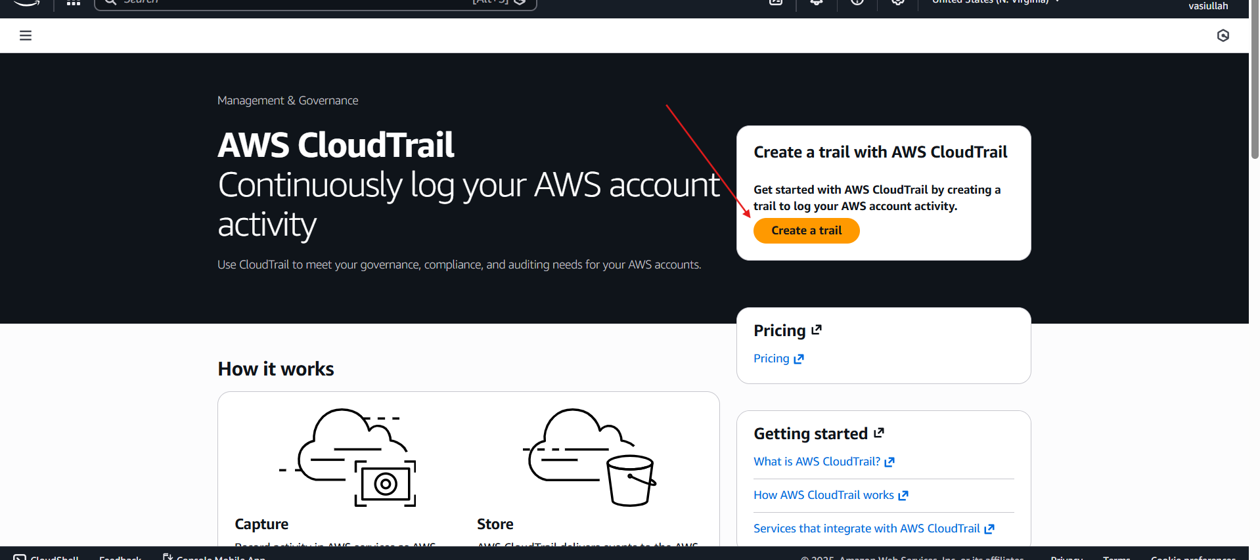

Objective
- To establish a single, authoritative audit trail that automatically captures management events from all existing and future accounts within an AWS Organization

Prerequisites
- Management Account Access: You must perform these steps from the AWS Organizations Management account or a designated administrator account.
- Organization Enabled: The AWS Organization must be active with "All Features" enabled to support organizational trails.

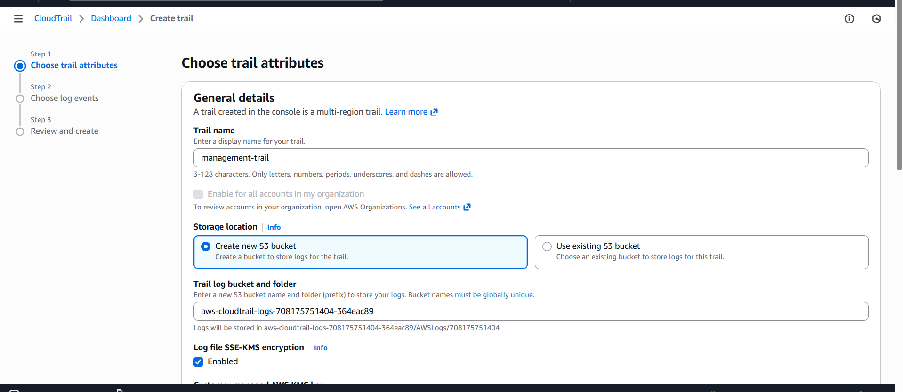

Step-by-Step Implementation
- Open CloudTrail Console: Log in to the Management account and navigate to CloudTrail > Trails.
- Create Trail: Click Create trail and enter a unique Trail name (e.g., org-security-audit-trail).

Choose Event Types:
- Management Events: Select Read and Write events to capture all administrative actions.
- Data Events (Optional): Enable these for specific S3 buckets or Lambda functions if you require object-level visibility (Note: Additional costs apply).

Issues Faced
- Missing EventsInsufficient bucket permissions if using an existing S3 bucket.Update the S3 Bucket Policy to explicitly grant s3:PutObject to the CloudTrail service principal.
- The IAM role policy for CloudWatch Logs is missing or incorrect.

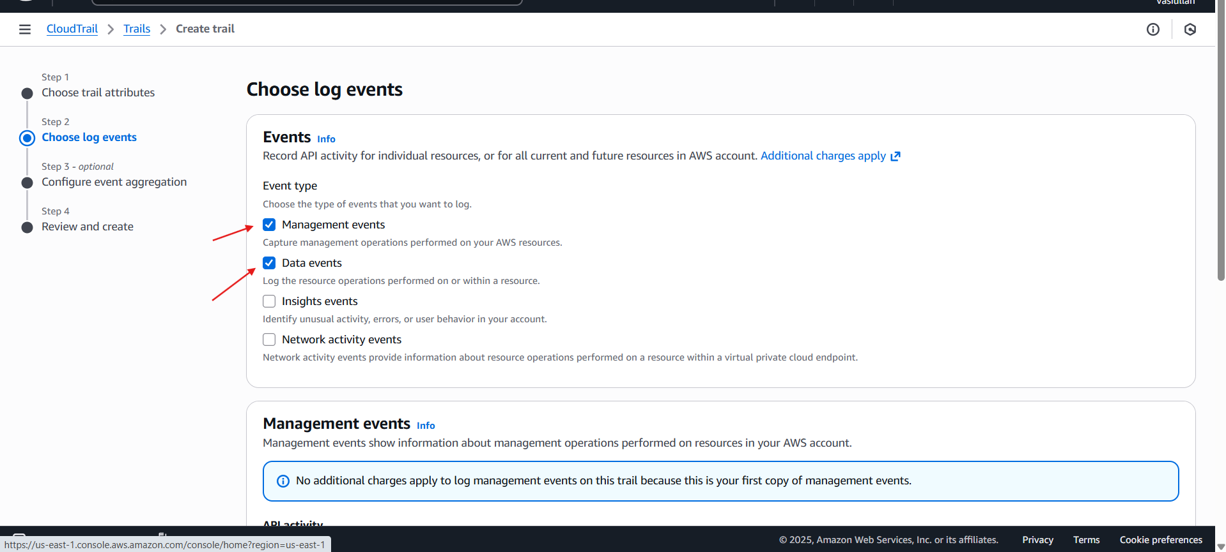
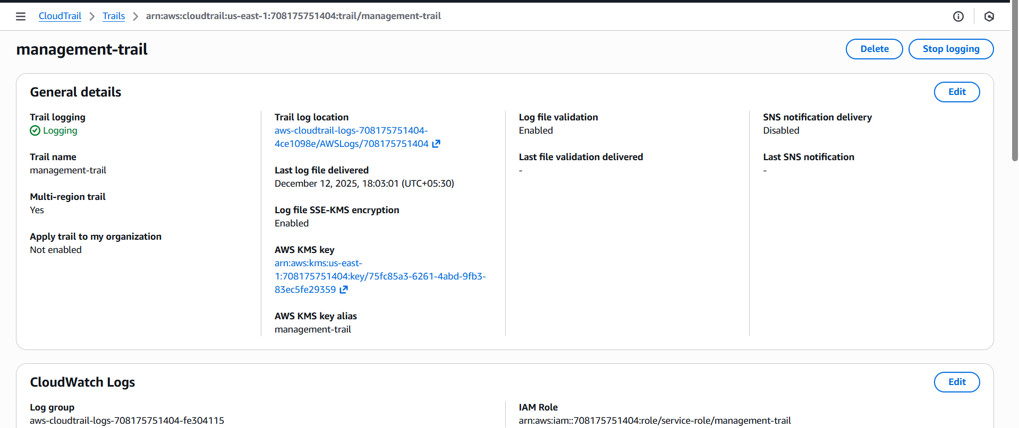

Conclusion
- Implementing an organizational trail is the cornerstone of AWS governance. It provides a tamper-evident, centralized log repository that automatically scales as your organization grows. By integrating with CloudWatch Logs, you move from reactive auditing to proactive security monitoring.

2. Enable SNS for CloudTrail to send alert on email

Task Title
- SNS for CloudTrail to send alert on email

Objective
- To create a multi-region organizational trail that captures all account activities, stores them securely in S3, monitors them via CloudWatch, and triggers immediate email notifications via Amazon SNS whenever a log file is delivered.

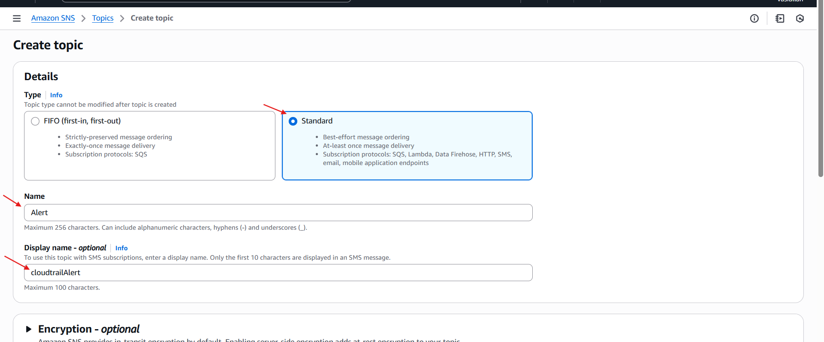

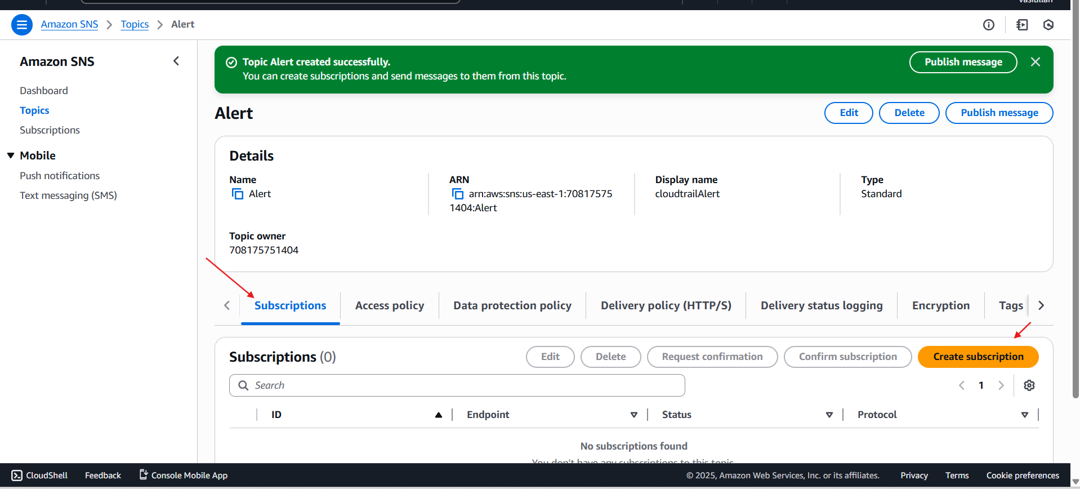

Prerequisites
- Management Account Access: Operations must be performed from the AWS Organizations Management account.
- Permissions: IAM user requires full access to CloudTrail, S3, SNS, and CloudWatch Logs.
- Valid Email: A functional email address to receive and confirm the alert subscription.

Step-by-Step Implementation
- Establish the SNS Notification Channel
- Create Topic: In the Amazon SNS console, create a Standard topic named Alert with a display name like cloudtrailAlert.
- Create Subscription: Within the topic, click Create subscription. Select the Email protocol and enter your email address (e.g., syedvasiullah05@gmail.com).
- Confirm Subscription: Open your email inbox, find the AWS notification, and click Confirm subscription. The status in the console will change from "Pending confirmation" to "Confirmed."
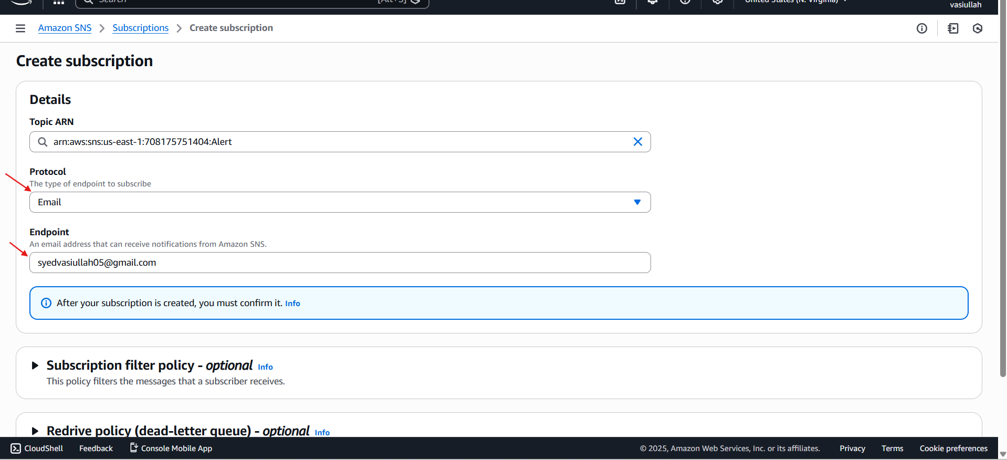

Issues Faced
- Alerts Not ReceivedSubscription status stuck in "Pending confirmation."Re-send the confirmation email from the SNS console and click the link in your inbox.
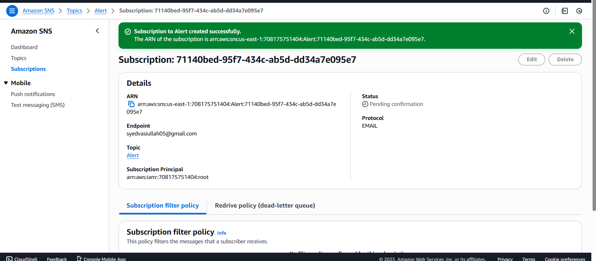
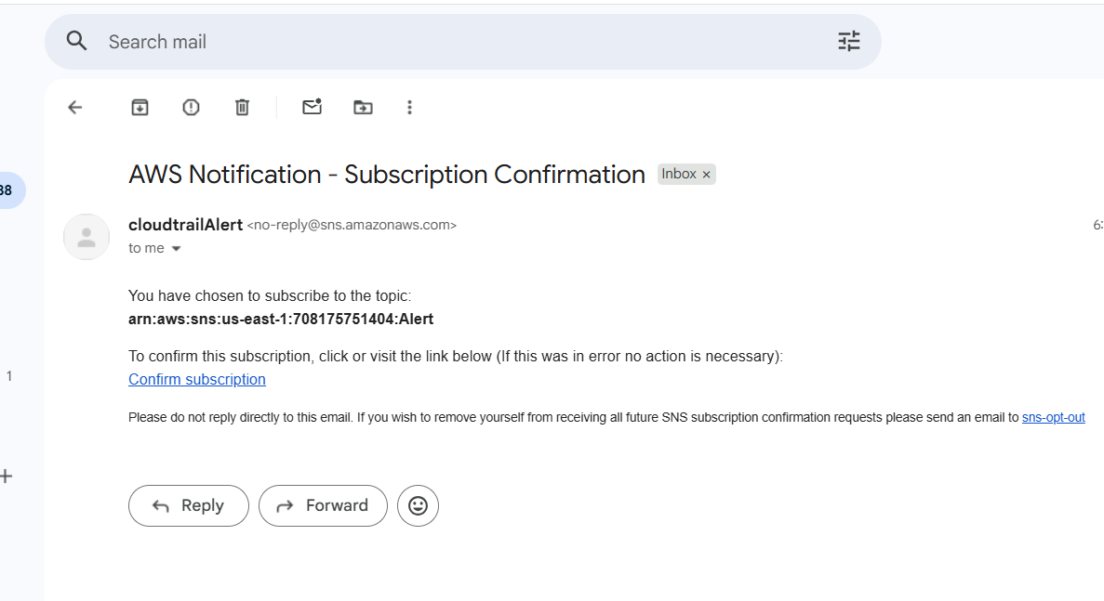

Conclusion
- By combining CloudTrail, S3, and SNS, you have successfully built a robust auditing architecture. This setup ensures that every action taken within your AWS Organization is not only recorded for compliance but also actively monitored through instant email alerts, providing a critical layer of security oversight.
3. Configure CloudWatch monitoring for EC2 (CPU and other metrics)

Task Title
- Implementing Detailed Monitoring and Custom Dashboards for AWS EC2 Instances

Objective
- To enable high-resolution monitoring for an EC2 instance and consolidate critical performance metrics into a centralized CloudWatch Dashboard for real-time visibility.

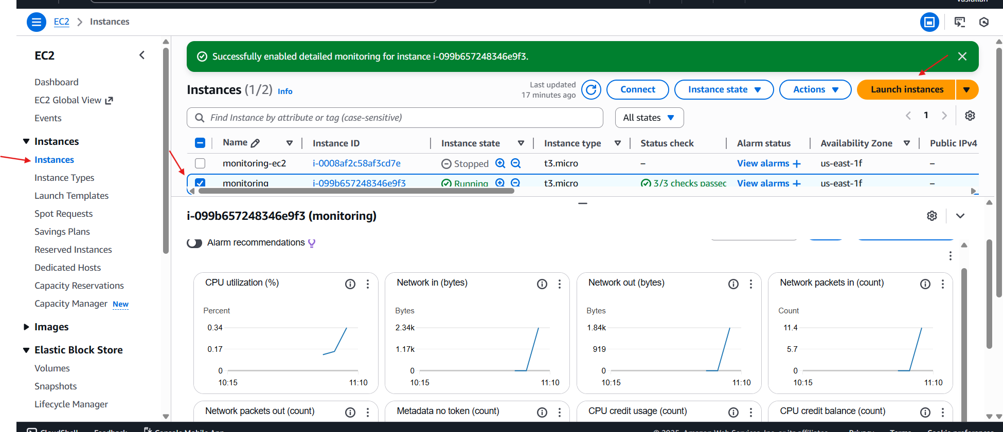
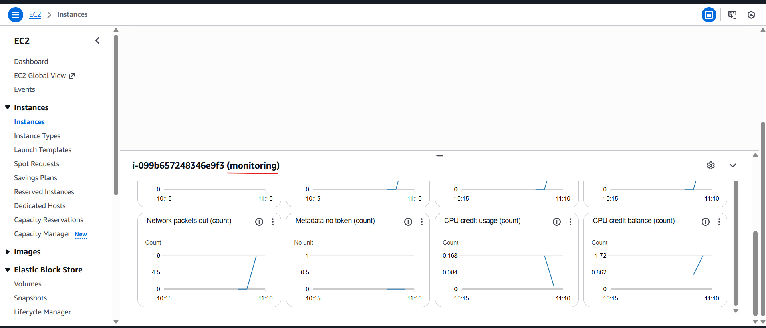

Prerequisites
- An active AWS Account.
- An EC2 instance (e.g., t3.micro as seen in your screenshots) launched and running.
- Appropriate IAM permissions to access CloudWatch and EC2.

Step 1: Enable Detailed Monitoring
- By default, EC2 sends metrics to CloudWatch every 5 minutes. To get 1-minute granularity:
- Navigate to the EC2 Console and select Instances.
- Select your instance (ID: i-099b657248346e9f3).
- Click Actions > Monitor and troubleshoot > Manage detailed monitoring.

Step 2: Create a Custom CloudWatch Dashboard
- Navigate to the CloudWatch Console.
- In the left sidebar, click Dashboards.
- Click the orange Create dashboard button.

Step 3: Add Metrics to the Dashboard
- Within your new dashboard, click Add widget.
- Select a widget type (e.g., Number or Line).
- In the Browse tab, select EC2 > Per-Instance Metrics.
- Search for CPUUtilization for your specific Instance ID.
- Under the Graphed metrics tab, ensure the statistic is set to Average and the period is set to 5 minutes (or 1 minute if detailed monitoring is active).

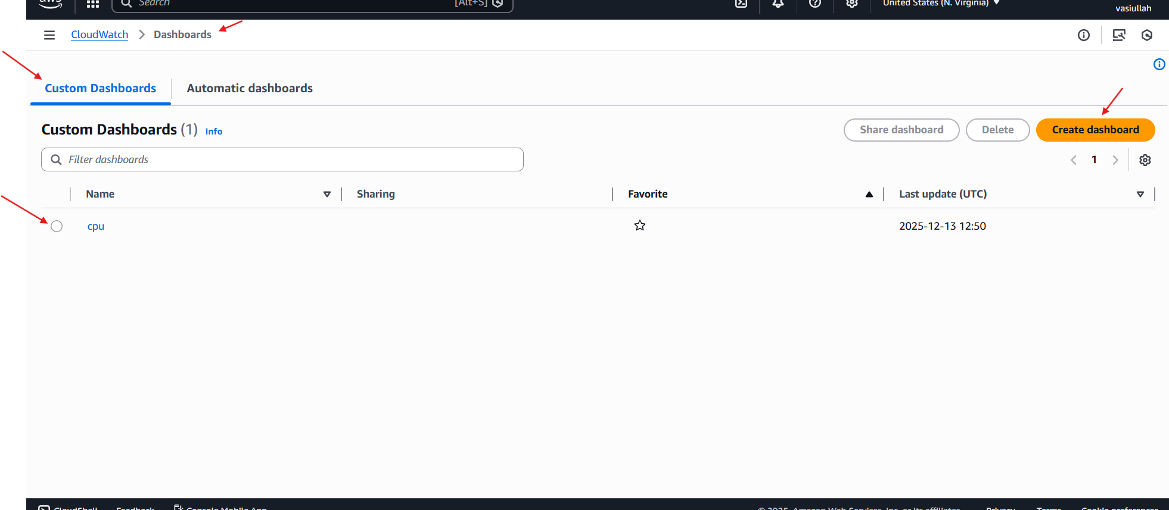

Validation Steps
- Metric Flow: Check the EC2 "Monitoring" tab to ensure graphs for CPU, Network, and Disk are populating (as seen in your first and fourth images).
- Dashboard Accuracy: Open your "cpu" dashboard in CloudWatch and verify that the widget displays the correct value (e.g., the 50% CPU utilization shown in your third image).

Issues Faced
- Data Lag: Initially, metrics may take a few minutes to appear after enabling detailed monitoring.
- Cost Management: A reminder that Detailed Monitoring is a paid feature, unlike the default basic monitoring.
- Metric Selection: Finding the specific instance among many can be difficult; using the Instance ID in the search bar is the most reliable method.

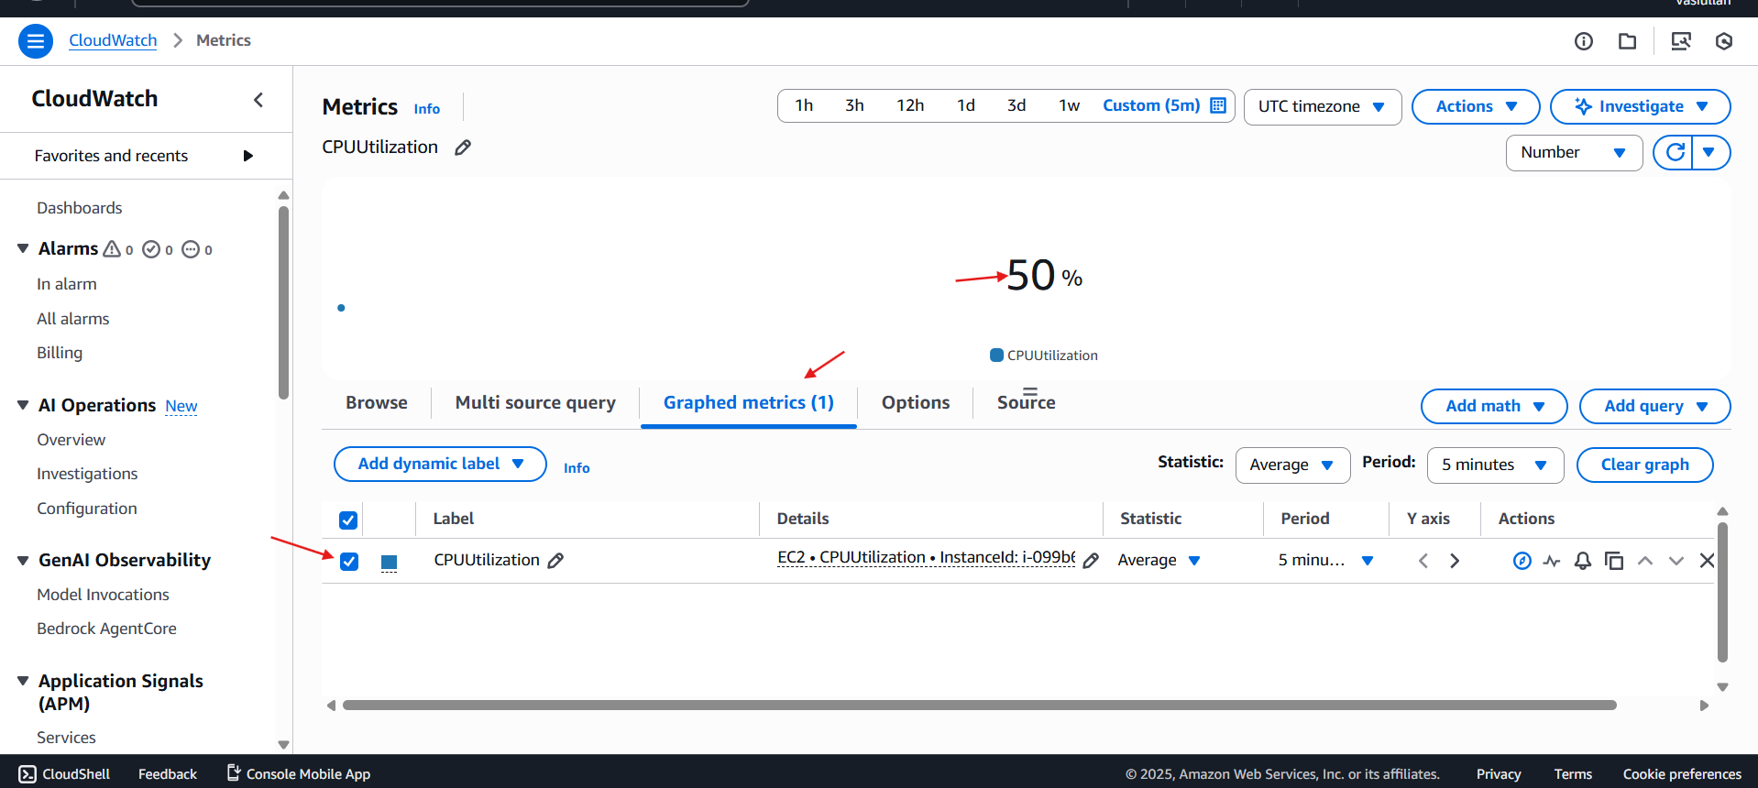

Conclusion
- By enabling detailed monitoring and configuring a custom CloudWatch dashboard, we have established a robust observation layer. This setup allows for faster incident response and a clearer understanding of resource consumption patterns for the monitoring-ec2 instance.
4. Create alarm to send email if CPU utilization > 70%

Task Title
- Monitoring EC2 Performance with CloudWatch Alarms and SNS Notifications

Objective
- To implement a real-time monitoring solution for an AWS EC2 instance that triggers an email notification via Amazon Simple Notification Service (SNS) whenever the CPU Utilization exceeds 70%.

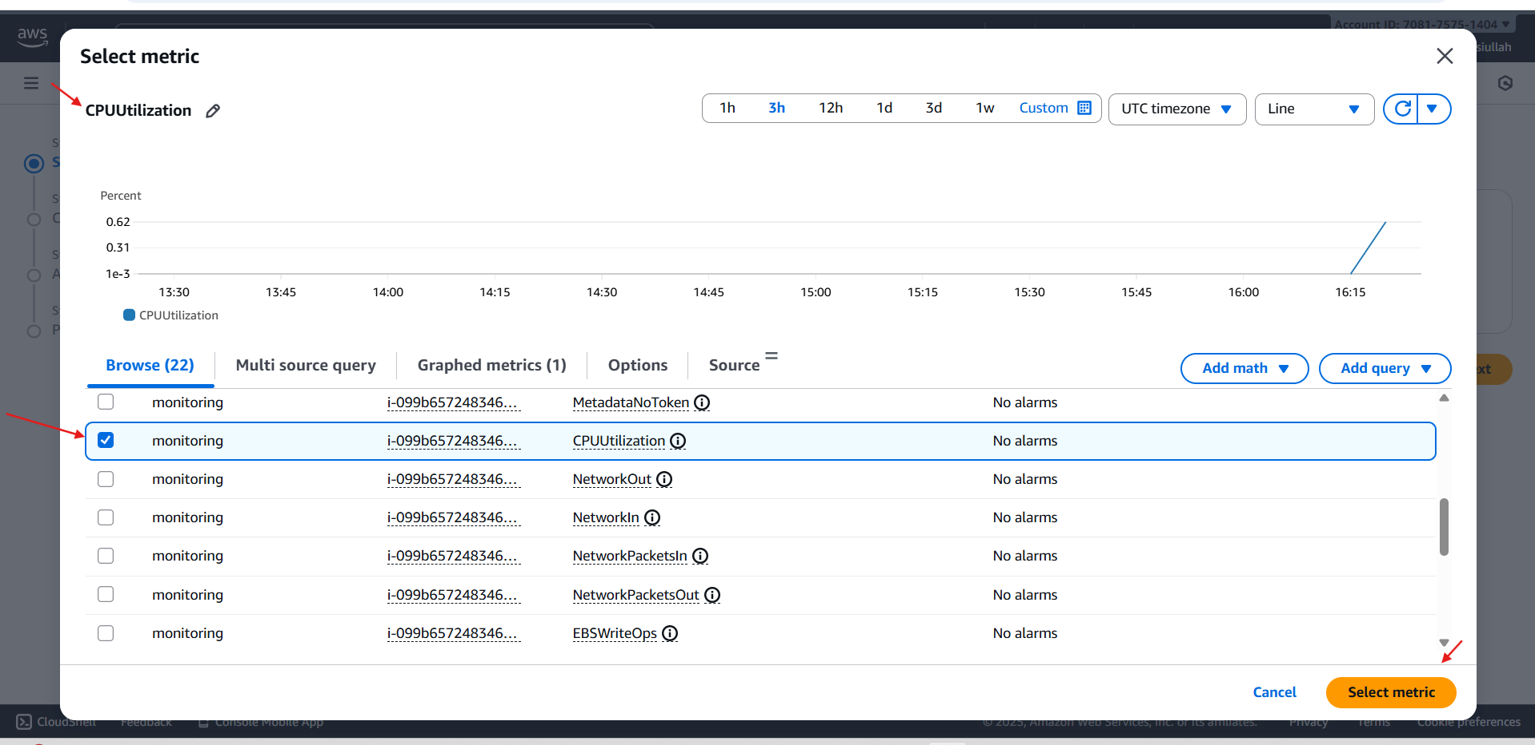

Prerequisites
- An active AWS Account.
- A running EC2 instance (Instance ID: i-099b657248346...).
- Permissions to access CloudWatch and SNS services.
- A valid email address to receive notifications.

Step-by-Step Implementation

Select the Metric
- Navigated to the CloudWatch console and selected All Alarms > Create Alarm.
- Selected the metric: EC2 > Per-Instance Metrics.
- Chose CPUUtilization for the specific instance named "monitoring" (i-099b657248346e9f3).

Configure Actions (SNS)
- Linked the alarm to an SNS topic.
- Configured the SNS topic to send an email to the administrator's email address.

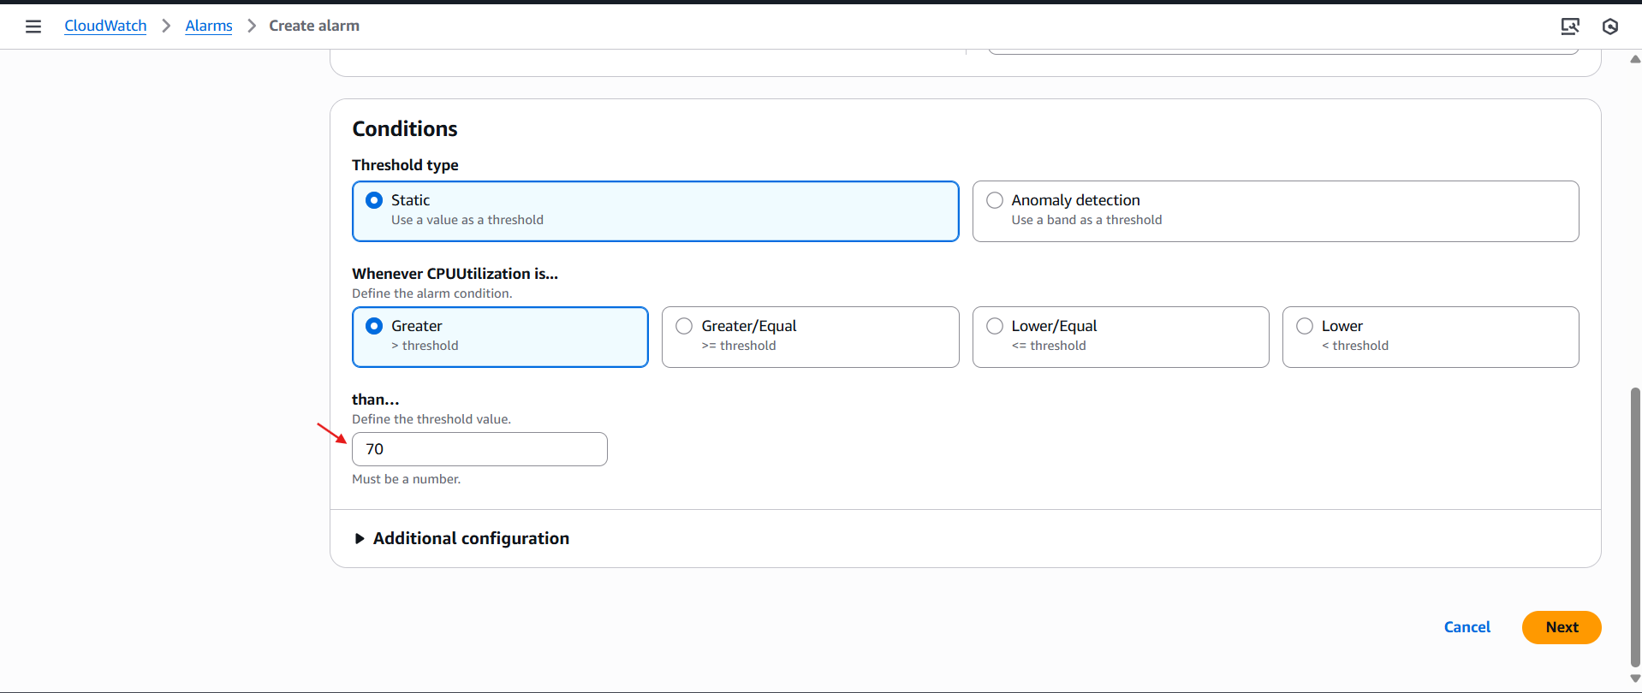

Validation Steps
- Check Alarm State: In the CloudWatch dashboard, the alarm cpu-vasi is visible.
- Current Status: The alarm currently shows "Insufficient data". This is normal immediately after creation until enough data points are collected (usually 1–5 minutes).
- Threshold Verification: The details page confirms the threshold is set to CPUUtilization >= 70 for 1 datapoints within 1 minute.

Issues Faced
- Initial "Insufficient Data" State: Upon creation, the alarm did not immediately show "OK" or "In Alarm."
- Resolution: Waited for the 1-minute period to pass for the EC2 instance to report its first metric data point.
- Pending Confirmation: The SNS notification won't work until the email link is clicked.
- Resolution: Accessed Gmail and clicked "Confirm subscription" to move the SNS status from PendingConfirmation to Deleted (or Active).

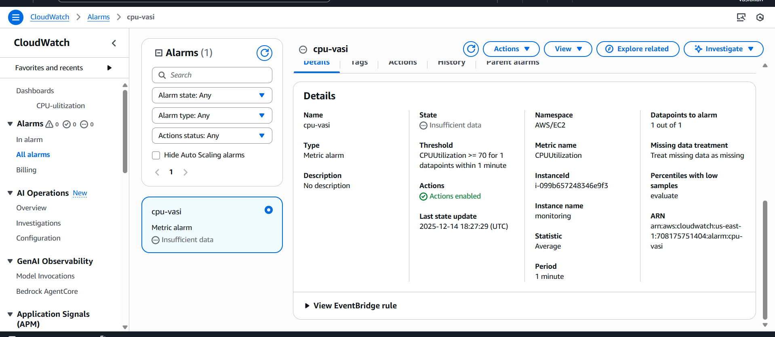

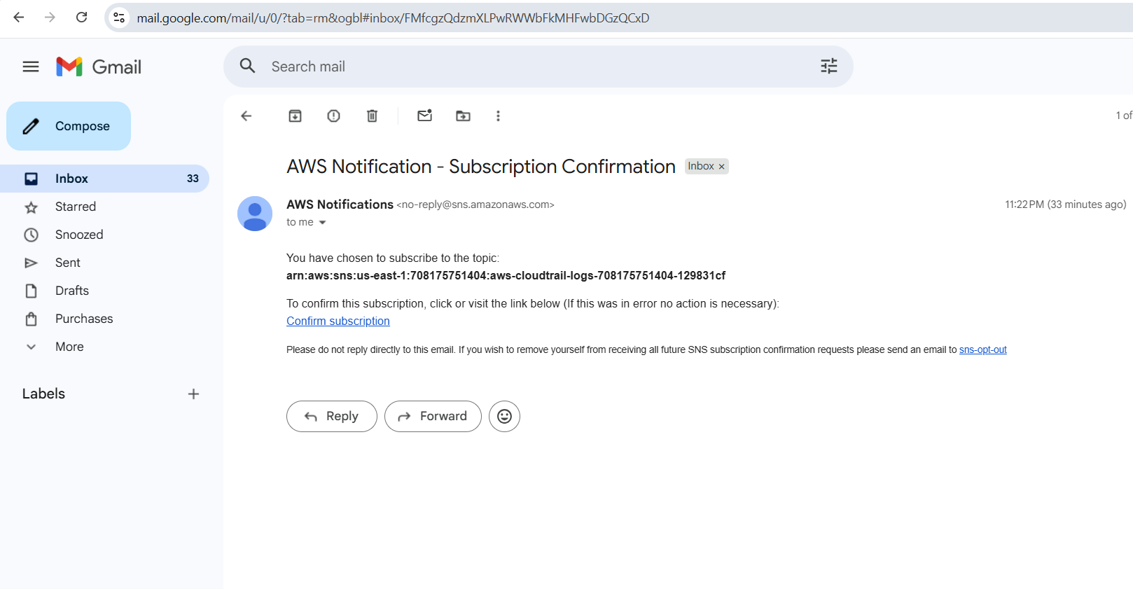

Conclusion
- The monitoring system is now live. By setting the threshold at 70%, the system provides a proactive warning before the instance reaches critical levels. This setup ensures that high-load events are documented and reported instantly, allowing for timely manual intervention or automated scaling.

5. Create Dashboard and monitor Tomcat service (running or not) and send alert
Task Title
- Monitoring Tomcat Server Status with Custom CloudWatch Metrics

Objective
- To create a monitoring solution that tracks the availability of a tomcat9 service on an EC2 instance and triggers an automated alarm in Amazon CloudWatch if the service goes down.

Prerequisites
- EC2 Instance: Running Amazon Linux 2023 (as seen in the package manager).
- Service: tomcat9 installed and configured.
- IAM Permissions: The EC2 instance must have an IAM role with cloudwatch:PutMetricData permissions.
- AWS CLI: Installed and configured on the server.

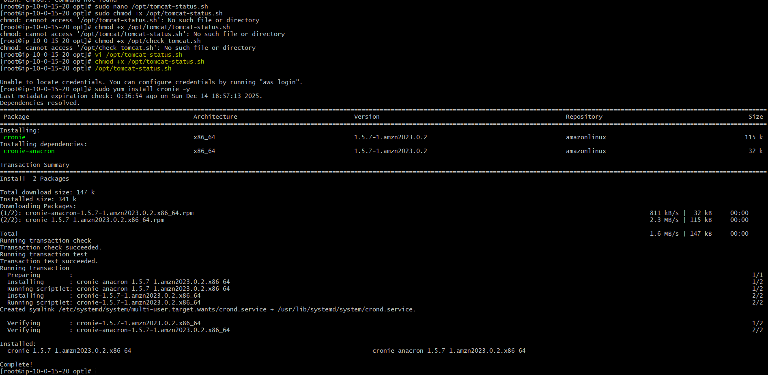

Step-by-Step Implementation

Create the Monitoring Script
- Developed a Bash script located at /opt/tomcat-status.sh.
- The script checks if the tomcat9 service is active using systemctl is-active.
- Logic: It assigns a VALUE=1 if the service is running and VALUE=0 if it is stopped.
- It pushes this data to CloudWatch under the namespace "Tomcat" and metric name "Status" using the aws cloudwatch put-metric-data command.

Automate with Cron
- Installed the cronie package to manage scheduled tasks.
- Set script permissions using chmod +x /opt/tomcat-status.sh to ensure it is executable.
- (Implicitly) Added a crontab entry to run the script at regular intervals (e.g., every minute) to provide continuous data points to CloudWatch.

Configure CloudWatch Alarm
- Navigated to the CloudWatch Alarms console.
- Created a new alarm named "tomact-server".
- Condition: Configured the alarm to trigger based on the custom metric.

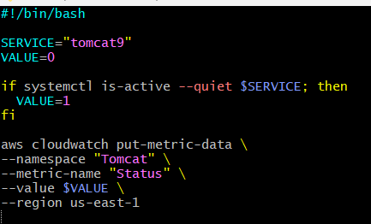

Validation Steps
- Script Execution: Manually ran /opt/tomcat-status.sh to ensure no syntax errors and that data is sent to the us-east-1 region.
- Metric Visualization: Opened the CloudWatch "View in metrics" graph to confirm that data points (0 or 1) are being received over time.
- Alarm State: Verified the alarm status in the console. Currently, the "tomact-server" alarm shows "Insufficient data", indicating it is waiting for more data points to complete its initial evaluation cycle.

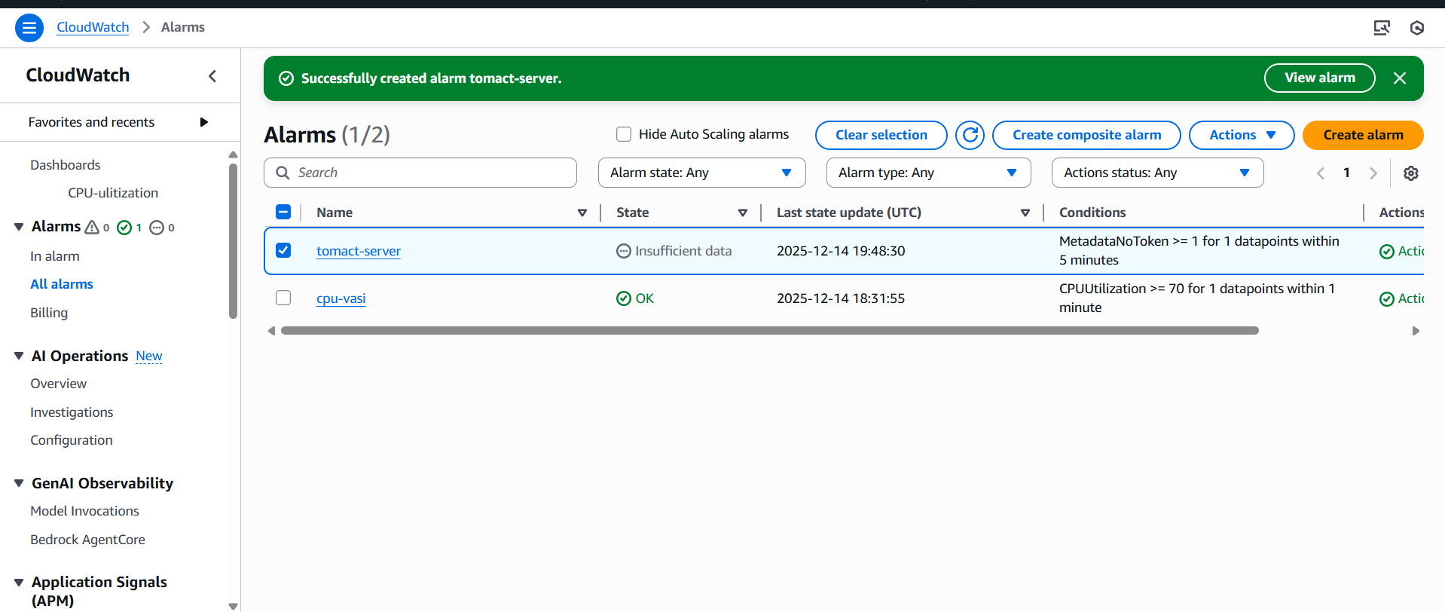

Issues Faced
- Permission Denied: Encountered initial issues with file access, requiring the use of sudo chmod +x to make the script executable.
- Missing Dependencies: The cron service was not initially available, requiring the installation of the cronie package.
- Credentials: Received an "Unable to locate credentials" error, which was resolved by ensuring the environment had the correct AWS access or IAM role assigned.

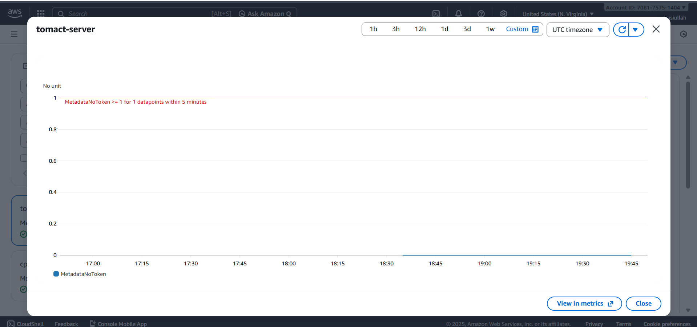

Conclusion
- This implementation provides a proactive way to monitor application-level availability. By pushing custom metrics from within the instance to CloudWatch, we can gain visibility into service health that standard infrastructure metrics (like CPU or Disk) cannot provide.

6. Create Dashboard and monitor Nginx service and alert if not running
