SQS (Simple Queue Service)AWS MQ(message queue)
- TASK : Create SQS Queue
STEP 1: Open Amazon SQS
—> sqs —-> queues —> create queues
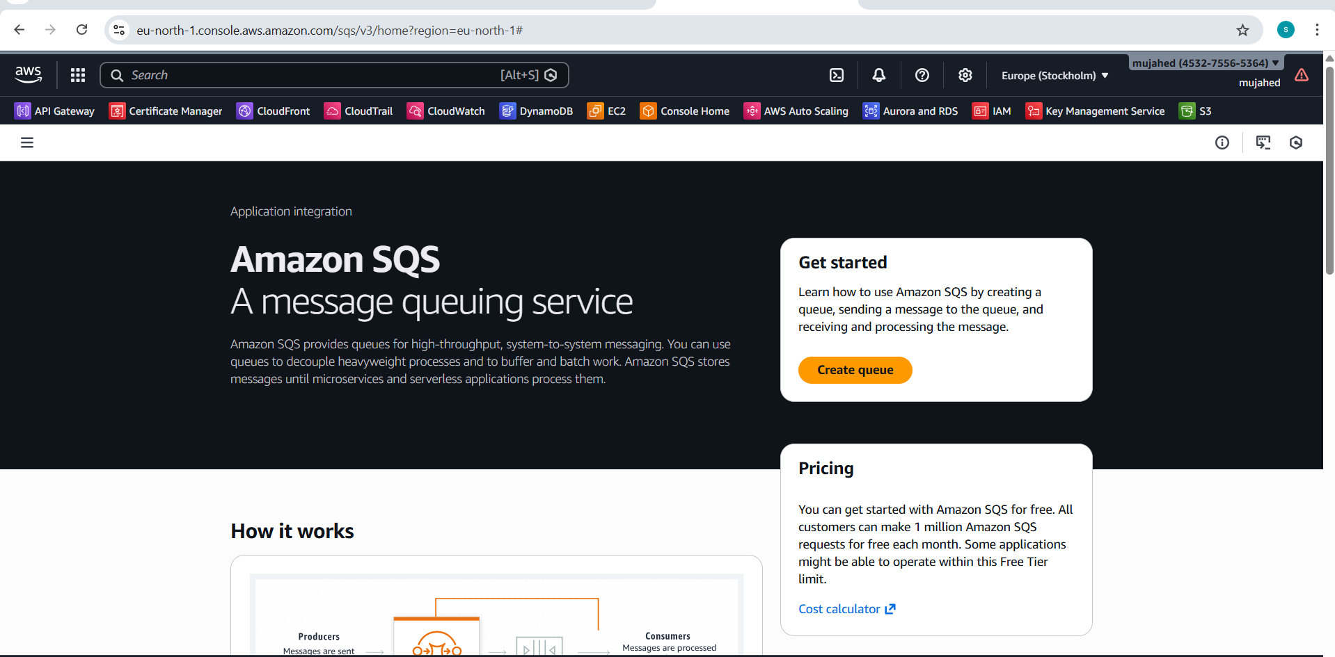
Opened Amazon SQS service from AWS Management Console.
STEP 2: Create Queue
Click Create queue
Select Standard queue
Enter queue name: sqs-queue
—> Configure Queue Settings
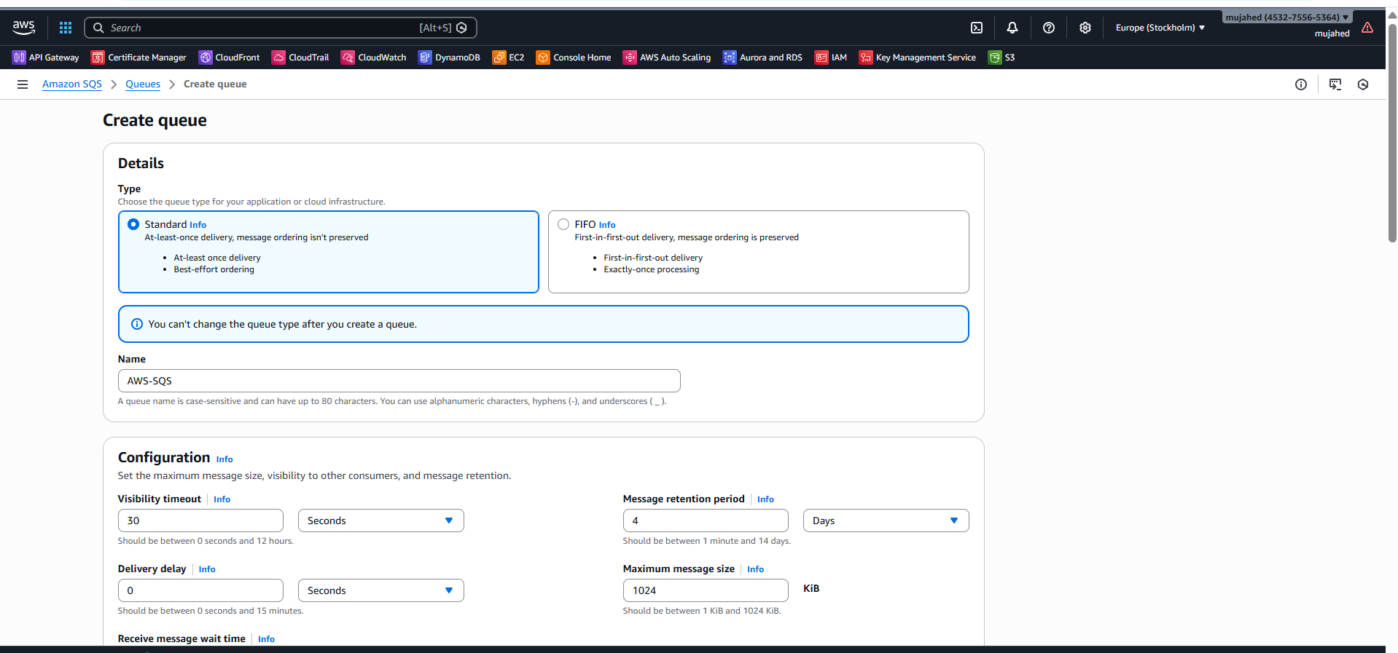
- Created an Amazon SQS Standard Queue named sqs-queue.
- Set up the queue using default configurations, including visibility timeout and message retention period.
- Successfully completed the queue creation process.
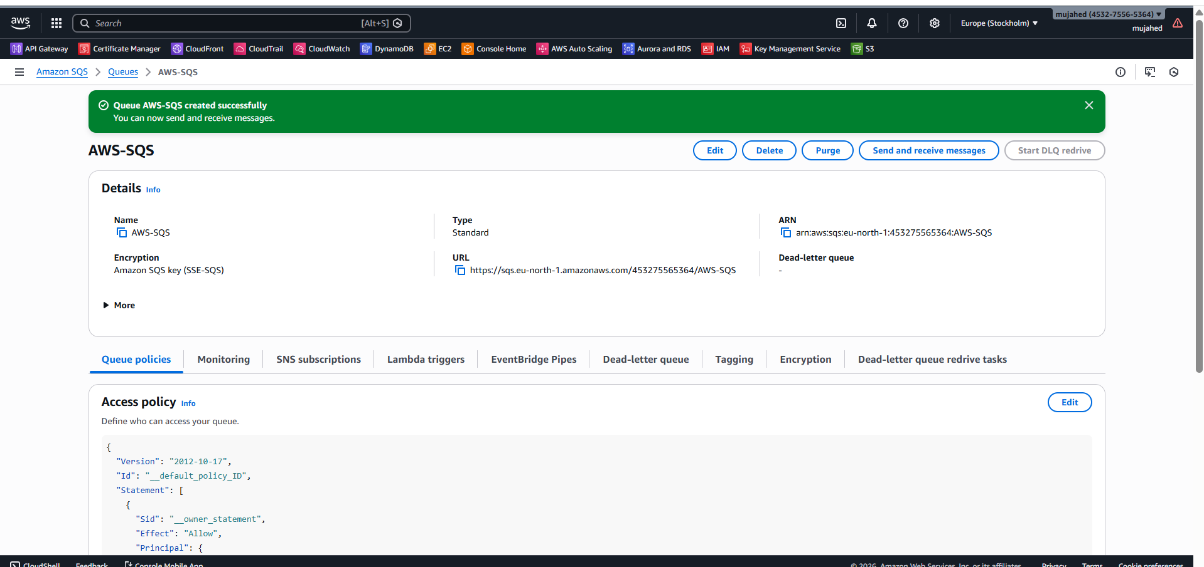
- The sqs-queue was created successfully in Amazon SQS.
- A confirmation message appeared showing the queue was created.
- The system automatically opened the queue details page.

TASK 2: Send & Receive Messages
- Open Send and Receive Messages Page
Action
- Click on Send and Receive Messages to open the message management page.
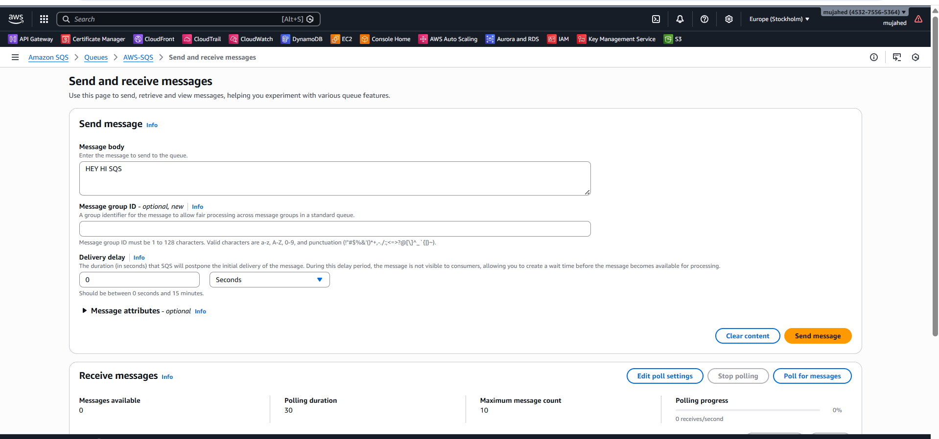
Send a Test Message to SQS Queue
- In the message body field, type: hey hi sqs
- Set Delivery delay to 0 seconds
- Click on Send Message
- A test message with the text hey hi sqs is successfully sent to the SQS queue.
- Message has been sent successfully
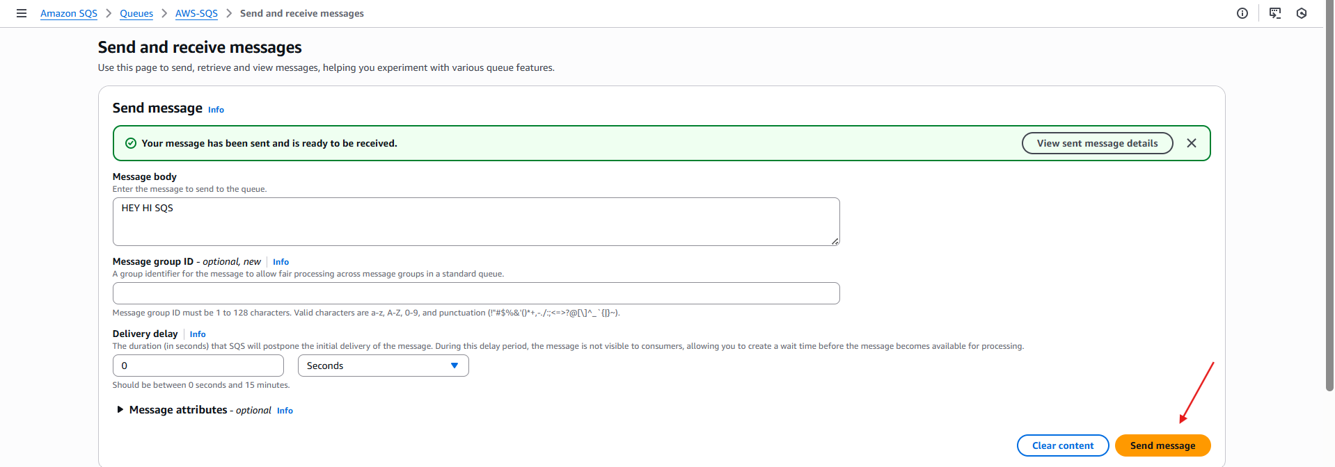
• A green confirmation message is displayed indicating success
• The message is now available in the queue to be received
- Receive Message from Queue
- Click on Poll for messages
- The message is successfully retrieved from the queue
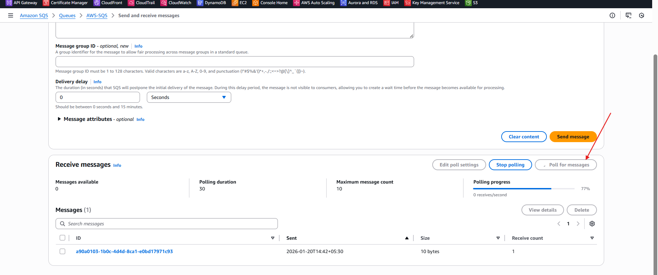
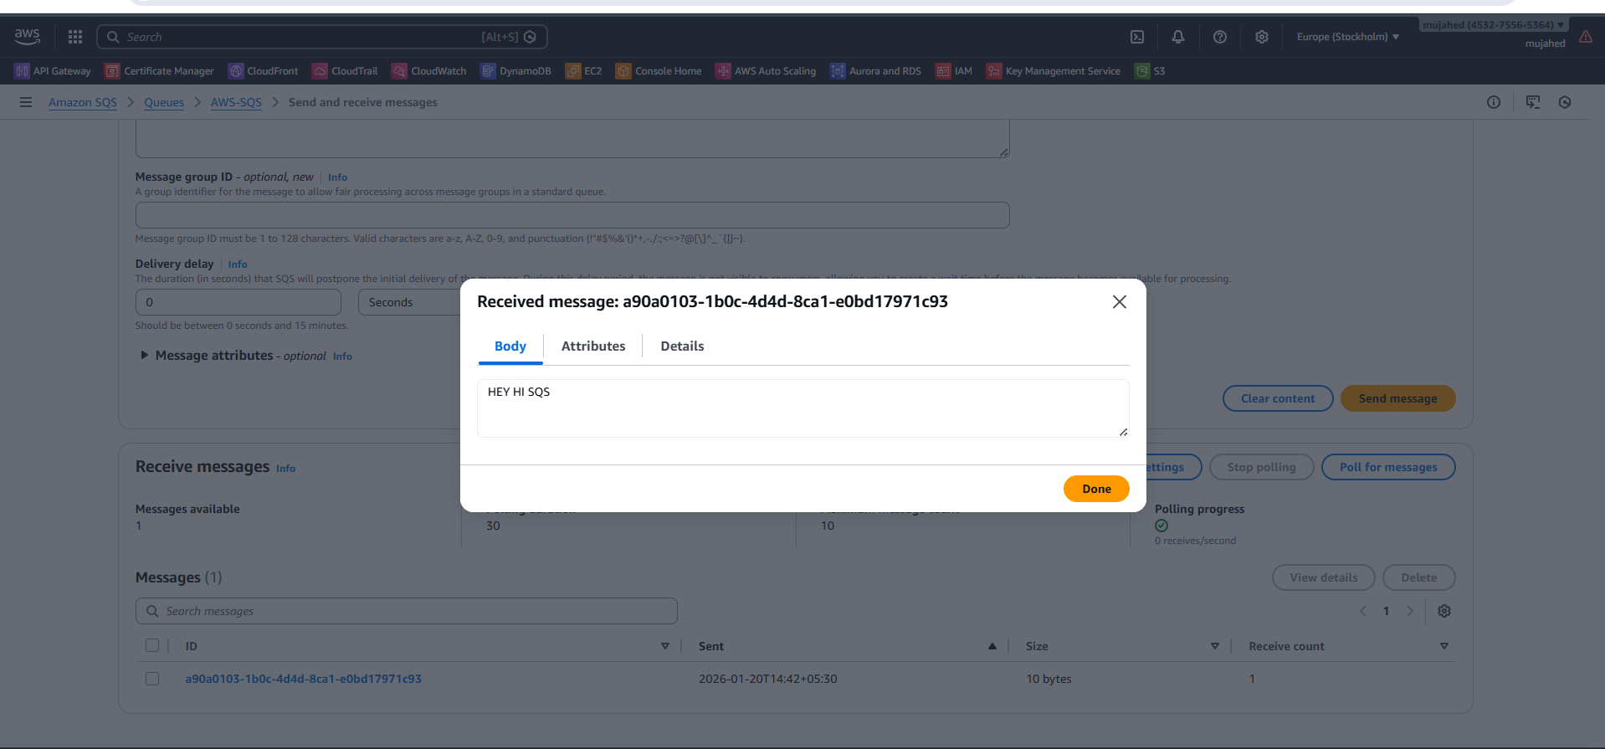
- Message Receiving Confirmation
- The queue was polled successfully.
- The message was received without any issues.
SQS Architecture Flow
Overall Flow:
Producer → SQS Queue → Consumer
Process Explanation:
- The Producer sends a message to the SQS queue.
- SQS safely stores the message until it is needed.
- The Consumer polls the queue to fetch new messages.
- After processing, the message is deleted from the queue.

Amazon MQ
- What is Amazon MQ?
- Amazon MQ is a managed message broker service on AWS.
- It is used when you already have applications that use traditional message brokers like:
- Apache ActiveMQ
- RabbitMQ
- AWS manages the infrastructure, but you use the same messaging concepts you already know.
- Amazon MQ lets you run ActiveMQ or RabbitMQ on AWS without managing servers.
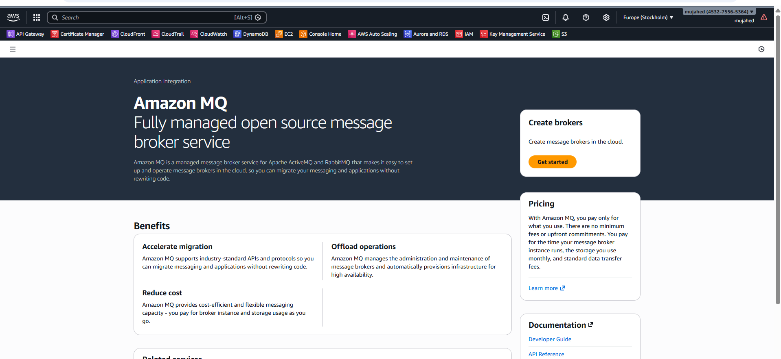
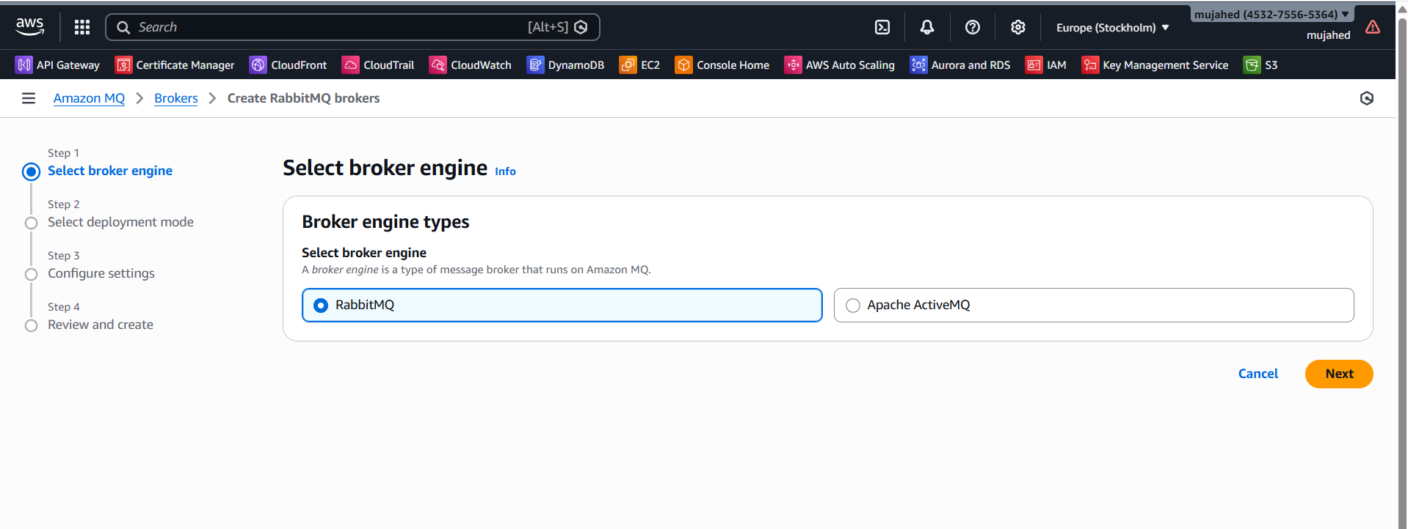
- Deployment Mode: Single-instance
- Action: Deselect Cluster Deployment Mode
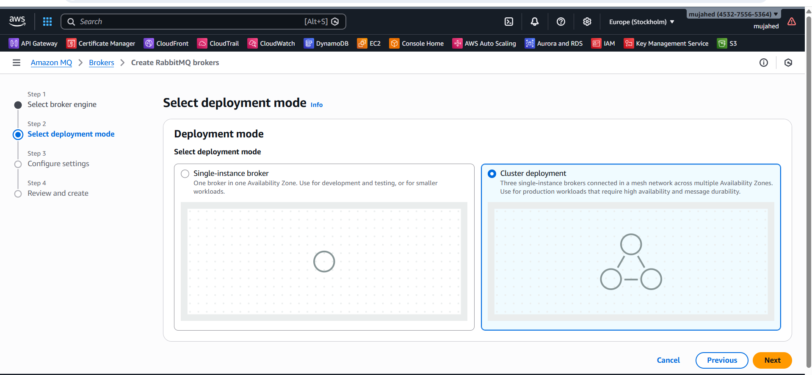
Create Broker User
Username : project1
Password: syedvasi@123
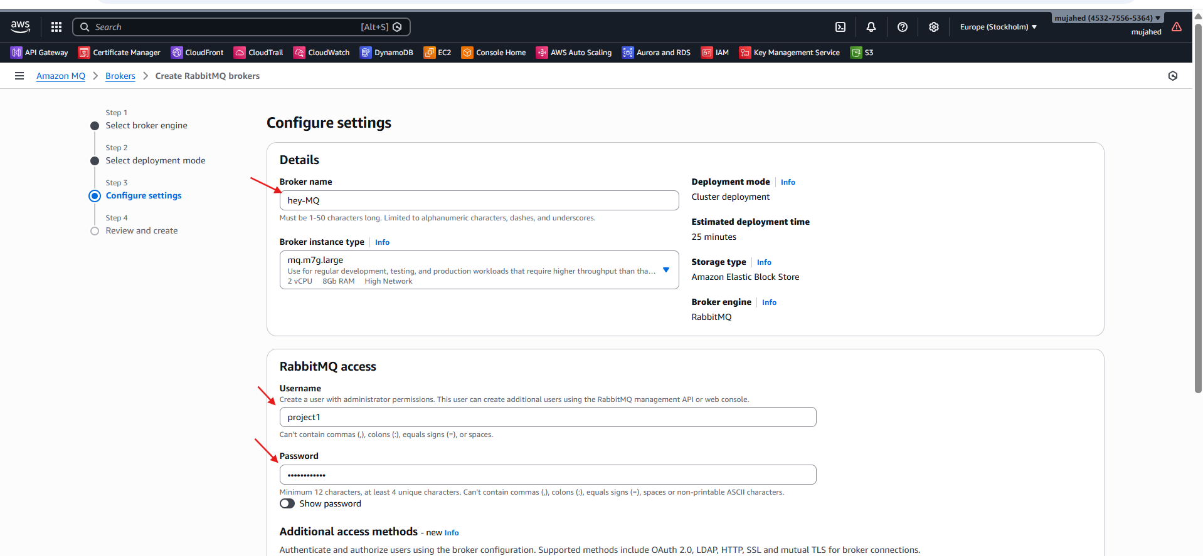
Create Broker User
Action:
Click Next to proceed.
In the Users section, create a new broker user.
Enter a Username and Password for broker access.
Click Next to continue.
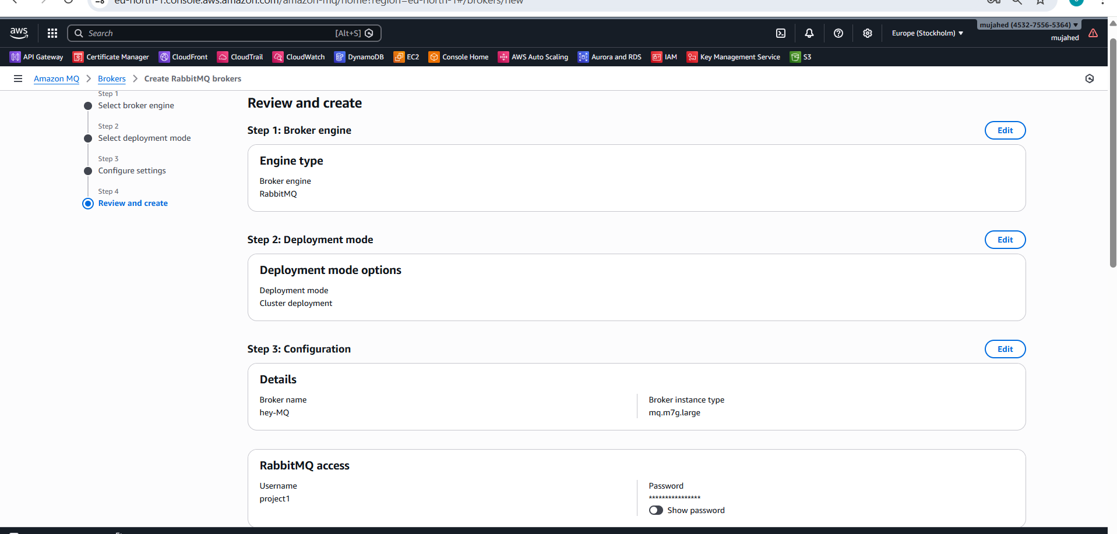
- preview and create the broker user
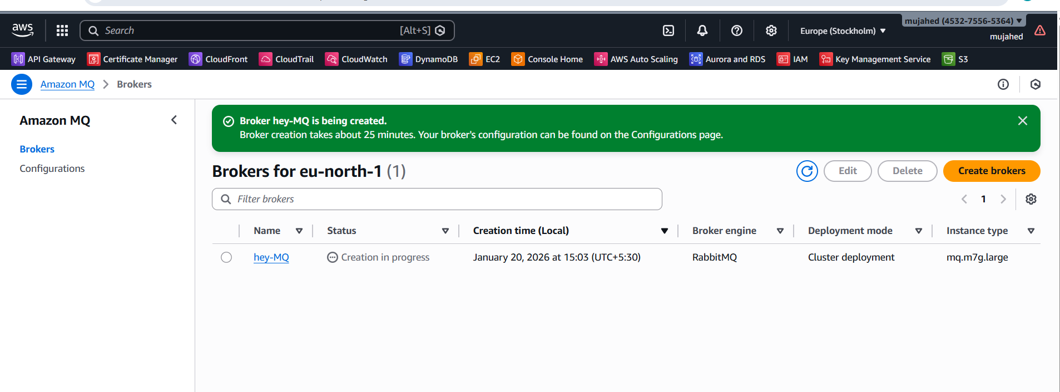
- Wait for until the status is running
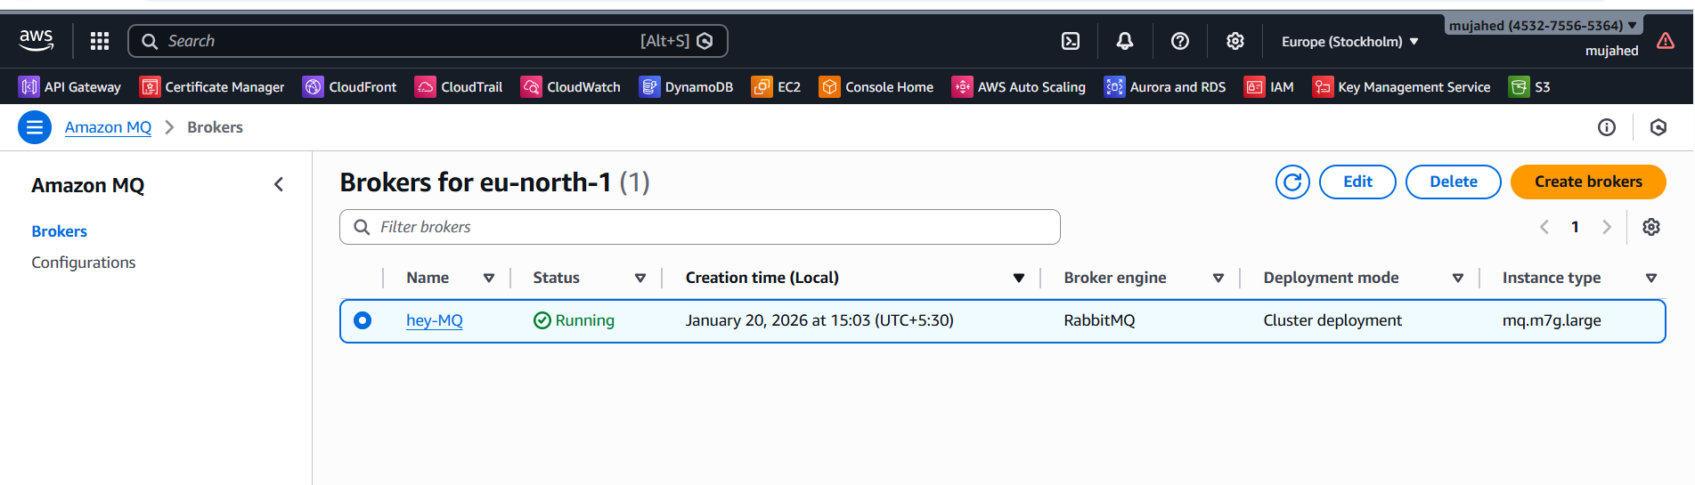
- now go to the rabbit MQ web console and copy the url and search in browser
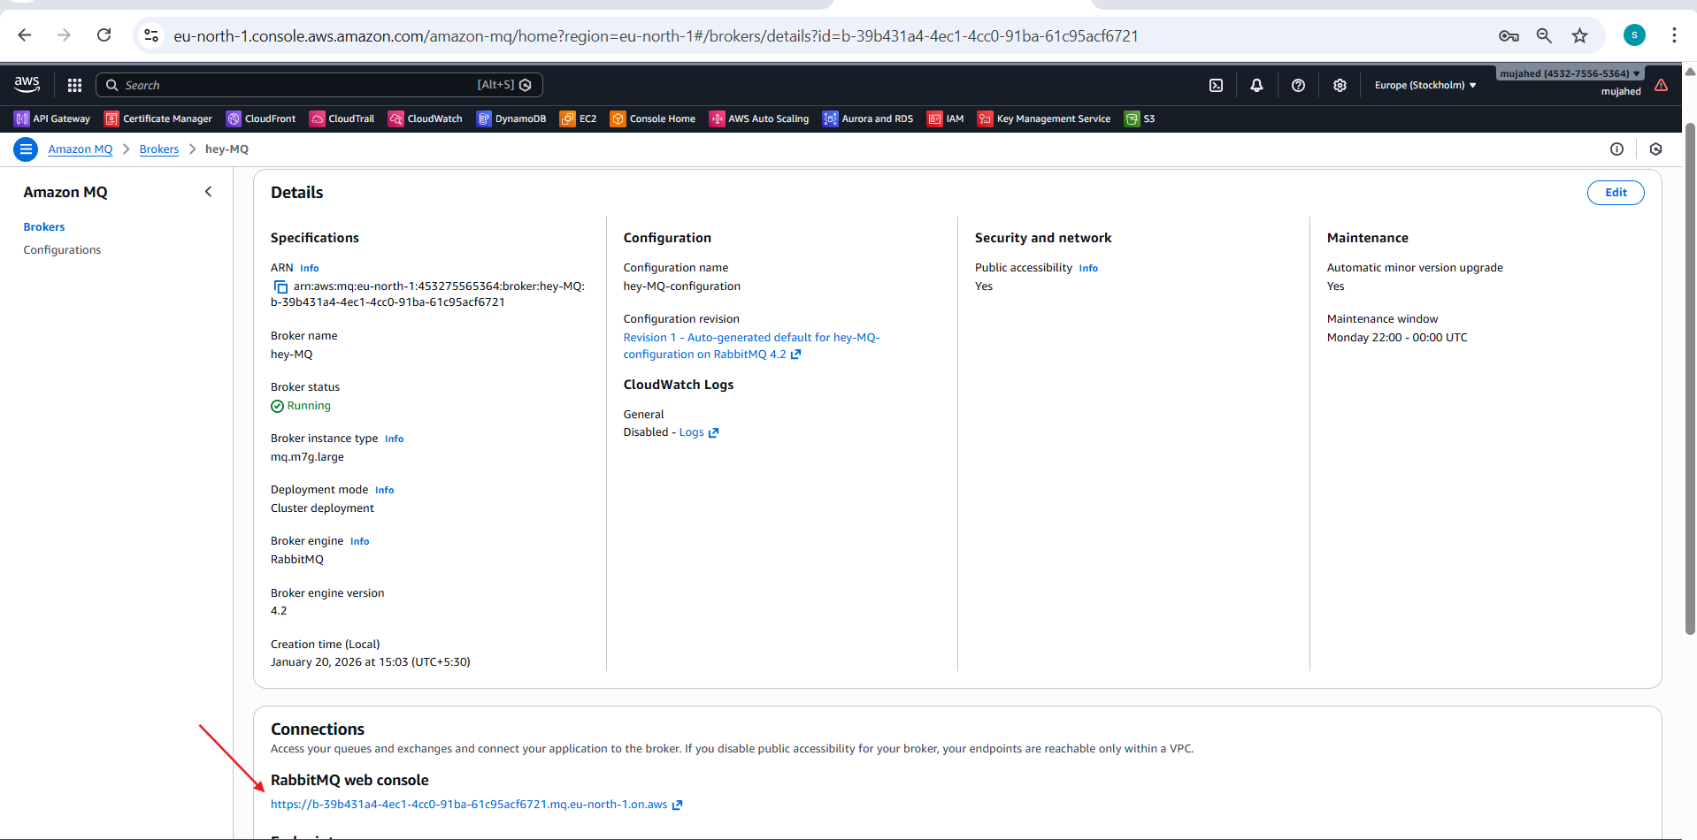
- Now the add the user name and password which we created in MQ
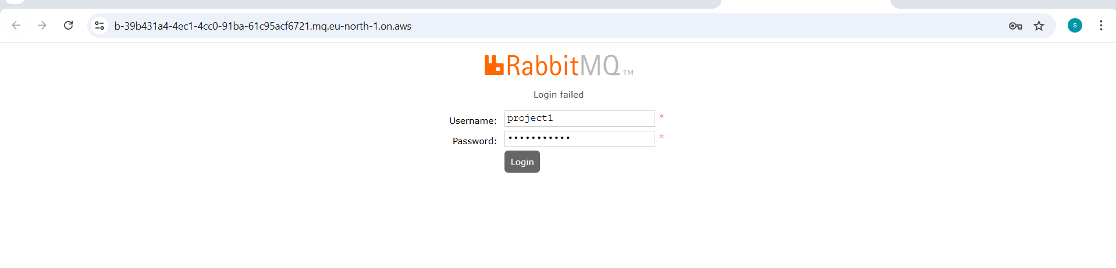
- Connect Application
