

PLANT SEEDLING CLASSIFICATION

Image Classification Using CNNs

OCTOBER 27, 2019

# 

# 

# Abstract

Is it possible for the naked human eye to differentiate between a weed and a crop seedling?

If this process is carried out effectively, it can result in yielding better quality crops and plantation. It can also help in better supervision of the crop-producing lands.

has recently released a dataset containing images of approximately 960 unique plants belonging to 12 species at several growth stages.

Kaggle hosted this dataset to give the ML community a chance to try out various image classification architectures and improve recognition results and amalgamate ideas.

This project is basically selected from a competition on the website “KAGGLE”. The link to the project and data on kaggle is as follows:

<https://www.kaggle.com/c/plant-seedlings-classification>

The image dataset is already provided in collaboration with groups at the Aarhus University Signal Processing department and the University of Southern Denmark.

# 

# Introduction

## Project Description:

Machine learning is being used in many fields and Big Data is no exception. Deep learning a subfield of machine learning which has been popular in recent years for progress they made on unstructured data tasks for image classification, object detection, image segmentation etc. Recent progress in deep learning has made the image classification task very efficient and accurate process. Convolutional Neural Networks which is a type of deep learning architecture styles have been proved to be very good at image classification task. So we propose a Simplified VGG-Net for the Plant Seedlings Classification. VGG Net is the state-of-the-art architecture for image classification originally trained and tested on ImageNet dataset. Here we have simplified the original VGG-Net for lesser number of classes and fewer images available. Our simplified VGG-Net has much lesser number of convolutional layers as compared to original VGG-Net. We proposed and find out that our approach will be helpful in the Plant Seedlings Classification from their images.

## Dataset:

The dataset contains roughly 4750 unique images of plants of 12 different species at multiple stages of growth. The dataset provided by kaggle for the competition has the following attributes:

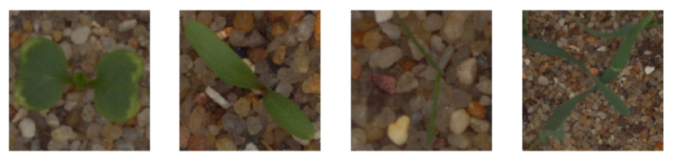

1. 4750 images divided into 12 different classes
2. Image Resolution - 196 X 196
3. The class Categories are as follows:
   1. Black-grass
   2. Charlock
   3. Cleavers
   4. Common Chickweed
   5. Common wheat
   6. Fat Hen
   7. Loose Silky-bent
   8. Maize
   9. Scentless Mayweed
   10. Shepherds Purse
   11. Small-flowered Cranesbill
   12. Sugar beet
4. Dataset division:
   1. Training set - 3040 images
   2. Validation set - 950 images (20% of training data)
   3. Testing set - 760 images

## Problem Statement:

Classify the seedlings of plants from the images into the species from which they belong to.

We are given the image of seedling and we have to determine what species does it belong.

# 

# Methodology

## Multiclass Image Classification

Image classification is assigning the class from the available number of classes to the image e.g. if we have photos of cats and dogs and we have segregate their images, we use the image classifier to assign classes of cats and dogs to the images. Multiclass image classification is the task in which we have more than 2 classes available image classification.

## Convolutional Neural Networks

Convolutional Neural Networks(a type of deep neural networks) is a very popular set of algorithms for image classification task. They have different convolutional layers which learn the different features from image. We input raw images to the network and the network learns the features by itself, as opposed to traditional machine learning where we have to input the features to the algorithm.

Convolutional layers consists of set of kernels which are used to learn the features from images.

The training algorithm has following steps:

**Initializing the parameters**: Weights of kernels are initialized. Xavier initialization[1] is considered to be the best way of initialization which gives us the best result.

**Forward pass**: Here we feed the images to the network where we calculate the results.

**Calculate loss:** Error is computed to determine how far is it from the correct labels.

**Backward pass**: The loss/error is back propagated to the network and the weights are adjusted to give the better for next pass.

**Epochs:** It is the number of times every image in the training dataset is visited.

# 

# Experiments:

## Model/Architecture:

The model built for the classification is a simplified VGG with following properties:

1. 5 Convolutional Layers
2. ReLu - Activation Function
3. Max Pooling
4. Batch Normalization
5. DropOut
6. Fully Connected Layer
7. Sigmoid - Activation Function
8. SGD - Loss Function

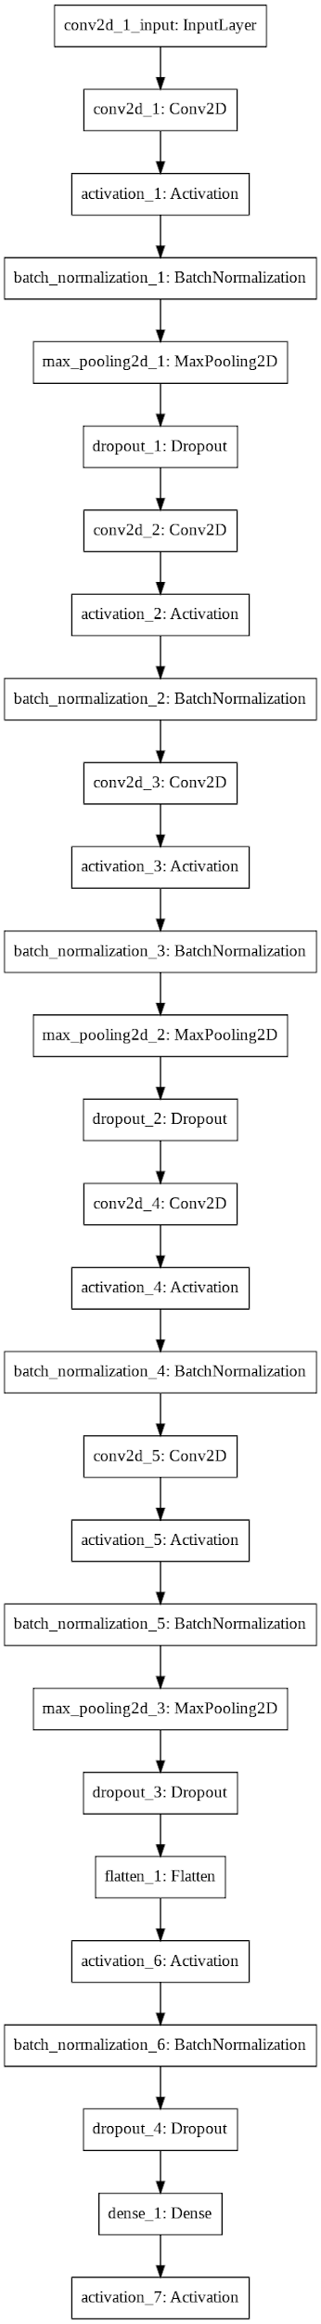

## Implementation:

The model in the figure is of simplified VGG-Net which is implemented in Keras using Tensorflow backend. Following are the hyperparameters which gave the best results during the experimentation:

1. **Preprocessing** → Image resizing to 224 X 244 to be fed to VGG
2. **Batch Size** → 32
3. **Epochs** → 50
4. **Learning Rate** → 0.001

## Results:

|  |  |
| --- | --- |
|  | **ACCURACY** |
| **TRAINING** | 73.32% |
| **VALIDATION** | 72.74% |
| **TESTING** | 71.71% |

## Analysis:

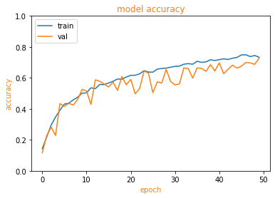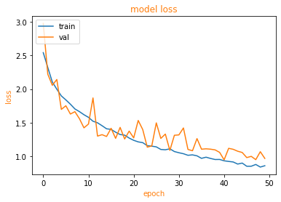

Results in the previous section shows that the proposed model learnt the classification task. The testing accuracy and validation accuracy is close to the training accuracy which shows that the model is not overfitted. The above graphs represent that the training has been done completely as both the accuracy and loss graph plateau after 50 epochs. If we try to run more than 50 epochs, the model will get overfitted and the validation accuracy will go down. The model is tested on test images set and predictions of the model are compared to the ground truth. We get the following results:

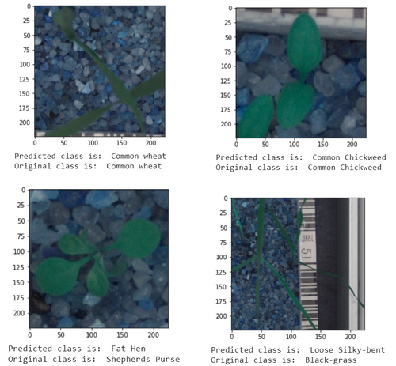



# Conclusion

We can conclude by the above experiments and results, that the proposed model for image classification is suitable for the plant seedling classification. The proposed model gives us good accuracy. Although the proposed model is not perfect, we can say that the work done is in the right direction.

Future improvements may include **data augmentation** which will increase the size of our dataset and make the model more robust, **optimizing hyperparameters** can help to improve the model to achieve better results,

## Comments:

We can say that with further improvements, we can effectively automate the process of plant seedling classification.

# References:

[1]: [Understanding the difficulty of training deep feedforward neural networks](http://proceedings.mlr.press/v9/glorot10a/glorot10a.pdf)