# Department of Computing

**CS471: Machine Learning**

**Class: BESE-7AB**

**Lab 5: Artificial Neural Network**

**CL03: Understand over fitting, bias-variance tradeoff and parameter optimization**

**Date: 22-02-2019**

**Time: 10:00 am– 1:00 pm & 2:00 pm-5:00 pm**

**Instructor: Dr. Pakeeza Akram**

**Lab 5: Artificial Neural Network**

**Tasks**

Develop your own ANN

* **Iamtrask code for basic ANN development**

(Described above)

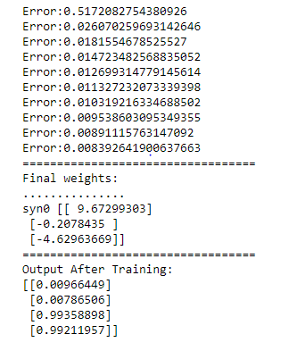

* **Change the number of layers and neurons**

Combination 1 (1 hidden layer with 4 nodes)

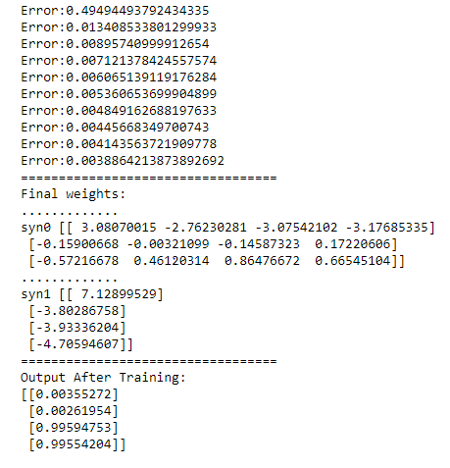

Combination 2 (1 hidden layer with 10 nodes)

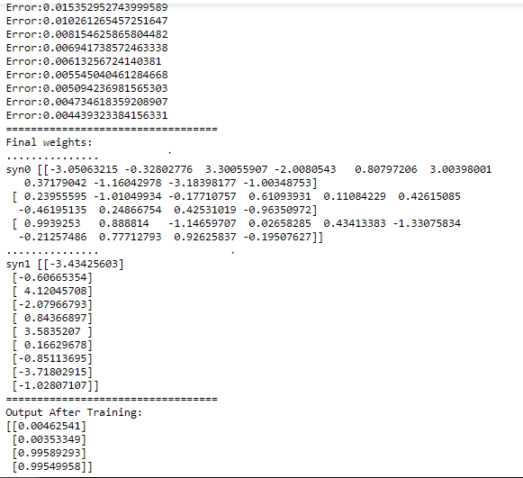

Combination 3 (2 hidden layers with 5 nodes each)

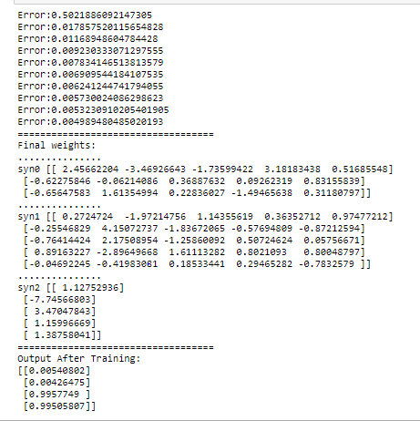

* **Multi-class classification**

Changing sizes of syn0 and syn1 changes the number of neurons in layers. To make it multi-class classification syn1 has to have columns= # of classes.

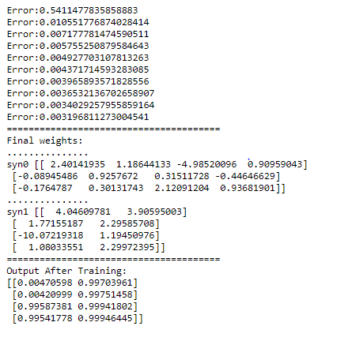

* **Regression function by using different layers as regressors rather than logreg.**

