**Mini Project Report**

**Vehicle Anti-Theft System**



**Authors Name & Affiliation**

* Team Leader Syed Waqaruddin 160419735010
* Author 1: Nakerkomula Manideep 160419735302
* Author 2: Mohammed Abdul Khaleeq 160419735016

**Mini project Co-ordinators Name & Affiliation**

Mrs. Shubhangi Saxena, Assistant Professor, Muffakham Jah College of Engineering and Technology, Hyderabad.

Ms. Maliha Naaz, Assistant Professor, Muffakham Jah College of Engineering and Technology, Hyderabad.

Table of Contents

Abstract 1

Components Used 2

Arduino Uno 2

Fingerprint Sensor R307 3

Specifications: 3

GSM/GPRS Module SIM900A 4

Specifications: 4

GPS Module Neo 6M 5

Specifications: 5

DC Motor 6

BC547 6

1N4007 6

Ignition Key 6

Technical Approach 7

STEP 1: 7

STEP 2: 7

BLOCK DIAGRAM 7

FLOW CHART 8

STEP 3: 9

STEP 4: 9

Description of project with Block / circuit diagram: 9

General Working: 9

Technical Working: 9

CIRCUIT DIAGRAM 10

ARDUINO AND PERIPHERAL INTERFACING: 10

Arduino and fingerprint sensor 10

Arduino and GPS module 11

Arduino with GSM module 11

Arduino with motor interface 12

Project Outcomes 12

Conclusion 14

Further Improvements 14

References 14

Appendix A: - 15

Arduino UNO 15

FINGERPRINT SENSOR R307 16

GSM SIM900A 17

GPS NEO 6M 18

Appendix B: - 19

Program Code 19

Appendix C: - 26

FINANCIAL REPORT 26

Appendix D:- 27

Acknowledgement 28

# Abstract

Vehicle is a very important asset in an individual’s life. Safety of a vehicle is as much important as maintaining and using it. This project model is designed to authenticate the usage of vehicle and to track its location of start/stop. This project model serves the cheapest way to safeguard one’s vehicle from being stolen. Modern vehicle tracking uses the active vehicle tracking and GPS technology. The system can save the information about the engine that it is in working condition or stop by ignition ON/OFF detection. Fingerprint sensor captures the fingerprint images, matches the uniqueness of each print read by the sensor and compares it to the one stored in its module or local system database. A vehicle tracking system that works using GPS and GSM technology, which would be the cheapest source of vehicle tracking and it would work as anti-theft system. It is an embedded system which is used for tracking and positioning of any vehicle by using Global Positioning System (GPS) and Global system for mobile communication (GSM).

Keywords—Vehicle tracking, GPS technology, fingerprint sensor, GSM technology, anti –theft system.

# Components Used

## Arduino Uno

The **Arduino Uno** is a microcontroller board based on the ATmega328. Arduino is an open-source, prototyping platform. It has 14 digital input/output pins (of which 6 can be used as PWM outputs), 6 analog inputs, a 16 MHz ceramic resonator, a USB connection, a power jack, an ICSP header and a reset button. It contains everything needed to support the microcontroller.

Specifications:

Fig: Arduino UNO

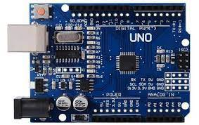

|  |  |
| --- | --- |
| Microcontroller | ATmega38P – 8 bit AVR family microcontroller |
| Operating Voltage | 5V DC |
| Recommended Input Voltage | 7-12V DC |
| Input Voltage Limits | 6-20V DC |
| Analog Input Pins | 6 (A0-A5) |
| Digital I/O Pins | 14 (Out of which 6 provide PWM output) |
| DC Current on I/O Pins | 40mA |
| DC Current on 3.3V Pin | 50mA |
| Flash Memory | 32 KB (0.5 KB is used for Bootloader) |
| SRAM | 2kB |
| EEPROM | 1kB |
| Frequency (Clock Speed) | 16MHz |

## Fingerprint Sensor R307

The Finger Print Sensor is one optical fingerprint sensor with a TTL UART interface for direct connections to microcontroller UART or to PC through MAX232 / USB-Serial adapter, which will make fingerprint detection and verification adding super simple. There's a high powered DSP chip AS601 that does the image rendering, calculation, feature-finding and searching. Up to 1000 finger prints can be stored in the onboard FLASH memory directly. The user can store the fingerprint data in the module and can configure it in 1:1 or 1:N mode for identifying the person.

Fig: Fingerprint Sensor R307

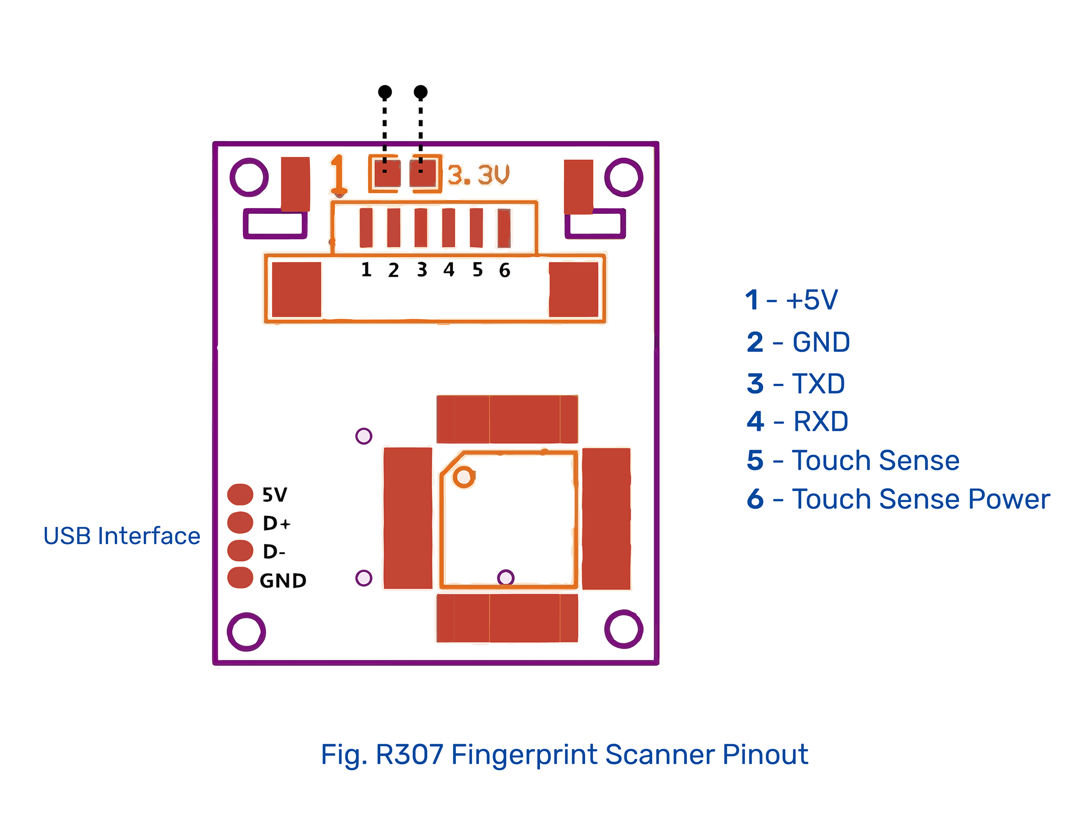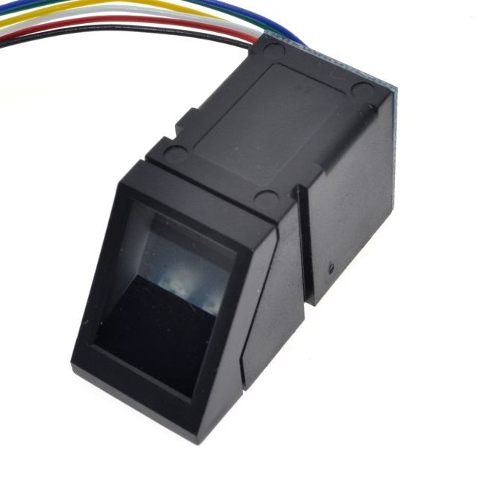

### Specifications:

|  |  |
| --- | --- |
| Operating Voltage (V) | 4.2~6 V DC |
| Current Consumption | <75mA |
| Verification Speed | 0.2 sec |
| Scanning Speed | 0.3 sec |
| Character file size | 256 bytes |
| Template size | 512 bytes |
| False Acceptance rate (FAR) | <0.0001% |
| False Rejection Rate (FRR) | <0.1% |
| Resolution | 500 DPI |
| Operating Temperature | -200 ~ +500 C |

## GSM/GPRS Module SIM900A

SIM900A GSM Module is the smallest and cheapest module for GPRS/GSM communication. It is common with Arduino and microcontroller in most of embedded application. The module offers GPRS/GSM technology for communication with the uses of a mobile sim. It uses a 900 and 1800MHz frequency band and allows users to receive/send mobile calls and SMS.

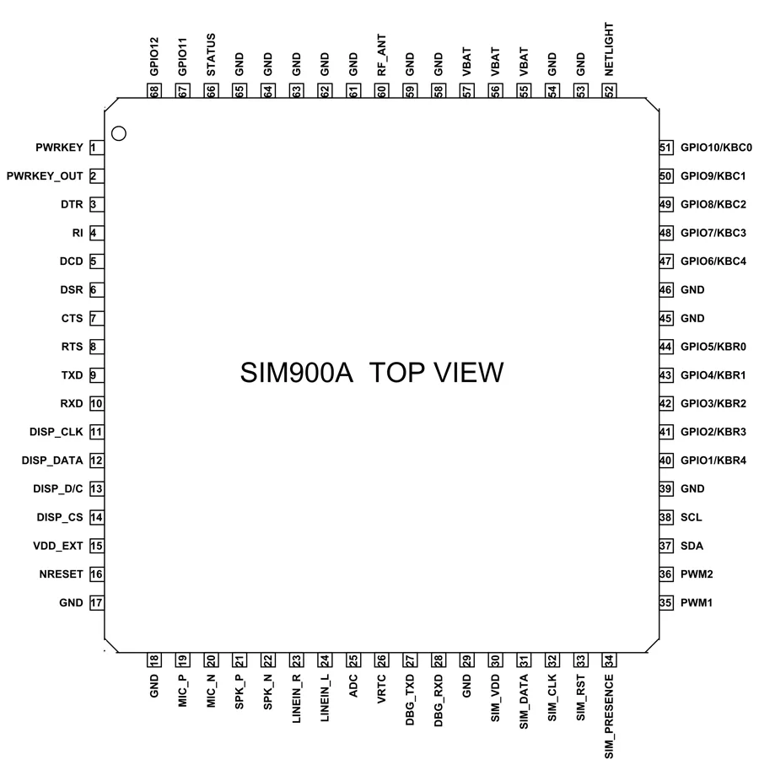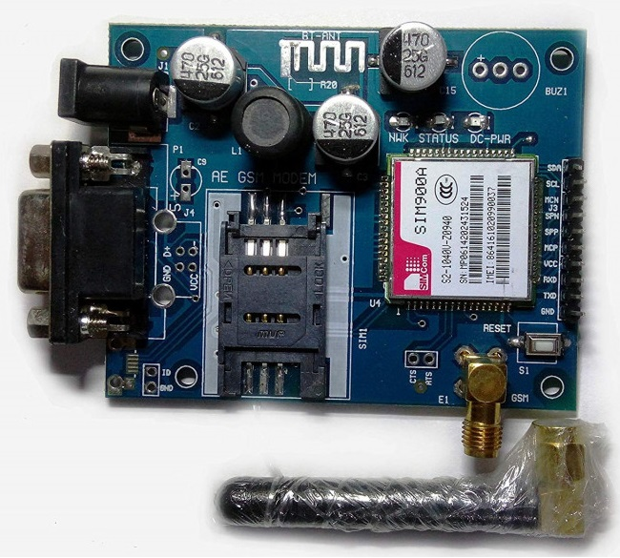

Fig: SIM900A GSM/GPRS module

Fig: SIM900A pinOUT

### Specifications:

|  |  |
| --- | --- |
| Operating Voltage (V) | 5 ~ 12 V DC |
| Operating Frequency | EGSM900 and DCS1800 |
| Transmitting Power Range | 2V for EGSM900 and 1W for DCS1800 |
| Data Transfer Link | Download: 85.6kbps Upload: 42.8kbps |
| SMS | MT, MO, CB, Text and PDU mode |
| Antenna support | Available |
| Serial port | I2C and UART |
| Audio input/output | Available |
| Serial Debug Port | Available |

## GPS Module Neo 6M

The NEO-6M GPS module is a well-performing complete GPS receiver with a built-in 25 x 25 x 4mm ceramic antenna, which provides a strong satellite search capability. This module can track up to 22 satellites and identifies locations anywhere in the world. The power and signal indicators help to monitor the status of the module.

Fig: Neo 6M GSM Module

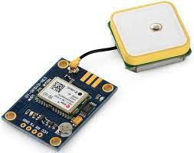

### Specifications:

|  |  |
| --- | --- |
| Operating Voltage (V) | 2.7 ~ 3.6 V DC |
| Operating Current | 45mA |
| Receiver Type | 50 channels, GPS LI(1575.42MHz) |
| Horizontal Position Accuracy | 2.m |
| Navigation Update Rate | 1Hz (max 5Hz) |
| Capture Time | Cool start: 27s Hot start: 1s |
| Navigation Sensitivity | 161dBm |
| Communication Protocol | NMEA, UBX Binary, RTCM |
| Serial Baud Rate | 4800-230400 (default 9600) |
| Operating Temperature | -40 ~ 85 C |
| TXD/RXD Impedance | 510 Ω |

## DC Motor

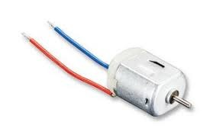

Fig: DC Motor

## BC547

Fig: Transistor BC547

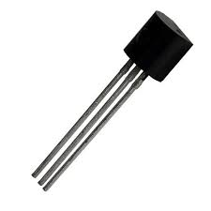

## 1N4007

Fig: 1N4007 diode

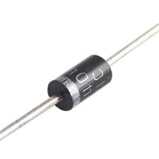

Ignition KeyResistor 1kohm

Fig: 1kohm resistor

Fig: Ignition Key

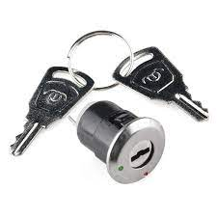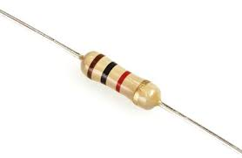

# Technical Approach

## STEP 1:

We as a team and individually had experience as of working with microcontrollers and various peripheral sensors. Our daily lifestyle took our attention to authentication and security of the essentials. Biometric authentication uses personal features. A Biometric is unique in its presence, permanence, collectability and universal. This motivated us to make a vehicle authentication based tracking system that uses GSM/GPRS and GSM technology, contributing to anti-theft system.

## STEP 2:

### BLOCK DIAGRAM

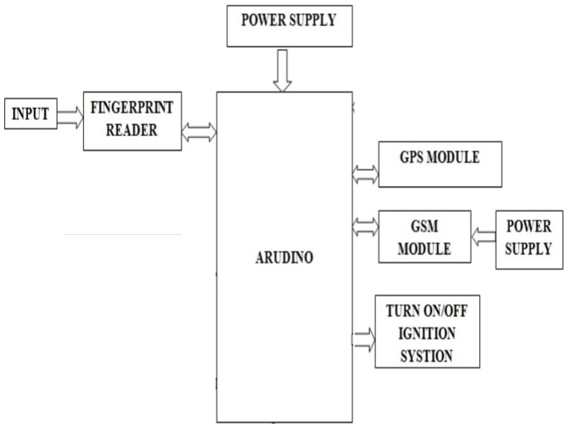

### FLOW CHART

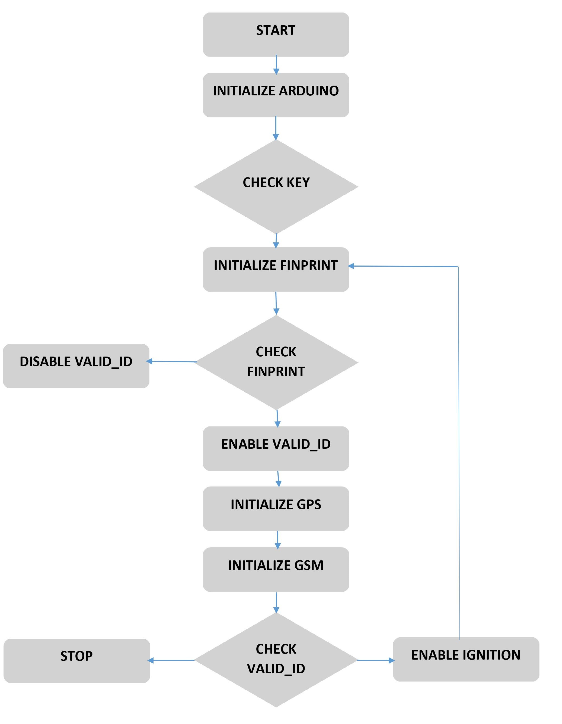

## STEP 3:

Since we had 3 peripheral devices connected to the Arduino.

The program to be compiled/written for the serial communication between the peripherals and the Arduino was quite complex, as baud rates of communication of each peripheral are different from each other.

Each peripheral was tested individually for several times, and for successful communication with minimum or no delays, dynamic change of baud rates and communication protocols were practiced.

## STEP 4:

The Tool/Software used to dump/upload the program into the Arduino board was Arduino IDE, which is an open-source platform to compile/upload programs in advanced embedded microcontrollers.

# Description of project with Block / circuit diagram:

## General Working:

In vehicle on start when the fingerprint matches with the fingerprint of enrolled users, gps and gsm are enabled and a message is sent to the registered mobile regarding the start of vehicle along with the co-ordinates of the location. Simultaneously the vehicle starts. If in case fingerprint does not match any of the enrolled users, gps and gsm are enabled and a message is sent to the registered mobile regarding the unauthorized attempt of starting the vehicle along with the co-ordinates of the location.

## Technical Working:

The Arduino is connected to the power supply, when the ignition key is turned ON, it activates the fingerprint sensor, now the Arduino initializes the fingerprint sensor to collect the fingerprint image and verify its existence in its database, meanwhile the gsm module and the gps module are activated by the Arduino, when an input is received by the Arduino, the gps module gets enabled and reads the coordinates of the location, whereas the gsm module initializes message send mode. If the fingerprint received as input matches with the fingerprints in the database of the fingerprint sensor, the Arduino sends a pwm signal is sent to the transistor BC547 which is connected to dc motor (considered as engine) which pushes the transistor in amplification mode which results in start of the dc motor, collectively the Arduino sends a message to the registered mobile number via the GSM/GPRS module acknowledging the authenticated start of the vehicle with the location coordinates. If the fingerprint received as input does not match with fingerprints in the database of the fingerprint sensor, the Arduino sends a message to the registered mobile number via the GSM/GPRS module acknowledging the unauthenticated attempt to start the vehicle with the location coordinates.

### CIRCUIT DIAGRAM

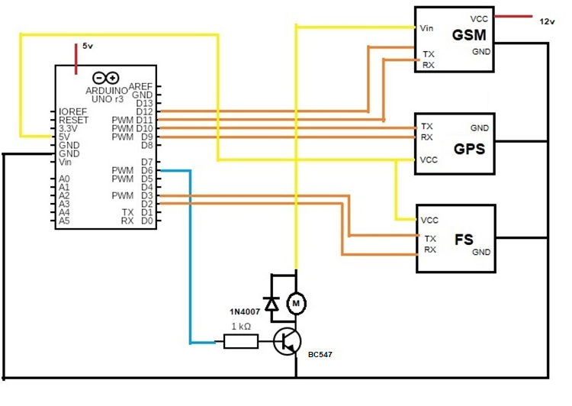

## ARDUINO AND PERIPHERAL INTERFACING:

### Arduino and fingerprint sensor

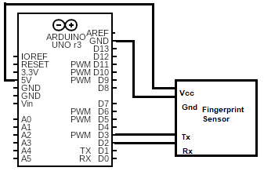

Fig: Fingerprint module interface

The fingerprint module’s RX and TX are connected to the D2 and D3 digital pins of the Arduino board. Besides that, the fingerprint module takes supply from the Arduino board. The pins D2 and D3 act as TX, RX respectively of the Arduino when connected to fingerprint sensor with fingerprint input is enabled.

### Arduino and GPS module

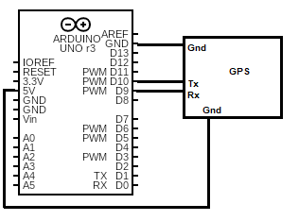

Fig: GPS module interface

The GPS module’s RX and TX are connected to the D9 and D10 digital pins of the Arduino board. Besides that, the GPS module takes supply from the Arduino board. The pins D9 and D10 act as TX, RX respectively of the Arduino when connected to fingerprint sensor with fingerprint input is enabled.

### Arduino with GSM module

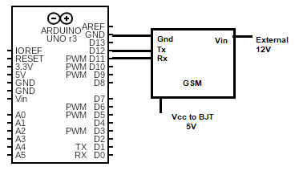

Fig: GSM module interface

The GSM module’s RX and TX are connected to the D11 and D12 digital pins of the Arduino board. Besides that, the GSM module only shares the ground with the Arduino board. The pins D11 and D12 act as TX, RX respectively of the Arduino when connected to fingerprint sensor with fingerprint input is enabled. It is connected to an external supply.

### Arduino with motor interface

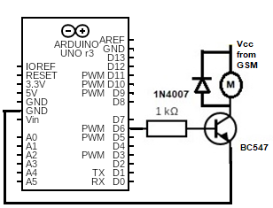

Fig: DC motor interface

The DC motor in parallel with 1N4007 is connected along the output of the BJT BC547, the BC547 is connected with an input resistance, and Vcc from the GSM module

# Project Outcomes

* Two Stage authentication for vehicles, better safety.

Relevance of Project with Program outcomes:

|  |  |
| --- | --- |
| Program Outcome | Relevance of project (Refer Program Outcomes) |
| PO1 | 3. Basic principles of Science and Engineering fundamentals applied |
| PO2 | 2. |
| PO3 | 2. |
| PO4 | 3. Research on communication protocols(baud rates) have been done |
| PO5 | 2. |
| PO6 | Relevance to Society:2. Two authentications for vehicle safety |
| Relevance to Health:1. |
| Relevance to Safety:1. |
| PO7 | 2. |
| PO8 | 3. |
| PO9 | 3. |
| PO10 | 3. |
| PO11 | 3. Every member is well acquainted with the project |
| PO12 | 1 This model can be lot more developed |

Mapping with Program Specific Outcomes of ECE department:

|  |  |
| --- | --- |
| Program Specific  Outcome | Mapping (Refer Program Specific Outcomes) |
| PSO1 | 1. |
| PSO2 | 2. |
| PSO3 | 3. This model totally depends upon the internal and external communication over different baud rates |
| PSO4 | 3. This project has a complex code, need good programming skills |

3: STRONG 2: MODERATE 1: WEAK 0: NIL

# Conclusion

This project is a basic example for authentication and location tracking, it helps the recipient or the user, with the data of usage of his vehicle, and security.

This can be used in:

Sports Bicycle

Electric Bikes

Electric Cars

Further Improvements:

It can be used for live tracking of vehicle.

It can be used as remote control for a vehicle (long distance control).

It can be used in traffic management.

It can be used as a database for vehicle movement.

# References

[**https://www.researchgate.net/publication/331966489_Implementation_of_smart_anti-theft_car_security_system_based_on_GSM**](https://www.researchgate.net/publication/331966489_Implementation_of_smart_anti-theft_car_security_system_based_on_GSM)

[**https://www.electroschematics.com/neo-6m-gps-module/**](https://www.electroschematics.com/neo-6m-gps-module/)

[**https://www.u-blox.com/sites/default/files/products/documents/NEO-6_DataSheet_(GPS.G6-HW-09005).pdf**](https://www.u-blox.com/sites/default/files/products/documents/NEO-6_DataSheet_(GPS.G6-HW-09005).pdf)

[**https://www.rhydolabz.com/wiki/?p=1545**](https://www.rhydolabz.com/wiki/?p=1545)

# Appendix A: -

1. Pin description and pin configuration of special IC’s

## Arduino UNO

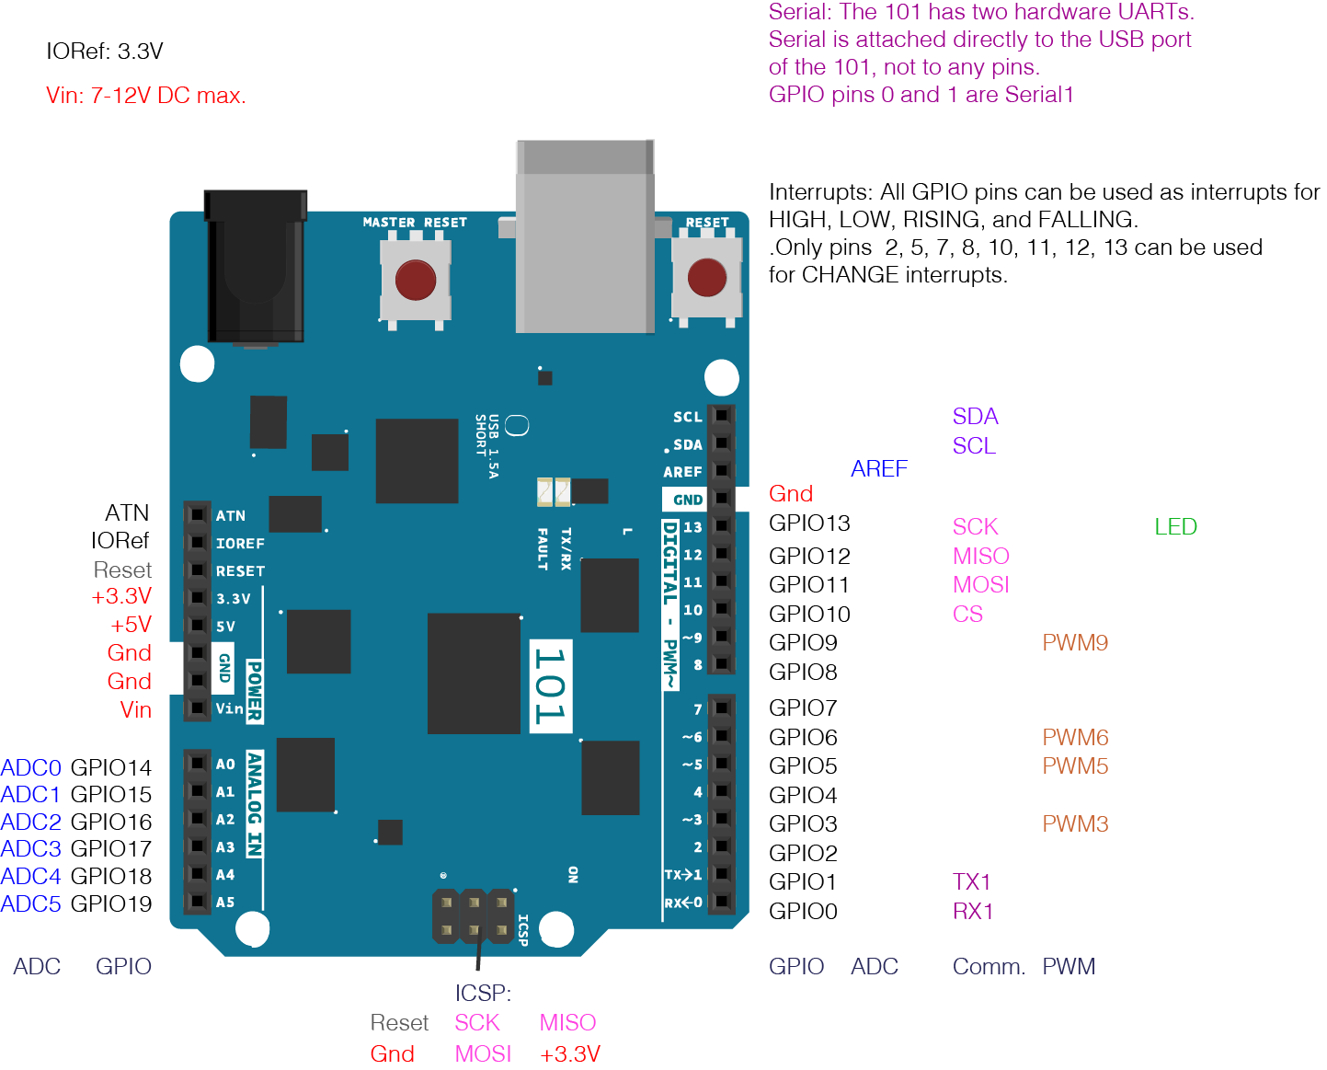

Fig: Pin configuration Arduino UNO

**Vin:**This is the input voltage pin of the Arduino board used to provide input supply from an external power source.

**5V:**This pin of the Arduino board is used as a regulated power supply voltage and it is used to give supply to the board as well as on-board components.

**3.3V:** This pin of the board is used to provide a supply of 3.3V which is generated from a voltage regulator on the board

**GND:** This pin of the board is used to ground the Arduino board.

**Reset:** This pin of the board is used to reset the microcontroller. It is used to Resets the microcontroller.

**Analog Pins:**The pins A0 to A5 are used as an analog input and it is in the range of 0-5V.

**Digital Pins:**The pins 0 to 13 are used as a digital input or output for the Arduino board.

**Serial Pins:** These pins are also known as a UART pin. It is used for communication between the Arduino board and a computer or other devices. The transmitter pin number 1 and receiver pin number 0 is used to transmit and receive the data resp.

**External Interrupt Pins:** This pin of the Arduino board is used to produce the External interrupt and it is done by pin numbers 2 and 3.

**PWM Pins:** This pins of the board are used to convert the digital signal into an analog by varying the width of the Pulse. The pin numbers 3,5,6,9,10 and 11 are used as a PWM pin.

**SPI Pins:** This is the Serial Peripheral Interface pin; it is used to maintain SPI communication with the help of the SPI library. SPI pins include:

1. SS: Pin number 10 is used as a Slave Select
2. MOSI: Pin number 11 is used as a Master Out Slave In
3. MISO: Pin number 12 is used as a Master In Slave Out
4. SCK: Pin number 13 is used as a Serial Clock

**LED Pin:**  The board has an inbuilt LED using digital pin-13. The LED glows only when the digital pin becomes high.

**AREF Pin:** This is an analog reference pin of the Arduino board. It is used to provide a reference voltage from an external power supply.

## FINGERPRINT SENSOR R307

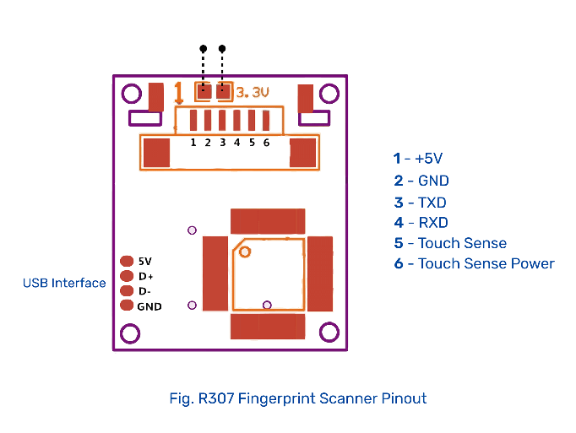

|  |  |  |  |
| --- | --- | --- | --- |
| **Pin Number** | **Name** | **Type** | **Description** |
| 1 | +5V | IN | Positive Supply (DC 4.2-6V) |
| 2 | GND | GND | Supply Ground |
| 3 | TXD | OUT | Data Output(TTL) |
| 4 | RXD | IN | Data Input(TTL) |
| 5 | Touch | OUT | Finger Detection Signal (max o/p current:50mA) |
| 6 | 3.3V | IN | Finger Detection Power |

## GSM SIM900A



Fig: GSM Module SIM900A

|  |  |  |
| --- | --- | --- |
| **S no** | **Pin Name** | **Description** |
| 1 | SDA | Serial Data [I2C] |
| 2 | SCL | Serial Clock [I2C] |
| 3 | MCPA | Multi Carrier Power Amplifier |
| 4 | SPP | Serial Port Profile |
| 5 | SPH | - |
| 6 | TXD | Data input |
| 7 | RXD | Data output |
| 8 | VCC | V in |
| 9 | GND | Ground |

## GPS NEO 6M

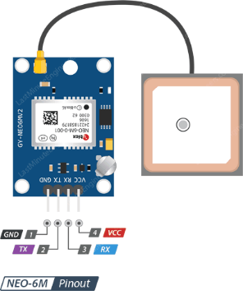

Fig: GPS Neo 6M

|  |  |  |
| --- | --- | --- |
| **S No.** | **Pin Name** | **Description** |
| 1. | GND | Supply Ground |
| 2. | TXD | Data Output(TTL) |
| 3. | RXD | Data Input(TTL) |
| 4. | +5V | Positive Supply (DC 4.2-6V) |

Appendix B: -

Program Code

#include<SoftwareSerial.h>

#include<TinyGPS++.h>

#include<Adafruit_Fingerprint.h>

#define motor 6

SoftwareSerial Finger(2,3);

SoftwareSerial GPS(9,10);

SoftwareSerial GSM_(11,12);

TinyGPSPlus gps;

Adafruit_Fingerprint finger = Adafruit_Fingerprint(&Finger);

void setup() {

bool mn=false;

float la=0;

float lo=0;

pinMode(motor,OUTPUT);

// put your setup code here, to run once:

Serial.begin(115200);

while(!Serial);

Finger.begin(9600);

delay(5);

if (finger.verifyPassword()) {

Serial.println("Found fingerprint sensor!");

} else {

Serial.println("Did not find fingerprint sensor :(");

while (1) { delay(1); }

}

Serial.println(F("Reading sensor parameters"));

finger.getParameters();

Serial.print(F("Status: 0x")); Serial.println(finger.status_reg, HEX);

Serial.print(F("Sys ID: 0x")); Serial.println(finger.system_id, HEX);

Serial.print(F("Capacity: ")); Serial.println(finger.capacity);

Serial.print(F("Security level: ")); Serial.println(finger.security_level);

Serial.print(F("Device address: ")); Serial.println(finger.device_addr, HEX);

Serial.print(F("Packet len: ")); Serial.println(finger.packet_len);

Serial.print(F("Baud rate: ")); Serial.println(finger.baud_rate);

finger.getTemplateCount();

if (finger.templateCount == 0) {

Serial.print("Sensor doesn't contain any fingerprint data. Please run the 'enroll' example.");

}

else {

Serial.println("Waiting for valid finger...");

Serial.print("Sensor contains "); Serial.print(finger.templateCount); Serial.println(" templates");

}

GPS.begin(4800);

Serial.println("Fetching Location...");

delay(100);

GSM_.begin(9600);

delay(100);

}

void loop() {

// put your main code here, to run repeatedly:

Finger.listen();

while(Finger.available()>0){

getFingerprintID();

delay(50);

}

while(GPS.available()>0){

if (gps.encode(GPS.read())){

if(gps.location.isValid()){

if(gps.location.isUpdated(){

la=gps.location.lat();

lo=gps.location.lng();

cl=String(la,7)+' '+String(lo,7)

GSM_.listen();

}

}

}

if (millis() > 5000 && gps.charsProcessed() < 10)

{

Serial.println(F("No GPS detected: check wiring."));

while(true);

}

if(mn==false){

msg='Unknown auth at\n'+cl+'\nVehicle start stopped.';

}

else{

msg='Vehicle Started at\n'+cl;

}

}

mn=false;

while(GSM_.available()>0){

GSM_.println("AT+CMGF=1"); //Sets the GSM Module in Text Mode

delay(1000); // Delay of 1000 milli seconds or 1 second

GSM_.println("AT+CMGS=\"+918341731809\"\r"); // Replace x with mobile number

delay(1000);

GSM_.print(msg);// The SMS text you want to send

delay(100);

GSM_.println((char)26);// ASCII code of CTRL+Z

delay(1000);

}

}

uint8_t getFingerprintID() {

uint8_t p = finger.getImage();

switch (p) {

case FINGERPRINT_OK:

Serial.println("Image taken");

break;

case FINGERPRINT_NOFINGER:

Serial.println("No finger detected");

return p;

case FINGERPRINT_PACKETRECIEVEERR:

Serial.println("Communication error");

return p;

case FINGERPRINT_IMAGEFAIL:

Serial.println("Imaging error");

return p;

default:

Serial.println("Unknown error");

return p;

}

// OK success!

p = finger.image2Tz();

switch (p) {

case FINGERPRINT_OK:

Serial.println("Image converted");

break;

case FINGERPRINT_IMAGEMESS:

Serial.println("Image too messy");

return p;

case FINGERPRINT_PACKETRECIEVEERR:

Serial.println("Communication error");

return p;

case FINGERPRINT_FEATUREFAIL:

Serial.println("Could not find fingerprint features");

return p;

case FINGERPRINT_INVALIDIMAGE:

Serial.println("Could not find fingerprint features");

return p;

default:

Serial.println("Unknown error");

return p;

}

// OK converted!

p = finger.fingerSearch();

if (p == FINGERPRINT_OK) {

Serial.println("Found a print match!");

mn=true;

} else if (p == FINGERPRINT_PACKETRECIEVEERR) {

Serial.println("Communication error");

return p;

} else if (p == FINGERPRINT_NOTFOUND) {

Serial.println("Did not find a match");

return p;

} else {

Serial.println("Unknown error");

return p;

}

// found a match!

Serial.print("Found ID #"); Serial.print(finger.fingerID);

Serial.print(" with confidence of "); Serial.println(finger.confidence);

return finger.fingerID;

analogWrite(motor,200);

GPS.listen();

}

// returns -1 if failed, otherwise returns ID #

int getFingerprintIDez() {

uint8_t p = finger.getImage();

if (p != FINGERPRINT_OK) return -1;

p = finger.image2Tz();

if (p != FINGERPRINT_OK) return -1;

p = finger.fingerFastSearch();

if (p != FINGERPRINT_OK) return -1;

// found a match!

Serial.print("Found ID #"); Serial.print(finger.fingerID);

Serial.print(" with confidence of "); Serial.println(finger.confidence);

return finger.fingerID;

}

# Appendix C: -

## FINANCIAL REPORT

|  |  |  |  |
| --- | --- | --- | --- |
| S no | Component | Quantity | Price |
| 1. | Arduino UNO | 1 | 350 |
| 2. | Fingerprint Sensor R307 | 1 | 1000 |
| 3. | GSM module SIM900A | 1 | 800 |
| 4. | GPS module Neo 6M | 1 | 340 |
| 5. | Ignition key | 1 | 60 |
| 6. | DC motor | 1 | 30 |
| 7. | Jumper wires | 1 set | 60 |
| 8. | BC547 transistor | 1 | 2 |
| 9. | 1N4007 Diode | 1 | 3 |
| 10. | Resistor 1kohm | 1 | 1 |
|  | Total: | +18%@GST | 3122.28 INR |

# Appendix D:-

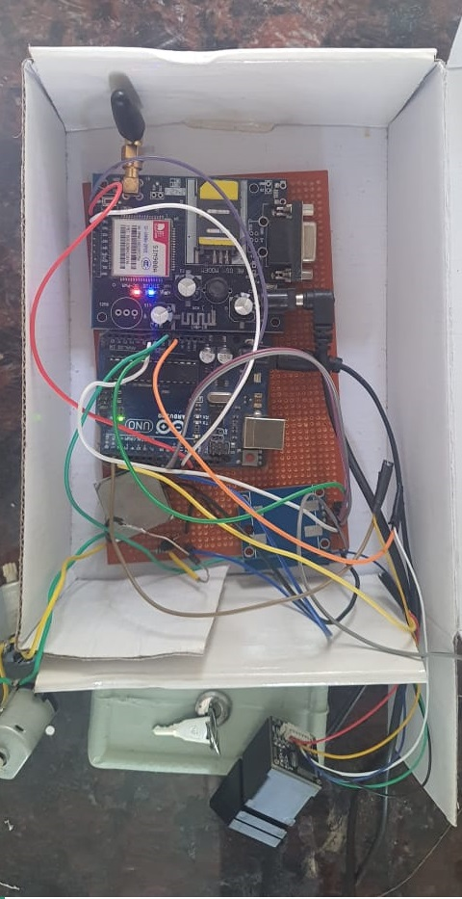

# Acknowledgement

It is great pleasure and sense of satisfaction that we present our project on VEHICLE ANTI-THEFT SYSTEM. We would like to hereby acknowledge and thank all those who helped us in making it a success.

First and foremost, we would like to express our sincere gratitude to Mrs. Shubhangi Saxena and Ms. Maliha Naaz our project coordinators for guiding and supervising us throughout the project for its completion.

We would also like to thank our seniors, and people who selflessly helped us in this project.