**1. In the below elements which of them are values or an expression? eg:- values can be integer or string and expressions will be mathematical operators.**

*

'hello'

-87.8

-

/

6

Ans: As per the above examples, values are (‘hello’, -87.8, 6) & expressions are (*, - , / , +)

**2. What is the difference between string and variable?**

* ***Variable:*** It refers to a container that holds some value & it would be anything list, string, tuple, set, dictionary.
* ***String*:** It denotes to a value that mention either within the single or double quotes for instance: ‘I am a student of iNeuron’ or “I am a student of iNeuron”.

**3. Describe three different data types.**

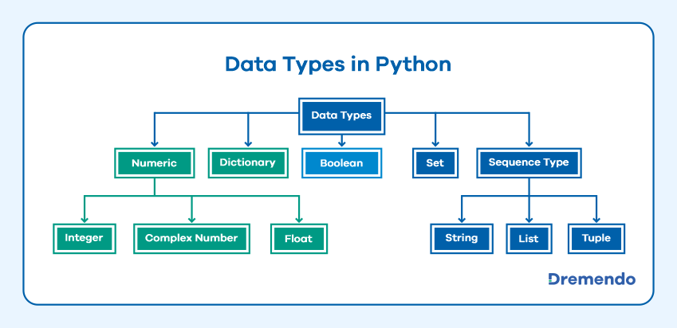

There are broadly 5 different varieties of data types available in Python but as the question constrains let’s talk about sequence data type which further classified into three types & those are: String, List, & Tuple.

* ***String:*** To be precise, string is something that contains any alphanumeric value either within single or double quotes e.g.: ‘This is Syed’ & “This is Syed”.
* ***List:*** It similarly act like a list only where we store something even in this list we can store any data irrespective of its nature like string, tuple, list, set, & dictionary. It allows duplicate value & it’s mutable along with ordered & index feature. List written under Square Bracket [].

Eg. [1,2,3, ‘Syed’, 99.2, true]

* ***Tuple:*** Tuple is similar to list except these two major differences, it’s an immutable data type which means it’s not changeable & we write it down under parenthesis or round brackets ().

Eg. (1,2,3, ‘Syed’, 99.2, true)

***4. What is an expression made up of? What do all expressions do?***

Ans: A combination of operands and operators is called an expression. E.g: A, B, C are Operand & +, * are Operator & there are various types of operators for instance Arithmetic, Comparison, Logical, Bitwise, Membership, Special, Assignment operators.

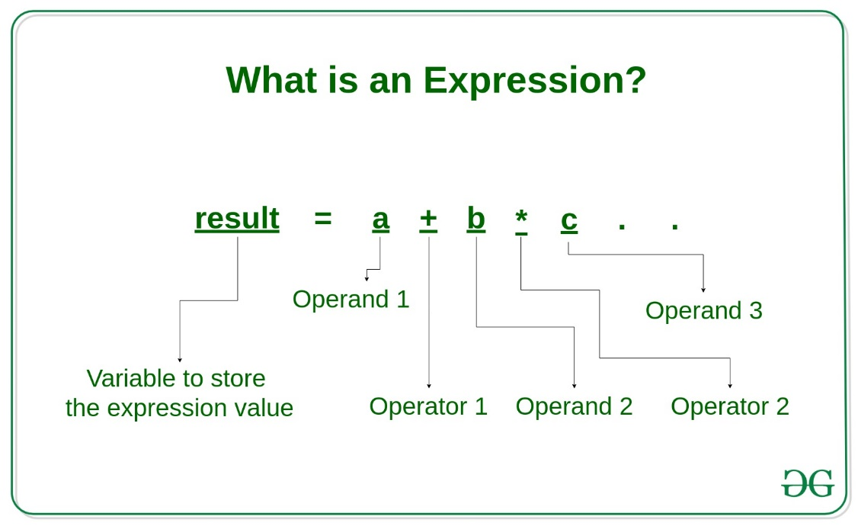

***5. This assignment statements, like spam = 10. What is the difference between an expression and a statement?***

* The expression in Python produces some value or result after being interpreted by the Python interpreter. *E.g. var = x + 10*
* A statement is used for creating variables or for displaying values. A statement is not evaluated for some result. *E.g., var = 10*
* A statement can be an expression but an expression can’t be a statement.

***6. After running the following code, what does the variable bacon contain?***

bacon = 22

bacon + 1

Ans: Bacon will contain “23”

***7. What should the values of the following two terms be?***

'spam' + 'spamspam'

'spam' * 3

Ans: In both cases, it should be 'spamspamspam'

***8. Why is eggs a valid variable name while 100 is invalid?***

**Ans:** Eggs & 100 both are not a reserved word like ‘for’, ‘while’, ‘in’, ‘and’**, ‘**or’ . Thus, eggs can be a variable but 100 which is just a numerical character so as per the variable's condition variable name can’t start with a number.

***9. What three functions can be used to get the integer, floating-point number, or string version of a value?***

**Ans:** int(), float(), & str() functions will evaluate to the integer, floating-point number, & string versions of the value passed to them.

***10. Why does this expression cause an error? How can you fix it?***

***'I have eaten ' + 99 + ' burritos.'***

Ans: It’s throwing an error because string can’t concatenate with integers as its 99, but string concatenates with other string with ‘+’ operator.

The appropriate way to put it in correct ways are

'I have eaten ' + str(99) + ' burritos.'

or

'I have eaten 99 burritos.'