Project Title

Voice Controlled Object Detection Robot Using Arduino

Course: Artificial Intelligence & Machine Learning
Presented By:
YAMEEN SAYYAD

Academic Year:
2025 – 2026
1. Abstract:
Robotics and automation technologies are becoming increasingly important in modern engineering applications. This project focuses on the design and implementation of a voicecontrolled robot with obstacle detection capability using the Arduino platform. The main objective of this system is to develop an intelligent robot that can move in different directions based on voice commands while also ensuring safe navigation through automatic obstacle detection.
The robot is controlled through a Bluetooth communication system that connects a smartphone to the robot using the HC-05 Bluetooth module. Voice commands given through a mobile application are converted into text commands and transmitted to the Arduino Uno microcontroller, which acts as the central processing unit of the system. Based on these commands, the Arduino processes the data and controls the motion of the robot through the L298N motor driver module, which regulates the direction and speed of the DC motors responsible for the robot's movement.
To enhance safety and automation, the robot is equipped with an HC-SR04 ultrasonic sensor that continuously measures the distance between the robot and nearby objects. The sensor works by emitting ultrasonic sound waves and calculating the time taken for the echo to return after hitting an obstacle. If the detected distance falls below a predefined threshold value, the Arduino automatically stops the motors, thereby preventing collisions and protecting the robot from potential damage.
The robot is capable of performing basic movement operations such as moving forward, backward, turning left, turning right, and stopping, based on the voice commands received from the user. This combination of voice control and obstacle detection enables the robot to operate efficiently in dynamic environments.
The proposed system demonstrates the practical integration of embedded systems, wireless communication, sensor technology, and robotic motion control. It also serves as an educational platform for understanding fundamental concepts of Arduino programming, motor control, and real-time sensor interaction.
Overall, the project provides a cost-effective, simple, and efficient robotic solution that can be further expanded for advanced applications such as autonomous robots, smart vehicles, assistive technologies, and intelligent surveillance systems.

2. Introduction:

Robotics is one of the most rapidly growing fields in modern technology. Robots are widely used in various sectors such as industrial manufacturing, healthcare, military operations, space exploration, and home automation. These robotic systems are designed to perform tasks efficiently, accurately, and with minimal human intervention. With the advancement of embedded systems, sensors, and wireless communication technologies, robots are becoming smarter and more capable of interacting with their environment.
In traditional robotic systems, movement and control are typically achieved through manual operation using remote controllers or wired interfaces. These systems require continuous human supervision, especially in environments where obstacles or unexpected conditions may occur. As a result, such robots may face limitations in terms of efficiency, flexibility, and safety.
Modern robotics aims to overcome these limitations by incorporating intelligent control systems and automated decision-making capabilities. Technologies such as voice recognition, wireless communication, and sensor-based navigation allow robots to perform tasks more autonomously. Voice-controlled robots provide a convenient way for users to interact with machines by simply giving spoken commands, eliminating the need for complex control devices.
This project focuses on the design and development of a voice-controlled robot with obstacle detection capability using Arduino. The robot can be controlled through voice commands given via a smartphone application. The commands are transmitted wirelessly through a Bluetooth module (HC-05) to the Arduino Uno microcontroller, which processes the received data and controls the robot's movement accordingly.
The robot is capable of performing basic directional movements such as moving forward, moving backward, turning left, turning right, and stopping. To ensure safe navigation, the system is integrated with an ultrasonic sensor (HC-SR04) that continuously monitors the distance between the robot and nearby objects. When the sensor detects an obstacle within a predefined distance, the robot automatically stops to avoid collision.
The movement of the robot is controlled using DC motors connected through an L298N motor driver module, which acts as an interface between the Arduino and the motors. The motor driver ensures proper control of motor direction and speed while protecting the microcontroller from high current loads.
The main objective of this project is to demonstrate how voice control technology and sensor-based obstacle detection can be integrated to create a simple yet effective robotic system. This project also provides a practical understanding of embedded systems programming, Bluetooth communication, sensor interfacing, and robotic motion control.
Overall, this system serves as an educational platform for learning robotics and automation concepts and can be further developed into more advanced applications such as autonomous vehicles, intelligent delivery robots, smart home assistants, and surveillance robots.

3.Problem Statement :

In recent years, robotics technology has been widely used in various fields such as industrial automation, healthcare, military applications, and smart home systems. However, many robotic systems still rely heavily on manual control mechanisms, which require constant human supervision to operate safely. Traditional remote-controlled robots depend entirely on the user to guide their movement and avoid obstacles. If the operator fails to react quickly, the robot may collide with objects, causing damage to the robot or the surrounding environment.
Another major challenge with conventional robotic systems is the lack of intelligent interaction between humans and machines. Many systems use complicated controllers or wired communication methods that are not convenient for users. This reduces the flexibility and accessibility of robots, especially for beginners or people who are not familiar with complex control devices.
In addition, many advanced robotic systems with intelligent navigation features are often expensive and difficult to implement, which makes them unsuitable for educational purposes or small-scale applications. Therefore, there is a need for a simple, cost-effective, and user-friendly robotic system that can demonstrate intelligent behavior while remaining affordable and easy to build.
The main problems addressed in this project include the following:

- Developing a Low-Cost Robotic System:
The project aims to design a robot using affordable and easily available components such as Arduino Uno, ultrasonic sensors, Bluetooth modules, and DC motors. This ensures that the system can be built and used for educational and research purposes without high costs.
- Enabling Voice-Based Movement Control:
Instead of using traditional manual controllers, the robot can be operated using voice commands through a smartphone application. This allows users to control the robot in a more natural and convenient way by simply speaking commands such as forward, backward, left, and right.
- Providing Automatic Obstacle Detection:
To improve safety and reduce the risk of collisions, the robot is equipped with an ultrasonic sensor that continuously detects obstacles in its path. When an object is detected within a specific distance, the robot automatically stops its movement.
- Improving Efficiency and Safety:
By combining voice control and obstacle detection, the robot becomes more efficient and safer to operate in dynamic environments where unexpected obstacles may appear.
This project therefore aims to develop a smart robotic system that integrates wireless communication, voice control, and sensor-based obstacle detection, providing a practical solution for safe and efficient robot navigation.

4. Objectives :

The main objective of this project is to design and develop a voice-controlled robot with obstacle detection capability using Arduino technology. The system combines wireless communication, sensor technology, and motor control to create a smart robotic platform capable of responding to user commands while ensuring safe movement. The specific objectives of this project are as follows:

4.1. To Design a Voice-Controlled Robotic System:

One of the primary objectives of this project is to develop a robot that can be controlled using voice commands. Instead of traditional manual controllers, the robot receives commands from a smartphone application where the user's voice is converted into control signals. This allows the user to control the robot in a more convenient, natural, and interactive manner.

4.2. To Implement Bluetooth Communication Between Smartphone and Robot:

The project aims to establish wireless communication between the robot and a smartphone using the HC-05 Bluetooth module. This communication allows the robot to receive movement commands from the user. Bluetooth technology is chosen because it is costeffective, reliable, and widely supported by mobile devices.

4.3. To Enable Directional Movement of the Robot:
The robot should be capable of performing basic directional movements such as moving forward, moving backward, turning left, turning right, and stopping. These movements are controlled using DC motors connected through the L298N motor driver, which regulates the speed and direction of the motors based on signals received from the Arduino microcontroller.

4.4. To Detect Obstacles Using an Ultrasonic Sensor:

Another important objective is to integrate an HC-SR04 ultrasonic sensor into the robotic system. This sensor continuously measures the distance between the robot and nearby objects. By detecting obstacles in advance, the robot can avoid potential collisions and navigate more safely in its environment.

4.5. To Implement Automatic Stopping Mechanism:
The system is designed so that when the ultrasonic sensor detects an obstacle within a predefined distance, the robot automatically stops its movement. This feature improves the safety and reliability of the robot, especially in environments where obstacles may appear unexpectedly.

4.6. To Develop an Intelligent and Interactive Robotic System:

This project aims to combine voice control, wireless communication, and sensor-based obstacle detection to create an intelligent robotic platform. The system demonstrates how multiple technologies can be integrated to develop a robot that can interact with users and respond intelligently to environmental conditions.
4.7. To Provide a Learning Platform for Robotics and Embedded Systems:

Another objective of this project is to create an educational platform that helps students understand fundamental concepts of robotics, embedded systems, sensor integration, and wireless communication. The project allows learners to gain practical experience in Arduino programming, motor control, and real-time system design.

5. Literature Survey:

Robotics and automation systems have gained significant importance in recent years due to their wide range of applications in industries, healthcare, military, and domestic environments. Researchers and engineers have developed various robotic systems that incorporate wireless communication, sensors, and intelligent control mechanisms to improve robot performance and efficiency. The concept of voice-controlled robots with obstacle detection has been studied and implemented in several research works.
One of the fundamental technologies used in robotic systems is the Arduino microcontroller platform. According to the official Arduino documentation, Arduino boards provide an easy-to-use hardware and software environment for developing embedded systems and robotic applications. Many researchers prefer Arduino because it is open-source, costeffective, and highly flexible, making it suitable for educational and prototype development. Arduino allows easy integration with sensors, motors, and communication modules, which makes it an ideal choice for building robotic systems.
Several studies have explored the use of Bluetooth technology for wireless robot control. Bluetooth communication provides a simple and reliable way to transmit commands between a smartphone and a robotic system. Research shows that Bluetooth modules such as HC-05 and HC-06 are commonly used for short-range communication because they offer stable connectivity and are easy to interface with microcontrollers. Bluetooth-controlled robots allow users to send commands through mobile applications, improving user interaction and convenience.
Another important area of research in robotics is voice recognition technology. Voicecontrolled robots allow users to operate machines using spoken commands, making the system more intuitive and user-friendly. Researchers have developed various mobile applications that convert voice commands into text signals, which are then transmitted to the robot through wireless communication. Voice control systems have been widely used in assistive technologies, smart home automation, and service robots to enhance accessibility and ease of operation.
Obstacle detection is also a critical feature in robotic navigation systems. Many researchers have used ultrasonic sensors to detect obstacles and measure distances between objects and the robot. The HC-SR04 ultrasonic sensor is widely used because of its high accuracy, low cost, and ease of implementation. The sensor works by emitting ultrasonic sound waves and measuring the time taken for the echo to return after hitting an object. By calculating this time, the system can determine the distance between the robot and the obstacle.

6. Hardware Components
The hardware components used in this project form the physical structure of the robot and enable it to perform movement, communication, and obstacle detection. Each component plays an important role in the functioning of the robotic system. The main hardware components used in this project include the Arduino Uno microcontroller, L298N motor driver module, ultrasonic sensor (HC-SR04), Bluetooth module (HC-05), DC motors, and battery power supply.

6.1 Arduino Uno:

The Arduino Uno is the main controller of the robot and acts as the brain of the entire system. It is an open-source microcontroller board based on the ATmega328P microcontroller. The Arduino receives input signals from the Bluetooth module and ultrasonic sensor, processes the data, and then sends control signals to the motor driver to move the robot accordingly.
The Arduino Uno is widely used in robotics projects because it is easy to program, affordable, and compatible with many sensors and modules. The Arduino IDE software is used to write and upload programs to the board.

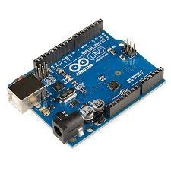
Fig 1 : Arduino Uno

Features of Arduino Uno
- Microcontroller: ATmega328P
- Operating Voltage: 5V
- Input Voltage: 7–12V
- Digital I/O Pins: 14 pins (6 PWM pins)
- Analog Input Pins: 6 pins
- Clock Speed: 16 MHz
- USB Interface for programming and communication

Role in the Project
In this robot, the Arduino Uno performs the following functions:
- Receives voice command signals from the Bluetooth module
- Processes commands such as forward, backward, left, and right
- Reads distance data from the ultrasonic sensor
- Controls the motor driver module to move the robot
- Stops the robot when an obstacle is detected

6.2 L298N Motor Driver

The L298N motor driver module is used to control the speed and direction of the DC motors. Since the Arduino cannot supply enough current to drive motors directly, the motor driver acts as an interface between the Arduino and the motors.
The L298N module contains a dual H-Bridge circuit, which allows the control of two motors independently. By sending different signals from the Arduino to the motor driver, the robot can move forward, backward, left, or right.

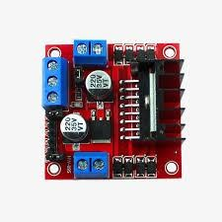

Fig 2 : L298N Motor Driver Features of L298N Motor Driver
- Dual H-Bridge motor driver
- Can control two DC motors simultaneously
- Motor supply voltage range: 5V – 35V
- Maximum current: 2A per channel
- PWM support for speed control
- Built-in voltage regulator

Role in the Project
The L298N motor driver performs the following tasks:
- Receives control signals from Arduino
- Controls the direction of DC motors
- Regulates motor speed and movement
- Allows the robot to perform directional movements

6.3 Ultrasonic Sensor (HC-SR04)
The HC-SR04 ultrasonic sensor is used to detect obstacles in front of the robot. This sensor works by emitting ultrasonic sound waves and measuring the time taken for the echo to return after hitting an object.
Using this time calculation, the Arduino determines the distance between the robot and the object. If the object is too close, the robot automatically stops to prevent a collision.

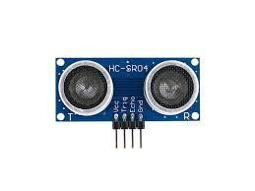

Fig 3 : Ultrasonic Sensor (HC-SR04)

Features of Ultrasonic Sensor
- Operating Voltage: 5V
- Detection Range: 2 cm – 400 cm
- Accuracy: ±3 mm
- Operating Frequency: 40 kHz
- Measuring Angle: 15 degrees

Sensor Pins
- VCC – Power supply (5V)
- Trig – Trigger pin to send ultrasonic pulse
- Echo – Receives reflected signal
- GND – Ground connection

Role in the Project
The ultrasonic sensor is responsible for:
- Detecting obstacles in front of the robot
- Measuring the distance to nearby objects
- Sending distance data to Arduino
- Helping the robot stop automatically when an obstacle is detected

6.4 Bluetooth Module (HC-05)
The HC-05 Bluetooth module is used for wireless communication between the robot and a smartphone. It allows the user to control the robot by sending voice commands through a
mobile application.
The Bluetooth module receives commands from the smartphone and transmits them to the Arduino through serial communication.
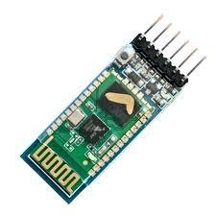

Fig 4 : Bluetooth Module (HC-05)

Features of HC-05 Bluetooth Module
- Bluetooth version: 2.0 + EDR
- Operating Voltage: 3.3V – 5V

• Communication Range: approximately 10 meters
- Serial communication interface
- Baud rate commonly set to 9600

Role in the Project
The HC-05 module performs the following tasks:
- Receives voice commands from smartphone
- Converts them into serial data
- Sends commands to Arduino microcontroller
- Enables wireless robot control

6.5 DC Motors
DC motors are used to provide movement to the robot. These motors convert electrical energy into mechanical motion, allowing the robot to move in different directions.
The robot typically uses two DC gear motors attached to the wheels. By controlling the direction and speed of each motor, the robot can perform various movements.
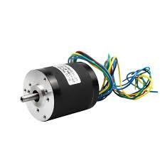

Fig 5 : DC Motors Functions of DC Motors
- Move the robot forward
- Move the robot backward
- Turn the robot left
- Turn the robot right
- Stop when necessary

Role in the Project
In this robot system:
- DC motors are connected to the L298N motor driver
- The motor driver receives signals from Arduino
- Based on the commands, the motors rotate in different directions to move the robot

6.6 Battery (Power Supply)
The battery provides the necessary electrical power required for the robot to operate. It supplies energy to the Arduino board, motor driver module, sensors, and motors.
Usually, a 12V rechargeable battery or lithium battery pack is used to power the robot.
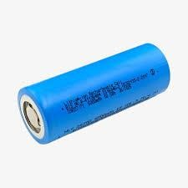

Fig 6 : Battery
Features of Battery Power Supply
- Provides stable power to all components
- Portable and rechargeable
- Supports continuous robot operation

Role in the Project
The battery performs the following functions:
- Supplies power to Arduino Uno
- Powers the motor driver module
- Drives the DC motors
- Provides energy for the sensors and Bluetooth module.

7. Working Principle:
The working principle of the Voice Controlled Object Detection Robot is based on the integration of wireless communication, sensor technology, and motor control using an Arduino microcontroller. The robot is designed to respond to user voice commands while also ensuring safe movement by detecting obstacles in its path.
The system mainly operates in two functional modes:
1. Voice Control Mode

2. Object Detection Mode
These two modes work together to ensure that the robot moves according to the user’s commands while automatically preventing collisions with nearby objects.
7.1 Voice Control Mode:
In the voice control mode, the robot receives movement instructions from the user through a smartphone application. The smartphone converts the spoken commands into text-based control signals and sends them to the robot through Bluetooth communication.
The HC-05 Bluetooth module receives these commands and transmits them to the Arduino Uno microcontroller using serial communication. The Arduino then processes the received command and sends appropriate control signals to the L298N motor driver module, which controls the movement of the DC motors attached to the robot wheels.
Based on the command received, the robot performs the following movements:
- Forward: Both motors rotate in the forward direction, moving the robot straight ahead.
- Backward: Both motors rotate in the reverse direction, causing the robot to move backward.
- Left: One motor stops or rotates in reverse while the other motor moves forward, causing the robot to turn left.
- Right: The opposite motor movement occurs to turn the robot toward the right side.
- Stop: Both motors stop rotating, and the robot remains stationary.
This voice-based control system allows users to operate the robot easily without using physical controllers. It provides a simple, interactive, and user-friendly interface for controlling the robot.
7.2 Object Detection Mode:
In addition to voice control, the robot is equipped with an ultrasonic sensor (HC-SR04) that enables obstacle detection. This sensor continuously monitors the distance between the robot and nearby objects.
The ultrasonic sensor works by emitting ultrasonic sound waves from its transmitter. These sound waves travel through the air and reflect back when they hit anobject. The sensor then receives the reflected signal through its receiver. By calculating the time taken for the sound waves to return, the Arduino determines the distance between the robot and the object.
The distance measurement is continuously monitored by the Arduino microcontroller. If the detected distance becomes less than a predefined threshold value, it indicates that an obstacle is present in front of the robot.
When this situation occurs, the Arduino immediately sends a signal to the motor driver module to stop the motors. As a result, the robot stops moving automatically, preventing a collision with the obstacle.

7.3 Combined System Operation
Both voice control and obstacle detection functions operate simultaneously in the system. Even when the robot is moving according to voice commands, the ultrasonic sensor continuously monitors the environment for obstacles.
If an obstacle is detected while the robot is moving forward, the system overrides the voice command and stops the robot automatically to ensure safety. Once the obstacle is removed or the robot changes direction, normal movement can resume.
This combination of wireless voice control and automatic obstacle detection makes the robot more intelligent, efficient, and safe to operate in dynamic environments.

7.4 Overall System Operation Steps
The complete working process of the robot can be summarized in the following steps:
- The user gives a voice command through a smartphone application.
- The smartphone converts the voice command into a Bluetooth signal.
- The HC-05 Bluetooth module receives the signal and sends it to the Arduino.
- The Arduino microcontroller processes the command.
- The Arduino sends control signals to the L298N motor driver.
- The motor driver controls the DC motors to move the robot in the desired direction.
- Meanwhile, the ultrasonic sensor continuously measures the distance to nearby objects.
- If an obstacle is detected within the threshold distance, the Arduino stops the motors automatically.
- The robot waits for further commands from the user.

This working principle demonstrates how Arduino, Bluetooth communication, motor control, and ultrasonic sensing can be integrated to create a smart robotic system capable of voice control and automatic obstacle detection.

8. Methodology
The methodology of this project describes the step-by-step process used to design, develop, and implement the voice-controlled object detection robot. The system integrates hardware components such as sensors, motors, and communication modules with software programming to achieve the desired functionality.
The development of this robotic system is carried out through several stages including system design, hardware integration, programming, and testing.

8.1 System Design
The first step in the methodology is the design of the robotic system architecture. In this stage, the required hardware components are identified and the connections between them are planned.
The main components used in the system include:
- Arduino Uno microcontroller
- HC-05 Bluetooth module
- HC-SR04 ultrasonic sensor
- L298N motor driver module
- DC motors
- Battery power supply
The Arduino Uno acts as the central controller, receiving input from the Bluetooth module and ultrasonic sensor while controlling the motor driver module.

8.2 Hardware Integration
In the second stage, all hardware components are connected according to the circuit design.
The connections are performed as follows:
- The Bluetooth module (HC-05) is connected to the Arduino for wireless communication.
- The ultrasonic sensor (HC-SR04) is connected to the Arduino to detect obstacles.
- The L298N motor driver module is connected to the Arduino to control the motors.
- DC motors are connected to the motor driver to provide movement to the robot.
- A battery power supply provides electrical energy to the entire system.
Proper wiring and connections are essential to ensure that all components communicate correctly with the Arduino.

8.3 Software Development
The next stage involves developing the Arduino program using the Arduino IDE. The software is responsible for controlling the entire robot operation.
The program performs the following tasks:
- Reads voice command signals received from the Bluetooth module.
- Interprets the commands and determines the required movement.
- Sends control signals to the motor driver to move the robot.
- Continuously reads distance data from the ultrasonic sensor.
- Stops the robot automatically if an obstacle is detected within a predefined distance.
The program is written in Embedded C language and uploaded to the Arduino board through a USB connection.

8.4 Voice Command Processing
Voice commands are given through a smartphone application that supports voice recognition. The application converts spoken commands into text signals and sends them through Bluetooth to the robot.
Common commands used in the system include:
- Forward
- Backward
- Left
- Right
- Stop
These commands are received by the Arduino through serial communication and processed to control the movement of the robot.

8.5 Obstacle Detection Mechanism
The ultrasonic sensor is used to detect obstacles in front of the robot. It continuously sends ultrasonic pulses and measures the time taken for the echo signal to return.
Using this time value, the Arduino calculates the distance between the robot and nearby objects.
If the detected distance is less than the predefined safety distance, the Arduino immediately sends a signal to stop the motors. This ensures that the robot avoids collisions and operates safely.

8.6 System Testing
After assembling the hardware and uploading the program, the robot is tested to ensure that all functions operate correctly.
The following tests are performed:
- Testing Bluetooth connectivity with the smartphone.
- Verifying that voice commands correctly control robot movement.
- Checking that the ultrasonic sensor accurately detects obstacles.
- Confirming that the robot stops automatically when an object is detected.
Any errors or issues identified during testing are corrected by adjusting the program or hardware connections.

8.7 Final Implementation
After successful testing, the system is implemented as a fully functional voice-controlled robot with obstacle detection capability. The robot can move in different directions based on voice commands while continuously monitoring its surroundings for obstacles.
This methodology ensures that the robotic system is efficient, reliable, and safe to operate, demonstrating the integration of wireless communication, sensor technology, and embedded systems.

9. System Architecture
The system architecture of the voice-controlled object detection robot describes the overall structure and interaction between the different hardware components used in the system. The architecture illustrates how data flows from the user to the robot and how the robot processes this information to perform movement while detecting obstacles.
The system is designed around the Arduino Uno microcontroller, which acts as the central controller responsible for processing input signals, making decisions, and controlling the output devices. The main components involved in the system architecture include the smartphone, Bluetooth module, Arduino microcontroller, ultrasonic sensor, motor driver module, DC motors, and power supply.

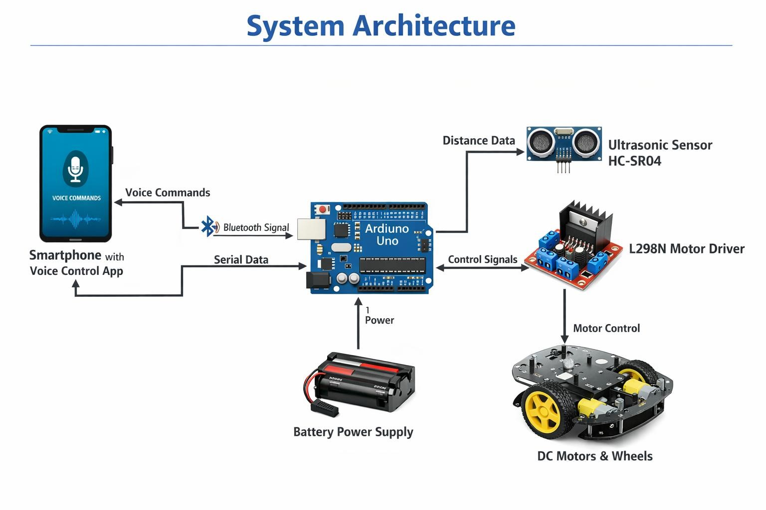
Fig 7 : System Architecture
9.1 System Components
The architecture of the system consists of the following major components:

1. Smartphone with Voice Control Application
The smartphone acts as the input device in the system. A voice control application installed on the smartphone allows the user to give voice commands such as forward, backward, left, right, and stop.
The application converts the voice commands into text-based control signals and transmits them to the robot through Bluetooth communication.

2. Bluetooth Module (HC-05)
The HC-05 Bluetooth module acts as the communication bridge between the smartphone and the Arduino microcontroller. It receives the commands transmitted from the smartphone and sends them to the Arduino through serial communication.
This wireless communication eliminates the need for physical connections and allows the robot to be controlled from a distance.

3. Arduino Uno Microcontroller
The Arduino Uno is the central processing unit of the robot. It receives commands from the Bluetooth module and processes them according to the program stored in the microcontroller.
The Arduino performs several important tasks:
- Interprets the received voice command
- Controls the motor driver module to move the robot
- Reads distance data from the ultrasonic sensor
- Stops the robot if an obstacle is detected
Thus, the Arduino acts as the decision-making unit of the robotic system.

4. Ultrasonic Sensor (HC-SR04)
The ultrasonic sensor is used to detect obstacles in front of the robot. It continuously sends ultrasonic pulses and measures the time taken for the reflected signal to return.
The sensor sends the distance information to the Arduino. If the distance between the robot and the object is below the predefined threshold, the Arduino sends a command to stop the motors.
This component ensures safe navigation of the robot.

5. Motor Driver Module (L298N)
The L298N motor driver module acts as an interface between the Arduino and the DC motors. Since the Arduino cannot provide enough current to drive motors directly, the motor driver amplifies the control signals and supplies sufficient power to the motors.
The motor driver allows the Arduino to control:
- Motor direction
- Motor speed
- Robot movement

6. DC Motors
The DC motors are responsible for the movement of the robot. They are connected to the wheels and receive power from the motor driver module.
By controlling the rotation direction of the motors, the robot can perform different movements such as:
- Moving forward
- Moving backward
- Turning left
- Turning right
- Stopping

7. Power Supply
The battery power supply provides electrical energy to all components of the robot, including the Arduino board, motor driver module, sensors, and motors.
A stable power supply is necessary to ensure smooth operation of the system.

9.2 Data Flow in the System
The flow of data in the system occurs in the following sequence:
- The user gives a voice command through the smartphone application.
- The command is transmitted via Bluetooth to the HC-05 module.
- The Bluetooth module sends the command to the Arduino.
- The Arduino processes the command and determines the appropriate action.
- The Arduino sends control signals to the motor driver module.
- The motor driver controls the DC motors to move the robot.
- At the same time, the ultrasonic sensor continuously checks for obstacles.
- If an obstacle is detected within the threshold distance, the Arduino immediately stops the motors.

9.3 Advantages of the Architecture
The proposed system architecture provides several advantages:
- Simple and easy to implement
- Low-cost hardware components
- Efficient wireless communication
- Automatic obstacle detection for safety
- Flexible and expandable for future upgrades
This architecture provides a clear and efficient structure for integrating voice control, wireless communication, and sensor-based obstacle detection into a single robotic system.

10. Flowchart Explanation
The flowchart represents the logical sequence of operations performed by the voice-controlled robot with obstacle detection. It explains how the system starts, receives commands, checks for obstacles, and controls the robot movement.
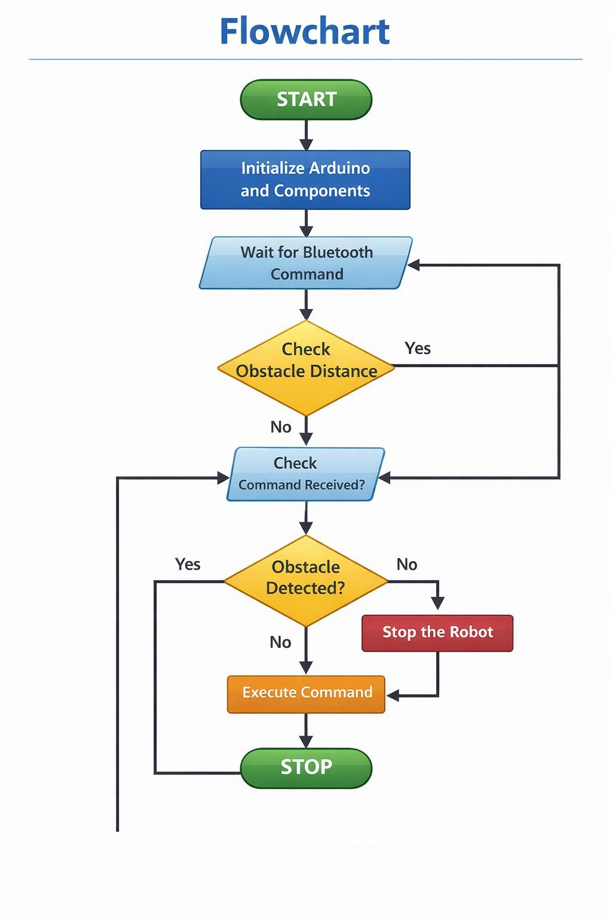
Fig 8 : Flow Chart

System Initialization
The process begins when the robot is powered on. The Arduino Uno microcontroller initializes all the connected components including the Bluetooth module, ultrasonic sensor, and motor driver.
During initialization:
- Input and output pins are configured.
- Serial communication is established for the Bluetooth module.
- The ultrasonic sensor is prepared to measure distances.
- Motors are set to the default stopped state.
This ensures that the robot starts safely and waits for user commands.

Voice Command Reception
Once initialization is complete, the system enters the command-receiving stage.
- The user opens a voice control mobile application.
- The user speaks a command such as:
o Forward o Backward
o Left
o Right
o Stop
- The mobile application converts the voice command into text.
- The text command is transmitted to the robot via Bluetooth communication.
The HC-05 Bluetooth module receives this command and sends it to the Arduino through serial communication.

Command Processing
After receiving the command, the Arduino microcontroller processes it and determines the appropriate action.
The Arduino program checks the received command using conditional statements.
For example:
- If command = Forward, move robot forward.
- If command = Backward, move robot backward.
- If command = Left, turn robot left.
- If command = Right, turn robot right.
- If command = Stop, stop the motors.
Before executing movement commands, the robot performs an important safety check using the ultrasonic sensor.

Obstacle Detection
The ultrasonic sensor continuously measures the distance between the robot and objects in front of it.
The working process includes:
- The Trig pin sends an ultrasonic pulse.
- The pulse travels through the air.
- If it hits an obstacle, it reflects back.
- The Echo pin receives the reflected signal.
- Arduino calculates the distance based on the travel time.
The calculated distance is then compared with a predefined threshold value (for example 20 cm).
Decision Making
After calculating the distance, the system makes a decision.

Case 1: No Obstacle Detected
If the measured distance is greater than the threshold distance:
- The robot continues executing the received command.
- Motors move according to the user’s voice instruction.
For example:
- Move forward
- Move backward
- Turn left or right

Case 2: Obstacle Detected
If the distance is less than the threshold value:
- The robot immediately stops
- Motors are turned off
- This prevents collision with the object
The system then waits for the next command from the user.

Motor Control
The L298N motor driver module is responsible for controlling the motors.
The Arduino sends signals to the motor driver which determines:
- Motor direction
- Motor speed
- Motor rotation
This allows the robot to perform different movements such as:
- Forward motion
- Reverse motion
- Left turn
- Right turn
- Complete stop

Continuous Monitoring
The system operates in a continuous loop. After executing a command, the robot again:
- Checks for new voice commands
- Monitors obstacle distance
- Executes movement safely
This loop ensures real-time robot control and safety monitoring.

Summary of Flowchart Steps
The overall process of the robot can be summarized as follows:
- Start the system.
- Initialize Arduino and components.
- Wait for Bluetooth command.
- Receive voice command.
- Check obstacle distance.
- If obstacle detected → Stop robot.
- If no obstacle → Execute command.
- Repeat the process continuously.

11. Software Requirements
The successful implementation of the voice-controlled robot with obstacle detection requires several software tools for programming, communication, and testing. These software components help in writing the program, uploading it to the microcontroller, and controlling the robot through voice commands.

1. Arduino IDE
The Arduino Integrated Development Environment (IDE) is the primary software used to write, compile, and upload the program to the Arduino Uno microcontroller.
The Arduino IDE provides a simple and user-friendly interface that allows developers to write code using the Arduino programming language, which is based on C/C++.

Features of Arduino IDE
- Easy-to-use programming interface
- Built-in libraries for sensors and modules
- Serial monitor for debugging and testing
- Cross-platform support (Windows, Linux, macOS)
- One-click code upload to Arduino board
Using the Arduino IDE, the developer writes the logic for receiving Bluetooth commands, processing them, controlling the motors, and detecting obstacles using the ultrasonic sensor.

2. Voice Control Mobile Application
A voice control mobile application is required to send voice commands from the smartphone to the robot through Bluetooth communication.
The application converts spoken words into text commands and transmits them to the Bluetooth module connected to the Arduino.

Functions of the Mobile Application
- Converts voice input into digital commands
- Sends commands via Bluetooth
- Provides an easy interface for robot control
- Allows wireless communication with the robot
Common commands used in the application include:
- Forward
- Backward
- Left
- Right
- Stop
These commands are received by the Bluetooth module and forwarded to the Arduino for processing.

3. Bluetooth Communication Software
Bluetooth communication is established between the smartphone and the robot using the HC05 Bluetooth module.
The module uses serial communication to exchange data with the Arduino microcontroller.

Key Functions
- Wireless communication between smartphone and robot
- Data transmission using serial protocol
- Reliable communication within a range of approximately 10 meters
The Bluetooth module receives commands from the mobile application and sends them to the Arduino for further processing.

4. Embedded Programming
The robot system uses embedded programming to control hardware components such as motors, sensors, and communication modules.
The program written in Arduino IDE performs several tasks including:
- Reading commands from the Bluetooth module
- Controlling the motor driver
- Measuring distance using the ultrasonic sensor
- Making decisions based on sensor data
- Preventing collisions by stopping the robot
Embedded programming ensures that the robot operates efficiently and responds quickly to commands and environmental changes.

5. Serial Communication
Serial communication is used for data exchange between the Arduino and Bluetooth module.
In this project, serial communication helps in:
- Receiving commands from the smartphone
- Debugging the program using the Serial Monitor
- Monitoring system performance
This communication plays a crucial role in ensuring smooth interaction between the robot and the user.

12. Applications
The voice-controlled robot with obstacle detection has many practical applications in different fields. This type of robot combines wireless communication, sensor technology, and automation to perform tasks efficiently. The system can be used in environments where human control is difficult or unsafe.

1. Industrial Automation
In industries and factories, robots are widely used to perform repetitive and hazardous tasks. A voice-controlled robot can help workers control robotic movement easily using voice commands instead of manual control systems.
Such robots can be used for:
- Material transportation within factories
- Inspection of machinery
- Automated movement of tools and components
Obstacle detection ensures that the robot avoids collisions with equipment and workers.

2. Assistance for Physically Disabled People
Voice-controlled robots can assist people with physical disabilities who may have difficulty operating traditional devices.
Using voice commands, users can control the robot to perform simple tasks such as:
- Fetching objects
- Moving items from one place to another
- Assisting with household activities
This technology improves accessibility and independence for individuals with mobility challenges.

3. Home Automation and Smart Homes
The robot can be integrated into home automation systems where users can control devices using voice commands.
Possible home applications include:
- Smart cleaning robots
- Remote-controlled service robots
- Automated household assistants
Obstacle detection allows safe movement inside homes without hitting furniture or walls.

4. Military and Defense Applications
Robots are increasingly used in military operations where human safety is a priority. Voicecontrolled robots can be used for surveillance and reconnaissance tasks.
Examples include:
- Monitoring dangerous areas
- Detecting obstacles in unknown environments
- Assisting soldiers during operations
Such robots help reduce risks to human life in dangerous situations.

5. Educational and Research Purposes
This project is very useful for students and researchers learning about robotics, electronics, and embedded systems.
It helps in understanding:
- Arduino programming
- Sensor integration
- Bluetooth communication
- Robot navigation
Educational institutions often use such projects for practical demonstrations and robotics competitions.

6. Surveillance and Security
Voice-controlled robots equipped with sensors can be used for security monitoring in buildings, offices, and restricted areas.
They can help in:
- Patrolling specific locations
- Detecting obstacles or unusual movements
- Assisting security personnel in monitoring environments
This improves safety and surveillance efficiency.

13. Advantages
The voice-controlled robot with obstacle detection offers several advantages in terms of ease of use, safety, and efficiency. By combining voice recognition, wireless communication, and sensor technology, the robot becomes an intelligent system capable of performing tasks with minimal human effort.

1. Easy to Control
One of the major advantages of this system is that it can be controlled using simple voice commands. The user only needs to speak commands such as forward, backward, left, right, and stop through a mobile application. This makes the robot very easy to operate without using complex control devices.

2. Hands-Free Operation
Since the robot operates using voice commands, it allows hands-free control. This is especially useful in situations where the user cannot physically operate the robot using buttons or joysticks.

3. Obstacle Detection and Safety
The robot is equipped with an ultrasonic sensor that continuously checks for obstacles in front of it. If an object is detected within a certain distance, the robot automatically stops. This prevents collisions and improves the safety of the robot while moving.

4. Wireless Communication
The use of a Bluetooth module allows wireless communication between the smartphone and the robot. This eliminates the need for wires and provides flexibility in controlling the robot from a distance.

5. Low Cost and Simple Design
The project uses commonly available components such as Arduino Uno, ultrasonic sensor, Bluetooth module, and DC motors. These components are affordable and easy to assemble, making the system cost-effective.

6. Educational Value
This project is very useful for students and beginners who want to learn about robotics, embedded systems, and sensor technology. It helps in understanding how different hardware and software components work together to create an intelligent robotic system.

7. Energy Efficient
The robot consumes relatively low power since it uses efficient electronic components and microcontroller-based control. This allows it to operate for a longer time using battery power.

8. Expandable System
Another important advantage is that the system can be easily upgraded. Additional features such as camera modules, GPS tracking, Wi-Fi communication, or advanced sensors can be integrated in the future to enhance the robot's capabilities.

14. Limitations
Although the voice-controlled robot with obstacle detection provides several advantages, it also has certain limitations. These limitations arise due to hardware constraints, environmental factors, and the simplicity of the system design.

1. Limited Bluetooth Range
The robot uses a Bluetooth module for communication between the smartphone and the Arduino controller. Bluetooth typically works within a limited range of approximately 10 meters. If the user moves beyond this range, the connection may be lost and the robot will not receive commands.

2. Dependence on Voice Recognition Accuracy
The system relies on voice commands from a mobile application. If the voice recognition system does not accurately interpret the user's command due to background noise or unclear speech, the robot may not respond correctly.

3. Limited Obstacle Detection Area
The ultrasonic sensor detects obstacles only in the direction where it is placed. This means the robot may not detect objects on the sides or behind it. As a result, collisions may occur if obstacles appear outside the sensor’s detection range.

4. Sensitivity to Environmental Conditions
Ultrasonic sensors can sometimes be affected by environmental conditions such as soft surfaces, irregular shapes, or noise interference. These factors may reduce the accuracy of distance measurements.

5. Basic Navigation System
The robot follows simple movement commands such as forward, backward, left, and right. It does not have advanced navigation capabilities like path planning, mapping, or automatic route selection.

6. Battery Limitations
The robot depends on battery power for operation. If the battery level becomes low, the performance of the motors and sensors may decrease, affecting the overall functioning of the robot.

7. No Autonomous Decision Making
The robot mainly relies on user commands for movement. Apart from stopping when an obstacle is detected, it cannot make complex decisions or perform autonomous navigation like advanced robots.

15. Future Scope
The voice-controlled robot with obstacle detection is a basic robotics system that can be further improved by adding advanced technologies and features. In the future, this project can be enhanced to perform more complex tasks and operate more intelligently.

1. Integration with Artificial Intelligence
In the future, artificial intelligence can be integrated into the robot to improve its decisionmaking capabilities. AI algorithms can help the robot understand complex voice commands and perform tasks more efficiently.

2. Wi-Fi or Internet-Based Control
Instead of using only Bluetooth communication, the robot can be upgraded to use Wi-Fi or Internet connectivity. This will allow users to control the robot from anywhere in the world through a mobile application or web interface.

3. Camera and Video Monitoring
A camera module can be added to the robot to enable live video streaming. This will allow the robot to be used for surveillance, monitoring, and security purposes in homes, offices, or industrial areas.

4. Advanced Obstacle Detection
More sensors such as infrared sensors, LiDAR sensors, or multiple ultrasonic sensors can be added to improve obstacle detection. This will allow the robot to detect obstacles in all directions and move more safely.

5. Autonomous Navigation
Future versions of the robot can include automatic navigation systems. The robot could move on its own without human commands by using path planning and mapping technologies.

6. Integration with Smart Home Systems
The robot can be integrated with smart home systems so that it can interact with other smart devices such as lights, doors, and appliances. This would make the robot a useful assistant in home automation.

7. GPS Tracking System
A GPS module can be added to track the robot's location in real time. This feature would be useful for outdoor applications such as delivery robots or surveillance robots.

8. Voice Assistant Integration
The system can be connected with modern voice assistants like Google Assistant or Alexa for more advanced voice control and automation features.

16. Conclusion
The voice-controlled robot with obstacle detection is an innovative and practical robotics project that combines voice recognition, wireless communication, and sensor technology. The main objective of this project is to design and develop a robot that can be controlled using simple voice commands while ensuring safety through obstacle detection.
In this system, the Arduino microcontroller acts as the central controller that processes commands received through the Bluetooth module. The voice commands given through a smartphone application are transmitted to the robot, allowing the user to control its movement easily. The ultrasonic sensor plays an important role in detecting obstacles and preventing collisions by stopping the robot when an object is detected within a certain distance.
This project demonstrates how different electronic components and software tools can work together to create an intelligent robotic system. It also provides a practical understanding of embedded systems, sensor integration, Bluetooth communication, and motor control.
The robot is simple, cost-effective, and easy to implement, making it suitable for educational purposes and basic automation tasks. With further improvements such as advanced sensors, camera modules, and internet connectivity, the system can be developed into a more advanced and intelligent robotic platform.
Overall, the project successfully achieves its goal of building a voice-controlled robot capable of detecting obstacles and operating safely. It highlights the growing importance of robotics and automation in modern technology and provides a strong foundation for future developments in this field.

