**Semester Project Report:**

**Project title:**

**“Phase Shifters ”**

**Objectives:**

The objectives of this project are as follows:

* Learn the concept of phase shifters
* Mathematical calculations for leading and lagging phase angles
* Phase angles of resistive, capacitive, and inductive circuits
* Phase angles of RC and RL circuits
* Practical implementation of circuits
* Increase the knowledge of dealing with hardware components
* Working with AC voltage source
* Circuit implementation on a breadboard
* Circuit implementation on stripboard circuit boards
* Soldering of electrical components
* Working and testing of electrical components
* Managing circuit voltages with transformer
* Introduction to the oscilloscope
* Increase the knowledge of searching and selecting components for projects
* Use of proteus software for simulation purpose

**Table of Contents**

1)Background…………………………………………………………………………………………3

1.1)Nature of Loads…………………………………………………………………………………...3

1.2)Combined Load Effect……………………………………………………………………….…...4

2)Introduction…………………………………………………………………………………............5

2.1)RC leading and lagging circuit……………………………………………………………………5

2.2)RL leading and lagging circuit……………………………………………………………………6

3) Project Task…………………………………………………………………………………..........6

3.1)Statement…………………………………………………………………………………............6

3.2)Components Selection Criteria…………………………………………………………………...6

3.3)Mathematical Calculations………………………………………………………………….……6

3.4)Reason for RC circuit only…………………………………………………………….…………6

3.5)Components……………………………………………………………………………….……...7

3.6)Circuit Diagram and Block Diagram……………………………………………………..………7

3.7)Simulation………………………………………………………………………………………...7

3.8)Project………………………………………………………………………………….................9

4) Conclusion………………………………………………………………………………….............10

5)Project Outcome…………………………………………………………………………………......10

**1.Background:**

Every concept has some background idea behind it and how it started, and phase shifters also have some background behind it, in this paragraph, we will have a look at the basic idea or concept of phase shifters. As we are dealing with Alternating Current we know the general wave form of AC is sinusoidal, due to potential differences across any load there is flow of charges called current, in AC circuit current and voltages have phase angles, either it can be zero leading or lagging depending upon the nature of load.

* 1. **Nature of Load:**

The nature of load can be characterized into 3 types

1)Resistive

2)Inductive

3)Capacitive

In ideal situation it can be purely resistive, capacitive or inductive. The following concept is for purely resistive, capacitive and inductive circuits.

**Resistive :**

The kind of circuit or load in which the element is resistor no inductance or capacitance involved and it is the real part of impedance.

So In resistive load the voltage and current are in phase

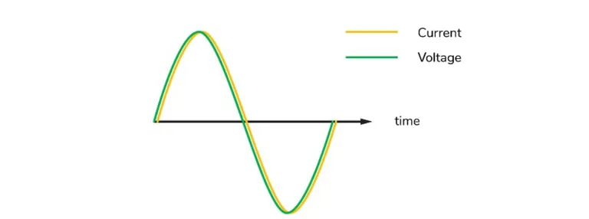

Fig 1(a)

**Inductive :**

The kind of circuit or load which involves only inductor no other elements are involved, this is the positive imaginary part of impedance.

So in inductive load or circuit the voltage and current are out of phase by 90 degrees, voltage leads in inductive circuit

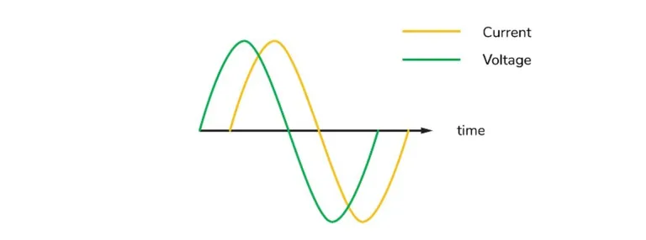

Fig 1(b)

**Capacitive:**

The kind of circuit or load which involves only a capacitor and no other elements are involved, this is the negative imaginary part of the impedance.So in a capacitive load or circuit, the current and voltage are out of phase by 90 degrees, where the current leads the voltage.

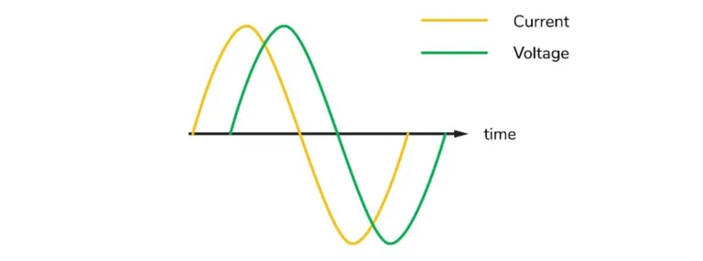

Fig 1(c)

* 1. **Combined element Effect:**

We now know the effect of all the loads individually that whatwould happen if we have a combination of these loads? so this is where the concept of RL,RC and RLC circuits rises.Due to the combine effect of resistance + inductance, and resistance +capacitance typically known as RL and RC circuits respectively the phase angle between current and voltage is not exactly 90 degrees because the resistive nature of the load attracts the phase towardsthe real part while the capacitive and inductive behavior of load attract the phase towards imaginary part depending on what’s the reference voltage or current.

**RC circuit:**

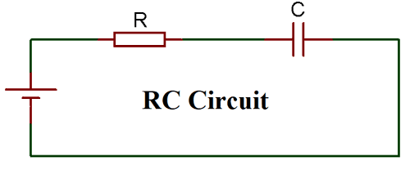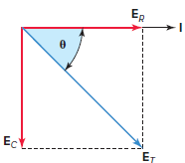

Fig 1.2(a) Fig 1.2(b)

Circuit diagram for simple series RC circuitphasor diagram for the RC circuit.

**RL Circuit:**

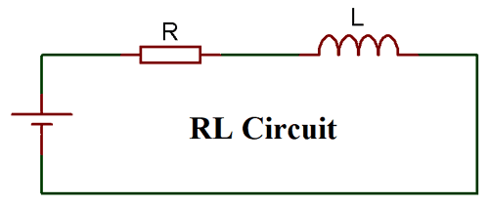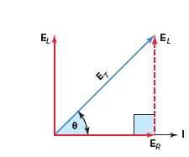

Fig 1.2(c) Fig 1.2(d)

Circuit diagram for simple series RL circuitphasor diagram for the RL circuit.

Now after discussing these concepts we have a better idea of the phase anglebehavior in RC and RL circuits, phase shifters are one of the very useful applications of RL and RC circuits.

1. **Introduction:**

A phase-shifting circuit is often employed to correct an undesirable phase shift already present in a circuit or to produce special desired effects. An *RC* circuit is suitable for this purpose because its capacitor causes the circuit current to lead the applied voltage also RL circuit is suitable for this purpose because its inductor causes the circuit current to lag the applied voltage. The angle will be in between 0 and 90 degrees. depending on the values of R,XC and XL.The following graph and formulasshow how to calculate the phase angle for RL, and RC circuits.

XL *θ*1=Tan-1(XL/R)

Vo

*θ*1 Is

*θ*2 R *θ*2=Tan-1(XC/R)

Vo

XC

* 1. **RC leading and lagging circuit:**

When the output voltage is taken at Resistor then there will be a leading output voltage and when the output voltage is taken at the capacitor then the output voltage will be lagging the input voltage

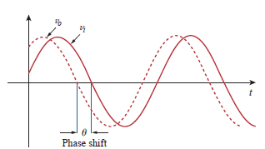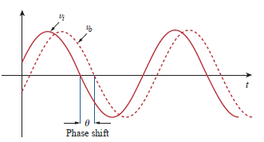

Fig 2.1(a) Fig 2.1(b)

Leading at resistor lagging at the capacitor

**2.2RL leading and lagging circuit:**

When the output voltage is taken at the resistor then there will be lagging output voltage and when the output voltage is taken at the inductor then the output voltage will be leading the input voltage.

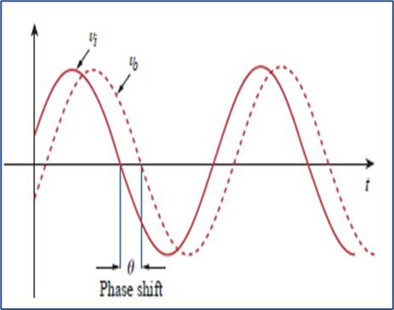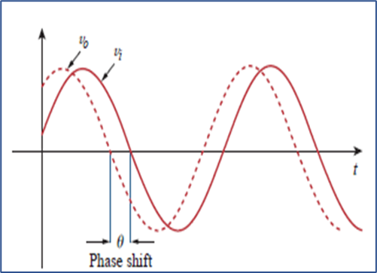

Fig 2.1(c) Fig 2.1(d)

Lagging at Resistor Leading at inductor

**3Project Task:**

**3.1Statement:**Design a phase shifter using RC or RL circuits with a variable resistor so that the phase angle can be adjusted.

A simple phase shifter RC series circuit is composed of one resistor and capacitor connected in series with one another.

**3.2 Selection of components:**

As for the engineering point of view, we must select the components based on efficient selection criteria’s few of them mentioned below

* Manufacturers
* Reference design, software tools or simulation availability
* Less circuit complexity and the same results
* Close to the ideal situation
* Mechanical Parameters [dimension, package, weight, etc.]
* Environmental Parameters: Temperature / Humidity / Pressure / Vibration
* Easily replaceable
* Cost
* Availability

**3.3 Mathematical Calculations:**

Before making any project, it includes some mathematical calculations based on which the components are selected. so in our case the major components were the resistor, and capacitor.

Formula for phase angle=>Q=Tan-1(X/R)

**3.4 Why only an RC circuit?**

In our project we preferred to design a phase shifter using an RC circuit only, it has some reasons behind it in topic 3.2 the selection criteria were discussed, in an RL circuit phase shifter the availability of the inductor is the issue because its not easily available in the market while on the other hand capacitors are easily available. Another reason is the internal resistance of inductors in the initial lab experiments we found that the internal resistance of inductors affects the phase shift value and it creates a major difference between theoretical and experimental values so that’s why the RC circuit was designed and preferred in this project.

**3.5 Components:**

Based on mathematical calculations and selection criteria the following components were selected

1. 2 pieces 0.33 microfarad capacitors in parallel to get 0.66 microfarad
2. 1 piece 10k ohms variable resistor
3. Step-down transformer 220v to 12v (low wattage components)
4. Breadboard
5. Stripboard circuit board
6. Wiring
7. Oscilloscope for phase angle testing

**3.6 Circuit Diagram and Block Diagram:**

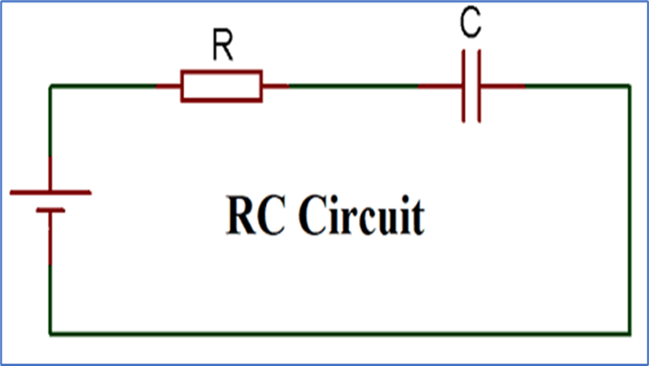

Fig 3.6(a)

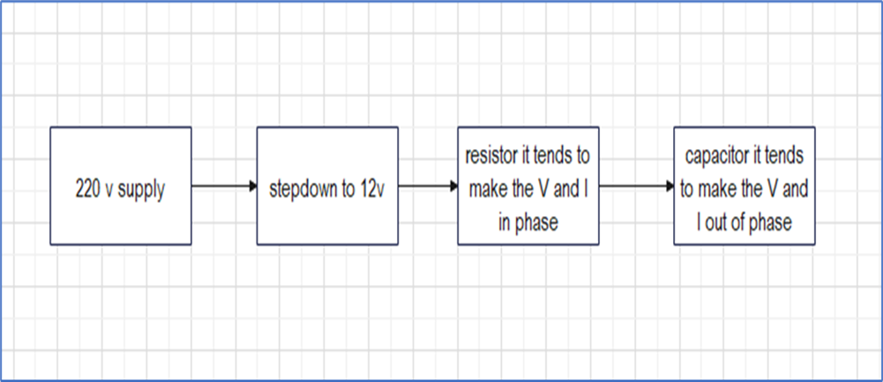

Fig 3.6(b)

**3.7Simulation:**

Before implementing the actual circuit it’s better to have a simulation of the circuit to check the connectivity and other working operations of circuit, for this purpose simulation tools like proteus can be used, in this project proteus software was used.

**3.6.1 Circuit:**

Simulation of simple RC circuit with step-down transformer

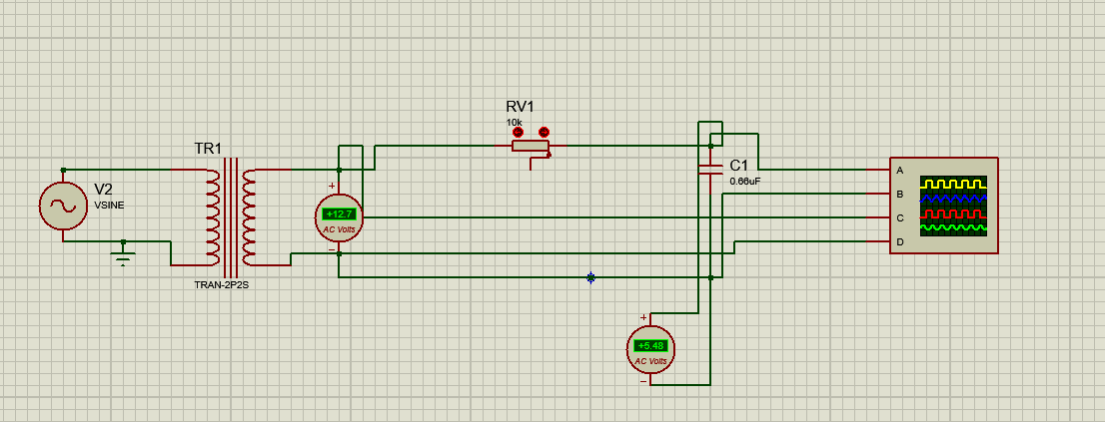

Fig 3.6.1(a)

**3.6.2Output:**

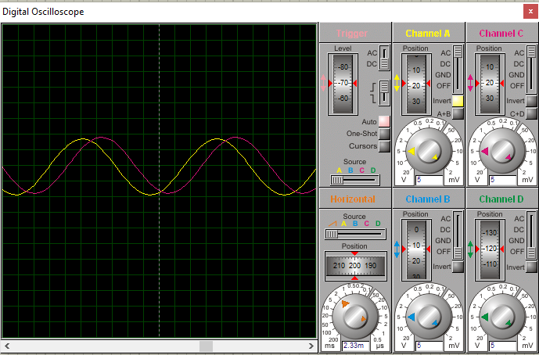

It can be observed that our circuit works fine and gives us the phase shift,so now we can build the actual project circuit.

**3.7 Project:**

**3.7.1Circuit:**

After assembling all the elements in the circuit our project circuit looks like this

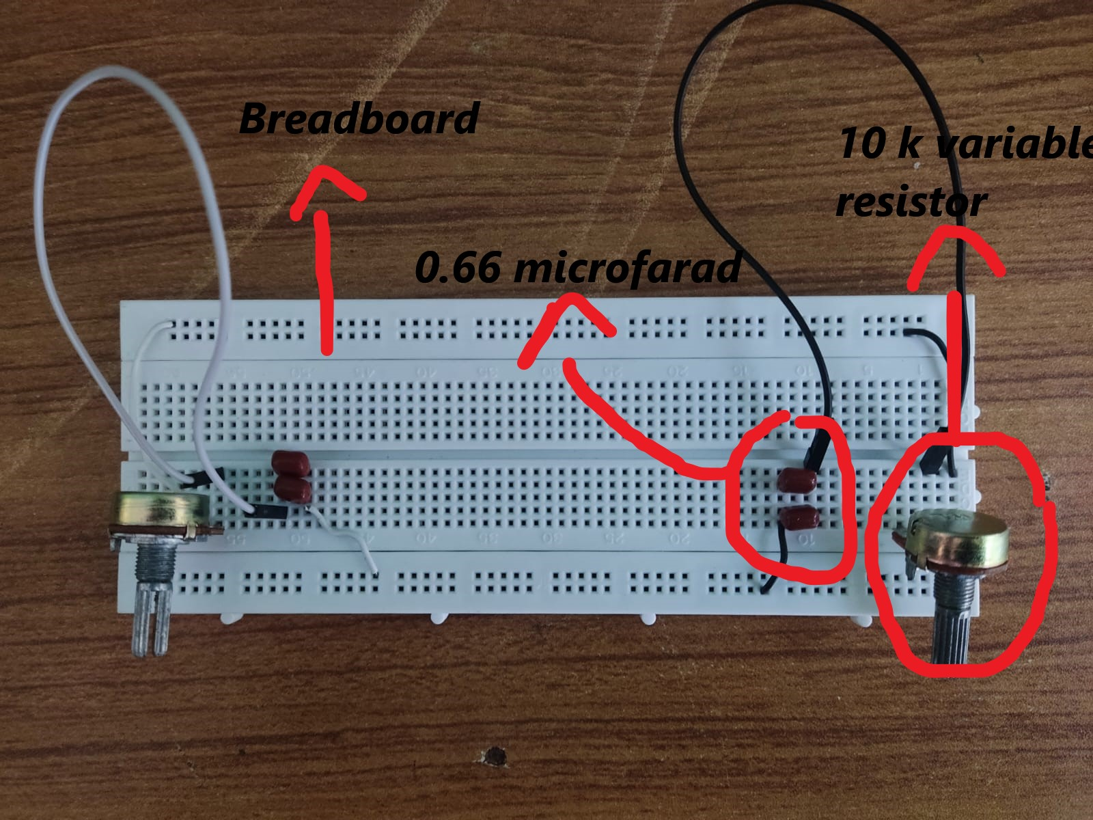

Fig 3.7.1(a)

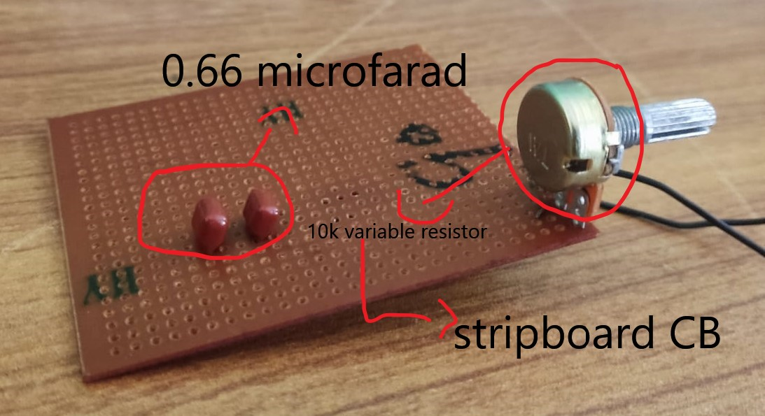

Fig 3.7.1(b)

**3.7.3Output:**

For the demonstration of phase angles digital oscilloscope RIGOL DS1052E was used

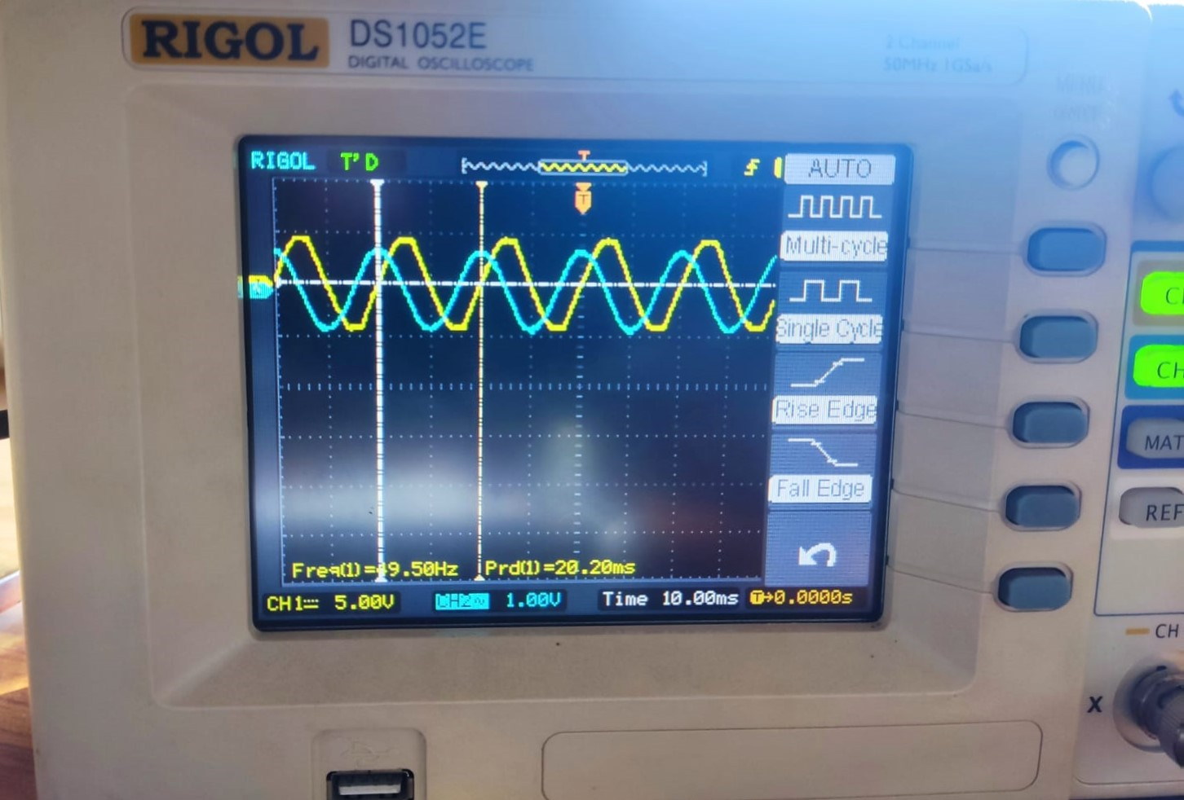

Fig 3.7.3(a)

The graph does not show the direct value of phase angle it has to be calculated, the formula for calculation is as follows ***Φ = td /tp × 360***Where: td is the delay between waveforms and tp is the period of the waveforms.

For this very output the calculation is as follows:

1 grid = 10 ms, 1 period = 20 ms , 1 small point = 4 ms

Here td=4ms,tp=20 ms => 4/20=0.2*360 = 72 degrees

This is how the calculation is done on the basis of result of oscilloscope.

**4Conclusion:**

A phase-shifting circuit is often employed to correct an undesirable phase shift already present in a circuit or to produce special desired effects, so with these simple circuits and 2-3 components we should be able to design a phase shifter that can make out of phase angles in phase or provide any kind of phase shift depend on required criteria.

**5Project Outcome:**

The outcome of this project is very fruitful because it helped us understand the working of AC circuits more and also boosted our confidence in implementing the circuit practically,while making this project we made mistakes and it was also part of learning, this project helped us understand the concept of RC and RL circuits and their application as phase shifters. with this project, we got introduced to the simulation software proteus which will be helpful for future projects as well and also the use of an oscilloscope was also a new learning experience overall it was a good experience making this project.