**Mind Map**

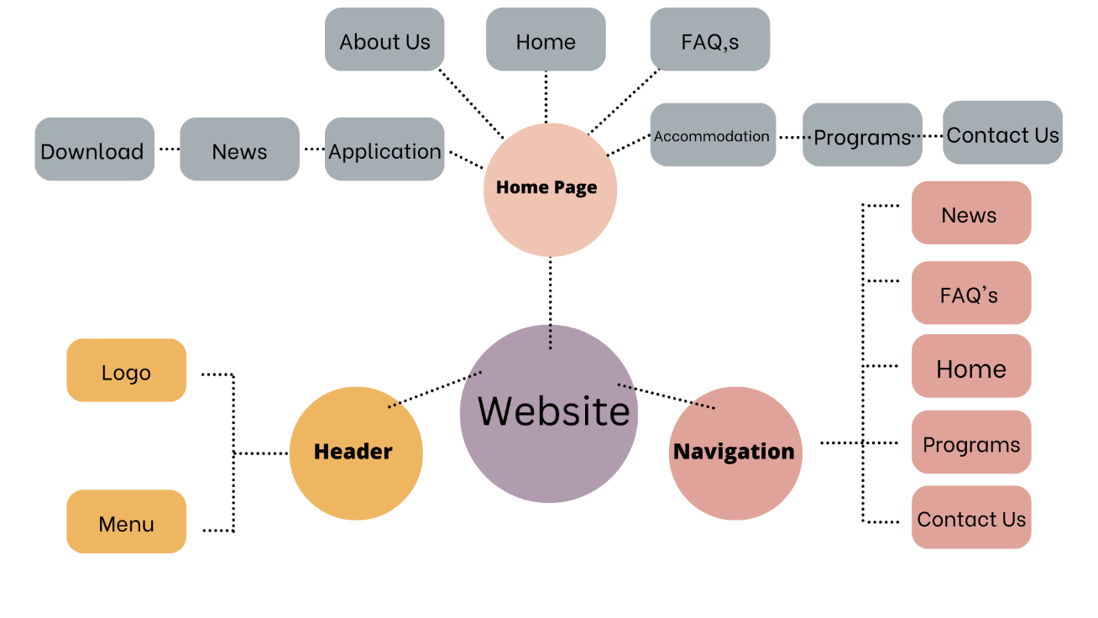

**DESIGN PATTERN**

In this website I use #008b8b color as background of header and navigation bar and White color as text and icons and use black color for whole content in Website.

**Example**

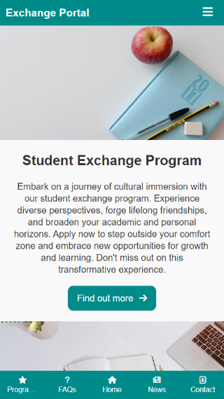

Sure, here's a revised pattern tailored to include the specific pages you mentioned:

1. Header:

- Logo: Top left corner, links back to the homepage.

- Navigation menu: Across the top or in a sidebar, includes links to main sections of the site (Home, About Us, Contact Us, News, FAQs, Application, Accommodation, Programs, Downloads).

- Contact information: Phone number, email, or social media links.

2. Hero Section:

- Large image or video: Captures attention and sets the tone.

- Welcome message or headline.

- Call-to-action (CTA) button: Encourages visitors to take action, like "Learn More" or "Apply Now".

3. About Us:

- Description of the company, organization, or institution.

- Mission statement or values.

- History, team, or achievements.

4. Contact Us:

- Contact form: Name, email, subject, message.

- Map or address.

- Social media links.

5. News:

- Latest articles, news, or updates.

- Thumbnail images, titles, and brief summaries.

- Pagination or load more button for older articles.

6. FAQs:

- Frequently asked questions and answers.

- Organized in categories if necessary.

- Search bar for easy navigation.

7. Application:

- Instructions on how to apply.

- Application form or link.

- Deadline information, if applicable.

8. Accommodation:

- Information about available accommodations or housing.

- Photos, descriptions, and amenities.

- Contact information for inquiries.

9. Programs:

- Description of available programs or courses.

- Program details, requirements, and benefits.

- Testimonials or success stories.

10. Downloads:

- Resources, forms, or documents available for download.

- Organized by category or type.

- Links to software or applications if applicable.

This layout should provide a clear and organized structure for my website, making it easy for visitors to find the information they need.

**Wireframes**

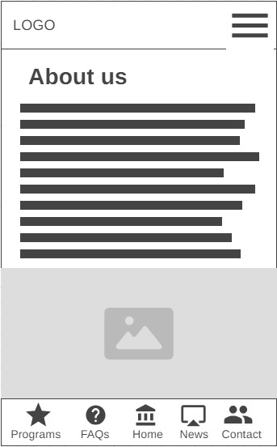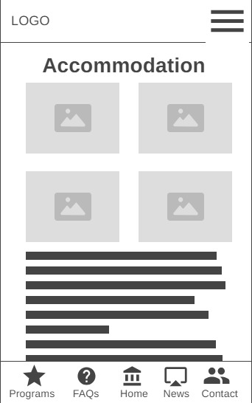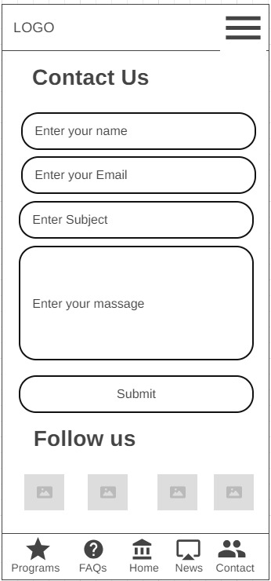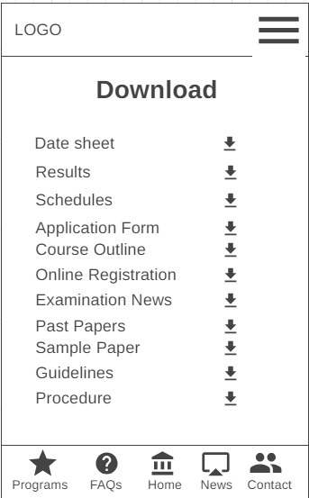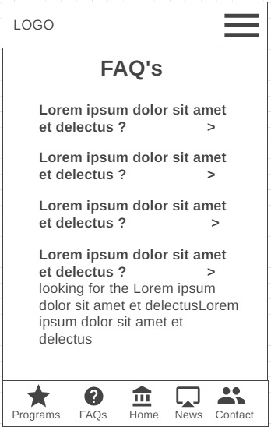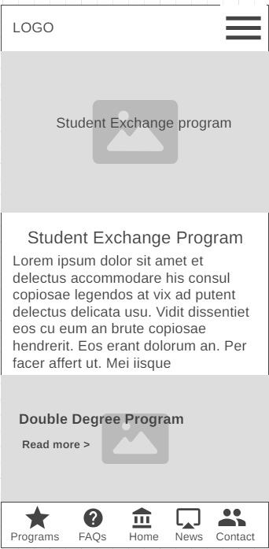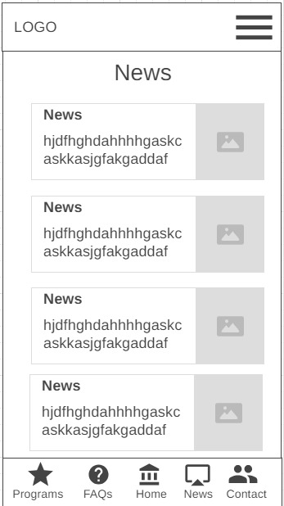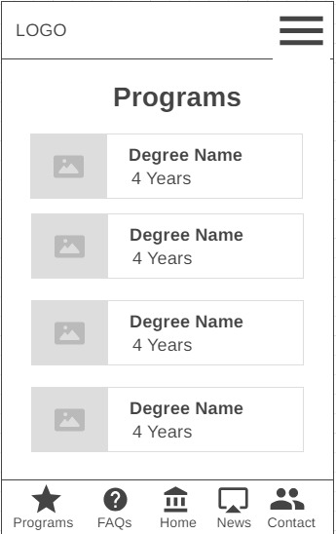

**Prototypes**

