Reasoning-RL proposal: What Does Reasoning RL Change in Belief Tracking?
Oct 27, 2026 · @syed zahedi

Summary
Working title: What Does Reasoning RL Change in Belief Tracking? Transfer, Traces and the Use of Story Information.
Central question: when reasoning RL improves belief-question accuracy, which improvements transfer to unrewarded consequences, and how do those gains depend on generated traces and on the model's causal use of story information? The motivating question is whether reasoning RL puts the belief in the trace, which bears on chain-of-thought monitoring. The measurements below test what can be established about it, without treating any outcome as a failure in advance.
This proposal trains small models on paper one's theory-of-mind world under four regimes: answer-only and reasoning formats, each trained by supervision and by RL. Three measurements follow: transfer to unrewarded consequences with no trace, a crossed test of which traces help which readers, and component interventions within each model before and after training.
RL is central because it is the intervention under study. The headline results are no-trace transfer to unrewarded consequences, the crossed trace and reader comparison, and how shortcut-correlated training changes cue dependence. A null result counts only when positive controls show the test could have detected an effect.
Thesis fit. This drops multi-agent debate. Paper one asks what an intervention changed beyond its fitted answer; this paper asks what training changed beyond its rewarded answer. The Bridge proposal: Does Reward Install What Interchange Installs? is the leading conditional follow-on after this plan's pilot. The debate-based alternatives are Paper 2 proposal: Beyond the Conceded Answer and RL proposal: Beyond the Rewarded Answer.

Gap and positioning
Reasoning RL is known to help theory of mind on clean data and to learn shortcuts on dirty data. Chain-of-thought faithfulness is now tested causally, and recent work compares what RL and SFT change inside models. None of it tests transfer to unrewarded consequences in a world where the task-defined belief is known.
Strand | What it shows | What it leaves open
Chain-of-thought faithfulness: Anthropic 2025, Reasoning Models Don't Always Say What They Think | Outcome-based RL raised faithfulness at first, then plateaued at 28% on MMLU and 20% on GPQA. Faithfulness was measured behaviourally, by whether traces mention hints the model used; probing internal activations was named as a future direction. | No causal test through internal state, and no controlled setting with a task-defined belief.
Faithfulness across reasoning models: Han et al., RFEval (ICLR 2026) | Across 12 open reasoning models, about half of outputs were unfaithful. Adding RL-style objectives on top of SFT could lower faithfulness even when accuracy held. | Judged from output text alone; no internal state or task-defined belief.
Reasoning versus retrieval: Y. Wang et al., Reasoning or Retrieval? (ICLR 2026) | Answers come from two competing mechanisms, trace reasoning and memory retrieval, and models can use retrieval as a shortcut that games the reward. | Uses behavioural perturbations; does not locate the shortcut inside the network.
Causal grounding of traces: Q. Wang et al., From Concept Alignment to Causal Grounding (2026) | Tests whether the internal concepts a trace engages causally drive the answer; causal faithfulness peaks at mid-to-late layers. | No task-defined belief, and not about what training installs.
Faithfulness rewards: Hong et al., Making LLMs Say What They Think (arXiv 2026) | Post-training with an interpretability-based faithfulness signal improves agreement between traces and internal computation on its measure, and separates changes in computation from changes in reporting. | Trains for faithfulness directly; not ordinary outcome rewards or unrewarded consequences.
RL versus SFT internals: Shi et al., Why Does Reinforcement Learning Generalize? (ACL 2026) | Compares RL- and SFT-tuned models from the same base on the same problems; a compact set of features causally mediates RL's generalisation. | General tasks rather than belief tracking, and the two arms receive different supervision.
Theory-of-mind representations: Li et al., CoSToM (ACL 2026) | Causal tracing locates theory-of-mind layers, and tuning targeted there improves social reasoning and dialogue. | Training aimed at a located representation, not what ordinary outcome-reward training changes.
Reasoning RL for ToM: Zhong et al., From Shortcuts to Reasoning (ICML 2026) | On shortcut-free data, RL with reasoning traces beat SFT by about 6 points and generalised better. RL without traces trailed by 7 points on average (10 on OpenToM). Mechanism evidence is last-layer attention maps and trace quality. | No causal test of what changed, and no test of whether gains depend on the trace.
Shortcut learning under RL: Sarangi & Salam 2025 | On shortcut-prone ToM data, RL gains stayed in-distribution, and models learned rigid question-type mappings. | Behavioural only; no internal analysis.
What RL changes inside: Du et al. 2026, Fixed-SAE Track | RL drift in maths was small, late-layer and mostly formatting; steering those features recovered about 80% of RL's gain. | Maths only; no belief variables.
RL-trained steering vectors: Sinii et al. 2025, Small Vectors, Big Effects | Steering vectors trained with RL matched full fine-tuning on maths. The last-layer vector acted as a first-token bias; a penultimate-layer vector worked through the MLP and value path, leaving attention patterns intact. | Maths only; no comparison with interchange-fitted interventions.
Interchange interventions: paper one; Right Answer, Wrong Mechanism (2026) | Answer success under DAS does not identify the variable, and optimised interventions can succeed through pathways the model never uses on natural inputs. | Not applied to changes installed by training.
The contribution target is narrower: how outcome-reward training changes the causal use of belief-related information in traces and internal computation, measured on consequences that were not rewarded. That means no-trace transfer scored against task targets, a crossed comparison of trace sources and readers, and component interventions within each model before and after training. The companion Bridge proposal: Does Reward Install What Interchange Installs? asks a separate, conditional question: whether the teacher or the site decides what a fitted edit installs.

Hypotheses and estimands
Three hypotheses, each with an estimand fixed before training. A null result counts only when positive controls show the test could have detected an effect. Consequence views are scored against the task's ordinary targets; paper one's rewrite forecasts apply only to the specified swaps in Test 3.
- H1: Reasoning RL improves trace production, trace use, or both. Estimands: (a) no-trace transfer, the gain on unrewarded consequence views under immediate answering, trained minus base; (b) from the crossed test, the benefit each reader gets from each trace source, measured as the share of that reader's remaining errors the trace fixes. Prediction: the trained model's traces help both readers, and the trained reader gains more from a fixed trace than the base reader does. No-trace transfer is reported as transfer to direct-answer inference, not as evidence of a stored belief.
- H2: Shortcut-correlated training changes cue dependence and the scope of transfer. Estimands, reported separately: improvement on consequences that need the intended belief computation; preservation of unrelated or already-correct answers; dependence on the planted cue, from test items where it agrees with, is independent of, or conflicts with the answer; and joint correctness across each story's views. Prediction: at matched direct-answer accuracy, shortcut-trained models depend more on the cue and transfer less to belief-dependent consequences.
- H3: Training changes how attention components contribute to observer-dependent consequences. Estimand: within each checkpoint, the effect on the consequence pattern of swapping critical-token keys, values or the residual stream between matched story pairs, compared before and after training. Prediction: arms with more no-trace transfer show larger changes at critical-token components; no prior is fixed for keys versus values.

Design
Four trained arms and a base reference on one controlled world, three measurements, and a leading conditional follow-on.
Training arms. Qwen2.5-3B-Instruct for development and Qwen2.5-7B-Instruct for final runs. Trained arms use LoRA with target modules fixed in advance and reported, since direct updates to query, key and value projections change how Test 3 is read.
Training | Answer-only format | Reasoning-then-answer format
Supervision | Label-only SFT | Reasoning-SFT, on traces from a stated source
RL (GRPO) | Answer-only RL | Reasoning RL
The untrained base model is the reference for every comparison. Reasoning-SFT receives trace supervision that outcome-reward RL does not, so its trace source and the extra information it carries are documented. Each checkpoint is evaluated in its native format and in the immediate-answer format, and arms are compared at matched direct-answer accuracy as well as unconditionally.
Data. Paper one's generator: 20 objects, six locations, two characters, belief depth up to two. Training uses only the direct-belief question, so the other seven consequence views are unrewarded by construction. A shortcut twin plants a cue, with the last-mentioned location answering 90% of training questions. Its test sets render the same underlying worlds with the cue agreeing with, independent of, or conflicting with the answer, matched for length and entity frequency. OpenToM is the external check.
Test 1: no-trace transfer. Each checkpoint answers the eight consequence views immediately, as single tokens after an Answer: prefill. Answers are scored against the task's ordinary targets, split into views that should change with the belief computation and views that should stay intact. This measures whether the benefit transfers to direct-answer inference, including unrewarded consequences; it does not show where a belief is stored.
Test 2: crossed trace and reader. For each story and question, one trace comes from the base model and one from the trained model. Both models then read both traces, with the story, question, formatting and answer delimiter held fixed.
Reader | Base-model trace | Trained-model trace
Base model | Reads its own trace | Reads the trained trace
Trained model | Reads the base trace | Reads its own trace
Holding the reader fixed asks whether training improves the traces; holding the trace fixed asks whether it improves their use. Each reader's benefit is measured against its own no-trace baseline, as the share of its remaining errors the trace fixes. Any interaction is reported as such, not as a share of the gain stored in the trace. Controls:
- Own-trace replay, which should reproduce the model's ordinary continuation.
- Meaning-preserving paraphrase.
- Targeted semantic edit to an intermediate fact, with its predicted consequences.
- Answer cue that states the evaluated answer directly.
- Belief summary, used as a premise for later consequence questions.
- Irrelevant edit of comparable text.
- No supplied trace.
Editing the trace follows standard faithfulness practice (Lanham et al. 2023). Continuations regenerated after an edit run alongside minimal edits, because resampling gives larger and more consistent effects than inserted sentences (Macar et al. 2026). A model that resists a contradictory trace is a possible finding, not a failed edit.
Traces written after seeing the direct question are question-dependent. A second condition writes the trace before later questions are revealed and holds it fixed across them.
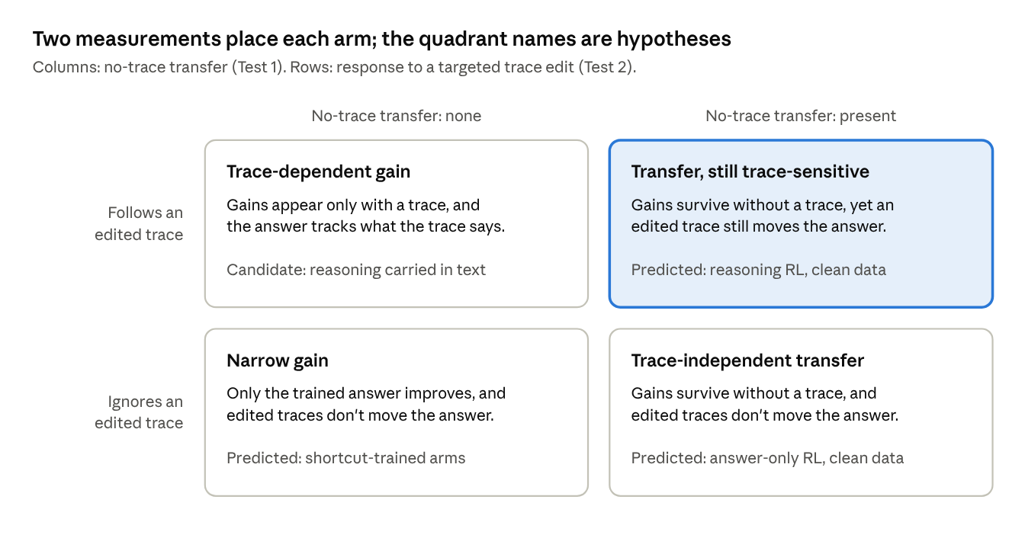
two measurements · 4 candidate readings
The axes are measurements: Test 1 sets the column, and the targeted-edit condition of Test 2 sets the row. The quadrant names are candidate readings that need the crossed test and Test 3 to support them.
Test 3: component interventions within each model. Matched story pairs differ in one observation or communication event. Within each checkpoint, critical-token keys, values and the residual stream are swapped between the pair, and the consequence pattern is scored against the swap's predicted effects. Controls follow paper one: own keys, a signed-permutation null and natural donors, with the residual-stream swap as the positive control. Comparing the same swaps before and after training shows whether training changed how these components contribute; it does not by itself locate a new belief representation. Swaps between the base and trained models are a secondary analysis, run on identical token prefixes.
Leading conditional follow-on. The Bridge proposal: Does Reward Install What Interchange Installs? asks whether the teacher or the site decides what a fitted edit installs. It is the leading candidate after the pilot, started by the decision rule in that doc rather than by date.

Pilot specification
A three-week feasibility pilot at 3B, on one seed and fewer arms, checks that the measurements work for about $9–17 of Colab compute; no paid 7B run starts until the gates are read.
Models. Qwen2.5-3B-Instruct for development and Qwen2.5-7B-Instruct for final runs, the sizes Zhong et al. used. A larger model is used only if the pilot shows a capability or optimisation limit that blocks the question; shorter traces at 3B are a result, not a failure.
Pilot arms. Reasoning RL, answer-only RL and label-only SFT on clean data, one seed each. The full four-arm grid, the shortcut twin and three seeds are for the confirmatory runs.
RL stack. LoRA-GRPO on an open stack (TRL or verl), group size 8, traces capped at 384 tokens. The generation arrangement and memory options are set from the profiling run.
Data. 2,000 training stories each for the clean set and the shortcut twin, plus 120 development and 120 confirmation stories, as in paper one. Difficulty is calibrated on development stories, then frozen before training.
Profiling first. A short representative run measures generation speed, update time, peak memory, truncation and checkpoint overhead; the costs below are preliminary assumptions until then. Colab does not guarantee a GPU type, and memory needs at 7B depend on the configuration.
Compute reporting. For every arm: training examples and answer supervision, prompt exposures and sampled completions, generated and optimised tokens, GPU time, and learning curves.
Stage | Model and GPU | Hours (est.) | Cost (est.)
Profiling run | Qwen2.5-3B, Colab A100 40GB | 2–4 | ≈ $1–3
Pilot, gates G0–G4 | Same | 15–25 | ≈ $8–14
Main runs: 4 arms × 2 datasets × 3 seeds | Qwen2.5-7B, A100 80GB | 63–116 | ≈ $47–101
Tests 1–3 | Same | 10–20 | ≈ $8–17
Total |  | 90–165 | ≈ $64–135
All estimates are in US dollars; the £500 ceiling is converted at the rate on the day of purchase. Rates: Colab A100 40GB at 5.40 units/h and A100 80GB at 7.52 units/h, with units at $0.10 (McCormick, checked March 2026); vast.ai A100 PCIe 80GB from $0.873/h (ComputePrices, 26 Oct 2026). The conditional bridge is costed in its own doc.
Go/no-go gates (3B, development stories). Gates check that the measurements work, not that a preferred result appears.
Gate | Test | Go if | If not
G0 Calibration | Base accuracy and failure types on development stories | Difficulty is set, then frozen before training | Recalibrate once, before any training
G1 Learnability | Reasoning RL learning curve on clean data | Direct-belief accuracy rises clearly above base on a stable curve | Diagnose whether the failure is optimisation, format or task; move to 7B only for a capability or optimisation limit, cost approved first
G2 Cue renderings | Shortcut twin and its three test renderings | Renderings match in length and entity frequency, and the cue agrees with the answer at the designed rates | Regenerate the renderings
G3 Trace replay and edits | Test 2 controls | Own-trace replay reproduces ordinary continuations; edits change only the intended fact; paraphrase and irrelevant edits behave as expected | Fix the replay and editing procedure
G4 Component swaps | Test 3 within one checkpoint | Implementation verified; the residual-stream positive control moves the consequence pattern; nulls stay flat; effects are estimated precisely enough to be useful | Fix the implementation, or add stories

Timeline and budget
Twenty-six weeks from 2 November 2026 give a full draft by 2 May 2027, with one gate review before any paid compute.
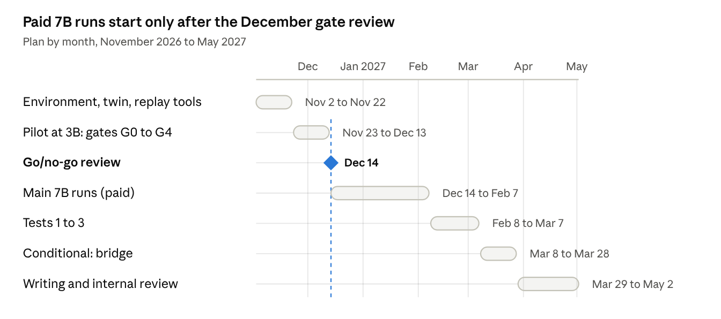
26-week plan · 6 work blocks, 1 gate
The review on 14 December decides whether the paid 7B runs start; everything before it runs on Colab.
Total compute is about $64–135 (table above), preliminary until the profiling run. The 7B runs are the only paid step, costed from the profiling run and approved before they start.

Risks and mitigations
Risk | Mitigation
The results read as “reasoning RL helps”, without saying what changed. | Lead with no-trace transfer to unrewarded consequences, the crossed trace and reader comparison, and changes in component contributions, each at matched direct-answer accuracy.
The base model sits at ceiling or floor, leaving nothing for RL to change. | Calibrate difficulty on development stories and freeze it before training (gate G0).
Small models shorten their traces while staying accurate: Lu et al. 2025 report this “reasoning collapse” at 3B and below, alongside high accuracy and generalisation. | Treat short traces as a result for Tests 1 and 2, not a training failure; move to 7B only for a capability or optimisation limit.
Edited traces act as authoritative hints, or look unnatural. | Replay, paraphrase, answer-cue and irrelevant-edit controls, plus continuations regenerated after edits.
Swapping components between differently trained models measures mismatch rather than meaning. | Swap within each checkpoint and compare before and after training; cross-model swaps are secondary and use identical token prefixes.
A competing paper dissects reasoning RL for theory of mind first. | The unrewarded-consequence tests, crossed trace design and within-model comparisons are distinctive. Hypotheses are fixed before training, and arXiv is checked monthly.
7B runs are unstable or exceed the hour estimates. | Cut optional analyses and layer searches before seeds; the confirmatory comparison keeps three seeds.

Key references
- Paper one: Beyond the Fitted Answer (under review, ICLR 2027). Code.
- Companion bridge proposal (leading conditional follow-on): Bridge proposal: Does Reward Install What Interchange Installs?.
- Zhong et al. 2026, From Shortcuts to Reasoning: Robust Post-Training of Theory of Mind with Reinforcement Learning (ICML 2026).
- Anthropic 2025, Reasoning Models Don't Always Say What They Think.
- Han et al. 2026, RFEval: Benchmarking Reasoning Faithfulness under Counterfactual Reasoning Intervention in Large Reasoning Models (ICLR 2026).
- Y. Wang et al. 2026, Reasoning or Retrieval? A Study of Answer Attribution on Large Reasoning Models (ICLR 2026).
- Q. Wang et al. 2026, From Concept Alignment to Causal Grounding: An Intervention Test of Chain-of-Thought Faithfulness.
- Hong et al. 2026, Making LLMs Say What They Think: Measuring and Improving CoT-Interpretability Alignment (arXiv).
- Shi et al. 2026, Why Does Reinforcement Learning Generalize? A Feature-Level Mechanistic Study of Post-Training in Large Language Models (ACL 2026).
- Li et al. 2026, CoSToM: Causal-oriented Steering for Intrinsic Theory-of-Mind Alignment in Large Language Models (ACL 2026).
- Lanham et al. 2023, Measuring Faithfulness in Chain-of-Thought Reasoning.
- Macar et al. 2026, Thought Branches: Interpreting LLM Reasoning Requires Resampling (ICLR 2026).
- Sarangi & Salam 2025, Small LLMs Do Not Learn a Generalizable Theory of Mind via Reinforcement Learning.
- Lu et al. 2025, Do Theory of Mind Benchmarks Need Explicit Human-like Reasoning in Language Models? (formerly ToM-RL).
- Du et al. 2026, What Does an LLM Learn from Reinforcement Learning? (Fixed-SAE Track).
- Sinii et al. 2025, Small Vectors, Big Effects: A Mechanistic Study of RL-Induced Reasoning via Steering Vectors.
- Right Answer, Wrong Mechanism: Detecting Pernicious Divergence in Causal Interventions (2026).
- Geiger et al. 2024, Finding Alignments Between Interpretable Causal Variables and Distributed Neural Representations (DAS).
- Xu et al. 2024, OpenToM.

