Reasoning-RL proposal (revised): What Does Reasoning RL Change in Belief Tracking?
Oct 29, 2026 · @syed zahedi

Summary
Working title: What Does Reasoning RL Change in Belief Tracking? Transfer, Traces and the Use of Story Information.
Central question: when reasoning RL improves belief-question accuracy, which improvements transfer to unrewarded consequences, and how do those gains depend on generated traces and on the model's causal use of story information? The motivating question is whether reasoning RL puts the belief in the trace, which bears on chain-of-thought monitoring. The measurements below test what can be established about it, without treating any outcome as a failure in advance.
This proposal trains small models on paper one's theory-of-mind world under four regimes: answer-only and reasoning formats, each trained by supervision and by RL. Three measurements follow: transfer to unrewarded consequences with no trace, a crossed test of which traces help which readers, and component interventions within each model before and after training. A fourth records how often each model's trace states the queried belief at all.
RL is central because it is the intervention under study. The headline results are no-trace transfer to unrewarded consequences, the crossed trace and reader comparison, and how shortcut-correlated training changes cue dependence. A null result counts only when positive controls show the test could have detected an effect.
This revision keeps the question, hypotheses, arms and three tests of the 27 October version. It replaces the story distribution, which let the rewarded answer be read off without tracking beliefs, and settles details that version left open. Estimands are preregistered before training, and pilot gates are reviewer decisions on stated evidence, with no numerical pass marks.
Thesis fit. This drops multi-agent debate. Paper one asks what an intervention changed beyond its fitted answer; this paper asks what training changed beyond its rewarded answer. The Bridge proposal: Does Reward Install What Interchange Installs? is the leading conditional follow-on after this plan's pilot. The debate-based alternatives are Paper 2 proposal: Beyond the Conceded Answer and RL proposal: Beyond the Rewarded Answer.
Implementation: the paper2 repository implements this design; its preregistration and departures record hold the operational detail.

Changes from the 27 October version
The question, hypotheses, four arms and three tests are unchanged. The changes below make the measurements valid and remove choices that would otherwise be made after seeing results.
Area | Change | Why
Stories | Paper one's world and state engine, with new stories: nine events about the queried object, with varied observers | Paper one's stories let the rewarded answer be read off without tracking beliefs
Depth two | The nested answer matches both, one or neither character's own belief, in fixed proportions | Otherwise first-order beliefs give the nested answer away
New measure | Editability: how often each model's trace states the queried belief | Bears directly on whether training puts the belief in the trace
Trace edits | Generated by a frozen editor model, audited on a random sample, applied to the belief the trace states | Hand-editing every trace does not scale, and wrong traces must stay editable
Second timing | The model's own direct-question trace, held fixed across the later questions | Tests the trace the rewarded question elicits, without an untrained prompt
Belief summary | States only the queried belief | The full symbolic state answered most questions outright
Quadrant | Arms plotted on two continuous axes with intervals | The quadrant names are candidate readings, not categories
Test 3 | Keys, values and residual swapped at every layer from 1 to the last, all at once | Paper one's key effects needed a broad band
H3 | The cross-arm prediction is read descriptively | Eight arm-and-dataset points support description, not a test
Training | Each story seen once per arm; Zhong et al.'s rates as references; optional rate panel | Matches story exposure; those rates may not suit LoRA
Matching | At the highest accuracy every compared run reaches | Replaces an arbitrary tolerance
Gates | Reviewer decisions on stated evidence, no numerical pass marks; G1 covers all three pilot arms | Gates check that measurements work
Reporting | Preregistration; 20,000 whole-story bootstrap resamples, seeds averaged within story | Fixed before training; follows paper one
OpenToM | Official prompts and macro-F1 are primary | Comparability with the benchmark
Pilot cost | Likely above the original estimate; the profiling run sets it | Full-pass training, the rate panel and trace editing add compute
The H3 cross-arm analysis is the one change not yet in the code.

Gap and positioning
Reasoning RL is known to help theory of mind on clean data and to learn shortcuts on dirty data. Chain-of-thought faithfulness is now tested causally, and recent work compares what RL and SFT change inside models. None of it tests transfer to unrewarded consequences in a world where the task-defined belief is known.
Strand | What it shows | What it leaves open
Chain-of-thought faithfulness: Anthropic 2025, Reasoning Models Don't Always Say What They Think | Outcome-based RL raised faithfulness at first, then plateaued at 28% on MMLU and 20% on GPQA. Faithfulness was measured behaviourally, by whether traces mention hints the model used; probing internal activations was named as a future direction. | No causal test through internal state, and no controlled setting with a task-defined belief.
Faithfulness across reasoning models: Han et al., RFEval (ICLR 2026) | Across 12 open reasoning models, about half of outputs were unfaithful. Adding RL-style objectives on top of SFT could lower faithfulness even when accuracy held. | Judged from output text alone; no internal state or task-defined belief.
Reasoning versus retrieval: Y. Wang et al., Reasoning or Retrieval? (ICLR 2026) | Answers come from two competing mechanisms, trace reasoning and memory retrieval, and models can use retrieval as a shortcut that games the reward. | Uses behavioural perturbations; does not locate the shortcut inside the network.
Causal grounding of traces: Q. Wang et al., From Concept Alignment to Causal Grounding (2026) | Tests whether the internal concepts a trace engages causally drive the answer; causal faithfulness peaks at mid-to-late layers. | No task-defined belief, and not about what training installs.
Faithfulness rewards: Hong et al., Making LLMs Say What They Think (arXiv 2026) | Post-training with an interpretability-based faithfulness signal improves agreement between traces and internal computation on its measure, and separates changes in computation from changes in reporting. | Trains for faithfulness directly; not ordinary outcome rewards or unrewarded consequences.
RL versus SFT internals: Shi et al., Why Does Reinforcement Learning Generalize? (ACL 2026) | Compares RL- and SFT-tuned models from the same base on the same problems; a compact set of features causally mediates RL's generalisation. | General tasks rather than belief tracking, and the two arms receive different supervision.
Theory-of-mind representations: Li et al., CoSToM (ACL 2026) | Causal tracing locates theory-of-mind layers, and tuning targeted there improves social reasoning and dialogue. | Training aimed at a located representation, not what ordinary outcome-reward training changes.
Reasoning RL for ToM: Zhong et al., From Shortcuts to Reasoning (ICML 2026) | On shortcut-free data, RL with reasoning traces beat SFT by about 6 points and generalised better. RL without traces trailed by 7 points on average (10 on OpenToM). Mechanism evidence is last-layer attention maps and trace quality. | No causal test of what changed, and no test of whether gains depend on the trace.
Shortcut learning under RL: Sarangi & Salam 2025 | On shortcut-prone ToM data, RL gains stayed in-distribution, and models learned rigid question-type mappings. | Behavioural only; no internal analysis.
What RL changes inside: Du et al. 2026, Fixed-SAE Track | RL drift in maths was small, late-layer and mostly formatting; steering those features recovered about 80% of RL's gain. | Maths only; no belief variables.
RL-trained steering vectors: Sinii et al. 2025, Small Vectors, Big Effects | Steering vectors trained with RL matched full fine-tuning on maths. The last-layer vector acted as a first-token bias; a penultimate-layer vector worked through the MLP and value path, leaving attention patterns intact. | Maths only; no comparison with interchange-fitted interventions.
Interchange interventions: paper one; Right Answer, Wrong Mechanism (2026) | Answer success under DAS does not identify the variable, and optimised interventions can succeed through pathways the model never uses on natural inputs. | Not applied to changes installed by training.
The contribution target is narrower: how outcome-reward training changes the causal use of belief-related information in traces and internal computation, measured on consequences that were not rewarded. That means no-trace transfer scored against task targets, a crossed comparison of trace sources and readers, how often traces state the belief, and component interventions within each model before and after training. The companion Bridge proposal: Does Reward Install What Interchange Installs? asks a separate, conditional question: whether the teacher or the site decides what a fitted edit installs.

Hypotheses and estimands
Three hypotheses, each with an estimand fixed before training. A null result counts only when positive controls show the test could have detected an effect. Consequence views are scored against the task's ordinary targets; paper one's rewrite forecasts apply only to the specified swaps in Test 3.
- H1: Reasoning RL improves trace production, trace use, or both. Estimands: (a) no-trace transfer, trained minus base accuracy on the seven unrewarded views under immediate answering; (b) from the crossed test, the benefit each reader gets from each trace source, measured as the share of that reader's remaining errors the trace fixes; (c) edit sensitivity, on traces that state the queried belief, the rise in answers that follow the edited belief's predicted consequences, relative to the unedited trace; (d) editability, the share of each model's direct-question traces that state the queried belief at all. Prediction: the trained model's traces help both readers, and the trained reader gains more from a fixed trace than the base reader does. No-trace transfer is reported as transfer to direct-answer inference, not as evidence of a stored belief.
- H2: Shortcut-correlated training changes cue dependence and the scope of transfer. Estimands, reported separately: improvement on unrewarded views that need the intended belief computation; performance on views that should stay intact, and retention of answers that were already correct; dependence on the planted cue, from test items where it agrees with, is independent of, or conflicts with the rewarded answer, reported per question type; and joint correctness across each story's eight views. Prediction: at matched direct-answer accuracy, shortcut-trained models depend more on the cue and transfer less to belief-dependent consequences.
- H3: Training changes how attention components contribute to observer-dependent consequences. Estimand: within each checkpoint, the effect on the consequence pattern of swapping critical-token keys, values or the residual stream between matched story pairs, compared before and after training. Prediction: arms with more no-trace transfer show larger changes at critical-token components; no prior is fixed for keys versus values. With eight arm-and-dataset combinations, this prediction is read descriptively: each arm's unrewarded transfer is plotted against its change in key, value and residual effects, with intervals.
Which views should change. A view needs the intended belief computation when editing only the queried belief changes its answer: direct, search, unobserved overwrite and report. World, other character, observed overwrite and irrelevant object should stay intact. Event-rewrite effects, where rewriting a move can also change the world, belong to Test 3 only.

Design
Four trained arms and a base reference on one controlled world, three tests plus an editability measure, and a leading conditional follow-on.
Training arms. Qwen2.5-3B-Instruct for development and Qwen2.5-7B-Instruct for final runs. Trained arms use rank-16 LoRA on the query, key, value, output and MLP projections, fixed in advance and reported, since direct updates to query, key and value projections change how Test 3 is read.
Training | Answer-only format | Reasoning-then-answer format
Supervision | Label-only SFT | Reasoning-SFT, on traces from a stated source
RL (GRPO) | Answer-only RL | Reasoning RL
The untrained base model is the reference for every comparison. Reasoning-SFT trains on a deterministic symbolic walk-through of each story, about 160 tokens long, that states each observation and the belief it produces. It therefore receives intermediate belief states that outcome-reward RL does not, and this extra information is documented.
Training settings. Every arm sees each of the 2,000 training stories once, so story exposure is matched while optimiser steps differ. Each RL arm makes 2,000 GRPO updates from 16,000 sampled completions; each SFT arm makes 250 updates.
Learning rates start from the values Zhong et al. report: 2e-5 for RL and 1e-6 for SFT, with no KL penalty. That paper does not say whether it used LoRA, and LoRA's best rate is typically about ten times the full fine-tuning rate (Schulman et al. 2025). An optional development panel therefore tests 1, 3, 10 and 30 times these rates, and the chosen setting is frozen before confirmation.
Evaluation and matching. Each checkpoint is evaluated in its native format and in the immediate-answer format. Arms are compared unconditionally and at matched direct-answer accuracy. The match target is the highest development accuracy every compared run reaches; each run contributes its saved checkpoint closest to it, and the accuracies actually reached are reported.
Data: paper one's world, new story distribution. The world is paper one's: its unchanged state engine, 20 objects, six locations, two characters and belief depth up to two. Paper one's stories held one event about the queried object, always witnessed by the queried character, so the rewarded answer could be read off without tracking beliefs.
Each story now has nine events about the queried object, with varied observers. The deciding observation sits at one of six interior positions; events before it may reach the queried character, and events after it do not. At depth two, the nested answer matches both, one or neither character's own belief in the proportions 1:5:5:25, so first-order beliefs carry no information about it.
First-event, last-event and initial-location rules now answer at chance. Weaker rules remain: a fixed event position or the most-mentioned location answers about 31–35% of questions against 17% chance, and "the last event both characters saw" answers about 55% at depth one. These are reported as reference lines beside model accuracy, and eight-view results are no longer directly comparable with paper one's panel.
Training uses only the direct-belief question, so the other seven consequence views are unrewarded by construction. Each of the 2,000 training stories appears in a clean set and in a shortcut twin that differ only in a cue. Every story ends with the six locations listed as unrelated inventory labels; the last-listed location matches the answer in 90% of shortcut stories and one in six clean ones.
Test sets render the same underlying worlds with the cue agreeing with, independent of, or conflicting with the answer, matched exactly for length and entity frequency. The cue is a planted label rather than narrative recency, so H2's conclusions concern this cue. Answers are single letters A–F after an Answer: prefill.
OpenToM is the external check, scored with its official prompts and macro-F1 by question type. A version using this project's prompt format is secondary. Neither reproduces Zhong et al.'s accuracy figures, which are aggregated differently.
Test 1: no-trace transfer. Each checkpoint answers the eight consequence views immediately, as single tokens after an Answer: prefill. Answers are scored against the task's ordinary targets, split into views that need the belief computation and views that should stay intact, with the heuristic reference lines alongside. This measures whether the benefit transfers to direct-answer inference, including unrewarded consequences; it does not show where a belief is stored.
Test 2: crossed trace and reader. For each story and question, one trace comes from the base model and one from the trained model. Both models then read both traces, with the story, question, formatting and answer delimiter held fixed.
Reader | Base-model trace | Trained-model trace
Base model | Reads its own trace | Reads the trained trace
Trained model | Reads the base trace | Reads its own trace
Holding the reader fixed asks whether training improves the traces; holding the trace fixed asks whether it improves their use. Each reader's benefit is measured against its own no-trace baseline, as the share of its remaining errors the trace fixes. Any interaction is reported as such, not as a share of the gain stored in the trace. Controls:
- Own-trace replay, which should reproduce the model's ordinary continuation, run on the exact generated tokens and through the reader's ordinary prompt.
- Meaning-preserving paraphrase.
- Targeted semantic edit to the queried belief as the trace states it, even when wrong, with its consequences predicted by the symbolic world.
- Answer cue that states the evaluated answer directly.
- Belief summary: the queried belief alone, used as a premise for later consequence questions.
- Irrelevant edit of comparable text.
- No supplied trace.
Editing the trace follows standard faithfulness practice (Lanham et al. 2023). A frozen editor model and prompt propose paraphrases, semantic edits and irrelevant edits; a named reviewer audits a random sample, and the flaw rate is reported with the bound it places on results. A model that resists a contradictory trace is a possible finding, not a failed edit.
Continuations regenerated after an edit run alongside minimal edits, because resampling gives larger and more consistent effects than inserted sentences (Macar et al. 2026). The source model regenerates each continuation once, and both readers read that same text. Traces that never state the queried belief cannot be edited; they count toward the editability measure rather than being dropped.
Traces written after seeing a question are question-dependent. A second condition takes each model's own trace for the direct question, written before the later questions are revealed, and holds it fixed across them. This frozen trace is the primary basis for the edit measure, because the rewarded question elicits it.
Reading the two measurements. Each arm is placed by its no-trace transfer from Test 1 and its edit sensitivity from Test 2, both with intervals. The four regions are candidate readings that need the crossed test and Test 3 to support them; no arm is assigned to one by a cut-off.
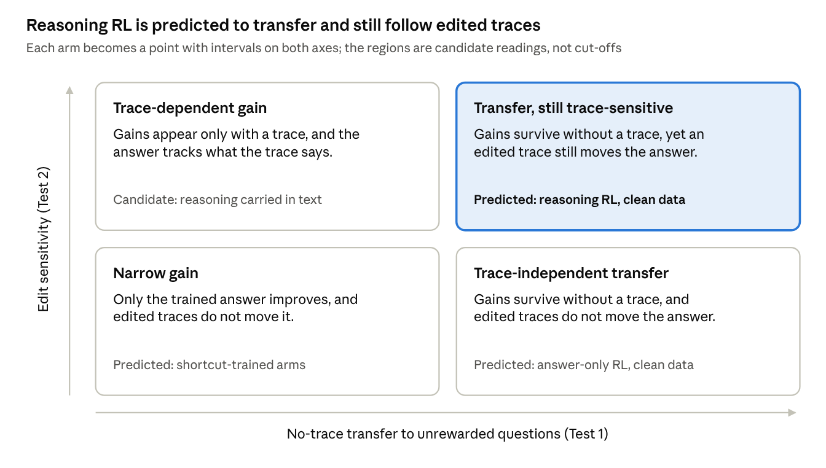
reading the two measurements · 2 axes, 4 candidate readings
Until the measurements exist, the arm names mark predictions, not results.
Test 3: component interventions within each model. Matched story pairs differ in the location of one observation or communication event, the deciding one. Within each checkpoint, critical-token keys, values and the residual stream are swapped between the pair at every layer from 1 to the last, all at once. The consequence pattern is scored against the swap's predicted effects: views that should change, views that should stay intact, and all eight jointly.
Controls follow paper one: own keys, a signed-permutation null and natural donors, with the residual-stream swap on the same layers as the positive control. Single-layer results are descriptive. Comparing the same swaps before and after training shows whether training changed how these components contribute; it does not by itself locate a new belief representation.
Swaps between the base and trained models are a secondary analysis, run on identical token inputs. Unlike paper one's key experiment, which exchanged keys between learned and PCA patches, these swaps are between natural stories.
Leading conditional follow-on. The Bridge proposal: Does Reward Install What Interchange Installs? asks whether the teacher or the site decides what a fitted edit installs. It is the leading candidate after the pilot, started by the decision rule in that doc rather than by date.

Preregistration and reporting
Before research training, a preregistration fixes the estimands above, their analyses, the matching rule, the positive control each null is read against, and the evidence each gate reviewer sees. Amendments are dated, keep their predecessors, and say whether any relevant outcomes had been seen.
Intervals come from 20,000 paired whole-story bootstrap resamples, after averaging the three training seeds within each story, as in paper one. They describe uncertainty over stories, not over training seeds. Ratio estimands resample numerators and denominators together, and a reader at ceiling has an undefined repair share, not zero.
Positive controls are the rewarded direct question's own gain for Test 1, the answer cue and belief summary for Test 2, and the residual swap for Test 3. A null estimate without informative positive-control evidence is inconclusive. Per-layer and per-view results are descriptive, and no significance or interval-width cut-off selects results.
Gates are reviewer decisions on stated evidence, with no numerical pass marks. Integrity requirements stay strict: exact cue rates and length matching, no story leakage between splits, frozen hashes and complete panels. Confirmation measures and reports; it adds no further qualification step.

Pilot specification
A three-week feasibility pilot at 3B, on one seed and fewer arms, checks that the measurements work; no paid 7B run starts until the gates are read. The profiling run sets its cost: the original estimate of about $9–17 of Colab compute predates full-pass training and will rise.
Models. Qwen2.5-3B-Instruct for development and Qwen2.5-7B-Instruct for final runs, the sizes Zhong et al. used. A larger model is used only if the pilot shows a capability or optimisation limit that blocks the question; shorter traces at 3B are a result, not a failure.
Pilot arms. Reasoning RL, answer-only RL and label-only SFT on clean data, one seed each. The full four-arm grid, the shortcut twin and three seeds are for the confirmatory runs.
RL stack. LoRA-GRPO on TRL, group size 8, traces capped at 384 tokens, on one GPU. The generation arrangement and memory options are set from the profiling run.
Data. 2,000 training stories, each rendered in the clean set and the shortcut twin, plus 120 development and 120 confirmation stories, as in paper one. Difficulty is calibrated on development stories, then frozen before training; confirmation stories are never used to calibrate or select.
Profiling first. A short representative run measures generation speed, update time, peak memory, truncation, development-evaluation time, checkpoint overhead and adapter storage. The costs below are preliminary assumptions until then. Colab does not guarantee a GPU type, and memory needs at 7B depend on the configuration.
Training budget. One pass over the 2,000 stories per arm, as set out under Design. Development accuracy is measured every 50 RL updates in the immediate format, keeping each adapter for matching, and every 250 updates in the native format.
Learning-rate panel (optional). Eight settings per pilot arm: 1, 3, 10 and 30 times the reference rates, each with and without warmup, chosen by final native development accuracy. That is 24 pilot runs, eight times the single-setting count, so it is costed before it is chosen. If it is too costly, drop the warmup factor or select on a fixed share of the pool, deciding before any learning.
Compute reporting. For every arm: training examples and answer supervision, prompt exposures and sampled completions, generated and optimised tokens, distinct stories seen, GPU time for training and evaluation, adapter storage, and learning curves.
Stage | Model and GPU | Hours (27 Oct est.) | Cost (27 Oct est.)
Profiling run | Qwen2.5-3B, Colab A100 40GB | 2–4 | ≈ $1–3
Pilot, gates G0–G4 | Same | 15–25 | ≈ $8–14
Main runs: 4 arms × 2 datasets × 3 seeds | Qwen2.5-7B, A100 80GB | 63–116 | ≈ $47–101
Tests 1–3 | Same | 10–20 | ≈ $8–17
Total |  | 90–165 | ≈ $64–135
These estimates predate full-pass training, the rate panel, trace editing and the human audit; the profiling run replaces them before any paid commitment. All estimates are in US dollars, and the £500 ceiling is converted at the rate on the day of purchase.
Rates: Colab A100 40GB at 5.40 units/h and A100 80GB at 7.52 units/h, with units at $0.10 (McCormick, checked March 2026); vast.ai A100 PCIe 80GB from $0.873/h (ComputePrices, 26 Oct 2026). The conditional bridge is costed in its own doc.
Go/no-go gates (3B, development stories). Gates check that the measurements work, not that a preferred result appears. Each is a named reviewer's decision with a written rationale and hashed evidence.
Gate | Evidence for the reviewer | Go if the reviewer judges that | If not
G0 Calibration | Base direct accuracy and its interval, against chance (1/6) and ceiling; failures by depth and event kind; heuristic reference accuracies | Difficulty sits clear of floor and ceiling, and is then frozen before training | Recalibrate once, before any training
G1 Learnability | Native and immediate learning curves with intervals for all three pilot arms; stability, truncation and exposures | Each arm's learning is interpretable, and reasoning RL rises clearly above base on a stable curve | Diagnose optimisation, format or task; move to 7B only for a capability or optimisation limit, cost approved first
G2 Cue renderings | Shortcut twin and its three test renderings; real-tokenizer length checks | Renderings match exactly in length and entity frequency, and the cue agrees with the answer at the designed rates | Regenerate the renderings
G3 Trace replay and edits | Raw and re-rendered replay; audited editor samples and their flaw rate; editability by reason; answer-cue and belief-summary controls | Replay reproduces ordinary continuations; edits change only the intended fact; paraphrase and irrelevant edits behave as expected | Fix the replay and editing procedure
G4 Component swaps | Implementation receipts; complete panels for layers 1 to the last; residual positive-control effects with intervals; own and null controls | The residual control moves the consequence pattern, nulls stay flat, and effects are precise enough to be useful | Fix the implementation, or add development stories

Timeline and budget
Twenty-six weeks from 2 November 2026 give a full draft by 2 May 2027, with one gate review before any paid compute.
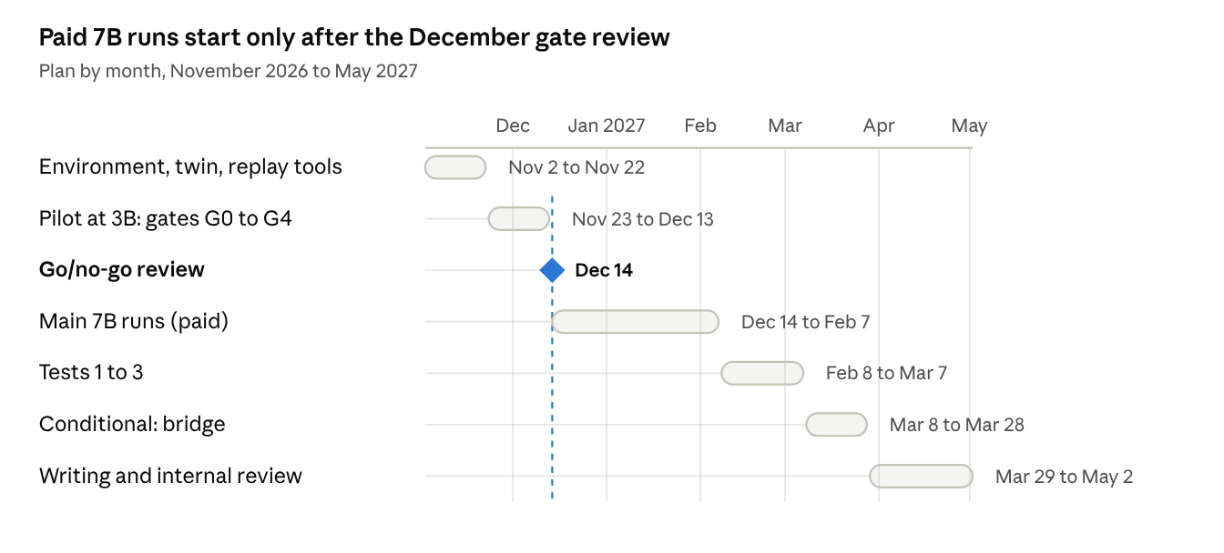
26-week plan · 6 work blocks, 1 gate
The dashed line marks the 14 December review; nothing paid starts before it.
The review on 14 December decides whether the paid 7B runs start; everything before it runs on Colab. The 7B runs are the only paid step, costed from the profiling run and approved before they start, within the £500 ceiling.
Full-pass training, trace editing and the human audit add work to the pilot and to the Tests 1–3 block. If the pilot overruns, optional analyses and layer searches are cut before seeds.

Risks and mitigations
Risk | Mitigation
The results read as “reasoning RL helps”, without saying what changed. | Lead with no-trace transfer to unrewarded consequences, the crossed trace and reader comparison, and changes in component contributions, each at matched direct-answer accuracy.
The rewarded question can be answered without tracking beliefs, so training teaches a lookup. | Nine-event stories vary who observes the deciding event; decisive lookup rules answer at chance, and the weaker heuristics are reported as reference lines.
The base model sits at ceiling or floor, leaving nothing for RL to change. | Calibrate difficulty on development stories and freeze it before training (gate G0).
Small models shorten their traces while staying accurate: Lu et al. 2025 report this “reasoning collapse” at 3B and below, alongside high accuracy and generalisation. | Treat short traces as a result for Tests 1 and 2, not a training failure; report editability by arm; move to 7B only for a capability or optimisation limit.
Traces never state the queried belief, so edits cannot be applied. | Edit the belief as the trace states it, right or wrong; count non-editable traces by arm as an outcome rather than dropping them.
Edited traces act as authoritative hints, or look unnatural. | Replay, paraphrase, answer-cue and irrelevant-edit controls, plus continuations regenerated after edits.
Model-generated edits are flawed. | Freeze the editor model and prompt before generation, audit a random sample, and report the flaw rate and the bound it places on results.
Reported learning rates do not suit LoRA, leaving an arm barely trained. | Treat Zhong et al.'s rates as references, offer the 1–30× development panel, and review every pilot arm's learning curve at G1.
Swapping components between differently trained models measures mismatch rather than meaning. | Swap within each checkpoint and compare before and after training; cross-model swaps are secondary and use identical token inputs.
The pilot exceeds its compute estimate. | Profile training, evaluation and storage first; use the cheaper panel options; cut optional analyses before seeds.
A competing paper dissects reasoning RL for theory of mind first. | The unrewarded-consequence tests, crossed trace design and within-model comparisons are distinctive. Hypotheses are fixed before training, and arXiv is checked monthly.
7B runs are unstable or exceed the hour estimates. | Cut optional analyses and layer searches before seeds; the confirmatory comparison keeps three seeds.

Key references
- Paper one: Beyond the Fitted Answer (under review, ICLR 2027). Code.
- Implementation of this proposal: paper2 repository, with its preregistration and record of departures.
- Companion bridge proposal (leading conditional follow-on): Bridge proposal: Does Reward Install What Interchange Installs?.
- Zhong et al. 2026, From Shortcuts to Reasoning: Robust Post-Training of Theory of Mind with Reinforcement Learning (ICML 2026). Appendix E gives the reference learning rates.
- Schulman et al. 2025, LoRA Without Regret (Thinking Machines). Reports LoRA's best learning rate at about ten times full fine-tuning's.
- Anthropic 2025, Reasoning Models Don't Always Say What They Think.
- Han et al. 2026, RFEval: Benchmarking Reasoning Faithfulness under Counterfactual Reasoning Intervention in Large Reasoning Models (ICLR 2026).
- Y. Wang et al. 2026, Reasoning or Retrieval? A Study of Answer Attribution on Large Reasoning Models (ICLR 2026).
- Q. Wang et al. 2026, From Concept Alignment to Causal Grounding: An Intervention Test of Chain-of-Thought Faithfulness.
- Hong et al. 2026, Making LLMs Say What They Think: Measuring and Improving CoT-Interpretability Alignment (arXiv).
- Shi et al. 2026, Why Does Reinforcement Learning Generalize? A Feature-Level Mechanistic Study of Post-Training in Large Language Models (ACL 2026).
- Li et al. 2026, CoSToM: Causal-oriented Steering for Intrinsic Theory-of-Mind Alignment in Large Language Models (ACL 2026).
- Lanham et al. 2023, Measuring Faithfulness in Chain-of-Thought Reasoning.
- Macar et al. 2026, Thought Branches: Interpreting LLM Reasoning Requires Resampling (ICLR 2026).
- Sarangi & Salam 2025, Small LLMs Do Not Learn a Generalizable Theory of Mind via Reinforcement Learning.
- Lu et al. 2025, Do Theory of Mind Benchmarks Need Explicit Human-like Reasoning in Language Models? (formerly ToM-RL).
- Du et al. 2026, What Does an LLM Learn from Reinforcement Learning? (Fixed-SAE Track).
- Sinii et al. 2025, Small Vectors, Big Effects: A Mechanistic Study of RL-Induced Reasoning via Steering Vectors.
- Right Answer, Wrong Mechanism: Detecting Pernicious Divergence in Causal Interventions (2026).
- Geiger et al. 2024, Finding Alignments Between Interpretable Causal Variables and Distributed Neural Representations (DAS).
- Xu et al. 2024, OpenToM; official prompts and scorer in the OpenToM repository.

