Engineering Placements Analysis Through Data Visualization

Introduction:

Syed Zeeshan Ahsan-02208117 (Team Lead)
Fawaz Mokthar-02188727

Predicting engineering placements is a crucial task with practical implications for students, universities, and recruiters. By analyzing historical data on students' attributes and placement outcomes, we can develop models to forecast the likelihood of future placements. This report presents an analysis of engineering placements based on a dataset from a University's On-Campus Placement Records for the years 2013 and 2014.
Dataset Overview:
Source: Engineering Placements Prediction dataset from Kaggle Size: 10kb
Features:
Age: Age of the student
Gender: Gender of the student (Male, Female, Other) Stream: Engineering stream (CSE, ECE, IT, MECH, CIVIL) Internships: Number of internships completed by the student
CGPA: Cumulative Grade Point Average (CGPA) of the student Hostel: Whether the student stayed in hostel (0 - No, 1 - Yes) History of Backlogs: Number of backlogs in academic history Placed or Not: Placement outcome (0 - Not Placed, 1 - Placed)

TASK:
What: This report analyzes engineering placement data from a University's On- Campus Placement Records for the years 2013 and 2014. It examines factors such as age, gender, stream, internships, CGPA, hostel accommodation, and academic history to understand their impact on placement outcomes.

Why: The analysis aims to provide insights into the factors influencing engineering placements, assisting students in career planning, universities in program enhancement, and recruiters in optimizing hiring processes. By

identifying trends and patterns in historical data, stakeholders can make informed decisions to improve placement success rates.
How: Through data visualization techniques such as bar charts, area charts, and gauge charts, the report presents a visual representation of placement status by stream, the relationship between internships and placements, and the overall placement percentage. These visualizations help convey key findings and trends in a clear and concise manner, facilitating better understanding and decision-making.

Visualizations:
- Bar Chart - Placement Status by Stream:
This visualization illustrates the placement status (Placed or Not Placed) across different engineering streams.
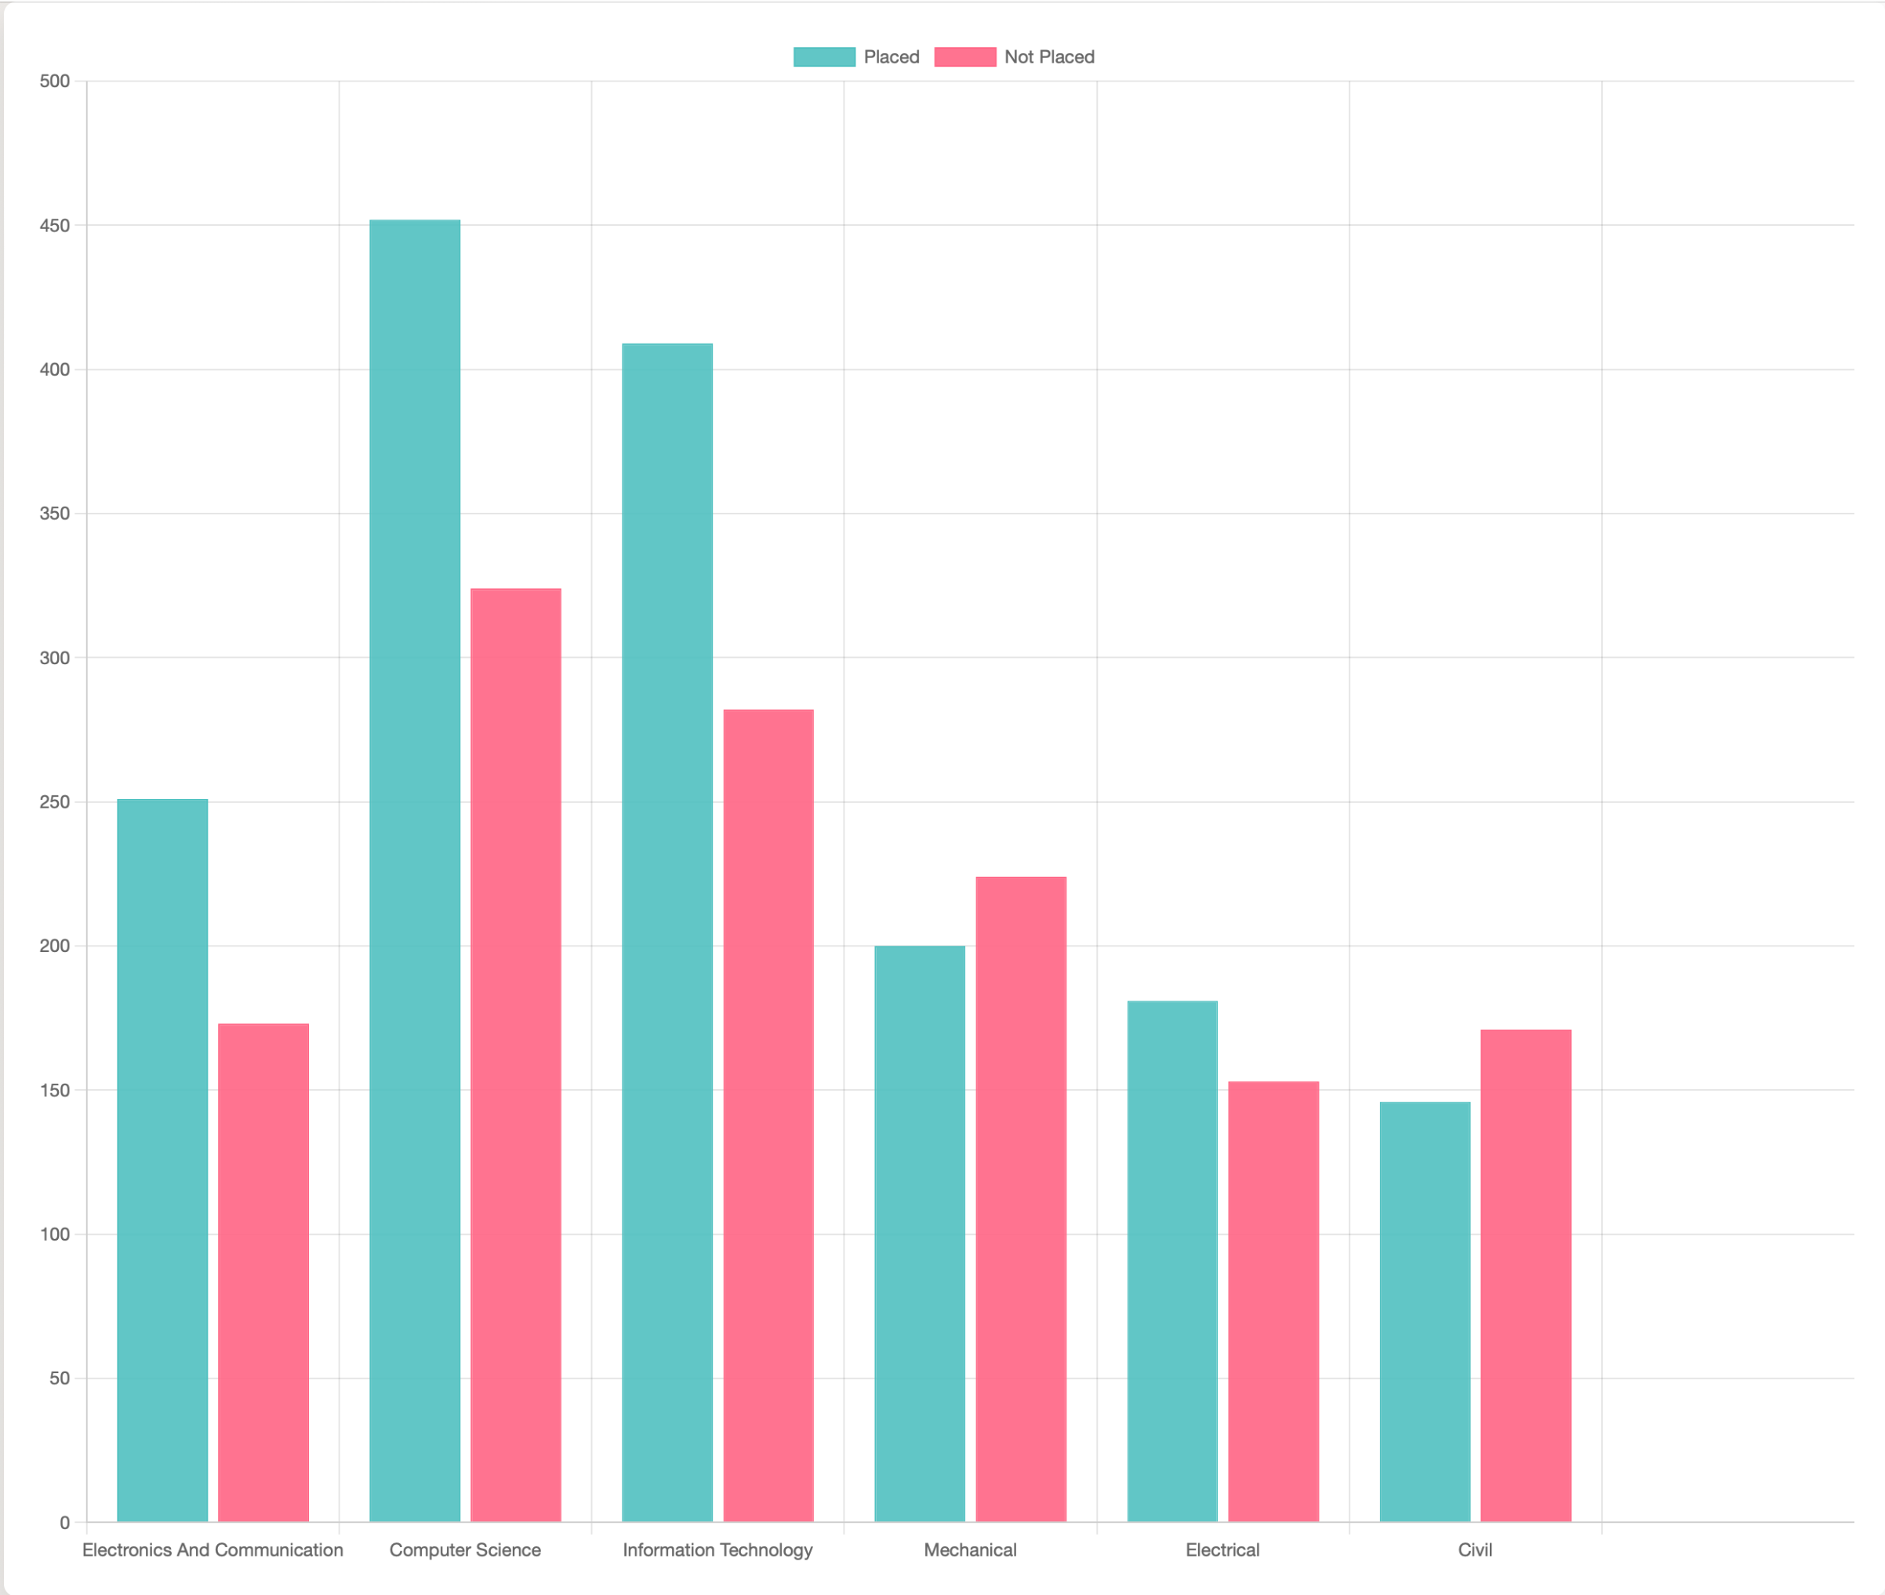
It provides insights into the placement success rates for each stream, highlighting potential areas for improvement.

- Area Chart - Internships vs. Placements by Stream:
The area chart displays the trend of internships completed by students and their corresponding placement outcomes for each engineering stream.
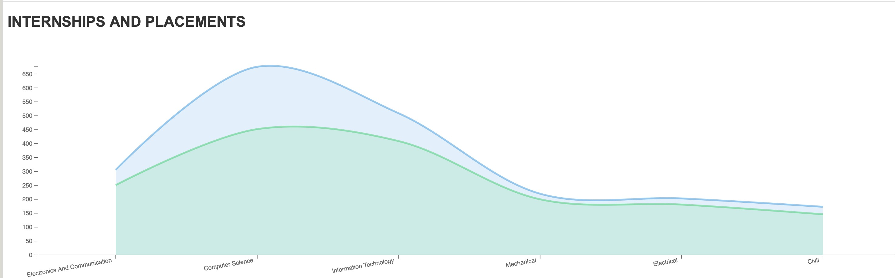
It helps identify whether students with more internships have higher placement rates and how this varies across streams.

- Gauge Chart - Placement Percentage:
The gauge chart presents the overall placement percentage of students across all streams.
It offers a quick snapshot of the placement success rate, providing a high-level overview of the dataset.

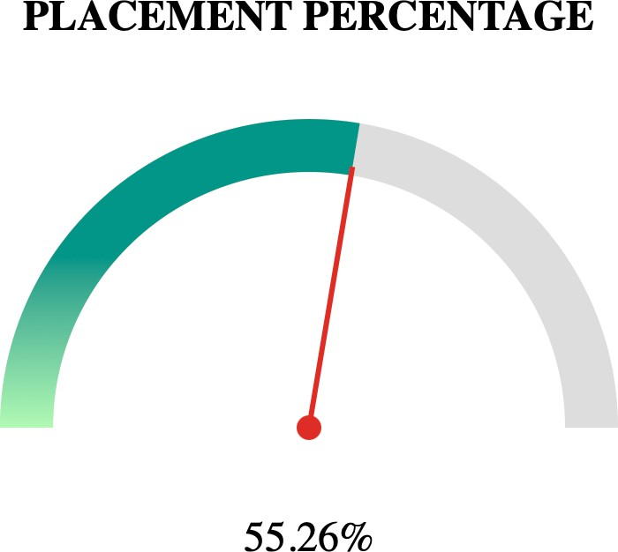

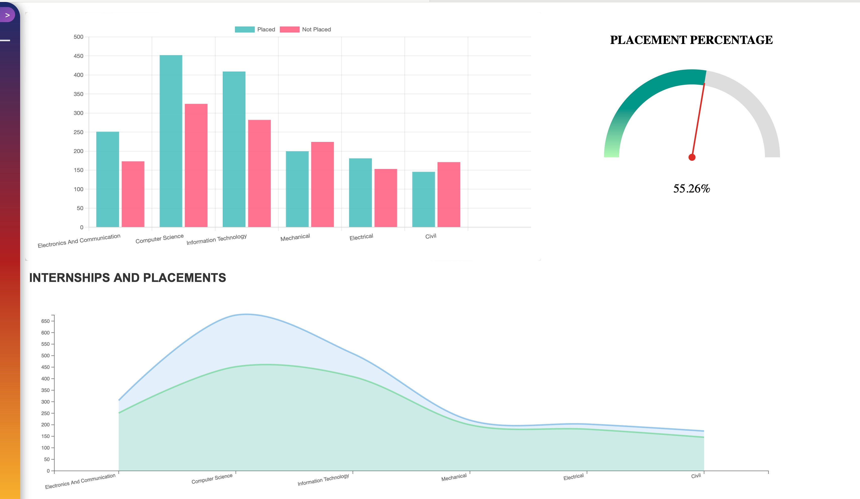
- Dashboard:

Conclusion:
Engineering placements prediction is a multifaceted task influenced by various factors such as age, gender, stream, internships, CGPA, hostel accommodation, and academic history. By leveraging data analysis and visualization techniques, we can gain valuable insights into placement trends, thereby assisting stakeholders in making informed decisions. This analysis serves as a foundation for further exploration and model development to enhance the accuracy of placement predictions.

