**Terraform task 01**

**1)Install Terraform on your PC**

**>>search for terraform download on your pc >>**

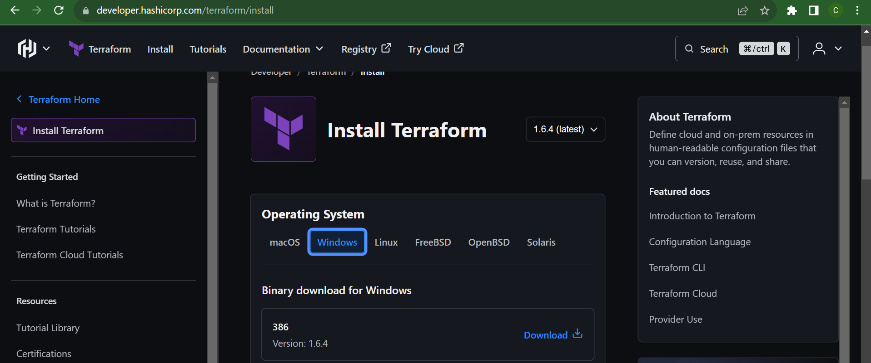

**Extract the folder and add in C drive**

**Go to environment variables and edit environment variables >> select path >> add the path of the extracted folder forwarded by back slash**

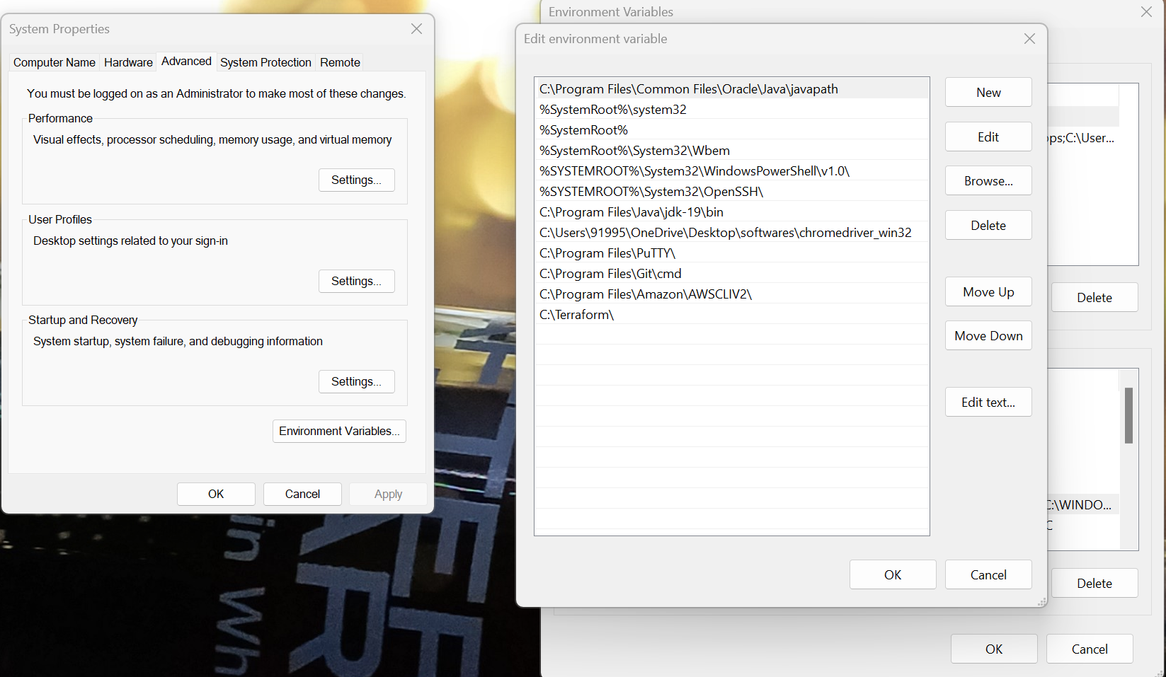

**Go to CMD and check the version if terraform is downloaded**

**Terraform –version**

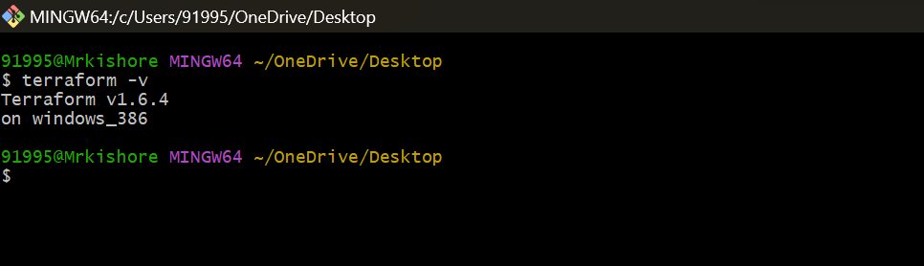

**2) Execute all the templates shown in video.**

**Sample Template using visual studio**

**Create a repo with the name terraform and open using Visual Studio**

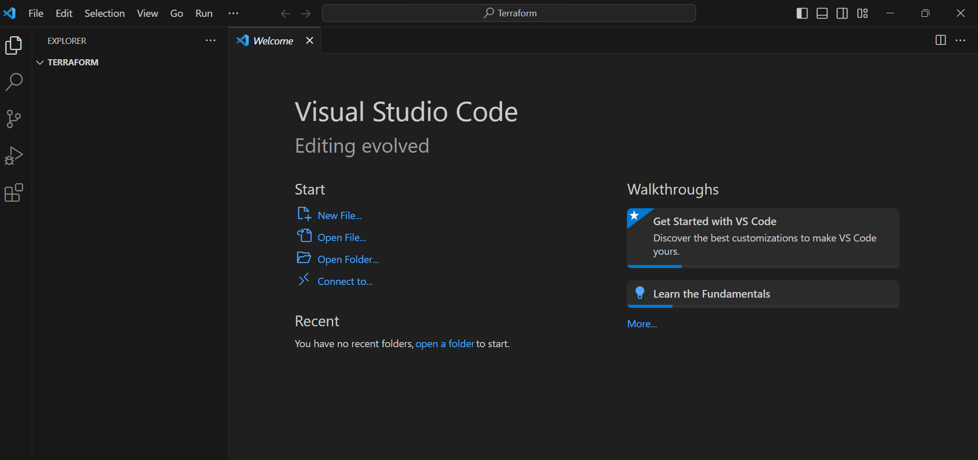

**Make sure to install Harshi Corp Terraform in Visual Studio which is a onetime activity**

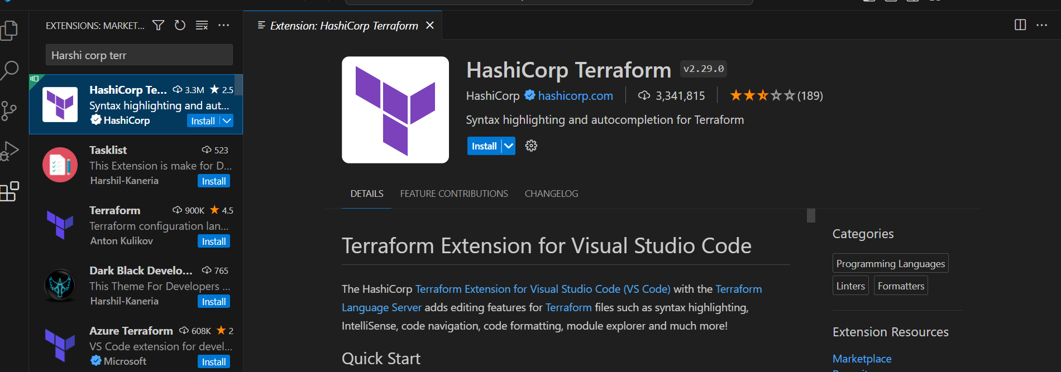

**Click on file >> new file and create a file**

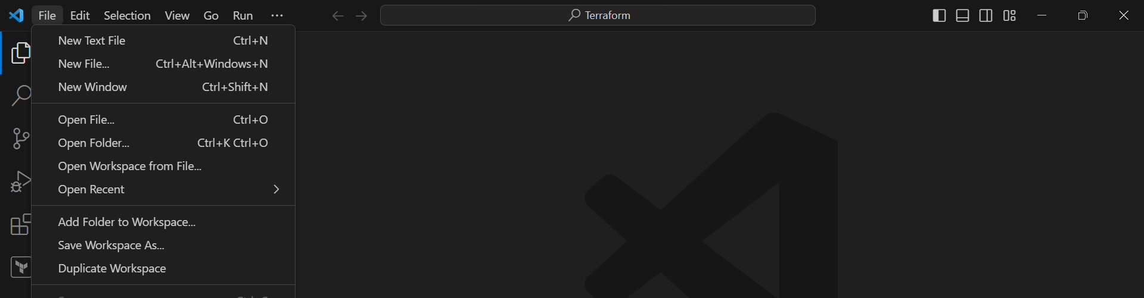

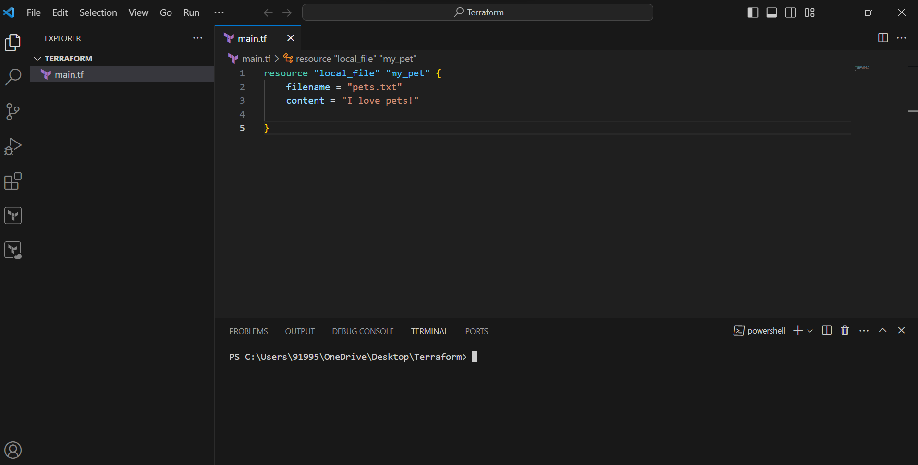

**Now open command line and pass the command terraform init command which will initialize the folder as wll as download the providers to perform the action needed to the dependency Aswell**

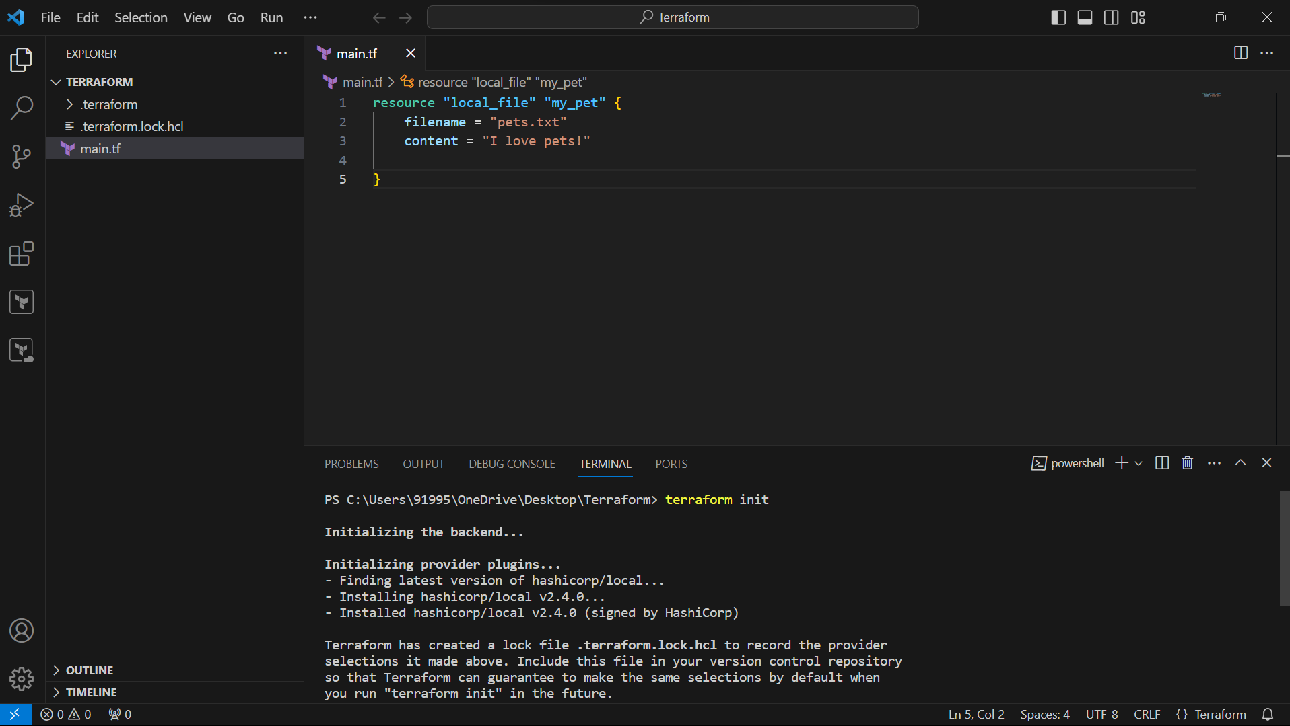

We can see that terraform has been successfully initialized

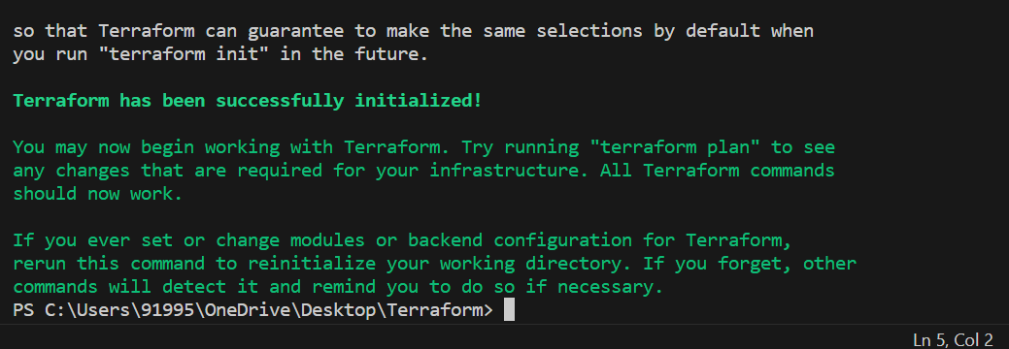

Terraform plan

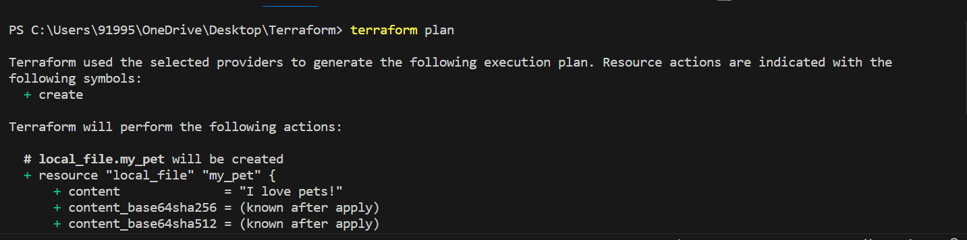

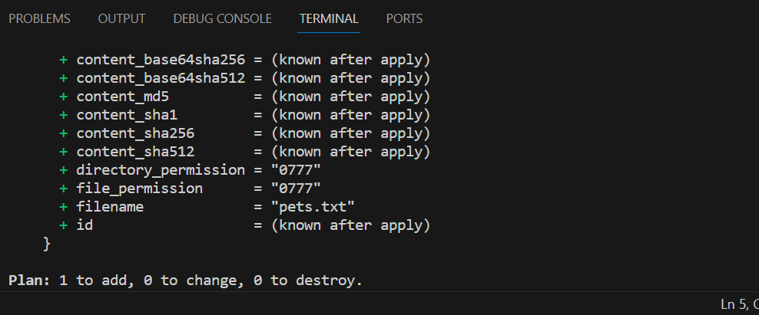

Terraform apply

Will help us to execute our template

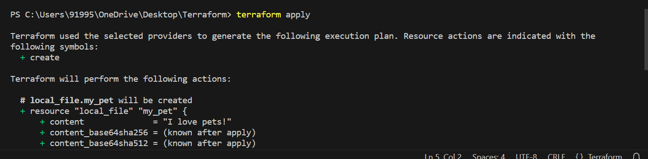

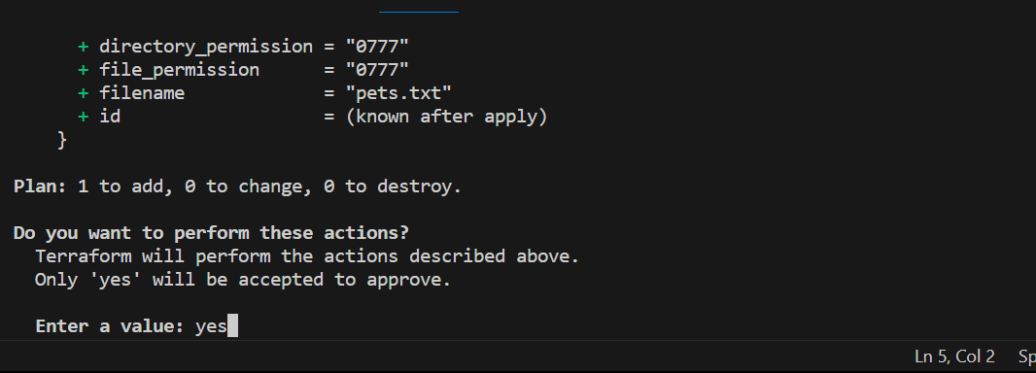

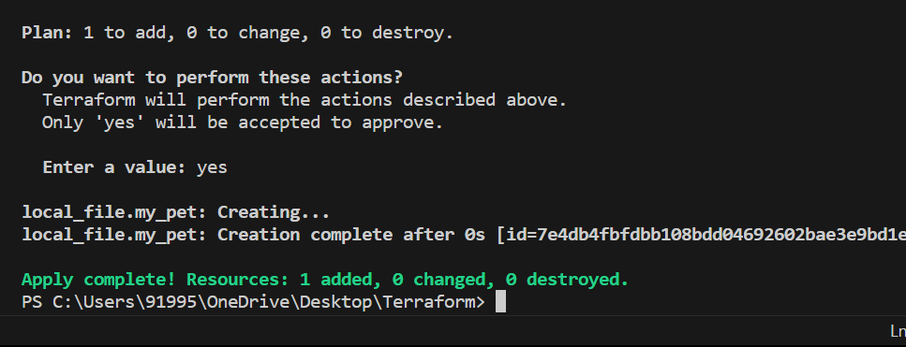

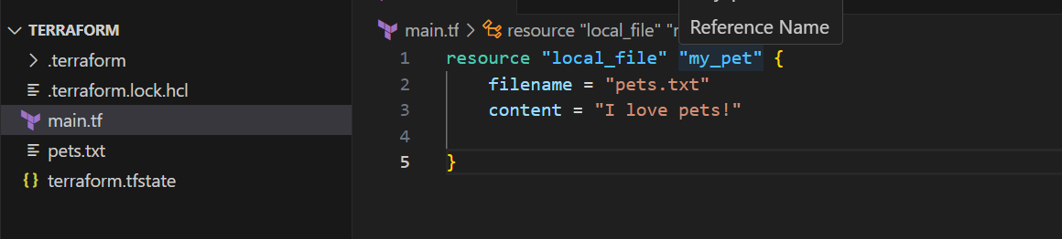

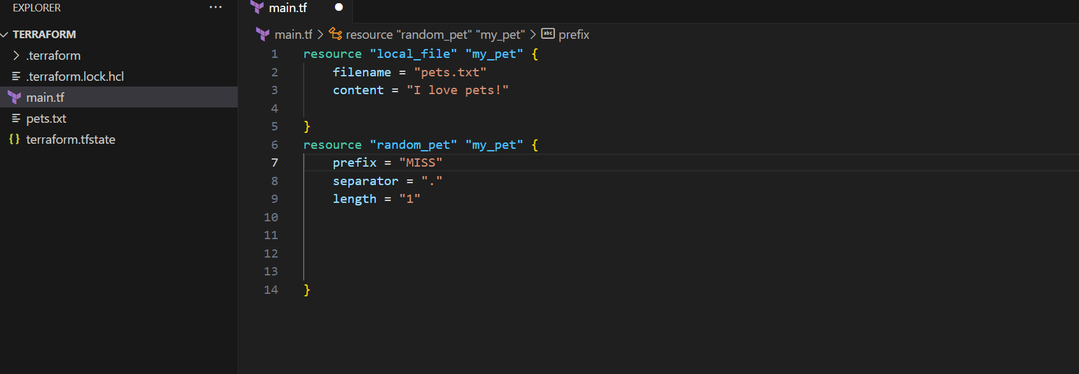

**4) Integrate a sample Terraform template in Jenkins.**

**Start Jenkin’s**

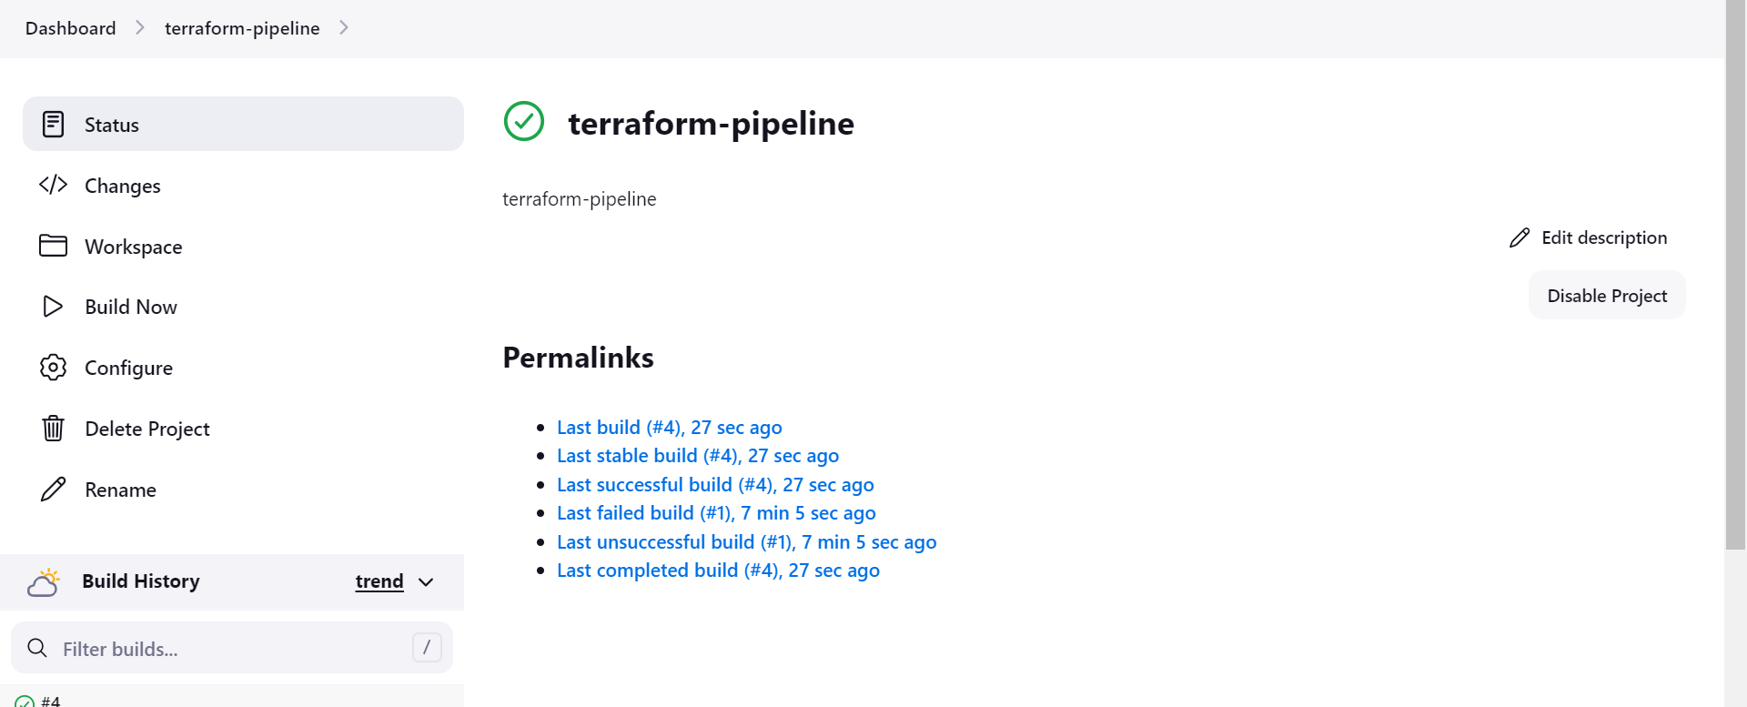

**Manage Jenkin’s >> plugins >> install terraform plugins**

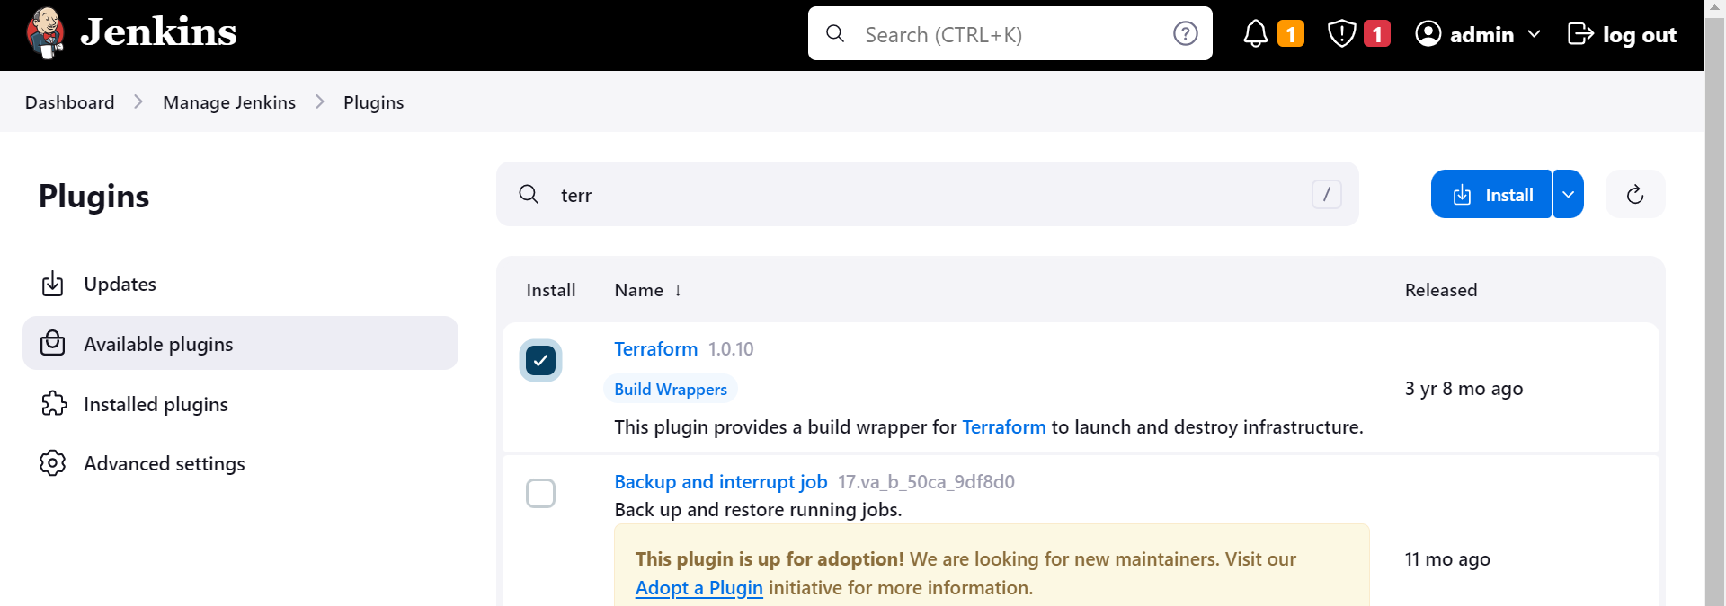

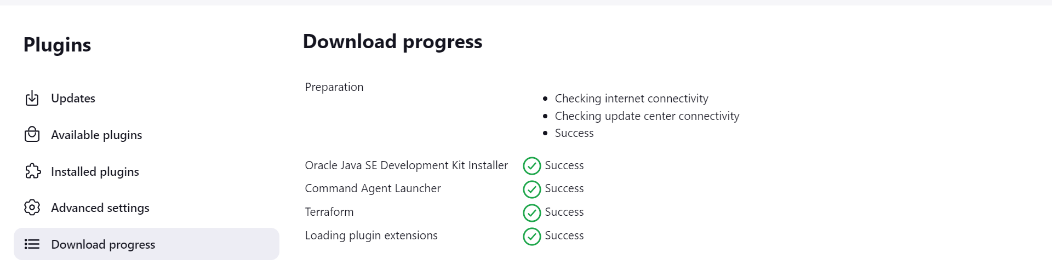

**In Jenkin’s master wget terraform and unzip the file mv to /usr/bin folder**

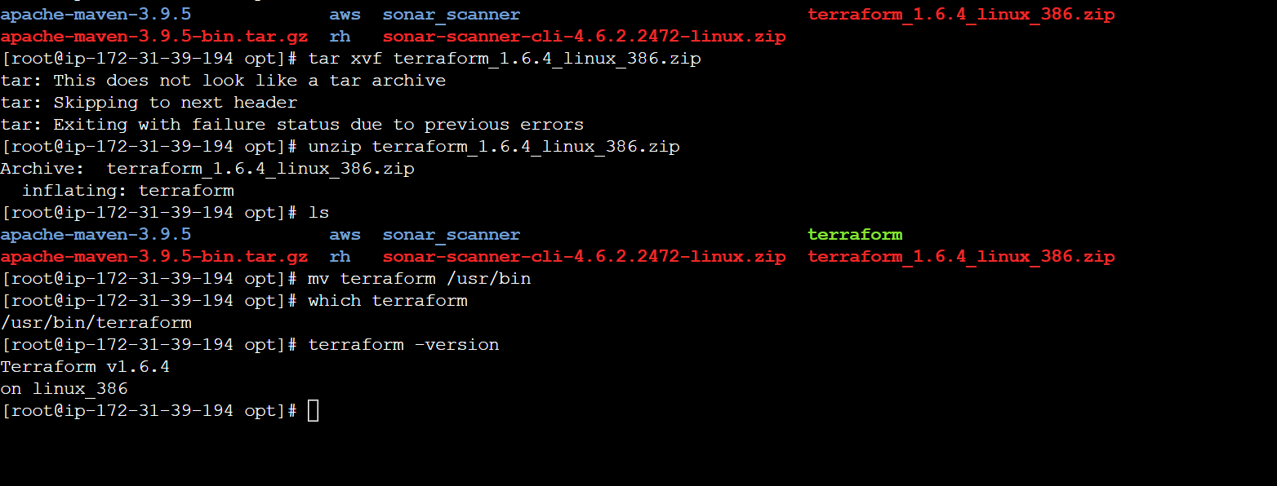

**Go to global tool configuration in Jenkin’s and add terraform path where terraform is installed**

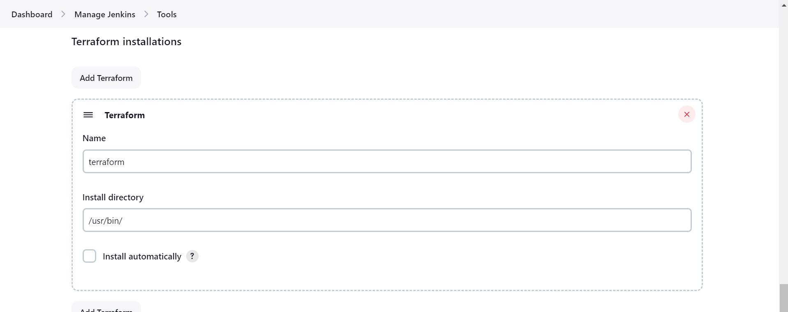

Create a new job free style



Puss the code

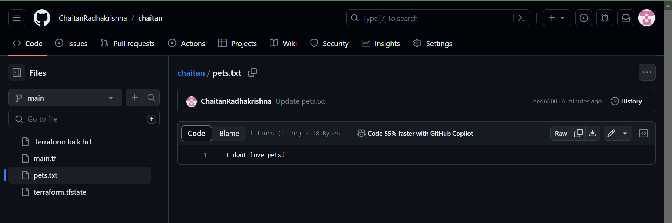

Clone the repo with Jenkin’s

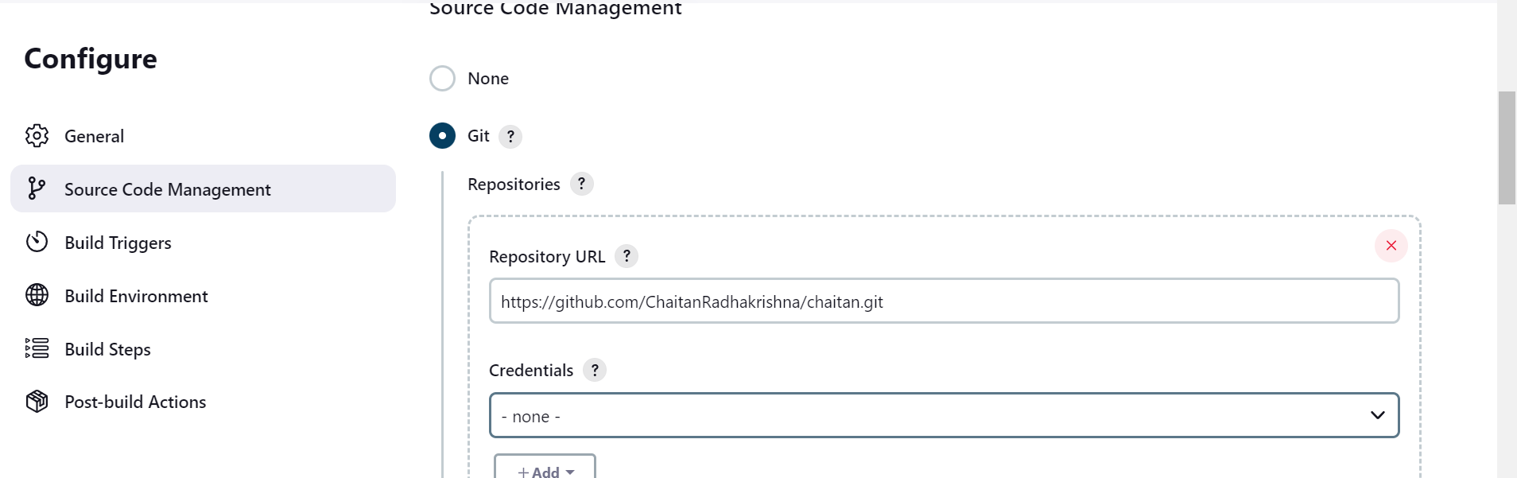

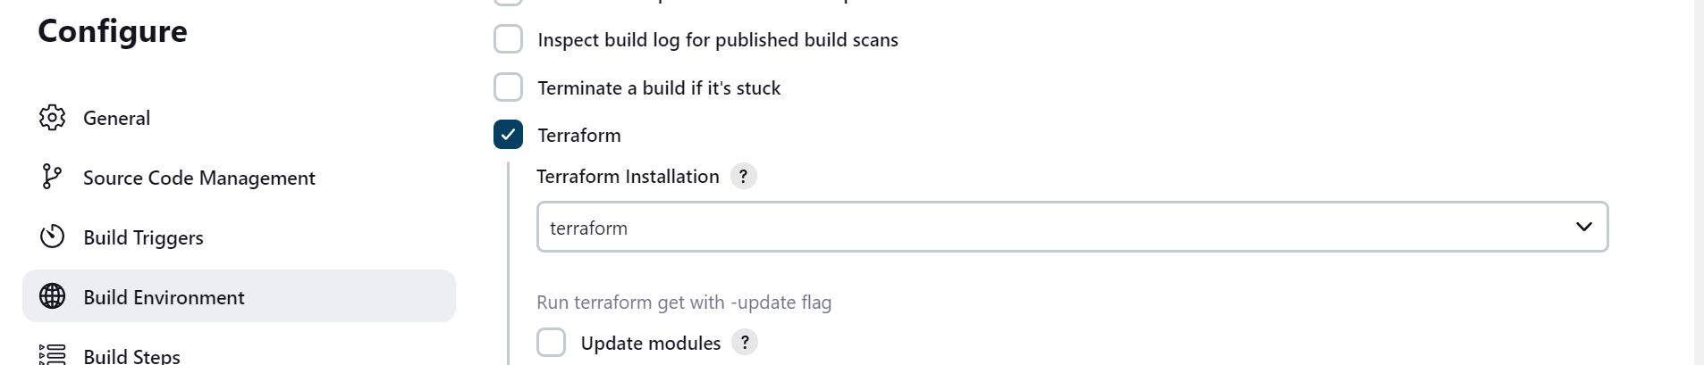

Pass terraform commands in execute shell

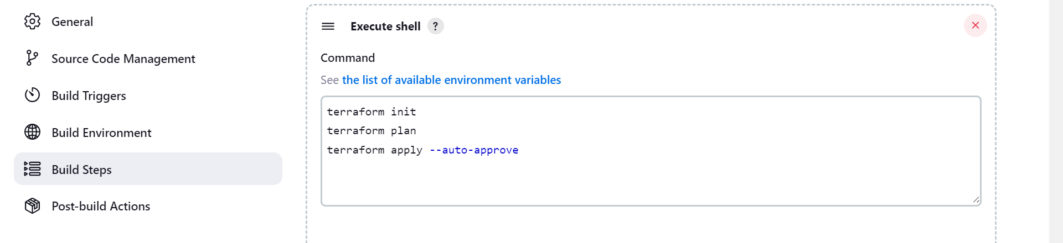

console output

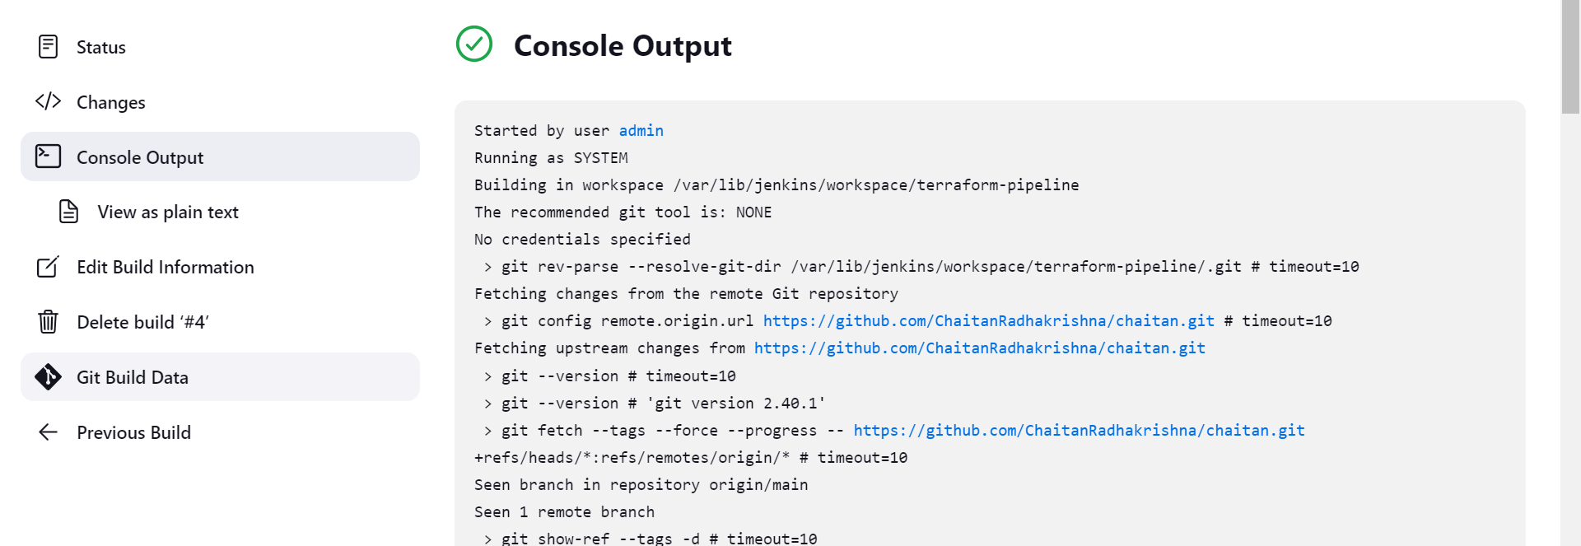

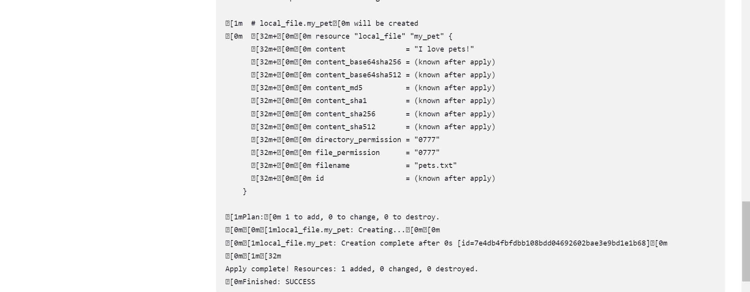

Made changes to .ts file and we can see the reflected changes in cli and console output

