Instruction Sheet for ‘Stimulus Construction’
- In this study, we are interested in how people learn how to construct visual objects. You will learn how to build such objects, which will be similar to playing Lego/Tetris.

- In each trial, you will be presented with an object that you have to build, which will be displayed on a 6x6 grid at the bottom left of the screen. Subsequently, you will have to decide which building blocks you want to use to build them:
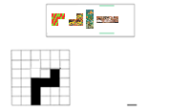
- You can select blocks with ENTER, and move around with the left and right ARROW. Once you are happy with your selection, press SPACE. You can also skip a trial by pressing the left CONTROL key.

- After you have made your selection, you can move the elements around and construct the object:
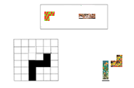
- Select the element you want to move with ENTER. You can then move them around with the ARROW keys, and confirm the final position by pressing ENTER again.

- You can undo your selection/moves with the BACKSPACE key.

- Once the last element is placed you will receive feedback (correct/incorrect)

- Your pattern is also incorrect if some building blocks overlap, even if the shape of your object is correct!

