**Batik Pattern Recommendation Based on User’s Sketch**

2015105890 Ecstexela Syenne

**Abstract**

Create our own target batik pattern image converting from sketch into image by combining Pix2pix algorithm and Batik classification with Deep Convolutional Network Transfer Learning

1. **Introduction** 
   1. **Research Background**

Batik fabric is one of the most profound cultural heritage in Indonesia. Batik has unique pattern (motifs), it is natural to consider it as a key to classification. It is not easy for common people recognize the pattern of batik in detail. When they want to custom their batik design, they do not know what kind of pattern they should describe it to the designer. By giving them a recommendation of the pattern, it will be helpful for them. In Pix2pix journal, they success to convert sketch into an image of the object type. And also, in Batik Classification journal, deep learning model is proposed as a better alternate to classify the most common Batik motifs. Both of them already exist, but how about combine them to help people and batik designer? By sketching the sample motif, then convert it into recommendation of batik pattern image and then classify them.

* 1. **Research Purpose**

The main purpose of this research is for giving people a convenience to get batik pattern according to what they want by giving them recommendation image based on their sketch. Dataset and the codes have been founded each of the research task, but in this situation, our purpose is to combine them into one application. Therefore people can sketch, also receive the batik motifs and their type.

1. **Related Works**

Recent researches has founded two kinds of researches that will be combined together into one which are 2.1 Pix2pix and 2.2 Batik classification using Deep CNN Transfer Learning.

* 1. **Related Work 1**

**Pix2pix.** Image-to-Image Translation with Conditional Adversarial Network journal. Pix2Pix uses a range of features, including an algorithm to interpret information, a discriminator that can analyze both the original and the output when it's created, and a neural network that it relies on to guess what the image should look like. In other words, your creations are tossed around inside a computer's brain to spit out an image that hopefully looks realistic.

For training the network, two steps have to be taken: training the discriminator and training the generator. The overview of pix2pix edges to photo is described in Figure 1. All networks were trained from scratch. Weights were initialized from a Gaussian distribution with mean 0 and standard deviation of 0.02. First, the generator generates an output image. The discriminator looks at the input/target pair and the input/output pair and produces its guess about how realistic they look. The weights vector of the discriminator is then adjusted based on the classification error of the input/output pair and the input/target pair.

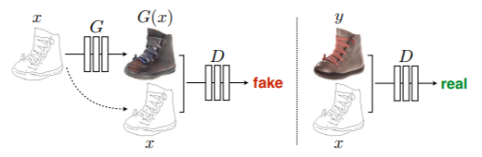

Figure 1 an overview of Pix2pix edges to photo

In the wild results of Figure 2, the user sketches the shoes from one edge to another edge, then pix2pix converts it into the similar sketched shoes with more real image. From this journal, we think it will be helpful for us when we recommend a target batik motif, the motif can be converted naturally onto the image of object type.

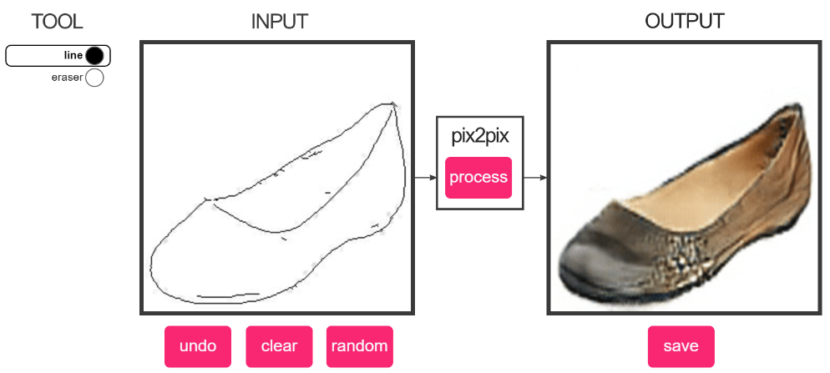

Figure 2 In the wild results

* 1. **Related Work 2**

**Batik Classification Using Deep Convolutional Network Transfer Learning.** Convolutional Neural Network (CNN) is one of deep learning architecture which able to learn data representation by combining local receptive inputs, weight sharing and convolutions in order to solve invariance dilemma in image classification. In this paper, a deep learning model is proposed as a better alternative to classify most common Batik motifs: Parang, Lereng, Kawung, Ceplok and Nitik (Figure 4). They propose a deep convolutional neural network composed by a pre-trained VGG16 (without its top layer in Figure 4) as automatic feature extractor and a fully-connected feed-forward neural network as classifier. The method of using pre-trained deep network as part of another neural network to solve different (but related) task can be considered as transfer learning or self-taught learning.

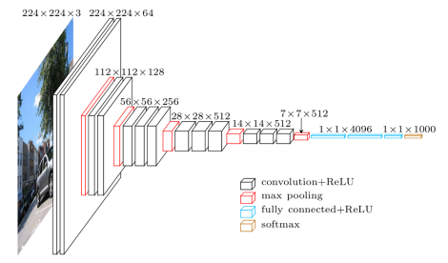

Figure 3 VGG16 Deep Convolutional Network Model

of Visual Geometry Group, Oxford

Through this paper, we think that batik classification is need to distinguish the type of batik because Batik motifs are complex and unique.

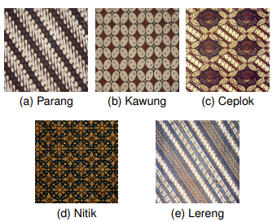

Figure 4 General Batik pattern classification

* 1. **Problems of Existing Research**

According to the first existing research about Pix2pix, the models were trained on automatically detected edges, but generalize to human drawings. Therefore, sometimes if the sketch (Figure 5) is not clear, the output image can be blurred, or the shape and texture will be not perfect.

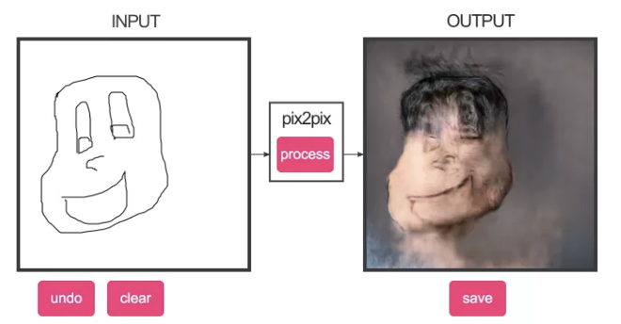

Figure 5 Failure output because of the sketch

The second existing research about Batik Classification, we found that some motifs data often overlaps each other for example, Parang and Lereng motifs (Figure 6). This condition often confuses classifier during training and causes less accurate generalization. Furthermore, due to the various sources of data, the quality of the data are also various.

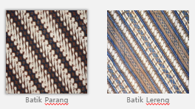

Figure 6 Batik Parang and Lereng with the similar motifs

1. **Project** 
   1. **Differences and Solutions for Existing Research**

It is possible if the research is not perfect. In Pix2pix research, the output image can be blurred. It is not only by improving to train dataset, but it needs more capability to sketch it in detail. In Batik Classification research, to avoid overlaps each other motifs, we need to train the dataset in a lot of time to help the classifier. In addition to train dataset, by removing low quality data and preprocessing high quality ones may produce homogeneous data and improve classifier training process.

* 1. **Project Contents**

In purpose to get batik pattern according to what user want, through our project it can be giving them recommendation batik pattern image based on their sketch by using deep CNN transfer learning and edges detection. Dataset will be trained into sketch by using edge detection, then all the sketches will be trained by using pix2pix until get the real image. Through the real image, pix2pix will test them until they get the similar pattern image by following the type of the batik motif. Figure 7 is our expectation of the project result.

Figure 7 Expectation of the Result

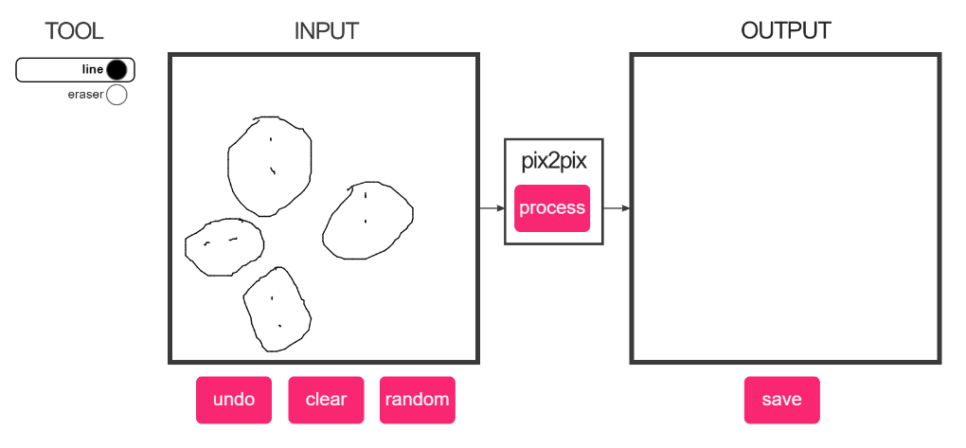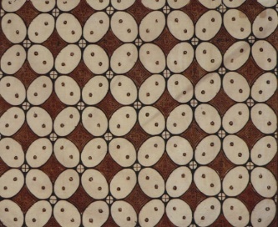

Batik Kawung

1. **Timeline Progress**

Batik Kawung

|  |  |  |
| --- | --- | --- |
| Weekly Progress | Person in charge | Contents |
| ~7 | Syenne | Collecting data and data for project progress |
| 7~9 | Syenne | Training the open source and machine learning |
| 9~11 | Syenne | Run the Pix2pix and check the results |
| 11~13 | Syenne | Run the Batik classification and check the results |
| 13~16 | Syenne | Interlock and combine Pix2pix and Batik Classification |
| 16 | Syenne | Final Presentation and Demo |

1. **Conclusion**

The model give user the batik pattern that user want to get and help them to choose which batik’s design is good for them and it is convenience for the designer received recommendation pattern based on simple sketch. Using this model will reduce the amount of time to worry about drawing or thinking the design because of the complexity of the batik motifs. It can be utilized not only for common people, but for fashion and design company. It will be good if the model can be used in mobile as an application. Therefore, everyone will be able to try and use it anytime, anywhere.

**References**

**[1]** Isola, Phillip, et al. "Image-to-image translation with conditional adversarial networks." Proceedings of the IEEE conference on computer vision and pattern recognition. 2017.

**[2]** Gultom, Yohanes, Aniati Murni Arymurthy, and Rian Josua Masikome. "Batik Classification using Deep Convolutional Network Transfer Learning." Jurnal Ilmu Komputer dan Informasi 11.2 (2018): 59-66.