Equity TCA
Arrival vs Interval-VWAP — Cost Gap Analysis (2026 H1)
Market orders · GTC excluded · value-weighted (FX-adjusted USD) · positive = cost
1 · Objective & logic
Where do we see higher or lower arrival-to-execution slippage for market orders? Two benchmarks isolate different things:
• Arrival cost (A) = side·(AvgPx − ArrPx)/ArrPx·1e4 — vs the decision price; contains execution/impact plus market drift.
• Interval-VWAP cost (V) = side·(AvgPx − VWAP)/… — vs the market’s own average; drift-free execution.
• Gap A − V ≈ timing drift — how the price moved against/for your side while trading.
Read: A≈V → genuine execution/impact (controllable). A≫V → adverse drift (timing, mostly not). A≪V → favorable drift masking weak execution (red flag). Judge broker skill on V.
2 · Parameters, statistics & categories
Parameter | Value
Population | Market orders (LmtPx=MKT), GTC excluded — n = 805
Weighting | FX-adjusted USD notional (value-weighted) + equal-weighted mean
Benchmarks | Arrival + Interval VWAP
Statistics | VW cost, mean cost, t-stat (H0: mean=0), gap A−V
Min sample | 25–30 per cell (raise to 50 before acting)
Trend bar | n ≥ 25 and |t| ≥ 2 and VW/mean agree in sign
Categories | Direction; Spread×Dir; ADV%×Dir; Cap×Dir; Region×Dir; Broker×Dir; Region×Broker

Book baseline (market orders): Arrival -0.6 bps, VWAP +0.9 bps — the book essentially trades at its decision price; findings are read against this.
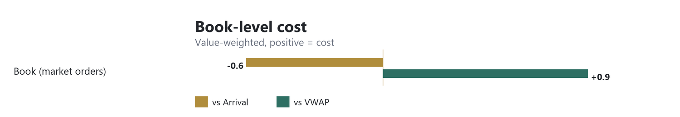

3 · Robust trends
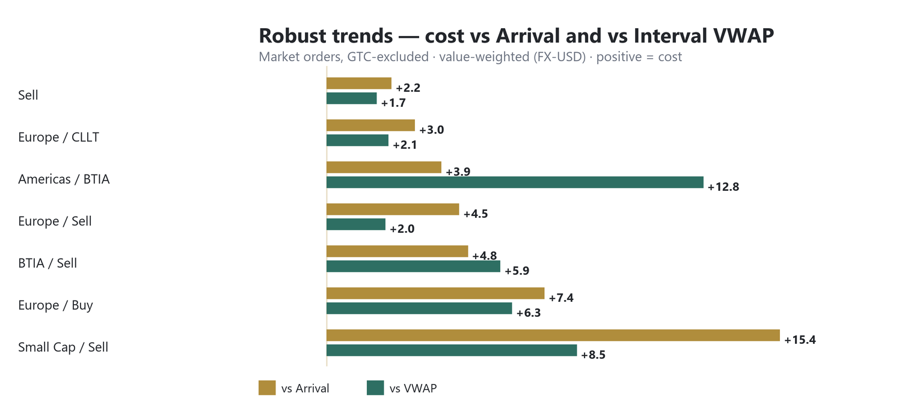
Segment | n | A (VW) | V (VW) | Gap | t(A) | Read
Cap×Dir: Small Cap / Sell | 61 | +15.4 | +8.5 | +6.9 | +3.0 | exec worse | adverse drift
Region×Dir: Europe / Buy | 151 | +7.4 | +6.3 | +1.1 | +1.7 | exec worse | no drift
Broker×Dir: BTIA / Sell | 85 | +4.8 | +5.9 | -1.1 | +2.0 | exec worse | no drift
Region×Dir: Europe / Sell | 84 | +4.5 | +2.0 | +2.5 | +2.2 | exec ~ mkt | no drift
Region×Broker: Americas / BTIA | 115 | +3.9 | +12.8 | -8.8 | +2.0 | exec worse | favorable drift
Region×Broker: Europe / CLLT | 221 | +3.0 | +2.1 | +0.9 | +2.1 | exec ~ mkt | no drift
Direction: Sell | 327 | +2.2 | +1.7 | +0.5 | +2.9 | exec ~ mkt | no drift

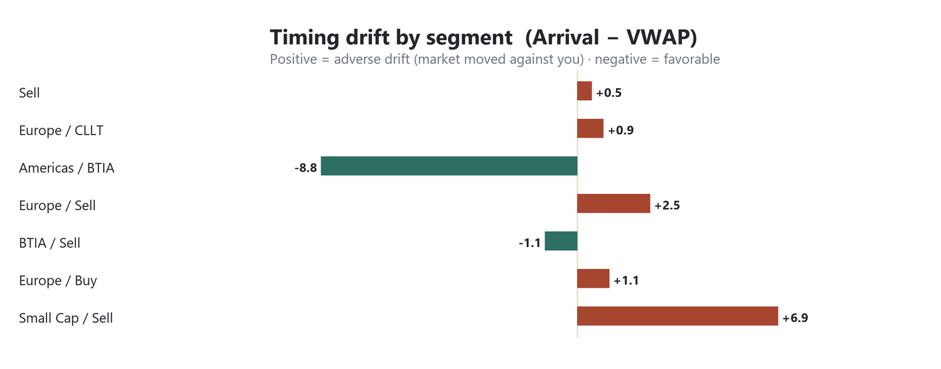
4 · Insights
• The one sizeable, controllable pocket is small-cap sells (~+15 bps, t=3.0): both execution (worse than VWAP) and adverse drift hurt. Slow the schedule / source block liquidity.
• Two brokers look better on arrival than they execute: Americas/BTIA (A +3.9 but V +12.8) and Asia/ICBI (A −6 but V +3.9) — favorable drift masks weak execution. Rank brokers on V.
• European flow carries a real execution cost on both sides (buys V +6.3, t=2.6; sells A +4.5, t=2.2) with little drift — a venue/algo question, not timing.
• Sells cost, buys don’t at book level (Sell A +2.2, t=2.9 vs Buy −2.0 n.s.).
5 · Caveats
• Extreme cells (Very-Large ADV, Very-Wide spread) fall below min-n in market-orders-only, so they do NOT qualify as trends — flag for more data.
• Some value-weighted cells are large but insignificant (one/two big tickets) — excluded by the VW/mean-agreement rule.
• Market cap uses approximate static FX; GICS industry ~43% populated. Cost is trading-related IS vs arrival, not full implementation shortfall.

