11

10

9

8

7

3

1

calculateRoVib2DIRSpectrum.m

Define Simulation Parameters

Process Experimental 2DIR Data

2DIR .mat files

GO

Setup Eigenspace

Calculate Transition Dipole Matrix

Calculate Hamiltonian Matrix

Calculate Density Matrix

Calculate Time propagation matrices

Calculate Windowing Functions

Calculate Simulation Matrices

FTIR .csv file

setupSimWorkspace(params)

For i = 1:length(t2)

Calculate t2 Time Propagation

Calculate Lineshape Functions

Calculate Non-Rephasing Response

Calculate Rephasing Response

Save Simulation Data

Calculate FFTs

Simulation .mat file

Interpolate Sim Data to Experiment

Plot Data

END

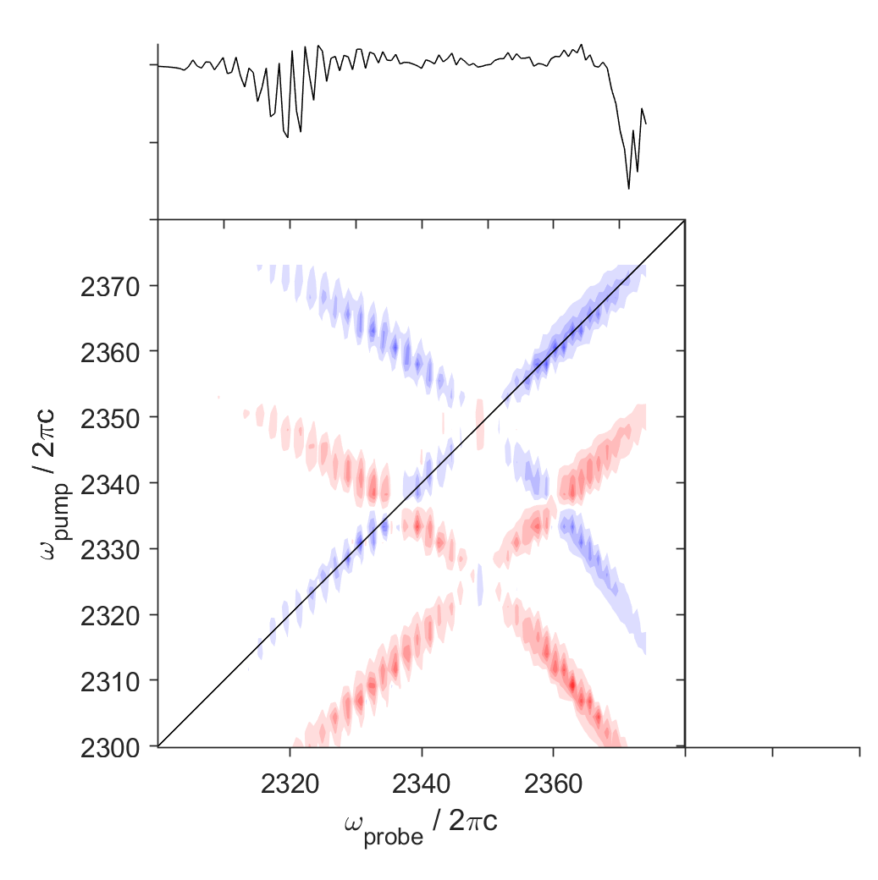

2

4

5

6

12

13