homework2

Yihao Song(Allen)

2017骞5鏈<88>15鏃

# 1st question  
power <- 0.8  
alpha <- 0.05  
z0 <- qnorm(p = 0.975)  
z1 <- qnorm(p = 0.2)  
n <- 2 * (z0 - z1) ^ 2  
n

## [1] 15.69776

# relations between sample size N with delta(effect size)  
N <- NULL  
Del <- NULL  
for(del in c(1:1000)){  
 Del <- c(Del,del)  
 N <- c(N, (2 * (z0 - z1)^2 / del ^ 2))  
}  
plot(x = log(Del), y = N)

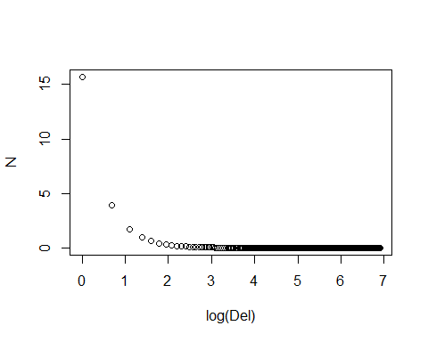

# relations between sample size N with variance  
Var_a <- NULL  
N <- NULL  
for(var in c(1:1000)){  
 Var_a <- c(Var_a, var)  
 N <- c(N, ((2 * var) * (z0 - z1)^2))  
}  
plot(x = Var_a, y = N)

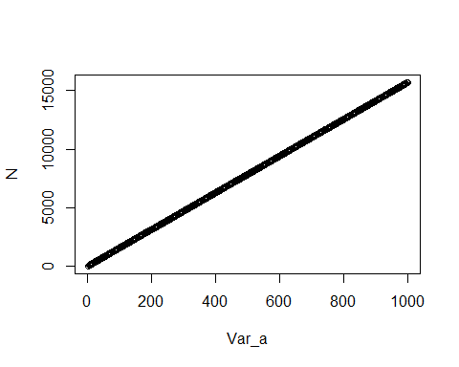

# rolling dice  
# using chi square test to test if they are fair dices  
# test goodness of fitting  
p1 <- 1/6  
p0 <- 5/6  
chisq.test(x = c(48,35,15,3),  
 p = c(  
 p0 ^ 3,   
 choose(3,1) * p1 * (p0 ^ 2),  
 choose(3,2) * (p1 ^ 2) * p0,  
 p1 ^ 3  
 )  
 )

## Warning in chisq.test(x = c(48, 35, 15, 3), p = c(p0^3, choose(3, 1) * p1  
## * : Chi-squared approximation may be incorrect

##   
## Chi-squared test for given probabilities  
##   
## data: c(48, 35, 15, 3)  
## X-squared = 24.676, df = 3, p-value = 1.804e-05