Name: 胡翔崳

Student ID: 7107056054

Basic

1. Show the execution result (snapshot) of UDP server

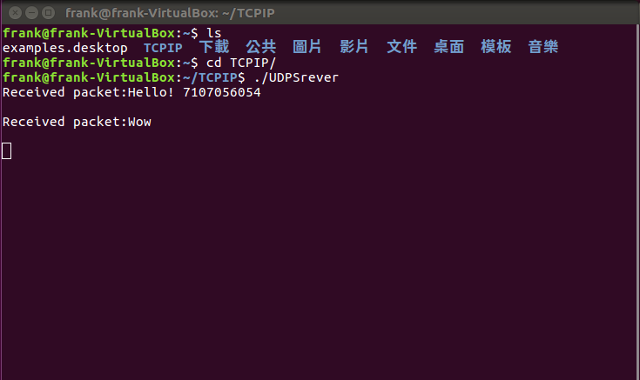

1. Show the execution result (snapshot) of UDP client

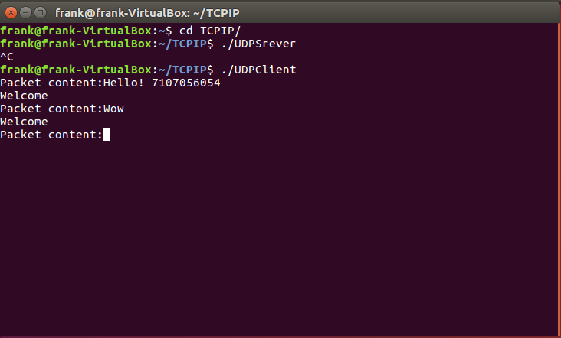

1. Show the execution result (snapshot) of TCP server

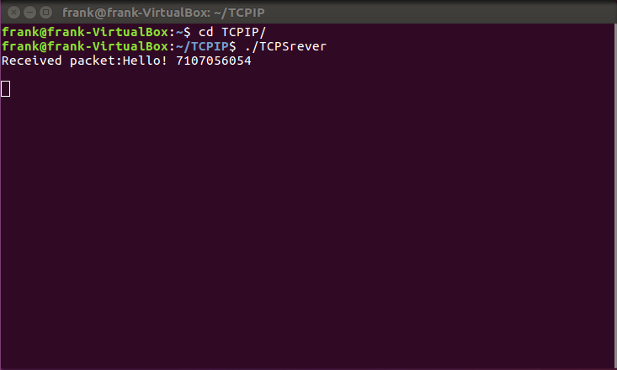

1. Show the execution result (snapshot) of TCP client

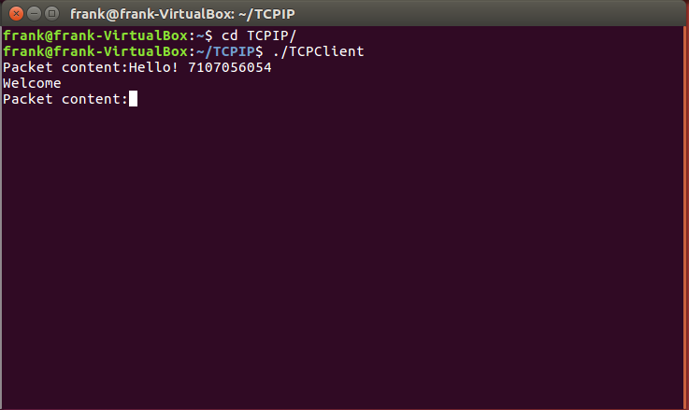

Advanced

1. How do you measure the latency?

將Server收到封包的時間減去Client傳出封包的時間

1. Show the latency result

TCP:

以下圖Latency為 25 微秒

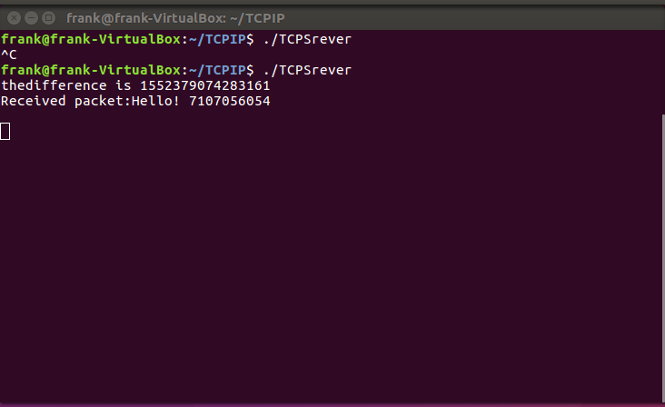

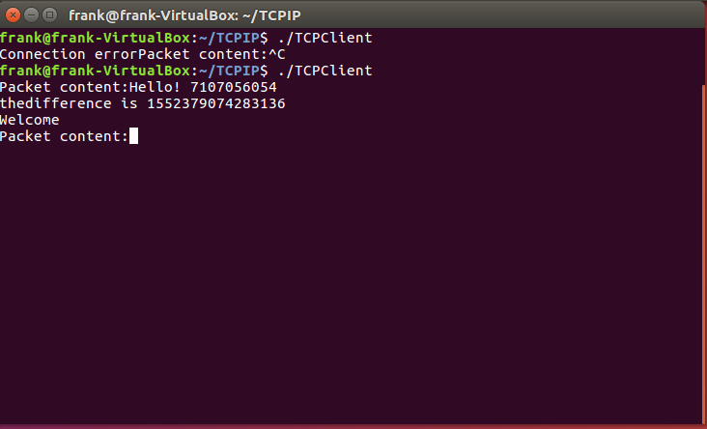

UDP:

以下圖Latency為 30 微秒

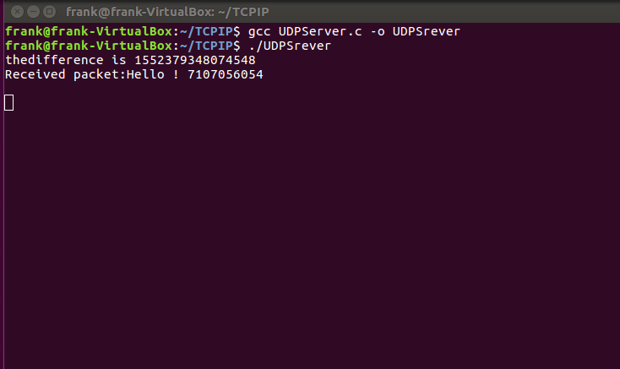

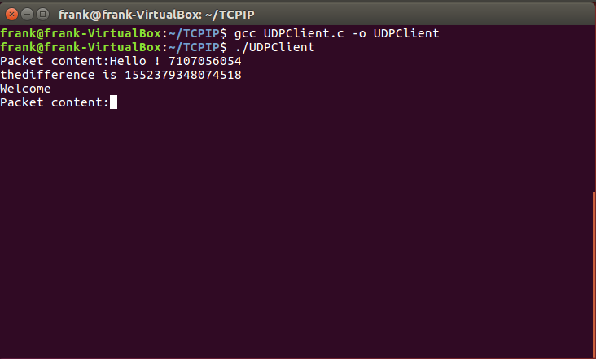

1. How do you measure the throughput?
2. Show the throughput result