Name:胡翔崳

Student ID:7107056054

Basic

1. Show the execution result (snapshot) of server
2. Show the execution result (snapshot) of client

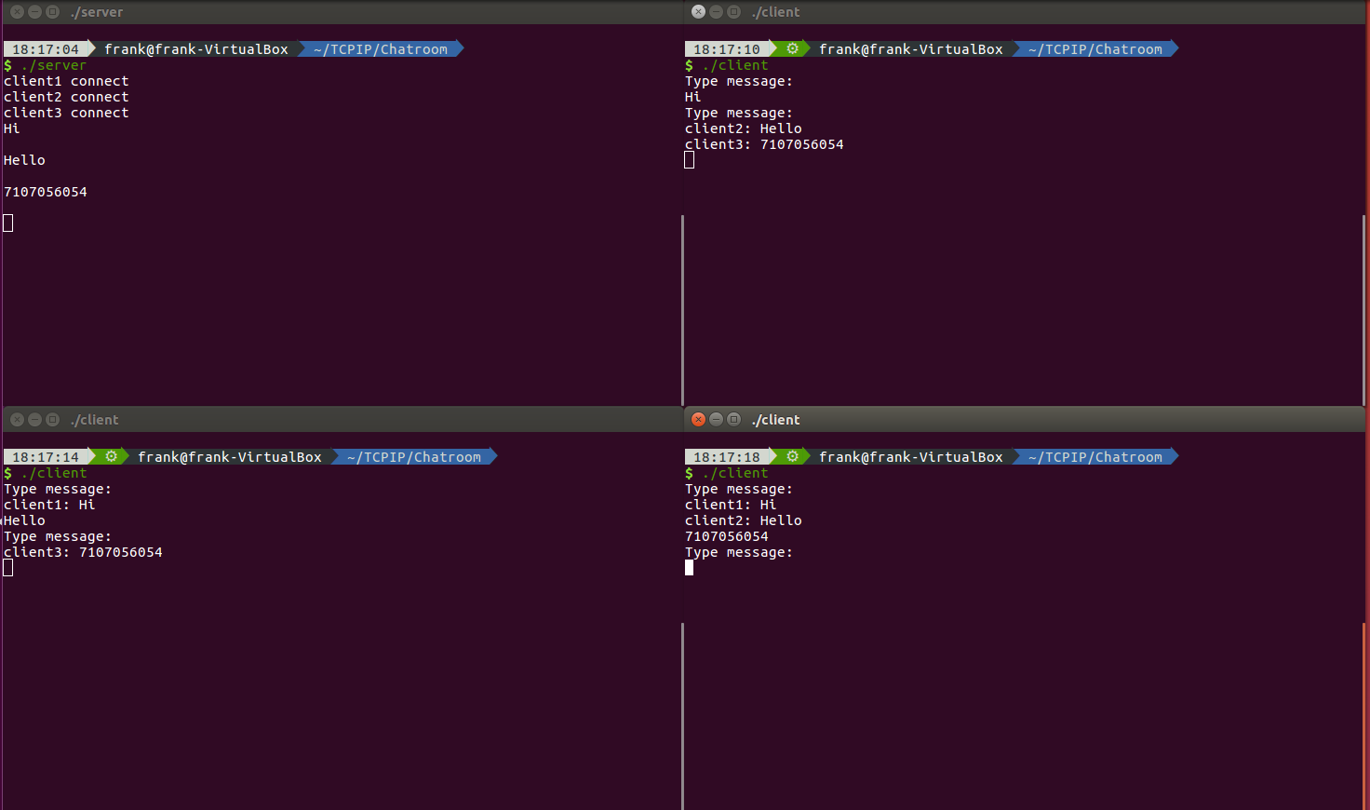

Advanced

1. Show the execution result(snapshot) of server
2. Show the execution result(sanpshot) of client

