Name: 胡翔崳

Student ID: 7107056054

Basic

1. Show the execution result (snapshot) of HW3-1

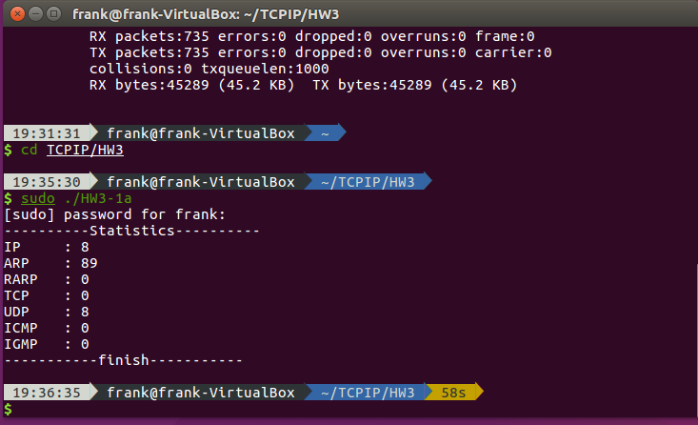

1. Show the execution result (snapshot) of HW3-2

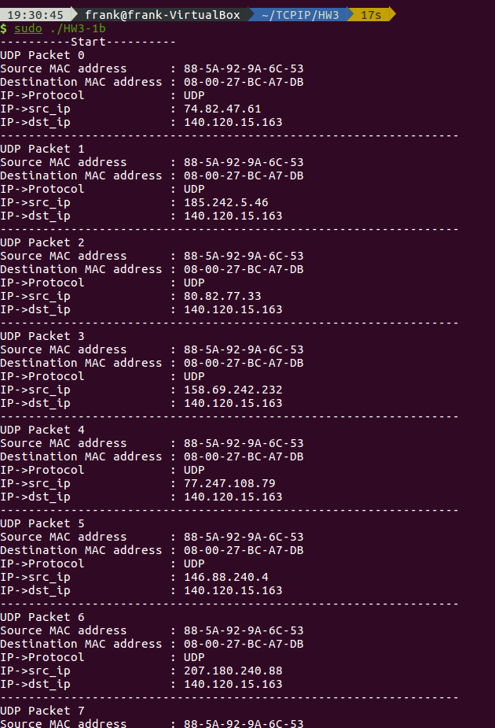

1. Show the execution result (snapshot) of HW3-3

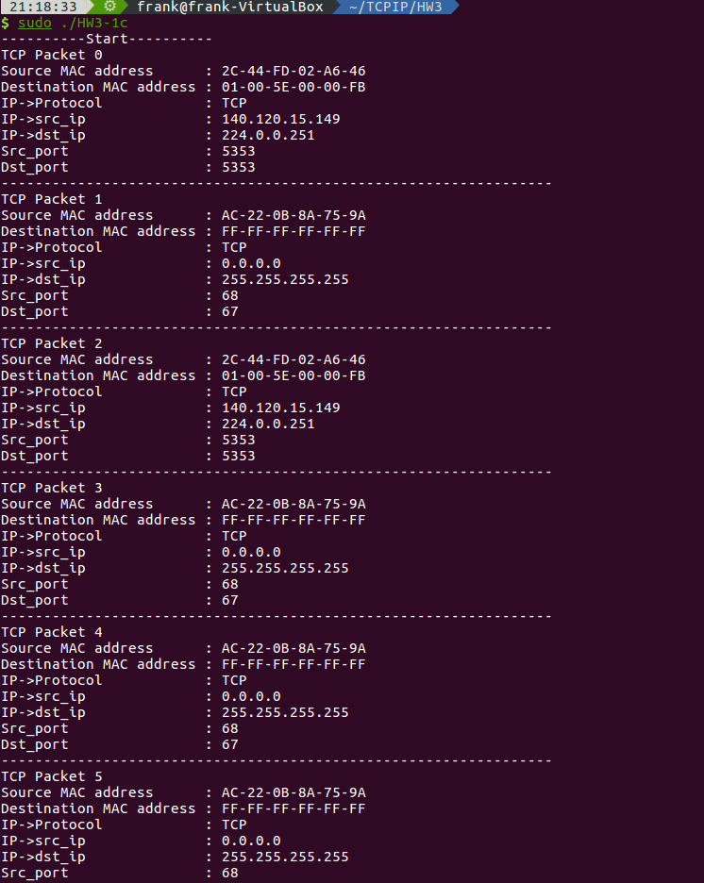

Advanced

1. Please describe that how do you fake ip address ?
2. Show the execution result (snapshot) of HW3-4
3. Please describe that how do you modify payload?
4. Show the execution result (snapshot) of HW3-5, please show the original payload and fake payload.